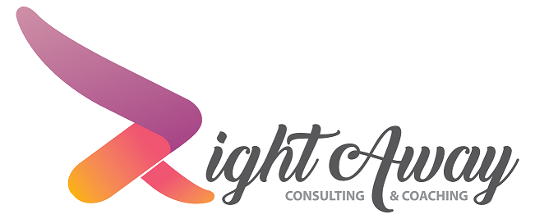
Engage, Inspire, and Empower

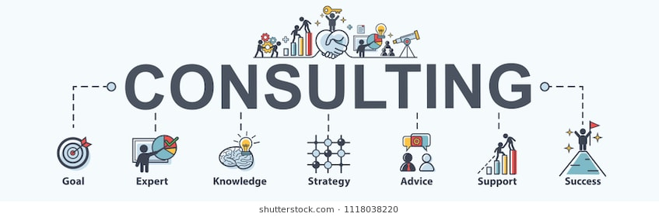
RightAway LLC provides consulting services and specializes in the credit and collection industry. The area of focus for consulting is debt collection agencies, creditors, asset buyers, and solution providers. Our consulting services are focused on two avenues; staying ahead of the curve and turning challenging situations into positive experiences. RightAway offers a holistic approach to it’s consulting but also offers an ala carte process by focusing in the areas of Operational Excellence, Compliance, Employee Development, Business Development, Client Experience, Information Technology, and Public Relations. RightAway takes great pride in getting organizations to obtain maximum output with minimum input while increasing efficiency, effectiveness, and profitability.
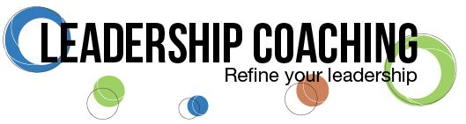
RightAway also specializes in leadership coaching with a focus on mid-level, senior, and executive level management. We have found over the years that most organizations do a good enough job in training their front line employees but fail to train the leaders that are leading the organization. That is where RightAway comes in, with over two decades of training all levels of employees our training program is customized to reach upper level management. We focus on where the individual or the organization wants or needs to be in order to be the most productive individually and corporately. Our program interacts with everyone on their level in a way that energizes them to achieve extraordinary results with desired objectives and goals in mind. It is important for us to identify and understand each situation and priorities of the individual and organization so that each unique situation is strategized on how to reach them while providing a learning environment that teaches them to overcome obstacles that rise along the journey. RightAway Leadership focus on five avenues; Mindset, Purpose, Caring, Communication, and Courage.
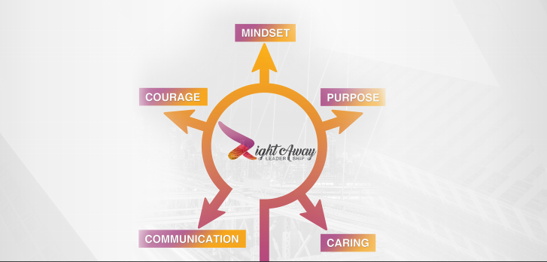

Services Provided
Operational Excellence
- We will provide an exhaustive and unbiased review of your organizations current collection strategies from a cradle to grave work flow standpoint. This will include best practices from across the industry and provide you with templated procedures, necessary reporting, workforce management, and ensuring your organization is working with the right technology providers at the right cost to the organization.
- We will also provide you with in-depth expert advice encompassing two decades of experience providing actionable solutions that will provide organizations with methods to increase recoveries, liquidation, and revenue.
- If warranted, a full and complete review of the organizations profit, and loss statement would be reviewed and findings shared with executive management to identify areas and trends where the strengths and areas of opportunities are.
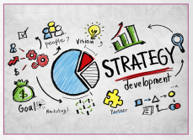

Compliance
- Perform an exhaustive review and determine the maturity of your organizations existing Compliance Management System
- Produce a framework to build upon a CMS from the current maturity level which includes development and/or enhancement of policies, procedures, controls, work instructions, exception reporting, and technology usage/opportunities.
- Having gone through several ACA Professional Practices Management System Certifications (PPMS) as an agency owner and certified instructor we are prepared to assist your organization to fast track this critical component of an agency’s compliance management system. We can save you time, money, and resources by assisting with the awesome program.
- If you are interested in learning how to implement processes that will streamline the state licensing and bonding, we can save you time, effort, and energy by showing you how to do it yourself or how to negotiate with the vendors available to assist you.
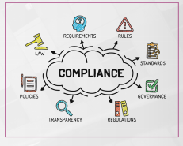
Employee Development
- When it comes to any organization, the number one asset is the employees. If you take care of your employees, they will take care of your consumers, and that will take care of your organization. Ultimately, all we do starts and ends with our employees and we have developed a training curriculum from the first day all the way through years of gainful employment.
- Unfortunately, the debt collection industry operates under several strict lability statutes which means all employees must always be perfect. We all realize that is an unreasonable request but a request that must be adhered to nonetheless. We spend a lot of time with employees on how to operate under these statutes and what they can do to mitigate violating the various laws they must follow but still performing at optimal levels.
- We will help build a foundation and create or enhance your current employee development program which includes orientation, initial and ongoing training, employee handbooks, training manuals, and talent evaluations and reviews for each department.
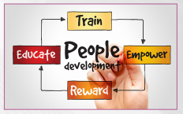
Corporate Branding
- The bottom line is image is everything. If an organization wants to get their foot in the door with a prospective client then they must portray themselves in a light that exudes confidence, competence, and the ability to impress the potential prospect. We will work with your current branding and leverage our great marketing team to ensure everything from your initial brochure to your website is top notch to ensure that you will not just get one foot in the door, but both.
- If you do not have top notch corporate branding then regardless of how great your organization is or how great you think it is, getting an opportunity to realize your organizations full potential will be very difficult.
- We will build your corporate branding from A to Z that encompasses everything great about your organization while at the same time customizing it to meet the needs of your target market.
- Public relations also place a role in corporate branding and we will help you identify who or whom in your organization would be best suited to take the reigns of your public relations campaign.
- We will work with them and prepare them for everything they need to know to be successful while leveraging our vast network to position your organization into various opportunities that will pay dividends with existing clients and future partners.
- In addition to your employees, the second most asset to your organization is your clients or what I refer to as partners with the client experience. So why is there not enough emphasis placed on ensuring your partners experience is one they will never forget. There are so many little ways you can make your partners experience superlative and we can walk you through each of those ways in order to make sure your partners or just that, partners and not just another client.
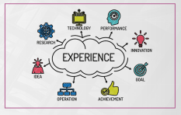
Information Technology/Data Security
- We will ensure that you are aware of all the options available to reduce costs, increase compliance, improve efficiency, and maximize overall performance. We understand that IT costs can be extremely costly, so it is important for us to lay out what options are out there and what they cost are while determining what other options may be best suited for your organization and still achieve the intended result.
- We have relationships with all the major and minor players in the collection software, telephony, skip-tracing, scoring, speech analytics, and other industry solutions in which we can leverage that network to obtain the best product at the lowest cost possible.


Vendor Oversight
- Whether you are a creditor or asset buyer who needs to oversee your outside vendor partners, RightAway is where you want to come to make that happen. Having spent two decades going through hundreds of audits in all scope and sizes, RightAway knows what creditors and asset buyers are looking for and in addition to the compliance end of the spectrum, we provide the added benefit of looking at the audit the operation lenses as well to see where opportunity may provide itself to increase revenue while mitigating risk,
- As a collection agency, it is imperative that you are monitoring and auditing your vendors such as skip-tracing, telephony, collection software, and others. RightAway can either handle this for you are teach you and your team how to ensure you are auditing your vendors and following all applicable work standards and laws in this complicated area.
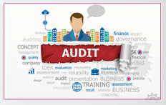

Solution Providers
- For vendors or as I refer to them as solution providers seeking to do business with creditors, asset buyers, and collection agencies then RightAway is the team you need to make it happen while we leverage our vast network to increase exposure and opportunity.
- Utilizing two decades of experience in the credit and collection industry while utilizing or testing most products on the market, we can provide an unparallel and unique perspective regarding your product and service while providing candid feedback and what steps need to be taken in regards of areas of opportunities and outlining the strengths that need to be taken advantage of as well.
- In this program we will perform an exhaustive and unbiased review of your organizations product of service while providing cost and market analysis of similar products and services.


Nick Jarman
Owner
RightAway, LLC.
Nick Jarman has two decades of experience encompassing all facets of credit and collection operations. As one of the most respected leaders in the credit and collection industry, Nick is a nationally recognized speaker, writer, and consultant. Nick served a three-year term on ACA International’s Board of Directors and was the youngest elected President of the Missouri Collectors Association. He is adamant about leading by example and ensuring that in everything he does, it is done the “Right Way.”
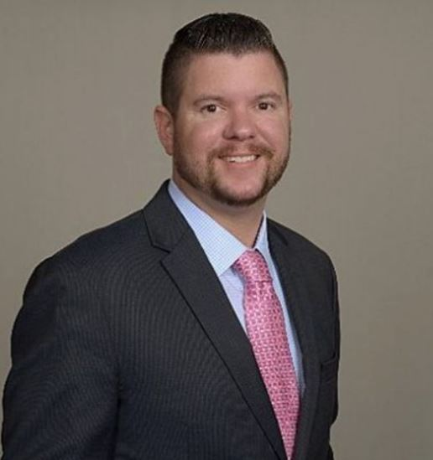

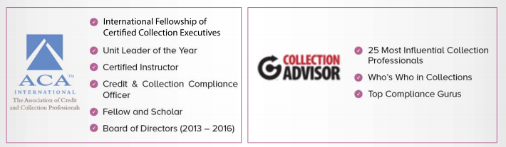

Contact Us
Phone: (636) 233-9779 Email: nick.jarman@therightaway.com



@RightAwayCC

https://www.linkedin.com/in/njarman/
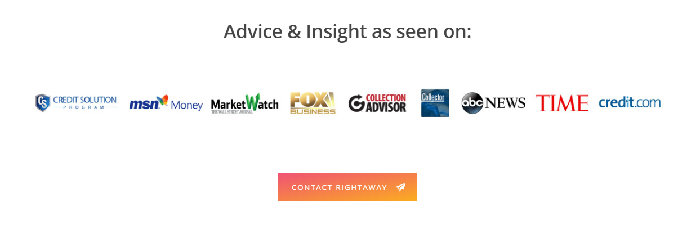


RightAway’s Weekly Blog contains actionable solutions with a run down of the top industry stories from the prior week.

RightAway also puts on industry leading events that challenge the norm and set the standard for how industry events should be run. All of RightAway events are created to provide quality content at a reasonable price-point while providing real world solutions to real word problems. Our events provide a foundation of direction, insight, and actionable solutions that can be applied regardless of the size of an organization. Expert speakers with customized solutions for each event set our forums apart from other industry events.



Fall Event
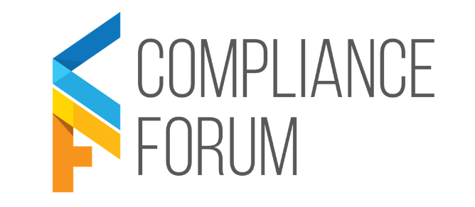
Spring Event

