Judith Fox Dietitian. About me
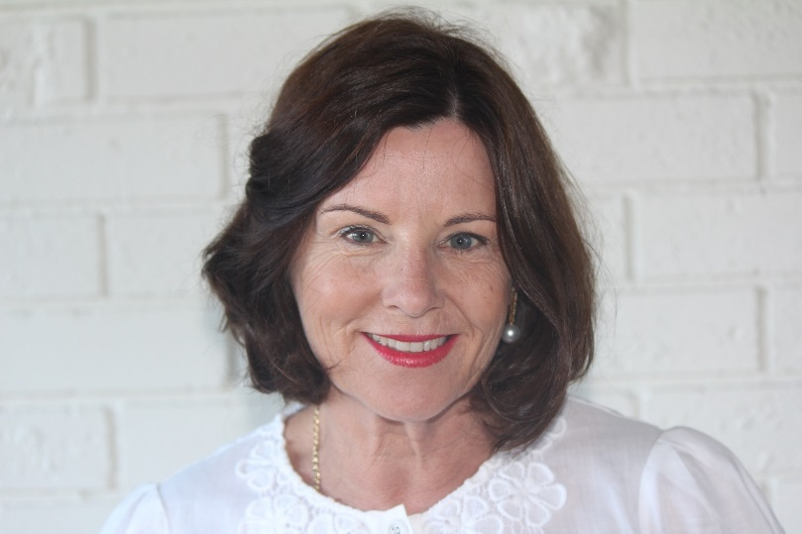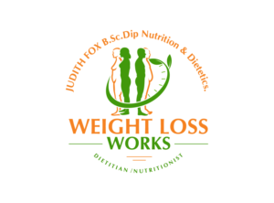
I completed my Bachelor of Science and Post graduate diploma in Nutrition and Dietetics in 1975.
I have combined a working career with being the mother of 4 children.
My many years of experience has included positions in several public hospitals throughout Australia including being the Chief Dietitian at The Children’s hospital in Sydney.
I wrote a book which was published by Pitman Publishers in 1990 titled “Bottle Feeding Without Feeling Guilty” as I saw many mothers struggling with the issues around breast feeding.
In the early years of Dietetics in Australia few Dietitians did Private Practice as most diet related disease occurred in patients who were hospitalised or attended the out -patient clinics at major public hospitals.
As weight gain and obesity became alarmingly prevalent in Australia I began specialising in Weight Loss Management. I had one of the first private practices in Australia.
Weight control is very important to me and I am also a lover of good food, dining out and above all sitting at a long table with family and friends enjoying a special meal.
I am fortunate to live on a couple of acres where I have a large vegetable garden, fresh eggs from my chickens and enjoy the excellent seafood available in a coastal town.
I am well aware that many people don’t really enjoy cooking and their lives are busy. I am able to teach a wide range of people how to shop, cook and eat outside home and steadily lose weight.
I wish to share my life and experience as a Dietitian with you in the easy to understand web site.

