1 page BACK

LIMITLESS CBD MISSION

OUR VISION
Limitless CBD was founded by entrepreneurs Brian Lytle and Tony Russo. Their mission is to introduce people to the healing benefits of hemp, and to inspire holistic wellness by designing and developing the highest quality CBD products available. To that end, we have formulated tinctures, vaporizers, and topicals to provide people with powerful options for their health and wellness needs. Furthermore, Limitless CBD aims to lead the industry through our values of transparency, superior quality, and sustainability.

PURPOSE
Inspiring hope and restoring happiness. Healing body, spirit and mind. Paving the way for your state of well-being.

Our Mission
our mission is to provide the highest quality, Cannabidiol (CBD) offering customers a safe, effective alternative to prescriptions painkillers, other toxic prescription and over the counter drugs that contain harsh chemical compounds alien to nature perfect remedies.

What is CBD?
Cannabidiol is one of the most well- known, non-psychoactive cannabinoids found in hemp plant. CBD bind to receptors in your immune system, providing a variety a medicinal benefits. It was originally patented by the united sates government in 2003 as a neuroprotectant and antioxidant.
CBD oil is obtained by extracting CBD from the hemp plant using a process in which CO2 is at a low temperature, under high pressure. By doing this, CO2 is capture in a liquid state, drawing out CBD and terpenes from the hemp planet.

2 page BACK

HEMP PROCESSING CYCLE

SEEE EXAMPLE

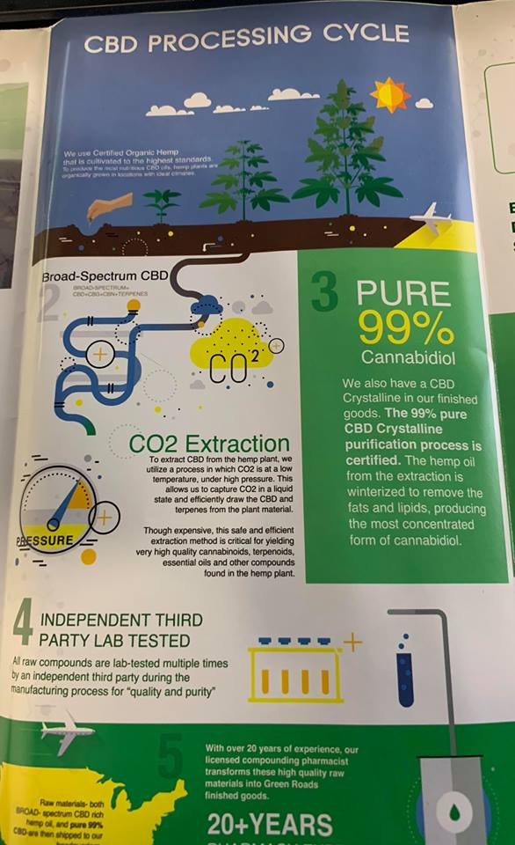

PAGE 3 BACK
COMPANY HIGHLIGHTS

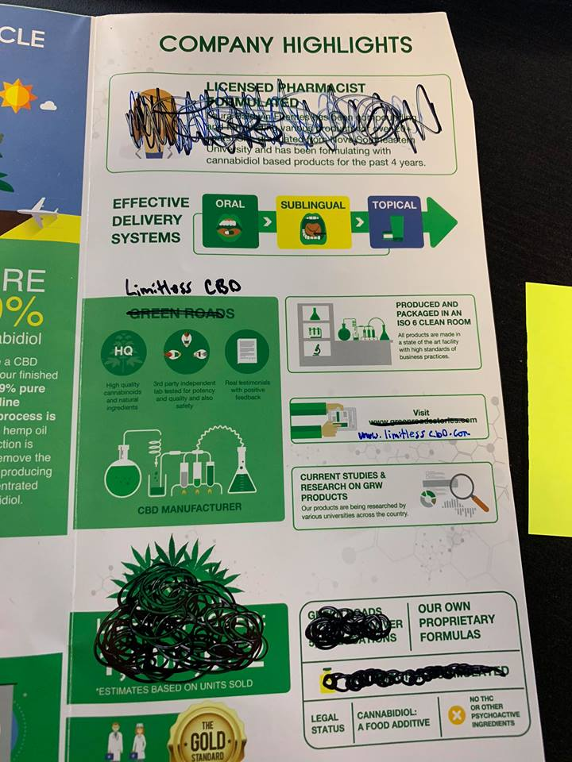

PAGE1 FRONT COVER

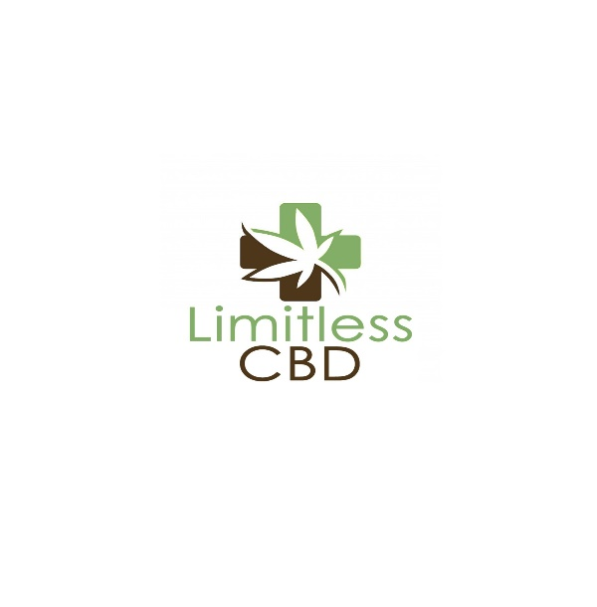
- 3RD PARTY LAB*
- *NO THC*

VARIOUS PICTURES HERE WITH COOL DESIGN

PAGE 2 FRONT

WHY LIMITLESS CBD?

- Footprint in all 50 states-
Read our 5 star reviews

I will supply these

BACK PAGE PAGE 1
CBD OILS

Our premium cbd oils have a proprietary blend that provides a safe and effective sublingual delivery. Our
250mg
500mg
750mg
15000mg
Ingredients: hemp oil, pure cbd isolate
Flavor- natural or peppermint
Volume- 30ml
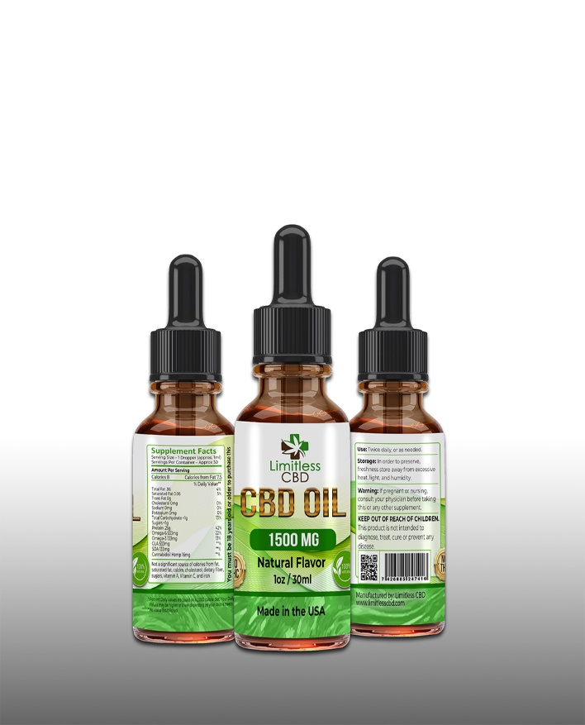

Back page 2

CBD EDIBLES

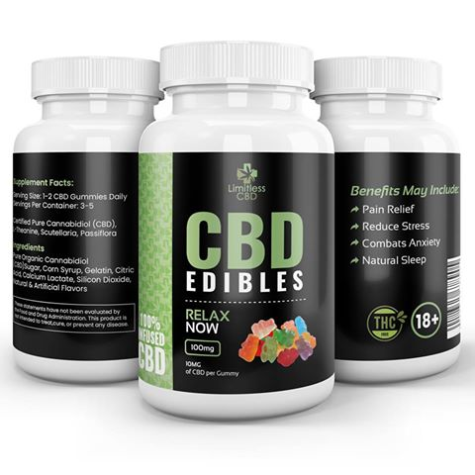

Produced in house to control purity and accuracy. Through our procedure we are able to ensure our products are of the highest quality.

Available CBD POTENCIES:
100MG

BACK PAGE 3

TOPICALS
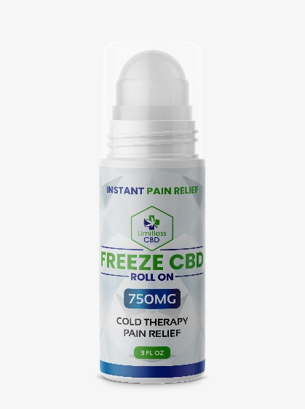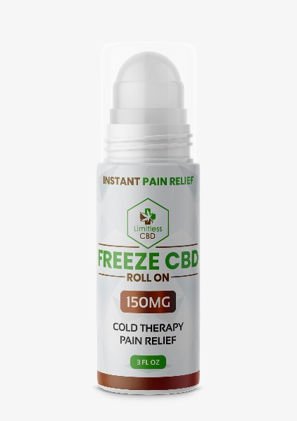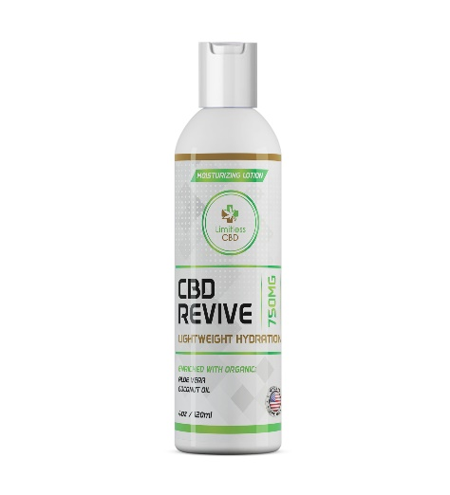

CBD PAIN FREEZE ROLL ON- Freeze Pain Relief Gel is formulated for a variety of skin types, it’s endorsed by nursing homes, individuals suffering from chronic pain alike. With our proprietary ingredient mix, CBD Freeze is specifically crafted for alleviating join pain, stiffness and muscular tenderness. Avaible in 150mg and 750mg

Lotion
Revitalize your skin with Topical Moisturizing Lotion that combines high-concentration CBD with all-natural coconut oil, aloe vera, and other essential oils to have your skin feeling babies-bottom soft. Our lightweight, moisturizing formula uses the highest premium-grade CBD compounds
Made from 100% organic, USA-grown industrial hemp, our specially formulated moisturizing formula will give your skin that sexy summertime glow while providing hours of protective, nourishing moisture for dry, cracked, and irritated skin. Avaible in 300mg or 750mg.

Back page

CBD E-LIQUID

Vape Oil- Limitless CBD E-Liquid comes in a variety of flavors including: Blueberry Cotton Candy, Ripe Strawberry, Pink Lemonade, Sugar Cookie and Mixed Berry which are manufactured from pure CBD Isolate at over 99% purity. Available in 500mg

Cartridges- 1ml prefilled cartridge. Available in 100mg & 500mg

