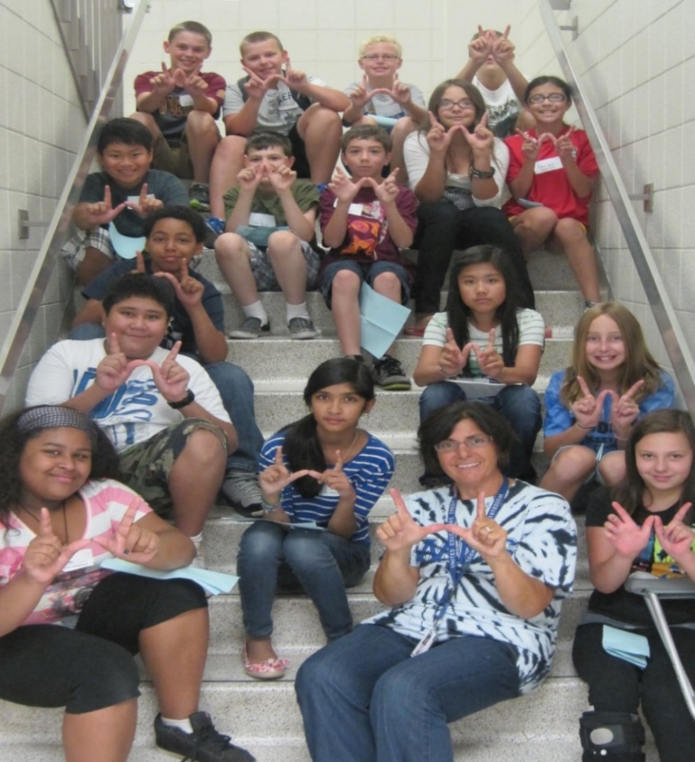  What’s the data say?  In 2016, the percentage of 8th graders who felt that educators care about them was dramatically lower than 5th graders.  Minnesota Student Survey, 2016  What’s the issue?  Students who are not connected to a caring adult in school are at greater risk for lower education and health outcomes.  Whole Learners© creates connections  Through our tailored trainings, classroom observations, and relational coaching, we help educators engage ALL students.  want to change your school climate & culture?  Whole Learners© is a comprehensive and innovative program that improves connections between teachers and their students, resulting in increased student engagement, and fundamental positive changes in school culture and climate. |   © 2018 Regents of the University of Minnesota. All rights reserved. The University of Minnesota is an equal opportunity educator and employer.
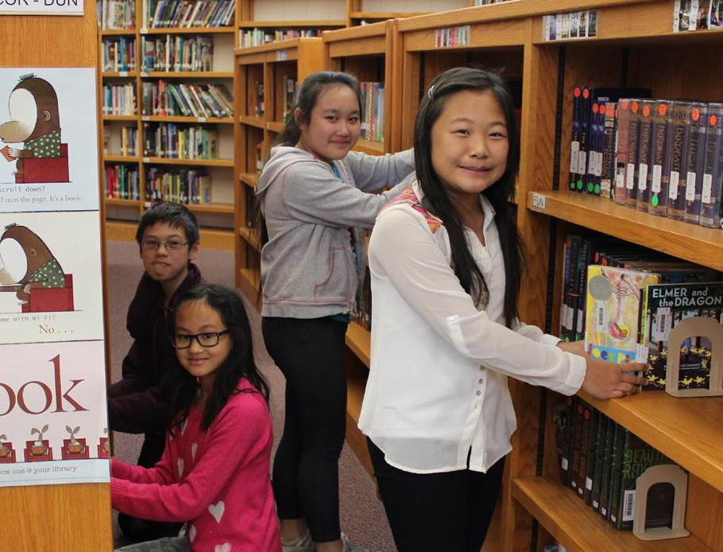
Customized Services
Our services respond to schools’ individual needs and are delivered by highly engaging experts allowing participants to learn, reflect, and grow. We work with you to design a program that supports your goals, including site-specific training topics, and budget-responsive levels of coaching.

Our Partners
Since 2010, we have worked with eight districts and 11 middle schools in urban, suburban and rural locations in Minnesota.

Contact Us
We look forward to adding new partners. For more information, to request a bid, or schedule a free consultation, contact:

Paul Snyder, MSW, MDiv, LGSW
612-626-8412
psnyder@umn.edu

Abigail Gadea, MSW, MPP, LISW
612-625-6415
gadea002@umn.edu

No-yawn Professional Development!
The unique Whole Learners© program provides yearlong training, feedback and support that results in increased ability to implement new knowledge and skills in the classroom, improved communication with school staff and students, and enhanced school climate and culture.

“This program has filled my teaching tool kit and can be considered one of the most formative experiences in my teaching career.”

“I found it exhilarating…it was a helpful, caring and supportive format. This is a program that I wish all teachers could experience.”

“The training was fun, and brought my cohort of 6th grade teachers together in a closer way than we had been.”

