Mushroom Steak
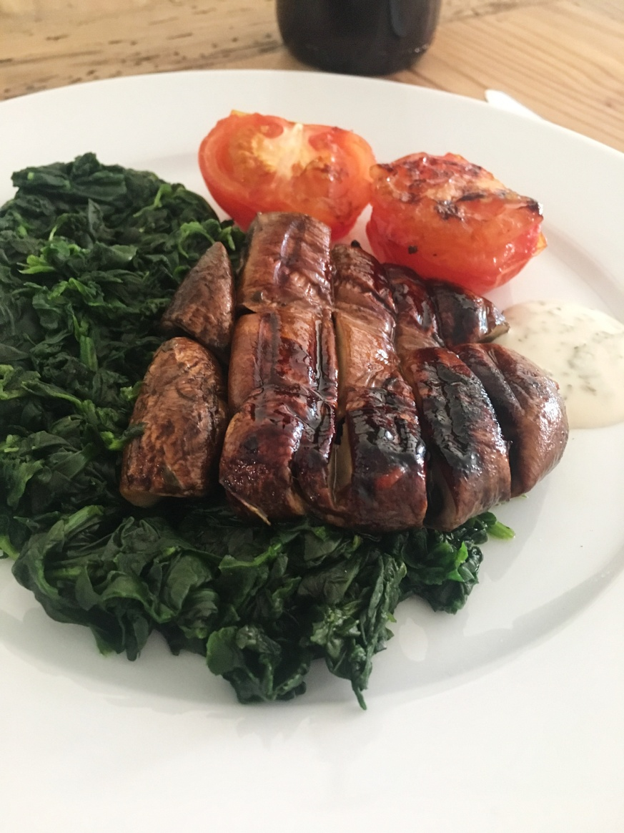
Steak and vegan don’t go in the same sentence BUT trust me on this…a decent sized Portobello shroom cooked just right with a blend of delicious marinade, it has the meatiest texture and its delicious as well oh and did we mention it is completely cruelty free!?
To get the right texture you need the right tools so I always suggest cooking this on a griddle pan or even on the BBQ to give it that additional boost of flavours.
When my non vegan friends are looking for something to cook when they have the plant powered team over for dinner, I always use this as a suggestion. The sides can be mixed and matched so in this instance I have used a grilled tomato and a pile of steamed spinach but you can add fries or salad or anything else that would be served alongside a steak. So all in all, it is a very versatile dish.

Recipe and ingredients
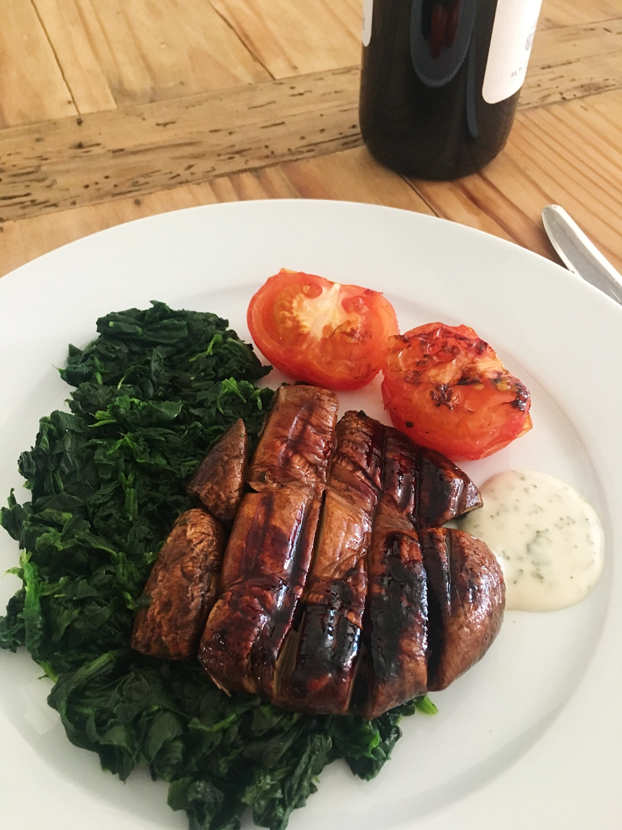
Serves 1
Ingredients
1 large Portobello mushroom- cleaned well and destalked
1 tbsp balsamic vinegar
½ tbsp olive oil
Pinch of cumin
Pinch of salt and pepper
Pinch paprika
½ garlic clove minced

250g Spinach
1 large tomato cut in half and seasoned
Add chips, a jacket potato or any other sides.

- Mix together the olive oil, balsamic vinegar, cumin, salt and pepper and paprika
- Add in the Portobello mushroom and marinate for 15 minutes, turning the mushroom over half way through
- Turn on the grill and place the tomato, seasoned on a baking tray for 10 minutes.
- Heat a non stick griddle pan to a medium heat and add the marinated mushroom to the pan. Cook on each side for 4 minutes or until it turns a beautiful caramelized colour.
- In the meantime steam or sauté the spinach
- Plate up the goodness and enjoy…simple as that!

The dip that I used here was just a combination of vegan mayo, dash of lemon juice, fresh chopped basil and a ¼ tsp of mustard.

