On Philly in the Desert, I share some delicious recipes either my own or from other fabulous sites that I have come across, my meal plans, reviews of products and restaurants that I visit and more.
And yes, I live on a plant based diet. Shock…horror…brakes on…leaves site… !
Just hear me out a minute… I am not going to lecture you about becoming vegan or being plant powered or eating cruelty free. If you are looking for Meat Free Monday inspiration, perhaps you want to try a plant based diet for a week or just looking to save some cash with some veggie recipes, I hope this is where I can help. And this is what I want to achieve; as small changes can make a big difference right? And for my fellow plant food lovers...hopefully you will find some inspiration!
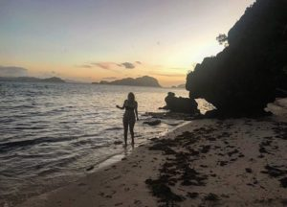

So a little bit about me… I’m Philly (short for Philippa). Born and raised in the UK (with the odd stint in South Africa and Mauritius) but been living in Dubai since 2012. I have always had a love for animals after growing up around all sorts; from dogs, horses, cats, hamsters, rabbits, the odd injured pigeon or hedgehog in the house (whilst the mother would be nursing them back to health) and even scary cockerels to name a few! I am a massive foodie, love travelling the world, new adventures, the beach and working out (mainly so I can eat more and drink copious amounts of ‘grape juice’).

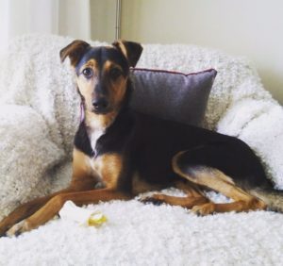
My little buddy, Mason is a mixed breed doggo that I adopted in Dubai in March 2017. He was only around 4 months old but had already gone through enough terror in his life before he was luckily rescued by one of the awesome charities in the region. I took him in to foster and the rest as they say is history. And before you ask…no, Mason is not vegan. He is partial to peas, carrot and sweet potato but that is as far as his plant based diet goes.

