www.cfxf.io



Your Money Growth
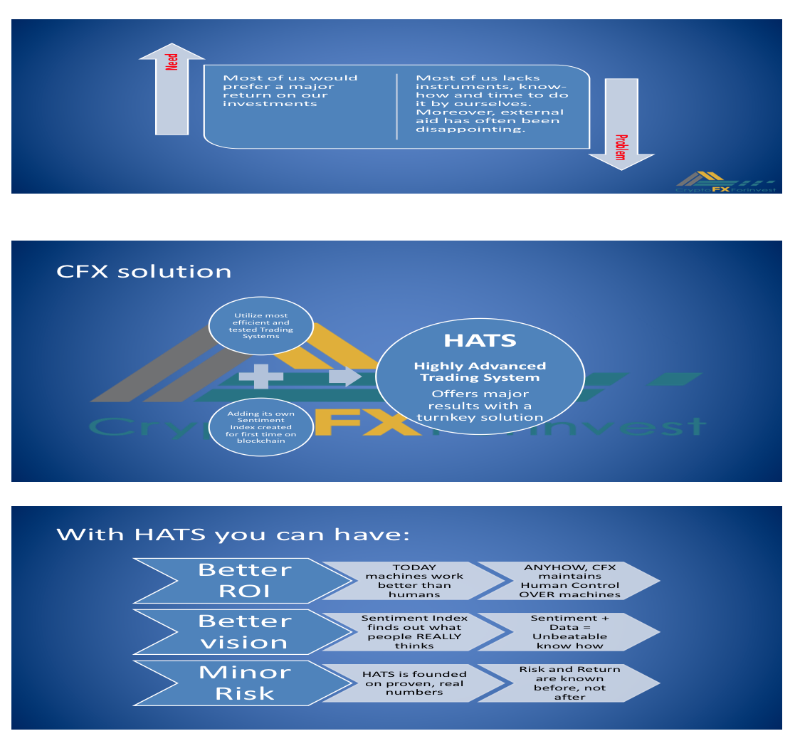

BACK OF PAGE:

We are waiting for you!

Ask your invitation to our CFX Hostess and be welcommed to:
Presidential Suite
Level 18
…..
www.cfxf.io

