Who we are/what we are trying to achieve:

- Our ideal client/patient is:
  - Committed to/follow treatment plans
  - Excited for office events
  - Teachable
  - Advocate
  - Working professional
  - Male-Female 22-60
  - Cheerful
  - Maintenance
  - Call to cancel apts
  - On time for apts
  - Books multiple apts
  - Refers others
  - Gets good relief from treatments

- Adjectives/key points that we want people to associate Central Avenue Health Centre with:
  - Great location
  - One stop wellness shop
  - Knowledgeable and caring therapists/chiropractors
  - Friendly, caring, warm, clean, safe and welcoming environment
  - Very professional
  - Know patients by their first name, familiar, knows my name
  - Thorough, helpful
  - Convenient
  - High caliber - can answer all my questions, knowledgeable
  - Gives back
  - Non-judgemental
  - Relief
  - Enjoyable
  - Interesting
  - Engaging
  - Positive results
  - Honest
  - Qualified
  - Leaders
  - Quality service

- Why we are better than our competitors
  - Friendly, warm, competent,
  - Exciting/more than just chiro (other services and events)
  - Above and beyond customer service/ a team that goes the “extra mile”
  - Excellent treatments and therapies/quality (quality at reasonable prices)
  - Multidisciplinary approach to wellness
  - Not just another patient - you are special to us, genuinely care
  - Thoroughness
  - Convenience
  - Direct billing
  - Able to book the service they need when they need it

Our Current Logo


Logo Styles to AVOID
- NO Blue/Greens
- Spine shapes
- Nature themes – leaves, trees
- Person figures/graphics (too similar to what we have now)
- We are not targeting families. We target men and women aged 22-60

Below are examples of logos that we want to avoid looking like.

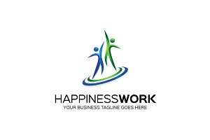
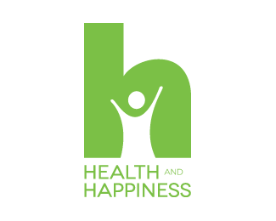

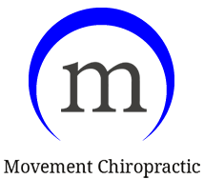

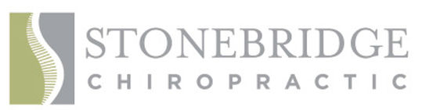
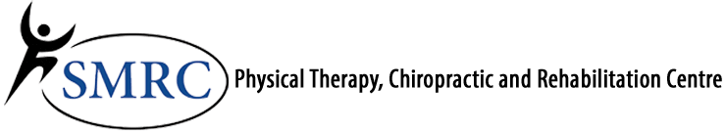


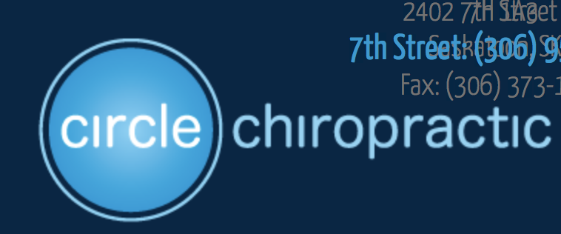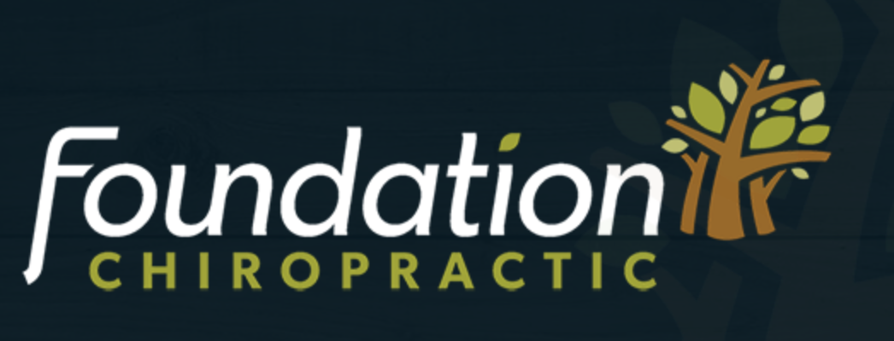

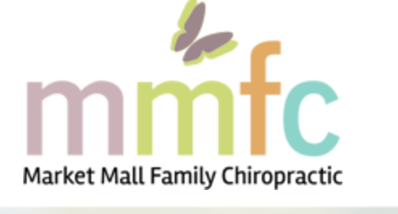
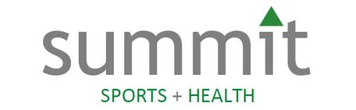
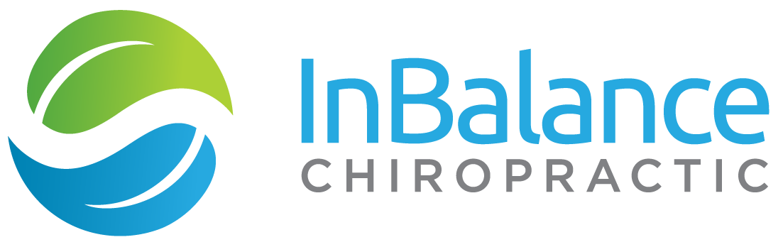

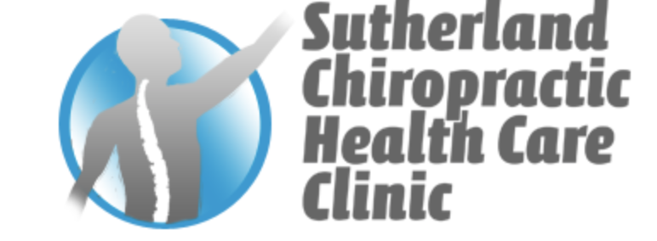
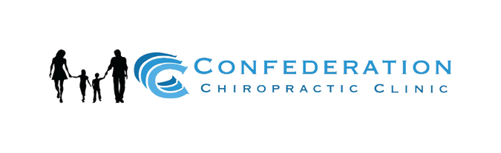
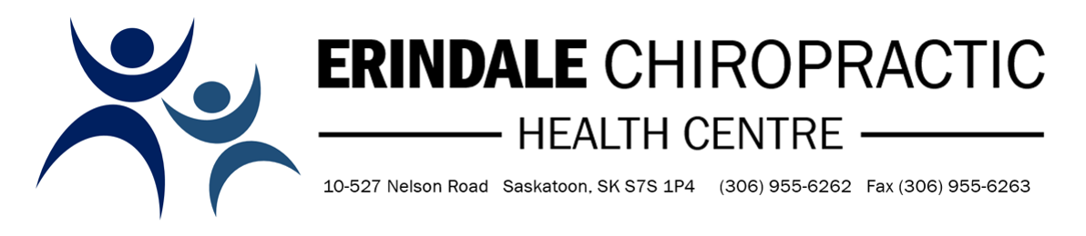

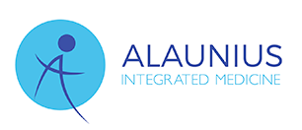
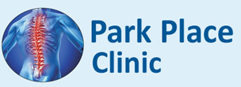
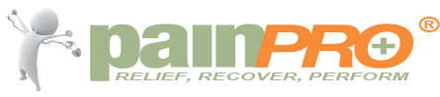

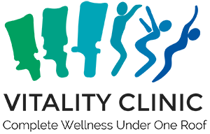

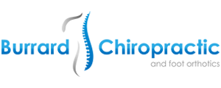
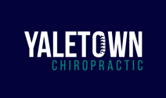

These logos are an overview of how a lot of them look the same. Blue, green, spine graphics, nature, and people figures/graphics. We want to avoid looking like everyone else.
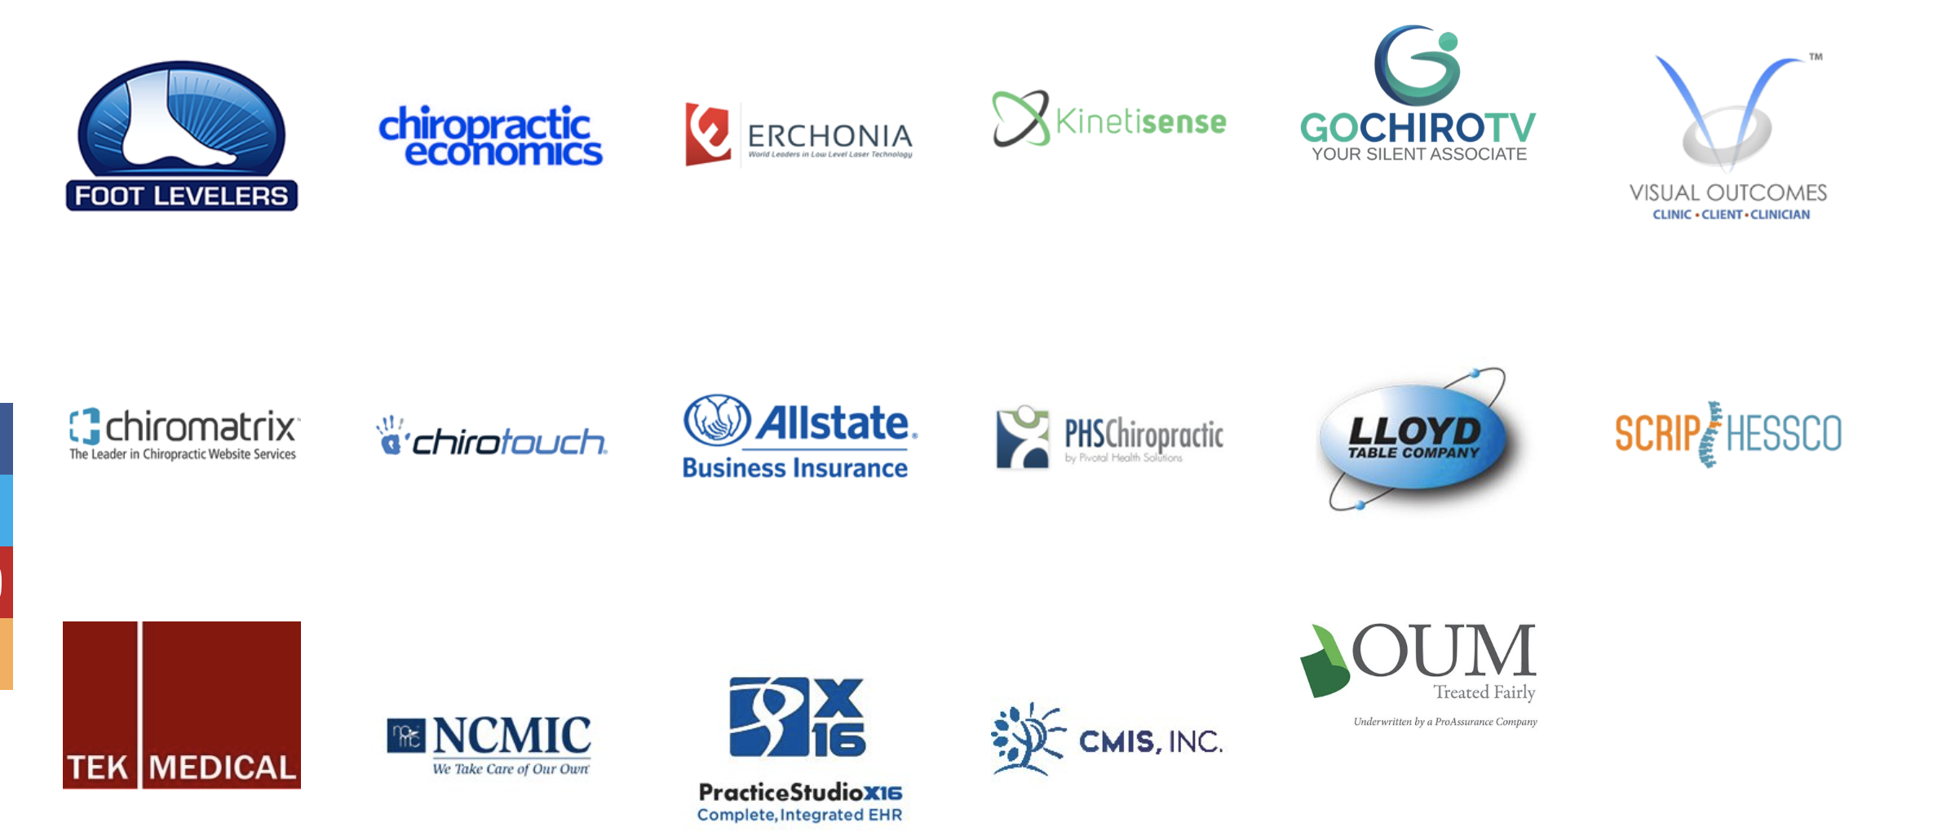

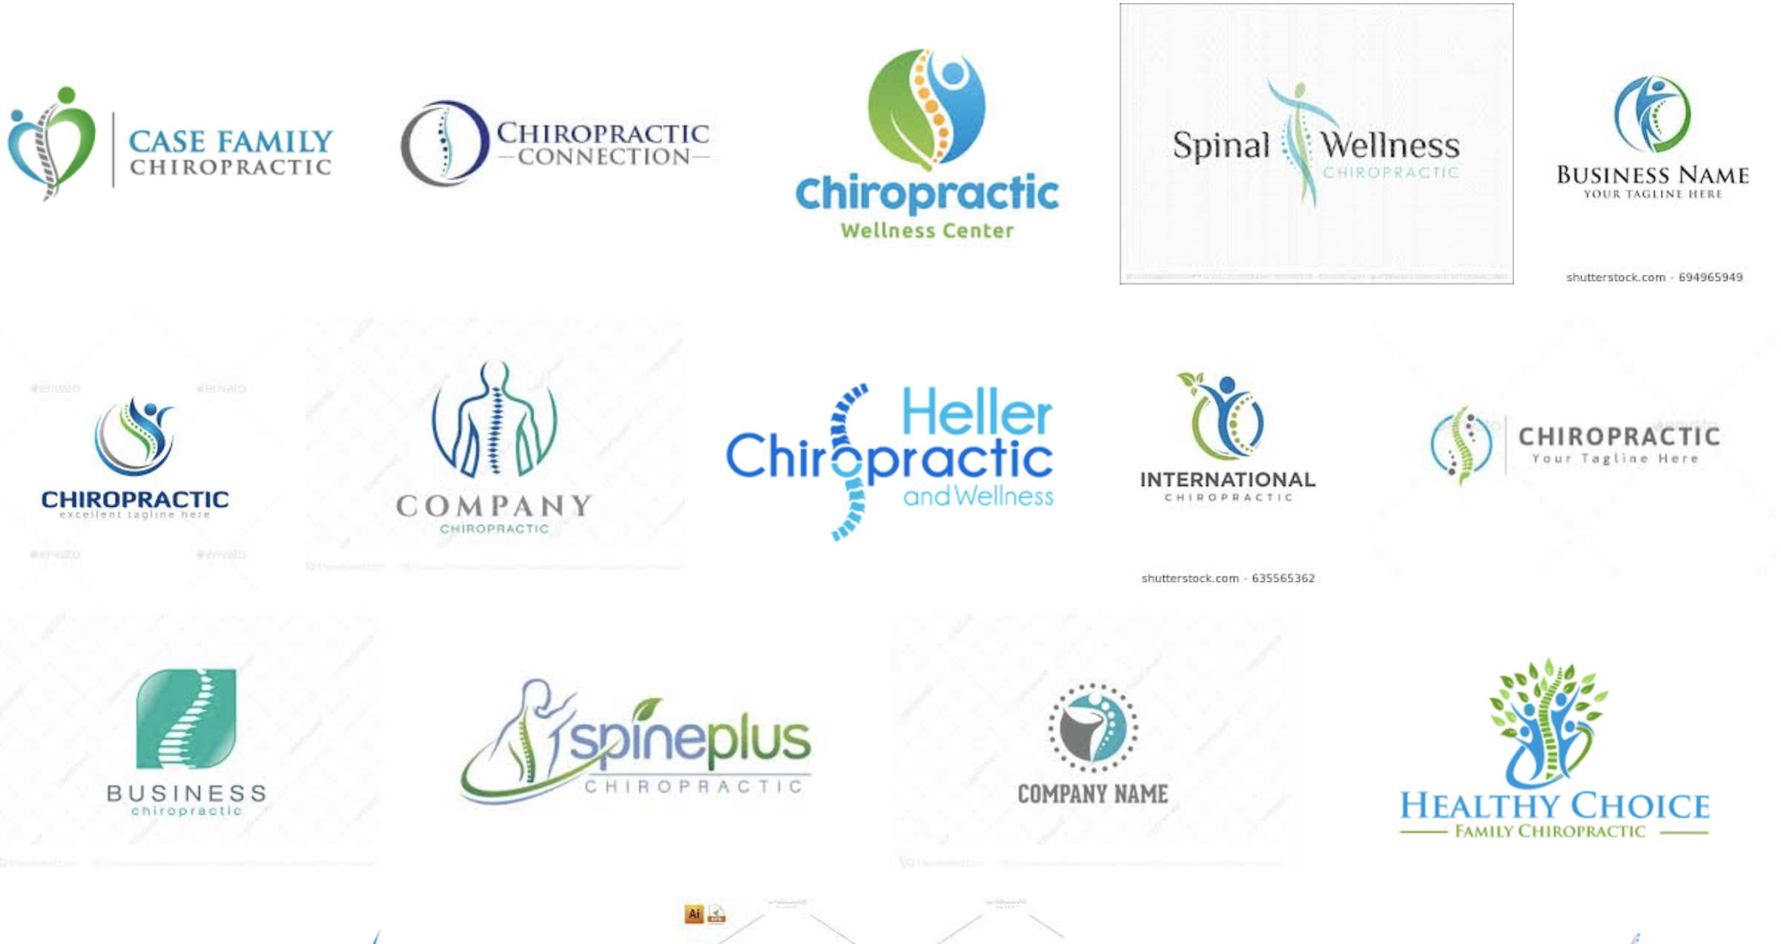

We would like to be in the optimism spectrum of colour emotion …
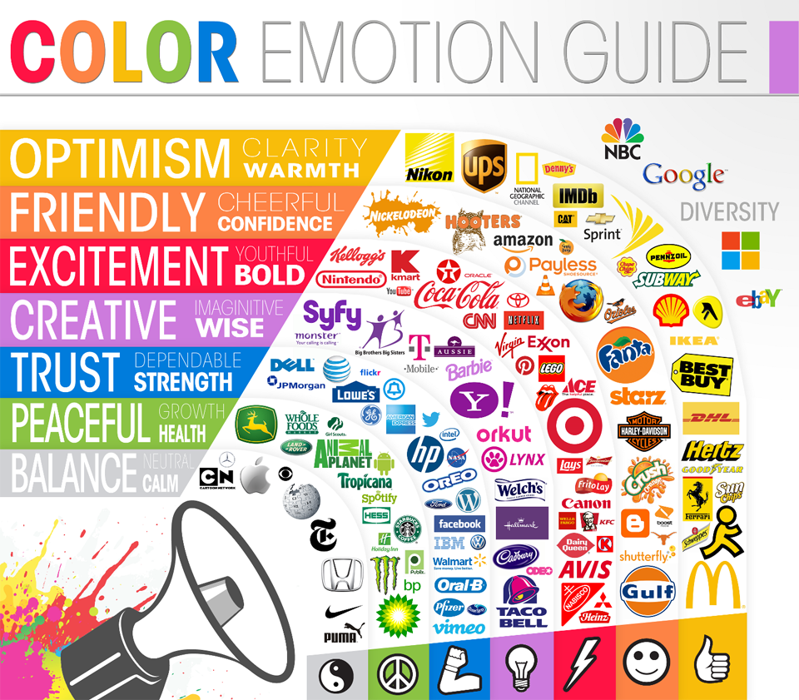

Logos we kind of like …

We like this logo because of the colours used and how it ‘shines’ … it does use the spine depiction which we want to avoid, but here it looks good.

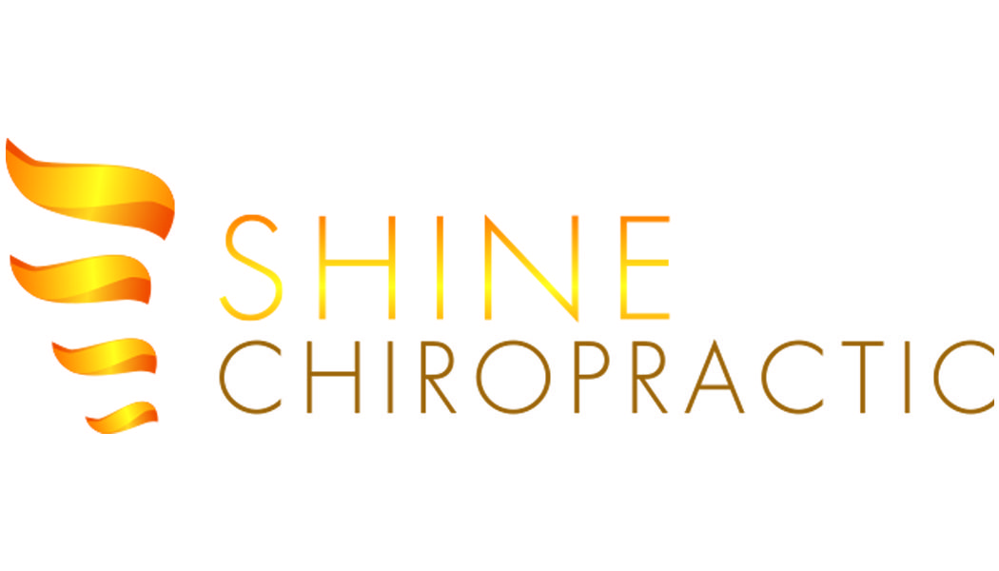

Who we are/what we are trying to achieve:

- Our ideal client/patient is:
  - Committed to/follow treatment plans
  - Excited for office events
  - Teachable
  - Advocate
  - Working professional
  - Male-Female 22-60
  - Cheerful
  - Maintenance
  - Call to cancel apts
  - On time for apts
  - Books multiple apts
  - Refers others
  - Gets good relief from treatments

- Adjectives/key points that we want people to associate Central Avenue Health Centre with:
  - Great location
  - One stop wellness shop
  - Knowledgeable and caring therapists/chiropractors
  - Friendly, caring, warm, clean, safe and welcoming environment
  - Very professional
  - Know patients by their first name, familiar, knows my name
  - Thorough, helpful
  - Convenient
  - High caliber - can answer all my questions, knowledgeable
  - Gives back
  - Non-judgemental
  - Relief
  - Enjoyable
  - Interesting
  - Engaging
  - Positive results
  - Honest
  - Qualified
  - Leaders
  - Quality service

- Why we are better than our competitors
  - Friendly, warm, competent,
  - Exciting/more than just chiro (other services and events)
  - Above and beyond customer service/ a team that goes the “extra mile”
  - Excellent treatments and therapies/quality (quality at reasonable prices)
  - Multidisciplinary approach to wellness
  - Not just another patient - you are special to us, genuinely care
  - Thoroughness
  - Convenience
  - Direct billing
  - Able to book the service they need when they need it

