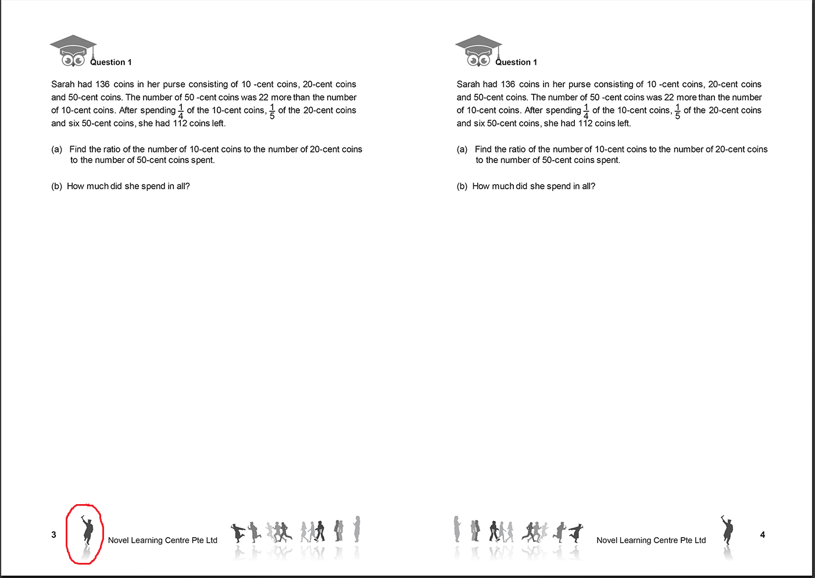

Hi.
Can you flip the image horizontally?
Thanks.

