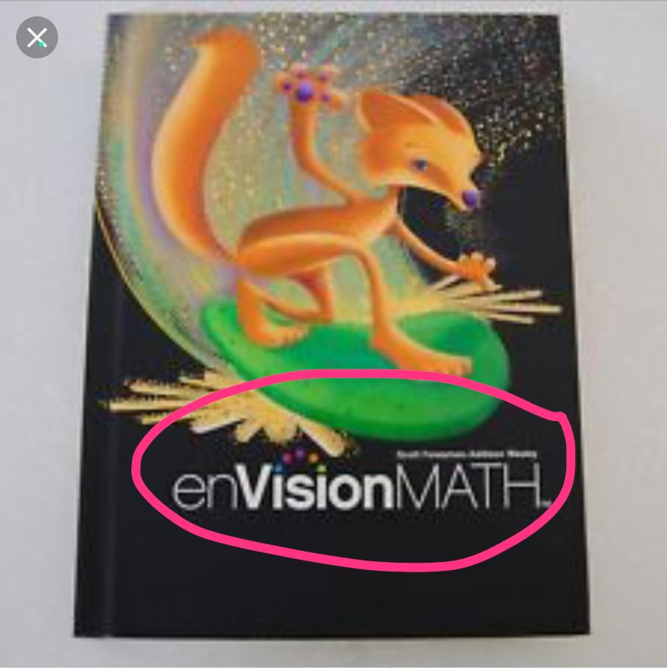
https://i.ebayimg.com/thumbs/images/g/oMwAAOSwUAxbY36-/s-l225.webp

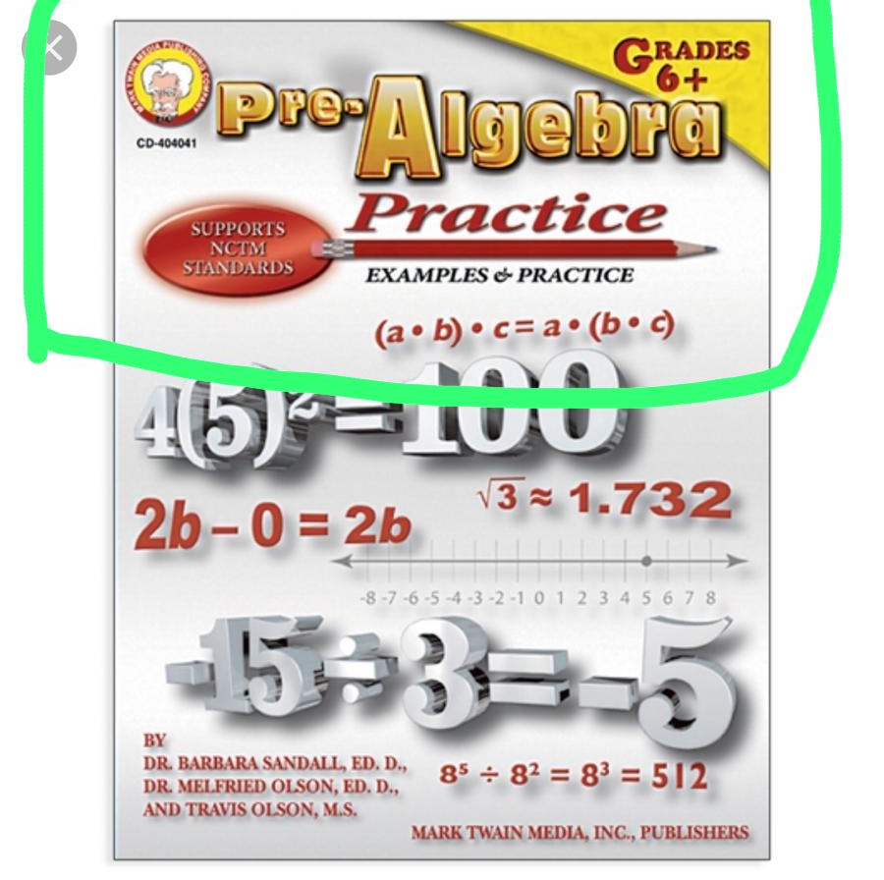https://encrypted-tbn0.gstatic.com/images?q=tbn:ANd9GcT7oiusE4yYdRYpR4QVNxH8ASCqRRWHK1up8URpzETnjLUgydjqBg

https://images.schoolspecialty.com/images/1460465_980EAEF37AF74A2AB6FC1331AB7C614B.jpg

