LOGO NOTES & OPTIONS WE LIKE – but we are open to all suggestions!

Notes:
  - Text could be upper or lower case or a combination of both.
  - These are fonts we like, but again would be open to ideas based on the design.
Scripts: | Sans:
- Coalhand luke  - Trailmade  - Thillends  - Good karma  - Handelson  - Felt that  - Montana typeface  - Hokyaa  - Organika  - Nexa Rust  - Authenia | - Museo Sans  - TT Rounds neue  - Brandon text  - Nexa Slab  - Andes Condensed  - Harlan

Design Ideas We Like:

- A logo that is our text only – simple, easy to read.
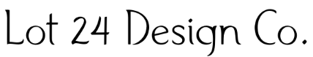
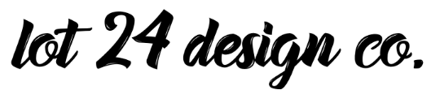
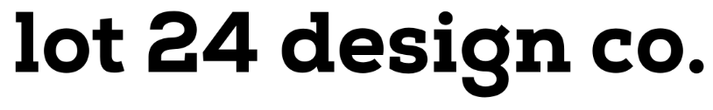
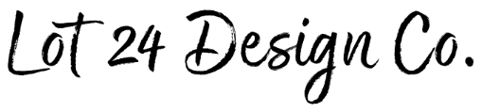

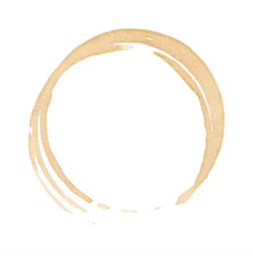
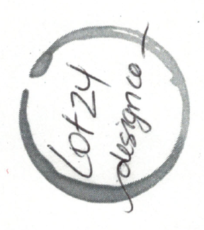
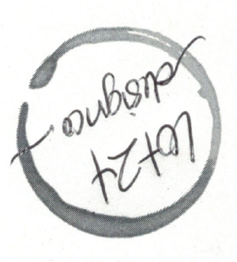
- Logo that has a “coffee stain” circle with text inside.
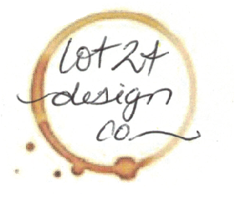

Lot 24 Design Co.

- For reference, the idea came from these pictures:
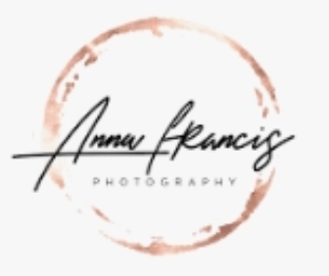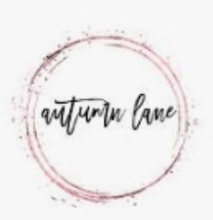

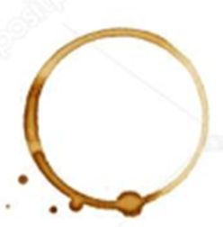
- Here are some of the stains that we like:
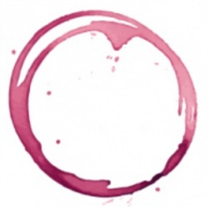
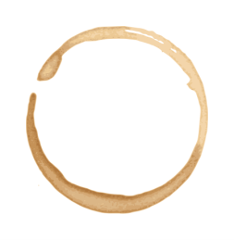
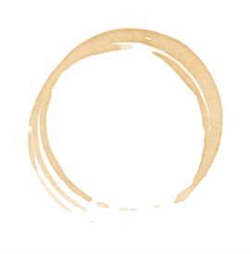
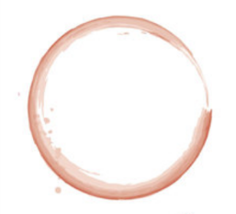
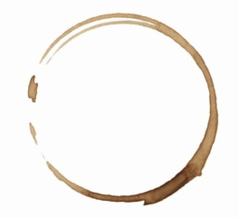

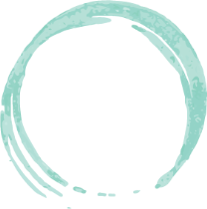
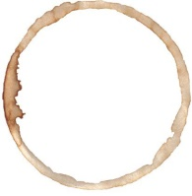
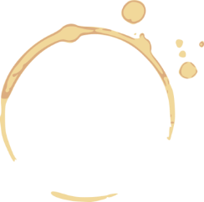
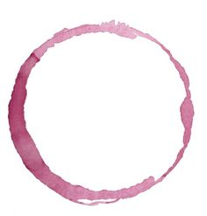
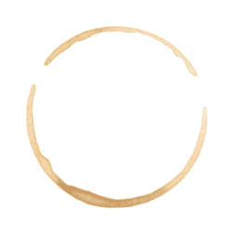
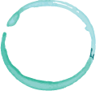

- Hand drawn shape with text inside – see below for examples.
