WCO Study Report on Illicit Financial Flows via Trade Mis-invoicing

(Draft)

Disclaimer

This Study Report contains input from a multitude of Organizations, individuals and Customs administrations, each of whom is credited as co-authors throughout the Report. The views and opinions presented herein are those of the authors and do not necessarily reflect the views or policies of the WCO or WCO Members.

Please do not cite or circulate this draft copy without express permission from the Authors.
Table of Contents

Executive Summary 1

Part 1. Introduction 3
1. Introduction 4
2. Conceptual Basis of Illicit Financial Flows, Trade Mis-invoicing and Trade Discrepancy 11

Part 2. Estimating Illicit Financial Flows (IFFs) via Trade Mis-invoicing (TM) 28
3. Estimating IFFs/TM :Partner Country Method 29
I. Introduction 29
II. The PCM in Principle 29
III. The PCM in Practice 31
IV. Conclusions for Identifying TM Risk with the PCM Approach 39
4. Estimating IFFs/TM :Price Filter Method 47
I. Price FilterMethodology (PFM) 47
II. PFM Estimates of Trade Mispricing from Existing Literature 51
III. PFM Estimates of Trade Mispricing in the U.S. Export and Import data, 2012-2016 54
IV. Summary 61
V. Bibliography 61
5. Cross-reference of PFM and PCM : Analysis of South African TM Risks – Imports, 2010-15 64
I. Data & Methods 64
II. Estimation Results 68
6. Cross-reference of PFM and PCM : The U.S. trade with its partner countries 75
I. Introduction 75
II. Summary of Findings 76
III. Data Source and Methodology 76
IV. Comparison of misinvoiced import amount estimated by the PFM and the PCM 78
V. Appendix 82
VI. Bibliography 87
7. Cross-reference of PFM and PCM: 3 case studies 90
I. Introduction 90
II. Overview of PCM and PFM 91
III. Data and Methodology 92
IV. Result 95
V. Conclusion 101

Part 3. Best Practices in Combating Illicit Financial Flows via Trade Mis-invoicing 107
8. Use of Customs valuation risk management techniques 108
9. Inter-Agency Cooperation: focused on but not limited to Customs-Tax cooperation 111
I. Introduction – Importance of inter-agency cooperation 111
II. Collaboration opportunities against trade mis-invoicing 114
III. OECD Survey: Institutional frameworks for inter-agency co-operation between tax and customs authorities 115
IV. WCO Survey: Exchange of information and co-operation in practice 119
V. WU Global Tax Policy Center: some lessons from the Tax and Good Governance Project 125
10. Combating Illicit Financial Flows: Practice of Korea Customs Service 141
I. Background 141
II. Legal instrument and administrative tools 141
III. Case studies 144
IV. Conclusion 145
11. Customs-Customs Exchange of Information 148
I. Introduction 148
II. WCO Instruments and Tools 148
III. Globally Networked Customs 149
IV. WTO Agreement on Trade Facilitation (TFA) 150
12. Potential Use of Technology : Block-chain 155
13. Other best practices of the WCO Members 159
I. Briefing on China Customs’ Crackdown on Illegal Money Transfer 159
II. COMBATTING IFFs : THE SUCCESS STORY OF THE NORWEGIAN CURRENCY REGISTER 160
III. Illicit Financial Flows (IFFs): Guardia di Finanza 163

Part 4. Conclusion 165
14. Policy Recommendations 166

Executive Summary

This Study report responds to the request from the G20 Leaders’ Communiqué September 2016 for the WCO:
“We will continue our work on addressing cross-border financial flows derived from illicit activities, including deliberate trade misinvoicing, which hampers the mobilization of domestic resources for development, and welcome the communication and coordination with the World Customs Organization for a study report in this regard following the Hangzhou Summit.” (paragraph 36)
The report has been prepared in collaboration between experts and scholars from the WCO, OECD, GFI, academia and Customs administrations, under the responsibility of the Secretariat of the WCO. However, the report should not be regarded as the officially endorsed views of those organizations or of their member countries.
The request from the G20 arises in the context of increased concern about Illicit Financial Flows (IFFs) channeled via trade mis-invoicing (TM). Empirical research revealed significantly high estimates of IFFs via TM (IFFs/TM). In particular, the United Nations High Level Panel on Illicit Financial Flows from Africa (2015) argued that Africa lost over 50 billion USD annually from illicit financial outflows, which exceed levels of Official Development Assistance to the continent.
In that context, the report 1) examines whether such high estimates of IFFs/TM are reliable, and 2) presents policy recommendations summarized from the best practices of Customs administrations to tackle IFFs/TM.
1) Estimates of IFFs/TM
Empirical research employed either of the following methods to estimate the magnitude of IFFs/TM;
- Partner Country Method (known as mirror data analysis), which measures discrepancies in bilateral trade records between trade partners; and
- Price Filter Method (known as unit price analysis), which measures the mis-invoiced value of trade transactions for which the unit price is considered abnormal.
The report suggests that estimates of IFFs/TM are not sufficiently robust across the two methods. Even estimates from the same method with the same trade data ranged widely according to the different assumptions. Therefore, the high estimates of IFFs/TM which feature prominently in current literature, research and even media outlets, should not be understood as a reliable quantitative measurement of the scale of IFFs/TM, but rather as a risk indicator, which can be useful in comparing the risk of IFFs/TM across commodities, countries and over a longer time period.
The report contends that rather than disputing the accuracy of individual assessment mechanisms, attention should rather focus on the actions to combat IFFs/TM, the existence of which is indisputable, however, the estimates of which are dependent on the methodologies used.
2) Key policy recommendations
An indispensable prerequisite to tackling IFFs/TM is ensuring that Customs have sufficient mandate and resources to examine whether ‘financial transactions’ between traders correspond to the ‘value of traded goods’. Customs used to concentrate its attention only on under-invoicing of imports in line with its traditional mandate of detecting possible revenue leakage. However, in response to the risk of IFFs/TM, Customs should have sufficient mandate and resources to tackle;
- over-invoiced imports intended to disguise capital flight as a form of trade payment,
- under-invoiced exports intended to conceal trade profit abroad such as tax havens, and
- over-invoiced exports or under-invoiced imports intended to bring illicit proceeds into the domestic legal financial system.
Provide capacity building including financial and human resources for Customs to combat IFFs/TM. In managing human resources, Customs should enhance integrity, as it is a pre-requisite for the effective and efficient functioning of a Customs administration, and it is essential in combating IFFs.
Enhancing partnership of Customs with i) trade business, ii) other government agencies such as tax authorities, Financial Intelligence Units (FIU) and police, and iii) Customs administrations of trade partners is also essential so that Customs can secure timely information and data to detect IFFs concealed in trade.
New technology such as blockchain could potentially provide a solution to prevent and detect any fraudulent manipulation of trade transactions and related financial transactions by sharing and analyzing relevant information in a trusted and secure manner.
The WCO believes that it would be helpful for the WCO to get a mandate from the G20 to continue its work in the fight against IFFs/TM in cooperation with members, business, relevant authorities and international organizations. The WCO will report the progress to the G20 periodically.

Part 1. Introduction

1. Introduction

Yeon Soo CHOI and Rachel McGauran

Illicit Financial Flows
The term Illicit Financial Flows (IFFs) came into being in the 1990s; however, it only began to resonate with leaders, international organizations and other entities in the last ten years. A perfunctory glance at Google Trends best demonstrates the upward trajectory best; the term was first consulted via Google in 2007, and interest seemed to peak in September 2016 and May 2017, coinciding with the release of G20 Communiqués issued at the end of G20 Meetings in China and Germany, respectively.
Empirical research (GFI, 2008-2017; AUC/ECA, 2015; UNCTAD, 2016) has laid the groundwork for these estimates, and provided theoretical underpinnings. The research suggests that there have been a significant amount of IFFs originating from developing countries, which undermine domestic resources for economic development. In particular, the High Level Panel on Illicit Financial Flows from Africa (2015) argued that Africa lost over 50 billion USD annually from illicit financial outflows, which exceed levels of Official Development Assistance to the continent. The UN Sustainable Development Goals specifically reference the significant threat posed by Illicit Financial Flows (IFFs), as captured in Goal 16 of the SDGs (16.4):
‘By 2030, significantly reduce illicit financial and arms flows, strengthen the recovery and return of stolen assets and combat all forms of organized crime’
However, IFFs should not be regarded as a problem of only developing countries. Considering that IFFs can be characterized as a reaction to the numerous offshore financial centers for tax evasion (Herkenrath, 2014), destabilize the global financial system (World Bank 2012), and are exploited to finance international organized crime and terrorist activities, IFFs should be considered as a global problem which necessitate urgent collective action.
Trade mis-invoicing and IFFs
The aforementioned empirical research identified trade mis-invoicing as a main channel of IFFs, illustrating significant discrepancies in bilateral trade statistics. Global Financial Integrity (GFI) has suggested that more than 80% of IFFs are accompanied by trade mis-invoicing. While such high figures have been criticized due to their estimation methods, empirical research (Nitsch, 2012; Carrere and Grigoriou, 2014; Kellenberg and Levinson, 2016; Choi, 2018) support, at least, the presence of trade mis-invoicing in the trade discrepancy.
Another group of research (Boyrie, Nelson & Pak, 2007; Hong and Pak, 2016; Zdanowicz, 2016) also revealed a significant amount of trade mis-invoicing based on the large value of trade, the unit prices of which were too abnormal compared to those of the same or similar goods.
Case studies on money laundering (Asia/Pacific Group on Money Laundering, 2012) and trade mis-invoicing (WCO, 2017) revealed in detail how the international trade system has been exploited for IFFs in collusion with the importer, exporter and/or financial intermediaries. Simplified examples are as follows:
- over-invoiced imports to disguise capital flight as a form of trade payment,
- under-invoiced exports to conceal trade profit abroad (in a third-party country such as tax havens), and
- over-invoiced exports or under-invoiced imports to incorporate illicit proceeds into the domestic legal financial system.
Customs and IFFs
Many organizations and individuals have emphasized the importance of the role of Customs in combatting IFFs which exploit the international trade system (G20, 2016-2017; Asia/Pacific Group on Money Laundering, 2012; GFI, 2015-2017). Customs administrations have a well-established pedigree with respect to combating cash smuggling, a subset of IFFs, and under-invoicing of imports, a subset of trade mis-invoicing. The traditional Customs’ roles of examination of ‘goods’ and collecting ‘revenues’ from trade continue to occupy the majority of their time and expertise, consequently, it is unsurprising that the realm of IFFs via trade mis-invoicing seems unfamiliar and remains unexplored territory for the vast majority of Customs administrations. As a consequence of their limited mandate, Customs may be unaware of the importance of trade mis-invoicing as a main channel of IFFs. According to a WCO survey (Han and Ireland, 2016), 62% of Customs administrations identified a ‘narrow or non-existing mandate’ as the biggest impediment in fighting against money laundering. The OECD Official Development Assistance to support countering IFFs via trade mis-invoicing (Box 1) gives an indication of the low level of interest from development partners in the role of Customs in combating IFFs.
Box 1. How much aid goes into addressing illicit financial flows (IFFs)
Provided by the OECD
Identifying the volume of Official Development Assistance (ODA) that is targeted towards addressing IFFs is difficult; projects targeting IFFs are not tagged as such in the Creditor Reporting System that the DAC donors use to report their ODA spending. In their 2014 report, Illicit Financial Flows from Developing Countries: Measuring OECD Responses, the OECD identified that the Government and Civil Society sector was most likely to feature IFF or IFF related programmes. Spending in this area has declined in recent years from USD 14.5bn in 2011 to USD 11.9bn in 2016.
This sector of ODA spending does not, however, cover assistance targeted towards trade, and so may not pick up projects that are specifically targeting customs responses to IFFs. An alternative approach is to analyse the project descriptions to identify key words that indicate projects targeting IFFs. This was done for the Government and Civil Society sector, and the Trade Policy and Regulations sector. This analysis identified spending of USD 6.47m on projects that were specifically targeting illicit activities, and a further USD 68.75m that was focussed on customs activities in 2016. There was only one project that mentioned both countering illicit activities and customs in the project descriptions.
If the search is broadened to include all projects that refer to transparency (a key tool in countering IFFs), there is again a very small percentage of spending including reference to both transparency and customs, or transparency and countering illicit activities (see Figure 1).
While such analysis is unlikely to be the complete picture, and will for example miss projects that are indirectly supporting work on addressing trade based IFFs, this initial analysis suggests that development partners have not yet sufficiently prioritised funding towards projects to support countering trade based IFFs.
Figure - ODA spending on customs, transparency and countering illicit activities (2016)
Total spending USD 311.83 million

This Study Report advocates for a re-evaluation of the role of Customs and their mandate to ensure that an appropriate response to IFFs is adopted, particularly in the context of heightened awareness among stakeholders; laypersons, practitioners and experts alike. The two major conclusions of this Report, compiled by the WCO with input from a range of experts and policy specialists, suggest that Customs should be adequately equipped in order to be able to examine whether ‘financial transactions’ between traders correspond to the actual ‘value of traded goods’. Furthermore, Customs should be equipped with a mandate to investigate all types of trade mis-invoicing; not only to secure Customs revenue but also to prevent traders from exploiting trade mis-invoicing for IFFs.
Some WCO Members have already begun to incorporate the combat against IFFs and trade mis-invoicing into their core mission. Germany decided in 2016 that in order to enable Customs to examine financial flows between traders, its Financial Intelligence Unit should be transferred and amalgamated into the General Customs Directorate (GZD). In order to enable Customs to investigate all types of trade mis-invoicing, regardless of their impact on Customs revenue, Korea revised its Customs Act and bestowed Customs with the ability to penalize an importer or exporter for trade mis-invoicing in 2013.

Scope of the Report
In consideration of the global interest in this topic and the interest shown by Customs administrations, this Report aims to support Customs administrations to combat IFFs and trade mis-invoicing, by covering the following two questions;
- How significant are IFFs via trade mis-invoicing?
- What measures/policies should Customs administrations take to combat IFFs/TM?
Structure of the Report
Before addressing the main questions, Chapter 2 will provide a conceptual foundation for the Report;
- The conceptual relationship between IFFs, trade mis-invoicing and trade discrepancies will be defined to give the reader some background information, in addition to an outline of the principle methods used to measure trade mis-invoicing: PFM and PCM and the benefits and limitations of these methods; and
- The conceptual framework behind a trade transaction in an effort to outline the various types of trade mis-invoicing and the Customs policies that could be enforced against such trade mis-invoicing.
Chapters 3 and 4 will go into further detail by defining the conceptual underpinnings governing PFM and PCM and the advantages, limitations and empirical estimates obtained from existing literature. Chapters 5, 6 and 7 will present 3 forms of research (6 case studies) which cross-referenced the PFM and PCM methods in order to verify:
- the reliability of PFM and PCM in estimating the magnitude of IFFs/TM; and
- the effectiveness of PFM and PCM in assessing the risk of trade transactions suspicious of IFFs/TM.

Chapters 8, 9, 10, 11, 12 and 13 will present the best practices of Customs administrations in combating IFFs/TM.
Chapter 14 will present policy recommendations summarized from the best practices. The policy recommendations are categorized into three groups;
- Mandate to Customs
- Collaboration with trade business, other government agencies and Customs administration of partner countries
- Potential use of new technology: Blockchain

References
Asia/Pacific Group on Money Laundering. 2012. APG Typology Report on Trade Based Money Laundering. Sydney South: Asia/Pacific Group on Money Laundering.
Carrère, C. & Grigoriou, C. 2014. CAN MIRROR DATA HELP TO CAPTURE INFORMAL INTERNATIONAL TRADE? POLICY ISSUES IN INTERNATIONAL TRADE AND COMMODITIES RESEARCH STUDY SERIES No. 65. New York: United Nations. http://unctad.org/en/PublicationsLibrary/itcdtab65_en.pdf
Choi, Y.S. 2018.Traces of trade misinvoicing in trade discrepancy (not published).
De Boyrie, M.E., Nelson, J.A., and Pak, S.J. 2007. "Capital movement through trade misinvoicing: the case of Africa", Journal of Financial Crime 14(4):474-489. https://doi.org/10.1108/13590790710828181
Global Financial Integrity. 2017. Illicit Financial Flows to and from Developing Countries: 2005-2014. Washington DC: Global Financial Integrity.
Global Financial Integrity. Illicit Financial Flows: Analytical methodologies utilized by Global Financial Integrity. Retrieved from http://www.gfintegrity.org/issues/illicit-financial-flows-analytical-methodologies-utilized-global-financial-integrity/.
Han, C.R., and Ireland, R. 2016. A survey of Customs administration approach to Money Laundering. WCO Research Paper No. 36. Brussels: World Customs Organization.
Herkenrath, M. 2014. Illicit Financial Flows and their Developmental Impacts: An Overview.International Development Policy | Revue internationale de politique de développement [Online]. DOI : 10.4000/poldev.1863. Retrieved from http://journals.openedition.org/poldev/1863 ;
Hong, K.P., and Pak, S.J. 2016. “Estimating Trade Misinvoicing from Bilateral Trade Statistics: The Devil Is in The Details”. The International Trade Journal 31(1):3-28. doi: 10.1080/08853908.2016.1202160.
Kar, D., and Spanjers, J. 2015. Illicit financial flows from developing countries: 2004-2013. Washington DC: Global Financial Integrity.
Kellenberg, D., and Lenvinson, A. 2016. “The trade data gap: Mistakes and malfeasance.” Retrieved from http://voxeu.org/article/trade-data-gap-mistake-and-malfeasance.
Nitsch, V. 2012. “Trade mispricing and illicit flows.” In Draining development? Controlling flows of illicit funds from developing countries, edited by Reuter, P., 309-334. Washington DC: The World Bank.
Nitsch, V. 2017.Trade Misinvoicing in Developing Countries.CGD Policy Paper 13. Washington, DC: Center for Global Development.
Reuter, P. 2012. “Introduction and Overview: The Dynamics of Illicit Flows.” In Draining development? Controlling flows of illicit funds from developing countries, edited by Reuter, P., 1-18. Washington DC: The World Bank.
UNCTAD. 2016. TRADE MISINVOICING IN PRIMARY COMMODITIES IN DEVELOPING COUNTRIES: The cases of Chile, Côte d’Ivoire, Nigeria, South Africa and Zambia. New York: United Nations.
United Nations Economic Commission for Africa (AUC/ECA). 2015. Illicit Financial Flow: Report of the High Level Panel on Illicit Financial Flows from AFRICA. Commissioned by the AU/ECA Conference of Ministers of Finance, Planning and Economic Development.
Zdanowicz, J.S. 2016.Executive Summary - Trade based tax evasion and money laundering – 2003 to 2014.Retrieved from https://business.fiu.edu/pdf/trade-based-tax-evasion-and-money-laundering.pdf.

ENDNOTES

2. Conceptual Basis of Illicit Financial Flows, Trade Mis-invoicing and Trade Discrepancy

Yeon Soo CHOI and Rachel McGauran

Introduction
In order to thoroughly understand the high estimates of IFFs via trade mis-invoicing from existing literature and to take appropriate action against them, a holistic perspective on the conceptual relationship between three key components; ‘IFFs’, ‘trade mis-invoicing’ and ‘trade discrepancy’ is necessary.
Illicit Financial Flows (IFFs)
There is no universal definition of IFFs, at least not one that has been agreed by all parties. The definition most commonly ascribed to is that proffered by Global Financial Integrity (GFI); ‘IFFs are cross-border transfers of funds that are illegally earned, transferred or utilized’. The term encompasses a variety of practices including: trade mis-invoicing; cash smuggling; bank transfers (disguised or unreported); an informal transfer system (Hawala) and disguised foreign investment. The sources of IFFs also vary (AUC/ECA, 2015), often originating from; 1) tax evasion; 2) proceeds of criminal activities (including the illicit drug trade, human trafficking, illegal arms dealing, and smuggling of contraband); and 3) bribery of corrupt government officials.
Trade discrepancy (TD)
Each trade transaction contains two statistics; one recorded by the importing country and the other recorded by the exporting country. These statistics are based on the export and import Customs declarations. Trade discrepancy represents the difference between the trade value recorded by the importing country and that recorded by the exporting country. Trade discrepancy can be calculated at various levels; from the most disaggregated level (transaction level) to the most aggregated level (country-pair level).
Trade discrepancy at the most disaggregated level can provide a strong hint as to the existence of trade mis-invoicing. However, due to the sensitivity of transaction-level data, countries are reluctant to share data with trade partners. As an alternative, aggregated trade data arranged by HS code and partner countries, which are available from international organizations, have been employed in trade discrepancy analysis. However, it should be noted that trade discrepancy may arise simply on account of statistical and logistical reasons in aggregating trade data.
Trade mis-invoicing (TM)
Figure 3 presents a conceptual framework of trade, which will be used throughout this Report. In a legal trade transaction: ①the invoice value declared by an importer to a Customs administration; ②the importer’s payment recorded by financial institutions; ③the invoice value declared by an exporter to a Customs administration and ④the exporter’s receipt as recorded by financial institutions should accord with ⑤the true or accurate value of the traded goods.
Figure 1. Conceptual frame of trade
Importing country |  |  |  |  |  |  |  | Exporting country
① Customs record(IM) |  |  |  |  |  |  |  | ③ Customs record(EX)
 |  |  | = | ⑤ Value  of goods |  |  | =
 | = |  |  |  |  |  |  |  | =
② Financial record(IM) |  |  | = |  |  |  | = | ④ Financial record(EX)

Trade mis-invoicing can be defined as fraudulent cases where either the importer and exporter -or both- manipulate the value (e.g. price, quantity, or quality) of trading goods in their Customs declarations. The motives governing such trade mis-invoicing range from evading tariff or tax, avoiding trade regulations, exploiting trade incentives or disguising capital flight (IFFs via TM).When an attempt is made at disguising IFFs via a trade transaction, financial records reported to relevant financial institutions (the amount actually paid/received) may not correspond with the true or correct value of the goods, but rather with manipulated invoices.
Estimating IFFs via TM
Figure 4 below illustrates the relationship between IFFs (red), trade mis-invoicing (blue) and trade discrepancies (yellow). While each of the three circles (concepts) intersects at certain points, none are subject to any of the others.
Part E represents IFFs not relevant to trade; such as IFFs via cash smuggling and foreign investment. Part F represents trade discrepancies which arise naturally in the production of trade data, not relevant to trade mis-invoicing or IFFs.
Part A, B, C and D respectively represent 4 types of trade mis-invoicing; type A (a subset of trade discrepancies, but not of IFFs), type B (a subset of neither trade discrepancies nor IFFs), type C (a subset of both trade discrepancies and IFFs) and type D (a subset of IFFs, but not of trade discrepancy).
Figure 2. Conceptual relation among IFFs, trade mis-invoicing and trade discrepancy
IFFs
(Illegally earned,
transferred
and utilized)
Trade mis-invoicing
(Invoice ≠ actualprice)
Trade discrepancy
(Import record
≠ Export record)
E
D
C
B
A
F

Area | Description | Examples
A | TM and a subset of TD, but not of IFFs | - under-invoicing of import to evade tariff  - over-invoicing of export to exploit export incentives
B | TM and a subset of neither TD nor IFFs | - over-invoicing both by importer and export in collusion to exploit trade incentives
C | TM and a subset of both TD and IFFs | - over-invoicing of import to disguise capital flight as a form of trade payment  - under-invoicing export to conceal trade profit abroad
D | TM and a subset of IFFs, but not of TD | - over-invoicing both by importer and exporter in collusion to move capital from import countries to exporting countries
E | IFFs not relevant to trade | - IFFs via cash smuggling  - IFFs via disguised FDI
F | TD from legitimate reasons | - difference in CIF/FOB ratio, incoterms, attribution of trade partner, FX rate, time period, low value thresholds between trade partners

As IFFs via TM (area C+D) are concealed in countless trade transactions, it is impossible to directly measure the magnitude of them. Empirical research has employed alternative methods to try to estimate IFFs via TM by comparing trade discrepancies (Partner Country Method; PCM) with international trade databases or by estimating trade mis-invoicing (Price Filter Method; PFM) using a national trade database.
As indicated in the conceptual relationship between IFFs, TM and TD in Figure 1, their estimates have intrinsic limitations. In the case of PCM (i.e. measuring A+C+F):
- Simply aggregating the value of TD is likely to over-estimate TM, since not all the TD are TM (i.e., TD may arise from legitimate reasons);
- Excluding same mis-invoicing in collusion of importer and exporter, which is not a subset of TD, is likely to under-estimate TM;
- Simply regarding TM as IFFs is also likely to over-estimate IFFs/TM, since not all the TM are IFFs (i.e., there is TM only for evading tariff, not for IFFs).
PFM estimates (i.e., measuring A+B+C+D) have limitations in that:
- Simply regarding TM as IFFs is likely to over-estimate IFFs/TM;
- The definition of an abnormal price can be somewhat arbitrary. In addition, there are legitimate reasons for abnormal unit prices such as business cycles.
The accuracy of estimates depends on the relative influence of each factor and therefore, the shape of diagrams. For example, in the trade environment (1) of figure 3, measuring trade discrepancies (A + C + F) or trade mis-invoicing (A + B + C + D) could provide a good proxy for IFFs through trade mis-invoicing (C + D). On the other hand, in the trade environment (2), any measurement of trade discrepancies or trade mis-invoicing is likely to be exaggerated. Unfortunately, there is scant empirical research on the relationship among IFFs, trade mis-invoicing and trade discrepancies, and questions such as ‘to what extent do trade discrepancies occur in legitimate circumstances(F)?’ and ‘to what extent does trade mis-invoicing occur with the collusion of the importer and exporter (B+C)?’ still remain to be studied.
Figure 3. Different trade environment in terms of IFFs, trade mis-invoicing and trade discrepancy
Trade environment (1)
E
D
C
B
A
F

E
D
C
B
A
F
Trade environment (2)
Trade mis-invoicing
Trade mis-invoicing
IFFs
IFFs
Trade discrepancy
Trade discrepancy

Acknowledging the theoretical limitations of mirror data analysis and unit price analysis, this report conducted 6 case studies to check whether both methods present similar estimates of IFFs via trade mis-invoicing for the same country or not. In PCM, HS 6 digit level trade data from the UN COMTRADE were used, and transaction-level Customs data from 3 WCO Member Customs administrations were used in PFM. Details of the case studies will be presented in Chapters 5, 6 and 7.
Assessing the risk of IFFs via TM
In spite of the flaws PCM and PFM contain as methods by which to estimate IFFs, six case studies revealed that cross-referencing the two methods could be an effective tool to assess the risk of trade transactions which were likely to contain instances of trade mis-invoicing. This finding is supported by empirical research (Nitsch, 2012; Carrere and Grigoriou, 2014; Kellenberg and Levinson, 2016; Choi 2018), which contended that the scale of trade discrepancy is significantly correlated with trading partners’ characteristics such as tariff, financial secrecy (being tax havens), auditing standards, corruption level and gap in direct tax burden between trade partners, suggesting the existence of illicit components in trade discrepancies. The WCO reported that unit price analysis (use of a valuation database) is used as one of the risk management tools by many Customs administrations to assess the risk of under or over-invoicing.
Figure 6 illustrates four types of trade mis-invoicing, and demonstrates how Customs records could play a crucial role in detecting them by: 1) comparing Customs records of the importer (or exporter) with the actual value of goods; 2) comparing Customs records with financial records; and 3) comparing Customs records between trade partners. It should be emphasized that such comparison in practice can be used only for the purpose of risk management, as trade discrepancy may arise from legitimate reasons, and the definition of abnormality can be arbitrary.
- TM Type A : As an example, an under-invoiced import aiming at evading tariff belongs to the trade mis-invoicing type A. As an importer submitted a forged invoice in the Customs declaration, this trade mis-invoicing can be detected by unit price analysis (comparing the Customs record of an importer with the actual value of the traded goods) or by mirror data analysis (comparing the Customs record of an importer with the Customs record of an exporter). As the importer paid the original invoiced amount (not corresponding to the import declaration for Customs) to the exporter, it can also be detected by comparing Customs records of the importer with the financial transaction records of the importer. Financial records could be acquired from financial institutions such as Financial Intelligence Units, foreign exchange banks or central banks.
Figure 4. Types of trade mis-invoicing
 | Trade discrepancy  (Import record ≠ Export record) | No-Trade discrepancy  (Import record = Export record)
IFFs  (Payment  =  actual value of goods) | Type A : TD and no-IFFs | Type B : No-TD and No-IFFs
  ①Customs record(IM) |  |  | ======/====== |  |  |  |  | ③Customs record(EX)
   |  |  | ≠ | ⑤Value of goods |  |  | =
   | ≠ |  |  |  |  |  |  |  | =
  ②Financial record(IM) |  |  | = |  |  |  | = | ④Financial record(EX)
  ①Customs record(IM) |  |  | ============ |  |  |  |  | ③Customs record(EX)
   |  |  | ≠ | ⑤Value of goods |  |  | ≠
   | ≠ |  |  |  |  |  |  |  | ≠
  ②Financial record(IM) |  |  | = |  |  |  | = | ④Financial record(EX)
No-IFFs  (Payment  ≠  Forged invoice) | Type C : TD and IFFs | Type D : No-TD and IFFs
  ①Customs record(IM) |  |  | ======/====== |  |  |  |  | ③Customs record(EX)
   |  |  | ≠ | ⑤Value of goods |  |  | =
   | = |  |  |  |  |  |  |  | =
  ②Financial record(IM) |  |  | ≠ |  |  |  | = | ④Financial record(EX)
  ①Customs record(IM) |  |  | ============ |  |  |  |  | ③Customs record(EX)
   |  |  | ≠ | ⑤Value of goods |  |  | ≠
   | = |  |  |  |  |  |  |  | =
  ②Financial record(IM) |  |  | ≠ |  |  |  | ≠ | ④Financial record(EX)
* TD : tradediscrepancy, IM : importer, EX : exporter

- TM type B : If such a case of under-invoicing was done in collusion with the importer and the exporter, it is an example of type B. As both importer and exporter, in collusion, submitted the same forged invoices to the Customs administrations, this type of mis-invoicing does not exhibit any signs of trade discrepancy, and therefore cannot be detected by mirror data analysis. Unit price analysis and cross-referencing between Customs and financial data can detect this type of trade mis-invoicing.
- TM type C : An over-invoiced import used to transfer domestic capital abroad (IFFs) is a representative case of trade mis-invoicing type C. In this case, a financial intermediary in collusion with the importer receives the over-valued payment from the importer, and transfers only the original amount to the exporter. The difference in value between the original invoice and the forged invoice tends to return to the importer in the form of foreign direct investment or multiple small transfers from the financial intermediary. As the importer’s payment accords with the forged invoice submitted to Customs, it is not detected by cross referencing between the Customs record and the financial record, however, it can be detected by unit price analysis and mirror data analysis.
- TM type D : One example of type D is the case where an importer transfers money to the exporter in collusion through over-invoicing of low-value goods. This type of trade mis-invoicing is detected neither by mirror data analysis nor by cross-referencing between Customs records and financial transaction records. Only the Customs valuation referenced by unit price analysis can be used. Customs-Tax cooperation such as the exchange of information regarding beneficial ownership of traders may help Customs and tax authorities to focus their enforcement resources to high-risk transactions.
As the above examples demonstrate, Customs records on trade transactions contain key information that can be used to assess the risk of trade mis-invoicing and relevant IFFs. Consequently, Customs should be equipped with a more expansive mandate and resources through interagency and international cooperation. Further details of each type of trade mis-invoicing are presented in Table 2~7, and Chapters 8~13 will present best practices in detecting IFFs via trade mis-invoicing.

Box 1. Establishing the Customs value of imported and exported goods

Customs valuation of imported goods

The international standard for establishing the Customs value of imported goods where ad valorem duty rates apply is based on the methodology set out in the Agreement on Implementation of Article VII of the General Agreement on Tariffs and Trade 1994 (the ‘Agreement’). Application of the Agreement is a legal obligation for WTO Members (164 countries) and hence applies to the vast majority of all international trade.

The Agreement, which is based on the principal of actual value, as defined in Article VII of GATT, states that the transaction value method should be used to the greatest extent possible. The transaction value is based on the price actually paid or payable for the imported goods (defined in Article 1 of the Agreement and typically represented by the invoice price) plus certain additional elements which are to be included in the Customs value where the appropriate criteria are met.

The additional elements (listed in Article 8 of the Agreement) which must be added if the appropriate criteria met, include, inter alia, selling commissions, the value of materials and parts sent by the buyer free of charge or at a reduced price for use in manufacture of the goods to be imported, and royalties and licence fees.

Under the Agreement (Article 8.2), Members are given an option whether or not to include in the transaction value freight, insurance and handling costs to the point of entry into the Customs territory (most countries have chosen to include these charges, some, such as United States and South Africa do not).

Where the parties to the sale are related (typically the case in a multi-national enterprise transaction), the Agreement provides tests to be applied in cases where Customs has reasons to doubt the price in order to determine whether or not the price has been influenced by the relationship

The Agreement provides a series of alternative methods of valuation which are to be applied where the transaction value cannot be established (for example, where the imported goods have not been sold for export). The vast majority of importations however (over 90% in many countries) are valued under the transaction value method.

Further information on the methodology for establishing the Customs value of imported goods is available via the WCO website, here: http://www.wcoomd.org/en/topics/valuation/instruments-and-tools.aspx

Customs valuation of exported goods

It should be noted that the Agreement is binding on WTO Members only for the determination of the value of imported goods. The value declared to Customs for exported goods is governed by national requirements; no international rules apply and it is used mainly for statistical purposes. Some administrations choose to use the principles of the WTO Valuation Agreement for establishing an export value; in practice this may simply be based on the export invoice price.

Comparison of import and export Customs value data

It is important to bear in mind that there are a number of reasons why import and export values for Customs purposes may differ for the same consignment. For example :

  - Any adjustments to the import Customs value to be made under Article 8 of the Agreement are not likely to be reflected in the declared export value for the consignment in question.
  - Depending on the choice made by the Member regarding the inclusion or exclusion of freight and insurance charges as mentioned above, and
  - The Incoterms agreed upon for the transaction in question.

Box 2. What is the difference between transfer pricing and trade mis-invoicing?
Provided by the OECD
A number of different definitions of Illicit Financial Flows (IFFs) exist, but the term is generally regarded as relating to cross-border financial flows involving fraudulent mis-information or other illegal activities.

Trade mis-invoicing, or the fraudulent mis-reporting of key information on an invoice (e.g. price, quantity of goods, nature or quality of goods, etc) for the purpose of facilitating illicit cross-border financial flows may sometimes be confused with transfer pricing – the practice of determining prices for goods or services transferred between parts of a multinational enterprise group. Transfer pricing itself is a neutral term: transfer prices may be fall anywhere in the spectrum from entirely appropriate, to mistaken, to fraudulently mis-reported.

In most countries, cross-border transactions between related parties must be priced for tax purposes in accordance with the arm’s length principle: that is, transfer prices must be determined as if the transaction took place between independent parties. In many cases, however, this can be difficult to determine precisely because exact analogues for the intra-group transactions may not be available and a degree of approximation and judgement may be required as a result. This means that reasonable people can disagree as to what is the correct transfer price in a particular case.

Many multinational enterprises seek to comply with transfer pricing regimes to which they are subject and may invest significant resources in determining appropriate, arm’s length transfer prices. That said, transfer pricing can also be used as part of an aggressive tax planning policy by a multinational enterprise group: the transfer pricing policy may be applied in such a way as to comply with the strict letter of the law, but that aggressively pushes the boundaries of what is acceptable under those laws. Some multinational enterprises may also engage in illegal tax evasion through fraudulent transfer mis-pricing.

Customs valuations rules also require that the price of goods sold between related parties has not been influenced by the relationship between them. In principle, therefore, it seeks to achieve a similar objective to transfer pricing rules based on the arm’s length principle. While the WTO Valuation Rules govern the application of this principle for the purposes of customs valuation, national laws (often supplemented by internationally accepted guidance such as the OECD Transfer Pricing Guidelines) will be applicable to the transfer pricing question.

While transfer pricing and indeed customs valuation each remain key compliance issues for many tax and customs administrations around the world, this report is focused on the separate problem of trade mis-invoicing.

Box. 3 IFFs via trade mis-invoicing and Trade-based money laundering

Trade-based money laundering is the process of disguising the proceeds of crime and moving value through the use of trade transactions in an attempt to legitimize their illicit origins. In practice, this can be achieved through the misrepresentation of the price, quantity or quality of imports or exports (FATF). It can involve moving illicit goods, falsifying trade documents, and misrepresenting trade-related financial transactions with the purpose of integrating criminal proceeds (https://www.ice.gov/trade-transparency).

The IFFs via trade mis-invoicing is a broader concept than TBML, as it includes a case of illegal transfer of legally earned profits. However, in practices, TBML is the most representative case (subset) of IFFs via trade mis-invoicing.

Table 1. Trade mis-invoicing case 1
Type |  | Type A (TD and no-IFFs)
Source / Product |  | WCO typology 2017 / Camera
Summary | Trade  mis-invoicing | Under-invoicing import  The importer submitted the under-valued invoice in the import declaration.
Summary | Trade discrepancy | Yes  In contrast, the exporter submitted the original invoice in the export declaration (record by importer < record by exporter).
Summary | IFFs | No  The payment was made corresponding to the original invoice.
Summary | Collusion | Importer and Exporter  Exporter issued false invoices for the importers.
Summary | Illicit motives | Tariff and tax evasion  The importer exploited tax exemption scheme for low value goods.
Visualization
  Customs record(IM) |  |  |  |  |  |  |  | Customs record(EX)
   |  |  | ≠ | Value of goods |  |  | =
   | ≠ |  |  |  |  |  |  |  | =
  Financial record(IM) |  |  | = |  |  |  | = | Financial record(EX)
How to detect |  | - Comparing the import invoice with the declared Customs value  - Comparing the import invoice with the export invoice  - Comparing the import invoice with the actual financial flow-out

Table2.Trade mis-invoicing case 2
Type |  | Type C (TD and IFFs)
Source / Product |  | WCO member / Semiconductors
Summary | Trade  mis-invoicing | Over-invoicing import  The importer submitted the over-valued invoice in the import declaration.
Summary | Trade discrepancy | Yes  In contrast, the exporter submitted the original invoice in the export declaration (record by importer > record by exporter).
Summary | IFFs | IFFs out of the importing country  The importer remitted the over-valued amount of FX to a financial intermediary in collusion.  The financial intermediary transferred the original amount of FX to the exporter, and returned the remaining fund (the difference between over-value and original-value) to the importer in the forms of foreigners’ donations and FDIs.
Summary | Collusion | Importer and financialintermediary
Summary | Illicit motives | The importer created secret fund broad, evading domestic financial controls.
Visualization
  Customs record(IM) |  |  |  |  |  |  |  | Customs record(EX)
   |  |  | ≠ | Value of goods |  |  | =
   | = |  |  |  |  |  |  |  | =
  Financial record(IM) |  |  | ≠ |  |  |  | = | Financial record(EX)
How to detect |  | - Comparing the import invoice with the Customs valuation data  - Comparing the import invoice with the export invoice

Table 3.Trade mis-invoicing case 3
Type |  | Type A (TD and no-IFFs)
Source / Product |  | WCO typology 2017 / small and high value goods
Summary | Trade  mis-invoicing | Over-invoicing export  The exporter made a fake export declaration without actual export of goods.
 | Trade discrepancy | Yes  Only the export record exists.
 | IFFs | No  No actual payment was made.
 | Collusion | -
 | Illicit motives | Tax evasion  The exporter exploited the VAT exemption benefit in purchasing goods to be exported, and sold the goods in domestic markets at a higher, VAT-inclusive price.
Visualization
  Customs record(IM) |  |  |  |  |  |  |  | Customs record(EX)
   |  |  | = | Value of goods |  |  | ≠
   | = |  |  |  |  |  |  |  | ≠
  Financial record(IM) |  |  | = |  |  |  | = | Financial record(EX)
How to detect |  | - Comparing the export invoice with the import invoice  - Comparing the import invoice with the actual financial flow-in

Table 4.Trade mis-invoicing case 4
Type |  | Type C (TD and IFFs)
Source / Product |  | WCO typology 2017 / Unknown
Summary | Trade  mis-invoicing | Over-invoicing export  The exporter submitted the over-valued invoice in the export declaration.
Summary | Trade discrepancy | Yes  In contrast, the importer submitted the original invoice in the import declaration. (record by importer < record by exporter)
Summary | IFFs | IFFs into the exporting country  A financial intermediary (a hawala operator) in collusion with the exporter combined his illicit proceeds with the original payment from the importer, and remitted the over-valued payment to the exporter.
Summary | Collusion | Exporter and financialintermediary
Summary | Illicit motives | The exporter enjoyed the unauthorized receipt of duty drawback of export goods, and brought back illicit proceeds into the own country.
Visualization
  Customs record(IM) |  |  |  |  |  |  |  | Customs record(EX)
   |  |  | = | Value of goods |  |  | ≠
   | = |  |  |  |  |  |  |  | =
  Financial record(IM) |  |  | = |  |  |  | ≠ | Financial record(EX)
How to detect |  | - Comparing the export invoice with the Customs valuation data  - Comparing the export invoice with the import invoice

Table 5.Trade mis-invoicing case 5
Type |  | Type B (No-TD and no-IFFs)
Source / Product |  | WCO typology 2017 / Frozenpork
Summary | Trade  mis-invoicing | Over-invoicing import and export  The importer and exporter in collusion submitted over-valued invoices respectively in import and export declarations.
Summary | Trade discrepancy | No  Record by importer = record by exporter
Summary | IFFs | No  The amount of actual payment corresponded to the original value of goods.
Summary | Collusion | Importer and Exporter  The both involved bogus companies to use fabricated invoices.
Summary | Illicit motives | Tariff evasion  The importer evaded the price differential duty, which is imposed to protect domestic industry.
Visualization
  Customs record(IM) |  |  | ============= |  |  |  |  | Customs record(EX)
   |  |  | ≠ | Value of goods |  |  | ≠
   | ≠ |  |  |  |  |  |  |  | ≠
  Financial record(IM) |  |  | = |  |  |  | = | Financial record(EX)
How to detect |  | - Comparing the import invoices with the declared Customs value  - Comparing the import invoices with the actual financial flow-out  - Exchanging information on the beneficial ownership of traders

Table 6.Trade mis-invoicing case 6
Type |  | Type D (No-TD and IFFs)
Source / Product |  | WCO Member / Steel products
Summary | Trade  mis-invoicing | The importer and exporter in collusion submitted the over-valued invoices respectively in import and export declarations.
Summary | Trade discrepancy | No  record by importer = record by exporter
Summary | IFFs | IFFs out of importing country to exporting country  The importer remitted the over-valued payment to the exporter, which was deposited in bank accounts of the exporting company’s share-holders. The importer (as a share-holder of the exporting company) withdrew the illicit proceeds little by little for hundreds of times at ATMs in his country.
Summary | Collusion | Exporter and importer  The exporter is a subsidiary shell company of the importer.
Summary | Illicit motives | IFFs  The importer created a secret fund broad, evading domestic financial controls.
Visualization
  Customs record(IM) |  |  | ============= |  |  |  |  | Customs record(EX)
   |  |  | ≠ | Value of goods |  |  | ≠
   | = |  |  |  |  |  |  |  | =
  Financial record(IM) |  |  | ≠ |  |  |  | ≠ | Financial record(EX)
   |  |  | =============
How to detect |  | - Comparing the import invoice with the declared Customs value  - Exchanging information on the beneficial ownership of traders

References
Carrère, C. & Grigoriou, C. 2014. CAN MIRROR DATA HELP TO CAPTURE INFORMAL INTERNATIONAL TRADE? POLICY ISSUES IN INTERNATIONAL TRADE AND COMMODITIES RESEARCH STUDY SERIES No. 65. New York: United Nations. http://unctad.org/en/PublicationsLibrary/itcdtab65_en.pdf
Choi, Y.S. 2018.Traces of trade misinvoicing in trade discrepancy (not published).
Kellenberg, D., and Lenvinson, A. 2016. “The trade data gap: Mistakes and malfeasance.” Retrieved from http://voxeu.org/article/trade-data-gap-mistake-and-malfeasance.
Nitsch, V. 2012. “Trade mispricing and illicit flows.” In Draining development? Controlling flows of illicit funds from developing countries, edited by Reuter, P., 309-334. Washington DC: The World Bank.
United Nations Economic Commission for Africa (AUC/ECA). 2015. Illicit Financial Flow: Report of the High Level Panel on Illicit Financial Flows from AFRICA. Commissioned by the AU/ECA Conference of Ministers of Finance, Planning and Economic Development.

ENDNOTES

Part 2. Estimating Illicit Financial Flows (IFFs) via Trade Mis-invoicing (TM)

3. Estimating IFFs/TM :Partner Country Method

Matthew Salomon

Introduction

Trade mis-invoicing (TM) is the wilful falsification of the value, volume and/or classification of an international transaction of goods or services by at least one party to the transaction. As such, TM represents a particular method by which value can be illicitly transferred across national borders. As is the case with illicit financial flows generally, TM is not typically observed directly. While customs and financial intelligence interventions and prosecutions can provide detailed data on particular instances of TM, such data are available only sporadically. As a result, the overall scope and extent of TM is largely unobservable and must be estimated and inferred indirectly.
One strand of research uses aggregate (macro) trade data to produce quantitative estimates of TM. Such macro methods seek to identify irregularities in aggregate trade data to infer possible relationships between such irregularities and potential TM. Both the partner country method (PCM) and the price filter method (PFM) are examples of such methods. This section presents an overview of the PCM (the PFM is discussed in a later chapter).
The basic concepts underlying the PCM are first presented in an idealized setting with an eye toward identifying some strengths and weakness of the method per se. Next, it is recognized that even the best data available for PCM-based research in practice are less than ideal; additional considerations arise that further complicate the identification of TM. An overview of those considerations is presented along with a discussion of strategies taken in recent years by researchers using the PCM approach. The section concludes with a discussion of the kinds of information the PCM method can provide to identify TM risks in practice.

The PCM in Principle

We begin by developing the basic principles of the PCM using an idealized setting in which we can assume all relevant transaction-level trade are available. While this setting is a gross simplification of reality, it will serve to identify some basic strengths and limitations of the PCM approach to estimating TM. The additional issues arising in the more realistic circumstances facing practitioners are summarized in section III.
The trade gap. At the core of the PCM is the concept of the trade gap, defined as the discrepancy (if any) in the value of a particular international trade transaction as independently reported by the two partners to the transaction. In order to highlight more precisely what the trade gap measures in relation to trade mis-invoicing, it is useful to work through an illustration of a hypothetical transaction between two parties to a transaction.
Suppose a business in country A imports a particular volume of goods at a particular unit price from a business in country B. The importer in country A reports the value and volume of its import transaction with B to customs officials in country A; similarly, the exporter in country B reports the value and volume of its export transaction to customs officials in country B. If we denote the values (denominated in the same currency) for the transaction reported by the importer in country A by V^{A} and by the exporter in country B by V^{B}, the trade gap between those “mirror” reports of the same transaction is simply the arithmetic difference between the two values, or V^{A} - V^{B}. Using the reported volumes and the unit prices implied (i.e., value divided by volume), the trade gap can be further expressed in terms of all the available data by
V^{A} - V^{B} = P^{A} * Q^{A} - P^{B} * Q^{B} [1]
where the Q’s record the volumes (i.e., quantities) of trade reported by the partners in A and B for the transaction and the P’s record the unit values associated with the transaction. The trade gap in [1] (in this case, an import gap) is the basic measurement underlying the PCM approach to estimating TM.
The trade gap and TM. In the ideal setting assumed in this section, potential risks of TM would be indicated when the trade gap in [1] is significantly different from zero. Moreover, in this idealized setting, such identifications of TM risks would also indicate whether the particular value estimate of TM is associated with misstatements of volumes (i.e., discrepancies between the quantities Q^{A} and Q^{B}), prices (i.e., discrepancies between the unit prices P^{A} and P^{B}), or some combination of both.
Before leaving the idealized setting, however, some further characteristics of the PCM should be pointed out:
- TM is not directly observable. Even for trade gaps calculated with ideal data, TM is not readily distinguishable from random reporting errors. While the statistical characteristics of reporting errors might reasonably be expected to differ from those of TM (e.g., in significance and persistence), additional inference is required to distinguish TM from other factors contributing to trade gaps, even in the idealized setting.
- A zero trade gap does not necessarily mean no TM. If the two partners to the transaction collude in misstating the value of the transaction (i.e., by misstating the volume, or price, or both) the trade gap calculated using [1] could be zero even if significant TM was a factor in the transaction. One upshot of this fact is that the trade gap will not pick up such abusive practices as same-invoice faking.
- A trade gap alone cannot identify a culprit. Even when one might be reasonably confident that an observed trade gap indicates TM, that gap alone carries no information as to which of the two partners to trade (or both) are misstating the value of the transaction and to what degree. If, in the example above, the value of imports reported by A were lower than the value of exports by B (i.e., V^{A} < V^{B}), the apparent (or, net) import under-invoicing might be the result under-invoicing of imports by A, or over-invoicing of exports by B, or, indeed, some combination of both.
- Motivations for TM are not identified. By themselves, the calculated trade gaps provide no information as to the possible illicit motivations (such as evasion of trade or income taxes, fraudulent claims on trade subsidies, and black market currency exchanges among others) for any associated TM.
Those four characteristics are basic limitations of not only the PCM approach, but macro approaches to estimating TM in general. (The PFM method, discussed in a later chapter, carries analogous limitations, even in principle.) But such limitations do not invalidate the macro methods. Rather, a recognition of those basic limitations serves to inform the decisions of practitioners of the macro methods as to what constitutes best practice in the context of a particular research objective.
Before describing the additional issues raised by the limitations of available data in the practice of the PCM, it should be clear even in this simplified idealized setting that there is no single unique answer that a particular implementation of PCM can provide with respect to TM. Any implementation of the PCM approach requires additional assumptions to be made and inferential techniques to be chosen. The additional assumptions and inferences that might be appropriate for one research objective (e.g., to estimate TM as a component of measured capital flight from a country or region) may not be appropriate for a different research objective (e.g., to identify TM risks for particular commodities and countries).

The PCM in Practice

Even the best bilateral trade databases available to researchers are considerably less detailed and considerably more “noisy” than the hypothetical transaction-level database imagined for the purposes of discussion above. In this section, we provide an overview of the additional limitations of such real data for PCM-based research in practice, along with a broad strategy for how such research might be used to identify TM risks in light of such constraints. The section concludes with a review of several recently published studies that have implemented such strategies for identifying TM risks.
The PCM approach with available macro data. Owing to its reliance on the trade gap as a basic measure for estimating TM, the PCM approach requires the availability of bilateral trade data (i.e., country and partner reports on trade). Available bilateral trade data—such as the UN’s Comtrade database, or the IMF’s Direction of Trade Statistics (DOTS) or matching detailed unilateral trade data published by some countries—differ from the idealized setting in two broad respects.

- First, the available databases report trade flows that are aggregated over individual transactions. If this aggregation issue were the only difference from the idealized transaction-level database, the information content of available data would be close to the ideal for the PCM approach. But that issue is not the only difference and the aggregation issue conflates with other characteristics of available data (discussed in further detail below) to further complicate the estimation of TM.
- Second, the available databases tend to report at most only two of the three items required to calculate the ideal trade gap. Mirror reports are available for the mirror values of the trade (i.e., V^{A} and V^{B} in [1]) and, in some cases, the mirror volumes volumes for (i.e., Q^{A} and Q^{B} in [1]). Even when mirror volumes are available (as in Comtrade and some detailed country databases), the associated unit prices (i.e., P^{A} and P^{B} in [1]) must be calculated by dividing the mirror values by the respective mirror volumes. Because the unit prices are not independently observed, practitioners simply do not have the data necessary to distinguish falsified prices from falsified quantities in estimating TM using macro data.
Those two broad characteristics of bilateral trade data affect all implementations of the PCM approach to some extent. Additional characteristics of such data encountered in practice also demand attention in the practice of the PCM approach insofar as they may represent legitimate sources for observed trade gaps and not TM. Related aggregation issues as well as issues related to the treatments of transport margins, transhipments, currency conversion, country-specific reporting idiosyncrasies and reporting lags are discussed in turn.
- Aggregation issues. Two related aggregation issues stem from characteristics of bilateral databases: (a) trade flows are aggregated over time; and (b) trade flows are aggregated over commodities.
- Time aggregation. The major trade databases record trade flows at monthly frequencies. Because the international shipment of goods necessarily takes time, an importing country will likely report receipt of the shipment in a later month than the month the exporting country reports the goods having left its port. Transit times will vary by shipping route, by mode of transport and by the types of goods shipped. Moreover, regular transit times may be further affected by such extraneous factors as weather. Thus, it is by no means clear how to match mirror reports of particular types of trades. Largely because of this but also to reduce the unwieldiness of monthly data, researchers have tended to use bilateral flows aggregated to annual frequencies. This aggregation of the monthly flows would tend to ease the month-matching problem for shipments received some months into a calendar year. Clearly, though, some import trade gaps early on in a calendar year would be inflated simply because corresponding exports were recorded in the previous year.
- Commodity aggregation. Bilateral trade databases record trade flows at varying degrees of commodity aggregation, ranging from no commodity detail in DOTS (i.e., country-level aggregates only) to harmonized system (HS) commodity aggregation at the 6-digit level of detail in Comtrade. Detailed unilateral trade data published by some countries will typically contain a greater degree of commodity refinement (8- to 10-digit classifications are common) but the WCO’s classifications are not harmonized beyond the 6-digit classification, making it difficult to match country data sets beyond that level.
- Transport margins. By convention, exports are reported on a “free on board” (FOB) basis while imports are reported on a “cost, insurance and freight” (CIF) basis. As such, import values reported by most countries will be reported on a CIF basis, thereby including the costs to the importer of insuring the cargo and transporting it from its origination port in the exporting country, to its terminal port in the destination country as well as to its final destination within that country. As a result, in most cases, the importing country’s record of trade with a particular partner and a particular good will exceed the partner country’s record of the same trade (i.e., V^{A} > V^{B}) for legitimate reasons, further complicating the tasks of identifying TM from available data. Directly observed data on transport margins are not commonly available so, in practice, researchers have resorted to estimating the transport margins or, more simply, assuming them.
- Transshipments. The practice of routing exports through intermediate locations prior to their final destination—known as transshipments, re-exports or foreign exports—has become more commonplace over time as technological advances have made hub-and-spoke delivery systems more attractive than traditional point-to-point systems in maritime trade. This practice introduces issues within official mirror trade databases that are difficult to address under the PCM approach. Country practices differ, but if countries follow UN recommendations on reporting, exporters will report destination countries as “last known destination” and importers will report source countries as “country of origin.” To illustrate the potential for bias such legitimate practices can create, consider an hypothetical example of three countries that use the approach recommended by the United Nations. Suppose, as in our earlier example, country B exports to country A through an entrepôt country C. Ideally, the matched pair of transactions should be corresponding positive values reported by the importer (V^{A}) and the exporter (V^{B}), with no reference to country C. However, the exporting country B is likely to report its shipment to C (last known destination) while the entrepôt C will report its import from B (the country of origin). The trade gap calculated from the official data (i.e., V^{A} – V^{B}) would then overstate the true gap (which would likely be recorded in the data as an unknown fraction of V^{A} – V^{C}, correspondingly distorted).
- Currency conversion. Bilateral trade transactions are typically recorded in customs declarations in local currency units. Ultimately, they are reported by the international organizations that publish the data in U.S. dollars. Between the time the initial recordings of the transaction are made and the time data are released in U.S. dollars, possibilities for distortions arising from currency conversion abound. The potential for such distortion increases the longer is the transit time for a transaction and the more volatile are the movements in the relevant exchange rates during the transit period. The presence of multiple exchange rate regimes in either (or both) of the countries that are party to the transaction would also raise the potential for such valuation discrepancies. Finally, customs offices in one or both countries partnering in trade may use their own currency conversion protocols for valuing trade flows and those exchange rates which may differ from the respective official rate(s).
- Country-specific reporting idiosyncrasies. A variety of country-specific idiosyncrasies in reporting bilateral trade can distort gaps calculated from mirror trade data. For example, if countries have different minimum reporting thresholds, a country with a higher threshold might report an import from a country with a lower threshold, while the lower-threshold country would report its export as zero. Alternatively, some countries may suppress records of shipments of certain commodities for strategic reasons (e.g., arms flows, precious metals). For example, until fairly recently, Switzerland did not record its bilateral exports of gold. That would mean that large import gaps would arise for countries that report significant imports of gold from Switzerland.
- Reporting lags. Reporting practices vary widely across countries, and many countries, particularly in the developing world, will report their data with substantial lags (if at all). Historically, such reporting lags have been treated differently in different official databases. In its estimates for DOTS, the IMF fills in missing country reports with estimated values. By contrast, the UN Comtrade data makes no special accounting for missing observations. Such data are simply not reported until the missing data become available, thereby leaving the task to the researcher as to how to treat the missing data when calculating trade gaps.
Those issues are among the challenges facing researchers investigating TM using macro trade databases. Measurement uncertainties arising from those issues can, in practice, be partially mitigated by statistical treatment of the basic trade data. But the appropriate statistical treatment is tied to the research objective and, even in the best cases, no statistical treatment can decisively eliminate the measurement uncertainty. Finally, the issues in practice make it even more difficult to distinguish between legitimate and illicit factors that contribute to observed trade gaps.
A widely-used taxonomy of the potential factors giving rise to trade gaps distinguishes three classes. Those classes are:
- Unavoidable differences. Both the time and costs of trade lead to unavoidable (irresolvable) differences between partner trade reports. In the available macro trade databases, both time aggregation and unobserved transport margins would largely fall under the unavoidable heading.
- Structural differences. Differences in compilation criteria between trade partners which might be addressed in fully standardized international trade data are designated structural. In fact, the standardization of international trade necessarily is an ongoing process that continuously adapts to the evolution of global trade (e.g., to account for the emergence of new traded goods). As a result, standardization has substantially mitigated though not fully resolved such structural factors. Of the practical issues discussed above, commodity aggregation, transshipments, currency conversion, country-specific reporting idiosyncrasies and, to some extent, reporting lags would generally fall under the heading of structural factors that contribute to observed trade gaps.
- Human errors and deliberate misreporting. This category would include both legitimate reporting errors by customs officials as well as deliberate misstatements of some combination of the prices, volumes and classification (i.e., goods class, origin/destination countries) of particular trades owing to illicit motives.

In light of the many practical issues facing researchers using the PCM approach, this taxonomy enables us to articulate a practical research strategy for the PCM approach. The strategy is to treat the observed trade gaps using relevant related data in a way that is appropriate to the particular research objective in order to account for unavoidable and structural factors that contribute to trade gaps. Those treated gaps are then regarded as potential indicators of TM. While the strategy is sufficiently broad to encompass a number of implementations of the PCM approach in any particular research context, it also clarifies the kinds of questions that must be asked of any empirical research using that approach. How appropriate are the treatments used in a particular exercise using the PCM approach? How robust is the determination of TM in a particular context? Are the results sensitive to particular assumptions or techniques used in the analysis? No study of TM risks using macro trade data is complete without some attention to such questions.
Representing TM risks. How best to represent TM risks identified by the PCM approach? Often TM is presented in value terms, most commonly in terms of U.S. dollars. Representing TM in value terms is a natural choice as the most commonly used trade databases with fairly comprehensive coverage (DOTS and Comtrade) are published in dollar terms. In some contexts, dollar magnitudes can speak to the overall scale of TM, particularly when reported over a broad swath of countries, regions and years. It is impossible, however, to assess any particular dollar level on its own, that is, without reference to another relevant magnitude. If a dollar magnitude is large or small, the question is relative to what?
Moreover, it is difficult to compare dollar magnitudes of TM across studies and, within a particular study, across individual years, across individual countries and even across individual commodities traded by particular countries at a particular time. Such difficulties in comparing dollar magnitudes of TM might reflect differences in coverage and scope of the basic trade databases (e.g., country coverage in Comtrade would vary from year to year due to reporting lags) as well as trend characteristics evidenced in most macroeconomic data. Those differences can be illustrated with a comparison of import and export flow totals from DOTS and Comtrade for a sample of up to 189 countries and territories over the period from 2000 to 2015 (Table 1).

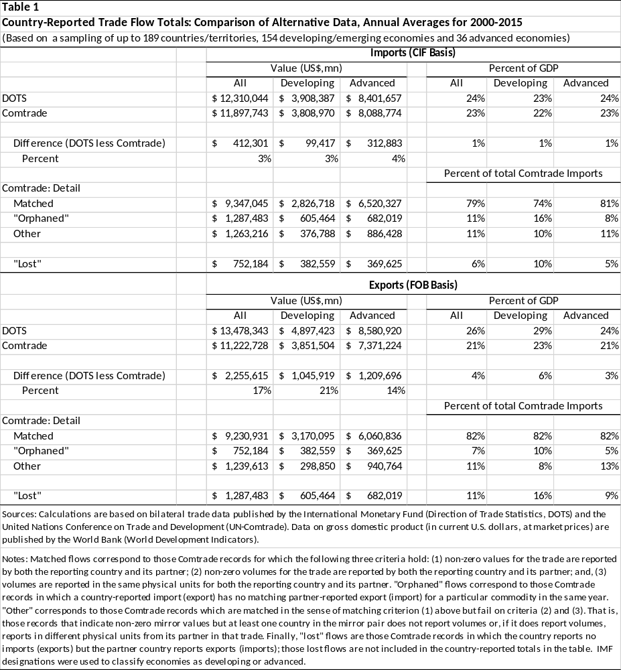

The data underlying the trade totals in the table are not entirely independent. In particular, the DOTS data rely on Comtrade data to some extent (and, to a greater extent with imports than with exports) but not exclusively. So it should not be surprising that the trade totals differ. The differences for imports are relatively small, with Comtrade import totals averaging about 3 percent below (or 1 percent of GDP) than those reported in the DOTS data. For exports, however, the differences are substantially larger: the Comtrade exports are, on average, 17 percent below the DOTS totals, with larger discrepancies for developing country reporters than for advanced country reporters (for developing countries, the export discrepancy amounts to 6 percentage points of GDP versus 3 percent for advanced countries). Because of the presence of missing data in Comtrade (as opposed to DOTS), those dollar discrepancies in magnitudes vary even more in a year-by-year comparison.
Additionally, while relative to DOTS the Comtrade data contain additional commodity detail that is useful for developing TM risk assessments, only a fraction of the country-reported data is directly useful in the PCM approach. On average, only 79 percent of country-reported imports and 82 percent of country-reported exports can be fully matched with partner-country mirror reports over the 2000-2015 period. While that still leaves a considerable amount of data for PCM analysis, any dollar magnitudes assigned to a particular estimate of TM may be more sensitive to factors beyond the researcher’s control (such as the irregular arrival of newly reported Comtrade data for some countries in some years) than would corresponding propensities.
Finally, even if it were possible to produce a time series of TM estimates that is consistent in terms of country/commodity coverage over time, that time series alone could not decisively determine whether TM has increased or decreased over time. That is because nearly all macroeconomic time series exhibit upward trends, generally reflecting changes in the scale of economic activity resulting from population growth and technological advance. Thus, an apparent trend in the estimated value of TM might, in fact, largely reflect a secular trend in trade.
For these (and other) reasons, appropriate measures of TM risk are normalizations of estimated TM values. While there is no particular normalizations that is uniquely appropriate (many have appeared in the literature), the most useful measures aim at indicating the propensity for TM associated with particular partner/commodity pairs in particular years. Because it seems intuitively plausible that TM varies with the volume of trade, representing TM risk as an estimated propensity (e.g., estimated import misreporting as a percent of total imports, or estimated export and import misreporting as a percent of total trade) is likely to be more informative than in value terms.
Finally, a natural point that follows from this illustrative comparison of the DOTS and Comtrade trade flows is that none of the official databases used by PCM researchers can be expected to correspond precisely to the more detailed (and mostly unpublished) trade data available to country customs officials. The DOTS and Comtrade dollar trade flows cannot be fully reconciled with each other and there is no reason to expect them to be fully reconcilable with country-level detail (not to mention the many reasons we should expect differences). Accordingly, the task of identifying patterns of TM risk for use by customs agencies may be better served by a focus on estimating TM propensities rather than value flows in dollars or any other currency.
Recent PCM empirical research on identifying TM risk. Given the uncertainties and data limitations outlined so far, it should be clear that no macro approach to identify TM risks can do so with certainty. Even so, the macro approaches can identify patterns of irregularities that can inform the work of customs officials.
Research using the PCM approach has been underway for more than half a century and the empirical literature is voluminous. With that growth of research, an evolved sense of what constitutes best practice in using the PCM approach to identify TM risks has emerged. Four recent empirical studies of TM using the PCM approach that exemplify current practice are worth reviewing here (Table 2).
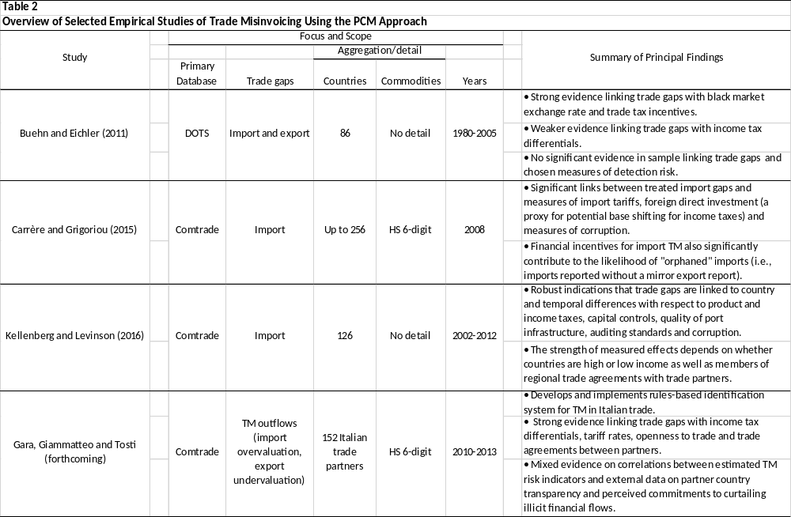

Using different samples taken from the DOTS and Comtrade databases, the four studies implement variants of the aforementioned research strategy to examine the sensitivity of observed trade gaps to related data that correspond to unavoidable and structural factors for trade gaps as well as financial incentives for TM. And, broadly, the studies all find evidence of some sensitivity of the treated trade gaps to TM incentives.
Buehn and Eichler (2011) develop an expected profit-maximizing decision framework within which partners to trade can choose whether to misreport trade values and the degree to which they misreport based on financial incentives for TM (net trade and domestic income taxes, black market exchange rate premia) in relation to expected costs if the misreporting is detected. Using country-level bilateral trade data (DOTS), the authors categorize the trade gaps into the four possible TM outcomes (i.e., under/over valuations of exports/imports) and, separately for each group, statistically test the normalized trade gaps for their sensitivities to the various financial incentives as well as measures of detection risk. They find robust evidence that black market premia and net trade taxes influence TM in the directions that the hypothesized optimization framework would predict. Their findings as to potential links between the trade gaps and domestic income tax rates are weaker.
Carrère and Grigoriou (2015) undertake a similar exercise but with considerably more commodity detail (HS6-digit detail in Comtrade) for one year (2008). Their research can be characterized as an examination of whether factors related to TM can help explain what standard empirical models for bilateral trade (the “gravity” type model) cannot explain. They find significant statistical support for the role of TM incentives in explaining some of the variation in trade gaps. After accounting for unavoidable factors (such as the effects of geographical characteristics of trade partners on transport margins) and structural factors (such as the role of transhipments and trade partner membership in regional trade agreements, or RTAs), the authors find the import gaps (measured proportionately) to be further influenced by country tariff rates, foreign direct investment (a possible proxy for base shifting across borders to avoid or evade income taxes) and a survey measure of perceived corruption in countries. They extend their analysis to orphaned imports (i.e., reported imports with no mirror export report, hence no calculable trade gap) and, significantly, find that TM incentives are also correlated with the likelihood that particular partner country-commodity combinations appear in the orphaned import class (particularly for commodities with less significant or infrequent trade). Of particular relevance to use of the PCM approach for identifying TM risk is the authors’ conclusion: “Far from being erratically driven, the [trade] gap can consequently be partly predicted by macroeconomic variables which should be used to better target the informal trade.”
Kellenberg and Levinson (2016) also begin with a decision-theoretic framework similar to that developed by Buehn and Eichlin (2011) (though they do not explicitly include the black market currency premia, for which data are limited) and examine the sensitivity of treated country-level trade gaps to TM incentives over a broader range of countries over a more recent period. The authors use a rich set of related data to control for unavoidable and structural differences contributing to trade gaps (e.g., port infrastructure quality) and potential TM incentives (e.g., tariff rates, tax rates, indexes of country-specific corruption, auditing standards and capital controls). The authors find that tariff rates are significantly correlated with undervaluation of imports for countries that are not members of RTAs and that effect is significantly stronger for such countries that are high-income than for low-income non-RTA countries. (For trading partners that are members of RTAs, tariff evasion is not a motive for undervaluing imports.) They also report robust evidence that poorer auditing and accounting standards and elevated indications of corruption significantly encourage undervaluation of exports.
Finally, Gara, Giammatteo and Tosti (forthcoming) build on the earlier studies and explicitly focus on the design of TM risk indicators for use by customs officials. Using bilateral Comtrade data for Italian trade with 152 trade partners at the HS-6 digit level of commodity detail, the authors examine those trade gaps that contribute to financial outflows from Italy (i.e., import overvaluation and export undervaluation). With an econometric model broadly similar to but somewhat more sophisticated than that used in Carrère and Grigoriou (2015), along with more refined survey data on transport margins in Italian trade than are generally available for most countries, the authors find robust correlations between trade gaps and such TM incentives as differential tariff and income tax rates as well as country characteristics such as openness to trade and RTA membership. The study presents results ranked by risk (percent share of anomalous trade lines) for (unnamed) trade partners and their significance to overall trade with Italy.

Conclusions for Identifying TM Risk with the PCM Approach

Macro approaches (both PCM and PFM) are inherently uncertain but still informative in the identification of TM risk. Which method is most appropriate will depend on the context for research and the particular data available.
The PCM approach is generally best suited for identifying broad patterns of TM risk in contexts with more comprehensive scope. The approach is most useful in investigating patterns of TM risk across countries, commodities and over longer periods of time. When detailed trade data for particular countries are not available, the PCM approach may be the only one available for assessing TM risk. Moreover, even when detailed country-specific trade data are available and suitable for the PFM approach, the PCM approach may be useful as a robustness check on the more detailed PFM analysis. Finally, by contributing to the growing body of stylized facts concerning TM, the PCM and PFM approaches can enhance the information that customs officials bring to their work.

WORKS CITED

Andriamananjara, S., Arce, H., & Ferrantino, V. M. (2004). Transshipment in the United States. United States International Trade Commission, Office of Economics Working Paper (No. 2004-04-B). Retrieved from https://www.usitc.gov/publications/332/ec200404b.pdf

Ardizzi, G., De Franceschis, P. & Giammatteo, M. (2016). Cash payment anomalies and money laudering: An econometric analysis of Italian municipalities. Banca d’Italia, Unità di Informazione Finanziaria, Quaderni dell’antiriciclaggio, Collana Analisi e Studi, 5. Retrieved from: http://uif.bancaditalia.it/pubblicazioni/quaderni/2016/quaderni-5-2016/index.html

Buehn, A. & Eichler, S. (2011). Trade misinvoicing: The dark side of world trade. The World Economy, 1263-1287. doi: 10.1111/j.1467-9701.2011.01375.x

Cantens, T. (2015). Mirror analysis and trade fraud. World Customs Organization, Research Paper (No. 35). Retrieved from: http://www.wcoomd.org/en/topics/research/activities-and-programmes/~/media/9F730547EF794600ADB7B2012BB5EE63.ashx

Carrère, C. & Grigoriou, C. (2015). Can mirror data help to capture informal international trade? Fondation pour les Études et Recherches sur le Développement International, Working Paper on Development Policies, (No. 12). Retrieved from: http://www.ferdi.fr/sites/www.ferdi.fr/files/publication/fichiers/wp123_carrere_grigoriou_web_1.pdf

Fortanier, F. & Sarrazin, K. (2016). Balancing international merchandise trade statistics. Organisation for Economic Co-operation and Development Statistical Directorate, Committee on Statistics and Statistical Policy, Working Party on International Trade in Goods and Services Statistics, (No. STD/CSSP/WPTGS(2016)18). Retrieved from: http://www.oecd.org/officialdocuments/publicdisplaydocumentpdf/?cote=STD/CSSP/WPTGS%282016)18&docLanguage=En

Federico, G. & Tena, A. (1991). On the accuracy of foreign trade statistics (1909-1935): Morgenstern revisited. Explorations in Economic History, 28 (3), 259-273. Retrieved from: https://e-archivo.uc3m.es/bitstream/handle/10016/5758/accuracy_tena_EIEH_1991.pdf?sequence=1

Gara, M., Giammatteo, M. & Tosti, E. (forthcoming). Magic mirror in my hand...how trade mirror statistics can help us detect illegal financial flows. Banca d’Italia, Unità di Informazione Finanziaria, Quaderni dell’antiriciclaggio, Collana Analisi e Studi, 10. Preliminary manuscript retrieved from: http://www.siecon.org/online/wp-content/uploads/2017/04/Giammatteo.pdf

Gaulier, G. & Zignano, S. (2010). BACI: International trade database at the product-level, the 1994-2007 version. Centre d'Études Prospectives et d'Informations Internationales, Document de Travail, (No. 2010-23). Retrieved from: http://www.cepii.fr/PDF_PUB/wp/2010/wp2010-23.pdf

Hamanaka, S. (2012). Whose trade statistics are correct? Multiple mirror comparison techniques: a test case of Cambodia, Journal of Economic Policy Reform, 15(1), 33-56.

Kellenberg, D. & Levinson, A. (2016). Misreporting trade: Tariff evasion, corruption and auditing standards. National Bureau of Economic Research Working Paper (No. 22593). Retrieved from: http://www.nber.org/papers/w22593

Marini, M., Dippelsman, R. & Stanger, M. (2018). New estimates for Direction of Trade Statistics. International Monetary Fund Working Paper, (No. WP/18/16). Retrieved from: https://www.imf.org/~/media/Files/Publications/WP/2018/wp1816.ashx

Miao, G. & Fortanier, F. (2016). Estimating CIF-FOB margins on international merchandise trade flows. Organisation for Economic Co-operation and Development Statistical Directorate, Committee on Statistics and Statistical Policy, Working Party on International Trade in Goods and Services Statistics, (No. STD/CSSP/WPTGS(2016)8). Retrieved from: http://www.oecd.org/officialdocuments/publicdisplaydocumentpdf/?cote=STD/CSSP/WPTGS(2016)8&docLanguage=En

Nitsch, V. (2012). Trade Mispricing and Illicit Flows,” In P. Reuter (Ed.), Draining Development? Controlling Flows of Illicit Funds from Developing Countries (pp.309-334). Washington, DC: The World Bank. Retrieved from: https://openknowledge.worldbank.org/bitstream/handle/10986/2242/668150PUB0EPI0067848B09780821388693.pdf?sequence=1&isAllowed=y

ENDNOTES

4. Estimating IFFs/TM :Price Filter Method

Philip K. Hong and Simon J. Pak

Price FilterMethodology (PFM)
The price filter method (PFM) estimates price filters for each Harmonized Commodity Description and Coding System (HS code) as a proxy for arm’s length prices and uses the price filters to detect suspicious transactions with abnormal prices, which is an indication of possible trade mispricing. Trade mispricing occurs when the unit price of a transaction declared is different from the arm’s length price of the transaction. The arm’s length price in a transaction varies depending on the particular transaction circumstance, such as contractual terms, economic circumstances, and business strategies pursued by buyer and seller, to name a few. The PFM is often used to estimate the amount of trade misinvoicing.

Detection of abnormally priced transactions

The price filters for each HS code include benchmark upper and lower bound prices allowing for variations in arm’s length price during a specified time period. The price filters may be constructed from observable market prices for some commodities such as gold and crude oil. The upper and lower bound prices may be set at (observed market price) +/- (α %) where α may be set for each HS code, based on the subjective judgment of analysts such as commodity specialists.
For example, the market prices for fine gold in London market can be used to create a monthly price filters. Figure 1 below plots the upper and lower bound prices for 1 oz fine gold at +/- 10% from the monthly gold price (2010-2014) in London market. The upper bound prices are in red line and lower bound prices in aqua line.
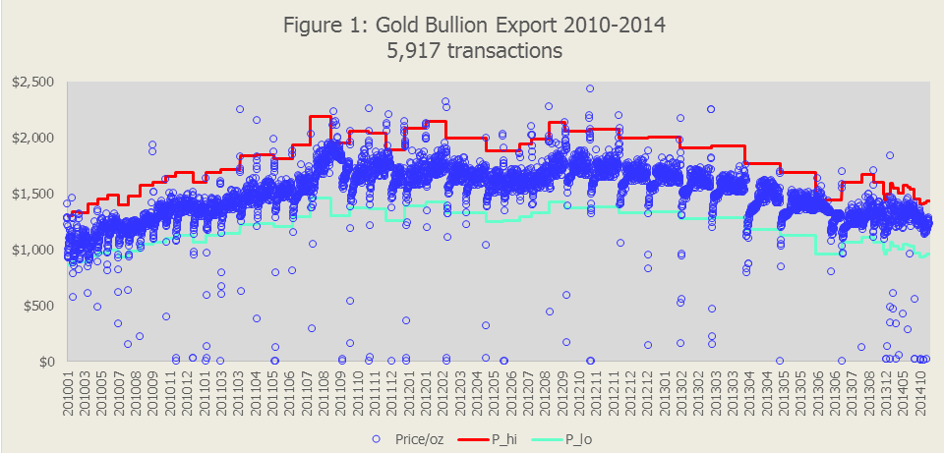

This figure plots 5,917 transactions of gold exports from an African country to the U.S. between 2010 and 2014. Each blue circle represents the price of one of 5,917 transactions and circles above the upper bound may be classified as overpriced and below the lower bound as underpriced. The price filter range may be set narrower or wider around the market price as appropriate.
Alternatively, the price filters may be constructed based on statistical estimates of upper and lower bound prices for each commodity classification with defined quantity, particularly for commodities with no observable market price. The statistical price filters are estimated using transaction-level trade statistics. The upper and lower bound prices may be set at the first quantile price and the last quantile price, such as the upper and lower quartile prices. Or they can be set at (the average price) +/- α(standard deviation) where α may be a subjectively selected number for each HS code based on the judgment of commodity specialists. The price filters may be estimated monthly or annually.
Figure 2a illustrates an example of a statistically estimated price filter for a heterogeneous commodity, Blood Fractions not elsewhere specified or included (HS10: 3002100290, Unit: KG). The lower quartile and upper quartile prices are estimated from 2,934 records in the 2016 U.S. import data. The available import data has 2,934 records aggregated from a total of 30,995 transactions. The blue dots show records with average prices below $5,000/KG. A quarter of all transactions have prices below the lower quartile price of USD 221/KG (aqua line) and may be classified as underpriced. Another quarter of all transactions have prices above the upper quartile price of USD 3,463 (red line) and may be classified as overpriced. Figure 2b expands the price axis to USD 3 million to plot all records, including records priced above $5,000.

Advantages and limitations of the price filter method

The PFM detects transactions with abnormal price by comparing the unit price in a declared invoice with the benchmark price filters. It does so efficiently and at low cost without relying on the partner’s transaction data. The PFM can detect suspicious transactions with same invoice mispricing, i.e., same forged price declared in both importing country and exporting country which the partner country method cannot detect. The PFM facilitates computerized real-time monitoring of inbound and outbound transactions as well as inspection of historical records to detect suspicious transactions systematically and efficiently. And finally, the PFM can identify high risk individuals with frequent overpricing or underpricing. This statement may be clarified using inter-quartile price filters as an example. The chance of one of two transactions priced above the upper quartile price is 1 in 2 ( 2*0.25). However, the chance of both transactions above the upper quartile price is 1/16. The chance of more than 50% of 100 transactions above the upper quartile is 1 in 47 million. Therefore, if an exporter or importer has over half of 100 or more transactions above upper quartile prices (or below lower quartile prices), the individual is very likely engaged in frequent mispricing unless the products are at high end (or at low end) within the commodity classification.
The PFM, however, has several limitations. The obvious limitation is the fact that the statistical price filters are generated endogenously using trade statistics which also includes abnormally priced transactions. Therefore, the PFM method will always find transactions with prices outside the statistical price filters. In addition, product classifications even at the most detailed level may include products with a different degree of heterogeneity. The price filters for heterogeneous product may result in false positives for products in very high and very low ends in quality, and miss detecting abnormal pricing of transactions of mid quality products. Transactions under a long-term contract may have prices different from the current spot market prices. A transaction price outside the price filter range may be an arm’s length price under the particular transaction circumstances. The trade statistics may have clerical or recording errors, in which case the PFM is not effective.
It is possible to miss detection of abnormally priced transactions with declared prices different only by a small margin and within the price filter range.It is also possible to estimate price filters inaccurately for products with volatile prices during a price filter estimation period, such as annual price filters used for crude oil when monthly crude oil price ranged between $56/bbl and $110/bbl in 2014.
Given the limitations, some arm’s length transactions may be classified falsely as abnormally priced, and some abnormally priced transactions may be classified falsely as having arm’s length price. Therefore, it is important all suspicious transactions identified by the PFM should be confirmed through an examination of trade documents. Price filters may be refined for selected HS codes. For example, benchmark price ranges may be set wider for products with too many false positives, and narrower for products too few detection of transactions with abnormal prices.

Estimating the misinvoiced amount

An offshoot of the detection of suspicious transaction through the PFM is to estimate the dollar amount of trade misinvoicing. The misinvoiced amount in a suspicious transaction may be estimated as follows:
- Overinvoiced Amount = (invoice price minus upper bound price) times (quantity)
- Underinvoiced Amount = (lower bound price minus invoice price) times (quantity)
In this approach, all abnormally priced transactions are assumed mispriced transactions. It is possible that the PFM may understate the misinvoiced amount when the PFM method misses transactions with large quantities mispriced by a small amount but not outside the price filter range. It is also possible that the PFM overstates the misinvoiced amount because detection of suspicious transactions in the PFM may results in false positives such as transactions outside the price filter range, but justifiably priced under the particular transaction circumstances. Therefore, an aggregated misinvoiced amount estimated through the PFM should be treated only as a first-order approximation.

PFM Estimates of Trade Mispricing from Existing Literature
There are two types of empirical studies on trade invoicing using the PFM depending the types of price filters used: one based on market prices and the other estimated statistically.

Price filter matrix based on market price

An article by Hong, Pak & Pak (2014) examines the degree of trade mispricing in the US fresh banana trade with Latin American and Caribbean countries using benchmark price filters based on the market price. The study finds that when the degree of mispricing is measured by two commonly used methods, interquartile price filter method and partner-country method, there is little evidence of undervaluation or overvaluation in the U.S. banana import. However, when measured using price filters based on the free-market price of fresh banana, the undervalued amount is 54 percent of the total banana import value declared by the US importers during the period between 2000 and 2009.
A report published by Publish What You Pay Norway (Pak 2012) analyzes the crude oil import by the E.U. and the U.S. for trade mispricing during 2000-2010 period. The price filters are based on the crude oil spot price published by the U.S. Energy Information Agency. The trade data sources for crude oil import are EUROSTAT External Trade Data for the E.U. import and the U.S. Imports of Merchandise, U.S. Census Bureau, for the U.S. import. The undervalued amount is estimated at $28.5 billion for the E.U. import during the 11-year period (1.35% of total import value) and $22.9 billion for the U.S. import (1.22%). Several countries show higher ratios of undervaluation ranging between 8% and over 200% in E.U. import, but only one country has over 10% in the U.S. import with all other countries at less than 4%.
The overvalued amount is estimated at $17.3 billion for the E.U. import (0.81% of total import value) and $42.1 billion of the U.S. import (2.18% of total import value). Three countries show higher ratios of overvaluation ranging between 11% and 88% in E.U. import, and one country has a ratio of 7.1% in the U.S. import with all other countries at no higher than 5.5%.
The trade data used in the banana trade and the crude oil trade are not transaction level data. Each record is an aggregation of transaction data.
Pak (2017) analyzed transaction level data on gold and cocoa beans exports from an African country during the 2010-2014 period. The gold transaction analysis is illustrated in Figure 1. The amount of undervaluation in gold export is estimated at $310 million (8.1% of declared export value), while the overvaluation is found insignificant. The cocoa bean export transactions are analyzed through the price filters based on the market price available from the IMF Primary Commodity Price data. Figure 3 below shows the upper bound price (red line) and lower bound price (aqua line) and individual export transactions in blue circles. The undervalued amount in cocoa export is estimated at $338 million (2.8% of declared export value), but the overvalued amount is found substantially larger, $3.9 billion (32.3 % of declared export value).

Statistically estimated price filter matrix

A number of empirical studies has estimated trade mispricing based on statistical price filter matrix for each commodity and each partner country. Empirical studies have used bilateral price filter matrix as well as world price filter matrix. The bilateral price filter matrices are constructed for each HS code and for each partner country using transaction data only with a specific partner country and world price filters are constructed for each HS code and for all partner countries using transactions data with all partner countries. Using bilateral price filter matrix may be appropriate if the commodities from one country are sufficiently different compared with commodities from other countries with an identical HS code. However, bilateral price filter matrix may be inappropriate when transactions with a partner country are mostly mispriced in one direction, underpriced or overpriced.
Several select empirical studies are briefly reviewed below.
Paul, Pak, Zdanowicz and Curwin (1994) published an article on the use of average world price to detect possible wrongdoing through international trade. Subsequently Pak &Zdanowicz (1994) published an article on the price filter method to detect abnormal prices using statistically estimated price filter matrix by HS code and by country. The price filter matrix includes monthly average prices and upper and lower quartile prices using moving 12-month data from the U.S. export and import data. The inter-quartile price range is used as a price filter to detect abnormal prices. The study also uses prices 50% below and above the average prices as an alternative price filter. The average prices estimated include simple mean, lognormal mean, and median. Using 50% deviations from simple mean price as price filters, the paper estimated the tax loss through overvalued U.S. import and undervalued U.S. export at $28.6 billion in 1992 and $33.1 billion in 1993.
McNair and Hogg (2009) reports the estimated amounts of capital flows through trade mispricing from non-EU countries to the 27 E.U. countries and the U.S. The trade data used are from EUROSTAT and the U.S. Census Bureau for 2005, 2006 and 2007. Partner specific quartile price filters (bilateral price filters) are estimated by commodity and by country based on bilateral trade data. Annual capital flows through trade mispricing during the three-year period are reported as ₤361 billion (GBP) to the U.S. and ₤230 billion (GBP) to the E.U. countries.
De Boyrie, Pak &Zdanowicz (2005) analyzed export and import transactions between the U.S. and Russia using interquartile price filters. Two sets of interquartile price filters are used in estimating abnormally priced transactions: bilateral U.S. - Russia price filters based on U.S. - Russia transactions and the U.S. - World price filters based on U.S. transactions with all countries. All overvalued U.S. exports and all undervalued U.S. imports are assumed facilitating capital flight and income shift from Russia to the U.S. Russia’s capital flight to the United States during 1995–1999 ranges from a maximum of $8.92 billion using the U.S. - World price filter matrix to a conservative estimate of $1.86 billion based on the bilateral U.S. - Russia price filter matrix. The study attributes the trade mispricing to either money laundering and/or tax evasion.
De Boyrie, Pak &Zdanowicz (2005) published an article on Switzerland’s capital flight through trade mispricing between 1995 and 2000. The mispriced amounts are estimated using the bilateral U.S. – Switzerland inter-quartile price filter. The study found that the amount of capital movement from Switzerland to the U.S. through trade mispricing was $31.7 billion during the six-year period. Switzerland passed a Money Laundering Act (MLA) in 1997 and the study examined the impact of the MLA on capital outflows. The study found significant changes in the degree of trade mispricing subsequent to the enactment of Switzerland’s anti-money laundering law. It is found, for example, that the estimated average monthly capital outflows are $222 million in 1995 and $560 million in 2000. Empirical tests on the capital outflows from Switzerland support the hypothesis that the passage and enactment of the MLA explains the increased capital outflows through trade mispricing during the period following the enactment.
De Boyrie, M., Nelson, J. & Pak, S. (2007) published an article on the capital movement between the U.S. and 58 African countries through trade misinvoicing. The mispriced amounts are estimated based on the U.S. – World interquartile price filter matrix. The amount of annual capital outflows from the African countries to the U.S. increased by 60%, from $3.07 billion in 2000 to $4.90 billion in 2005. The capital outflows are found mostly through low priced exports. Four Northern African countries (Egypt, Algeria, Morocco and Tunisia) alone moved approximately $6.7 billion through trade misinvoicing during the six-year period while the remaining 26 Sub–Saharan countries combined moved a total of $13.4 billion. The country moving the most capital to the U.S. through trade misinvoicing is found to be South Africa.
Finally, an article by Cathey, J., Hong, K. & Pak, S. (2018) estimates trade mispricing in the E.U.’s import from the Democratic Republic of Congo (DRC) and the U.S. import from the DRC between 2000 and 2010. Using the E.U. – World interquartile price filters, the study estimates the undervalued amount of EU import from the DRC as €9.95 billion, exceeding the declared total import value of €8.06 billion. Almost all of the underpricing in the E.U. import from the DRC, 98% of the total undervalued amount, is through non-industrial diamonds imported by Belgium and cobalt ore and mattes imported by Finland. The undervalued amounts based on the E.U. - DRC lower quartile price filters are negligibly small compared to the corresponding amounts based on the EU. - World lower quartile price filters. This can be explained if the two main items, diamonds and cobalt ore from DRC, are of very low quality compared to diamonds and cobalt ore from other countries, or if the majority of import transactions from DRC are underpriced so that bilateral E.U. – DRC price filters are significantly lower than the E.U. – World price filters, a result of endogeneity in price filter estimation.

PFM Estimates of Trade Mispricing in the U.S. Export and Import data, 2012-2016
An analysis of the U.S. merchandise trade data for the 2012 – 2016 period is presented below based on upper and lower quartile price filters for each HS10 code estimated from U.S. transactions with all countries (U.S. – World price filter matrix).

Data Description

The U.S. trade data in this analysis is the most detailed trade data available publicly from the U.S. Census Bureau. Each trade record includes transactions grouped by HS10 code, partner country, month, and customs district. In 2016, a total of 81.5 million import transactions are grouped to 7.3 million records with 3.3 million records containing single transaction. Thirty-six million export transactions are grouped to 5.6 million records with 2.9 million records containing single transaction. Eliminating records with no quantity defined (because unit price cannot be calculated), 5.4 million import records and 4.0 million export records are examined with the price filters.
Since the trade data is grouped, the average unit price for each record with more than one transaction ignores price dispersions within group. It means some transactions included in a record may have prices higher than the average price of the record and some other transactions record prices lower than the average price.

Detection of Abnormally Priced Transactions

The price filter method is illustrated below to detect abnormally priced transactions with two selected commodities: an import commodity and an export commodity.

MispricedImport records

The import commodity analyzed is “blood fractions not elsewhere specified or included’ (HS10: 3002100290, unit: KG), which is the commodity with the most import overpricing. The data description and the U.S. – World price filters are in Table 1:
Table 1. U.S. 2016 Import of “blood fractions nesoi” (HS10: 3002100290, unit: KG)
No of records | 2,934 | Minimum price | $1.03
No of transactions | 30,995 | Lower quartile Price | $221
Import amount | $13,220,767,595 | Median Price | $698
Import quantity | 6,420,546 KG | Upper quartile price | $3,463
 |  | Maximum price | $2,445,635

The top 10 overpriced records are listed in Table 1A and the top 10 underpriced records in Table 1B:
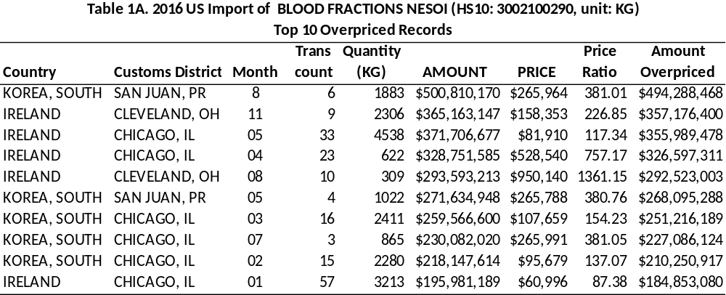 * The price ratio is defined as the price divided by the median price.

The overpriced import list is dominated by imports from South Korea and Ireland. The first line in Table 1A is an import record from South Korea with six transactions grouped together, imported through San Juan customs district in August 2016. The average price of the six transactions is $265,964/KG compared to the upper quartile price of $3,463/KG in 2016. The average prices of the top 10 records are substantially high compared with the upper quartile price.
The list of top 10 underpriced import records is in Table 1B and is dominated by imports from Mexico followed by China. The first line in Table 1B is an import from Argentina with six transactions grouped together, imported through Philadelphia customs district in January 2016. The average price of the six transactions is $1.4/KG compared with the lower quartile price of $221/KG in 2016.
The substantially wide variation in price may be partially due to the product heterogeneity, but it is suspicious enough to warrant investigation of import documents.
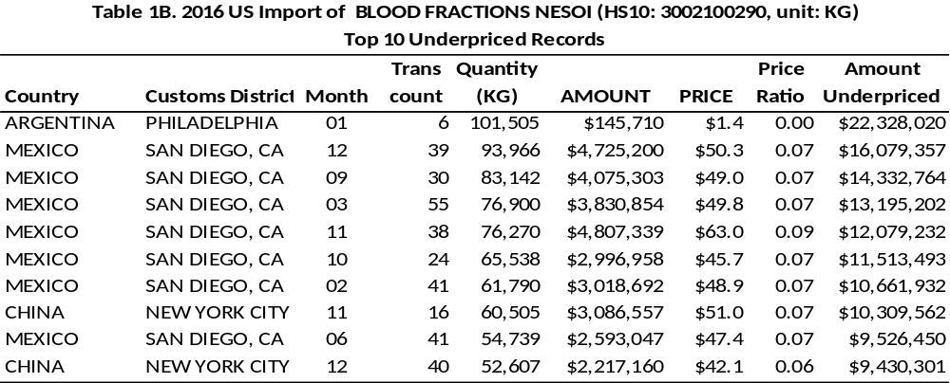

Mispriced Export records:

The export commodity analyzed is “gas turbine engine, except aircraft nesoi, of a power not exceeding 5,000 kw” (HS10: 8411818000, unit: NO). It is the commodity with the most export underpricing. The data description and the U.S. – World price filters are in Table 2:
Table 2. U.S. 2016 Export of gas turbine engine, except aircraft nesoi, of a power not exceeding 5,000 kw (HS10: 8411818000, unit: NO)
No of records | 220 | Minimum price | $1
No of transactions | 369 | Lower quartile Price | $181,987
Export amount | $187,936,244 | Median Price | $303,818
Export quantity | 1,000,492 items | Upper quartile price | $504,315
 |  | Maximum price | $3,000,000
The top 10 overpriced export records are listed in Table 2A and the top 10 underpriced export records in Table 2B. The overpriced export list is dominated by exports to the United Kingdom. The first line in Table 2A is an export record from the U.K. with four transactions grouped together, exported through Chicago customs district in February 2016. The average price of the four transactions in the record is $1.5 million per engine compared with the upper quartile price of $504,315 per engine in 2016. The average prices of the top 10 records are substantially high compared with the upper quartile price.
The list of top 10 underpriced export records is in Table 2B and is dominated by one export record to France. The first line in Table 2B is an export to France with single transaction, exported through Chicago customs district in October 2016. The price of the transaction is just $1.00 per engine compared with the lower quartile price of $181,987 per engine in 2016. The amount of underpricing is then $182 billion! It appears this is a case of data error because the quantity reported is 1 million engines which seems excessively large. An inspection of export documents of this transaction should clarify this case.
As in the case of blood fractions import, the substantially wide variation in price may be partially due to the product heterogeneity, but it is suspicious enough to warrant an investigation of export documents.
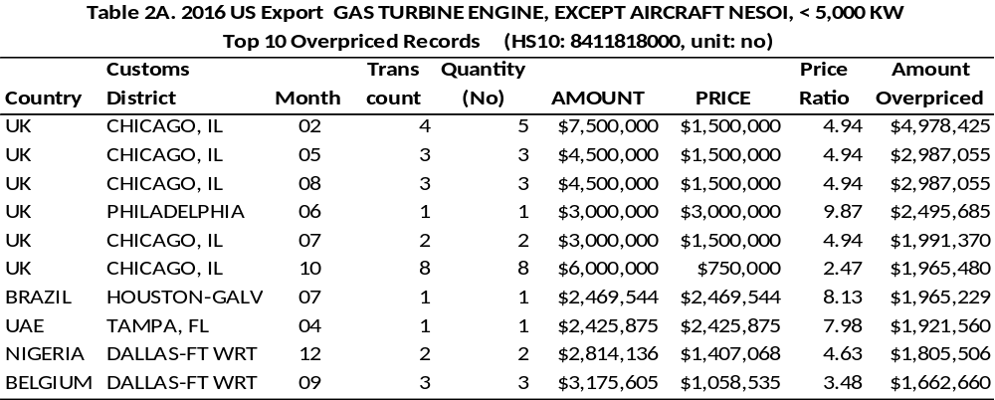
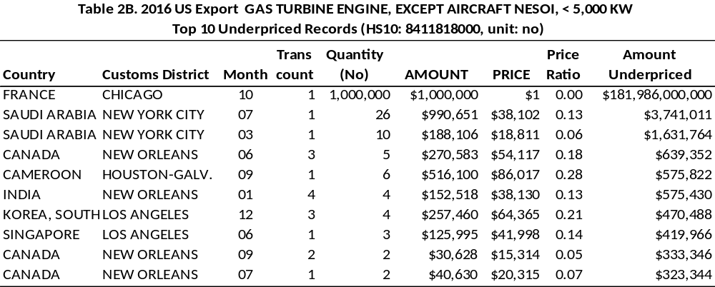
The examples above have demonstrated that the price filter method is an effective tool to identify suspicious transactions with abnormal price for further inspection of trade documents.

Commodities with High Risk of Trade Mispricing

Commodities with a high risk of trade mispricing can be identified by aggregating overpriced and underpriced amounts by HS 10. Import overpricing and export underpricing facilitate capital outflow and income shift away from the U.S, while import underpricing and export overpricing facilitates capital inflow and income shift to the U.S.
Commodities with a high risk of facilitating capital outflow and income shift from the U.S. are listed in two tables below: Table 3A lists top 10 import commodity groups in overpricing, and Table 3B top 10 export commodity groups in underpricing. Each commodity group may include transactions overpriced as well as transactions underpriced. The overpriced amount in Table 3A is the gross overpriced amount not counting underpriced records, and the underpriced amount in Table 3B is the gross underpriced amount not counting overpriced records. Among the top 10 commodity groups, three items are common in both tables, which can facilitate capital outflow through import overpricing and export underpricing (see the table below).
Three items with both import overpricing and export underpricing, U.S. Exp/Imp 2016
HS10 ITEM DESCRIPTION | Unit | Import Overpriced ($m) | Export Underpriced ($m)
BLOOD FRACTIONS NESOI | KG | 7,897 | 2,554
MEDICAMENTS PUT UP ... FOR RETAIL, NESOI | KG | 5,622 | 2,353
RADIO TELEPHONES DESIGNED FOR THE PUBLIC CELLULARSERVICE, Not FOR MOTOR VEHICLES | NO | 4,212 | 2,041

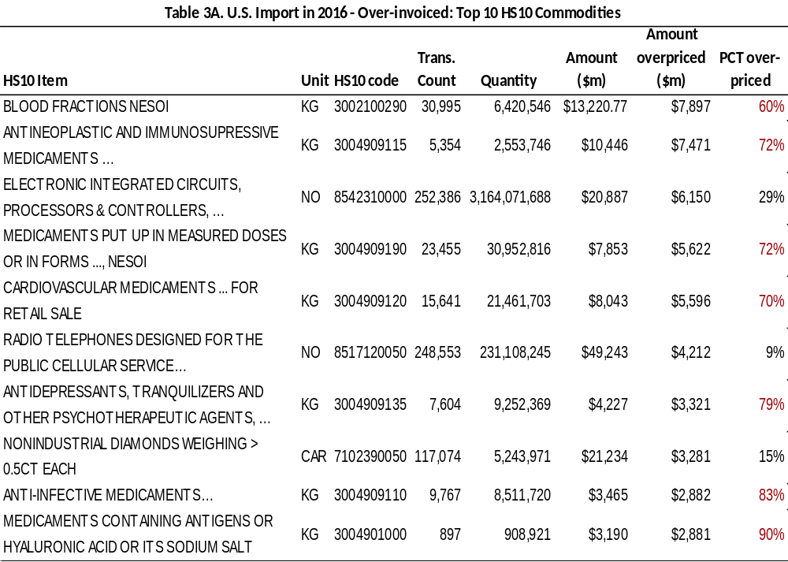

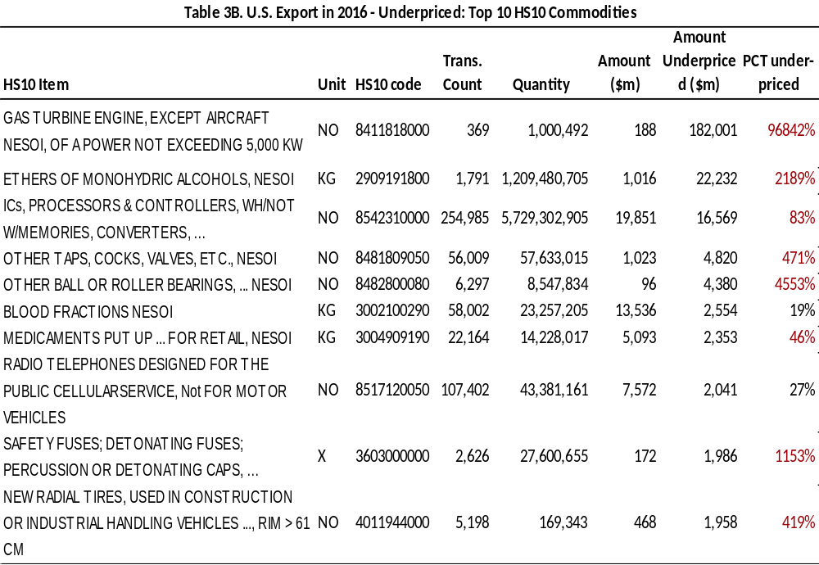

Annual Trend of Trade Mispricing, 2012 - 2016

Annual trade mispricing is estimated by aggregating trade mispricing of all records. Table 4A summarizes the gross overinvoiced import amount and gross underinvoiced import amount for the 5-year period. The total import amount includes only records with quantity defined. Non-quantified records are excluded from mispricing estimation. The overinvoicing shows no significant change from year to year, but the underinvoicing shows an increasing trend, both in the amount and in the proportion to the total import amount.
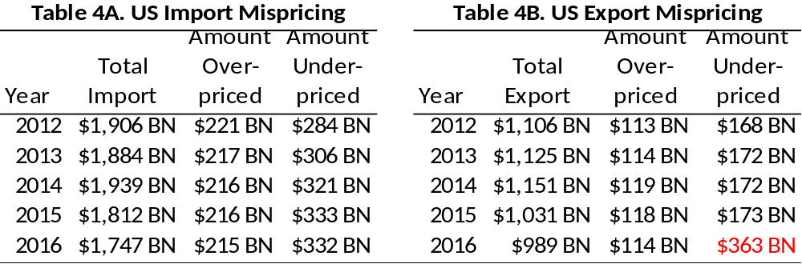

Table 4B summarizes the aggregate gross overpriced export amount and underpriced export amount for the 5-year period. The total export amount includes only records with quantity defined. Non-quantified records are excluded from mispricing estimation. The underinvoicedamount in 2016, $362 billion, is an outlier. It is more than double the amounts in previous years. This can be explained by the $182 billion underpricing of one export transaction of gas turbine engine to France, the first line in Table 2B. Assuming the underpricing is due to data error as discussed earlier, the 2016 total underpriced amount, $363 billion, may be adjusted by subtracting $182 billion to obtain $181 billion, which is still somewhat larger than in the previous years. This case reinforces the need for inspection of trade documents of abnormally priced transactions and the mispriced amount estimated by the PFM should be treated with reservation.

Summary
The PFM detects abnormally priced transactions efficiently and at low cost without using the partner’s transaction data. The PFM can be used in computerized real-time monitoring of transactions as well as inspection of historical records systematically and efficiently. The PFM can identify:
- High risk commodity groups for trade mispricing
- High risk trading partner countries for trade mispricing
- High risk individuals with frequent overpricing or underpricing.
The PFM has also limitations due to:
- Product heterogeneity
- Different contract details, such as long-term contracts vs short-term or spot transactions
- Endogeneity in statistical price filter estimation
- Clerical or recording errors in data
- Missing detection of transactions with large quantity but mispriced by a small margin
- Commodities with volatile price movements
Since not all abnormally priced transactions are mispriced transactions, it will be necessary for Customs to investigate trade documents of all suspicious transactions identified by the PFM. When the PFM is used to estimate mispriced amount, the estimated amount should be treated with reservation since the PFM may include false positives and miss identifying mispriced transactions.

Bibliography

Cathey, J. Hong, K. & Pak, S. (2018). Estimates of undervalued import of EU Countries and the U.S. from the Democratic Republic of Congo during 2000–2010.The International Trade Journal. V32, 2018 – Issue 1.
deBoyrie, M., Nelson, J. & Pak, S. (2007). Capital Movement through Trade Misinvoicing: The Case of Africa. Journal of Financial Crime, Vol 14, No. 4, 2007, pp 474 – 489
deBoyrie, M., Pak, S. &Zdanowicz, J. (2005). Estimating the magnitude of capital flight due to abnormal pricing in international trade: The Russia–USA case.Accounting Forum, 29, 249-270.
deBoyrie, M, Pak, S. &Zdanowicz, J. (2005). The impact of Switzerland’s money laundering law on capital flows through abnormal pricing in international trade. Applied Financial Economics, 15 (4), 217-230.
Hong,K,, Pak, C. & Pak, S. (2014). Measuring abnormal pricing – an alternative approach: The case of US banana trade with Latin American and Caribbean Countries.Journal of Money Laundering Control, Vol. 17 No. 2, 2014. pp. 203-218
McNair, D. & Hogg, A. (2009). False profits: robbing the poor to keep the rich tax-free. A Christian Aid report March 2009.https://www.christianaid.org.uk/resources/about-us/false-profits-robbing-poor-keep-rich-tax-free
Pak, S. &Zdanowicz, J. S. (1994). A statistical analysis of the U.S. merchandise trade data base and its uses in transfer pricing compliance and enforcement, Tax Management: Transfer Pricing Report, Vol. 3, No. 1, 50-57.
Pak, S. (2012).Lost Billions. Transfer Pricing in the Extractive Industries: Estimates of Mispricing in Crude Oil Import - The European Union and the United States, 2000-2010. Publish What You Pay Norway 2011-2012. (ISBN 978-82-93212-04-1, January 2012).
Pak, S. (2017). “A Real-time Monitoring of Illicit Financial Flows through Trade Mispricing.” A presentation at High Level Convening on Illicit Financial Flows, Accra, Ghana. 2017
Paul, K., Pak, S., Zdanowicz, J. &Curwin, P. (1994). The ethics of international trade: use of deviation from average world price to indicate possible wrongdoing, Business Ethics Quarterly, Volume 4, No. 1, 29-41.

ENDNOTES

5. Cross-reference of PFM and PCM : Analysis of South African TM Risks – Imports, 2010-15

Matthew Salomon

Do the PCM and PFM approaches to identifying TM risks provide similar results? This section reports on an empirical exercise designed to address this question. Each of the two macro approaches for risk identification is applied to annualized data on South African imports over the 2010-2015 period: the UN Comtrade bilateral trade database is used for the PCM approach while highly-detailed database on South African imports maintained by the South African Revenue Service (SARS) is used for the PFM approach.
While the estimated magnitudes of potential TM resulting from each method/database differ, the principal finding in this case study is that the two approaches do yield similar results as far as TM risk identification is concerned. Notably, both approaches indicate a higher degree of undervaluation of imports than overvaluation, a result that holds up year-by-year, across commodities and across the countries from which South Africa imports. Additionally, the undervaluation of imports appears to be strongly associated with South Africa’s tariff rates. Because tariff/duty evasion provides an incentive for import under-invoicing, this finding suggests that a considerable portion of the undervaluation of imports could be linked to TM. Finally, application of a simple rule for identifying TM risk in undervalued imports using PCM and PFM estimates at the HS 6-digit level of commodity detail leads to identical risk assessments in the overwhelming majority of cases.

Data & Methods

The PCM and PFM have been developed for use in different situations, with the appropriate contexts largely determined by the best data available for a particular set of countries, commodities under study as well as the relevant period of time. Generally, we’d expect bilateral trade databases (e.g., Comtrade) to be comparable to country-reported data (at least at some level of aggregation) but experience with many countries (particularly in the developing world) indicates this is not the case. In the present case, fortunately, the Comtrade data appear to be broadly comparable with the SARS data. Even so, each of the methods requires different treatments of the data (particularly so for Comtrade) to make them ready for the respective analysis. The statistical treatments were developed independently from one another, addressing only the questions pertinent to the use of the particular data. This section describes the methods and treatments applied to the respective data and a comparison of the results.
Comtrade database used with PCM. As outlined in an earlier chapter, the PCM approach relies on trade gaps. In the present context, the basic trade gap considered under PCM is the difference between what South Africa reports having imported of a particular commodity (defined at the HS 6-digit level of detail) from a particular country in a given year and what its partner country reports having exported.
Approximately 628,000 records in the Comtrade database correspond to South African reported imports over the 2010-2015 period. The implementation of the PCM approach, however, uses only a portion of those records, those which have matching entries for South African imports in terms of value and volume (i.e., quantity). The usable records comprised only about 45 percent of the total available; in terms of import value, however, the usable observations in the Comtrade database comprised a higher proportion, just under 70 percent, of total reported imports.
As discussed earlier, treatments of bilateral trade data are necessary to account for unavoidable and structural factors that, apart from TM, might give rise to trade gaps. Because South Africa reports its imports on an FOB basis, those data are already comparable to partner country exports (i.e., all exports are reported on an FOB basis) meaning that the South African import data required no adjustment for transport margins. Possible distortion to the trade gaps was mitigated (though not entirely resolved) by adjusting the Comtrade data using for Chinese re-exports via Hong Kong. Finally, in keeping with empirical practice, “reliability” weights were applied to the dollar-magnitude of the HS 6-digit trade gaps calculated with the Comtrade data.
SARS database used with PFM. The SARS database on South African imports is considerably more detailed than the Comtrade database. That stems largely from the fact that commodity imports are reported on an 8-digit level of detail in SARS and trades are reported at a monthly frequency. The SARS data included over 7.5 million observations of reported imports over the 2010-2015.
The PFM was implemented on a treatment of the SARS sample, designed to eliminate outliers, or singularly aberrant observations that might be the result of errors and that would exert undue influence on the analytical results if included. In a sample as large as the SARS database, the potential for such overly influential observations is not negligible.
The PFM method was implemented by organizing the SARS price data into groups of similar trades. Each group was defined by several criteria: (1) the year in which the trade is recorded (one of the six years in the 2010-2015 period); (2) the commodity traded (one of 7,860 8-digit SARS commodity classifications); and, (3) the physical units in which the volume (i.e., quantity) of trade are reported (17 distinct possibilities). The justification for keeping trades from different years in separate groups is to eliminate price inflation over time as a source of variation. That classification yielded 40,737 distinct groups. Additionally, to enhance comparability with the Comtrade data, the prices in the SARS database were converted from Rand to U.S. dollars using the same (annual) dollar-per-Rand rates used by the United Nations in Comtrade. Finally, the dollar prices were converted to natural logarithms for the analysis.
The basic treatment of the SARS data involved three passes through the data. In each pass, standard robust statistical criteria were applied to screen out unusually extreme values that are regarded as likely to be uninformative and unduly distort the estimated price distributions and thereby define admissible data for the PFM analysis. The three passes correspond to the following objectives:
- Identify admissible groups. On the first pass, a determination was made for each group as to whether the size of the group and the variation of the prices within the group were sufficiently great to merit further scrutiny. Groups with fewer than 5 observations were eliminated outright and those groups with 5 or more observations but limited variability in the prices were also eliminated from further analysis.
- Identify admissible price observations within groups. In the second pass, individual prices within those groups that survived the first pass were analyzed to detect within-group outliers (i.e., potentially influential but aberrant observations that could unduly distort the risk identification within the group). Those observations designated as within-group outliers in this second pass were removed from further analysis.
- Identify admissible price observations across groups. Finally, the third pass of treatments was designed to screen out any remaining outliers across groups among the observations not already excluded. Those price observations that survived the first two passes of treatments were standardized to allow comparison across groups. Once on a comparable basis, the entire surviving sample of standardized prices was screened and outliers removed from the sample.
The triple-pass treatment reduced the number of distinct groups to 36,487 and the number of admissible records in the SARS database to just over 7 million. The PFM procedure was then applied to each surviving record in the SARS sample by designating the price in each trade as: (1) high priced, if the price exceeded the 75th percentile price for its group, or (2) low priced, if the price was below the 25th percentile price for its group, or (3) neither of the above. In the first two cases, the degree to which valuations are extreme was determined by the absolute difference between the particular price and its corresponding group percentile (75th percentile for the high-priced trades and 25th percentile for the low-priced trades) multiplied by the particular volume associated with the trade.
Comparing the Comtrade and SARS data used in the analysis. Before discussing the estimation results, it should be recognized how the two databases compare in magnitude and coverage. While the two databases report comparable magnitudes for broad aggregates of commodities and partner countries, the proportion of data useful to each of the methods varies considerably. Summary statistics for the Comtrade and SARS databases, both before and after the respective treatments are presented in Table 1.

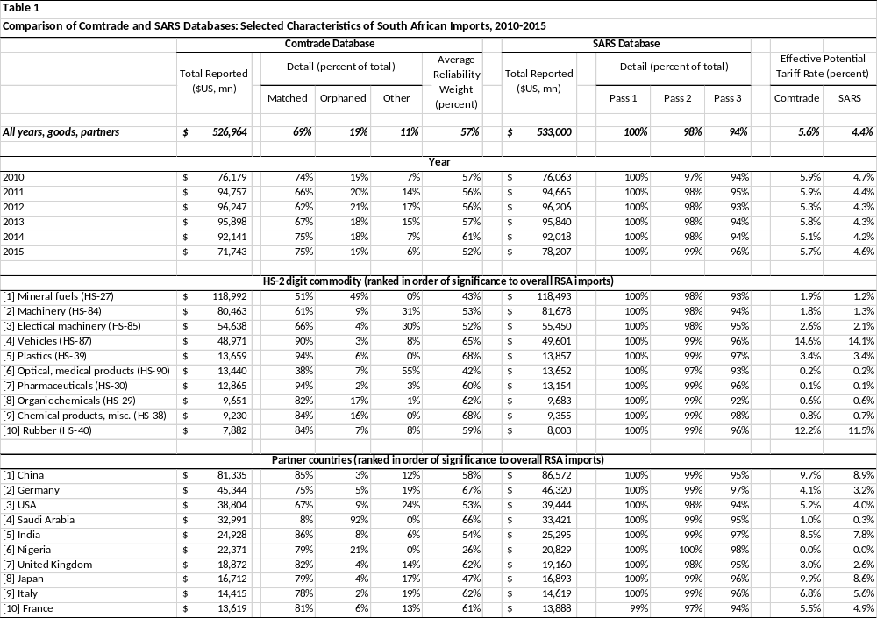

In terms of the overall levels of imports reported by South Africa, the Comtrade and SARS databases compare well. Aggregated over all years, commodities and partner countries, imports recorded in Comtrade amount to nearly $527 trillion as compared with $533 trillion in SARS, a difference of only about 1 percent. The broad aggregates also compare well in terms of the HS 2-digit commodity and partner country totals listed in the table (ranked by significance to overall South African imports, the rankings derived from the SARS database).
But the comparability of the dollar data in dollar terms diminishes when the post-treatment samples are compared. The PCM approach relies on trade gaps calculated from matched reports, and only 69 percent of the import value reported in Comtrade arises from South African reports that are fully matched by partner country export reports. Of the imports reported by South Africa in Comtrade, about 19 percent are labelled “orphaned” imports as they have no corresponding partner country reports. Finally, an addition 11 percent of the total value of imports reported by South Africa have matched partner country values but insufficient matching on partner country volumes (those are labelled “Other” in the table). The overall proportion of data useful for PCM in the case of South Africa is significantly higher than the average for all countries in Comtrade (e.g., orphaned imports typically comprise about half the sample over all countries from 2000 to 2014). Nevertheless, it is noteworthy that the sample coverage used for the PCM approach is considerably reduced relative to that used for the PFM approach. Moreover, the reduction in the sample made necessary by less than full matching in the Comtrade data varies considerably by commodity and partner country. Finally, the reliability weights used to adjust the dollar values of the trade gaps in the PCM exercise are considerable (averaging 57 percent overall) and vary quite a bit across goods and partner countries.
By contrast, the treatments applied to the SARS data reduce the original sample by less than is the case with the treatment applied to Comtrade. Not surprisingly, the first pass (which eliminates groups with extremely few observations) has little effect on the overall values surviving the treatment. Moreover, the elimination of within-group outliers (the second pass) leaves a high fraction of surviving value (98 percent overall) sample and fairly consistently over time, goods and partner countries. Finally, the treatment for outliers across groups in the third pass reduces the sample values somewhat more than the within-group treatment but it still leaves about 94 of the original sample intact and fairly consistently over time, commodities and partner countries.
The final comparison of the Comtrade and SARS samples is presented in the rightmost two columns of the table. There are reported “effective potential tariff rates” (or EPTR) essentially, a statistic that summarizes the potential significance of a particular import classification with respect to import tariff and duty collections by South Africa. While the EPTRs need not correspond precisely to actual tariff collections by SARS (which are defined at a higher degree of commodity detail than is available here), they serve as a convenient summary measure of revenue significance, particularly when applied to the over- and under-valuation of imports reported in the next subsection. As the table indicates, the EPTRs calculated for Comtrade and an HS 6-digit aggregation of the values in SARS are different (5.6 percent for the treated Comtrade data overall and 4.4 percent for the treated SARS data) but, more importantly, the differences appear relatively stable across commodity and partner country groupings.

Estimation Results

The PCM and PFM approaches were applied, respectively, to the Comtrade and SARS data at the highest degree of commodity detail available (HS 6-digit for Comtrade, 8-digit detail for SARS). Because of the differences in the coverage of the respective samples, as discussed above, the results are presented as propensities (calculated from the underlying dollar magnitudes). The results are summarized in Table 2, with the PCM estimates presented in the five columns on the left and the PFM estimates presented in the five columns on the right.
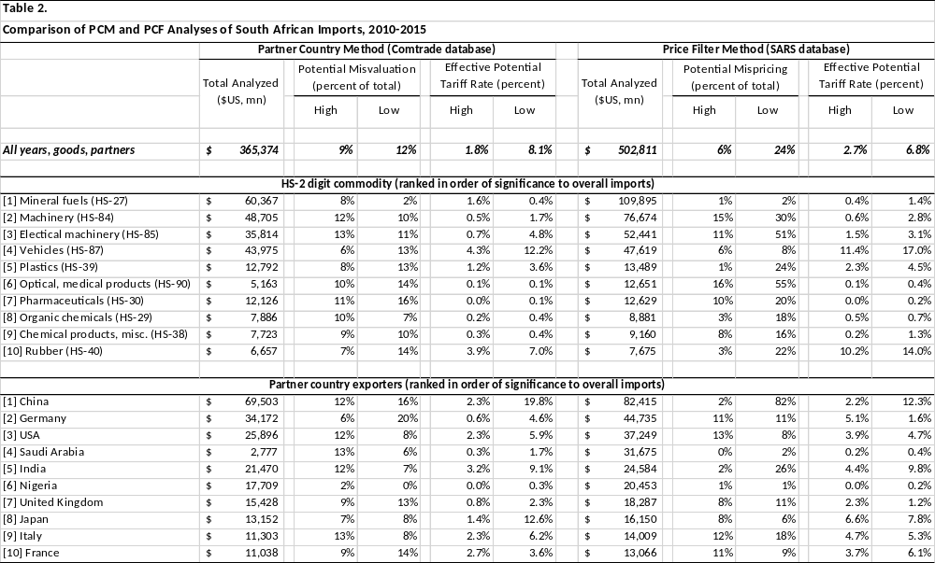
Overall, both approaches tended to identify import undervaluation as a greater risk for South Africa than overvaluation of imports (though the quantitative measurements differ). Over the entire sample, the magnitude of undervaluation in the PCM estimates (12 percent of the value of imports in the Comtrade sample) was slightly larger than the magnitude of overvaluation (9 percent of imports). The differences were even sharper in the PFM estimates: the degree to which undervalued imports fell short of the 25th percentile prices of the associated price groups averaged 24 percent of total import value in the sample, as compared with a 6 percent average excess for overvalued imports relative to the corresponding 75th percentile marks. On a qualitative basis, the two methods yielded broadly similar results across commodities and partner countries.
Significant to interpreting the results as TM, the estimates of import undervaluation appeared strongly correlated with tariff rates (as summarized by the EPTR). While the distributions of overvalued imports across commodities were relatively uncorrelated with tariff rates for both the PCM and PFM calculations, the Spearman rank correlation between the propensities for undervaluation was a significant 0.93 for both the PCM and PFM estimates.
The differences in the numerical magnitudes produced by the PCM and PFM approaches (even in propensity form) are unavoidable—they reflect fundamental differences between the techniques. Accordingly, the question of how the two methods compare in identifying TM risk can best be addressed by devising a simple rule for identifying TM risk in each case and applying the same rule to each sample of estimates.
The simple rule used here to illustrate the comparison between PCM and PFM focussed on potential import under-invoicing that might result from efforts to avoid South African import duties and tariffs: for each of 4,989 HS6-digit commodities represented in both databases, the rule flagged a trade as likely TM if both of the following two conditions hold: (1) the trade indicated a higher-than-average propensity for undervaluation and (2) the trade indicated a higher-than-average EPTR. Application of this rule independently to the PCM and PFM samples resulted in identical flagging of TM risks in about 85 percent of the trade records available (i.e., 4,227 of 4,989 records).

WORKS CITED

Carling, K. (2000). Resistant outlier rules and the non-Gaussian case. Computational Statistics & Data Analysis, 33, 249-258.

Carling, K. (2017) A reflection on outlier detection and skewed distributions. Dalarana University Working Papers in Transport, Tourism, Information Technology and Microdata Analysis, (2017:02). Retrieved from: http://www.diva-portal.org/smash/get/diva2:1150975/FULLTEXT01.pdf

ten Cate, A. (2007), Modelling the reporting discrepancies in bilateral data. CPB Memorandum, (179). Retrieved from: https://www.cpb.nl/sites/default/files/publicaties/download/memo179.pdf

Economic Commission for Latin America and the Caribbean (2016), Economic Survey of Latin America and the Caribbean, (C/G.2684-P) Santiago: United Nations, ECLAC. Retrieved from: https://repositorio.cepal.org/bitstream/handle/11362/40327/S1600797_en.pdf?sequence=50&isAllowed=y

Fortanier, F. & Sarrazin, K. (2016). Balancing international merchandise trade statistics. Organisation for Economic Co-operation and Development Statistical Directorate, Committee on Statistics and Statistical Policy, Working Party on International Trade in Goods and Services Statistics, (No. STD/CSSP/WPTGS(2016)18). Retrieved from: http://www.oecd.org/officialdocuments/publicdisplaydocumentpdf/?cote=STD/CSSP/WPTGS%282016)18&docLanguage=En

Gaulier, G. & Zignano, S. (2010). BACI: International trade database at the product-level, the 1994-2007 version. Centre d'Études Prospectives et d'Informations Internationales, Document de Travail, (No. 2010-23). Retrieved from: http://www.cepii.fr/PDF_PUB/wp/2010/wp2010-23.pdf

Rousseeuw, P. J. & Croux, C. (1993) Alternatives to the median absolute deviation. Journal of the American Statistical Association, 88 (424), 1273-1283.

ENDNOTES

6. Cross-reference of PFM and PCM : The U.S. trade with its partner countries

Philip K. Hong and Simon J. Pak

Introduction

The purpose of this study is to compare the magnitude of trade misinvoicing estimates based on the price filter method (PFM) and the partner-country method (PCM) using the U.S. Customs data for the PFM and the United Nations International Trade Statistics (UN COMTRADE) for the PCM in year 2016.
While both the PCM and the PFM attempt to estimate trade misinvoicing, they differ in the choice of arm’s length value. Ever since the PFM was first introduced in Bhagwati (1964), it has been used extensively in academic papers, in many reports from the Global Financial Integrity and in the report of the high-level panel on illicit finical flows from Africa. The PCM compares import (or export) values reported by one country with the corresponding export (or import) values reported by its partner country. By assuming partner’s trade statics as the arm’s length values, industrialized country in particular, the PCM treats the difference in the mirror statistics as the misinvoiced amount. This method requires bilateral trade statistics such as IMF’s Direction of Trade Statistics and UN COMTRADE. The critical assumption in this method is that the trade statistics of industrialized partner countries is accurate enough to be used as arm’s-length values.
However, the critical assumption that the PCM relies on has been challenged in a recent study by Hong and Pak (2017). They provide both empirical and analytical evidence that no misinvoicing assumption in partner countries (even in the advanced economy) cannot be supported, raising serious doubts about the reliability of the trade discrepancy measured by the PCM as an estimate of trade mispricing.
On the other hand, the PFM, an alternative to PCM, does not rely on the trade statistics of partner countries. The PFM relies on price filters constructed for some commodities with observable market prices and price filters constructed statistically for all other commodities using detailed trade records at the transaction level. For example, the price-filter method used in Pak and Zdanowicz (1994) assume the upper and lower quartile prices for each commodity as a range of arm’s length value in estimating the amount of misinvoicing in each trade record from the detailed U.S. merchandise trade statistics. The PFM has been used studies in de Boyrie, et. al. (2005a, 2005b) and Kar, Mammadov, Goodermote and Upadhyay (2008). The price-filter method requires a detailed transaction level trade data of a country for which the misinvoicing is to be estimated. While the PFM may be effective in detecting abnormally priced transactions, an estimate of misinvoiced amount should be treated with reservation as mentioned in the previous section, (vi)b.

Summary of Findings

This study documents a wide range of difference in the magnitude of under-invoicing and over-invoicing amount estimated by the PFM and the PCM. We do not find evidence that the PCM and the PFM provide comparable estimate of trade misinvoicing when the U.S. trade data is analyzed. The list of high risk transactions at HS 6-digit level are found different as well as the high-risk countries. Some highlights of findings during the sample period (2016) are as follows:
- The U.S. import over-invoicing amount from top 10 countries is $143 billion (11.8% of total imports from top 10 countries) based on the PFM estimation and $234 billion (20.4%) based on the PCM estimation.
- The U.S. import over-invoicing amount from China is $14 billion (4.1%) based on the PFM estimation and $101 billion (23.1%) based on the PCM estimation.
- The U.S. import of a commodity (HS6: 880240) from France is over-invoiced by $593 million (PFM) and $589 million (PCM), respectively, and both methods provide similar estimates. However, the U.S. import of a commodity (HS6: 220860) from France is over-invoiced by $86 million (PFM) and $421 million (PCM), respectively, and the magnitudes are quite different.
- The U.S. total export under-invoicing amount for a commodity (HS6: 854231) to the world is $16.6 billion (83.5% tot total exports) based on the PFM estimation and $4.1 billion (20.6%) based on the PCM estimation (Tables reported in the Appendix).
- The U.S. export of a commodity (HS6: 330490) to the U.K. is over-invoiced by $911 million (PFM) and $905 million (PCM), respectively, and both methods provide similar estimates. However, the U.S. export of a commodity (HS6: 710239) to the U.K. is over-invoiced by $283 million (PFM) and $360 million (PCM), respectively (Tables reported in the Appendix).

Data Source and Methodology

Price Filter Method

We use the U.S. trade data that is publicly available from the U.S. Census Bureau. The data is described in the earlier section ((vi)b). Each import and export record from the U.S. customs data for year 2016 is compared against statistical price filters. The upper quartile price and the lower quartile price are estimated for every commodity category (HS10 level) for the US-World pair. The price range between an upper quartile price and a lower quartile price is assumed to be the arm’s length price range. Any export or import prices that deviate from this inter-quartile range are assumed mispriced transactions. The misinvoiced amount for each transaction is calculated as follows:

US gross over-invoiced import amount | = quantity*MAX (0, M_{P} – M_{UpQ}) | (1)
US gross under-invoiced import amount | = quantity* MAX (0, M_{LoQ} - M_{P}) | (2)
US net over-/under-invoiced import amount | = (1) – (2) | (3)
US gross over-invoiced export amount | = quantity*MAX (0, X_{P} – X_{UpQ}) | (4)
US gross under-invoiced export amount | = quantity* MAX (0, M_{LoQ} - M_{P}) | (5)
US net over-/under-invoiced export amount | = (4) – (5) | (6)
, where M[X] stands for import [export], the subscript p is declared price (unit value implied in quantity and value in each trade record), LoQ is lower quartile price, and UpQ is upper quartile price. Each measure is separately calculated for the U.S. import and the U.S. export. The misinvoiced amount estimated at the HS10 level in the earlier section, vi(b), is aggregated to HS6 level so that the misinvoiced amounts estimated based on the PFM can be compared against the misinvoiced amounts based on the PCM on an equal footing. This step of aggregation was needed because the most detailed level of trade data in the UN Comtrade (for the PCM) is at the HS6 level. Once over-invoiced amount (Amt_ov) or under-invoiced amount (Amt_un) at each commodity is computed, they are aggregated by country (Table 1a and 1b) or by commodity level (Table 2a and 2b).

Partner-Country Method

We collect the reported dollar amount of import [export] by the U.S. and its partner country’s export [import] amount for year 2016 from the UN Comtrade database, the largest depository of international trade data. The UN Comtrade compiles the bilateral trade statistics by commodities/service categories and partner countries at different aggregation levels. In this study, we use the HS6 level aggregated data, the most detailed level available, and we focus on comparing U.S. import [export] statistics and its corresponding partner country’s export [import] statistics. The misinvoiced amount for each commodity (HS6) at the country pair level (i.e., US-Partner Country) is first calculated as follows:
US gross over-invoiced import amount | = Max (0, M _{US, Partner} – X _{Partner, US}) | (7)
US gross under-invoiced import amount | = -1*Min (0, M _{US, Partner} – X _{Partner, US}) | (8)
US net over-/under-invoiced import amount | = (7) – (8) | (9)
US gross over-invoiced export amount | = Max (0, X _{US, Partner} – M _{Partner, US}) | (10)
US gross under-invoiced export amount | = -1*Min (0, X _{US, Partner} – M _{Partner, US}) | (11)
US net over-/under-invoiced export amount | = (10) – (11) | (12)
, where the first subscript to M(import) or X(export) is the reporting country (i.e., U.S.) and the second subscript is a partner country. Once over- or under-invoiced amount at each commodity-country pair level is computed (used for Table 3a and 3b), they are aggregated by country (Table 1a and 1b) or by commodity level (Table 2a and 2b). The focus of our discussions is mainly on trade misinvoicing of U.S. imports.

Comparison of misinvoiced import amount estimated by the PFM and the PCM

In 2016, the U.S. had a total of 230 import partner countries according to U.S. customs data, or 223 according to UN Comtrade data. There are 4,747 (HS6, U.S. customs data) and 5,152 (HS6, UN Comtrade data) commodity groups. Due to this discrepancy in trade data reported by two agencies, we report both the dollar amount and the percentage difference in our analysis. In the appendix, we attach similar tables that are based on U.S. misinvoiced export amounts from which we draw similar inferences.

The U.S. import mispriced amount by partner country

Table 1a lists the top 10 U.S. partner countries with respect to U.S. gross over-invoiced import amount aggregated by country based on both the PFM (Formula 1) and the PCM (Formula 7). According to U.S. trade data statistics, the total U.S. imports from 230 different countries amount to $1.7 trillion in 2016. On the other hand, according to UN Comtrade data, the U.S. imports a total of $2.0 trillion from the world during the same period. The total over-invoiced U.S. import estimated based on the PFM and the PCM is $214.5 billion (12.3%) and $445.4 (21.8%), respectively, that is, the total over-invoiced import amount based on the PCM is more than double the amount based on the PFM. When we restrict the U.S. importing partner to top 10 countries, the over-invoiced import estimated based on PCM is still about 8.6% points higher than that of PFM estimates. Six countries (Ireland, Germany, Japan, China, Italy and Mexico) made the top 10 over-invoiced importing country list according to both the PFM and the PCM. However, when we examine the total over-invoiced amount by each country, the PFM and the PCM provide quite different pictures. For example, U.S. over-invoiced imports from China is $14.1 billion (or 4.1% of total imports) according to the PFM while it is $101.0 billion (or 23.1%) according to the PCM. The PCM estimate is $86.9 billion higher than the estimate by its counterpart method. However, for Ireland, the PFM estimate is $9.0 billion higher than the PCM estimate.
Table 1b lists the top 10 U.S. partner countries with respect to U.S. gross under-invoiced import amount based on both PFM (Formula 2) and PCM (Formula 8). The total under-invoiced U.S. import amount estimated based on the PFM and the PCM is $331.7billion (19.0%) and $405.3 (19.8%), respectively. When we restrict the U.S. importing partner to top 10 countries, the under-invoiced imports estimated based on PFM is 21.5% and 21.0% for PCM, which seem quite close. Five countries (China, Japan, Mexico, and Canada) made the top 10 under-invoiced importing country list according to both the PFM and the PCM. At each country level, the under-invoiced import amounts are quite different as well. The total U.S. under-invoiced imports from China are $128.5 billion (or 37.5% of total imports from China) according to the PFM while it is only $48.6 billion (or 11.1%) according to the PCM. The PFM estimate is $79.9 billion higher than the PCM estimate. However, for the Mexico case, the PCM ($52.1 billion) estimate is $29.9 billion higher than the PFM estimate ($22.2 billion).

Table 1a: The U.S. import Over-invoiced amount (Gross) in 2016 - Top 10 Partner Countries (unit: in million USD)
Price Filter Method |  |  |  |  |  | Partner-Country Method
 |  | Total Import | Amt_ov  ($) | Amt_ov (%) |  |  |  | Total Import | Amt_ov  ($) | Amt_ov  (%)
 | All 230 Ctry | $1,747,237 | $214,510 | 12.3% |  |  | All 223 Ctry | $2,043,826 | $445,445 | 21.8%
Rank | Top 10 Ctry | $1,212,796 | $142,923 | 11.8% |  | Rank | Top 10 Ctry | $1,150,674 | $234,527 | 20.4%
1 | IRELAND | 37,937 | 24,703 | 65.1% |  | 1 | CHINA | 437,742 | 101,003 | 23.1%
2 | GERMANY | 89,935 | 23,070 | 25.7% |  | 2 | MEXICO | 269,783 | 22,618 | 8.4%
3 | JAPAN | 108,571 | 16,306 | 15.0% |  | 3 | MALAYSIA | 33,939 | 17,956 | 52.9%
4 | CHINA | 343,051 | 14,118 | 4.1% |  | 4 | SAUDI ARABIA | 16,366 | 15,978 | 97.6%
5 | SWITZERLAND | 27,488 | 12,945 | 47.1% |  | 5 | IRELAND | 41,566 | 15,726 | 37.8%
6 | U.K. | 40,221 | 12,762 | 31.7% |  | 6 | FRANCE | 43,427 | 14,066 | 32.4%
7 | CANADA | 239,062 | 12,471 | 5.2% |  | 7 | JAPAN | 122,834 | 13,294 | 10.8%
8 | SOUTH KOREA | 62,496 | 9,660 | 15.5% |  | 8 | GERMANY | 105,697 | 12,236 | 11.6%
9 | ITALY | 36,223 | 8,711 | 24.1% |  | 9 | ITALY | 42,371 | 10,907 | 25.7%
10 | MEXICO | 227,811 | 8,175 | 3.6% |  | 10 | NOT SPECIFIED | 36,949 | 10,743 | 29.1%

Table 1b: The U.S. import in 2016 Under-invoiced amount (Gross) in 2016 - Top 10 Partner Countries (unit: in million USD)
Price Filter Method |  |  |  |  |  | Partner-Country Method
 |  | Total Import | Amt_un  ($) | Amt_un (%) |  |  |  | Total Import | Amt_un  ($) | Amt_un  (%)
 | All 230 Ctry | $1,747,237 | $331,696 | 19.0% |  |  | All 223 Ctry | $2,043,826 | $405,306 | 19.8%
Rank | Top 10 Ctry | $1,201,886 | $258,993 | 21.5% |  | Rank | Top 10 Ctry | $1,316,073 | $276,584 | 21.0%
1 | CHINA | 343,051 | 128,542 | 37.5% |  | 1 | MEXICO | 269,783 | 52,137 | 19.3%
2 | JAPAN | 108,571 | 23,847 | 22.0% |  | 2 | CHINA | 437,742 | 48,603 | 11.1%
3 | MEXICO | 227,811 | 22,218 | 9.8% |  | 3 | CANADA | 257,232 | 40,127 | 15.6%
4 | CANADA | 239,062 | 19,287 | 8.1% |  | 4 | HONG KONG | 6,861 | 37,192 | 542.1%
5 | SOUTH KOREA | 62,496 | 16,033 | 25.7% |  | 5 | GERMANY | 105,697 | 24,355 | 23.0%
6 | GERMANY | 89,935 | 13,347 | 14.8% |  | 6 | JAPAN | 122,834 | 21,005 | 17.1%
7 | TAIWAN | 27,299 | 12,347 | 45.2% |  | 7 | U.K. | 50,139 | 19,141 | 38.2%
8 | MALAYSIA | 26,731 | 9,036 | 33.8% |  | 8 | BELGIUM | 15,867 | 11,461 | 72.2%
9 | VIETNAM | 36,312 | 7,223 | 19.9% |  | 9 | SWITZERLAND | 33,497 | 11,300 | 33.7%
10 | INDIA | 40,618 | 7,113 | 17.5% |  | 10 | SINGAPORE | 16,421 | 11,264 | 68.6%

The U.S. import mispriced amount by Commodity (HS6 Level)

Table 2a reports the top U.S. gross over-invoiced import amount aggregated by commodity (HS6 level) based on both the PFM (Formula 1) and the PCM (Formula 7). The total over-invoiced import amount for the top 10 commodities is $78.9 billion (16.3% of total top 10 commodity imports) for the PFM and $156.4 billion (38.8%) for the PCM. The PCM estimates yield over twice as much over-invoiced amount as the PFM. Each method estimates quite different misinvoicing amounts. For example, the U.S. total over-invoiced amount for commodity with HS6 code-300490 is $36.2 billion (71.0%) for the PFM, but only $10.3 billion (22.2%) by the PCM. The PFM estimate is much higher in this case. However, the total over-invoiced amount for commodity with HS6 code-207900 is $3.8 billion (3.7%) for the PFM, but it is $41.2 billion (41.9%) for the PCM. The PCM estimate is over ten times greater than the PFM estimate.
Table 2b lists the top U.S. gross under-invoiced import amount aggregated by commodity (HS6 level) based on both the PFM (Formula 2) and the PCM (Formula 8). The total under-invoiced import amount for the top 10 commodities is $56.6 billion (33.0%) for the PFM and $67.6 billion (15.0%) for the PCM. Only two commodities made top 10 list of under-invoiced imports for the PFM and the PCM. For some commodities, the estimated under-invoiced import amount is quite different for the PFM and the PCM (e.g. HS6:870323).
Table 2a: The U.S. import Over-invoiced amount (Gross) in 2016 - Top 10 Commodities (HS6) (unit: in million USD)
Price Filter Method |  |  |  |  |  |  |  | Partner-Commodity Method
 |  | Total Import | Amt_ov ($) | Amt_ov (%) |  |  |  |  |  | Total Import | Amt_ov ($) | Amt_ov (%)
 | All Hs6 (4747) | $1,747,237 | $214,510 | 12.3% |  |  |  |  | All HS6 (5125) | $2,043,826 | $445,445 | 21.8%
Rank | Top 10 | $483,247 | $78,859 | 16.3% |  |  | Rank |  | Top 10 | $403,277 | $156,441 | 38.8%
1 | 300490 | 51,063 | 36,227 | 71.0% |  |  | 1 |  | 999999 | 78,566 | 46,513 | 59.2%
2 | 300210 | 13,493 | 7,957 | 59.0% |  |  | 2 |  | 270900 | 98,242 | 41,153 | 41.9%
3 | 870323 | 106,378 | 6,812 | 6.4% |  |  | 3 |  | 851762 | 41,647 | 17,485 | 42.0%
4 | 854231 | 20,887 | 6,150 | 29.4% |  |  | 4 |  | 854231 | 19,034 | 11,998 | 63.0%
5 | 870324 | 50,111 | 4,434 | 8.9% |  |  | 5 |  | 300490 | 46,677 | 10,345 | 22.2%
6 | 851712 | 49,797 | 4,232 | 8.5% |  |  | 6 |  | 851712 | 45,601 | 8,084 | 17.7%
7 | 270900 | 101,848 | 3,752 | 3.7% |  |  | 7 |  | 271019 | 20,940 | 6,446 | 30.8%
8 | 710239 | 62,496 | 3,452 | 15.0% |  |  | 8 |  | 950300 | 13,259 | 5,874 | 44.3%
9 | 293499 | 5,390 | 3,146 | 58.4% |  |  | 9 |  | 710239 | 21,393 | 4,338 | 20.3%
10 | 271019 | 21,785 | 2,696 | 12.4% |  |  | 10 |  | 847150 | 17,918 | 4,205 | 23.5%

Table 2b: The U.S. import Under-invoiced amount (Gross)in 2016 - Top 10 Commodities (HS6) (unit: in million USD)
Price Filter Method |  |  |  |  |  | Partner-Commodity Method
 |  | Total Import | Amt_un ($) | Amt_un (%) |  |  |  | Total Import | Amt_un ($) | Amt_un (%)
 | All HS6 (4747) | $1,747,237 | $331,696 | 19.0% |  |  | All HS6 (5125) | $2,043,826 | $405,306 | 19.8%
Rank | Top 10 | $171,346 | $ 56,620 | 33.0% |  | Rank | Top 10 | $ 451,600 | $67,606 | 15.0%
1 | 293500 | 4,185 | 7,814 | 186.7% |  | 1 | 870323 | 97,864 | 13,153 | 13.0%
2 | 854140 | 10,737 | 7,550 | 70.3% |  | 2 | 300490 | 46,677 | 9,461 | 20.0%
3 | 902750 | 1,181 | 6,478 | 548.4% |  | 3 | 999999 | 78,566 | 7,706 | 10.0%
4 | 870899 | 13,356 | 5,945 | 44.5% |  | 4 | 300210 | 12,297 | 7,081 | 58.0%
5 | 853710 | 9,914 | 5,905 | 59.6% |  | 5 | 841191 | 11,074 | 5,734 | 52.0%
6 | 870323 | 106,378 | 5,039 | 4.7% |  | 6 | 711319 | 6,355 | 5,277 | 83.0%
7 | 284440 | 530 | 4,878 | 920.0% |  | 7 | 880330 | 13,277 | 5,059 | 38.0%
8 | 901320 | 650 | 4,470 | 687.4% |  | 8 | 851762 | 41,647 | 5,017 | 12.0%
9 | 880330 | 14,406 | 4,331 | 30.1% |  | 9 | 270900 | 98,242 | 4,846 | 5.0%
10 | 847170 | 10,009 | 4,210 | 42.1% |  | 10 | 851712 | 45,601 | 4,272 | 9.0%

The U.S. import mispriced amount by Commodity within the Country

Table 3a (Table 3b) reports the U.S. net over-invoiced (under-invoiced) import amount aggregated by commodity (HS6 level) based on the PFM (Formula 3) and the PCM (Formula 9) within the selected country. The selected country is one of the countries found in the top 10 list of both the PFM and the PCM from Table 1. The reported trade amount at the country-commodity (H6) level available in the UN Comrade data for the PCM is already netted (i.e. the over- and under- invoiced individual transactions are aggregated). To be a fair comparison, we use the netted over- and under-invoiced amount for the PFM as well.
In Table 3a, we select the top 10 U.S. net under-invoiced import amount aggregated by commodity (HS6 level) from France. The total top 10 estimated over-invoiced U.S. imports from France by commodity are $2.1 billion (29.1%) for the PFM and $8.3 (51.2%) for the PCM, respectively, that is, the total over-invoiced import amount based on the PCM is about 22% points higher than that of the PFM. Four commodities in the top 10 lists of both methods show mixed estimates.
In Table 3b, we select the top 10 U.S. net under-invoiced import amount aggregated by commodity (HS6 level) from Mexico. The total top 10-estimated under-invoiced U.S. import from Mexico by commodity is $8.1 billion (40.4%) for the PFM and $15.5 (83.8%) for the PCM, respectively, that is, the total net under-invoiced import amount based on the PCM is about 43.4% points higher than that of the PFM. However, none of the top 10 commodities from the PFM list is found in the PCM top 10-commodity list.
Table 3a: The U.S. import Over-invoiced amount (Net) in 2016 - Top 10 Commodities within Country (unit: in million USD)
Price Filter Method |  |  |  |  |  |  | Partner-Country Method
 |  |  | Total Import | Amt_net ($) | Amt_net (%) |  |  |  |  |  | Total Import | Amt_net ($) | Amt_net (%)
Rank | Country | Top 10 | $7,166 | $2,084 | 29.1% |  | Rank | Country | Top |  | $16,126 | $8,253 | 51.2%
7 | FRANCE | 880240 | 3,209 | 593 | 18.5% |  | 6 | FRANCE |  | 999999 | 3,747 | 2,913 | 77.7%
7 | FRANCE | 300490 | 1,206 | 410 | 34.0% |  | 6 | FRANCE |  | 970110 | 1,819 | 1,627 | 89.4%
7 | FRANCE | 711319 | 245 | 208 | 84.8% |  | 6 | FRANCE |  | 711319 | 736 | 649 | 88.1%
7 | FRANCE | 220421 | 963 | 186 | 19.4% |  | 6 | FRANCE |  | 841191 | 3,464 | 639 | 18.4%
7 | FRANCE | 853710 | 202 | 156 | 77.4% |  | 6 | FRANCE |  | 330300 | 1,103 | 609 | 55.2%
7 | FRANCE | 420221 | 208 | 124 | 59.6% |  | 6 | FRANCE |  | 880240 | 2,920 | 589 | 20.2%
7 | FRANCE | 292250 | 114 | 112 | 98.1% |  | 6 | FRANCE |  | 220860 | 614 | 421 | 68.6%
7 | FRANCE | 854239 | 151 | 108 | 71.8% |  | 6 | FRANCE |  | 300490 | 1,116 | 325 | 29.1%
7 | FRANCE | 293339 | 198 | 100 | 50.4% |  | 6 | FRANCE |  | 901420 | 437 | 313 | 71.7%
7 | FRANCE | 220860 | 670 | 86 | 12.9% |  | 6 | FRANCE |  | 870130 | 169 | 169 | 99.8%

Table 3b: The U.S. import Under-invoiced amount (Net) in 2016 -Top 10 Commodities within Country (unit: in million USD)
Price Filter Method |  |  |  |  |  |  | Partner-Country Method
 |  |  | Total Import | Amt_net ($) | Amt_net (%) |  |  |  |  |  | Total Import | Amt_net ($) | Amt_net (%)
Rank | Country | Top 10 | $20,020 | $8,088 | 40.4% |  | Rank | Country | Top |  | $18,515 | $15,514 | 83.8%
2 | MEXICO | 870323 | 17,970 | 1,328 | 7.4% |  | 3 | MEXICO |  | 847149 | 556 | 3,909 | 703.0%
2 | MEXICO | 902750 | 15 | 1,291 | 8822.7% |  | 3 | MEXICO |  | 870850 | 1,488 | 1,709 | 115.0%
2 | MEXICO | 851761 | 57 | 1,196 | 2099.6% |  | 3 | MEXICO |  | 870333 | 1 | 1,655 | 9999.9%+
2 | MEXICO | 848340 | 120 | 900 | 748.8% |  | 3 | MEXICO |  | 851770 | 775 | 1,600 | 206.0%
2 | MEXICO | 853610 | 160 | 807 | 503.7% |  | 3 | MEXICO |  | 854231 | 38 | 1,548 | 4112.0%
2 | MEXICO | 842890 | 701 | 669 | 95.5% |  | 3 | MEXICO |  | 710813 | 135 | 1,145 | 846.0%
2 | MEXICO | 850440 | 710 | 649 | 91.4% |  | 3 | MEXICO |  | 854430 | 6,436 | 1,106 | 17.0%
2 | MEXICO | 843629 | 1 | 584 | 9999.9%+ |  | 3 | MEXICO |  | 847130 | 413 | 998 | 242.0%
2 | MEXICO | 841410 | 147 | 333 | 226.3% |  | 3 | MEXICO |  | 852872 | 7,936 | 995 | 13.0%
2 | MEXICO | 841950 | 139 | 331 | 238.2% |  | 3 | MEXICO |  | 852871 | 738 | 850 | 115.0%

Appendix

The impact of C.I.F. factor

Exports are reported in f.o.b. for all countries and imports are reported in c.i.f. for most of the countries except few countries reporting imports on the f.o.b. basis. Therefore, import values in c.i.f. are typically converted to f.o.b. values using a conversion factor to account for insurance and freight when the Partner-Country method is used. In this study we use a conversion factor of 1.10 to convert import values from c.i.f. to f.o.b. as used in most other studies (e.g. IMF1993; Naya and Morgan 1969; Buehn and Eichler 2011). However, according to the U.S. import data for 2016, the average cost of insurance and freight is 2.2% between the U.S. and European countries and 4.81% between the U.S. and South American countries while the overall average cost of insurance and freight between the U.S. and all other partner countries is 2.8%. To check for robustness, we also usea specific conversion factor for each trade (i.e., between 1.26% and 4.81%). Tables 1aa and 1bb compares misinvoiced U.S. import amount based on the PCM method: one estimated using the same c.i.f. factor of 1.10 across all partner countries and the other estimated based on a country specific c.i.f. factor. As expected, the overall over-invoiced import amount increases when the smaller c.i.f. factor is used, but the under-invoiced import amount decreases. The ranking of over- or under-invoiced amount by country slightly changes, however, our inferences do not change with this alternative conversion factor.
Table 1aa: The U.S. import Over-invoiced amount (Gross) in 2016 - Top 10 Partner Countries (unit: in million USD)
PCM (constant c.i.f. factor, 1.10) |  |  |  |  |  | PCM (country-specific c.i.f. factor, 1.0126 to 1.0481)
 |  | Total Import | Amt_ov  ($) | Amt_ov (%) |  |  | Country | Total Import | Amt_ov  ($) | Amt_ov  (%)
Rank | Top 10 Ctry | $1,150,674 | $234,527 | 20.4% |  | Rank | Top 10 Ctry | $1,232,716 | $285,307 | 23.1%
1 | CHINA | 437,742 | 101,003 | 23.1% |  | 1 | CHINA | 465,458 | 121,947 | 26.2%
2 | MEXICO | 269,783 | 22,618 | 8.4% |  | 2 | MEXICO | 293,069 | 33,813 | 11.5%
3 | MALAYSIA | 33,939 | 17,956 | 52.9% |  | 3 | MALAYSIA | 36,088 | 19,876 | 55.1%
4 | SAUDI ARABIA | 16,366 | 15,978 | 97.6% |  | 4 | IRELAND | 44,730 | 17,962 | 40.2%
5 | IRELAND | 41,566 | 15,726 | 37.8% |  | 5 | SAUDI ARABIA | 17,402 | 17,010 | 97.7%
6 | FRANCE | 43,427 | 14,066 | 32.4% |  | 6 | JAPAN | 130,611 | 16,946 | 13.0%
7 | JAPAN | 122,834 | 13,294 | 10.8% |  | 7 | FRANCE | 46,732 | 16,673 | 35.7%
8 | GERMANY | 105,697 | 12,236 | 11.6% |  | 8 | GERMANY | 113,742 | 15,571 | 13.7%
9 | ITALY | 42,371 | 10,907 | 25.7% |  | 9 | ITALY | 45,596 | 13,069 | 28.7%
10 | NOT SPECIFIED | 36,949 | 10,743 | 29.1% |  | 10 | NOT SPECIFIED | 39,289 | 12,440 | 31.7%

Table 1bb: The U.S. import Under-invoiced amount (Gross) in 2016 - Top 10 Partner Countries (unit: in million USD)
PCM (constant c.i.f. factor, 1.10) |  |  |  |  |  | PCM (country-specific c.i.f. factor, 1.0126 to 1.0481)
 |  | Total Import | Amt_un  ($) | Amt_un (%) |  |  |  | Total Import | Amt_un  ($) | Amt_un  (%)
Rank | Top 10 Ctry | $1,316,073 | $276,584 | 21.0% |  | Rank | Top 10 Ctry | $1,411,333 | $225,489 | 16.0%
1 | MEXICO | 269,783 | 52,137 | 19.3% |  | 1 | CHINA | 465,458 | 41,831 | 9.0%
2 | CHINA | 437,742 | 48,603 | 11.1% |  | 2 | MEXICO | 293,069 | 40,046 | 13.7%
3 | CANADA | 257,232 | 40,127 | 15.6% |  | 3 | HONG KONG | 7,296 | 36,935 | 506.3%
4 | HONG KONG | 6,861 | 37,192 | 542.1% |  | 4 | CANADA | 276,621 | 21,216 | 7.7%
5 | GERMANY | 105,697 | 24,355 | 23.0% |  | 5 | GERMANY | 113,742 | 19,646 | 17.3%
6 | JAPAN | 122,834 | 21,005 | 17.1% |  | 6 | U.K. | 53,955 | 17,192 | 31.9%
7 | U.K. | 50,139 | 19,141 | 38.2% |  | 7 | JAPAN | 130,611 | 16,880 | 12.9%
8 | BELGIUM | 15,867 | 11,461 | 72.2% |  | 8 | BELGIUM | 17,074 | 11,006 | 64.5%
9 | SWITZERLAND | 33,497 | 11,300 | 33.7% |  | 9 | SINGAPORE | 17,461 | 10,784 | 61.8%
10 | SINGAPORE | 16,421 | 11,264 | 68.6% |  | 10 | SWITZERLAND | 36,047 | 9,953 | 27.6%

The U.S. export mispriced amount by country
Table 4a: The U.S. export Over-invoiced amount (Gross) in 2016 - Top 10 Partner Countries (unit: in million USD)
Price Filter Method |  |  |  |  |  | Partner-Country Method
 |  | Total Export | Amt_ov  ($) | Amt_ov (%) |  |  |  | Total Export | Amt_ov  ($) | Amt_ov  (%)
 | All 230 Ctry | $989,407 | $113,843 | 11.5% |  |  | All 223 Ctry | $1,450,457 | $554,493 | 38.2%
Rank | Top 10 Ctry | $671,598 | $59,998 | 8.9% |  | Rank | Top 10 Ctry | $890,263 | $316,132 | 35.5%
1 | CHINA | 84,743 | 8,278 | 9.8% |  | 1 | CANADA | 266,765 | 81,934 | 30.7%
2 | JAPAN | 41,742 | 6,988 | 16.7% |  | 2 | MEXICO | 229,702 | 72,640 | 31.6%
3 | CANADA | 195,236 | 6,698 | 3.4% |  | 3 | CHINA | 115,602 | 33,473 | 29.0%
4 | SOUTH KOREA | 31,019 | 6,143 | 19.8% |  | 4 | U.K. | 55,280 | 30,140 | 54.5%
5 | U.K. | 30,466 | 6,131 | 20.1% |  | 5 | HONG KONG | 34,872 | 18,926 | 54.3%
6 | BELGIUM | 24,280 | 6,119 | 25.2% |  | 6 | JAPAN | 63,234 | 18,165 | 28.7%
7 | MEXICO | 158,231 | 5,875 | 3.7% |  | 7 | FRANCE | 32,618 | 17,527 | 53.7%
8 | GERMANY | 62,496 | 4,888 | 16.7% |  | 8 | NETHERLANDS | 39,683 | 15,979 | 40.3%
9 | NETHERLANDS | 25,437 | 4,870 | 19.2% |  | 9 | UNITED ARAB EMIR. | 22,400 | 14,007 | 62.5%
10 | TAIWAN | 17,948 | 4,008 | 22.3% |  | 10 | BRAZIL | 30,107 | 13,341 | 44.3%

Table 4b: The U.S. export Under-invoiced amount (Gross) in 2016 - Top 10 Partner Countries (unit: in million USD)
Price Filter Method |  |  |  |  |  | Partner-Country Method
 |  | Total export | Amt_un ($) | Amt_un (%) |  |  |  | Total export | Amt_un ($) | Amt_un (%)
 | All 230 Ctry (230) | $989,407 | $362,724 | 36.7% |  |  | All 223 Ctry (223) | $1,450,457 | $264,492 | 18.2%
Rank | Top 10 Ctry | $630,893 | $306,176 | 48.5% |  | Rank | Top 10 Ctry | $465,430 | $143,579 | 30.8%
1 | FRANCE | 12,718 | 184,105 | 1447.6% |  | 1 | CHINA | 115,602 | 28,350 | 24.5%
2 | MEXICO | 158,231 | 49,642 | 31.4% |  | 2 | GERMANY | 49,165 | 21,807 | 44.4%
3 | JAPAN | 41,742 | 26,083 | 62.5% |  | 3 | U.K. | 55,280 | 19,274 | 34.9%
4 | CANADA | 195,236 | 16,267 | 8.3% |  | 4 | FRANCE | 32,618 | 17,909 | 54.9%
5 | CHINA | 84,743 | 8,481 | 10.0% |  | 5 | JAPAN | 63,234 | 14,730 | 23.3%
6 | GERMANY | 29,222 | 4,697 | 16.1% |  | 6 | SINGAPORE | 26,692 | 10,654 | 39.9%
7 | SOUTH KOREA | 31,019 | 4,599 | 14.8% |  | 7 | SOUTH KOREA SOUTH | 42,308 | 8,347 | 19.7%
8 | U.K. | 30,466 | 4,321 | 14.2% |  | 8 | UN. ARAB EMIR. | 22,400 | 7,667 | 34.2%
9 | HONG KONG | 22,078 | 4,305 | 19.5% |  | 9 | BELGIUM | 32,094 | 7,493 | 23.3%
10 | NETHERLANDS | 25,437 | 3,676 | 14.5% |  | 10 | NOT SEPCIFIED | 26,037 | 7,349 | 28.2%

The U.S. export mispriced amount by commodity (HS6 Level)
Table 5a: The U.S. export Over-invoiced amount (Gross) in 2016 – Top 10 Commodities (unit: in million USD)
Price Filter Method |  |  |  |  |  | Partner-Commodity Method
 |  | Total export | Amt_ov ($) | Amt_ov (%) |  |  |  | Total export | Amt_ov ($) | Amt_ov (%)
 | All Hs6 (4747) | $989,407 | $113,843 | 11.5% |  |  | All HS6 (5125) | $1,450,457 | $554,493 | 38.2%
Rank | Top 10 | $233,245 | $33,411 | 14.3% |  | Rank | Top 10 | $331,570 | $224,519 | 67.7%
1 | 300490 | 18,816 | 6,371 | 33.9% |  | 1 | 999999 | 161,070 | 140,332 | 87.1%
2 | 300210 | 16,060 | 6,002 | 37.4% |  | 2 | 710239 | 18,845 | 16,081 | 85.3%
3 | 710239 | 18,846 | 5,223 | 27.7% |  | 3 | 847330 | 15,501 | 12,951 | 83.6%
4 | 854231 | 19,851 | 4,687 | 23.61`% |  | 4 | 271019 | 37,652 | 10,987 | 29.2%
5 | 848620 | 8,841 | 2,596 | 29.4% |  | 5 | 851762 | 18,856 | 10,092 | 53.5%
6 | 870323 | 21,941 | 2,434 | 11.1% |  | 6 | 854231 | 19,849 | 7,815 | 39.4%
7 | 854239 | 9,289 | 2,170 | 23.4% |  | 7 | 851712 | 9,897 | 7,710 | 77.9%
8 | 847150 | 62,496 | 1,533 | 24.8% |  | 8 | 710812 | 17,516 | 6,676 | 38.1%
9 | 870324 | 18,546 | 1,276 | 6.9% |  | 9 | 970110 | 8,116 | 6,375 | 78.5%
10 | 271019 | 38,561 | 1,119 | 2.9% |  | 10 | 271012 | 24,268 | 5,500 | 22.7%

Table 5b: The U.S. export Under-invoiced amount (Gross) in 2016 - Top 10 Commodities (unit: in million USD)
Price Filter Method |  |  |  |  |  | Partner-Commodity Method
 |  | Total export | Amt_un ($) | Amt_un (%) |  |  |  | Total export | Amt_un ($) | Amt_un (%)
 | All HS6 (4747) | $989,407 | $362,724 | 36.7% |  |  | All HS6 (5125) | $1,450,457 | $264,492 | 18.2%
Rank | Top 10 | $136,982 | $249,855 | 182.4% |  | Rank | Top 10 | $94,674 | $99,968 | 105.6%
1 | 841181 | 240 | 182,003 | 9999.9%+ |  | 1 | 841191 | 1,460 | 24,705 | 1691.8%
2 | 290919 | 2,060 | 22,260 | 1080.7% |  | 2 | 880330 | 5,495 | 17,393 | 316.5%
3 | 854231 | 19,851 | 16,569 | 83.5% |  | 3 | 841112 | 345 | 15,423 | 4468.3%
4 | 848180 | 5,900 | 8,550 | 144.9% |  | 4 | 300490 | 19,174 | 13,797 | 72.0%
5 | 848280 | 125 | 4,383 | 3518.8% |  | 5 | 300210 | 15,872 | 6,538 | 41.2%
6 | 271019 | 38,561 | 4,105 | 10.6% |  | 6 | 854239 | 9,117 | 6,323 | 69.3%
7 | 300490 | 18,816 | 3,958 | 21.0% |  | 7 | 710813 | 150 | 4,578 | 3060.0%
8 | 271012 | 25,453 | 2,795 | 11.0% |  | 8 | 854231 | 19,849 | 4,079 | 20.6%
9 | 300210 | 16,060 | 2,680 | 16.7% |  | 9 | 870323 | 21,928 | 3,629 | 16.6%
10 | 851712 | 9,917 | 2,552 | 25.7% |  | 10 | 854290 | 1,285 | 3,503 | 272.7%

The U.S. export mispriced amount by commodity within the country
Table 6a: The U.S. export Over-Invoiced amount (Net) in 2016 - Top 10 Commodities within Country (unit: in million USD)
Price Filter Method |  |  |  |  |  |  | Partner-Country Method
 |  |  | Total Export | Amt_net ($) | Amt_net (%) |  |  |  |  |  | Total Export | Amt_net ($) | Amt_net (%)
Rank | Country | Top 10 HS6 | $5,371 | $2,631 | 49.0% |  | Rank | Country | Top 10 HS6 |  | $25,482 | $22,415 | 88.0%
1 | U.K. | 300490 | 1,927 | 911 | 47.3% |  | 4 | U.K. |  | 999999 | 13,124 | 12,435 | 94.8%
1 | U.K. | 300210 | 1,103 | 649 | 58.9% |  | 4 | U.K. |  | 710812 | 3,886 | 3,886 | 100.0%
1 | U.K. | 710239 | 463 | 283 | 61.0% |  | 4 | U.K. |  | 970110 | 2,336 | 1,873 | 80.2%
1 | U.K. | 870840 | 401 | 254 | 63.3% |  | 4 | U.K. |  | 300490 | 1,993 | 905 | 45.4%
1 | U.K. | 870323 | 302 | 164 | 54.2% |  | 4 | U.K. |  | 870332 | 835 | 835 | 100.0%
1 | U.K. | 847150 | 265 | 96 | 36.4% |  | 4 | U.K. |  | 870333 | 812 | 810 | 99.7%
1 | U.K. | 847149 | 131 | 83 | 63.0% |  | 4 | U.K. |  | 300210 | 1,138 | 609 | 53.6%
1 | U.K. | 870324 | 270 | 74 | 27.5% |  | 4 | U.K. |  | 711319 | 595 | 404 | 67.8%
1 | U.K. | 380891 | 67 | 59 | 87.8% |  | 4 | U.K. |  | 710239 | 463 | 360 | 77.8%
1 | U.K. | 490199 | 440 | 58 | 13.1% |  | 4 | U.K. |  | 870323 | 301 | 298 | 99.0%

Table 6b: The U.S. import Under-Invoiced amount (Net) in 2016 - Top 10 Commodities within Country (unit: in million USD)
Price Filter Method |  |  |  |  |  |  | Partner-Country Method
 |  |  | Total Export | Amt_net ($) | Amt_net (%) |  |  |  |  | Total Export | Amt_net ($) | Amt_net (%)
Rank | Country | Top 10 HS6 | $1,799 | $182,916 | 10164.8% |  | Rank | Country | Top 10 HS6 | $1,042 | $12,297 | 1179.8%
1 | FRANCE | 841181 | 2 | 181,986 | 9999.9%+ |  | 8 | FRANCE | 880330 | 59 | 3,530 | 6000.0%
1 | FRANCE | 271019 | 1,396 | 317 | 22.7% |  | 8 | FRANCE | 841191 | 45 | 3,328 | 7409.0%
1 | FRANCE | 293499 | 64 | 219 | 341.8% |  | 8 | FRANCE | 841112 | 0 | 2,076 | 9999.9%+
1 | FRANCE | 848280 | 3 | 92 | 3577.7% |  | 8 | FRANCE | 300490 | 499 | 1,446 | 290.0%
1 | FRANCE | 391910 | 8 | 77 | 920.7% |  | 8 | FRANCE | 294190 | 66 | 507 | 773.0%
1 | FRANCE | 810890 | 234 | 59 | 25.4% |  | 8 | FRANCE | 300210 | 208 | 507 | 243.0%
1 | FRANCE | 330290 | 35 | 50 | 141.8% |  | 8 | FRANCE | 901890 | 95 | 341 | 358.0%
1 | FRANCE | 360300 | 2 | 42 | 2433.1% |  | 8 | FRANCE | 854232 | 37 | 214 | 586.0%
1 | FRANCE | 848220 | 39 | 38 | 99.4% |  | 8 | FRANCE | 901839 | 31 | 174 | 566.0%
1 | FRANCE | 850720 | 17 | 36 | 208.7% |  | 8 | FRANCE | 880320 | 3 | 173 | 5161.0%

Bibliography

Ajayi, M.S.I., 1997. An analysis of external debt and capital flight in the severely indebted low income countries in sub-Saharan Africa.International Monetary Fund.
United Nations.Economic Commission for Africa (AUC/ECA), 2015. Illicit financial flow: report of the High Level Panel on illicit financial flows from Africa.
Baker, R., 2014. Hiding in Plain Sight: Trade Misinvoicing and the Impact of Revenue Loss in Ghana, Kenya, Mozambique, Tanzania, and Uganda: 2002-2011. Global Financial Integrity.
Buehn, A., and Eichler, S. 2011. Trade Misinvoicing: The Dark Side of World Trade. The World Economy 34(8): 1263-1287.
Bhagwati, J., 1964. On the Underinvoicing of Imports," Bulletin of the Oxford University Institute of Economics and Statistics, 26, pp.389-397.
Boyce, J., 1990. The political economy of external indebtedness. A case study of the Philippines.Institute of Development Studies.
Boyce, J.K. and Ndikumana, L., 2001. Is Africa a net creditor? New estimates of capital flight from severely indebted sub-Saharan African countries, 1970-96. Journal of Development Studies, 38(2), pp.27-56.
Buehn, A. and Eichler, S., 2011. Trade misinvoicing: the dark side of world trade. The World Economy, 34(8), pp.1263-1287.
Chang, K.P. and Cumby, R.E., 1991. Capital flight in sub-Saharan African countries. African External Finance in the 1990s. Washington, DC: World Bank, pp.162-85.
deBoyrie, M.E., Pak, S.J. and Zdanowicz, J.S., 2005a. The impact of Switzerland’s money laundering law on capital flows through abnormal pricing in international trade. Applied Financial Economics, 15, pp. 217–230.
deBoyrie, M.E., Pak, S.J. and Zdanowicz, J.S., 2005b. Estimating the magnitude of capital flight due to abnormal pricing in international trade: The Russia-USA case.Accounting Forum, 29, pp 249-270.
Gaulier, G. and Zignago, S., 2010. BACI: international trade database at the product-level (the 1994-2007 version).
Gulati, S. K., 1987. A note on trade misinvoicing.in Donald Lessard and John Williamson (Eds.), Capital Flight and Third World Debt. Washington, DC: Institute for International Economics, pp. 68- 78.
Dong, G., 2010. Mirror Statistics of International Trade in Manufacturing Goods: The Case of China. United Nations Industrial Development Organization.
Eurostat, 1998. Statistics on the trading of goods - User guide, Office for Official Publications of the European Communities, Luxembourg.
Eurostat, 2006.Statistics on the trading of goods – User guide. Office for Official Publications of the European Communities, Luxembourg.
Eurostat, 2009.MEDSTAT II: Asymmetry in foreign trade statistics in Mediterranean partner countries
Hong, K. P., and S.J. Pak, 2017. Estimating Trade Misinvoicing from Bilateral Trade Statistics: The Devil is in the Details. The International Trade Journal, 31(1), pp 3-28.
Hong, K., Pak, C.H. and Pak, S.J., 2014. Measuring abnormal pricing – An alternative approach.The case of U.S. banana trade with Latin American and Caribbean Countries.Journal of Money Laundering Control, 17(2), pp 203-218.
International Monetary Fund, 1993.A guide to direction of trade statistics on CD-Rom and at http://www.imf.org/external/pubs/cat/longres.cfm?sk=154.0.
Kar, D., Mammadov, R., Goodermote, R. and Upadhyay, J., 2008. Capital flight from the democratic republic of Congo.”Global Financial Integrity. Washington, D.C.
Kar, D. and Cartwright-Smith, D., 2008.Illicit financial flows from developing countries: 2002-2006.Global Financial Integrity. Washington, D.C.
Kar, D. and Cartwright-Smith, D., 2010.Illicit financial flows from Africa: Hidden resources for development. Global Financial Integrity. Washington, D.C.
Kar, D., 2014. Brazil: Capital flight, illicit flows, and macroeconomic crises, 1960-2012. Global Financial Integrity. Washington, D.C.
Morgenstern, O., 1950. On the accuracy of economic observations: Foreign trade statistics. The Accuracy of Economic Observations.Princeton University Press, Princeton, N.J.
Naya, S. and Morgan, T., 1969. The accuracy of international trade data: the case of Southeast Asian countries. Journal of the American Statistical Association, 64(326), pp.452-467.
Ndikumana, L. and Boyce, J., 1998. Congo's odious debt: external borrowing and capital flight in Zaire. Development and Change, 29(2), pp.195-217.
Ndikumana, L. and Boyce, J., 2008. New estimates of capital flight from Sub-Saharan African countries: linkages with external borrowing and policy options. . Political Economy Research Institute Working Papers.University of Massachusetts Amherst.
Ndikumana, L. and Boyce, J., 2012. Capital flight from North African countries. Political Economy Research Institute Working Papers. University of Massachusetts Amherst
Pak, S., 2012. Lost billions: Transfer pricing in the extractive industries: Estimates of mispricing in crude oil import - The European Union and the United States, 2000-2010. Publish What You Pay Norway. January 2012 ISBN 978-82-93212-04-1.
Pak, S. and Zdanowicz, J.S., 1994.A statistical analysis of the US merchandise trade database and its uses in transfer pricing compliance and enforcement. Tax Management Transfer Pricing, 11, pp.50-57.
Patnaik, I., Gupta, A.S. and Shah, A., 2012. Determinants of trade misinvoicing. Open Economies Review, 23(5), pp.891-910.
Rozanski, J. and Yeats, A., 1994. On the (in) accuracy of economic observations: An assessment of trends in the reliability of international trade statistics. Journal of Development Economics, 44(1), pp.103-130.
Yeats, A.J., 1978. On the Accuracy of partner country trade statistics.Oxford Bulletin of Economics and Statistics, 40(4), pp.341-361.
Yeats, A.J., 1990. On the accuracy of economic observations: Do sub-Saharan trade statistics mean anything? The World Bank Economic Review, 4(2), pp.135-156.
ENDNOTES

7. Cross-reference of PFM and PCM: 3 case studies

Yeon Soo CHOI, Etim IBOK and Frank KALIZINJE

Introduction

Spotting the trade mis-invoicing as a main channel of Illicit Financial Flows (IFFs), empirical research has tried to estimate the magnitude of trade mis-invoicing. For the estimation, they analyzed the discrepancy in trade statistics between importing countries and exporting countries (PCM; Partner Country Method or Mirror Data Analysis), or analyzed the value of trade transactions unit price of which are too low or too high compared to those of the same goods (PFM; Price Filter Method or Unit Price Analysis).
The high estimates from these two methods attracted not only global attention but also heavy criticism for their methodological limitations such as; trade discrepancy may arise simply from legitimate reasons in aggregating trade statistics; and the criteria of “being too low or too high” is arbitrary.
In order to verify the reliability of PFM and PCM despite their methodological limitations, this research employed both methods to the same trade data, and checked whether their estimates of trade mis-invoicing are similar to each other. Then, it also checked whether suspicious trade transactions identified by PFM are similar to those identified by PCM. This research was possible thanks to the WCO Members who shared transaction level trade data for this research.
Key findings are as follows;
- For the magnitude of trade mis-invocing, PFM and PCM presented different estimates for the same trade data across the methods. Even within the same method and the same trade data, the estimates ranged widely according to the analysis assumptions.
- However, cross-referencing PFM and PCM was very effective in identifying high-risky trade transactions suspected of mis-invoicing. For the question of “which trade transactions are more suspected of mis-invoicing?”, both methods presented significantly similar lists of trade transactions even in a similar order. These suspicious trade transactions should be researched with other available risk indicators by Customs authorities or relevant law enforcement agencies.

Overview of PCM and PFM

Partner Country Method

Concept
By comparing a country’s trade data with mirrored data (reported by trade partners), PFM estimates the magnitude of trade mis-invoicing of the country. It assumes that trade partner’s statistics are accurate.
Advantages
- Owing to the technical development of trade statistics, mirrored trade data at the HS code 6-digit level could be acquired from international organizations. While it is not a common practice due to the secrecy of data, some countries share their transaction level trade data with trade partners.
- Publicly available world trade data enabled cross-national comparison and longitudinal survey over time.
- Bhagwati (1964), Fisman and Wei (2004), Kellenberg and Levinson (2016), Choi (2018) suggested that the size of trade discrepancies is correlated with tariff, exporter’s GDP, auditing and accounting standards, corruption and import controls, gap in direct tax burden between trading countries. These correlations imply that, at least, some parts of trade discrepancies could be explained by trade mis-invoicing for illicit motives.

Limitations
- Trade discrepancies could arise simply from logistics and statistical reasons. Empirical research on bilateral trade discrepancy presented that up to 85% were explained by the different attribution of trade partners (due to transit or indirect trade), trade recording system (Customs free zone), CIF/FOB valuation, time-lag, currency conversion, confidential trade, etc.
- The underlying assumption that trade partners’ statistics are accurate is not robust. Kellenberg& Levinson (2016) and Hong & Pak (2016) evidenced that there are trade statistics discrepancies even in the trade between advanced countries.
- Nitsch (2017) suggested that different HS classification for the same goods between importers and exporters may inflate the PCM estimates. In contrast, aggregating trade data from transaction level into country-pair level may cancel out over-invoicing transactions with under-invoicing transactions, deflating the PCM estimates.

Price Filter Method

Concept
Based on the statistical distribution of unit price of goods from transaction level trade data (normally from Customs authorities), PCM set a lower bound and upper bound for each product category (e.g. HS10 digit code). Trade transaction the unit prices of which are outside the lower and upper bound are regarded as suspicious of trade mis-invoicing. For each suspicious trade transaction, the difference between its unit price and the lower (or upper) bound multiplied by the quantity is the estimated value of the under- (or over-) invoicing.
Advantages
- With its own trade statistics, a country can analyze trade mis-invoicing (Boyrie, Nelson & Pak, 2007).
Limitations (Hong, Cabrini Pak and Simon Pak, 2014)
- Setting lower and upper bound for normal unit price is somewhat arbitrary.
- In case of products with highly heterogeneous sub-categories or products which prices are sensitive to natural/business environments, PFM may wrongly identify trade mis-invoicing.
- Trade mis-invoicing with small extent but large quantity may not be detected by PFM despite its substantial total amount.

Data and Methodology

Data

Transaction level trade data for PFM
For this research, two WCO Members shared their transaction level trade data; 1) the import data of country A in 2012-2014, 2) the import data of country B in 2015-2016 and 3) the export data of country B in 2015-2016. With the three data sets, this research employed PFM to detect the trade transactions suspicious of trade mis-invoicing, and estimated the magnitude of trade mis-invoicing.
Aggregated trade data by partner country and HS 6-digit code for PCM
In order to employ PCM with the three data sets, trade data of partner countries were sourced from the UN COMTRADE (https://comtrade.un.org/data/) at the HS code 6-digit level.

Methodology

PFM

Unit price
For each trade transaction, unit price was calculated;
- Unit price = Trade value / Quantity

Normal unit price range
Goods belonging to the same HS code (10-digit in country A and at 8-digit in country B) were regarded as the same goods. For each HS10 code, a lower bound and an upper bound of normal (acceptable) unit price range were set as follows;
- Lower bound is the unit price of the trade transaction which is ranked at n percentile in an ascending order of unit prices.
- Upper bound is the unit price of the transaction which is ranked at (100-n) percentile in an ascending order of unit prices.

Estimates of trade mis-invoicing
For each trade transaction which unit price is smaller than the corresponding lower bound, under-invoicing was calculated;
- Under-invoicing value = (Lower bound – Unit price) X Quantity
For each trade transaction which unit price is larger than the corresponding upper bound, over-invoicing was calculated;
- Over-invoicing value = (Unit price – Upper bound) X Quantity

PCM

Estimates of trade mis-invoicing
For each trade data aggregated by HS 6 digit code and by partner country (e.g. country A’s import of HS 711620 from Belgium), under-invoicing or over-invoicing was calculated;
- Under-invoicing value = Trade value recorded by partner country – Trade value recorded by reporting country (only for trade data where the reporter’s record is smaller than the partner’s record)
- Over-invoicing value = Trade value recorded by partner country – Trade value recorded by reporting country (only for trade data where the reporter’s record is larger than the partner’s record)

Cross-reference of PFM and PCM

Data level adjustment
While PFM data (sourced from Customs administrations) is the transaction level data, PCM data (sourced from the UNCOMTRADE) is the aggregated data by HS 6-digit code and by partner country. In order to cross-reference the results of PFM and PCM, PFM data and its estimates were aggregated by partner country and by HS6 code.
For an example, in case of country A’s import (2012-2014), 2.3 million trade transactions were aggregated into 54 thousands trades at the level of partner & HS6.
Table 7. Number of trade data in the 3 case studies
 |  | PFM data  (transaction) | PFM data  (aggregated) | PCM data  (aggregated) | Cross-referenced data  (aggregated)
Import of A  2012-2014 | # of obs. | 2,335,002 | 54,274 | 89,274 | 54,274
Import of A  2012-2014 | Value | $ 100 mil. | $ 100 mil. | $ 109 mil. | $ 100 mil.
Import of B  2015-2016 | # of obs. | 211,449 | 11,527 | 34,645 | 11,527
Import of B  2015-2016 | Value | $ 1,708 mil. | $ 1,708 mil. | $ 4,356 mil. | $ 1,708 mil.
Export of B  2015-2016 | # of obs. | 5,740 | 736 | 7,361 | 736
Export of B  2015-2016 | Value | $ 104 mil. | $ 104 mil. | $ 1,608 mil. | $ 104 mil.

Ranking trade transactions by over- or under-invoicing value
Each trade was classified into ‘over-invoicing’ or ‘under-invoicing’ group by PFM, and classified into ‘over-invoicing’, ‘under-invoicing’ and ‘neither’ group by PCM. Each trade has two types of ranks; PFM rank and PCM rank. Over- or under-invoiced trades were ranked in a descending order of their over- or under-invoicing value respectively by PFM and by PCM. The 1st in the rank of over- or under-invoicing value means that the transaction has the highest risk of over- or under-invoicing.
Table 8.Classfication of trade mis-invoicing (A's import 2012-2014)
 |  | Classification by PCM
 |  | Over-invoicing | Under-invoicing | Total
Classification by PFM | Neither | 8,002 | 3,393 | 11,395
Classification by PFM | Over-invoicing | 18,363 | 9,860 | 28,223
Classification by PFM | Under-invoicing | 9,347 | 5,309 | 14,656
Classification by PFM | Total | 35,712 | 18,562 | 54,274

In case of the import data of country A in 2012-2014, among 54,274 total trades, 18,363 trades were classified into over-invoicing imports both by PFM and PCM (Table 2). Each trade in this group was ranked in a descending order of its over-invoicing value by PFM and PCM respectively. Likewise, among 54,274 trades, 5,309 trades were classified into under-invoicing imports both by PFM and PCM, and were ranked in order of their under-invoicing values respectively by PFM and PCM.
For an example, A’s import of HS 711620 from Belgium was classified into under-invoicing both by PFM and PCM. In terms of the magnitude of under-invoicing, it was ranked at 5,357th largest among 18,363 trades (29th percentile rank) by PFM and 7,226th largest (39th percentile rank) by PCM. Comparing the PFM rank and PCM rank of a trade enabled to evaluate the risk of trade mis-invoicing of each trade. The same methodologies were employed in ranking trades by their over- or under-invoicing values in all the data sets.

Result

[Macro analysis] Estimating the scale of trade mis-invoicing

Interpretation (How to read figure 1 and 2)

Figure 7 and 8 present the estimates of trade mis-invoicing estimated by PFM and PCM. For the comparability between the three different data sets (A’s import, B’s import and B’s export), all the estimates were expressed as “the ratio of trade mis-invoicing to total import (or export)”. Blue bars represent the value of trade transactions suspected of under-invoicing divided by total import (or export), and red bars represent the value of over-invoicing divided by total import (or export).
In Figure 1 each bar presents the PFM estimates of trade mis-invoicing, respectively calculated from 5 different assumption of normal unit price ranges; 1) 1%~99% rank, 2) 5%~95% rank, 3) 10%~90% rank, 4) 20%~80% rank and 5) 25~75% rank. The estimate of over-invoicing import of Country A ranged from 0.117 to 0.339. The estimate of under-invoicing import seems more significant, ranging from 0.009 to 0.881.
Figure 5. PFM estimates of trade mis-invoicing in the import data of country A (2012-2014)
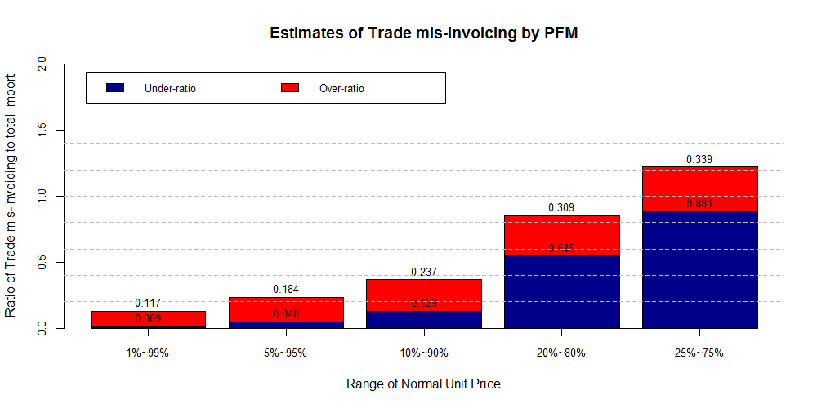
 | Range of normal unit price (lower bound ~ upper bound) (unit : $ mil.)
 | 1% ~ 99% | 5% ~ 95% | 10% ~ 90% | 20% ~ 80% | 25% ~ 75%
Under-invoicing | 917 | 4,827 | 12,912 | 54,623 | 88,219
Over-invoicing | 11,674 | 18,418 | 23,771 | 30,919 | 33,957
Total mis-invoicing | 12,592 | 23,246 | 36,684 | 85,542 | 122,176
Total import value | 100,167 | 100,167 | 100,167 | 100,167 | 100,167

In Figure 2 each bar presents the magnitudes of trade mis-invoicing, respectively calculated from 4 different data aggregation level; 1) trade data aggregated only by partner country, 2) aggregated by partner country and by HS2, 3) aggregated by partner country and by HS4, and 4) aggregated by partner country and by HS6. The estimate of over-invoicing import of Country A measured by PFM ranges from 0.053 to 0.49. The estimate of under-invoicing import ranges from 0.59 to 0.997.
Figure 6. PCM estimates of trade mis-invoicing in the import data of country A
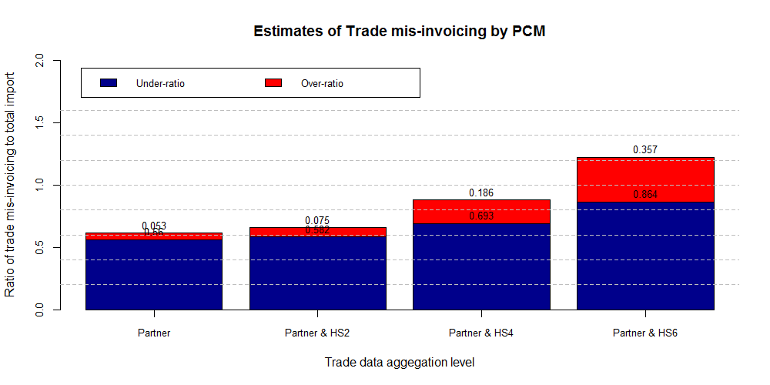
 | Trade data aggregation level (unit : $ mil.)
 | Partner | Partner & HS2 | Partner & HS4 | Partner & HS6
Under-invoicing | 60,852 | 73,638 | 87,489 | 108,287
Over-invoicing | 5,805 | 18,591 | 32,442 | 53,240
Total mis-invoicing | 66,658 | 92,230 | 119,932 | 161,527
Total Import | 108,606 | 108,606 | 108,606 | 108,606

The estimates of trade mis-invoicing of other cases (B’s import and B’s export) are presented in Figure 6.

Findings

PFM and PCM present different estimates on trade mis-invoicing for the same trade data. The difference mainly results from the fact that the two methods estimate different aspects of trade mis-invoicing, as presented in Figure 3. While PFM estimates the blue circle (A+B+C+D) by measuring the value of trade transactions unit price of which is abnormal, PCM estimates the yellow circle (A+C+F) by measuring the trade discrepancy.
Figure 7. Conceptual relation among IFFs, trade mis-invoicing and trade discrepancy
IFFs
(Illegally earned,
transferred
and utilized)
Trade mis-invoicing
(Invoice ≠ actual price)
Trade discrepancy
(Import record
≠ Export record)
E
D
C
B
A
F

- Part A, B, C and D respectively represent 4 types of trade mis-invoicing; type A (subset of trade discrepancy, but not of IFFs), type B (subset of neither trade discrepancy nor IFFs), type C (subset both of trade discrepancy and of IFFs) and type D (subset of IFFs, but not of trade discrepancy).
- Part E represents IFFs not relevant to trade; such as IFFs via cash smuggling and foreign investment.
- Part F represents trade discrepancy which arises naturally in producing trade data, not relevant to trade mis-invoicing or IFFs; such as difference in CIF/FOB ratio, attribution of trade partner, FX rate, time period and low value thresholds between trade partners.

Furthermore, the different estimates may be attributed to the different assumptions. In PCM, every trade was categorized into either over-invoicing or under-invoicing. In contrast, in PFM, a trade which unit price is within the normal price range was categorized neither into over-invoicing nor into under-invoicing, resulting in less scale of the trade mis-invoicing.
Even within the same method, the estimates ranged widely according to the assumptions of data analysis (i.e. normal unit price range for PFM and the trade data aggregation level for PCM).

[Micro analysis] Assessing risk of trade mis-invoicing

Interpretations (How to read figures)

Figure 4 presents 18,363 trades classified into over-invoicing imports both by PFM and PCM out of 54,274 trades of country A. Each dot in the scatter-plots represents a trade data (aggregated by partner countries and HS6). In details, Y-coordinate of each dot represents its percentile rank in order of its over- invoicing value by PCM. X-coordinate of each dot presents its percentile rank in order of its over- invoicing value by PFM.
For an example, a dot in the Figure 4 represents the import of HS 711620 from Belgium to country A, over-invoicing value of which is 5,357th largest among 18,363 trades (29th percentile rank) by PFM and 7,226th largest (39th percentile rank) by PCM. As the (percentile) rank is set in a descending order, the smaller number in the rank means the higher estimates of over-invoicing. In other words, dots closer to the origin of the graphs have higher estimates of over-invoicing value.

Figure 8. Cross-reference of PFM and PCM in over-invoicing import data of country A (2012-2014)
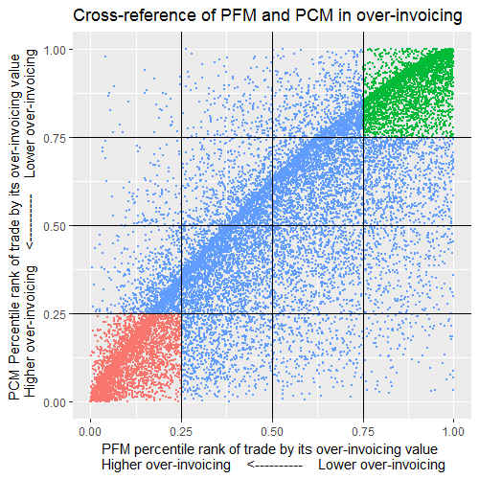

Findings

Cross-referencing PFM and PCM is very effective in assessing the risk of IFFs/TM of trade transactions where mis-invoicing is highly suspected rather than in estimating the value of trade mis-invoicing. In other words, the cross-reference is useful in answering the question; “Which trades are more suspected of mis-invoicing?” rather than “How significant the trade mis-invoicing is?”
Estimating the magnitude of trade mis-invoicing simply by aggregating all the mis-invoiced value of suspicious trade transactions may lead to unreliable (over-estimated) results. However, the list of suspicious trade transactions cross-referenced by PFM and PCM or or the rank of trade transactions in order of estimated value of mis-invoicing could be a risk indicator for Customs’ enforcement activities.
In case of the import of Country A in 2012-2014, trades which ranked within the top 25% both by PFM and PCM are 3,445 trades (red dots in Figure 4). By narrowing down the targets gradually into top 10%, top 5%, top 1% and top 0.1%, Customs can focus their enforcement resources into 1,212 trades, 569 trades, 93 trades and 9 trades given their available resources. If combined with other risk indicators such as the legal compliance of traders, cross-referencing PFM and PCM will be more effective in further scoping down the targets of enforcement.
 |  | Number of trade data
 |  | Total | Targeting
 |  | Total | Top 25% | Top 10% | Top 5% | Top 1% | Top 0.1%
Over-invoicing | Aggregated  trade | 18,363 | 3,445 | 1,212 | 569 | 93 | 9
Over-invoicing | Trade transaction | 733,730 | 589,483 | 461,812 | 368,301 | 178,404 | 1,370
Under-invoicing | Aggregated  trade | 5,309 | 702 | 191 | 68 | 9 | 1
Under-invoicing | Trade  transaction | 448,326 | 350,259 | 256,026 | 214,268 | 141,634 | 988

The investigations of those suspicious trades by Customs and other enforcement agencies will reveal to what extent trade mis-invoicing and IFFs are actually exploiting trade. A Customs officer of Country B confirmed that suspicious trades identified by this cross-referencing approach are similar to the trades that are deemed risky and suspicious by Customs officers.
The strong correlation between PFM ranks and PCM ranks of over-invoiced trades is noteworthy. The coefficients are very high (higher than 0.8) and statistically significant at the 0.1% level in all the 3 data sets. It means that, when asked to present the list of suspicious transactions, analysis of PFM and PCM present very similar lists of trade transactions even in a very similar order to each other.
However, the correlation between PFM ranks and PCM ranks becomes weak in the under-invoicing analysis in all the 3 data sets. Figure 5 presents 5,309 trades suspicious of under-invoicing imports both by PFM and PCM. Explaining the strong correlation between PFM ranks and PCM ranks only in the over-invoicing trades should be covered by the further research.
Figure 9. Cross-reference of PFM and PCM in under-invoicing import data of country A (2012-2014)
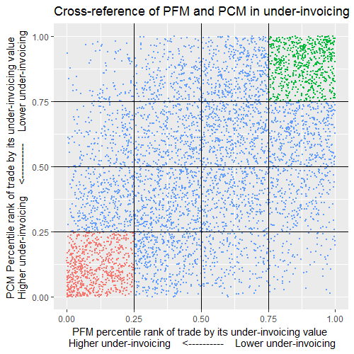

Conclusion
Using the transaction level trade data from the Customs administrations and partner countries’ trade data (aggregated by HS6 code) from the UNCOMTRADE, this research estimated the magnitude of trade mis-invoicing. The 3 case studies suggested that the estimates of trade mis-invoicing are considerably affected by the estimation methods (PFM or PCM) and their assumptions. High figures of IFFs and trade mis-invoicing from existing literature as well as this research should be understood with their estimation methods and assumptions.
In contrast to the heated arguments on the accuracy of estimations, the effectiveness of PFM and PCM as risk analysis tools have not been properly examined. In this research, cross-referencing PFM and PCM was very effective in assessing the risk of IFFs/TM of trade transactions where mis-invoicing is suspected rather than in estimating the magnitudes. Customs administrations are encouraged to employ the cross-reference of PFM and PCM with their transaction level trade data, identify high-risky trade transactions, and further research them with other risk indicators. However, it should be reminded that this approach should be limited to assessing risk of trade transactions, with a goal of detecting criminal activities, and not used for Customs valuation of traded goods.

Figure 10. Estimates of trade mis-invoicing in import and export data of country B (2015-2016)
B’s import in 2015-2016
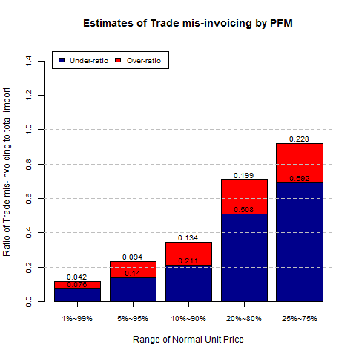 | 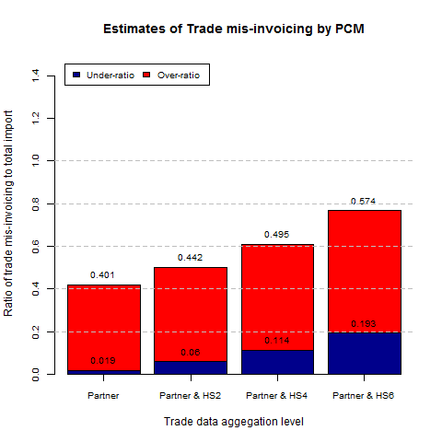
B’s export in 2015-2016
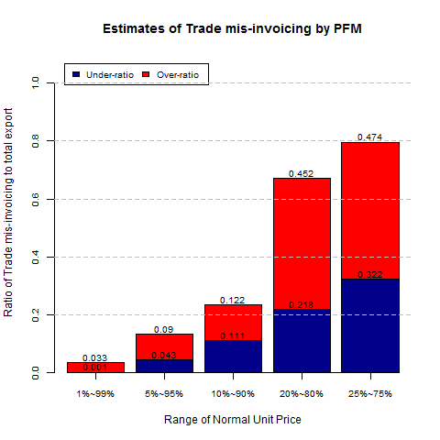 | 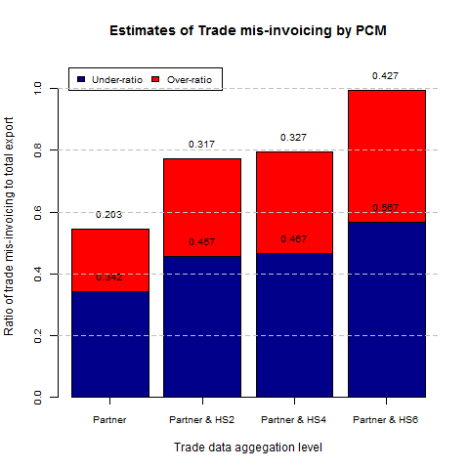

Figure 11. Cross-reference of PFM and PCM in trade mis-invoicing import and export data of country B (2015-2016)
B’s import in 2015-2016
Over-invoicing | Under-invoicing
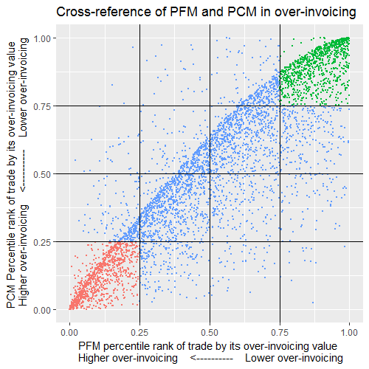 | 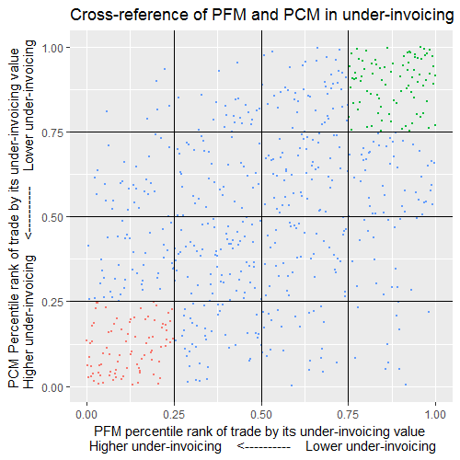
B’s export in 2015-2016
Over-invoicing | Under-invoicing
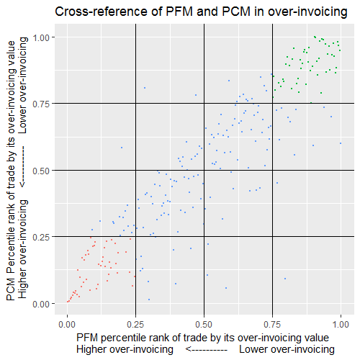 | 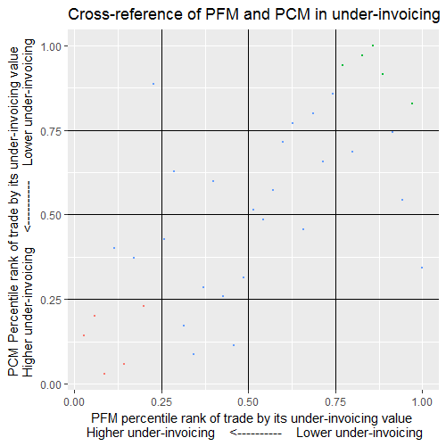

References
Asia/Pacific Group on Money Laundering. 2012. APG Typology Report on Trade Based Money Laundering. Sydney South: Asia/Pacific Group on Money Laundering.
Bhagwati, J.N. 1964. On the underinvoicing of imports. Bulletin of the Oxford University Institute of Economics and Statistics 26(4) 389-397.
Carrère, C. & Grigoriou, C. 2014. CAN MIRROR DATA HELP TO CAPTURE INFORMAL INTERNATIONAL TRADE? POLICY ISSUES IN INTERNATIONAL TRADE AND COMMODITIES RESEARCH STUDY SERIES No. 65. New York: United Nations. http://unctad.org/en/PublicationsLibrary/itcdtab65_en.pdf
China and the U.S. 2012. The Second Phase Report on the Statistical Discrepancy of Merchandise Trade between the U.S. and China. http://www.esa.doc.gov/sites/default/files/2ndphasereportjcctsigned1.pdf
Choi, Y.S. 2018. Traces of trade misinvoicing in trade discrepancy (not published).
De Boyrie, M.E., Nelson, J.A., and Pak, S.J. 2007. "Capital movement through trade misinvoicing: the case of Africa", Journal of Financial Crime 14(4):474-489. https://doi.org/10.1108/13590790710828181
Fisman, R., and Wei, S.J. 2004. Tax Rates and Tax Evasion: Evidence from “Missing Imports” in China. Journal of Political Economy 112(2):471-496. The University of Chicago.http://users.nber.org/~wei/data/fisman&wei2004/fisman&wei2004.pdf
Global Financial Integrity. 2017. Illicit Financial Flows to and from Developing Countries: 2005-2014. Washington DC: Global Financial Integrity.
Global Financial Integrity. Illicit Financial Flows: Analytical methodologies utilized by Global Financial Integrity. Retrieved from http://www.gfintegrity.org/issues/illicit-financial-flows-analytical-methodologies-utilized-global-financial-integrity/.
Han, C.R., and Ireland, R. 2016. A survey of Customs administration approach to Money Laundering. WCO Research Paper No. 36. Brussels: World Customs Organization.
Hong, K.P., Pak, C.H., and Pak, S.J. 2014. Measuring Abnormal Pricing – An Alternative Approach.The Case of U.S. Banana Trade with Latin American and Caribbean Countries. Journal of Money Laundering Control 17(2): 203-218.
Hong, K.P., and Pak, S.J. 2016. “Estimating Trade Misinvoicing from Bilateral Trade Statistics: The Devil Is in The Details”. The International Trade Journal 31(1):3-28. doi: 10.1080/08853908.2016.1202160.
Kar, D., and Spanjers, J. 2015. Illicit financial flows from developing countries: 2004-2013. Washington DC: Global Financial Integrity.
Kellenberg, D., and Lenvinson, A. 2016. “The trade data gap: Mistakes and malfeasance.” Retrieved from http://voxeu.org/article/trade-data-gap-mistake-and-malfeasance.

Nitsch, V. 2012. “Trade mispricing and illicit flows.” In Draining development? Controlling flows of illicit funds from developing countries, edited by Reuter, P., 309-334. Washington DC: The World Bank.
Nitsch, V. 2017.Trade Misinvoicing in Developing Countries.CGD Policy Paper 13. Washington, DC: Center for Global Development.
Pak, S.J. 2017. “Detecting Trade Misinvoicing: Price-Filter method vs. Partner-Country method.” Presented at the 12th Annual WCO PICARD Conference, Tunis, September 26-28.
Puzzilla, K. 2001. “Merchandise Trade Reconciliation; United States-Mexico-Canada 1998-1999”. United States Department of Commerce NEWS. Washington, DC: Economics and Statistics Administration. https://www.census.gov/foreign-trade/aip/recon9899.pdf.
UNCTAD. 2016. TRADE MISINVOICING IN PRIMARY COMMODITIES IN DEVELOPING COUNTRIES: The cases of Chile, Côte d’Ivoire, Nigeria, South Africa and Zambia. New York: United Nations.
United Nations Economic Commission for Africa (AUC/ECA). 2015. Illicit Financial Flow: Report of the High Level Panel on Illicit Financial Flows from AFRICA. Commissioned by the AU/ECA Conference of Ministers of Finance, Planning and Economic Development.

ENDNOTES

Part 3. Best Practices in Combating Illicit Financial Flows via Trade Mis-invoicing

8. Use of Customs valuation risk management techniques

Ian CREMER

The following recommended practices for Customs administrations have been developed by the WCO and its Members primarily to tackle undervaluation however the same approach will be effective in identifying overvaluation and suspected IFFs.

Risk management

A comprehensive and dynamic risk management system is the cornerstone to effective Customs control. A range of factors should be taken into account when developing a risk programme. These include:

Importer profiles

Importer profiles which record historic compliance records and other relevant data on the business in question provide a key indicator to future risks. .

This should include details of previous irregularities, under-declarations, penalties imposed, etc., as well as information on trade volumes and the nature of the business. Risk ratings can then be allocated to each importer accordingly.

Customs are encouraged to risk assess business operators to determine the appropriate level of Customs controls and interventions. High compliant operators should be subject to fewer documentary and physical checks at the frontier and post-importation. Customs can then direct their resources to the higher risk operators where there is a greater likelihood of discovering errors, possible fraud and underpaid revenue.

A process of continued review of compliance levels is required to ensure such profiles are up to date.

Analysis of aggregate trade statistics

An analysis of aggregate import statistics can provide a broad picture of trade levels indicating, for example, which goods are imported in the greatest volumes, the main countries of dispatch/origin and the major importers.

When coupled with information of the relevant duty rates for particular products, this can reveal the major sources of revenue and hence possible risk areas for Customs irregularities such as undervaluation, misclassification and misdescription of origin. Note that it is not the case that large trade volumes and high duty rates necessarily indicate high risk in their own right; a large duty payer may be highly compliant for example, but these are important criteria to take into account in determining whether it would be a good investment of Customs’ resources to examine further.

Customs entry processing systems can be used as the prime source of trade statistics and can be searched by tariff heading, country of origin and importer name, within a particular date range.

The comparison of export and import trade statistics, known as mirror analysis, is explained elsewhere in this report.

Development and use of a valuation database as a risk assessment tool

Many administrations have developed, or are considering the development of, a valuation database as a means to identify potential undervaluations of imported goods. Such databases can be useful tools, particularly for developing countries where there are typically high rates of non-compliance, coupled with poor or non-existent accounts and record-keeping.

The best source of data for such databases is prices taken from recent previously accepted Customs declarations..

Where a comparison with database prices for the same type of goods suggests the declared value may not be correct, Customs should may seek further evidence from the importer to support the declared value. A suspect price may not be rejected without conducting an enquiry and giving the importer the opportunity to provide further evidence.

The WCO emphasizes that valuation databases are to be used only as risk assessment tools, alongside other risk criteria. The WCO and the Technical Committee on Customs Valuation has developed guidance on the use of valuation databases: Guidelines on the Development and Use of a National Valuation Database as a Risk Assessment Tool.

Exchange of Customs Valuation information

The basis for exchange of Customs information is set out in Article 12 of the WTO Trade Facilitation Agreement. In respect of Customs value information, the Technical Committee on Customs Valuation has issued guidelines which encourage Customs administrations to first conduct enquiries within the country of importation before considering options to seek information from the country of exportation. Typically, such requests will be made on the basis of existing MOUs or mutual assistance agreements.

Stages of Customs control

The WCO advocates a comprehensive and effective valuation control programme which involves controls carried out at three stages; pre-clearance, at the time of Customs clearance and post-clearance. The objective should be to achieve a balanced control programme, based on these stages, which is appropriate for the country in question.
Documentary and physical checks should be conducted on the basis of targeted risk-profiling. Physical examinations can be useful where goods descriptions on the Customs entry are vague or incomplete but otherwise have limited use for Customs valuation purposes.
At the pre-clearance stage, there is the opportunity for Customs to provide advance rulings on Customs valuation issues. This is encouraged in the WTO Trade Facilitation Agreement (Article 3.9(b)).

At the time of clearance, Customs have a limited amount of documentary information available to them: typically, an invoice, bill of lading and ship’s manifest. Effective valuation controls require access to an importer’s books and records which are not available at the time of clearance. Documentation relating to other payments which may be includable in the Customs value, such as agency and royalty agreements, is also unlikely to be available. A further consideration is that time is limited to conduct such checks when goods are awaiting Customs clearance.
Controls at the time of clearance are most effective for targeting informal operators who typically do not retain formalized accounting records, may not have permanent business premises and deal in cash transactions.
These limitations do not exist in the post-importation environment, which is why post-clearance audit (PCA) is recommended as the optimum mode of valuation control, wherever feasible.
PCA also enables Customs to obtain a complete picture of the commercial operator and examine the backgrounds to multiple consignments simultaneously, which is more cost-effective than examining individual consignments.
At any stage where Customs identify potentially significant price irregularities which may suggest the existence of IFFs, subject to national procedures, the appropriate authorities, such as the Financial Intelligence Unit should be consulted.

---------------------------------------------
Further guidance is available from the WCO on effective valuation controls, post-clearance audit and other related issues under the Revenue Package programme, available to WCO Members.

9. Inter-Agency Cooperation: focused on but not limited to Customs-Tax cooperation

Introduction – Importance of inter-agency cooperation

Melissa Dejong and Pashupati Pandey

Financial crimes are growing in sophistication and often operate across international borders. Illicit financial flows, tax evasion and other related financial crimes are posing greater challenges to the political, economic and social interests of countries. While the globalization and liberalization of economic activity and trade has in effect transformed the business sector into a world without borders, Customs and Tax authorities continue to be constrained by national borders and resepctive legislations and regulatory approcahes, requiring enhanced inter-agency cooperation within and between governments for effective actions.
With the rapid globalization of the trade and the financial systems, the free movement of goods, capital and labour, shifting manufacturing bases and advances in information and communication technology (ICT), business operating models have undergone significant changes. Whilst these are notably positive developments, they have also increased the potential risk of Customs offences, tax evasion, tax avoidance and illicit financial flows, and have put Customs and Tax administrations under greater pressure in their risk assessment, compliance management and trade facilitation efforts. While traditional Customs fraud and evasion of Customs duties continue to pose challenges to Customs administrations, there have been increasing concerns regarding offshore tax evasion, where funds are being deposited and sheltered from the home Tax authorities, having potential connections with illicit financial flows and money laundering.
Tax authorities gather and hold a wealth of information on individuals, companies, and transactions that may be a valuable source of intelligence to customs authorities in combating financial crimes within their mandate. Similarly, customs authorities hold important information about cross-border flows of money and goods, as well as details of individual businesses. More specifically, customs authorities play a key role in preventing and detecting trade mis-pricing / mis-invoicing and other customs offences that typically contain a tax component.
As both agencies play an important role in mobilising revenues and combating financial crimes, it is therefore critical that tax and customs officials have effective co-operation frameworks in place to facilitate the prevention, detection, investigation, and prosecution of trade mis-pricing/invoicing, and other tax and customs offences.
Enhanced cooperation between and among Customs, Tax, and money laundering authorities is therefore becoming increasingly important to curb the menace of IFFs, including the implementation of related FATF Standards involving all relevant agencies. There is potentially a great opportunity for Customs and Tax authorities to work together on seeking solutions to cross-border tax evasion, aggressive tax minimization, illicit finciancial flows, terrorist financing, and Customs fraud. This collaboration allows leveraging the different legislative powers, information, expertise and mechanisms for international co-operation, and can result not only in more successful detection of these financial crimes but also result in greater efficiency and cost savings for the agencies involved.
The need for Customs-Tax cooperation at the national, as well as international cooperation to assist countries in tracking, tracing, and retrieving assets across borders and to prevent impunity is increasingly well recognized.
In 2000 the UN General Assembly adopted the Convention Against Transnational Organised Crime, including a commitment to criminalise the transfer, concealment, or disguise of assets of illicit origin. In 2001 the Economic and Social Council agreed a resolution (2001/13) to strengthen international cooperation in preventing and combating the transfer of funds of illicit origin derived from acts of corruption, and in 2005 the UN Convention Against Corruption (UNCAC) was adopted, including commitments on returning stolen assets. Since the 9/11 attack in 2001 there has also been increasing in focus on financial networks that support terrorism, as part of anti-money laundering controls.
The OECD has also been active in calling for inter-agency cooperation in fighting financial crime. The OECD’s 2010 Council Recommendation to Facilitate Co-operation between Tax and Other Law Enforcement Authorities to Combat Serious Crime (C(2010)119) recognized the important role tax authorities can play in the detection of all serious crimes and called for greater information sharing between tax and other law enforcement authorities. This “whole of government” approach to tackling financial crimes is a key pillar of the OECD’s work which it launched under the Oslo Dialogue in 2011, and which was welcomed by the G20 Leaders in 2012.The OECD released its first report on the domestic information sharing gateways and best practices for other forms of inter-agency co-operation in fighting financial crime in countries around the world in 2012 in its “Effective Inter-Agency Co-operation in Fighting Tax Crimes and Other Financial Crimes,”updated and expanded in 2013.The global importance of the whole of government approach was again endorsed at the OECD’s Fifth OECD Forum on Tax and Crime in 2017,where the third edition of the report was launched, now covering more than 50 countries on co-operation between customs, tax, policy, prosecutors, FIUs, financial regulators and anti-corruption authorities.The necessity of inter-agency co-operation was also recognized in the OECD’s Ten Global Principles on fighting tax crimes, which sets out the agreed core requirements for countries to effectively address tax crime and other financial crimes.
The important role that Customs and Tax authorities individually and collectively play in combating financial crimes, e.g., illicit financial flows, money laundering and terrorist financing has garnered even greater significance since 2012, when the Financial Action Task Force (FATF) revised the “International Standards on Combating Money Laundering, the Financing of Terrorism and Proliferation” to include ‘tax crimes (related to direct taxes and indirect taxes)’ and ‘smuggling (including in relation to Customs and excise duties and taxes)’ in the list of predicate offences for money laundering.Some countries have already reflected the updated FATF Standards in their national legislations. This change has brought the proceeds of tax crimes within the scope of money laundering investigations. This is expected to contribute to better coordination between Customs administrations, Tax authorities, Financial Intelligence Units, and other law enforcement agencies, and remove potential obstacles to domestic and international cooperation concerning tax crimes, such as increased access to suspicous transaction reports.The FATF recommendations no 30 and 31 are noteworthy in this respect.
Furthermore, the UN Sustainable Development Goals agenda (target 16.4) provides for significantly reducing illicit financial and arms flows, strengthening the recovery and return of stolen assets and combating all forms of organized crime by 2030. The Addis Ababa Action Agenda also emphasised the importance of inclusive cooperation and dialogue of different agencies both domestically and internationally.
Finally, the G7 Finance Ministers endorsed the whole of government approach, recognizing the importance of a holistic approach and greater exchange of information to fight financial crimes in its 2017 Bari Declaration on Fighting Tax Crimes and other illicit financial flows.

Collaboration opportunities against trade mis-invoicing

Pashupati Pandey

Often, trade mis-invoicing is cited as one of the largest component of illicit financial flows. This includes trade based money laundering, as well as illicit transfer of funds. By fraudulently manipulating the value, description, quantity, or quality of goods and origin, money is transferred across borders using legal and illegal/informal financial channels. In this context, Customs administrations’ import and export data and Tax authorities’ purchase and sales data may be mutually shared and matched, which could potentially result in the detection of irregularities concerning mispricing of imported and exported consignments. The sharing by Tax authorities of information on payment transactions [both import (purchase) and export (sales)] may also be useful to Customs from the valuation perspective.
When conducting compliance audit of the Customs value for related party transactions involving multinational enterprises, Customs administrations can benefit from information derived from the transfer pricing studies which have been developed for profit tax purposes, and which are generally based on the application of the OECD transfer pricing Guidelines. Both the OECD transfer pricing Guidelines and the WTO Customs Valuation methodology are designed to ensure that related party prices are comparable with those between unrelated parties. It is noted, however, that there are opposing risks, i.e., the risk to Customs is generally undervaluation of imported goods to reduce Customs duties, whereas the tax risk is overvaluation of goods and services to reduce the taxable profit. There is also a possibility that fraudsters are manipulating both tax and Customs declarations to their advantage; e.g. where low duty rates and high tax rates apply, Customs values may be deliberately overdeclared in order to reduce taxable profits. Therefore, sharing information and knowledge in this area would be mutually beneficial.
Customs valuation ensures ‘integrity’ to the downstream value addition activities for business and taxation purposes. A coordinated approach to Customs valuation and transfer pricing is therefore recommended between Customs and Tax authorities. In addition, Customs should also focus on export valuations, alongside import valuations, thus obviating the possibility of using export channel for illicit financial flows.
Additionally, a joint approach to compliance management, risk management and audit could be effective means to further enhance cooperation and coordination between Customs and Tax authorities. A comprehensive and harmonized approach by the two authorities would strengthen ongoing measures against IFFs.
As import/export activities may materially affect a businesses’ tax compliance obligations for both direct and indirect taxes, it is essential that the legislative arms of both Customs and Tax authorities should co-operate to ensure that the objectives of legislation in their respective fields do not conflict.

OECD Survey: Institutional frameworks for inter-agency co-operation between tax and customs authorities

Melissa Dejong

The OECD’s 2017 study on Effective Inter-Agency Co-operation in Fighting Tax Crimes and Other Financial Crimes (the “Rome Report”) , provides a comparison of the mechanisms for inter-agency co-operation in combatting tax crimes and other financial crimes in 51 developed and developing countries, from all geographic regions. This includes a detailed analysis of the role that customs administrations play in criminal investigations into tax crimes and other economic offences and the extent to which they can share information with tax authorities (responsible for civil and criminal matters) and vice versa.
A positive finding is that all countries surveyed for the OECD’s Rome Report either require or permit customs authorities to share information with tax crime authorities and vice versa. That said, information sharing in many countries is subject to restrictions and there is room for improvement in the range of gateways that countries make available and the manner in which these are implemented.
When implemented effectively, information-sharing frameworks can be used to identify evidence which may initiate investigations, support ongoing investigations, and reduce duplication. Mechanisms for reporting and information sharing may also foster relationships at the institutional level and at the investigator level, thus creating a culture of co-operation from the top-down and bottom-up. A customs administration may be established as a separate agency, or as part of a joint tax and customs administration. Fifty-five percent of countries surveyed for the Rome Report have a separate customs administration, typically under the Ministry of Finance, while the remaining 45% of countries have a single tax and customs agency. The organisational structure in place is relevant in identifying, and addressing, the legal or operational barriers to co-operation between tax and customs officials.
Regardless of the institutional framework adopted, it is important that tax and customs authorities have streamlined processes in place that allow them to report suspicions of criminal activity to each other, and share information related to those suspicions. This is equally important in countries where tax and customs authorities work within a single agency as officials will typically still sit in different units that may operate in silos.
The following discussion examines the legal gateways that countries have in place to permit information sharing between customs authorities and agencies responsible for both civil and criminal tax investigations. The analysis is based on the general position in each country and is not intended to reflect the complexity of the arrangements between agencies within each jurisdiction.
The frameworks for information sharing have been grouped into four broad models based on whether customs authorities can obtain information held by tax authorities (and vice versa) through (i) direct access to the information; (ii) mandatory spontaneous sharing of information; (iii) discretionary spontaneous sharing of information; (iv) information sharing on request only. Countries are strongly encouraged, within the framework permitted by their law, to make a range of legal gateways available for information sharing. While each of these models has the potential to work well when implemented effectively, information sharing will be most effective where the broadest range of gateways are available. For example, agencies are likely to obtain more comprehensive and targeted information where the tax authority provides customs authorities with direct access to its databases as well as where the tax authority can share information spontaneously and in response to a specific request of customs authorities.

Sharing of information held by tax administration for tax assessment purposes with customs authorities

Tax administrations and customs administrations often work closely together in the administration and enforcement of laws within their respective mandates, and this is also possible for issues related to trade mis-pricing / mis-invoicing. However, confidentiality provisions in international information exchange agreements and domestic data protection laws and other structural and operational issues often impede the free sharing of information, even where tax and customs are housed within a single agency.
All 51 countries covered by the Rome Report allow the tax administration to share at least some taxpayer information with customs authorities. Twenty-four countries provide customs officials with direct access to information held by the tax administration for tax assessment purposes. Sixteen of these countries have a combined tax and customs authority suggesting this organisational structure may better facilitate a direct access model. Direct access may take the form of shared access to specific databases (e.g. a common risk analysis centre, VAT database etc.), access to specific types of data (e.g. bank account data or movement of goods such as alcohol and tobacco), and may be restricted to specific circumstances (e.g. the investigation of suspected VAT fraud).
In ten countries, tax officials are obliged to provide customs officials with information that is relevant to their activities and in nine countries, officials are able, but not required, to do so. In almost all of these countries the tax and customs administrations are separate. Again, sharing may be subject to restrictions. For example, in one country, information held by the tax administration with respect to goods and services tax may be shared spontaneously with the customs administration but other tax information cannot be shared. Finally, in seven countries (all of which have separate customs agencies) the tax administration may only share information on request.

Sharing of information held by customs authorities with tax administration for tax assessment purposes

Customs administrations frequently gather and analyse financial information on individuals, businesses, and transactions that would be of great assistance to a tax administration in tax audits and examinations, and the determination of assessments. For example, when customs authorities detect trade mis-pricing / mis-invoicing (or an issue related to transfer pricing or valuation) between related entities, it is critical that they stay in close contact with the civil tax authorities, as the mispricing will also likely have a significant tax effect. Co-ordination between relevant customs and tax units will thus be key to resolving the pricing issue.
In all countries covered by the Rome Report, the customs administration is able to share at least some information with the tax administration for tax assessment purposes. In 22 countries, tax officials have direct access to information held by customs authorities. Fourteen of these have a single tax and customs authority and eight have separate authorities. In ten countries (seven of which have separate tax and customs agencies) customs officials are under an obligation to provide relevant information to tax officials. For example, in one country, all State, territorial, and regional bodies are required to report facts detected in the performance of their duty which are important for tax assessments to the tax administration. In 13 countries (12 of which have separate tax and customs agencies), customs officials have the discretion to provide information to the tax administration, and in five countries they may only do so on request.

Sharing of information held by customs authorities with agencies investigating tax crime

The financial information on companies and transactions held by customs authorities may also be of use to criminal investigators dealing with tax crimes and other economic crimes. Trade mis-pricing / mis-invoicing may involve tax evasion or even trade based money laundering, and as such it is critical that customs authorities have mechanisms to co-operate and share information with tax crime investigators.
In 16 countries, officials conducting tax crime investigations have direct access to certain information held by customs authorities. For example, the customs authority in one country has granted tax crime investigators direct access to software containing information on European and other international customs transactions. In a further 14 countries, customs officials are under an obligation to provide relevant information spontaneously and another 15 countries, grant customs officials the discretion to share such information. Several countries place restrictions on this sharing, for example, in one country information may only be shared where it is necessary for the enforcement of federal criminal laws or the protection of federal revenues. Six countries only permit customs officials to share information with tax crime investigators on request.

WCO Survey: Exchange of information and co-operation in practice

Pashupati Pandey

The WCO’s survey (2016) on the subject indicated that Customs administrations foresee several benefits in cooperating with Tax authorities, notable among them being efficient collection of legally due duties and taxes, including evaded/avoided duties and taxes (63 Membersout of a totalof 72 responses); comprehensive risk management and/or post clearance audit (56 Members); improving trade facilitation and business environment (55 Members); and curbing cross-border tax fraud/evasion, smuggling and money laundering (51 Members).
9 Members indicated certain additional benefits, such as: efficient identification of high-risk transactions and prevention of Customs frauds; development of a comprehensive compliance programme; joint accreditation/audit (thus reducing unnecessary duplications); increased transparency; enhanced security and safety of the supply chain; exchange of good investigative practices; and efficient data exchange with foreign administrations.

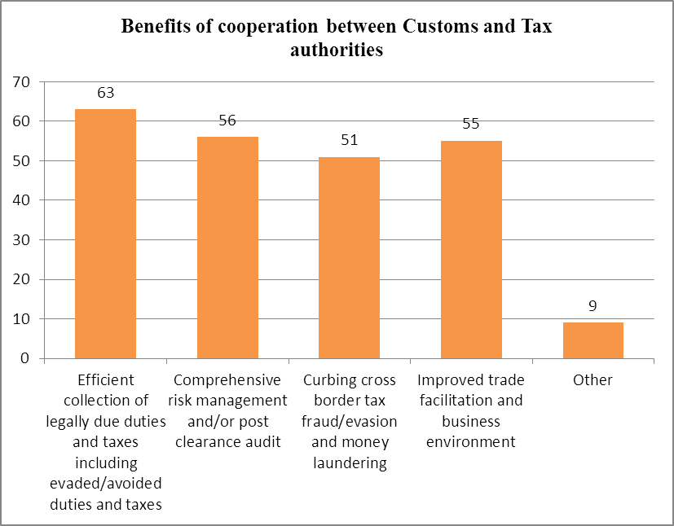
19 Members (out of a totalof 72 responses - 26 %) exchange tax databases, documents and related information on a periodic basis (including a few cases where Customs periodically submits online import and export reports to the Tax authorities, whereas the Tax authorities furnish data/information upon request only). At the same time, 29 Members (40 %) even provide full/limited access to each other’s databases.
Eight Members (11 %) mentioned additional processes/methods of cooperation, including for example joint audits, joint risk analysis, and in some cases even the merger of the two authorities’ risk divisions and the use of common databases/integrated systems.

Type of information/data exchanged

Customs administrations share a wide spectrum of information, data and documents, such as Customs import/export data (61 Members); travellers’ currency declarations (20); tax returns (purchase/sales data) (30); assessment/audit reports (29); enforcement-related information/intelligence (e.g., tax evasion/money laundering, smuggling, drug trafficking, currency, illicit payments, other criminal activities) (31); risk profiles/indicators (20); information regarding Customs/Tax defaulters (44); information obtained from foreign Customs or Tax administrations (23); information on compliant/non-compliant traders (38); recovery of Customs/Tax liability (34), Base Erosion and Profit Shifting (BEPS) cases/modus operandi (4) and best practices concerning tax compliance, assessment, audit, investigation, etc. (27).
14 Members also exchange other types of information. Examples given include: general information on enterprises, legal representatives, trade processes, business registration and financial reports; data on offenders, tax payer debt and information on shell companies.

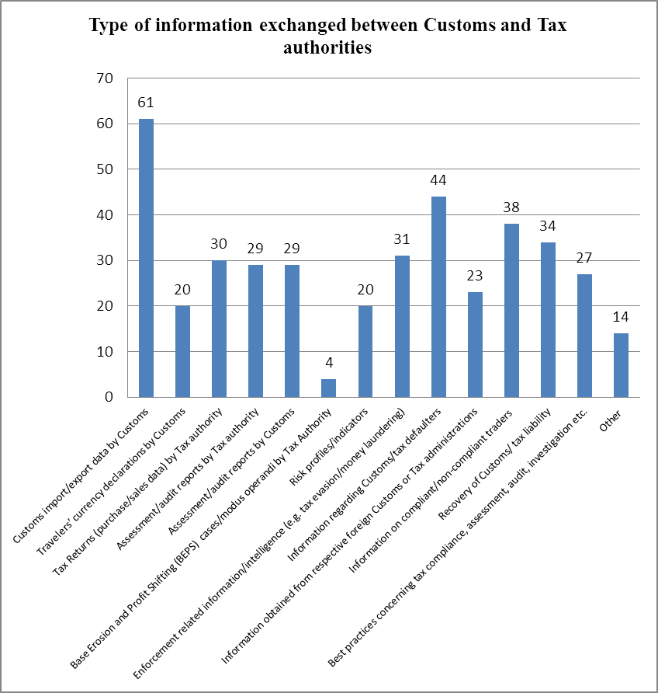

Data Exchange Mechanisms

Members employ a combination of means for exchanging information with Tax authorities, based on the requirement for and availability of information.47 Members (65%) share information/documents in physical form (by letter), while 35 (49%) do so using a secured e-mail/electronic communication channel. 36 (50%) have interoperable IT systems for information.
17 Members (24%) mentioned other means of exchange, for example the sharing of information/documents through meetings, telephone conversations, secured access via shared folder, Secure File Transfer Protocol (SFTP), data exchange portal, common document repository, access to each other’s IT systems/databases and integrated or shared systems.
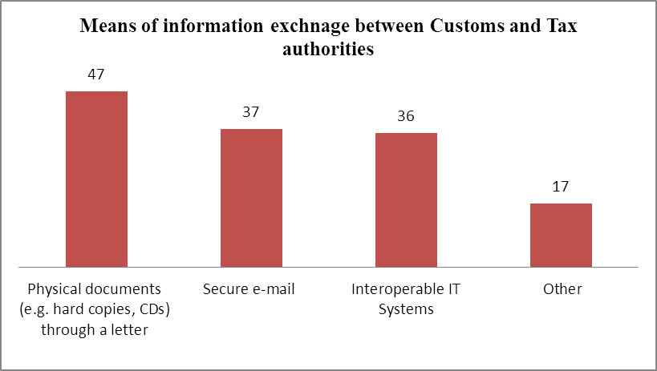
Two broad approaches have been identified for the exchange of information between Customs and Tax authorities : a common IT system and interoperable IT systems.

Common IT System

A common IT system includes both Customs and Tax information, to which
both Customs and Tax officers have access, with Customs and Tax information being filed under the individual number of each taxpayer. A single and fully centralized information system is available to all Customs offices throughout the country for the performance of their duties, by means of a Web-based information system with intranet technology. By way of example, the key features of Spain’s common IT system, including benefits, access and data, are set out in Annex 1.

Interoperable IT Systems

Interoperable IT systems allow a robust data access and sharing policy between Customs and Tax databases. By way of example, the essential prerequisites for India’s Customs-Tax data access and exchange through interoperable IT systems are outlind in Annex 2.

Cooperation mechanisms

35 Members (49%) have administrative arrangements with designated contact points, if and as appropriate. 23 (32%) have more formal arrangements, such as guidelines/instructions for interaction and exchange of information; technical and functional specifications; collaboration protocols; and Memorandum of Understanding/Agreement on cooperation and data exchange.
30 Members (42%) have developed additional cooperative arrangements which include: integrated administration; legal act, Ministerial decree or decision; inter-agency working groups/forums; joint committees; special task force; regular meetings; informal administrative arrangements; Customs and Tax border cooperation centres; and secondment of Customs officers to Tax authorities.
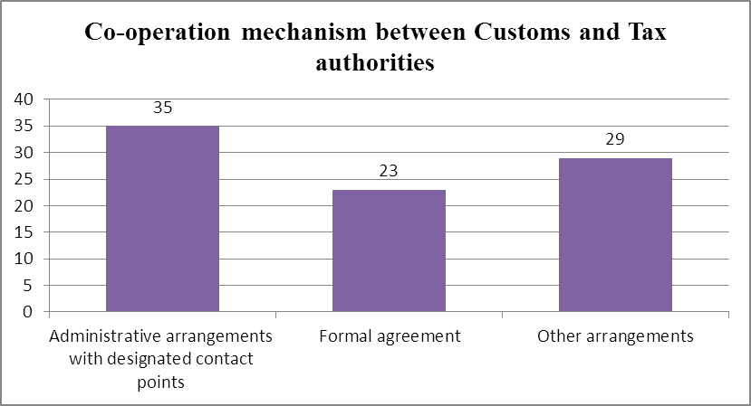

Legal act/formal policy for exchange of information

27 Members (38%) indicated that there are specific provisions under their respective Customs and Tax laws/acts which provide for the exchange of information. 28 Members (39%) have a general legislative framework for the exchange of information between/among Government agencies (which include the Customs and Tax authorities).
14 Members (19%) have established a Memorandum of Understanding with their respective Tax authorities. 12 (17%) have no specific legal act and/or formal agreement for the exchange of information (the majority have no need for one, being part of a Revenue Authority).

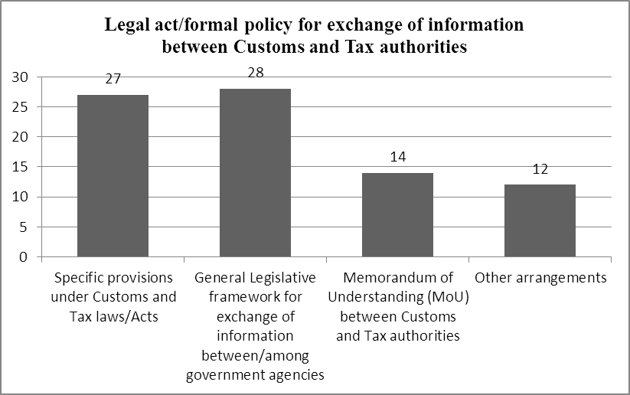
The WCO Survey (2016) also brought out that 54 Members (of 72 total responses - 75%) conduct some or other kinds of jointly coordinated activities between their Customs and Tax authorities including in particular joint investigation/examination, mentioned by 34 Members (47%), and joint audit which was mentioned by 28 Members (39%).
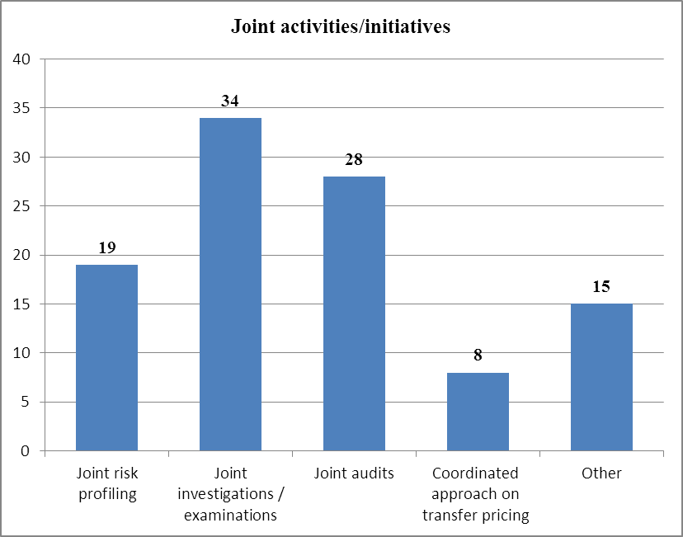

WU Global Tax Policy Center: some lessons from the Tax and Good Governance Project

Clement Migai and Jeffery Owens

The significance of IFFs problem for Africa was highlighted by the UN High Level Panel on Illicit Financial Flows from Africa report “Track it! Stop it! Get it!”IFFs were also a focal point of the Third International Conference on Financing for Development in Addis Ababa which appealed for efforts to eliminate IFFsto be redoubled (Addis Ababa Action Agenda)and the Agenda 2030 for Sustainable Development.
Considering this, from March 2015, the WU Global Tax Policy Centre at the Institute for Austrian and International Tax Law at WU - Vienna University of Economics and Business, in partnership with the African Tax Institute at the University of Pretoria, with the support of UNODC and the World Bank, cooperated together in a project that brought together government officials, business, academics, and international and regional organisations to discuss and identify solutions to IFFs from Africa.
The project involved research, workshops, seminars and conferences and training, all aimed at providing practical solutions that the participating countries can use to counter IFFs. It examined how to strengthen tax policy and administration, promoted effective implementation of international standards and supported enforcement and investigations. It particularly emphasised the role of good practices for cooperation between financial intelligence units, customs and tax administrations, and law enforcement agencies. It identified improvements that are required for enabling the domestic and international legal and institutional framework to facilitate cooperation between different government agencies.

Necessity for inter-agency cooperation

IFFs (including trade mis-invoicing) and other financial crimes may involve a broad range of activities and multiple actors who may be spread across various sectors. Activities perpetuating IFFs can also violate a number of different laws. As a result, different government agencies, including tax administrations, customs authorities, anti-money laundering authorities (including financial intelligence units/centres), the police and other specialised law enforcement agencies, the public prosecutor’s office and financial regulators may be involved in the different stages to facilitate effective detection, prevention, investigation and prosecution as well as the recovery of the proceeds thereof.
Given the mosaic of agencies involves in detection and investigation of different types of IFFs, each of these agencies many hold some operational and strategic information relevant to the activities of other agencies.Some of these agencies may have exclusive access to information not held by other agencies. Yet some may possess peculiar investigative and enforcement powers. The fragmented yet inter-connected and inter-dependent roles and powers of these agencies involved in combating IFFs may lead to a silo mentality, if not carefully managed. It therefore calls for a unified strategy and closer coordination, cooperation and collaboration by all concerned agencies if they are to be effective at both the domestic and international level.

Forms of inter-agency cooperation

The Tax and Good Governance Project conducted a survey amongst twelve Africa countries, namely Botswana, the Gambia, Ghana, Kenya, Liberia, Mali, Morocco, Niger, Nigeria, Sierra Leone, South Africa and Zambia, for the purposes of a training workshop on inter-agency cooperation in March, 2016. It identified several models for cooperation in these countries which echoes the recommendations by OECD and the Financial Action Task Force (FATF). These included but were not limited to:
- Information sharing
- Joint investigation teams
- Inter-agency centres of intelligence
- Secondments and co-location of personnel
- Other models: use of multi-agency task forces to combat financial crimes, having centralised structures for inter-agency cooperation, granting tax and customs access to STRs, inter-agency meetings and training sessions.

Some best practices from the Tax and Governance Project

The Tax and Good Governance encountered different models for deepening inter-agency cooperation in the participating countries. As pointed above, these models mostly aligned with the recommendations by the OECD and the FATF and covered information sharing, joint investigation teams, inter-agency centres of intelligence, secondments of personal as well as other models such as multi-agency task forces.

Information Sharing

Information is usually shared on a bilateral basis as provided by legislation and supplemented by bilateral MOUs. However, rather than establish bilateral MOUs, Sierra Leone put in place a multilateral MOU for the exchange of information between several law enforcement agencies, tax and customs administrations and security agencies in December 2015. This was done under the umbrella of the “AML/CFT Inter-Agency Intelligence Coordination Committee”.
This Committee is composed of the National Revenue Authority, the Financial Intelligence Unit, the Police, the Central Intelligence and Security Unit, the Republic of Sierra Leone Armed Forces, the Immigration Department, the Anti-Corruption Commission, the National Drug Law Enforcement Agency and the Transnational Organized Crime Unit.
The multilateral MOU has brought all the relevant agencies, including Customs authorities which is a part of the national Revenue Authority to one table rather than have a series of bilateral MOUs that deals with only two agencies at a time. This has greatly reduced bureaucracy that may hinder efficient and timely information sharing. It has also, in one go, enlightened the participating agencies of each other’s mandate and shared common objectives, broken down organisational silos, and established a one-stop shop for sharing information but with the usual limitations on use of such information for purposes outlined in legislation, international agreements and treaties.

Joint Investigation Teams

The South African Revenue Service (SARS) has identified the illicit economy and illicit financial flows as one of the strategic risks facing SARS over the years 2015/16 -2020/21. SARs has therefore earmarked increased customs compliance as one of its priority areasand proposes to achieve this by engaging with other “state enforcement agencies such as State Security Agency and Police to agree on Memoranda of Understanding (MOU’s) for establishment of dedicated resources for fighting illicit trade” and “enhance the inter-agency co-operation in fighting tax and other financial crimes.” The strategic plan also proposes the adoption of a whole of government view in managing the customs border environment through collaboration with other government agencies. These capture its spirit and need for inter-agency cooperation.
The ability of Customs to conduct joint investigations is covered by legislation. Hence joint investigations between the Directorate for Priority Crime Investigation (Hawks) and SARS are common place and are focussed on any fraud or revenue related matters.However, although SARS may participate in joint investigation teams effective participation is hampered by the fact that the officials assigned are prevented from using any special legislative powers held by virtue of their position as a tax administration employee. As a result parallel investigations are usually run by SARS but information is shared with the joint investigation team.

Multi-agency Task Forces

A presidential directive established a task force in Kenya in March 2015 to review the existing legal, policy and institutional framework for economic crimes (including corruption); determine why the institutions were not adequately responding to the challenges; and make recommendations for improvements. It came to a conclusion that: (a) there were many agencies each playing a different role; (b) despite interlinked and interdependent mandates most of the agencies acted in isolation and failed to cooperate, coordinate and or collaborate with one another; (c) and since most of the agencies acted in isolation, this had let to mistrust and failure to share intelligence and information which created loopholes with the system.
It therefore recommended that in order to enhance coordination and cooperation, a Multi-Agency Team on Enhancing the Investigation and Prosecution of Corruption and Economic Crimes in Kenya (“MAT”) should be established. The MAT was set up in November 2015 and its principal terms of reference included; (a) enhancing cooperation, coordination and collaboration among the member agencies; and (b) engaging other relevant agencies to enhance the effectiveness of the war on corruption and cases of organized crimes.
The principal members include the Office of the President; the Ethics and Anti-Corruption Commission; the Office of the Director of Public Prosecutions; the Directorate of Criminal Investigations; the National Intelligence Service; the Financial Reporting Centre; the Asset Recovery Agency; and the Kenya Revenue Authority. On a need basis, it incorporates the Communications Authority of Kenya; the Kenya Wildlife Services; the Kenya Forestry Services; the Anti-Counterfeit Agency; and the National Transport and Safety Authority. it operates at several levels with a High Level Consultative Team composed of the heads of the agencies with the EACC as the convener and the Office of the President serving as the secretary; a Technical Committee of nominees from each agency to facilitate liaison on technical matters; and a Secretariat.
Since its formation it has developed, inter alia, information and intelligence sharing guidelines and criteria for determining cases suitable for investigation and prosecution. It holds regular meetings that enable members to share information and intelligence on a real time basis a practice that has cultivated closer coordination and collaboration. The MAT has also conducted joint investigations and joint sting operations. For example, by using shared intelligence; the KRA was able to nab twenty-one, forty foot stuffed with new clothes but declared in import documents as coolers while the other three contained powder milk.Another example includes nabbing luxury cars declared as personal effects and household goods. Joint training has also increased the members awareness of each agencies mandate and how their agency can assist to fulfil this mandate. Other cases have seen the office of the Director of Public Prosecution, the Ethics and Anti-Corruption Commission and the Asset Recovery Agency refer cases to KRA for tax investigations. In other case KRA’s statutory powers have been leveraged to aid in prosecuting cases and obtaining preservation orders.
However, a main challenge is that the MAT is not anchored in law and relies on the statutes for each agency. The legality of joint operations can therefore arise. The formation and ongoing operations of the MAT are also based on the political will of the current leadership as a result of the presidential directive. Further, the Mat has to rely on the budgetary allocation from member agencies which can be impacted by individual institutional constraints.

Secondment of personnel

Nigeria reported since 2004 it has been seconding staff from the Nigerian Customs Service to the Economic and Financial Crimes Commission and the FIU. It had also received forensic officer seconded from the Independent Corrupt Practices and Other Related Offences Commission to help in detection of duty evasion. Secondment of specialised staff has been used extensively in Ghana. This practice has deepened ties between the tax administration and the other law enforcement agencies which has facilitated better cooperation.

Joint compliance and advance pricing agreements

Customs authorities and tax administrations do have some shared and often overlapping objectives. This is more evident in the linkages between transfer pricing and customs valuation which calls for closer cooperation amongst customs authorities and tax administrations. Joint compliance programs and advance pricing agreements that involves both customs and tax could therefore be another way of preventing trade mis-invoicing since they reduce the risk of manipulating the prices.

Conclusion

Whilst inter-agency cooperation is possible in most countries, agencies still need to overcome legal, regulatory, cultural, and operational barriers which may prevent the sharing of specialist information with other law enforcement agencies. Administrative and cultural barriers may inhibit closer working relationships even where this is enabled and supported by legislation. Complex or lengthy processes and/or procedures for obtaining information from another agency, a lack of awareness of the availability of information or other mechanisms for co-operation, or a lack of specialist training which reduces the effectiveness of existing legal gateways may also act as barriers. Further, the lack of political will from the political leadership and heads of various agencies that can provide crucial impetus for the agencies to adopt a whole-of-government approach, or to make the changes required to remove or reduce legal and operational barriers may also be another impediment. If these can be addressed adequately then inter-agency cooperation can be an effective barrier against trade mis-invoicing. It is a low hanging fruit which does not require legislation or extra resources – only willing agencies and leadership from the top.

Annex 1. Spanish Tax Agency
Common Databases for Customs and Taxes Purposes

1. The Spanish Tax Agency (AEAT)

The Tax Agency, created 25 years ago, is responsible for the effective application of the national Tax and Customs systems, and for those resources belonging to other State Public Administrations and the European Union which are entrusted to it for management by law or agreement.

For the effective application of the State Customs tax system, the Tax Agency performs an ensemble of activities, the most relevant of which are :

- The management, inspection and collection of the taxes whose management falls to the State (mainly Personal Income Tax, Corporate Tax, Non-Resident Income Tax, Value Added Tax and Excise duties).
- The collection of revenue on behalf of the European Union (Customs duty).
- Customs management and elimination of smuggling, in addition to ensuring security in the supply chain.
- The collection, through enforcement, of public revenue due to the State General Administration and associated or dependent Public Bodies.
- The collection of certain debts of local authorities and Autonomous communities, when this has been previously agreed upon.
- Assistance, collaboration and cooperation activities with the other EU Member States, or third countries with which this has been agreed upon, for the application of taxes.
- Collaborating in the prosecution of certain crimes, particularlyoffences against the Public Treasury, smuggling and money laundering.
- Tax revenue projections, the follow-up and analysis of tax collection and the elaboration of tax base statistics.
- Collaboration with other administrations in various aspects of the tax management system, and compliance with information exchange agreements.

The Tax Agency is based on an organizational model involving functional operational areas and support areas. Within the structure of the AEAT, there are departments which deal with specific types of tax (such as the Tax Management Department and the Customs and Excise Duty Department), and departments which deal with horizontal issues (such as the Human Resources Department, Financial Management Services, Legal Services, the IT Department and the National Office for Investigation of Fraud). This structure is reproduced at the central and territorial levels. The most important advantages of having a merged Customs and Tax administration are: the achievement of economies of scale and better management of human and IT resources; an in-depth knowledge of the Tax and Customs systems by officers; flexibility in allocating budgets and changing internal structures.

2. The IT Department

The IT Department is a horizontal department, which supports all other departments and services of the Tax Agency and which is placed at the same hierarchical level as them.

In Spain, there is a strong implantation of IT in Tax and Customs management and audit procedures. IT services are also oriented towards the citizens, with an emphasis on reducing taxpayers’ administrative burden and on facilitating compliance with their tax and Customs obligations. These IT systems are the responsibility of the IT Department.
The IT Department comprises several Sub-directorates: Planning and IT Coordination, Operating Systems, IT Applications, Customs and Excise, and Technologies for the Analysis of Information and the Investigation of Fraud.

Although there is a specific Sub-directorate for Customs and Excise within the IT Department, the Customs Department also benefits from the work of the other IT Department Sub-directorates. Around 1800 persons work for the IT Department: 600 at the central level and 1200 in territorial services.

The main tasks of the IT Department are :

- Analysis of the needs of the Tax Agency regarding IT systems and resources.
- Implementation, management, control and maintenance of those systems.
- Capture and computerized processing of relevant tax data coming from the fulfilment of the private and public sectors´ obligation to cooperate with the Tax Administration.
- Maintenance of the taxpayers and tax duties databases.
- Overseeing the integrity, accuracy and updating of the information and services available through the electronic site of the Tax Agency.

3. The Tax Agency Information System

The Tax Agency information system is centralized and integrated.
All legal or natural persons engaged in business activities, professionals and employers must register with the Tax Agency. All taxpayers must include their identification number for tax purposes in their tax declarations, invoices, deeds, etc. In this way, information held by the Tax Agency can be organized around a single identification number. The majority of declarations must be submitted electronically, using an electronic signature.

Databases are fed, on the one hand, from tax declarations submitted by taxpayers (income tax declarations, corporate tax declarations, VAT declarations, etc., including declarations to be produced for information purposes only), and on the other, by information submitted by third parties. Some agreements signed with other Public Administrations for the transfer of data also envisage the obtaining of information in the hands of those Administrations concerning taxpayers' assets, rights, incomes or activities; this enables the Tax Agency to improve the services provided to taxpayers to promote the voluntary fulfilment of their tax obligations and, above all, the fight against tax fraud. These agreements also usually include other forms of collaboration which go beyond the exchange of data.

Among these information exchange agreements and other forms of collaboration, especially important are those signed by the Tax Agency with : the General Treasury of the Social Security and the Labour Inspectorate, the Directorate-General of the Land Registry, the Department of Motor Vehicles, the General Council of the Notarial Profession, the Professional Association of Registrars, the National Statistics Institute (INE), the Autonomous Community Regions under the common regime, the Autonomous Community Tax Administrations and the Spanish Federation of Municipalities and Provinces, among others.

As a result of this collaboration, in addition to providing useful information for the development of the responsibilities of these bodies, the Tax Agency receives relevant information for the performance of its tasks.
The single and fully centralized information system is available to all Customs offices throughout the country, for the performance of their duties, by means of a web-based information system with intranet technology. There is full integration of Customs and Excise with the Tax Information System.

In the case of Customs officials, there are two main Sub-systems: an Operational Database for management purposes and a Business Intelligence Database for analysis.

4. IT tools for information analysis

As a result, there is a massive store of information in the Tax Administration’s databases. Internally, the IT Department has developed tools for the analysis of such information. These powerful in-house tools are tailor-made for the Tax Agency’s needs, filtering millions of data elements based on thousands of variables, with very short response times (seconds), allowing Tax and Customs officers to identify the segment of operators, goods or activities on which they should focus for management, audit and investigation purposes. The results of data filtering are shown in different formats (tables, graphics, nets analysis) and can be exported to Excel and Access applications.

5. Use of IT tools for Customs purposes.

Tax and Customs frauds are often related. The integrated IT system gives complete and comprehensive information about a taxpayer and its partners, which is really valuable in terms of thwarting tax fraud and evasion. It makes it possible to check discrepancies in the information that taxpayers have provided for different purposes.

For Customs purposes, the data and information analysis tools available to the Tax Agency are used, essentially, for
- Customs management,
- The granting of Customs authorisations and simplifications to trusted operators,
- Selecting Customs declarations for Customs controls on-the-spot,
- Post verification and audit, regarding either Customs declarations or Customs operators,
- The Investigation of Customs fraud,
- Customs debt recovery proceedings.

The use of IT tools makes it possible to focus on operators and operations with a relevant degree of deviation from the median.

6. Protection of personal and confidential data

Information acquired by the Tax and Customs authorities in the performance of their duties is confidential, and can only be used for the fulfilment of their legal responsibilities regarding Tax/Customs management, enforcement and the application of sanctions.

Personal data held within the databases is covered by the Law on the protection of individuals with regard to the processing of personal data and on the free movement of such data.

Access to databases by officials, within the framework of their duties, is subject to authorisation by their hierarchical superiors. Any access is recorded in the database (user, date and time, data consulted). Officials are obliged to specify their reasons for accessing the data. Undue access to information by officials is punishable. Information cannot be disclosed other than in the cases listed in the General Taxation Law, the Personal Data Protection Law or EU laws.

Annex 2. Indian Customs

Essential Prerequisites for a Robust Customs-Tax Data Exchange

The starting point of a Customs-Tax Data Exchange exercise would always be based on mutual recognition of what data/information is available with Customs and Tax Authorities, what is the extent of its usefulness to the other party, what is the extent to which such data can be shared with each other (in the context of National Data Protection and Privacy laws), and the most convenient mode and periodicity of such sharing.

Generally, most administrations have employed Information Technology for the automation of their processes. Import and Export Declarations, Manifest filing, Tax return and Taxpayer Registration and e-payment of taxes have become a vibrant reality within most administrations. This, in turn, enables the archiving and storage of historical data, data analysis, and fast data retrieval for specific purposes, including for data exchange under agreed parameters. Administrations with a certain basic level of automation of their processes and documentation will be in an advantageous position to commence the exchange of mutually agreed data. In such a scenario, a logical step-by-step approach would involve, inter-alia, the following basic steps :

- For day-to-day transactions, generally, a database is a prerequisite - however, when transactions are numerous, running reports on a transactional source system (or database) would entail the danger of slowing down the system, leading to performance issues.

- It is pragmatic to have a separate database, distinct from the transactional source system - a data warehouse, where both archived and historical data with certain thresholds of current data are kept. The advantage of this approach is two-fold : it reduces unnecessary reporting stress on a transactional system, and also enables faster querying and retrieval of the requisite data.

- Customs and Tax have a lot of data of mutual interest to each other; careshould, however, be taken to ensure that when such data is to be exchanged mutually, there should be some common identifier present in both data sources, such as a transaction ID, a common registration number, etc., which will help to link entity or transaction-level data across the two data sources.

- The need to develop a common taxonomy and data dictionary is paramount. It is important that before any exchange commences, both the Customs and Tax administrations should have clarity on the meaning of specific terms in their ecosystem : for example, it is easy to confuse “Value” as understood by Customs, with “Price” or “Cost” as understood by Tax. Defining the key taxonomy would help towards a more meaningful exchange.

- Once a database (preferably a distinct data warehouse) is in place, with common identifiers across tax systems, data definitions and common taxonomy, this will help to ensure a smooth exchange. However it is also important to utilize data analytical tools, including visual analytical tools, to make sense of the huge amount of data available with both Customs and Tax administrations.

- In order to commence the exchange of data, for practical purposes there should be the least possible human interface. The data sets to be exchanged, including the frequency and periodicity of such exchange, should be defined, and this process should be automated : server-to-server exchange, with no exchange of data on external media such as USB drives, CD-ROM, etc., is the ideal way to ensure that exchange takes place in a secure manner.

A governance structure should be put in place; this will help with coordination, troubleshooting and deliberations on the need to increase/decrease the ambit of the exchanges. Nodal contact points need to be exchanged, to facilitate the continuity of communications between the Customs and Tax administrations

ENDNOTES

10. Combating Illicit Financial Flows: Practice of Korea Customs Service

Chang-Ryung HAN

Background

There has been a conventional notion that; as IFFs are financial or tax-related issues, financial supervisory authorities or tax authorities should tackle them. However, when it comes to IFFs exploiting the international trade system (IFFs/TM; IFFs through Trade Mis-invoicing), customs should join the fight against them, since customs are more knowledgeable about cross-border trade transactions than financial institutions or the tax authorities. Even if customs are placed in a good position to tackle IFFs through trade mis-invoicing, they may not have effective legal instruments or administrative tools. This article aims to share the legal instruments and administrative tools of the Korea Customs Service (KCS) in combating IFFs through trade mis-invoicing.

Legal instrument and administrative tools

Ex Post Facto Examination of FX transactions (Access to FX transactions)

The KCS obtained the authority of ex post facto examination of FX transactions related to cross-border trade and criminal investigation of them in 1999, when the Korean government decided to enhance its competence of monitoring and ex post intervention, adopting liberalization policies in the trade and finance sectors. It is different from analysis of FX transactions data in the course of post clearance audits against evasion of trade taxes and criminal investigations of smuggling. Ex post facto examination of FX transactions and criminal investigation of them are procedures to probe deviant or criminal activities in FX transactions, such as informal fund transfers, money laundering, and capital flight.
When Customs investigators have inklings of deviant or criminal activities in FX transactions, they conduct ex post facto examination without search and seizure warrants as this is just an administrative measure. In practice, the KCS investigators initiate investigations through cross-referencing customs declarations data (on transferring of goods) and FX transactions data (on payment for the traded goods). An analysis of FX transactions data sheds light on a neglected dimension of cross-border trade and a new possibility in the fight against crime related to cross-border trade. Submission of falsified commercial invoices to customs is a well-known secret. However, it is extremely challenging for traders to manipulate FX transactions for trade payments and to conceal trails of the flow of trade payments, as banks involved in the FX transactions are subject to various obligations to report their transactions to financial supervisory institutions. Thus, cross-referencing customs declarations and corresponding FX transactions has resulted in a number of discoveries of illicit financial transactions.
For criminal investigations of suspicious FX transactions, customs investigators should obtain warrants from judges in order to collect evidence to prove alleged criminal traders’ criminal intents. In practice, there is a fine line between ex post examination and criminal investigation of FX transactions. Customs investigators tasked with investigations of illicit FX transactions can conduct not only ex post facto examination but also investigation. When they think that criminal investigation approach is needed while conducting ex post facto examination, they can swift their fighting tools. Thus, these authorities are likened to a set of two swords to customs investigators.

Criminalization of trade mis-invoicing irrespective of its impact of revenue

The necessity to fight IFFs/TM and the usefulness to employ analysis of FX transactions relate to the changed trade environment as well. As customs duty rates have dramatically decreased across the world due to the proliferation of RTAs, criminal traders have few incentives to declare undervalued prices of traded goods to customs for the purpose of evasion of trade taxes. Instead, they have sought to overvalue traded goods in order to evade corporate income tax and embezzle the government’s fund. As the amount of corporate income tax imposed is primarily determined on the basis of a company’s profit, an increase in the prices of import goods results in an increase in cost to the company and in turn leads to a decrease in the amount of corporate income tax to be imposed. In addition, the governments in many countries as one of largest consumers purchase a number of imported goods and provide financial supports for (import) goods that the disadvantaged often use, such as medicines, medical equipment, and agricultural equipment. Criminal traders seek to embezzle the government’s subsidy funds by overvaluation of import goods. The recent ICT and digital revolutions have also made it easier to falsify trade documents and manipulate prices of goods by collusion between importers and exporters.
The KCS realized that legal instruments and administrative tools that the KCS used in the fight against crime related to cross-border trade were primarily designed to tackle undervaluation of goods and had little effect in addressing overvaluation. Thus, the KCS criminalized manipulation of prices of goods itself irrespective of evasion of taxes, revising Customs Act in 2013 in cooperation with concerned government authorities. This revision has empowered the KCS to tackle manipulation of prices of import and export goods more actively than ever which would otherwise have been overlooked. The KCS investigated 24 price manipulation cases amounting to 82 million USD worth of criminal proceeds in 2013 alone. The total figure of price manipulation investigations from 2013 to 2017 stands at 154 cases involving 792 million USD worth of criminal proceeds.
Table 1: Price manipulation detected by the KCS
(Unit: # of cases; billion Korean won)
 |  | 2014 |  | 2015 |  | 2016 |  | 2017
 |  | Cases | Amount | Cases | Amount | Cases | Amount | Cases | Amount
Exports | Overvaluation | 1 | 85.7 | 7 | 230.6 | 6 | 41 | 7 | 307.3
Exports | Undervaluation | 6 | 2 | 13 | 4.6 | 4 | 19.7 | 2 | 5.4
Imports | Overvaluation | 3 | 0.6 | 9 | 21.7 | 10 | 54.7 | 4 | 30.2
Imports | Undervaluation | 14 | 3.8 | 22 | 24.6 | 27 | 22 | 18 | 44.4
Total |  | 24 | 92.1 | 51 | 281.5 | 47 | 137.4 | 31 | 387.3

Organization

The KCS established financial investigation units dedicated to fight illicit FX transactions in 2000: one unit in the headquarters and three units in local customs houses. Since then, as financial investigations have become one of core functions in the KCS, the number of field units for financial investigations has increased from three to seven and the number of customs investigators at the units has increased from 66 to 87. The KCS also participated in the establishment of the Korea Financial Intelligence Unit (KoFIU) in 2001, one information analysis unit of which is specialized with dealing with suspicious transaction reports (STRs) and currency transaction reports (CTRs) related to cross-border trade and is filled with customs officers.

Data warehouse

The KCS has been running a data ware house system, which contains not only cargo manifests and customs declarations data extracted from its automated clearance system but also FX transactions data from the central bank, tax reports data from the national tax authorities, immigration reports from the immigration authorities, and STRs and CTRs data from the KoFIU. The KCS investigators can inquire credit reports on suspicious companies through the data ware house system as the KCS subscribes to credit reports of several domestic and international credit rating agencies. Thus, the data ware house system works as an essential apparatus in conducting preliminary analyses for discovering abnormal transactions and launching examinations and investigations of them.

Cooperation with the FIU

When it comes to cooperation between customs and other government authorities in the fight against IFF, the cooperation with the KoFIU is special to the KCS, compared to that with other authorities. The KCS cooperates with the KoFIU on a regular basis, whereas its cooperation with the national police and tax authorities are primarily characterized as irregular or on the basis of cases concerned. There is a routine stream of information exchange between the KCS and the KoFIU. The KCS asks the KoFIU for provision of STRs and CTRs related to alleged criminal traders or tax evaders that it seeks to investigate. The KCS also requests for the KoFIU’s cooperation to contact foreign FIUs when it needs to examine alleged criminal traders’ financial transactions in foreign countries. The KoFIU provides the KCS with analysis reports of STRs and CTRs related to cross-border trade together with relevant STRs and CTRs, irrespective of the KCS’s request for STRs and CTRs. In particular, as STRs and CTRs provided by the KoFIU contain information of domestic financial transactions, they are useful in disclosing the origins or destinations of criminal proceeds laundered through FX transactions. Even though FX transactions data are valuable in the fight against crime related to cross-border trade, customs investigators have difficulty in tackling it only with FX transactions data as some criminal transactions originate from or are extended to domestic transactions. Thus, the KCS and the KoFIU sometimes establish joint operation teams to crack down on corruption syndicates moving their criminal proceeds through not only cross-border transactions but also domestic ones.

Case studies

The first case is a typical overvaluation case detected by cross-referencing customs declarations and FX transactions. Korean company “A” imported semiconductors directly from its business partner “B” in China. However, importer A pretended to customs that he imported company B’s semiconductors via company C in China which was a shell company established and controlled by importer A. Importer A declared to customs overvalued prices which were manipulated by getting company C fictitiously involved in the trade between importer A and company B. The differences between overvalued prices and genuine ones amounted to 16 million USD which were secretly hoarded in company C. Out of the criminal proceeds, 6 million USD was brought to Korea as if it were a legitimate income earned in China. A clue for this criminal business was caught in the course of cross-referencing customs declarations and FX transactions of importer A: customs investigators detected a strange pattern that prices of import goods suddenly increased right after establishment of company C. They carried out an investigation of importer A and his trade records and ascertained the extent of the criminal proceeds and the fictitious business relationship between importer A and company C by obtaining genuine invoices and falsified invoices through executing a search-and-seizure warrant. Further analysis of his FX transactions and ledgers led to a discovery that he laundered some of the criminal proceeds and brought them to Korea in the forms of his employees’ wages, foreigners’ donations, and foreign direct investments.
The second case involving documentary credit fraud was investigated based on an STR. Company “D” was a fuel supplier for thermoelectric power plants in Korea. It has a subsidiary company “E” purchasing wood pellets in Philippines and a subsidiary forwarding company “F” in Korea. When it encountered lack of funds, company D fabricated a fictitious contract document of importing wood pellets from Company E even if Company D did not have intent to import wood pellets from company E and opened letters of credit (L/Cs) through several banks. Company D also had company F issue bogus bills of lading (B/Ls) even if even if there were no actual shipments of wood pellets for company D. Company E received trade payments from a confirming bank, presenting to the confirming bank the falsified L/Cs and B/Ls prepared company D. Company D ended up defaulting on the L/Cs and resulted in embezzling the trade finances provided by the issuing banks. The criminal proceeds obtained by siphoning off the trade finances amounted to 17 million USD and were stashed in company E. Out of the criminal proceeds, 15 million USD was transferred to Korea and went into company D’s coffers. The remaining 2 million USD was used up for unspecified purposes by the owner of company D. An investigation of this case was initiated by an STR from one of the victimized banks indicting that company D submitted allegedly falsified B/Ls without shipments. Customs investigators analyzed company D’s import declarations and B/L numbers against information on L/Cs for company D obtained from the issuing banks and ascertained that company D opened L/Cs with falsified contract and B/Ls and defrauded the issuing banks of 17 million USD in way that company D claimed that it did not receive shipments from company E after company E took trade payments from the confirming bank.
The third case is about laundering criminal proceeds established in a foreign country into dividends from a foreign subsidiary and withdrawing the laundered proceeds at ATMs with debit cards. Importing company “G” in Korea sold import steel products in the domestic market. It established a subsidiary shell company “H” in Hong Kong and created 6.6 million USD worth of slush fund at company H by means of overvaluation of import steel products. In order to launder the criminal proceeds, company H reported the criminal proceeds as dividends to the tax authorities of Hong Kong and wire-transferred the proceeds to shareholders’ local bank accounts in Hong Kong. They withdrew the criminal proceeds at ATMs in Korea with debit cards connected to the local bank accounts and splurged on high-end cars and luxurious handbags and real estate property. An investigation was initiated by a discovery that the import prices of steel products from company H were higher than that from company “J” which supplied the same steel products to company G. The investigation of company G disclosed that even if company G actually imported steel products from company J directly, it declared that steel products were imported via company H and overvalued the import steel products in the course. Company G also hoarded the differences between the overvalued prices and the genuine prices of import steel products at company H. It was also discovered that the criminal proceeds stashed at company H were transferred to personal bank accounts of company H’s shareholders, and they withdrew the slush fund little by little for hundreds of times at ATMs in Korea in order to avoid law enforcement authorities’ traces.

Conclusion

The KCS has investigated approximately 3 billion USD worth of IFF related to cross-border trade every year. In the beginning, the KCS investigators tend to tackle simple violations of FX transaction regulations, such as informal fund transferring and unreported offset with a third party. However, since 2009, the focus of financial investigations at the KCS has been shifted on serious IFFs/TM. As shown in Table 2, the investigations of money laundering and flight of capital overseas tripled in number and in extent during the past ten years. This performance in financial investigations is not necessary attributed to the enhanced competence in financial investigations only. However, no one at the KCS is suspicious of the effectiveness of analysis of FX transactions in fight against crime related to cross-border trade as many law enforcement authorities also trace trails of money in order to disclose the scopes of criminal activities.
Table 2: IFF detected by the KCS
(million USD)
 | 2001~2008 |  | 2009~2016
 | No. cases | Criminal proceed detected | No. cases | Criminal proceed detected
Violation of FX Transactions Act | 14,089 | 2,530 | 12,554 | 3,434
Flight of capital | 87 | 55 | 150 | 140
Money laundering | 50 | 13 | 373 | 84
Total | 14,226 | 2,598 | 13,077 | 3,658

The KCS has recently launched special operations to tackle illicit flight of capital exploiting trade finance susceptible to collusion fraud. As of July 2017, the KCS investigated 22 cases of illicit flight of capital involving 225 million USD of criminal proceeds. These cases are more serious than or at least as serious as evasion of trade taxes in terms of the impact to national economies.
Customs administrations are inherently positioned in an effective place to tackle financial crimes related to cross-border crime and the KCS has demonstrated a competence in fight against money laundering and flight of capital, the substance of which is fraud and embezzlement. Thus, in order to facilitate investigations of such fraud and embezzlement related to cross-border crime, the KCS has endeavored to obtain the power and authority to investigate fraud and embezzlement stipulated in Criminal Act.
The approach of following money trails may not be well-known to customs administrations even if many customs administrations analyze foreign exchange transactions in investigations. Analysis of FX transactions has barely been an essential element in customs investigations as accessibility of customs administrations to FX transactions has been restricted. In order to unshackle the restriction on customs’ roles and assignments, the global customs community may need to build up a consensus that IFF/TM should be a target that customs administrations should tackle and to adopt analysis of FX transactions as an essential tool of customs investigations in fight not only IFFs/TM but also crime related to cross-border trade. Shifting a point of view as to what to tackle and how to fight should be made for prosperity of national and global economies and safety of national and global communities.
ENDNOTES

11. Customs-Customs Exchange of Information

Pashupati Pandey

Introduction
The globalization of trade coupled with the growing digitalization of business processes has resulted in goods being moved across borders in greater volume and at greater speed. This has increased the potential risk of Customs offenses including commercial fraud, mis-pricing, and duty evasion, and has put Customs administrations under greater pressure in their risk assessment and compliance management efforts.
While the more traditional methods of Customs fraud and evasion of Customs duties continue to pose challenges to Customs administrations, there have been increasing concerns about trade-based money laundering and illicit financial flows via trade mis-pricing. Enhanced Customs-Customs cooperation and exchange of information underpins the WCO strategy for meeting these challenges.
The exchange of information between Customs administrations supports effective control of illicit trade, prevention and detection of commercial frauds including trade mis-pricing, and enforcement of applicable laws and regulations while facilitating legitimate trade and promoting voluntary compliance. It helps to more thoroughly investigate complex and sophisticated trans-border financial crimes.
One of the key aspects of Customs cooperation is the exchange of information contained in the import/export declaration. Goods, upon which Customs administrations levy taxes and apply controls, leave trails in both import and export countries. Customs administrations could leverage data contained in export declarations sourced from export countries when assessing/auditing import declarations in order to verify their accuracy by comparing import data and the corresponding export data or vice versa, as the case may be, and detect/investigate potential discrepancies, including duty/tax evasion and trade based illicit flows of funds.

WCO Instruments and Tools

The Revised Kyoto Convention (RKC) provides in the General Annex (Standard 6.7) that ‘Customs shall seek to co-operate with other Customs administrations and seek to conclude mutual administrative assistance agreements to enhance Customs control’.
The WCO SAFE Framework of Standards (FoS) encourages Members to establish and enhance Customs-to-Customs network arrangements to promote seamless movement of goods through secure international trade supply chains. Paragraph 1.2 of the SAFE FoS aims at strengthening cooperation between Customs administrations to improve their capability to detect high-risk consignments.
To assist Members in developing a legal basis for exchange of information for purposes of enforcement and trade facilitation, the WCO has developed instruments for international co-operation, such as the revised Model Bilateral Agreement, the Nairobi Convention for mutual administrative assistance in the prevention, investigation and repression of Customs offences, the Johannesburg Convention for mutual administrative assistance in Customs matters, among others. Additionally, the Technical Committee on Customs Valuation has developed the Guide to the Exchange of Customs Valuation Information.
Furthermore, the Customs Enforcement Guidelines on Countering Money Laundering and Terrorist Financing are meant to supplement existing guidelines of other international organizations and regional bodies and provide some model cases of Customs enforcement practices which are being employed by Member administrations and proven to be effective.

Globally Networked Customs

The WCO Model Bilateral Agreement and the Model Memorandum of Understanding on Mutual Administrative Assistance in Customs Matters are being used extensively by Members as a basis for concluding bilateral agreements. However, the lack of standardization and multiplicity of bilateral agreements in information exchange has added to increased cost and complexity. To this end, the WCO has developed the GNC Feasibility Study, which has recognized that through ‘GNC’ there could be a systematic approach to the exchange of information between Members based upon protocols, standards and guidelines. The GNC envisages that exchange of information between Customs administrations would take place along two tracks :
- an enforcement track that supports information exchanges associated with exceptional situations where enforcement action is contemplated, such as cases involving commercial fraud, undervaluation, abuse of origin, etc.; and
- a commercial track that relates to flows of commercial data from day-to-day Customs transactions for the benefit of all parties concerned, leading to enhanced trade facilitation.

Some Utility Blocks (UBs) have already been developed and are being piloted and implemented by Customs administrations. These UBs can be consulted at : http://www.wcoomd.org/en/topics/facilitation/activities-and-programmes/gnc.aspx
In the spirit of the “Globally Networked Customs” initiative, the WCO has also established an “Information and Intelligence Centre (I2C)” at its Headquarters in Brussels to facilitate communication and coordination on Customs compliance and law enforcement-related matters.
The WCO instruments and tools for exchange of information are very comprehensive. Customs cooperation is not limited to an exchange of information for verification of a declaration or valuation, but includes inter alia –
- Information on commodity smuggling, drug trafficking, IPR, CITES, tobacco, beverages, precursors, weapons and explosives, currency, nuclear material, hazardous waste enforcements and other restrictions and prohibitions (works of art, stolen vehicles, anabolic steroids, etc.)
- Information on sensitive goods and other undeclared cargo carried on board or concealed in conveyances and suspected persons.
- Information on new modus operandi, law enforcement techniques, trends, typologies, concealment methods, routes, etc.
- Information on legal entities which can be linked with seizures and offences, with suspected persons, or methods of conveyance.
- Exchange of information on one’s own initiative also.
- Provides for investigative assistance, backtracking investigations and joint investigations.
- Assistance in surveillance.
- Sharing intelligence on real time basis, and
- Exchange of Advance Information.
To facilitate the exchange of information and intelligence, WCO has set up a global network of 11 Regional Intelligence Liaison Offices (RILOs) covering the WCO’s six regions and has also developed a set of tools for gathering data and information for intelligence purposes. The Customs Enforcement Network (CEN) is a global application that allows for the collection of non-nominal information for analytical purposes. The National Customs Enforcement Network (nCEN) is a national application managed by each Customs administration, which assists in the collection of nominal information. Both tools are compatible and complementary in nature. The Information Communication Interface (Icomm) feature of the nCEN allows for Customs officers to exchange information in a secure environment with other nCEN and CEN users. A supplementary tool, the Customs Enforcement Network Communication platform (CENcomm) provides operational support and a means of secure communication that is being used for joint operations as well as the systematic exchange of information.

WTO Agreement on Trade Facilitation (TFA)

WTO members concluded negotiations at the 2013 Bali Ministerial Conference on the landmark Trade Facilitation Agreement, which entered into force on 22 February 2017 following its ratification by two-thirds of the WTO membership. The TFA contains binding provisions for expediting the movement, release and clearance of goods, including goods in transit. It also sets out measures for effective cooperation between Customs and other appropriate authorities on trade facilitation and Customs compliance issues.
Article 12 of the WTO TFA on Customs Cooperation sets out the terms and requirements for its Members to share information in order to ensure effective Customs control while respecting the confidentiality of the exchanged information. Significantly, the Article encourages Members to develop and implement programs of voluntary compliance that would allow importers to self-correct without inviting penalties. Such programs would also involve stronger measures against non-compliant traders. The Article allows flexibility to Members in terms of establishing the legal basis for information exchange.
This Article provides for the exchange of information (as contained in the import or export declaration and the accompanying available documents such as commercial invoice, packing list, certificate of origin and bill of lading) upon request, for the purpose of verification of an import or export declaration in identified cases where there are reasonable grounds to doubt their truth or accuracy and when the requesting Member has conducted the appropriate verification, including the inspection of available documents.

Data privacy and confidentiality

Customs cooperation at a multilateral level has not achieved the desired momentum despite a long history of exchange of information at the bilateral level, availability of various WCO instruments and tools and an apparently favorable environment. One major concern remains the confidentiality and privacy of the data provided by the exporters/importers to their respective Customs administrations and whether the information provided by the exporters/importers to their respective administrations could be shared with other Customs administrations.
The commercial nature of data, the taxability of the import/export transactions and legal basis thereof managed by Customs is different from what is being dealt with by tax authorities. As an example, tax authorities of residence countries can request information on their residents’ incomes and assets from their counterparts based in source countries because they have a right to impose taxes on global incomes and assets of their residents living in source countries, based on the residency system. In contrast, Customs administrations of import countries do not necessarily have any legal jurisdiction on exporters, and the information submitted by them to their Customs administration, since the levying of taxes/duties and Customs control in the importing country is the responsibility of the importer.
There are many documented cases where the aforementioned concerns have been addressed to improve the seamless exchange of documents/information between the exporting and importing Customs administration. In the case of postal consignments, the same Customs declaration (CN22/23), which contains commercial information such as the shipper, consignee, description and value, affixed on the parcel, is exchanged through the entire supply chain including exporting and importing Customs. With E-Commerce growing by over 20% per annum, more and more merchandise goods are being sent through the post. The concept of the same Customs declaration on postal consignments is of immense value to both Customs administrations in facilitating and enforcing various laws and regulations including curbing trade mis-pricing.
Under the auspices of the ATA/Istanbul Convention, it is the same ATA Carnet issued in the exporting country containing commercial information including value (for the purposes of guarantee) which is presented and exchanged between exporting and importing Customs administrations and which moves through the entire supply chain. The situation is similar regarding the use of the same TIR carnet throughout its journey through various countries and Customs, from the Customs office of departure to the Customs office of destination. Some Members are also exchanging information on transit movements through their territory (including Customs Unions, Economic Blocs and Single Market territories), with a view to monitoring the transit movements and, in particular, whether the goods are being correctly declared for transit and whether the transit procedure is correctly completed through a declaration for release at the final destination.
This demonstrates that when a specific situation exists and when enabling legal instruments with suitable data protection mechanisms to address the commercial concern of the trade are put in place, the exchange of agreed information can be seamless.

Sharing of information using Blockchains

Given the context of illicit financial flows via trade mis-pricing, there is a greater need for Customs administrations to cooperate and exchange relevant information more effectively.
Blockchains with their specific features (e.g., trust, security, immutability, and provenance) could revolutionize the way entities exchange information and help overcome some of the challenges with regard to the exchange of information including data privacy and protection. Data sharing through “permissioned” Blockchains (a distributed architecture) in a trusted and secure manner can help to realize the vision of an end-to-end “data pipeline” and “GNC”. Such a Blockchain can be operated by supply-chain consortia, accessed and updated by all participants. Customs administrations of export, import and transit countries can obtain accurate data, direct from the source.
With respect to international cooperation frameworks, peer to peer (P2P) or bilateral exchanges between Customs administrations is not a new concept. However, it could prove to be a cumbersome process (often repetitive and resource intensive) when a Customs administration needs to connect other Customs administrations. The presence of a centralized facility is believed to be helpful, at least to manage the routing of the connection (Topology Star/ Central Connection Bus/ Hub). However, the establishment of a centralized facility is always challenging, from a financial and data security point of view. In this context, Blockchains with their decentralized/distributed architecture could support/enhance/promote the exchange of information between and among Customs administrations.
Furthermore, the Blockchain can enable the implementation of electronic certification of LPCO (License, Permit, Certificate and others), such as e-Certificate of Origin (e-CoO) in a more efficient, secure and trusted manner. It could ensure that a certificate is appropriately issued, and properly and digitally signed by a valid regulatory/issuing agency, and at the same time could also prevent any alteration of the content or misuse of an e-certificate by a third party.
Further details concerning Blockchain and its potential uses in the Customs environment can be found in Chapter 12.

ENDNOTE

12. Potential Use of Technology : Block-chain

Pashupati Pandey

The Blockchain technology has several important features that could be leveraged by Customs and other relevant agencies in improving their business process and effectively tackling frauds/crimes:
- The technology operates on a distributed, rather than centralized, platform, with each participant (node) having access to exactly the same ledger records.
- It provides “trust” between and among unknown parties to transact business and exchange information without an intermediary, whilst ensuring data integrity and providing a full audit trail.
- Transactions are verified and approved by consensus among participants in the network, making fraud more difficult.
- The full chronology of events (e.g. transactions) that take place are tracked, thus allowing anyone (having access) including regulatory authorities to trace or review prior transactions.
Although Blockchain has initially been thought about mainly from a financial services perspective, the distributed ledger technology (DLT) can serve as a basis for many useful applications including information management far beyond monetary transactions.
With the Blockchain technology, efficiencies in the supply chain can be improved not only in the reduction of intermediaries and paper/manual tasks but also in improving certainty and predictability based on the reliable real-time data available to all the stakeholders in a supply chain (the participants in a Blockchain). This allows for traceability and end-to-end visibility, thus enhancing supply chain security and facilitation.
As for the Customs administrations and other agencies, solutions based on Blockchain will improve significantly their capacity for risk analysis and targeting.
The Blockchain technology can potentially be used in Customs business processes to validate transactions/actions of different parties in the international supply chain through permissionedBlockchains - clearly defining roles, responsibilities, levels of access, and rights of validation for each party. It could equip Customs with necessary tools to tackle problems of compliance, as it provides an unbiased tool essentially designed for uploading and sharing information between unrelated parties. This can help in the end-to-end integrated supply chain management in a transparent and trusted manner.
Customs and other border agencies could explore the possibility of using Blockchain in the following areas :

Customs declaration

- Creation of Customs declaration documents is a very complex task, involving multifarious activities. There are challenges in collating (often manually) correct information from various documents and various stakeholders, such as sales data, product information, manufacturing details, as well as logistics information. Because of outsourced services and distributed data sources, this process is cumbersome and runs with a potential risk of non-compliance. In many cases, traders involve 3rd party providers to handle the Customs declaration process.
- Blockchains can help collecting all the required information from ordering, preparing and shipping the products in a common ledger. Going a step further, Customs could automatically pull the required information for a Customs declaration from the primary sources, having improved data quality and immutability thereof.
- This will provide benefits on the trader side due to significantly reduced work to accurately assemble the required pieces of Customs information, as well as on the Customs side by reducing their manual verification and resources required to validate declarations. This would lead to better data quality, faster Customs declaration processing and reduced end to end lead time.

Inter-agency cooperation : exchange of information

- There are several challenges in receiving advance electronic information and sharing it with other government agencies. There could be issues with data quality; data not being submitted in time; and potential inadvertent or deliberate mistakes in data due to its changing multiple hands.
- Blockchains can help overcome some of these challenges. Data sharing through “permissioned” Blockchains (a distributed architecture) in a trusted and secure manner can help realize the vision of end-to-end “data pipeline”. Such a Blockchain can be operated by supply-chain consortia, accessed and updated by all participants. Customs and other government agencies can get accurate data, right from the source.
- Given the global security environment and the renewed focus on trade facilitation with WTO Agreement on Trade Facilitation (TFA) being implemented, there is greater need for different government agencies to cooperate more effectively. The Blockchain may open up new possibilities for these different agencies, including Customs, to share information and resources by using a common distributed technical platform, especially in a Single Window environment and for cross-border data exchange.
- In a growing digital economy, this technology can also support enhancing cooperation between Customs and Tax authorities and the exchange of information between them for a more harmonized approach on revenue collection, audit, risk management as well as on the issue of Customs valuation/transfer pricing and illicit financial flows.
- In addition to improving traceability, Blockchain could also provide a more efficient platform for existing information sharing agreements

Electronic certification/verification of regulatory requirements

- Traders are required to comply with several requirements such as compliance with non-tariff requirements. There are increasing requirements for product certification in view of growing concerns about product quality and safety. Various licenses, permits, certificates, and other authorizations (LPCO) may be required for Customs clearance depending on the nature of goods and related national regulatory requirements.
- Several pieces of data including for example data concerning the certification of inputs to products (e.g. IPR of Products, IPR of inputs/constituents) are needed. Furthermore, several associated activities are carried by various stakeholders like certifiers, laboratories, producers, regulators and consumers. But, often this information is not shared between all concerned, leading to an iterative process of collation of information and carrying out necessary certification and verification.
- Blockchains can help overcome some of these challenges through a holistic product lifecycle data management. The community of producers, laboratories, logistics players, regulators, and consumers can all join hands on a Blockchain, providing a shared provenance, testing, certification, licensing, etc with all relevant actors having full access to all related information.
- Furthermore, the Blockchain can enable the implementation of electronic certification of LPCO, such as e-Phyto certificate and e-Certificate of Origin (e-CoO) in a more efficient, secure and trusted manner. It could ensure that a certificate is appropriately issued, and properly and digitally signed by a valid regulatory/issuing agency, and at the same time could also prevent any alteration/manipulation of the content or misuse of an e-certificate by a third party.

Identity Management

- The Blockchain technology can be very useful in identity management of multiple stakeholders and customers in a supply chain (particularly in the E-Commerce environment), thus enhancing security and improving service delivery. It would eliminate the need for an intermediary to certify the identity of business or individuals and perhaps help in unifying several identities with multiple numbers to make it one unique identity (e.g., unique personal identity, unique trader identification number) which would be recognized across the whole government-business ecosystem, for example in a Single Window environment.
- The blockchain technology, which has the ability to share immutable records across the network in near real-time in a secure manner, can be experimented for use in Know Your Customer (KYC) procedures. The use of blockchain can reduce compliance errors and remove the duplication of effort involved in validation of documents. Blockchain could also be of use in identifying entities attempting to create fraudulent histories. Subject to the provisions of data protection regulation, the data within it could even be analyzed by the banks to spot irregularities or foul play – directly targeting criminal activity.”

Revenue Collection

- The Blockchain technology could enable any intermediary in the supply chain to collect revenue on behalf of governments, potentially allowing duties and taxes to be automatically transferred to respective authorities using smart contracts. This could be useful while implementing new models of revenue collection on low-value and small shipments (e.g., vendor collection or intermediary collection) in the E-Commerce environment.
- Lack of transparency along the supply chain causes various concerns, including that the prices paid might be an inaccurate reflection of the true value having implication on revenue. The issue of under-valuation and mis-declaration can potentially be tackled in a more transparent manner in a Blockchain.

Compliance Management

- The Blockchain could provide provenance of data; reduce frauds; and enhance visibility in the supply chain, for example by accessing the commercial documents starting with the initial purchase order between the parties.
- The Blockchain can help in mitigating and eliminating risks around food security, conflict minerals, counterfeit goods, forced and child labour, corruption and so forth. Furthermore, the Blockchain can assist in IPR management, providing transparent processes in the rights registration, associated authorizations, enforcement, and taxation issues.

Post Clearance Audit

- Another potential use case of the Blockchain is in the audit of Customs declarations and associated transactions and documents, in particular system based holistic audit with an opportunity to look into each and every (as needed) transactional trails.

13. Other best practices of the WCO Members

Briefing on China Customs’ Crackdown on Illegal Money Transfer
Provided by China

Cooperation between China Customs and the People’s Bank of China

The Anti-Smuggling Bureau of the GACC (General Administration of Customs of China) and relevant departments of the People’s Bank of China have worked in cooperation in cracking down smugglings and related money laundry crimes under the framework of joint inter-ministerial meeting on anti-money laundry works. The two sides have worked in close collaboration and cooperation, giving full play to their own strengths. In view of the characteristics of smuggling activities in which, amongst others, transfer of large sums of money and money laundering by illegal private banks are inevitably involved, the anti-smuggling departments and anti-money laundering departments of the PBOC strengthened collaboration and coordination in investigating and gathering evidence on the illegal money transfers associated with smuggling, using data on large-sum and suspicious money transfers. At the same time, the anti-smuggling departments paid greater attention to finding clues about money laundering activities and gathering related evidence, thereby actively working alongside the anti-money laundering departments in their crackdown works. The two taskforces carried out studies of typical cases to gain intuitive understanding of money laundering practices and processes in reality, thereby further enhancing the analytical insight and capability of the anti-money laundering departments, which in turn greatly supports the monitoring and crackdown of money laundering activities associated with smuggling implemented by the anti-money laundering departments of PBOC. An excellent paradigm of win-win collaboration has been achieved.
The two taskforces have developed a sound working relationship and mechanisms for sharing information, including that on anti-money laundry at the PBOC and that on cash-carrying border exit-entry declarations collected by the customs. Specifically, on the one hand, the customs regularly report to the PBOC information on cash-carrying border exit-entry declarations. Pursuant to relevant regulatory documents, the Anti-Smuggling Bureau of the GACC routinely transmits to the Anti-money Laundering Monitoring and Analysis Center data of administrative cases involving individuals carrying excessive amount of currency in border exit and entry. And on the other hand, PBOC circulates to the customs relevant anti-money laundry information. The PBOC circulates relevant anti-money laundry information based on the ongoing cooperation and further strengthens support for the anti-smuggling departments of the customs in their queries on anti-money laundry information. The Anti-Smuggling Bureau of the GACC has significantly improved the effectiveness and targeted efforts in its anti-money laundry monitoring and analysis by increasing feedbacks on the use of suspicious transaction information of the China Anti-money Laundering Monitoring and Analysis Centre.

Related successful cases

(1) Case 1:
On November 19, 2016, under the unified command of the Anti-smuggling Bureau the GACC, the Economic Crime Investigation Bureau of Ministry of Public Security and the Anti-money Laundering Monitoring and Analysis Center of PBOC and with cooperation from the Hong Kong Customs and Excise Department, the Huangpu Customs, Public Security Bureau of Shenzhen Municipality, State Tax Bureau of Shenzhen Municipality and the Shenzhen Central Sub-branch of PBOC carried out a special law-enforcement raid with the codename “Spade II”. In the raid, a total of 324 law enforcement personnel was mobilized, including 180 customs officers from Huangpu Customs and 24 on-duty armed police officers. They worked in sync in Shenzhen, Guangzhou, Dongguan, Shanghai, Chengdu and Haikou, and raided a crime gang alleged of smuggling and forging special VAT invoices. Thirty-eight criminal suspects were arrested in the raid and the police impounded at the scene a number of audio and video equipment, smuggled goods, as well as computers, documents and other evidences concerning the case.
(2) Case 2:
At the end of 2014, the Huangpu Customs discovered through following a lead that a gang was smuggling fabrics and allegedly committing other crimes. Following the discovery, Guangdong Sub-administration of General Administration of China Customs coordinated with the Economic Crime Investigation Bureau of Public Security Department of Guangdong Province, Public Security Bureau of Shenzhen Municipality and Audit Division of State Tax Bureau of Shenzhen Municipality to form a joint working group. Their investigations found that a customs clearance company in Shenzhen colluded with a logistics company in Hong Kong; they set up warehouses in Guangdong and Hong Kong, and made repeated customs declarations by means of “importing at low price and exporting at high price” using props such as ramie fabrics, mobile phone cases, chess sets and other low-value commodities. Once the goods are cleared through customs, the customs clearance company would hand the customs declaration form to the criminal gang led by a Mr. Zhan through an agent named Yang. The case has been docketed for investigation and handling at the Public Security Bureau of Shenzhen Municipality. The initial estimate of the total value involved in the case is around RMB 10 billion Yuan.

COMBATTING IFFs : THE SUCCESS STORY OF THE NORWEGIAN CURRENCY REGISTER
Provided by Norway
The Norwegian Currency Register (C.R) has for more than 10 years proved to be the most efficient tool in fighting all kinds of border crossing crime; including, of course, Illicit Financial Flows. The Police, Customs, Tax, Labor Agency and the Financial Supervisory Authority all have full access to the C.R, of course limited by their own legal powers. There are, in recent years, hardly any successful Border Crossing crime investigation in Norway, that has not involved use of the C.R. The Norwegian Currency Register Law, which constitutes the legal fundament for the C.R. adopted by the Norwegian Parliament in 2004, sets a brave example for other countries to follow.
Background
The underlying background for establishing the Norwegian C.R was the rapidly growing Financial Globalization and Digitalization, combined with the acknowledgement that a substantial part of the border-crossing money flows originated from criminal activities or illegal transactions. These illicit financial flows are indeed enormous, stipulated by in the World Development Report 2017 (World Bank Group) to exceed 1 trillion $ annually. The Norwegian Government realized that having good knowledge of the digital money flows crossing the Norwegian border was essential for avoiding and disclosing border crossing crime in an open economy like the Norwegian.
Legal framework
The Currency Register Law which entered into force May 28th 2004, constitutes the legal basis for the Currency Register. The C.R Law has a unique purpose and aim; best described by quoting Paragraph No. 1 of the law: “The purpose of this Law is to prevent and combat Crime, and to contribute to correct payment of taxes and excises, by submitting to the enforcement- and investigative authorities access to information of currency exchanges and of physical or electronic transmitting of means of payment in- and out of Norway.”
Combatting Money Laundering is not specifically mentioned in Paragraph No 1, but it goes without saying that combatting Money Laundering is also one of the main purposes of the C.R.
A law, whose sole purpose is to prevent and combat border crossing crime and protect the tax and excise fundament, is rather unique, and represents, indeed, an example for other countries to follow.
The Currency Register
The task of setting up the C.R was given to Norwegian Customs, in the recognition of Customs being the Authority best suited to keep track of all flows, goods and money included, that crosses the border. The main challenge was not to come up with revolutionary software-solutions, but to obtain the required storing- and processing capacity and to simplify reporting to the Register for the obligatory rapporteurs; which are banks, financial institutions, exchange bureaus, money transmitting agencies, governmental agencies etc. Even the exchange of digital currencies like Bitcoins, is subject to reporting to the C.R.
Norwegian Customs successfully met the large challenge that setting up the C.R on time and budget represented, and the C.R was up and running by January 2005. As from 2016 the running of the C.R has been moved from Customs to Tax; Customs still being the major user of the C.R. Some figures to illustrate the information volumes of the C.R:
*Number of rapporteurs: 186
*Number of annual border crossing transactions. 100 million
*Amount annually reported to the C.R: 15 billion NOK
*Use of foreign credit (and debit) cards in Norway, annually: 11 million withdrawals / 14 billion NOK.
*Use of Norwegian credit (and debit) cards abroad, annually: 82 million withdrawals / 169 billion NOK.
Impact evaluation
It is, of course, impossible to quantify the Norwegian C.R´s effects on crime prevention and –solving, but there is no doubt that it amounts to billions of NOK in the course of the C.R´s more than 10 years existence.
Typical examples, that also promotes- and necessitates close cooperation, between Police, Customs, Tax and other Governmental Authorities, concerns drugs smuggling, trafficking, tax evasion, money laundering etc. where proof from the C.R. of the alleged perpetrators transmitting large sums of money abroad, often is the element leading to exposure and conviction. Even more importantly when it comes to effects of the C.R. are the preventive effects that the mere existence of the C.R. represents; by increasing the risk of being exposed and loosing the profit, to such a high level, that the potential perpetrator chooses to refrain from undertaking the underlying illegal action.
Social Security Fraud represents a type of crime against which the C.R. has proved to be a highly efficient tool. Living in Norway is a condition for obtaining several kinds of Social Security contributions. The C.R. can tell us in which cash machine or bank branch the money is withdrawn, and if that is consequently done in for example Poland or Nigeria, there is a strong indication of Social Security Fraud.
The arch-typical example, within Customs own home ground, of the benefits of the C.R, regards under-invoicing and under-declaration of imported goods, and the related tax- or excise evasion. This represents major economic threats to the funding of the welfare-state worldwide. We have thousands of examples of under-declarations being exposed and stopped, by comparing the declared import-value and the real value of the imported goods. And where can you find proof- or strong indications of the real value of the goods in question being substantially higher than the value declared? Yes, of course, in the Currency Register that registers the actual payment for the goods.
The C.R can also play a role in fighting international terror, as this frequently involves border crossing money flows. The national trauma in Norway in Oslo on July 22nd 2011, where 76 people were assassinated, can serve as an example. This was a terrible act, but it remains a fact that a Norwegian Customs officer in November 2010, on searching through the Currency Register, discovered 41 money transactions from Norwegian citizens to a country A chemical Manufacturer, and reported the transactions to the Police as suspicious. Unfortunately, the police, at that time, did not have sufficient grounds for taking action. Soon after the tragedy however, it was discovered that one of the 41 transactions was a payment for precursors chemicals used in the bomb attack. Had the 41 transactions, caught and registered by the Currency Register in December 2010, been further investigated it remains a possibility, although very faint, that the tragedy could have been avoided.

Illicit Financial Flows (IFFs): Guardia di Finanza

Massimiliano Mora

Information exchange with foreign counterparts

In the framework of the international cooperation conducted by the II Department of the General Headquarters, the topic of trans border movements of currency was examined, with a view to providing a contribution in the monitoring of asset transfers and the countering the illegal trans border movements of cash and bearer instruments.
Indeed, the non-traceability of sums and non-identification of the owners, senders and receivers of the values, poses a serious risk to the economic system, as it facilitates money laundering and terrorist funding activities, as well as frauds that are detrimental to national and EU financial interests.
In this process, detailed cooperation relations were developed with:
a. Europol, through a specific analysis unit dedicated to financial transactions and movements of suspicious capitals (named “SusTrans” – Suspicious Transaction). In this regard, the Corps’ contribution:
(1) has consisted so far in the sharing of data regarding physical persons entering and/or exiting the national territory, against whom the Guardia di Finanza established violations of the laws on trans-border movements;
(2) involved over 23,000 names in the period 2014-2017;
b. counterpart agencies in France, Germany, Spain and Belgium, regarding specific agreements and meetings held with the respective Legal Attaches, delegations from the French DNRED (Direction nationale du renseignement et des enquetes douanieres), the German ZKA (Zollkriminalamt), and also – through our Liaison Officer in Spain – the Vigilancia Aduanera.
The above information exchange was implemented by manually extracting, from all the statistics of currency documents, the identification data of the transgressors, the route followed, (country of destination, origin or transit) and the sums that were carried by persons in violation of Law Decree 195/2008.

2. Case study

In November 2017, in the framework of operation “LIQUID GOLD”, coordinated by the Judicial Authority in Milan, the local Tax Police Unit executed arrest warrants for 13 individuals under investigation for criminal association for the purpose of committing money laundering and for providing unlawful payment services aggravated by transnationality. (articles 416 and 648 bis, c.p., art. 131 ter of Legal Decree no. 385/1993 and articles 2, 3 and 4 of Law no. 146/2006).
At the same time, cash was seized for a counter value of nearly 1 million euros (in euros, dollars and other foreign currency), in execution of a preventive seizure order – also for the equivalent value - for the purpose of confiscating the assets of the suspects on national territory and in country A, up to the amount of the proceeds of the money laundering, currently equal to 3,937,925.
The investigations originated from a control carried out at the Milan Linate Airport in May 2015, concerning a currency declaration submitted (on entering the Country) by a person A for the possession of 297,000 euros in cash. As a result of the inspection, the individual was reported to the local Public Prosecutor’s Office for the crime of money laundering.
Further investigations conducted on the subject’s cellphone that was seized on the spot, contacts were identified between the country B citizen and several other country B and C nationals. Also, substantial material was found (photos showing considerable amounts of cash, arms and armaments, religious Islamist videos and photos , also of radical nature), leading to believe that he could be involved in illegal transfers of cash and be inked to Islamic fundamentalism.
Following the investigations, the existence of a transnational criminal association was identified, operating in Italy and abroad, active in the transfer, through the Hawala system, of considerable flows of illegal funds deriving from drug trafficking, arms trafficking and facilitating illegal immigration, amounting to at least 10 million euros.
Specifically, the criminal association provided a transnational illegal money transfer service, acting as an actual international clearing house, and therefore committing the crime of unlawful payment services activity.
Based on the system, the “clients” of the organization would deliver the illegally obtained funds to the Hawala brokers present on national territory, receiving in exchange a code to be sent to the foreign subjects who would collect the funds from the counterpart financial intermediaries in their country of residence.
In order to ensure the necessary and immediate cash availability within the mentioned system, the association employed cash couriers to transfer considerable amounts of money between the Countries involved in the financial transactions.

Part 4. Conclusion

14. Policy Recommendations

Based on this conceptual framework and best practices introduced in this Report, the WCO recommends that the Members:
- Mandate to Customs
- Ensure that Customs have sufficient mandate to tackle not only under-invoiced imports intended to evade Customs duty, but also over-invoiced imports intended to disguise capital flight as a form of trade payment, under-invoiced exports intended to conceal trade profit abroad such as tax havens, and over-invoiced exports or under-invoiced imports intended to bring illicit proceeds into the domestic legal financial system.
- Allow Customs to access foreign exchange transactions database, and equip Customs with a mandate to examine whether ‘financial transactions’ between traders correspond to the ‘value of traded goods’.
- Capacity Building
- Provide capacity building including financial and human resources for Customs to combat IFFs/TM. In managing human resources, Customs should enhance integrity, as it is a pre-requisite for the effective and efficient functioning of a Customs administration, and it is essential in combating IFFs.
- Collaboration
Customs – Trade Business partnership
- Promote a shared sense of responsibility between the private sector and Customs administrations and effective information exchange between them to tackle IFFs/TM which may arise, for example from collusion among importers and exporters.
- Establish/enhance Customs-Business partnerships (e.g., WCO Authorized Economic Operators Programme) to improve security, integrity and transparency of international supply chains.
Customs – Other Government Agencies partnership
- Review models for information sharing among Customs, Tax, FIU and other agencies to identify any political, legal, or operational challenges to effective co-operation with a view to addressing them.
- To the extent possible within a countries’ legal framework, employ enhanced models for co-operation, such as joint risk management, joint investigation teams, joint audit programmes, joint intelligence centres, secondments and co-location of personnel, and joint training programmes.
- Exchange information on the beneficial ownership of traders with Tax authorities, which may affect the actual transaction value of traded goods.
- Exchange Customs records on the trade and financial records of the matched trade.
Customs to Customs cooperation
- Provide a legal basis and/or develop administrative arrangements for the exchange of information between and among Customs administrations for purposes of compliance and enforcement using WCO instruments and tools such as the revised Model Bilateral Agreement, the Guide to the Exchange of Customs Valuation Information, the Nairobi Convention for mutual administrative assistance in the prevention, investigation and repression of Customs offences, and the Johannesburg Convention for mutual administrative assistance in Customs matters, among others
- Exchange information of trade data with trade partners including for example through the WCO Customs Enforcement Network (CEN) and WCO Globally Networked Customs (GNC) Utility Blocks, and identify anomalies and discrepancies that warrant further investigation.
- Potential use of new technology
- Avail of the potential offered by new technologies such as data analytics, blockchain to prevent and detect any fraudulent manipulation of trade transactions by sharing and analyzing relevant information in a trusted and secure manner.

The G20 Annual Progress Report 2017 also referenced “Customs and the Fight against Illicit Financial Flows: the WCO Action Plan” adopted by the WCO Policy Commission and Council as an interim response to the above G20 mandate.
The United Nations (AUC/ECA, 205), referencing Global Financial Integrity (GFI), defined IFFs as; “Money that is illegally earned, transferred or utilized. These funds typically originate from three sources: commercial tax evasion, trade misinvoicing and abusive transfer pricing; criminal activities, including the drug trade, human trafficking, illegal arms dealing, and smuggling of contraband; and bribery and theft by corrupt government officials.”
https://www.oecd.org/corruption/Illicit_Financial_Flows_from_Developing_Countries.pdf
Ibid Chapter 6
Data from OECD DAC CRS database, commitments to Government and Civil Society, Total, totals in current prices
Data from OECD DAC CRS database, keyword search on project level data
For example, difference in CIF/FOB ratio, incoterms, attribution of tradepartner, FX rate, time period, low value thresholdsbetweentradepartners, and anyadjustments to the import Customs value to be made under Article 8 of the Agreement on Implementation of Article VII of the GATT 1994, Intercoms
https://iccwbo.org/resources-for-business/incoterms-rules/incoterms-rules-2010/
Alternatively, the trade gap can be represented as a proportional difference (for example, (V^{A}-V^{B})/V^{A} or (V^{A}/V^{B}) or some other variants of this). Proportional differences are especially useful in the econometric analysis of trade gaps discussed later in this section.
The PCM literature covered in this overview is voluminous, spanning decades of research. For more detail on the evolution of this research, see the especially useful surveys in Nitsch (2012), Hamanaka (2012) and Cantens (2015) and the earlier works cited therein.
The available bilateral databases also differ from the idealized setting in that they only cover merchandise trade. TM in transnational trade of services is beyond the scope of those databases.
This problem affects both the PCM and PF approaches. For this reason, the PF approach (which focuses on irregular pricing) must assume that all TM is mispricing. This may be a realistic assumption, but it cannot be tested. In the case of the PCM approach, TM is generally associated with irregularities in the mirror reports for trade values. Many PCM practitioners have used mirror volumes, when available, as a way of assigning “reliability” weights to estimated trade value gaps, with higher weights assigned to those valuations of the trade gap (i.e., V^{A} – V^{B} in [1]) for which the associated differences in volumes are smaller. In effect, such implementations of the PCM approach would also treat TM as a mispricing phenomenon.
Over the years, there have been many studies using mirror trade gaps to estimate transport margins with mixed results; one area where researchers have tended to agree is that, at best, transport margins can explain only a portion of the calculated trade gaps. In recent years, two major research studies have endeavoured to estimate transport margins from the HS-6 commodity trade gaps in the Comtrade data. Using Comtrade data for the 1989-2004 period, Gaulier & Zignano (2010) estimate an average CIF/FOB margin of between 2.7 percent and 3.4 percent. More recently, Miao & Fortanier (2016) apply similar estimation techniques to a filtered sample of Comtrade data for the 1995-2013 period and estimate average CIF/FOB margin of 6.2 percent. Those authors attribute their higher estimate to the use of a filter that excludes Comtrade records with large volume discrepancies from the statistical analysis. Both those measures (as well as other estimates cited in the two papers) are well below the widely-used 10 percent margin (used, for example, by the IMF in its reporting of merchandise imports in recent decades).
See, for example, Andriamananjara, Arce and Ferrantino (2004) for a fuller discussion of this.
Historically, the IMF filled in missing country reports using a combination of partner country data, total trade, regional projections and trend extrapolations. In March 2017, the IMF first published DOTS estimates using a more sophisticated methodology designed to make the treatment of missing country reports better reflect observed developments in trade. For details on the new methodology, see Marini, Dipplesman and Stanger (2018).
This characteristic of the Comtrade data can be illustrated more concretely. A sampling of 190 countries’ import reports (154 developing countries and 36 advanced countries) for the 2000-2015 period yields over 106 million records of country-reported imports. Of those records, 57 percent (about 60 million records) yield matched reports (i.e., country-reported import values and partner-reported export values) and the remaining 43 percent (about 46 million records) represent “orphaned” imports (i.e., country-reported import values with no corresponding partner-reported export values). On top of that, an additional 32 million records of Comtrade data contain what might been called “lost” imports, or partner-reported exports with no corresponding country reported imports. In value terms, the problem seems less severe (79 percent matched imports and 11 percent orphaned imports and an additional $12 trillion of lost imports) but still significant. Implementing the PCM in practice with Comtrade data requires the researcher to make decisions about the treatment of matched, orphaned and lost trade flows.
The taxonomy is that originally presented in Federico and Tena (1991).
Among the most widely used auxiliary databases used to account for unavoidable and structural factors affecting trade gaps are the geographic data.
The designation of countries as developing/emerging or advanced is made by the IMF. The developing and emerging economies included in the sample are: Afghanistan, Albania, Algeria, Angola, Antigua and Barbuda, Argentina, Armenia, Aruba, Azerbaijan, Bahamas, Bahrain, Bangladesh, Barbados, Belarus, Belize, Benin, Bhutan, Bolivia, Bosnia and Herzegovina, Botswana, Brazil, Brunei Darussalam, Bulgaria, Burkina Faso, Burundi, Cabo Verde, Cambodia, Cameroon, Central African Republic, Chad, Chile, People’s Republic of China, Colombia, Comoros, Democratic Republic of Congo, Republic of Congo, Costa Rica, Cote d'Ivoire, Croatia, Djibouti, Dominica, Dominican Republic, Ecuador, Egypt, El Salvador, Equatorial Guinea, Eritrea, Ethiopia, Fiji, Gabon, Gambia, Georgia, Ghana, Grenada, Guatemala, Guinea, Guinea-Bissau, Guyana, Haiti, Honduras, Hungary, India, Indonesia, Iran, Iraq, Jamaica, Jordan, Kazakhstan, Kenya, Kiribati, Kosovo, Kuwait, Kyrgyz Republic, the Lao People's Democratic Republic, Lebanon, Lesotho, Liberia, Libya, Macedonia, Madagascar, Malawi, Malaysia, Maldives, Mali, Marshall Islands, Mauritania, Mauritius, Mexico, Federated States of Micronesia, Moldova, Mongolia, Montenegro, Morocco, Mozambique, Myanmar, Namibia, Nepal, Nicaragua, Niger, Nigeria, Oman, Pakistan, Palau, Panama, Papua New Guinea, Paraguay, Peru, Philippines, Poland, Qatar, Romania, Russia, Rwanda, Samoa, Sao Tome & Principe, Saudi Arabia, Senegal, Serbia, Seychelles, Sierra Leone, Solomon Islands, Somalia, South Africa, South Sudan, Sri Lanka, St. Kitts & Nevis, St. Lucia, St. Vincent & the Grenadines, Sudan, Suriname, Swaziland, Syria, Tajikistan, Tanzania, Thailand, Timor-Leste, Togo, Tonga, Trinidad & Tobago, Tunisia, Turkey, Turkmenistan, Tuvalu, Uganda, Ukraine, United Arab Emirates, Uruguay, Uzbekistan, Vanuatu, Venezuela, Vietnam, the Republic of Yemen, Zambia and Zimbabwe. The advanced economies included in the sample are: Australia, Austria, Belgium, Canada, Cyprus, the Czech Republic, Denmark, Estonia, Finland, France, Germany, Greece, Iceland, Ireland, Israel, Italy, Japan, the Republic of Korea, Latvia, Lithuania, Luxembourg, Malta, Netherlands, New Zealand, Norway, Portugal, San Marino, Singapore, Slovakia, Slovenia, Spain, Sweden, Switzerland, United Kingdom and United States.
The IMF also incorporates country reports they receive into DOTS, data not directly reflected in Comtrade. For more detail on the (recently revised) DOTS methodology, see Marini, Dippelsman and Stanger (2018).
To take another example, many researchers have represented TM as a share of a country’s gross domestic product (GDP). Such normalizations avoid some of the comparability issues associated with dollar magnitudes and can inform an assessment of the potential economic impact of TM on a particular country. However, as a general measure of TM risk, comparability issues remain in the TM/GDP indicator because the proportion of a country’s GDP stemming from trade will vary over time and trade shares vary across countries.
Customs officials involved with the detailed work of valuations at the transaction level are likely to already have developed a good sense of the nature of the many declarations they must decide on daily. Their work to curtail illicit trade can be made even more effective with the patterns and stylized facts about TM in the large as developed by solid PCM and PFM research.
A considerable amount of research using bilateral trade data for purposes other than estimating TM has benefited TM research as well. Most notable is the recent OECD effort toward balancing the UN-Comtrade database (see Fortanier and Sarrazin (2016)). While balancing the trade matrix (i.e., identifying adjustments and statistical procedures to eliminate the trade gaps in Comtrade) is somewhat at odds with the task of associating trade gaps with TM, the OECD research has identified numerous idiosyncrasies in the Comtrade data that are invaluable to TM researchers applying the PCM approach applied to those data.
Useful surveys of the earlier empirical literature are presented in each of the studies reviewed here. In particular, see Buehn and Eichler (2011).
Other things equal, higher net trade tax and domestic income tax rates would tend to encourage undervaluation of respective trade flows to avoid payment of those taxes. The existence of a black market premium (i.e., the degree to which a black market rate of currency exchange exceeds the official rate) offers incentives that depend on the direction of the trade flow. A higher premium would tend to encourage the undervaluation of exports (or, equivalently, discourage overvaluation) as an exporter can convert its (illicit) foreign currency revenues into domestic currency at a higher black market rate. For importers, the incentive runs in the opposite direction: a higher premium decreases (increases) the incentive to undervalue (overvalue) its imports. Finally, a higher probability of detection would raise the expected costs of cheating (e.g., fines and/or imprisonment) thereby lowering the expected profits from misreporting.
Carrère and Grigoriou (2015), p. 37.
This study complements the rules-based framework for assessing risks of transnational money laundering presented in Ardizzi, De Franceschis and Giammatteo (2016).
See for more details: U.N. Practical Manual on Transfer Pricing for Developing Countries, Chapter 7 Comparability Analysis: http://www.un.org/esa/ffd/tax/2011_TP/TP_Chapter7_ComparabilityAnalysis.pdf
Source: Bundesbank. See https://datahub.io/core/gold-prices or https://www.bundesbank.de/Navigation/EN/Statistics/Time_series_databases/Macro_economic_time_series/its_list_node.html?listId=www_s331_b01015_2
A lognormal distribution of prices is more reasonable than a normal distribution.
Customs with access to detailed transactions data can mitigate the endogeneity problem by estimating price filters without the transactions data of the target individual.
UNCTAD Statistical Information System: bananas, Central America and Ecuador, US importer’s price, f.o.b. US ports from free market commodity prices, monthly. See http://unctadstat.unctad.org/wds/TableViewer/tableView.aspx?ReportId=28768
The import records separate the customs district into two: district of entry and district of unlading.
The Comtrade data, downloaded in bulk on 3 January 2018, consisted of 627,758 records corresponding to imports reported by South Africa. Of those, only 284,138 records contained matched values and volumes of imports, the minimally sufficient information deemed useful for implementing the PCM approach here. Aside from those usable records, 284,751 records corresponded to “orphaned” imports (i.e., a value for imports reported by South Africa without a matching report by the partner country exporter). An additional 58,869 records contained matched values but did not include matching volumes.
The re-export data necessary for this re-export adjustment were supplied by the Census and Statistics Department of the Government of Hong Kong Special Administrative Region at the HS 6-digit level of commodity detail. In addition to this adjustment, the country re-alignments indicated as necessary in Fortanier and Sarrazin (2016) were performed on the downloaded Comtrade data.
The respective volumes reported on each import record were used in constructing the weights. Specifically, if Q^{RSA} and Q^{Partner} denote the reported volume of South African imports and partner country exports for a particular record, the weight applied to the trade gaps is specified as {1 - |Q^{RSA} – Q^{Partner}|/max(Q^{RSA},Q^{Partner}) } . This weighting scheme, frequently used in the PCM literature, effectively shrinks the arithmetic value trade gap by a factor that increases as the corresponding volume gap rises. That is, the value of a trade gap gets a higher value the closer are the associated matched volume reports. Generally, this might be interpreted as a reliability weight for matched Comtrade values, but in the present context, it also serves to privilege trade gaps that appear more likely to be due to mispricing (and, thereby, more comparable to the PFM approach). Other interpretations of this weighting scheme are possible (for example, see Economic Commission for Latin America and the Caribbean (2016), p. 124). Other specifications for weighting are possible as well; see. for example, ten Cate (2007) and Gaulier & Zignano (2010).
The database was provided to Global Financial Integrity in electronic form in April 2016. The author is grateful to both institutions for making the data available for use here.
This conversion preserves the within-group rankings of the prices expressed in dollar units (critical to the PFM approach) and was used to enforce that deviations within a group are proportional rather than arithmetical. This has the effect of making the data more amenable to the filtering passes described in the text than if prices had been expressed in dollar units. Similar transformations are commonly used by econometricians analysing price data in a variety of contexts.
Two other data treatments were used. First, all records in the SARS database corresponding to commodities in the HS 2-digit classifications 98 (commodities not specified according to kind) and 99 (other commodities not elsewhere classified) were eliminated from the SARS sample as they are affected by South African protocols and have no counterparts in the harmonized Comtrade database. Second, trade reports for partner countries included in one database and not the other were omitted from the database that reported such trades. The relatively few countries affected by this omission were invariably tiny and the decision to adjust the two databases for comparability in country coverage is expect to have minimal effect on the analytical results.
The methods for identifying outliers in the second and third pass of treatments utilized standard non-parametric methods as developed in Carling (2000) and further elaborated in Carling (2017). In the third pass, the price data were standardized by subtracting from each transformed price the group median and dividing the result by a robust measure of location developed in Rousseeuw and Croux (1993) (i.e., the measure designated as Q_{n}, pp. 1277-78.)
Only the first pass is strictly necessary to apply the PFM approach to the SARS database. While the techniques used in the second and third passes are standard practice in statistical analysis, they are arbitrarily applied to the data as treatments and the possibility of eliminating outliers that may actually correspond to extreme pricing and not errors must be recognized. In this sense, the statistical approach used here might be regarded as conservative with respect to the possibility of influential errors in the data. It turns out, however, that the risk identifications based on the PFM approach are broadly similar whichever treatment of the data is used. For the remainder of the report, only the results from the third pass sample are reported.
The effective potential tariff rate (EPTR) is calculated as follows. Indexing time by t, HS 6-digit commodity by k and partner country by j, the EPTR for a group of time periods (T), commodities (J) and partner countries (J) is calculated by the formula: EPTR_{TKJ} = (∑_{tϵT,kϵK,iϵJ} r_{tkj} v_{tkj})/ ∑_{tϵT,kϵK,iϵJ} v_{tkj}, where r_{tkj} denotes the ad-valorem tariff rate applied by South Africa to imports of good k from country j at time t, and v_{tkj} denotes the associated import value. The tariff rates for the calculation are from the available HS 6-digit rates tabulated by the World Bank in its World Integrated Trade Solution (WITS) database (https://wits.worldbank.org/).
See, for example, Ajayi (1997), Baker, et.al. (2014), Boyce (1990), Boyce and Ndikumana (2001), Ndikumana and Boyce (2012), Kar and Cartwright-Smith (2010), Chang and Cumby (1991), Gulati (1987), Kar (2014), Kar, et.al.(2008, 2010), Ndikumana and Boyce (1998, 2012, 2008), AUC/ECA (2015).
https://comtrade.un.org/
The total import amount, $1,747,237 million in the PFM excludes imports of commodities with quantity undefined or missing. The total import amount is $2,189,183 million (in customs value) including all import records with and without quantity.
This export amount is only for records with quantity defined. The total export is $1,453,721 million including all export records with and without quantity defined.
Equivalent USD values of import (based on CIF), were derived using the average monthly USD exchange rate from the data set.
In PFM (calculating unit prices), the following data were dropped; trade transactions without quantity; trade transactions of the HS10 codes which have less than 10 transactions; trade transactions which quantity equal to weight (suspicious of data errors); trade transactions which quantity is abnormally 1 incompatible with the weight (suspicious of data errors). Due to the data cleaning, number of data reduced from 2,525,820 to 2,335,002 in the import data of country A, from 545,466 to 211,449 in the import data of country B, and from 24,577 to 5,740 in the export data of country B.
FOB value was converted into CIF value by multiplying the fixed ratio of 1.1.
OECD (2017), Fighting Tax Crime: The Ten Global Principles, OECD Publishing, Paris. p.58 [108], [111] http://www.oecd.org/tax/crime/fighting-tax-crime-the-ten-global-principles.htm
G20 Leaders Declaration, G2012 Los Cabos, Mexico, 18-19 June 2012, [48] - http://www.consilium.europa.eu/uedocs/cms_Data/docs/pressdata/en/ec/131069.pdf
OECD (2012) Effective Inter-Agency Co-operation in Fighting Tax Crimes and Other Financial Crimes - Third Edition, OECD Publishing, Paris, http://www.oecd.org/tax/crime/effective-inter-agency-co-operation-in-fighting-tax-crimes-and-other-financial-crimes-first-edition.pdf. For a catalogue of the main instruments see OECD (2012b), International Co-operation against Tax Crimes and Other Financial Crimes: A Catalogue of the Main Instruments, OECD Publishing, Paris.
OECD (2013) Effective Inter-Agency Co-operation in Fighting Tax Crimes and Other Financial Crimes - Third Edition, OECD Publishing, Paris, http://www.oecd.org/tax/crime/effective-inter-agency-co-operation-in-fighting-tax-crimes-and-other-financial-crimes-second-edition.pdf
OECD Forum on Tax and Crime - http://www.oecd.org/ctp/crime/forum-on-tax-and-crime.htm
OECD (2017), Effective Inter-Agency Co-operation in Fighting Tax Crimes and Other Financial Crimes - Third Edition, OECD Publishing, Paris.http://www.oecd.org/tax/crime/effective-inter-agency-co-operation-in-fighting-tax-crimes-andother-financial-crimes.htm.
See OECD (2017), Fighting Tax Crime: The Ten Global Principles, n.4 supra p.57 et seq.
OECD (2015), Improving Co-operation Between Tax and Anti-Money Laundering Authorities: Access by Tax Administrations to Information Held by Financial Intelligence Units for Criminal and Civil Purposes, OECD Publishing, Paris, p.13-14: https://www.oecd.org/ctp/crime/report-improving-cooperation-between-tax-anti-money-laundering-authorities.pdf.
Addis Ababa Action Agenda of the Third International Conference on Financing for Development. The final text of the outcome document adopted at the Third International Conference on Financing for Development (Addis Ababa, Ethiopia, 13–16 July 2015) and endorsed by the General Assembly in its resolution 69/313 of 27 July 2015, para. 29. Available online at: http://www.un.org/esa/ffd/wp-content/uploads/2015/08/AAAA_Outcome.pdf. Accessed: 18.04.2016.
G7 Bari Declaration on Fighting Tax Crimes and other illicit financial flows of 13 May 2017, [1] -http://www.g7italy.it/sites/default/files/documents/Bari%20Common%20Delaration%20On%20Fighting%20Tax%20Crimes.pdf
A more comprehensive analysis of the information sharing agreements in place in specific countries can be found in Effective Inter-agency Cooperation in Fighting Tax Crimes and Other Financial Crimes available at: www.oecd.org/tax/crime/effective-inter-agency-cooperation-in-fighting-tax-crimes-and-other-financial-crimes-third-edition.pdf.
Argentina, Austria, Bolivia, Bulgaria, Cape Verde, Cyprus, Dominican Republic, Ecuador, France, Germany, Greece, Ireland, Italy, Latvia, Lesotho, Lithuania, Mauritius, Mozambique, Nigeria, Norway, Peru, Poland, Serbia, Slovenia, Timor-Leste, Turkey, Ukraine, the United States and Zimbabwe.
See United Nations. Economic Commission for Africa (2015). Illicit financial flows: report of the High Level Panel on illicit financial flows from Africa. Addis Ababa. UN.ECA. http://hdl.handle.net/10855/22695.
The Addis Ababa Action Agenda of the Third International Conference on Financing for Development, [23]. Available at http://www.un.org/esa/ffd/ffd3/index.html. United Nations, Resolution adopted by the General Assembly on 27 July 2015, A/RES/69/313, and annex. Para 24. reads as follows: “We will redouble efforts to substantially reduce illicit financial flows by 2030, with a view to eventually eliminating them, including by combating tax evasion and corruption through strengthened national regulation and increased international cooperation.”
United Nations, Resolution adopted by the General Assembly on 25 September 2015, A/RES7/70/1. Goal 16.4 reads as follow: “By 2030, significantly reduce illicit financial and arms flows, strengthen the recovery and return of stolen assets and combat all forms of organized crime”.
For more on the project see Tax and Good Governance - https://www.wu.ac.at/en/taxlaw/institute/gtpc/current-projects/tax-and-good-governance/.
See OECD (2017), Fighting Tax Crime: The Ten Global Principles, OECD Publishing, Paris. p.58 [107] - [108] http://www.oecd.org/tax/crime/fighting-tax-crime-the-ten-global-principles.htm. See also OECD (2013) Effective Inter-agency Co-operation in Fighting Tax Crimes and other Financial Crimes, p. 29
OECD., 2013, Effective Inter-agency Co-operation in Fighting Tax Crimes and other Financial Crimes, p. 29.
The questionnaire were conducted for the purpose of the Training Workshop on Inter-Agency Cooperation, Good Tax Governance and Illicit Financial Flows in Africa: Practical Steps for Tax and Law Enforcement Authorities held in Vienna, Austria, organized on 14-16 March, 2016. See https://www.wu.ac.at/en/taxlaw/institute/gtpc/current-projects/tax-and-good-governance/events/ and https://www.wu.ac.at/fileadmin/wu/d/i/taxlaw/institute/WU_Global_Tax_Policy_Center/Siemens/Oct_2015/Legal_and_Institutional_Framework_for_Inter-Agency_Cooperation_in_Africa.pdf
See also Madjanska, A., Migai, C., Ngwenya, L., &Schlenther, B., Inter-agency Cooperation and Illicit Financial Flows in Africa,Africa Tax Researchers Network (ATRN) 2016 Working Paper Series and Policy Briefs.
Eleven out of twelve of the participating countries had in place legislation enabling the different domestic tax and law enforcement agencies to conduct joint investigations. However, although the FIUs gather and analyse relevant data, their participation in such investigations were very limited with only two countries indicating their participation. Nine out of the twelve participating countries have enabled their agencies to undertake joint investigations with foreign tax administrations and law enforcement agencies. However, only four had statistics for such cross-border joint investigations.
Due to the fragmented and sometimes overlapping roles of the different agencies, more than half of the participating countries, namely Ghana, Kenya, Mali, Nigeria, Sierra Leone and South Africa, had in place a special body that was tasked with the responsibility of coordinating domestic cooperation.
OECD (2017), Fighting Tax Crime: The Ten Global Principles, [121] - [122].
Experience from Sierra Leone were presented by representatives of the Kenya Revenue Authority at the Capacity Building and Training Workshop on Effective Legal Gateways for Inter-Agency and Business Cooperation in Africa, 2 - 4 November 2016, Pretoria, South Africa
South African Revenue Service, Strategic Plan 2016/17 – 2020/2021, p.26. http://www.sars.gov.za/AllDocs/SARSEntDoclib/Ent/SARS-Strat-18%20-%20Strategic%20Plan%202016%202017%20to%202020%202021%20-%205%20September%202016.pdf. See also Bernd Schlenther, Tax Administrations, Financial Intelligence Units, Law Enforcement Agencies: How to Work Together?, in Jeffrey Owens, Rick McDonell, Riël Franzsen and Jude Amos (eds.) Inter-agency Cooperation and Good Tax Governance in Africa, PULP, Pretoria, 2018, p.92 et seq.
South African Revenue Service, Strategic Plan 2016/17 – 2020/2021, p.23
South African Revenue Service, Strategic Plan 2016/17 – 2020/2021, p.26, Bernd Schlenther, p.92 et seq.
South African Revenue Service, Strategic Plan 2016/17 – 2020/2021, p.26. which states “Continue to collaborate with a broad range of key stakeholders and government partners to develop and implement platforms to improve efficiency and effectiveness of operations across the whole of government.” At p.35 it provides that “Whole-of-government view with enhancement of value chain activities before and after it enters the SARS domain in order to build a chain of institutional respectability in the pursuit of service delivery excellence for SARS and its other government partners.”
Under Section 12(2) “A customs officer may, subject to subsection (1) and sections 690 and 715, perform an enforcement function4 at any time and without a warrant or previous notice”; and 12(3) “When performing an enforcement function, a customs officer may (a) be accompanied and assisted by any interpreters, technicians, workers, police officers or any other persons whose assistance may reasonably be required for the performance of that function.”
For example see Daily News, PICS: Hawks swoop on VAT syndicate, seize guns, gold, luxury cars and Euros, February 1, 2018, https://www.iol.co.za/dailynews/pics-hawks-swoop-on-vat-syndicate-seize-guns-gold-luxury-cars-and-euros-13046188; Kempton Express, Suspected illicit gold syndicate duo nabbed at luxury estate, May 30, 2015 - https://kemptonexpress.co.za/73837/suspected-illicit-gold-syndicate-duo-nabbed-at-estate/; South African Police Service, News: Suspected illicit gold syndicate duo nabbed, May 29, 2015 - https://www.saps.gov.za/newsroom/selnewsdetails.php?nid=4891.
OECD (2017), Effective Inter-Agency Co-operation in Fighting Tax Crimes and Other Financial Crimes - Third Edition, p.16-17
OECD (2017), Effective Inter-Agency Co-operation in Fighting Tax Crimes and Other Financial Crimes - Third Edition, p.138 [316].
Some data and experience from MAT were presented by representatives of the Kenya Revenue Authority at the Capacity Building and Training Workshop on Effective Legal Gateways for Inter-Agency and Business Cooperation in Africa, 2 - 4 November 2016, Pretoria, South Africa. For example see <http://www.standardmedia.co.ke/article/2000221955/13-kpa-and-kra-managers-charged-in-sh82m-container-scam> which involved Officials from Ethics Anti-Corruption Commission, Kenya Revenue Authority and the Directorate of Criminal Investigations, among others.
See for example Gitonga Marete, KRA seizes Sh150m contraband goods at Mombasa port, Daily Nation (Online) December 15, 2016 - https://www.nation.co.ke/business/KRA-seizes-Sh150m-contraband-goods-at-Mombasa-port/996-3487718-50rltm/index.html
Nancy Agutu, Interpol, KRA smash tax evasion racket, nab Sh42 million luxury cars destined for Uganda, The Star Newspaper (Online) March 29, 2016 - https://www.the-star.co.ke/news/2016/03/29/interpol-kra-smash-tax-evasion-racket-nab-sh42-million-luxury-cars_c1321855.
OECD (2017), Effective Inter-Agency Co-operation in Fighting Tax Crimes and Other Financial Crimes - Third Edition, p.17 [19].
The Korean government’s accession the OECD in December 1996 and reception of the IMF bailout package for overcoming the financial crisis marked a watershed in Korea’s financial regulatory regime: the government’s point of view on the financial sector shifted from regulation to liberalization. Regulations on FX transactions were also lifted. Instead, the Korean government focused on monitoring of FX transactions and post-examination of them. To support the change, the Korean government developed a FX transactions monitoring system that connects all financial institutions processing FX transactions in order to rapidly collect and analyze FX transactions. The KCS simultaneously joined a group of the government authorities that are entitled to receive FX transaction reports from the central bank on a regular basis.
Some traders employ informal fund transfer systems as known as hawala in some regions in order to hide their trade transactions from law enforcement authorities.
According to the WTO, regional trade agreements (RTAs) have dramatically risen in number since the early 1990s. As of June 2017, 279 RTAs are in force and all WTO members now have an RTA in force.
Developed from author’s previous work (WCO Policy Commission Document SP0477E1a)
Johannesburg Convention has not come into force

