Free Demo

Call us for a free consultation
- A brief conversation will explain all the details.
- Let us show you the process.
- No obligation, free consultation.
“The call only took a few minutes. They explained their operating system, their HIPAA-compliance measures, their turnaround. We exchanged information on our EMR and our specific preferences. They provide the equipment and on-site education. Sold!” Thomas M., Orthopedic Specialist CEO

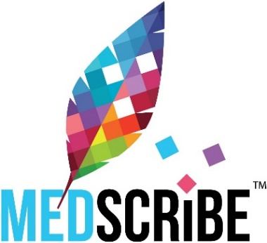 App Demo available on iTunes
- Let us explain how MedScribe can produce clinically relevant patient charts without sacrificing your providers’ and clinic staff’s valuable time.
What will you do with YOUR free time?

