miniMATHS
Maths In Nature Inquiries

Sponsored by the ACT Government Nature Play Grants Program and the Canberra Mathematical Association
1. How Many Leaves?

EYLF – Outcome 1: Children have a strong sense of identity

Children learn to interact in relation to others with care, empathy and respect when they...
display awareness of and respect for others’ perspectives

Educators promote this learning when they...
organise learning environments in ways that promote small group interactions and play experiences

This task provides an opportunity to:
- explore the concepts of “perspective” and “comparing”
- attempt the same task in different ways
- consider relationship between the individual and the group

1. How Many Leaves?
- Get a collection of leaves
- Draw a 20cm x 20cm square (approx.) on the ground
- Find how many of the leaves it takes to cover the square

Prompting questions
- Will it be the same if I change the way I arrange the leaves? Try several different arrangements.

Variations
- Change the types of leaves used
- Change the size of the box
- Use bodies to measure big spaces

Big Ideas
- Area
- Measure
- Count
- Space

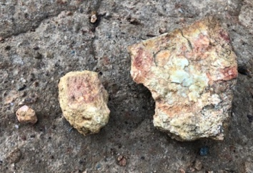

2. Big Bigger Biggest

EYLF – Outcome 2: Children are connected with and contribute to their world

Children become socially responsible and show respect for the environment when they...
explore relationships with other living and non-living things and observe, notice and respond to change

Educators promote this learning when they...
provide children with access to a range of natural materials in their environment

This task provides an opportunity to:
- explore the concepts of “change” and “growth”
- discuss how growth happens
- make predictions about change
- formulate strategies for coping with change

2. Big Bigger Biggest
- Find an object – stone, leaf, stick etc
- Now find a bigger one
- Now find an even bigger one than that
- Line them up – big bigger biggest
- Keep adding to your line

Prompting questions
- Where do you put new rocks in the line?
- Can you take away some rocks to make your “biggest” the “smallest”?

Variations
- Small Smaller Smallest
- Long Longer Longest

Big Ideas
- Comparison
- Visualization
- Prediction
3. Same Same Different

EYLF – Outcome 2: Children are connected with and contribute to their world

Children respond to diversity with respect when they...
notice and react in positive ways to similarities and differences among people

Educators promote this learning when they...
plan experiences and provide resources that broaden children’s perspectives and encourage appreciation of diversity

This task provides an opportunity to:
- explore the concepts of “same” and “different”
- discuss diversity
- model and sort based on specific criteria
- celebrate similarities and differences

3. Same Same Different
- Get 3 objects
- Ask partner to say which two are the same and which one is different
- Discuss attributes that are the same and different
- Swap roles with partner

Prompting questions
- Can you keep the same objects but have a new “different” object?

Variations
- Same Same Same
- Different Different Different

Big Ideas
- Same and different
- Justifying an idea
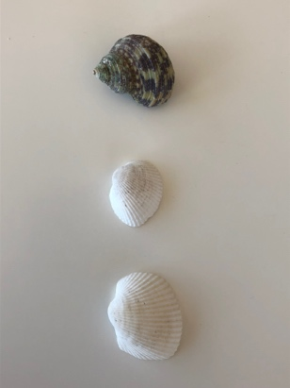
- Finding relationships
- Compare and contrast

4. One More

EYLF – Outcome 2: Children are connected with and contribute to their world

Children become aware of fairness when they...
are empowered to make choices and problem solve to meet their needs in particular contexts

Educators promote this learning when they...
engage children in discussions about respectful and equal relations

This task provides an opportunity to:
- explore the concepts of “equal” and “more”
- discuss how inequity happens
- explore sharing equally
- develop strategies for dealing with inequity

4. One More
- Make a line of objects
- Ask partner to make a line of similar objects “and one more”

Prompting questions
- Can you make a line that uses the same number of objects as the first line but it is longer? shorter? (by changing the spacing between objects)

Variations
- Make a line that is “one less”, “two more”
- Make more lines of the same number of objects beneath the first line to make a rectangle
- Change orientation of line from horizontal to vertical or diagonal

Big Ideas
- One-to-one correspondence
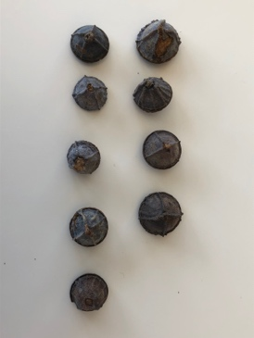
- Equivalence
- More than, less than
5. Shadows

EYLF – Outcome 2: Children are connected with and contribute to their world

Children become socially responsible and show respect for the environment when they...
demonstrate an increasing knowledge of, and respect for, natural and constructed environments

Educators promote this learning when they...
model respect, care and appreciation for the natural environment

This task provides an opportunity to:
- explore the concepts of “light” and “shadow”
- record and describe changes to shadows over time
- develop awareness of natural phenomena

5. Shadows
- Draw the outline of the shadow of a tree, plant, person, toy, building etc using coloured chalk, a stick in sand etc
- Revisit at different times of day and redraw using different coloured chalk etc to show change

Prompting questions
- How does the shadow change?
- How do you make a shadow?

Variations
- Make a “shadow gallery” in sandpit or garden
- Take photos of shadows
- Trace shadows onto large sheets of paper
- Play shadow tag

Big Ideas
- Shape
- Change
- Time
6. Stacking

EYLF – Outcome 3: Children have a strong sense of wellbeing

Children take increasing responsibility for their own health and physical wellbeing when they...
combine gross and fine motor movement and balance to achieve increasingly complex patterns of activity including dance, creative movement and drama

Educators promote this learning when they...
provide a wide range of tools and materials to resource children’s fine and gross motor skills

This task provides an opportunity to:
- explore the concepts of “balance” and “gravity”
- practice perseverance to achieve a task
- reflect on experiences to modify behavior
- describe “balance” as a requirement of growth

6. Stacking
- Get 3 stones
- Stack them one on top of the other
- Add another stone to the stack
- Continue until it falls down

Prompting questions
- How many stones can you stack?
- What makes them fall down?
- Do you always need to put the big ones on the bottom?

Variations
- Use materials other than stones
- Put the biggest stone on the top

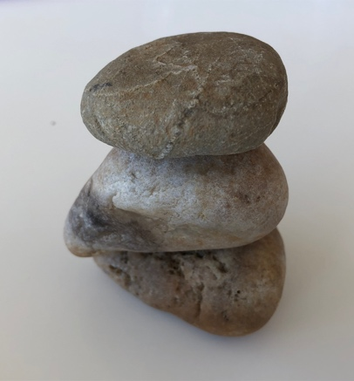
Big Ideas
- Prediction
- Balance
- Size

7. Make a Star

EYLF – Outcome 4: Children are confident and involved learners

Children develop dispositions for learning such as curiosity, cooperation, confidence, creativity, commitment, enthusiasm, persistence, imagination and reflexivity when they...
use play to investigate, imagine and explore ideas

Educators promote this learning when they...
provide learning environments that are flexible and open-ended

This task provides an opportunity to:
- explore the concept of “alternating turns”
- share and cooperate to produce a star
- explore concept of repeated addition
- develop awareness of radial symmetry

7. Make a Star
- Put down a number of objects in a circle or bunch
- Partner puts down a corresponding object on the outside of the circle, one for each original object
- Keep adding objects to each arm of the star as it grows

Prompting questions
- How big can you make the star?
- Does each arm of the star need to have the same number of objects?

Variations
- Start with different numbers of objects – 3 (triangle), 4 (square) etc and compare the resulting stars
- Use combinations of different materials to grow star
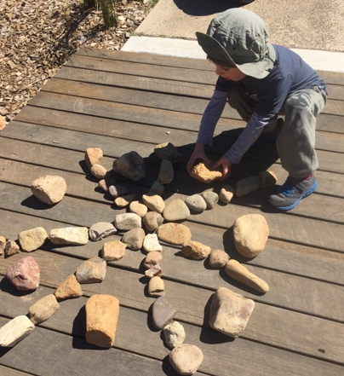
Big Ideas
- Repeated addition
- Symmetry
- Growing patterns
- Decreasing patterns

8. Does It Float?

EYLF – Outcome 4: Children are confident and involved learners

Children develop a range of skills and processes such as problem solving, inquiry, experimentation, hypothesising, researching and investigating when they...
manipulate objects and experiment with cause and effect, trial and error, and motion

Educators promote this learning when they...
plan learning environments with appropriate levels of challenge where children are encouraged to explore, experiment and take appropriate risks in their learning

This task provides an opportunity to:
- explore the concepts of “cause” and “effect”
- predict and test hypotheses
- develop awareness of natural phenomena

8. Does It Float?
- Half fill a shallow tub with water
- Experiment with objects to find three that float and three that sink

Prompting questions
- How are the floating objects similar?
- How are the sinking objects similar?
- Can you sink a floating object?
- Can you make a “boat” to support a sinking object?

Variations
- Make predictions about the floating ability of untested objects then test them

Big Ideas
- Sinking, floating
- Heavy, light
- Cause, effect
- Prediction
9. Rolling

EYLF – Outcome 4: Children are confident and involved learners

Children develop a range of skills and processes such as problem solving, inquiry, experimentation, hypothesising, researching and investigating when they...
make predictions and generalisations about their daily activities, aspects of the natural world and environments, using patterns they generate or identify and communicate these using mathematical language and symbols

Educators promote this learning when they...
provide opportunities for involvement in experiences that support the investigation of ideas, complex concepts and thinking, reasoning and hypothesizing

This task provides an opportunity to:
- explore the concepts of “speed” and “distance”
- make predictions and test them
- repeat a task and record results
- reflect on variations in results from testing

9. Rolling
- Get a collection of objects – stones, balls, toys etc
- Roll them down a slope
- Record how far they go

Prompting questions
- Which one went the furthest?
- If we tested the same object again, would it go the same distance as the first time?
- Why do some go further than others?
- How can you make something go further?
- How do objects roll – straight? wobbly? etc

Variations
- Change angle of the slope
- Change surface we roll on – dirt, grass, sand

Big Ideas
- Distance
- Slope, angle
10. Repeat My Pattern

EYLF – Outcome 5: Children are effective communicators

Children begin to understand how symbols and pattern systems work when they...
begin to recognise patterns and relationships and the connections between them

Educators promote this learning when they...
provide children with access to a wide range of everyday materials that they can use to create patterns and to sort, categorise, order and compare

This task provides an opportunity to:
- explore the concepts of “pattern” and “repeat”
- create, repeat and describe patterns
- explore connections between patterns and relationships
- develop awareness of regular cycles

10. Repeat My Pattern
- Make a pattern from your choice of materials
- Ask partner to continue the pattern
- Swap roles with partner

Prompting questions
- Can you keep the same objects but introduce a new object into your pattern?

Variations
- Change the pattern – partner removes something from your original pattern then continues on with the new pattern

Big Ideas
- Attributes
- Building on a pattern
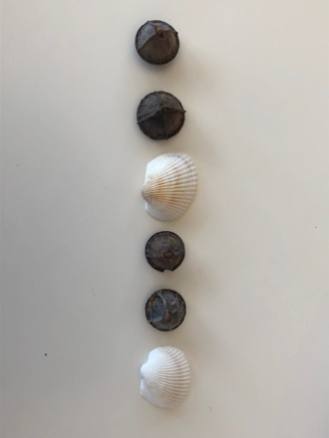
- Repeat

11. Informal Units for Measuring Distance

EYLF – Outcome 5: Children are effective communicators

Children interact verbally and non-verbally with others for a range of purposes when they...
demonstrate an increasing understanding of measurement and number using vocabulary to describe size, length, volume, capacity and names of numbers

Educators promote this learning when they...
include real-life resources to promote children’s use of mathematical language

This task provides an opportunity to:
- explore the concepts of “length” and “measurement”
- use a standard unit of measurement
- develop consistency in measurement by repeating a regular procedure

11. Informal Units for Measuring Distance
- Get a long stick
- Use the stick to measure the distance between 2 places
- Count each time you place down the stick and then move it on
- Try with a different stick

Prompting questions
- How far is 5 “sticks”? 10 “sticks”? etc
- Is the measurement the same when you change the stick?

Variations
- Try with different length sticks or different objects

Big Ideas
- Length
- Repeat
- Measure
- Compare
12. Insert you own idea here

EYLF – Outcome 5: Children are effective communicators

Children develop dispositions for learning such as curiosity, cooperation, confidence, creativity, commitment, enthusiasm, persistence, imagination and reflexivity when they...
are curious and enthusiastic participants in their learning

Educators promote this learning when they...
recognise and value children’s involvement in learning

This task provides an opportunity to:
- explore learning as their own responsibility
- use creativity and imagination to explore their world
- describe their wonderings about the world using their own language

12. Insert you own idea here

Prompting questions

Variations

Big Ideas

Thanks

I would like to acknowledge the Ngunnawal people, the tradition custodians of the land and carers for the magnificent environment in which Canberra is located and through which we are engaging in this project.

I would like to acknowledge the support of the ACT Government Nature Play Grant Program and the Canberra Mathematical Association in the production of this resource.

I would also like to thank the following people who contributed to the ideas and development of the resource:
Natalie Colbert, Richelle Fogarty, Emmaley Greene, Alex Hesterman, Jenny Lancaster, Tracy Logan, Maggie Quigley, Julie Rasmus, Margaret Rowlands, Lee Warmington, Anna Williams, Sue Wilson

Original artwork by Peter Tugwell, Red Knot Images

