Catalysts Nimbase Overview

Introduction
Nimbase is intended to be a complete publishing solution from Catalysts Ltd. It comprises:
- A choice of search / storage engines for storing and indexing product contents. Initially Rocket’s NXT publishing tools will provide the search / storage engine but both SQL and NoSQL products will be offered as alternatives during late 2018/ early 2019.
- Several easy to use search options ranging from a simple uncluttered search form to complex features which can be customised for a specific site or product.
- Subscription management which publishers can use to manage products, licenses, customers, orders, and renewals.
- Usage reports which can either be produced on demand through the subscription management system or automated on a regular schedule.
- Authentication and access control to both the subscription management administrator’s interface and to subscribers accessing online content. Authentication is used to verify that the request is genuine while access control restricts the use of features and access to online content according to the license(s) maintained in the subscription management system.
- Various add-ons are available which we have produced over the years and will continue to develop.
Nimbase is offered as a service hosted by Catalysts on cloud servers. Components of the service can also be purchased/licensed for use in-house.
A short description of the main components is provided below.

Nimbase Features and Components

Subscription Management
The Subscription Management system provides the features required to manage product content, licenses, customer accounts, and customer orders for a publishing site. A site will normally refer to an online site hosted as part of the NIMbase service but could also refer to an existing non-NIMbase website or hard copy products for fulfilment.
The screenshot of the dashboard shows the top-level view. Each publisher will log into and see only the information relating to their site(s). This screenshot illustrates the dashboard with infographics relating to current site usage statistics.
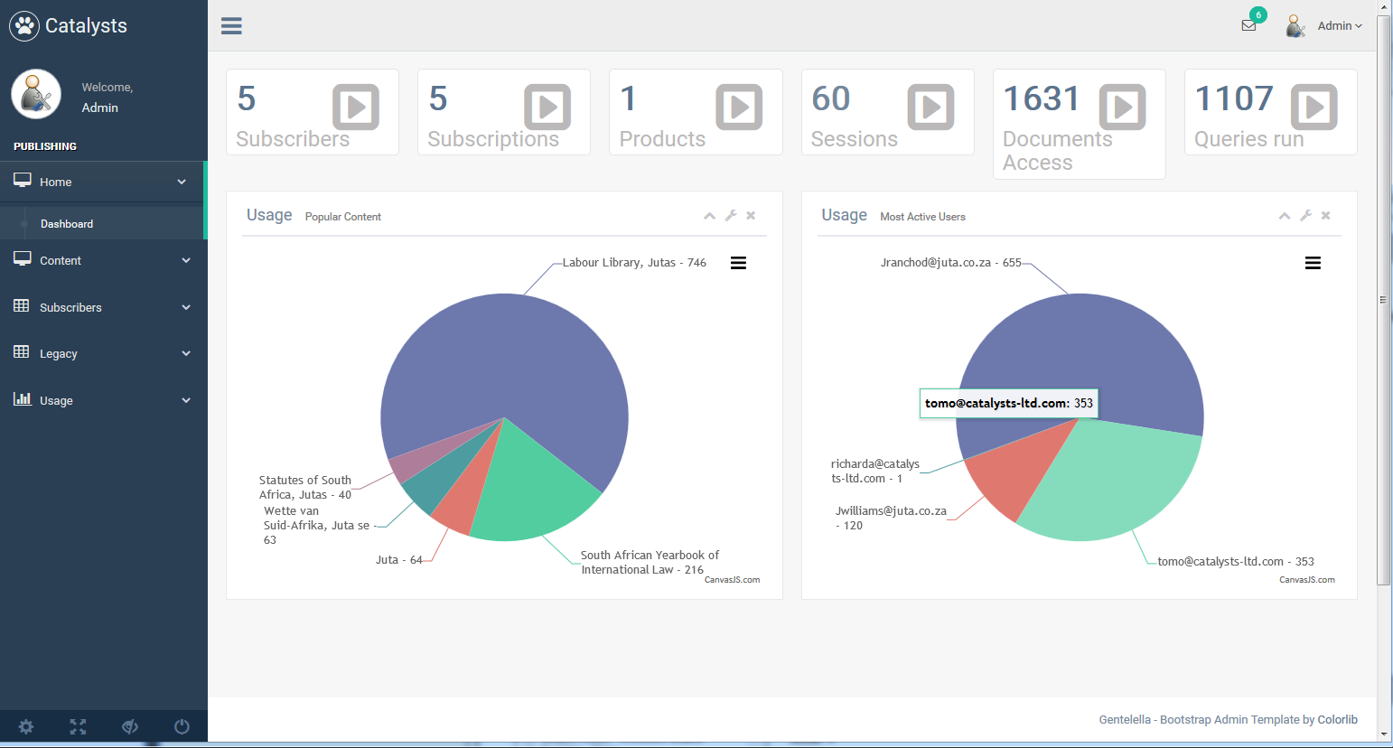
From a screen similar to the one shown above publishers will be able to:
- Manage customers
  - Add/change customers
  - Add/change customer orders
  - Add/change/remove customer login details, including IP addresses
- Manage content
  - Create new sites for subscription management
  - Add/change licences types, e.g. trial subscriptions to the current book, annual subscriptions to the current/previous book editions, etc
  - Set concurrency limits if required, e.g. a 10 user licence would be set to have a maximum of 10 simultaneous sessions to specific content
  - Add/change an external identifier which could be used to link usage statistics and customer orders back to information contained in an external (e.g. the publisher’s) customer database
- Request reports on an ad hoc basis
  - Usage reports including summary of logins and content accessed
  - Detailed report of documents accessed identifying the account used and time of access
  - Detailed report of search terms identifying the account used and time of access
  - List of logins including account used, originating IP address, and time of access
  - Identify orders due for renewal in the next 30 days and 60 days.

Subscriptions
By configuring the relevant license details in the Subscription Management system a wide set of business models can be offered that make use of the authentication and access features in the system. For example:
- By number of users:
  - Single user / no concurrent access to the content
  - Multiple user access up to an agreed concurrency limit, e.g. 2 user license, 3 user, 5 user, 20 user, etc
- By client location:
  - Single site based on one or more IP addresses
  - Multiple sites based on one or more IP addresses for each site
- By period:
  - Number of days from first login to the site (typically used for trial subscriptions)
  - Number of months / annual, either from first login or with a specific expiry date.
- By number of documents accessed:
  - Number of documents downloaded / viewed, e.g. set a limit of 10 documents which can be viewed or downloaded. Multiple searches can be made without affecting the counter (typically used for trial subscriptions)
- By content:
  - Content for single products, e.g. the 2018 edition of a book.
  - Content for multiple products, e.g. the 2018 editions of a book and it’s companion guide.
Each license defined in the system will be configured using some combination of the above, e.g.
- annual licence to the 2018 product content for a university site
- annual licence to the content of three related products for 5 concurrent users.

Integration with external systems
We are currently working on an interface which will enable a publisher’s in-house or cloud-based systems to interface directly with the Subscription Management system, e.g. to update customer and order details. For the technically inclined this type of interface is called a RESTful API.
This is scheduled for release in quarter 2 of 2018.

Reporting
In addition to the reports listed under Subscription Management custom reports can be developed and provided as CSV files, in PDF format, or viewable as HTML. Please let us know if you would like specific details not mentioned here.
Reports can either be requested on an ad hoc basis from the Subscription Management system or automated to run on a regular basis. We had anticipated displaying the reports in the browser or saving them to a folder on the server where they can be retrieved using an FTP client. Depending on the size of reports it may be possible to email them to an email address.

Service Provision

Catalysts cloud server hosting
Cloud servers are virtual computers which to all intents and purposes operate like a physical server. They run the same operating systems, can be configured like the existing system, programs can be installed, etc. However, each cloud server uses resources from a pool of physical computers making them less vulnerable to specific hardware failures. Once a cloud server has been set up it can be cloned allowing several instances to be run at the same time, subject to licence restrictions. This feature allows for on demand changes, increasing the number of servers available for the website during a busy period for example.

Pros and Cons:
- More resilient due to reduced reliance on specific hardware.
- One or more clones of the content/search server can be managed by a Load Balancing service to provide improved response at busy times and more resilience. There is an extra charge for the Load Balancing service
- More suited to handle an increase in usage by running clones of the search server during busy periods.
- Potentially more resilient to transatlantic communication problems by operating one or more clones of the search server in the US, Europe, or other regions. (Note: this feature is described on the ISP fact sheets but we have had mixed results and to date have found the best responses running from the UK.)
- Improve efficiency by operating each cloud server with a single function, e.g. as a subscription management/authentication server or content/search server.

How it works
When a subscriber opens a new browser session for the publishing site they will be directed to one of the authentication cloud servers (by the load balancer where more than one cloud server is in use). The information used to authenticate the user will either be taken from a central database under the control of the Subscription Management system, or by the referral from the publisher’s system.
Once authenticated, subscribers will be able to access content, search, view documents, etc. within the limits set by their current licenses.
Where two or three cloud servers are providing the site browser sessions will be spread across the servers, usually on a shortest response basis to spread the load as evenly as possible. If one server stops responding, sessions on that server will be redirected to another cloud server and automatically authenticated to minimize any inconvenience.

Based in-House
Individual components can be licensed and run in-house, e.g. the subscription management system or one of the search/storage engines. Please contact us for more information.

AWS / Azure / Google availability
The subscription management system will be available to run on one of these commercial cloud services from Q2/2018.
Rocket’s NXT tools are unlikely to be made available on these cloud services so the full Nimbase service will not be available from one of these cloud services immediately. However, the alternative search/storage engines mentioned above which are due in Q2/3 2018 can be operated on one of these cloud services.

Moving an existing site to Nimbase - implementation details
The steps involved in moving from an existing system to our Nimbase cloud servers are:
- Identify and make any specific changes requested by the publisher to the Nimbase system, e.g. custom reports.
- Convert existing content as necessary (e.g. convert to XML or HTML with suitable mark up to meet the search and presentation requirements
- Site and content branding (i.e. the user interface / layout / styling used by the site).
- Provide publisher with access to the Subscription Management system. In the short term this could be used to add new accounts or details alongside the existing methods of authenticating existing accounts by an inhouse system.
- Copy any existing IP details to the Subscription Management system.
- Testing by both Catalysts and publisher.
- DNS setup: sites can use the nimbase-hosting.com domain or one provided by the publisher.




Appendix 1: Schematic of hosted service with multiple cloud servers
Browsers
Publisher (Subscription Management)

Cloud based Load Balancing


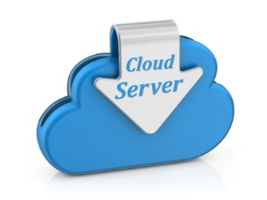
ISP
Search/storage webservers (clones)

Authentication / Subscriptions server

Appendix 2: About Catalysts

Catalyst’s Contact details:
Technical support for Nimbase hosted sites is available by email: techsupt@catalysts-ltd.com.
This email address is monitored Mon-Fri during working hours.

Sites hosted by Catalysts:
Catalysts Ltd have been hosting sites for commercial and corporate publishes for over 17 years. Current and past clients include …….

