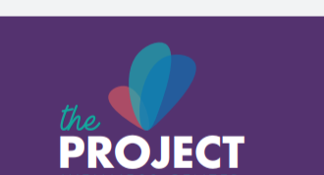
Likes: color tones, vibrant, bold, like the cursive “the” gave a tenderness feel
Dislikes: too feminine, symbol made people think of NBC peacock logo, and “is there other fonts to look at or play on the lettering design?
Overall, people felt initially it feels like us but what does the symbol mean? People felt the symbol did not represent what we do or how we do it such as taking our services into the community, connection, neighborhood medicine, we are a balance between medical services and social services. BUT we serve all income levels and color, in fact, 95% have insurance and 65% are NOT low income. Many of our patients are in transitional points in their life.

Below is a slight variation, but same feedback
