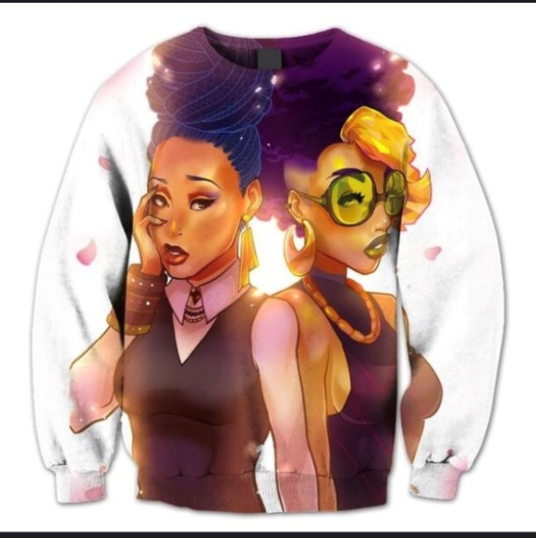
I like this but I have my own version I would like to have made. I want to keep the cartoony look but I want to have the females look a bit more real.

The female with her hand on her face I would like her nose to look less like plastic surgery and more like this nose: 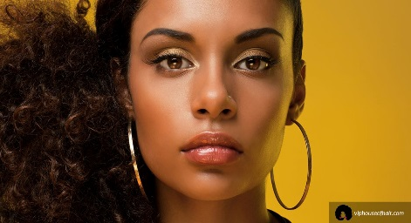
I need her upper lip to be fuller like this and her eyes to have the same shape and Fuller eyebrows as well. 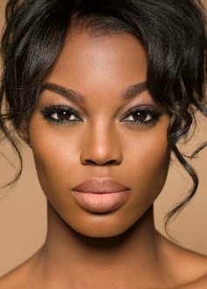

For her earrings I would like: 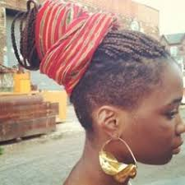

Her hair instead of the blue braids I would like it in a head wrap like this: 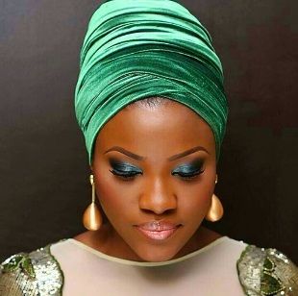

The girl with the glasses I would like her earrings to be this shape but gold: 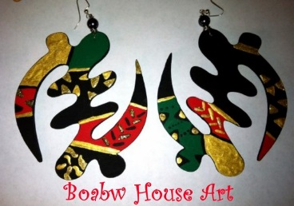 and her hair the yellow to be like a royal blue, a more chocolate skin tone, the lens in the glasses to be more green. A little less side boob.
Her necklace I would like: 