Advanced Hearing Packaging

- Hearing Aid Selection Guide
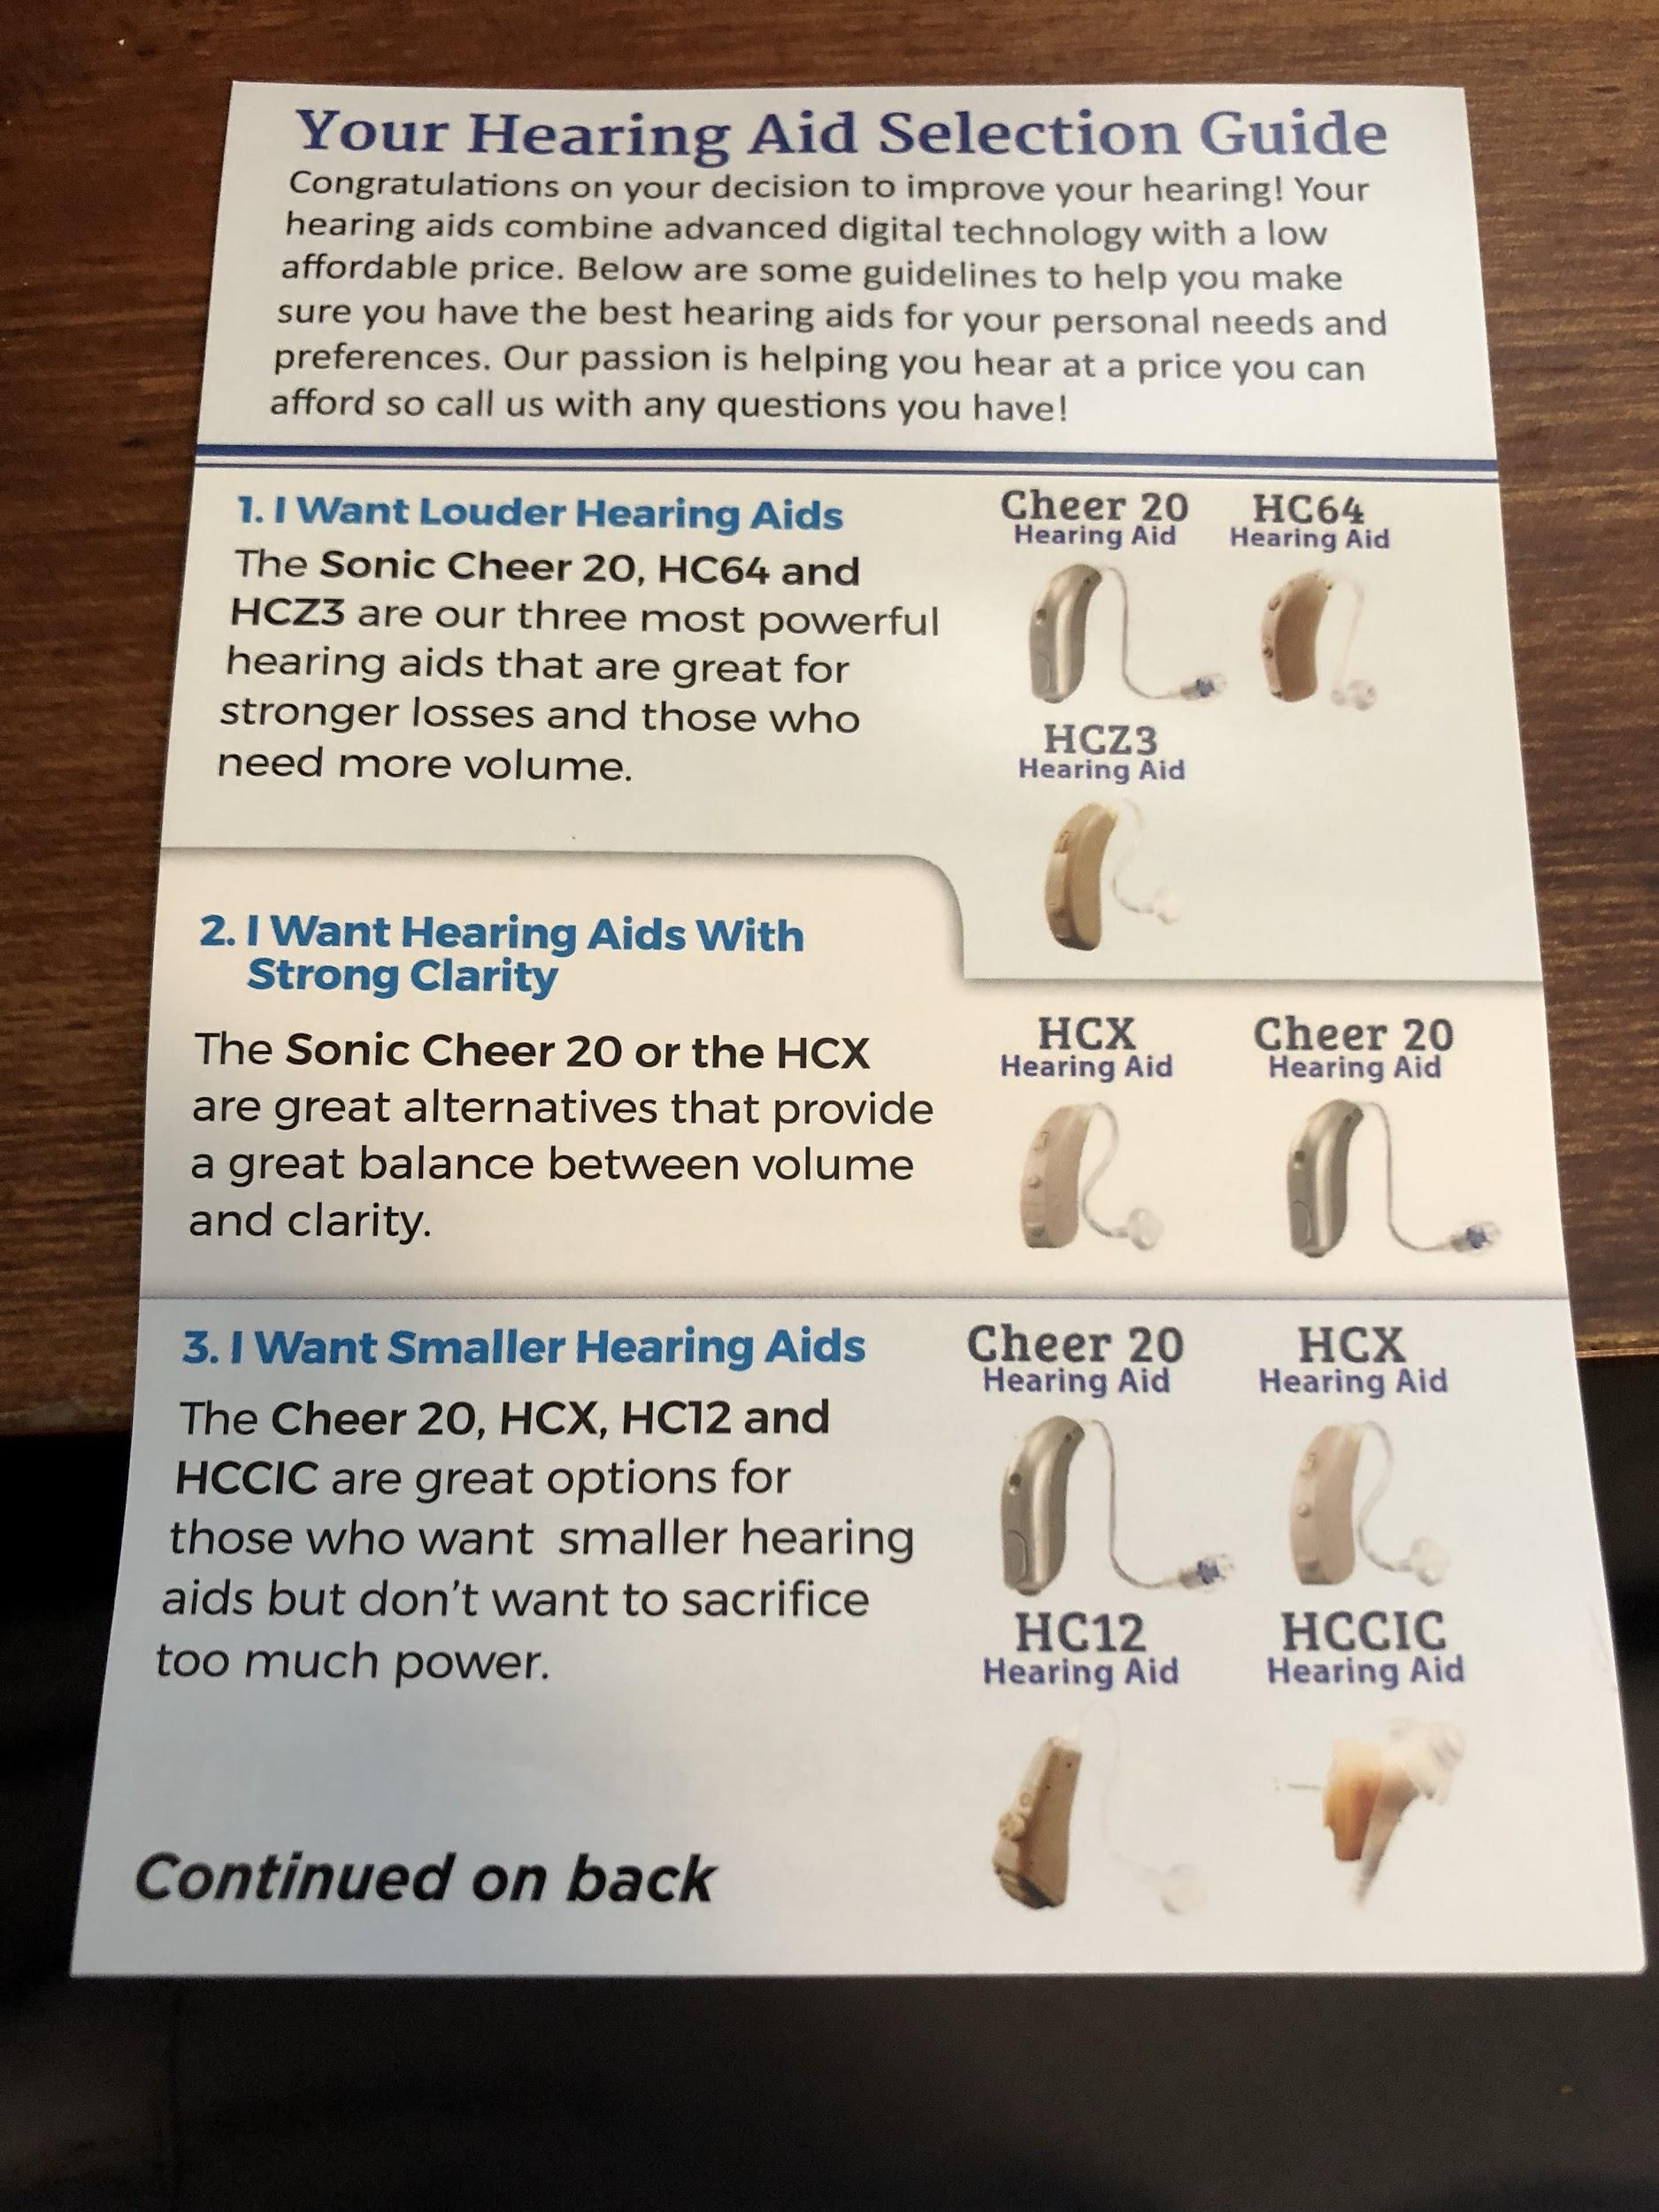

- Referral Card + Code
- Manual
  - Contents
  - Images of included parts
  - Warranty info
  - Congrats/welcome
  - Part diagram
  - Assembly
  - Choosing a dome
  - Charging
  - Charging cont., turn device on/off
  - How to put it on
  - Thick tube assembly
  - Cleaning and maintenance
  - Volume and program settings
  - Troubleshooting
  - Technical info
  - Benefits

MD Hearing Packaging

- Offer card ($25 Off another hearing aid) - we should do $50 off another pair



- Back side of offer card: benefits of hearing, fear based about brain health etc.
  - Use it or lose it (hearing deterioration)
  - Less strain on the brain
  - Rich and balanced sound
  - Higher awareness and safety
  - Clearer speech

- Journey to better hearing insert
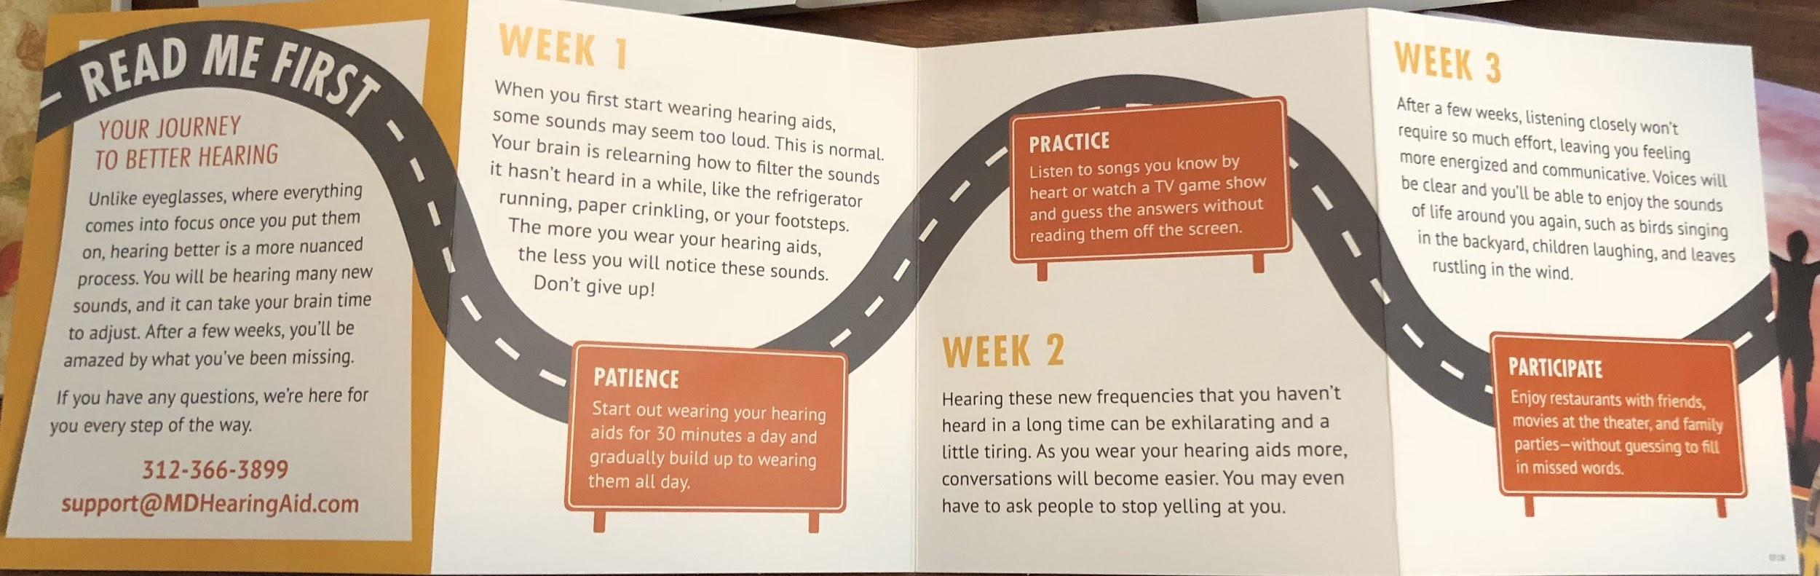

- User manual (very detailed)
  - Congratulations/welcome
  - Support info
  - Table of Contents
  - Package contents, diagrams of parts and of device
  - Testimonials
  - Quick start guide (3 easy steps)
    - Insert the battery, remove it, tips (all with diagrams)
    - Place in ear (diagrams)
    - Adjust volume
  - Replacing tips and tubing (diagrams)
  - Using different tube sizes
  - Care and cleaning
  - Program selection
  - Using the telephone
  - Troubleshooting
  - Return policy

Eargo Packaging

- Quickstart guide, foldout
  - 4 easy steps
  - What’s included
  - Diagram
  - Outline of each step
- Referral slips to give to friends to try a free sample
- Stickers to not use eargo in the shower
- Cleaning kit etc.
- SUPER detailed manual
  - Welcome
    - 4 easy steps
    - What’s in the box
    - diagrams
  - Indications, warnings, disclaimers
  - Cleaning
  - Getting to know Eargo (diagrams, explanation of all parts)
  - Charging, turning on device, diagrams etc.
  - Inserting and removing device, diagrams etc
  - Finding the perfect fit, ear tip etc. (diagrams)
  - Adjusting sound
  - Hearing journey, first month and beyond
  - Eargo care
  - Share the love (referrals)
  - Troubleshooting
  - Support
  - Appendix

Nano Goals

- Quickstart guide
  - 4-6 easy steps
  - What’s included
  - Diagram of device itself
  - Detail the steps quickly to get started, with diagrams (similar to Eargo)
- Referral slip (could be one slip with multiple tear-offs)
  - Give to a friend and they get $50 off
- Offer slip
  - Code for $50 off your next pair
- Hearing journey insert (condition them to wait 6-8 weeks)
- Manual
  - Welcome
  - Contents
  - What’s included in box (diagrams/pics and descriptions)
  - Diagram of device (buttons, etc)
  - Testimonials?
  - Quick start guide (turn on/off (charge or battery insert), adjusting volume, attaching tip
  - Replacing ear tips, find perfect fit
  - Maintenance
  - Troubleshooting
  - Warranty/support

