
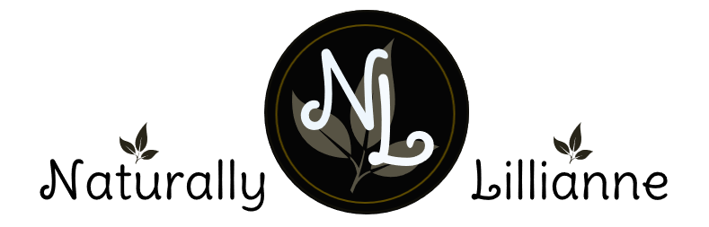
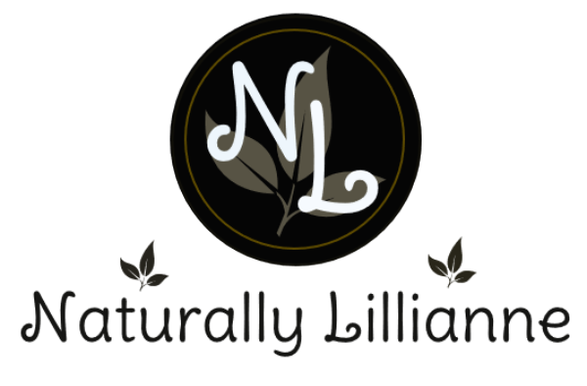
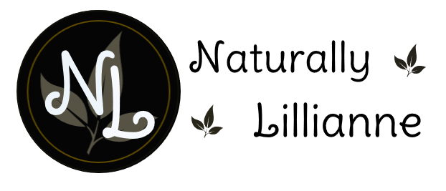

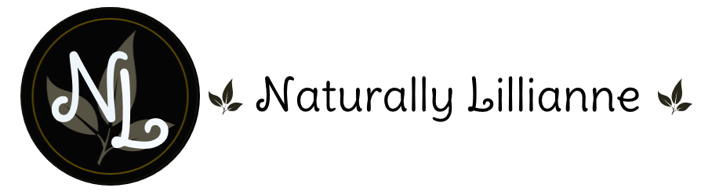



HONEY OATS LAVENDER
LEMONGRASS & CEDARWOOD
ROSE GERANIUM & MANDARIN
LAVENDER MINT
SWEET ORANGE &PATCHOULI
SANDALWOOD

