
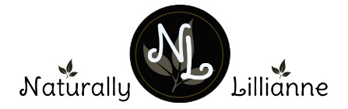


Six kinds of stickers to include the following – each variety will have different ingredient list
HONEY OATS LAVENDER
LEMONGRASS & CEDARWOOD
ROSE GERANIUM & MANDARIN
LAVENDER MINT
SWEET ORANGE &PATCHOULI
SANDALWOOD

Back of label Oval size: 63.5 x 42.3
to include Logo, web site details and ingredients list and leaf
All of Sticker to be Kraft paper – band to be 30mm W x 170mm L
Ingredients kedjfhasdbhasb vbvajsbdlbabhsdlvbalfjgsadhfvkjdan
110gms NET
HANDMADE
Honey Oats Lavender
www.naturallylillianne.com.au
Front of label- Oval size: 63.5 x 42.3
labelling would vary depending on type/ variety
This is logo only which would sit at the top of the bar of soap

