(Front cover – will send separately)

The BEST Flap Designs
The Cutting-Edge Incision Outlines for Successful Surgeries

Ziv Simon, DMD, MSc
Creator of SurgicalMaster®



Failure starts before you even put the blade to the tissue.

Failure starts with poor planning like not choosing the right flap design for your case.
Most of what we learn about soft tissue and flap design in dental schools and other programs is dogma & hype. Despite dentists going through major training, over 50% of all surgical cases have soft tissue problems. You too may be struggling right now.
Here’s the good news
- You can master soft tissue skills.
- You can learn to “see and think” like a surgeon.

This book teaches you the best flap designs for various procedures that I’ve used for past 20 years.
If you are currently struggling with flap design, my goal is not to further confuse you but rather give you clarity and confidence. I created a simple and concise method to convey the steps and illustrate so you fully understand.
I risk the impression of a simplistic “recipe book”. Here’s what I’m thinking. You are intelligent and know reading a 20 page book is part of the big picture. This is why I created an online course that goes right along with this book plus many other resources that teach you how to master the soft tissue.
Enjoy this book and master flap design.
To your surgical success!

Ziv.

Flap design #1
Functional crown lengthening
- Line angle--> line angle (2 teeth over)
- Intrasulcular
- Excision
- Full thickness flap

Single tooth
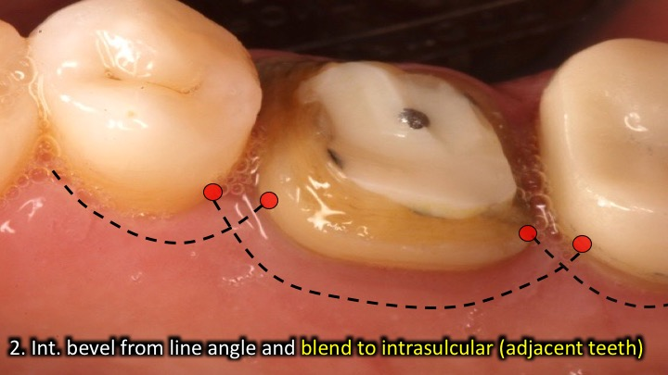
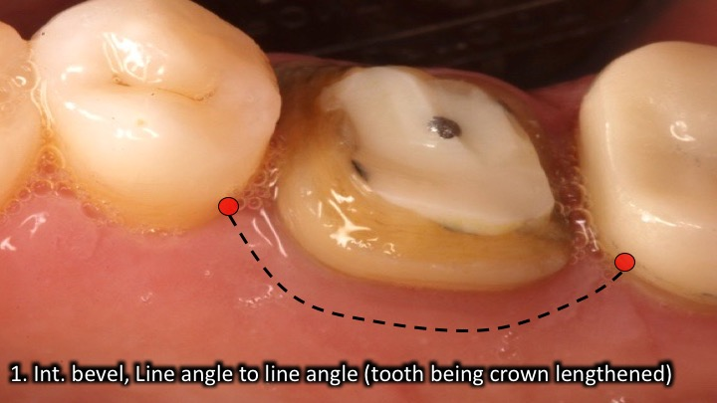

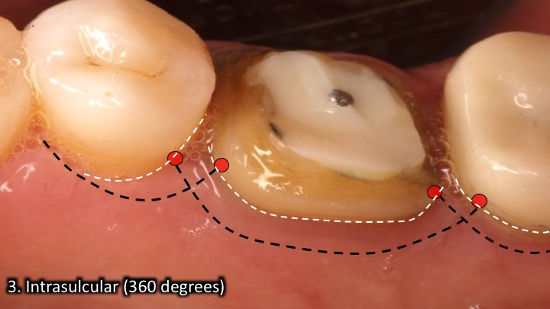
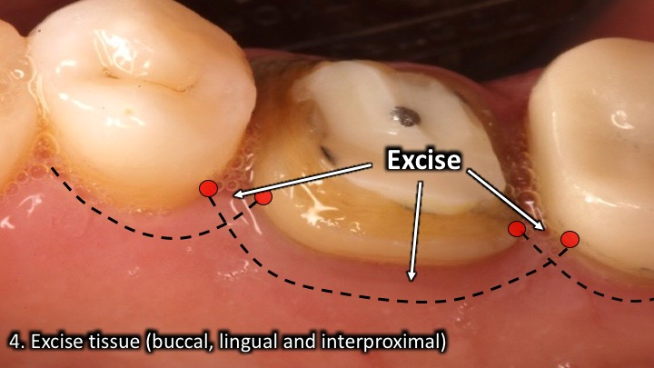

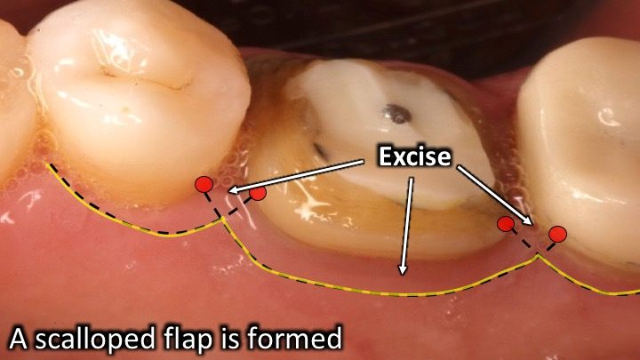
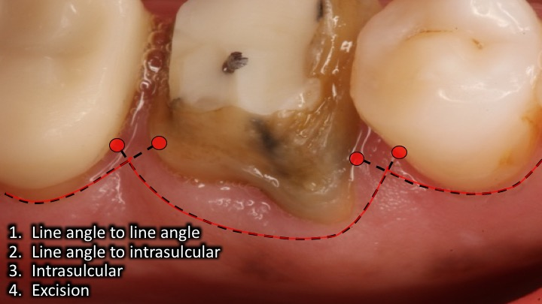

Multiple teeth
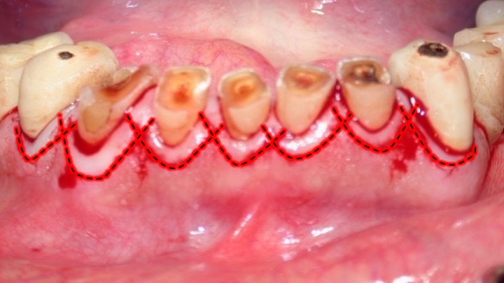
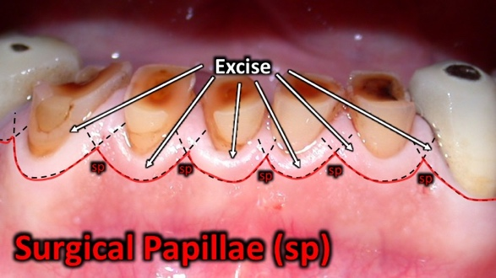

Flap design #2
Esthetic crown lengthening
- Line angle--> line angle (same tooth, buccal only)
- Intrasulcular line to angle excision
- Excision
- Secondary intrasulcular
- Connect with split thickness in the papilla
- Full thickness buccal flap
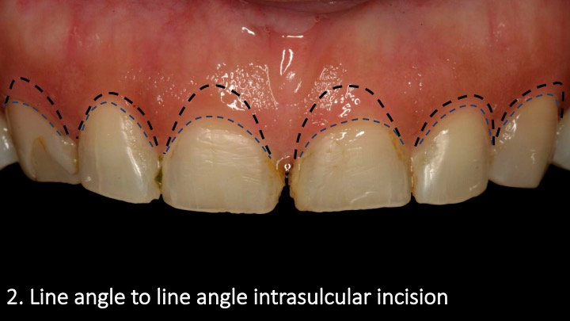
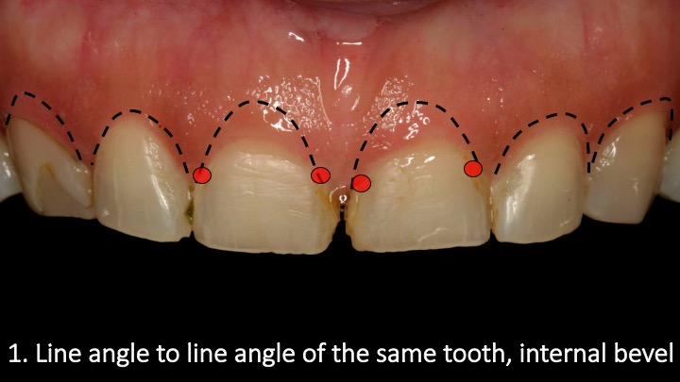

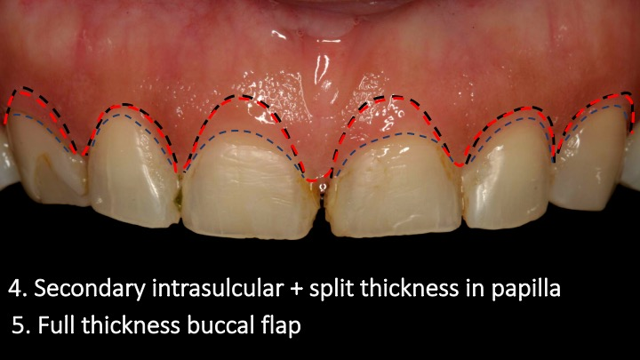
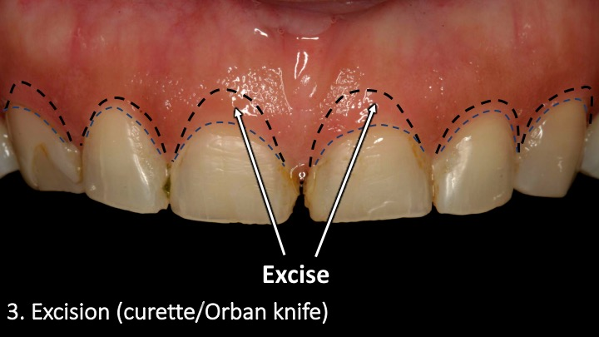

Flap design #3
Frenectomy
- Detach from gingiva – Parallel to attached gingiva
- Detach from Mucosa – Triangular
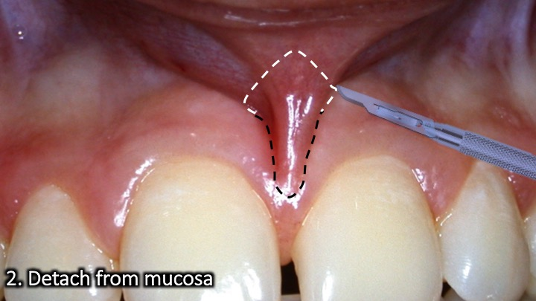
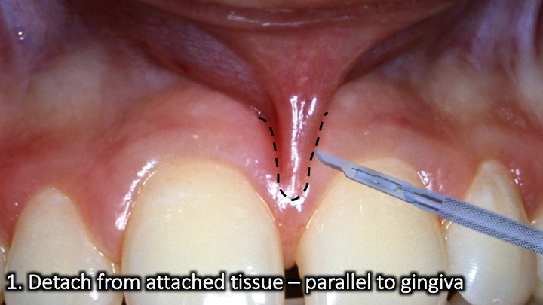
- Periosteal scoring – Straight incisions
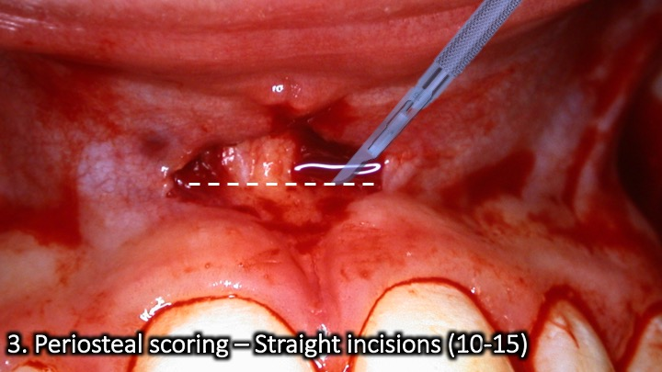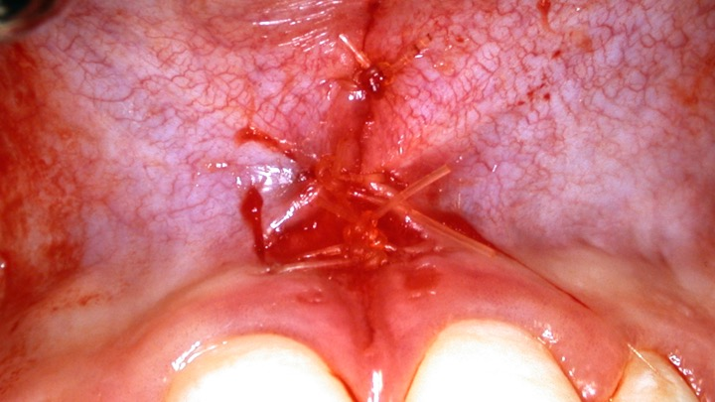

Flap design #4
Gingivectomy
- Line angle to line angle (skip 1 tooth)
- Vertical dissection or “scraping”

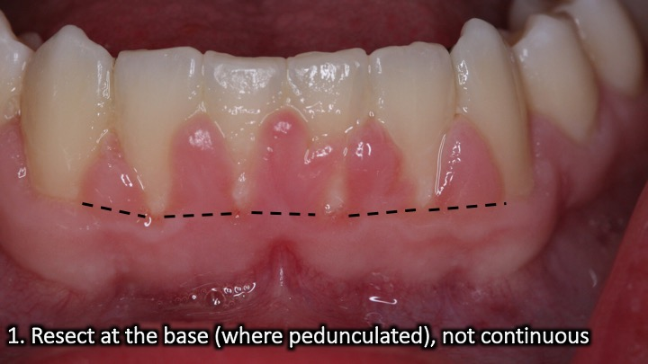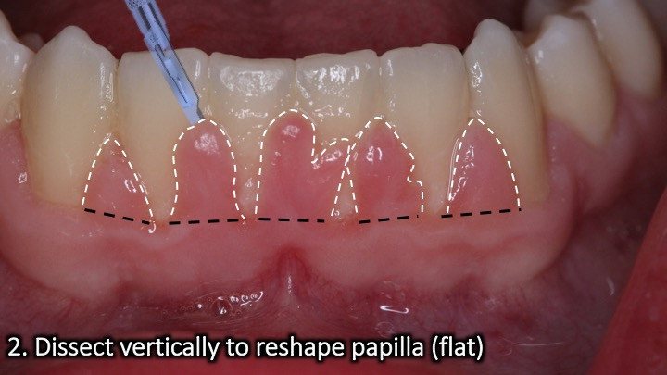

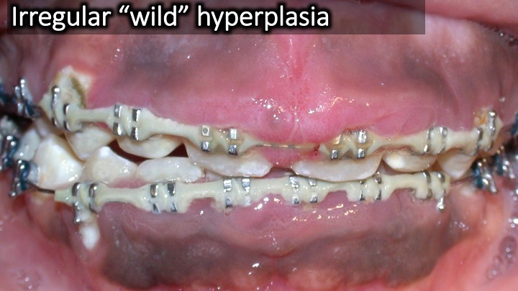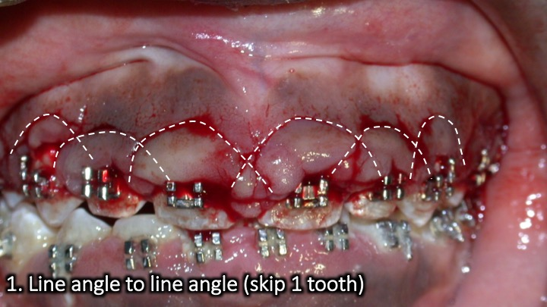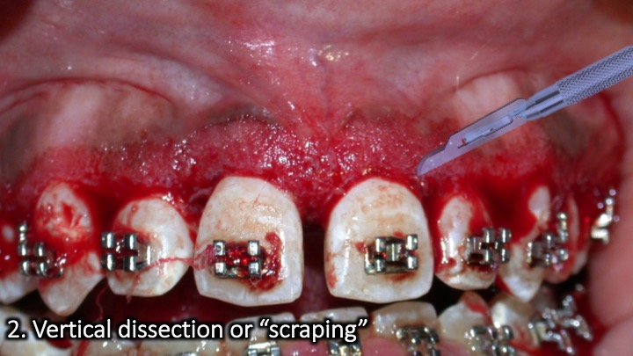

Flap design #5
Tuberosity reduction
- Parallel to palatal tissue (to bone)
- Parallel to buccal tissue (to bone)
- Connect distally
- Connect mesially
- Extend with mid crestal (mesial)

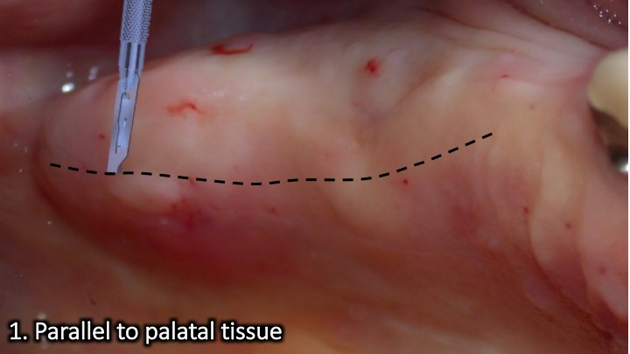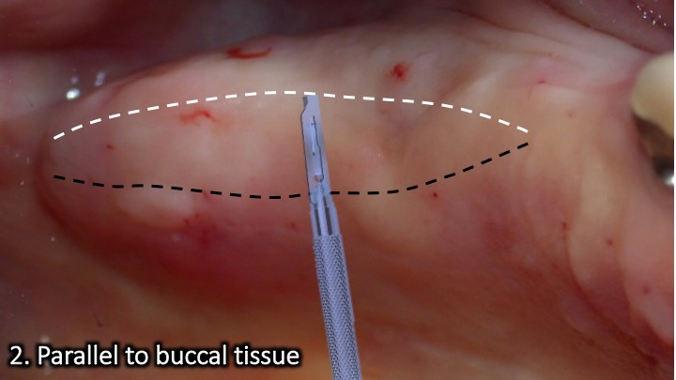
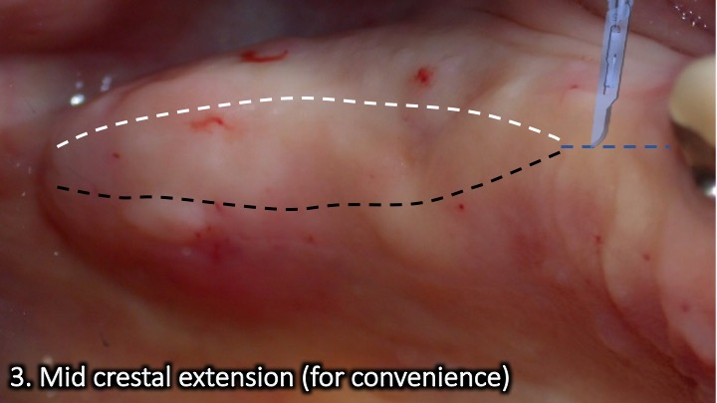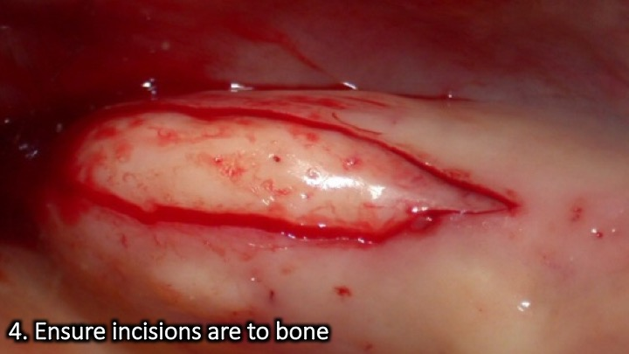
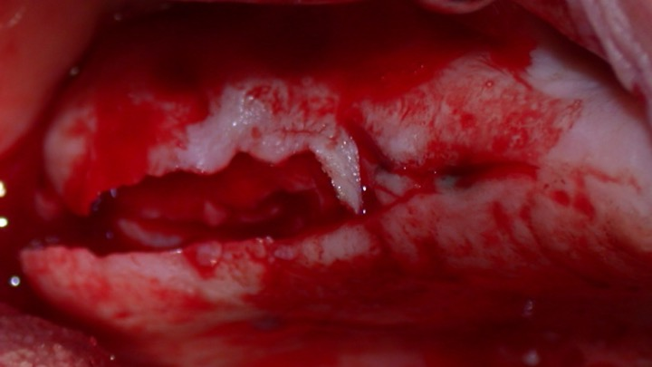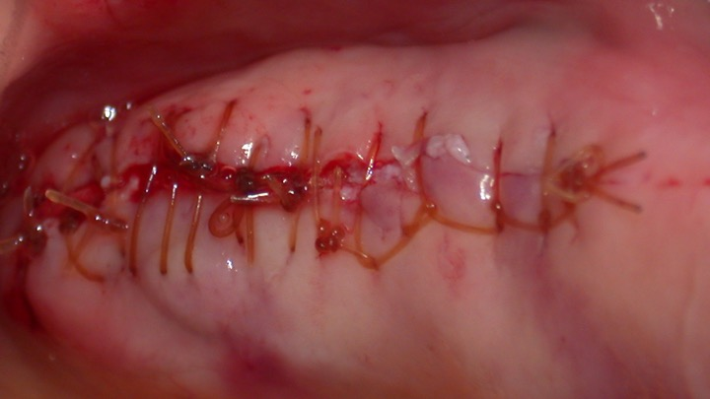

Flap design #6
Free gingival graft
Flap Recipient
- Split thickness at mucogingival junction
- Split thickness flap, stabilized apically
- De-epithelialize attached gingiva (parallel #15)
Flap Donor
- Split thickness rectangular outline (#15, 1.5mm)
- Split thickness dissection

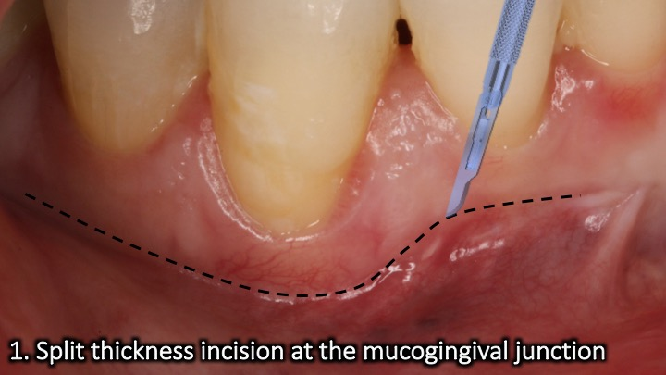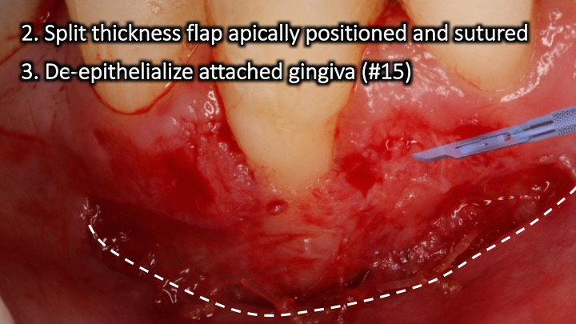
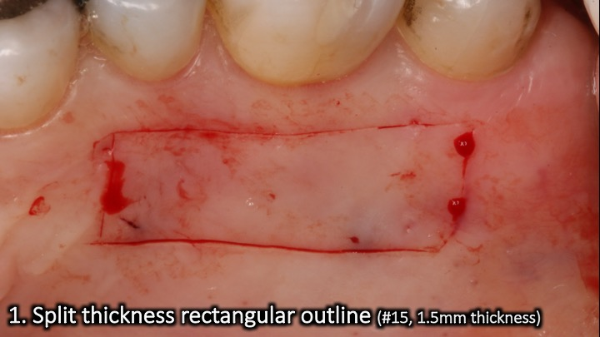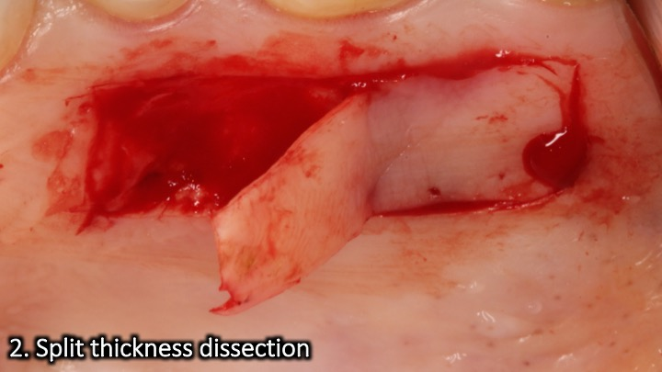

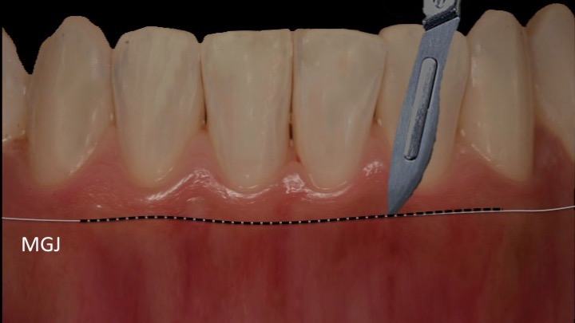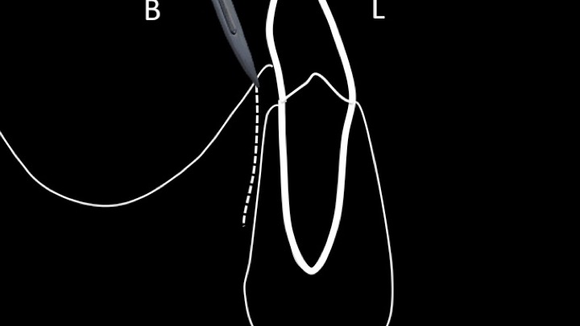
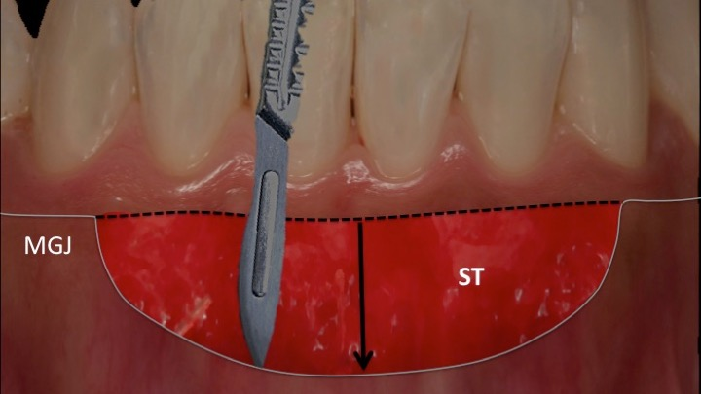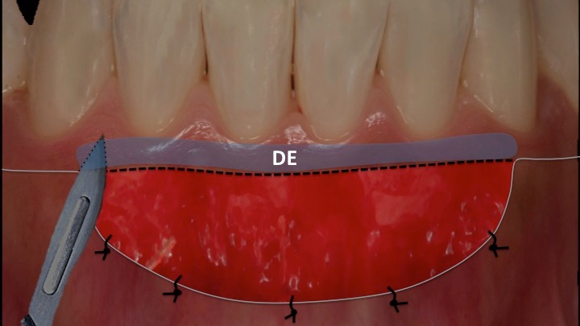

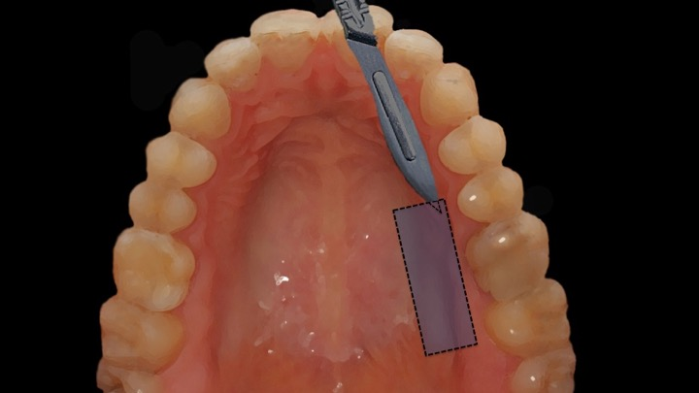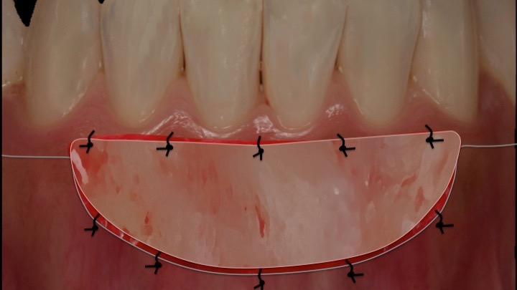

Flap design #7
Soft tissue ridge augmentation
Flap Recipient
- Split thickness at mucogingival junction
- Split thickness flap, stabilized apically
Flap Donor
- Split thickness rectangular outline (#15, 1.5mm)
- Split thickness dissection

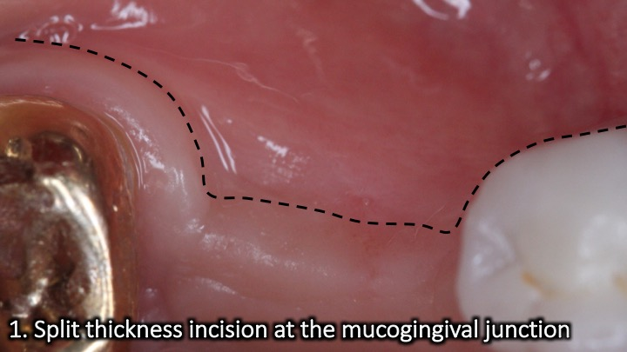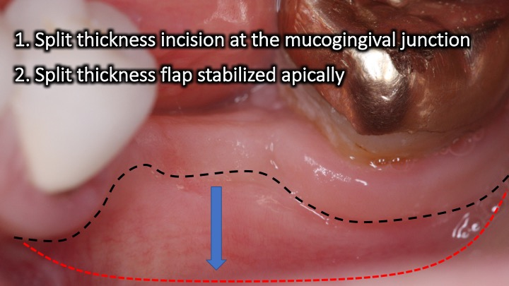
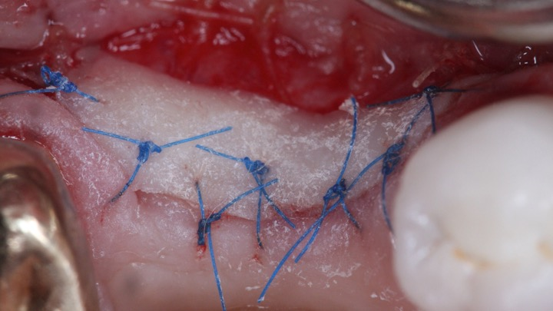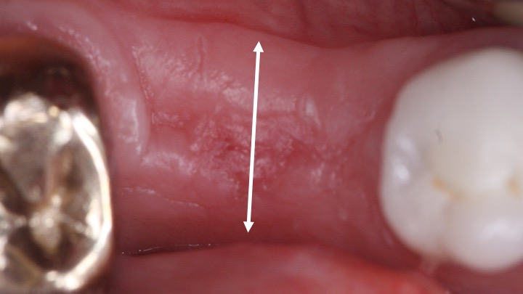
Flap design #8
Connective tissue graft (recipient site)
- Intrasulcular incision (#15)
- Split thickness triangular
3. Split thickness flap
4. De-epithelialize Papillae (buccal)
5. Coronally advance and stabilize

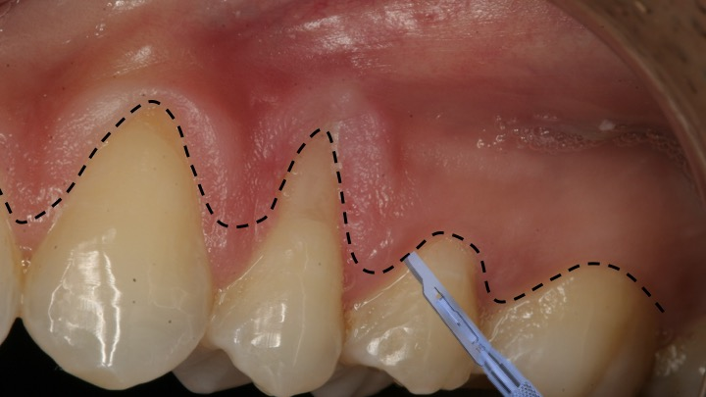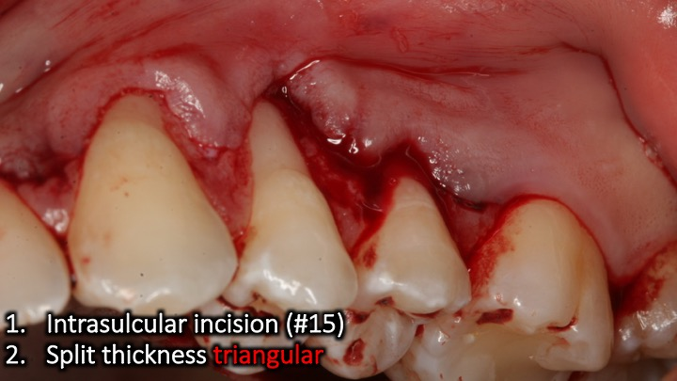
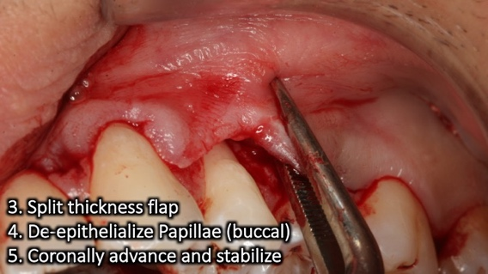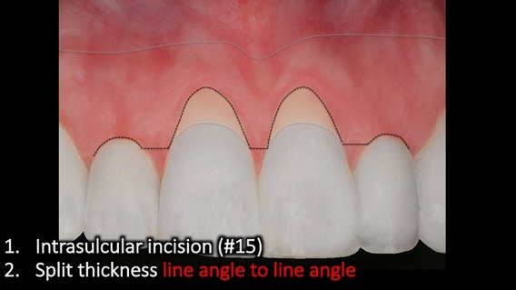
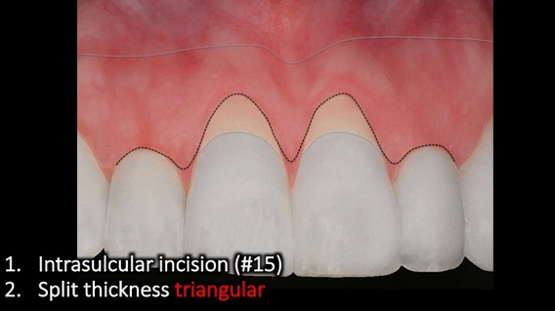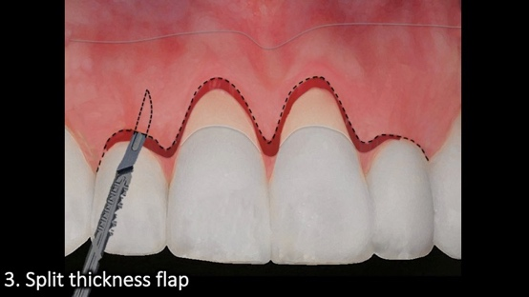
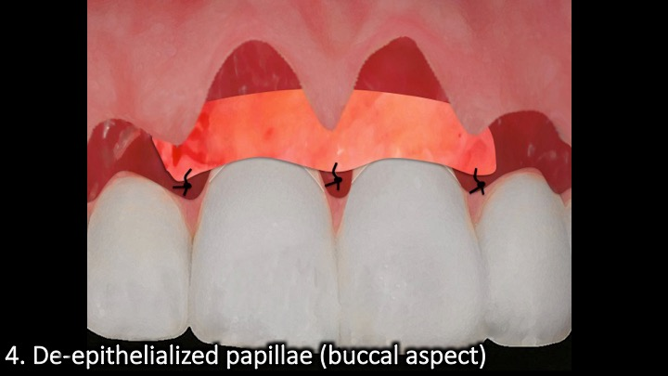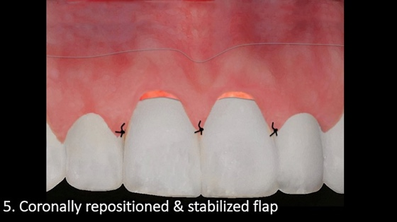

Flap design #9
Connective tissue graft (donor site)
- Straight to bone
- Superficial incision
- 3. Profound incision (or FTF)
- 4. Mesial detachment
- 5. Distal detachment
- 6. Apical detachment

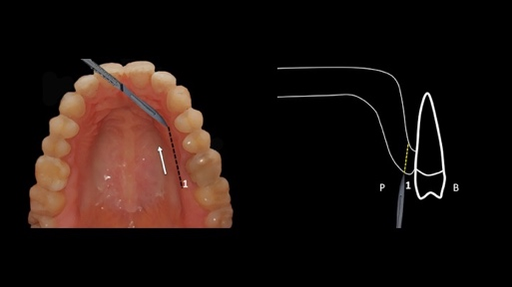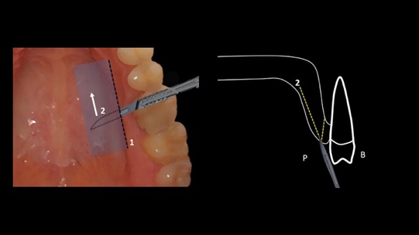
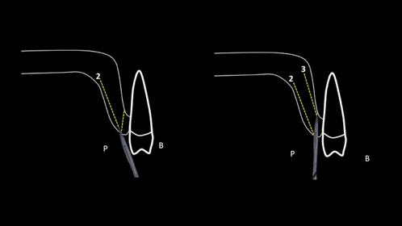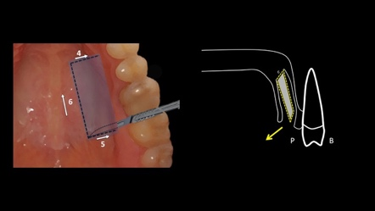
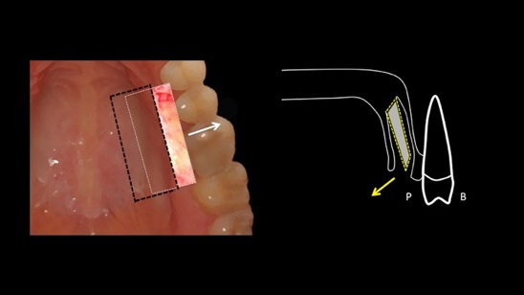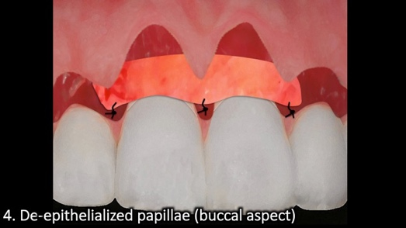

Flap design #10
Localized pouch (recipient)
- Intrasulcular incision (#15)
- Pouch apically/laterally beyond the MGJ
- Undermine and lift papilla
- Communicate to adjacent sulcus
- Coronally advance

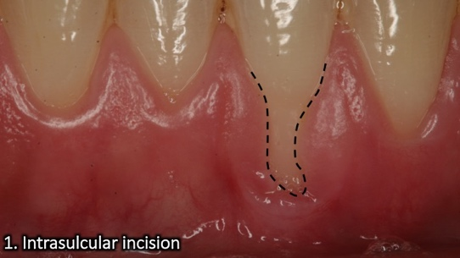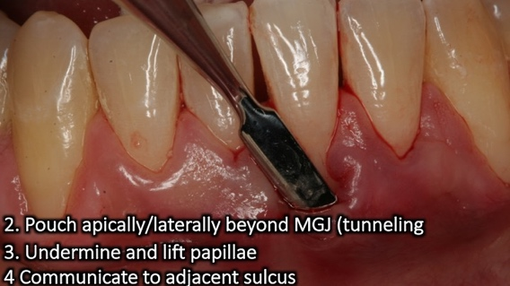
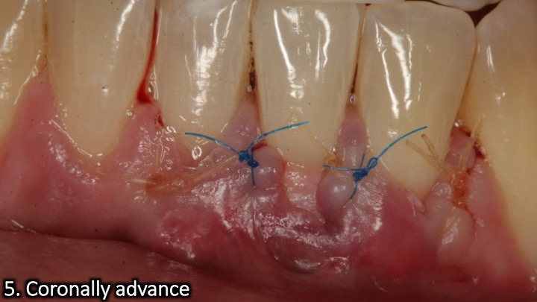

Flap design #11
Papilla sparing (papilla sparing)
- Spare 1-1.5mm
- Straight/curved vertical releases
- Beyond MGJ if contour graft
- Connect to crestal palatal incision on bone
- Full thickness flap
- Allows for contour graft and options (1 and 2-stage)

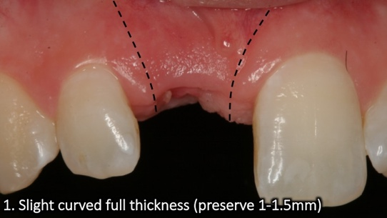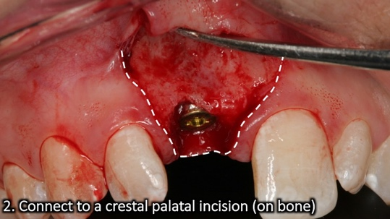
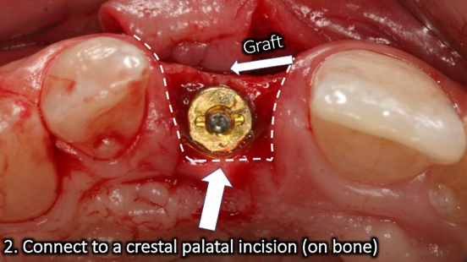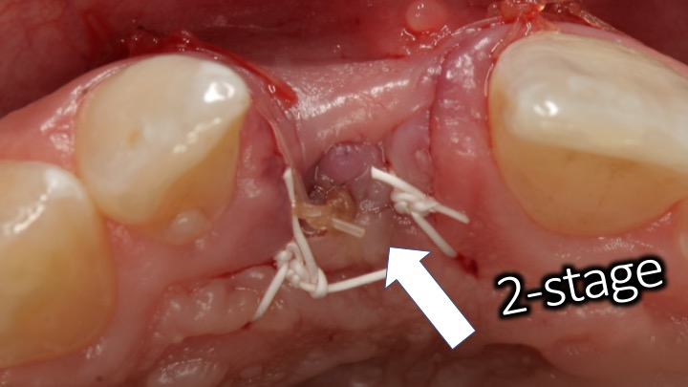
Flap design #12
Papilla sparing (papilla sparing)
- Crestal palatal incision on bone
- Connect straight/curved vertical releases (spare 1-1.5mm)
- Tunnel for additional grafting (full thickness)

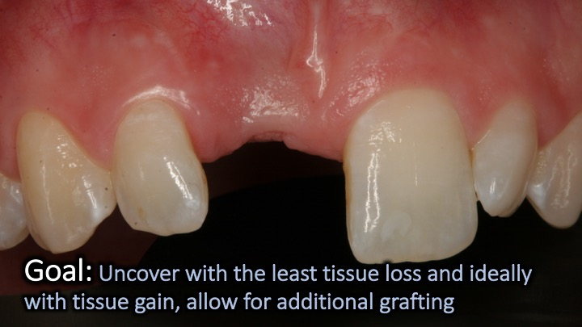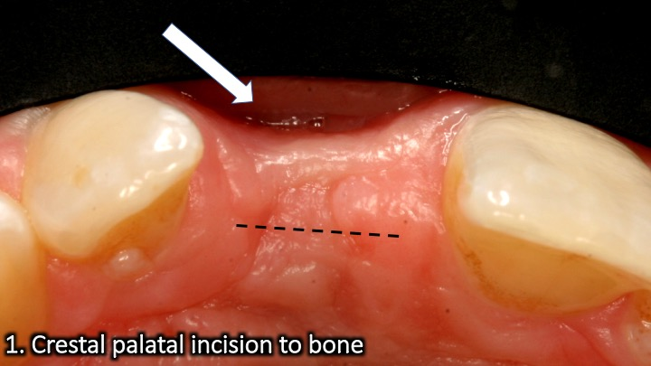
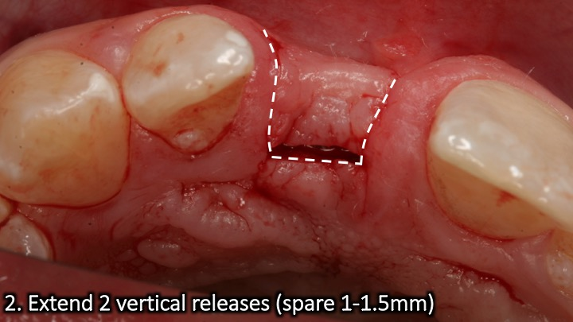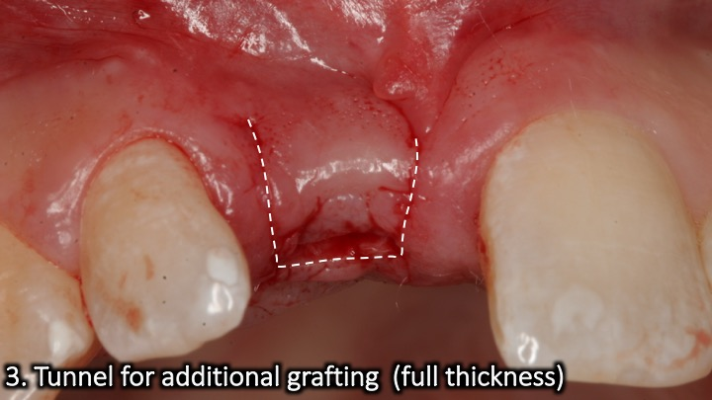

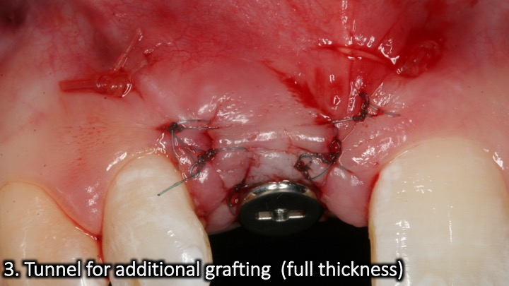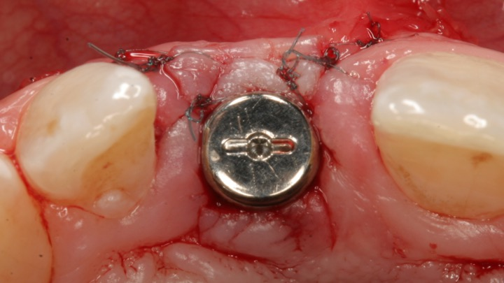
Flap design #13
Coronally advanced flap (multiple teeth)
- Intrasulcular between line angles
- Split thickness line angle to line angle
- Full thickness ~2mm
- Transition to split thickness beyond MGJ
- De-epithelialize papillae
- Periosteal release
- Advanced coronally
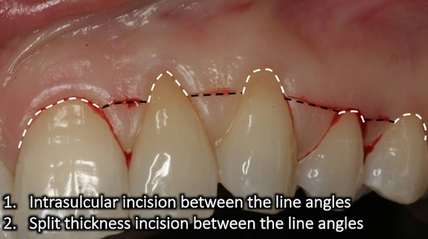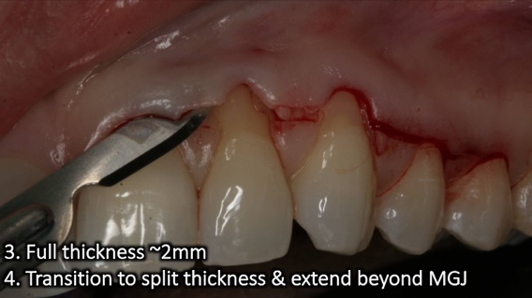
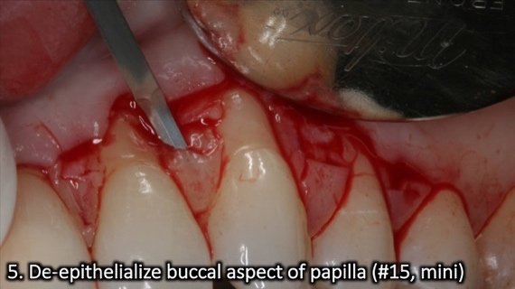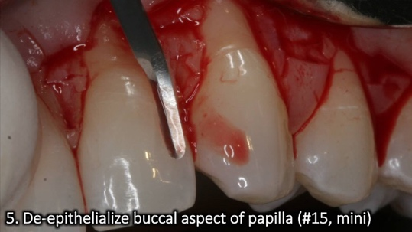
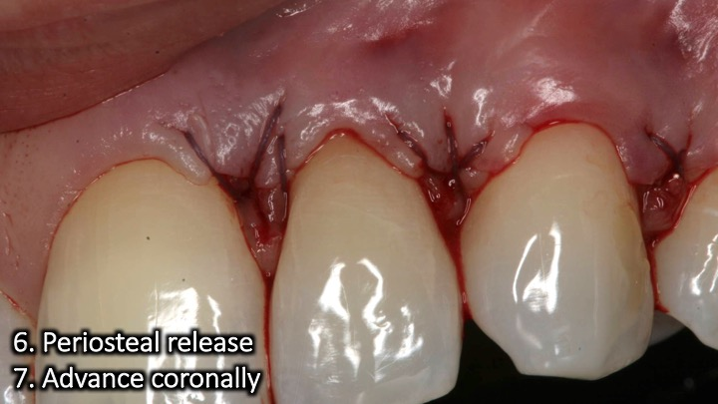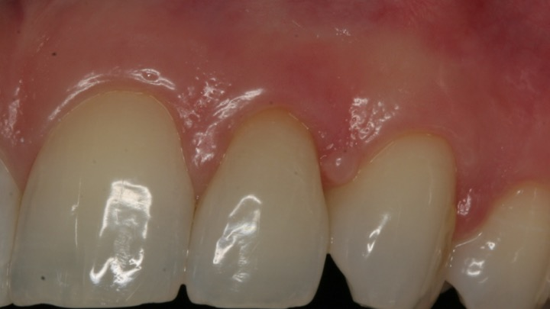
Flap design #14
Tunneling
- Intrasulcular separation (tunneling instruments)
- Lateral extension (full thickness)
- Apical extension beyond MGJ (full thickness)
- Papilla elevation (full thickness)
- Mobilize coronally

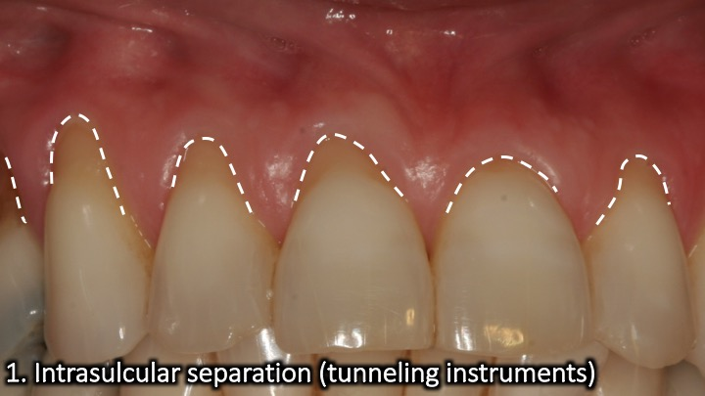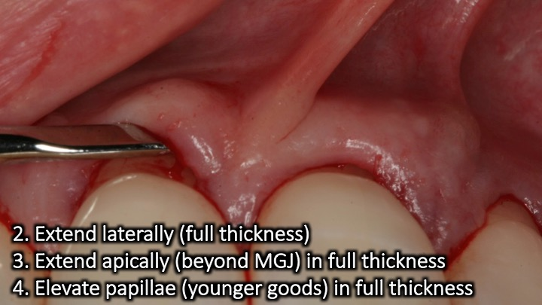
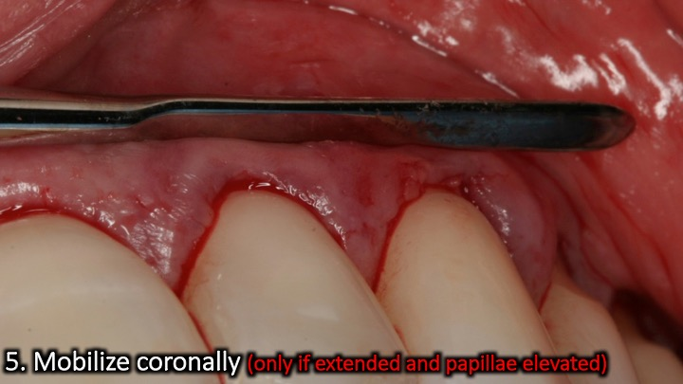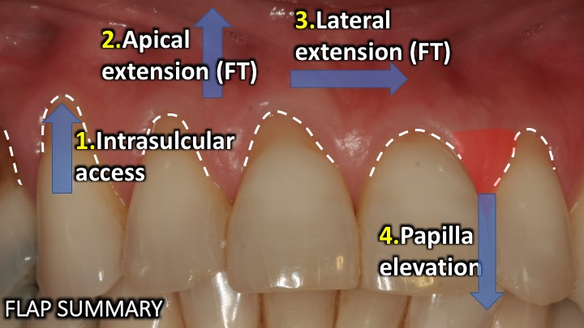

Flap design #15
Sliding flap for root coverage
- Split thickness scalloped incision on adjacent between line angles of adjacent teeth.
- Vertical diagonal split thickness incision parallel to root with recession (on adjacent tooth)
- Vertical diagonal split thickness incision on tooth to be parallel to root with recession (on adjacent tooth)
- Cut back incision
- De-epithelialize sliding flap vascular bed
- De-epithelialize papillae
- Mobilize flap laterally

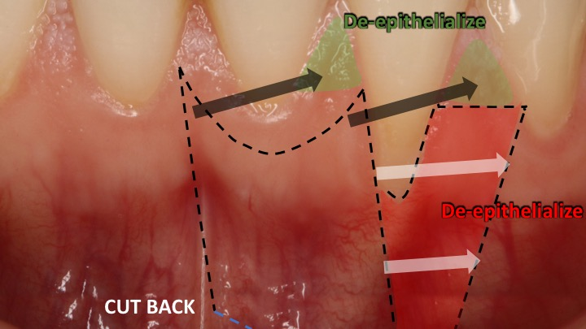
Flap design #16
Rotated palatal flap
- Intrasulcular 2nd molarsocket
- Full thickness
- Split flap distal mesial
- Tunnel buccal tissue
- Flip pedicle over extraction socket
- Tuck underneath buccal tissue

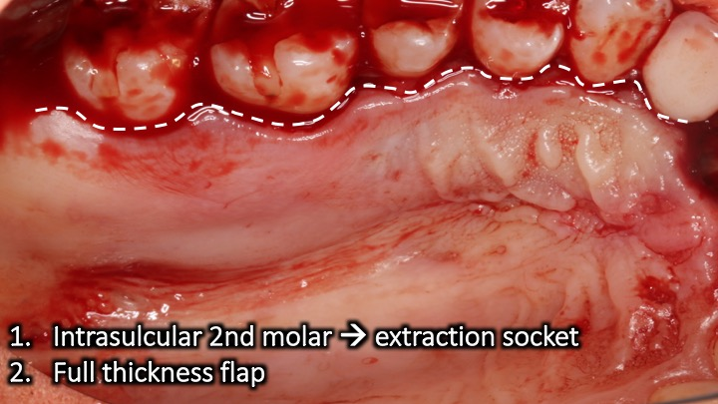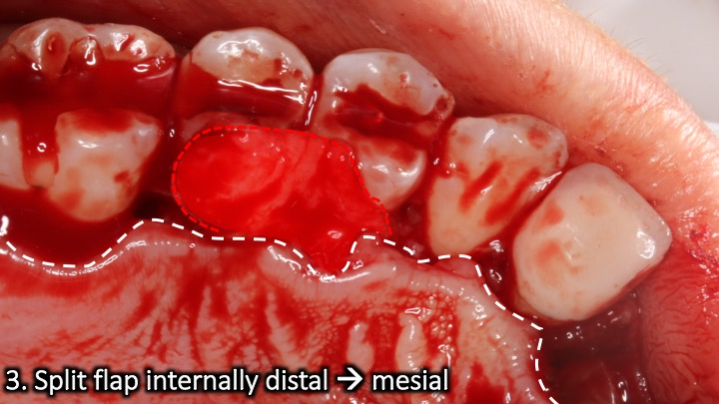
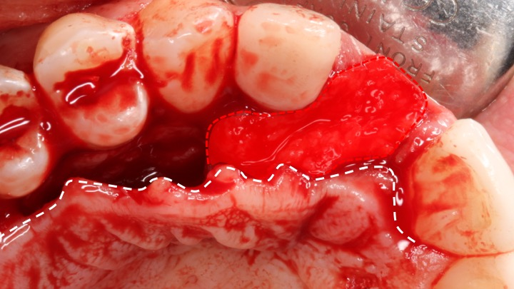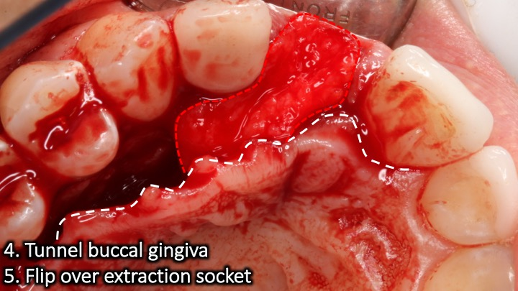
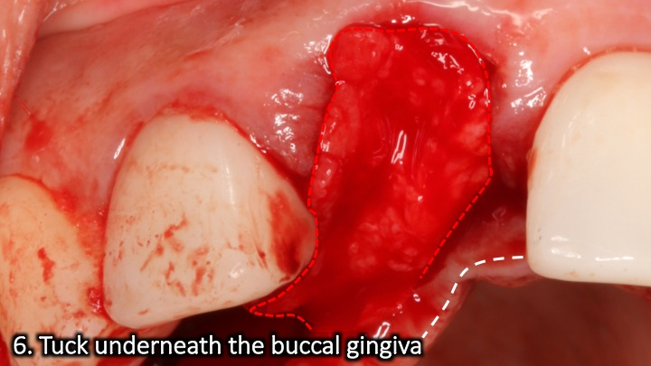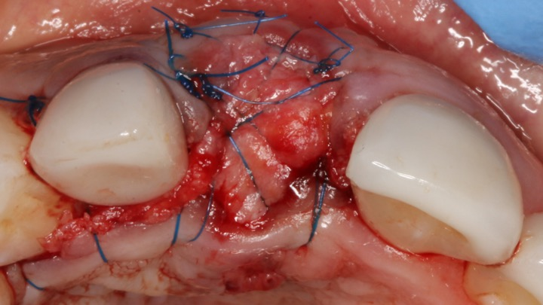
Flap design #17 Surgical lip repositioning

- Split thickness incision at the mucogingival junction
- Split thickness incision in the mucosa 10-12mm apically (connect both)
- Sharp dissection of the mucosa created between lines 1,2
- Coronally advance and suture line 2 to line 1
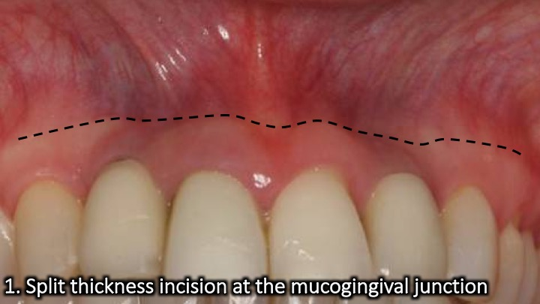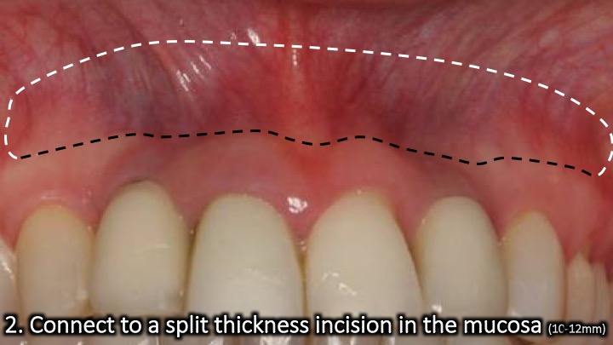
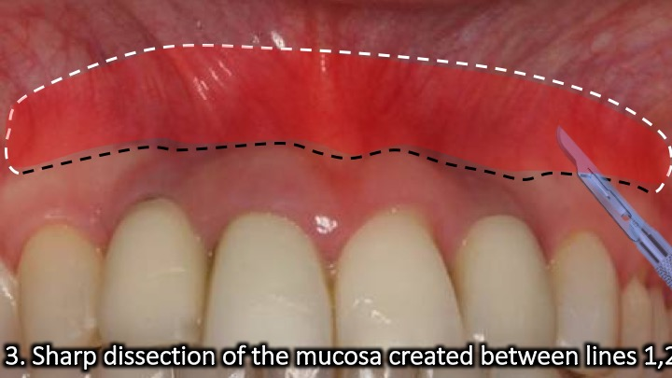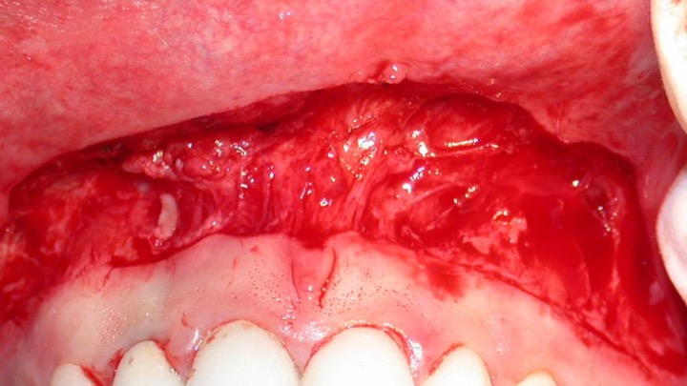
Flap design #18
Punch approach (implant)
- 2-3 mm of attached and keratinized gingiva
- Measure from where the gingiva transitions from occlusal to buccal
- Blade, punch tool or punch drill
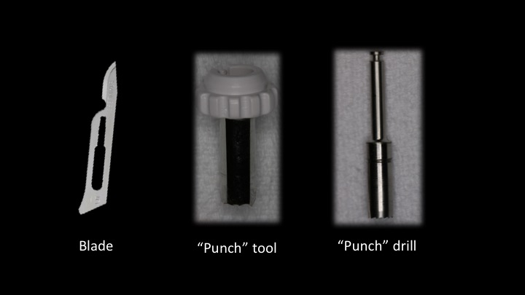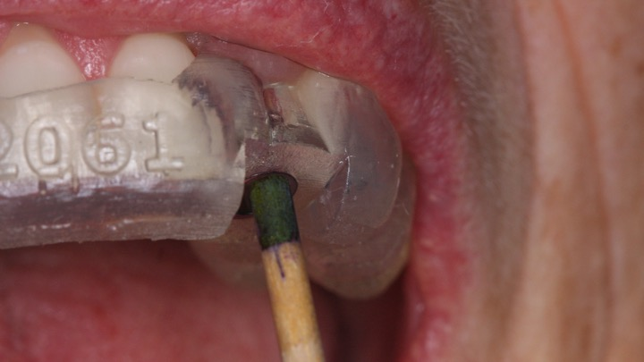
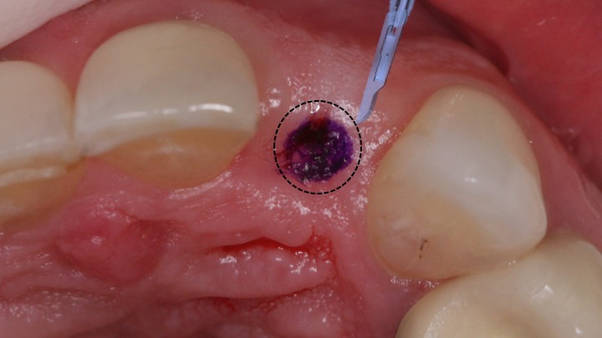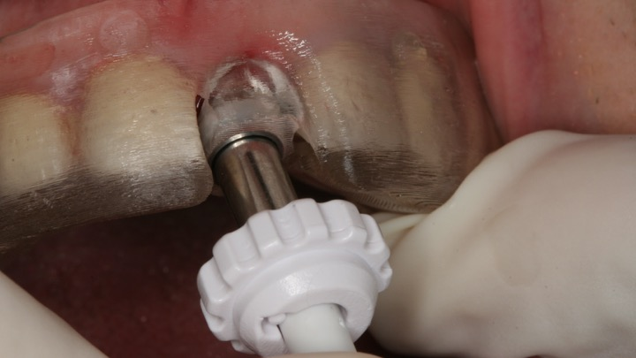

Flap design #19
½ punch approach (implant)
- Mid crestal incision
- Intrasulcular on buccal of adjacent teeth
- Full thickness buccal flap
- ½ punch of lingual tissue

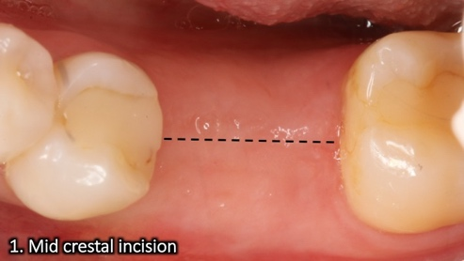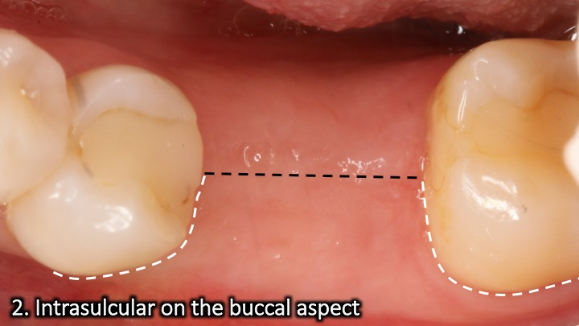
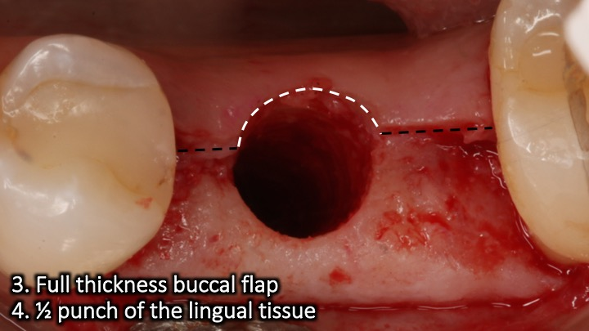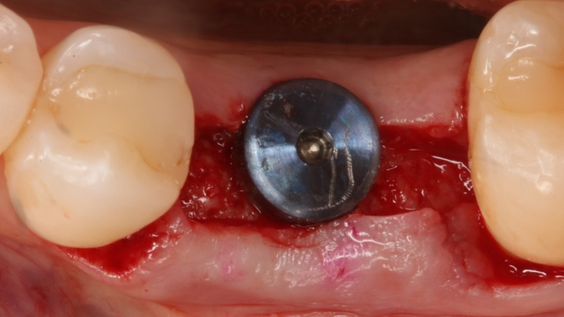
Flap design #20
Implant site tissue reduction
- Distal wedge
- Mid crestal extension (optional)
- Intrasulcular around implants
- Full thickness buccal/palatal
- Remove wedge
- Thin out buccal/palatal internally as needed
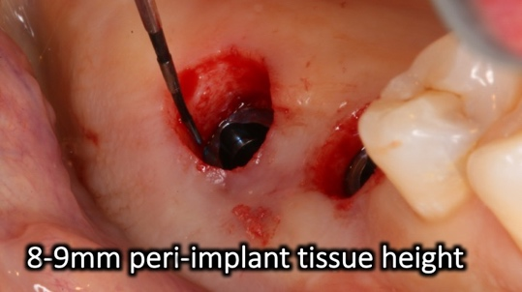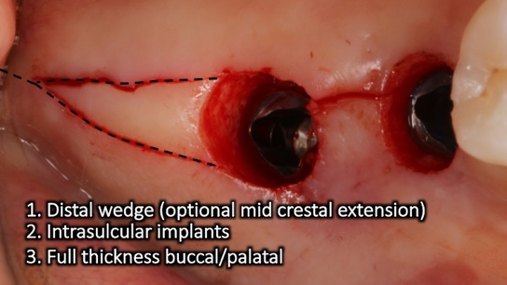
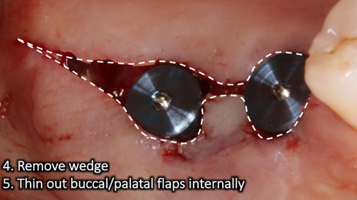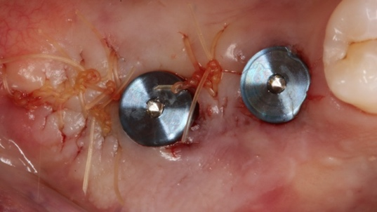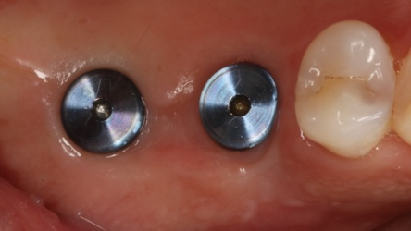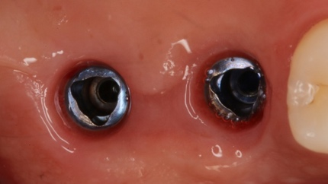

Flap design #21
Mid crestal approach (implant)
- Mid crestal
- Intrasulcular on adjacent teeth
- Full thickness flap (buccal and lingual)

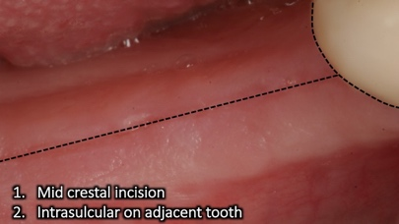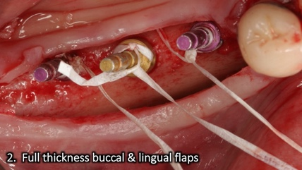
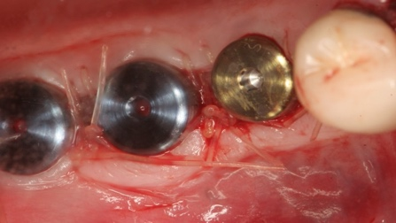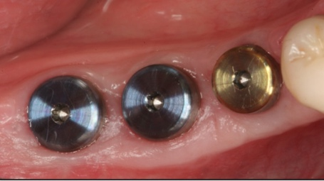
Flap design #22
Palatal approach (implant)
- Crestal palatal incision
- Intrasulcular on adjacent or vertical releases
- Full thickness buccal flap only
- Optional: Palatal roll combined with buccal flap
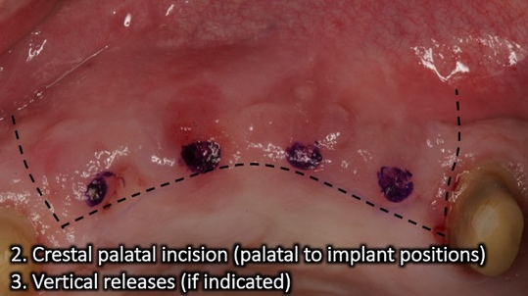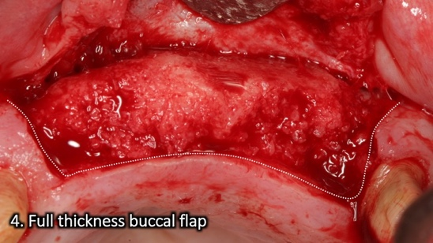
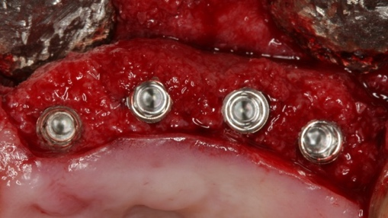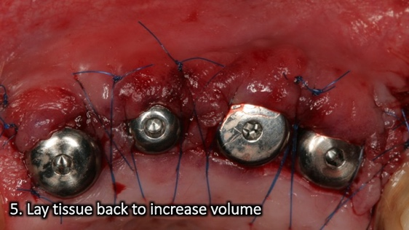

Flap design #23
Palatal roll (implant)
- Crestal palatal incision
- Connect with intrasulcular incisions on adjacent teeth
- Full thickness buccal flap
- De-epithelialize flap coronal aspect
- Roll under the buccal flap
- Adapt to healing abutment
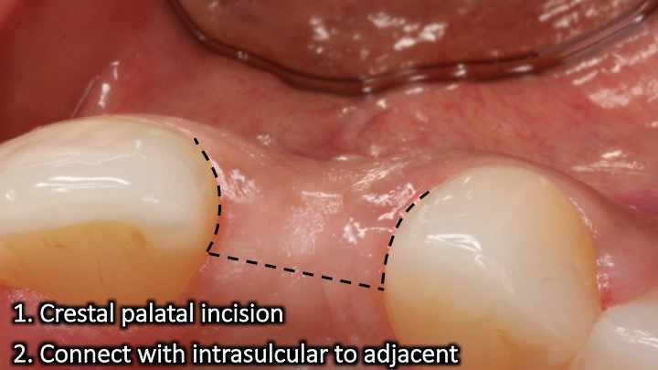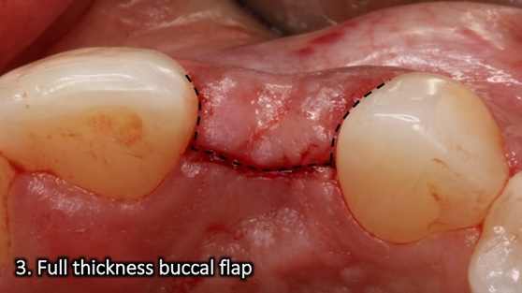

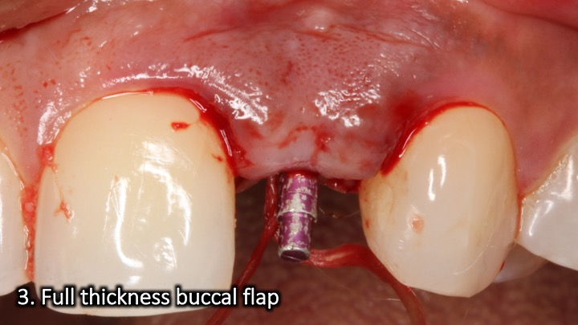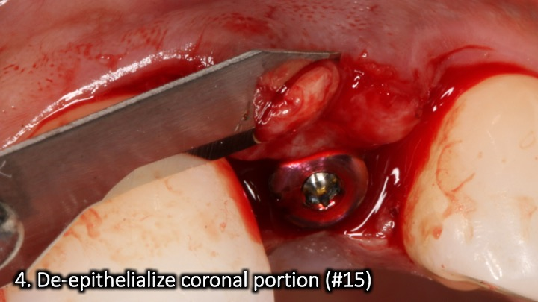
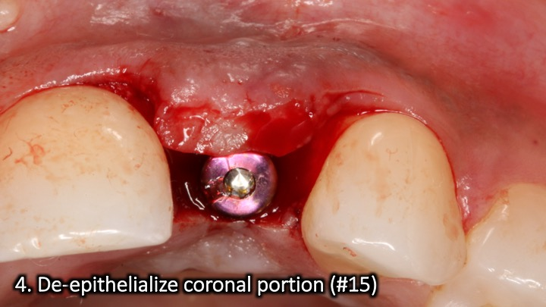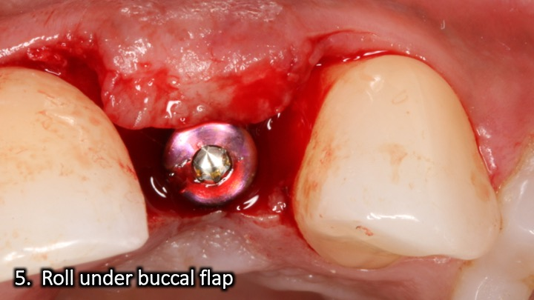
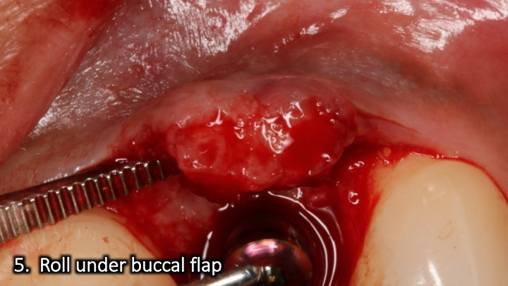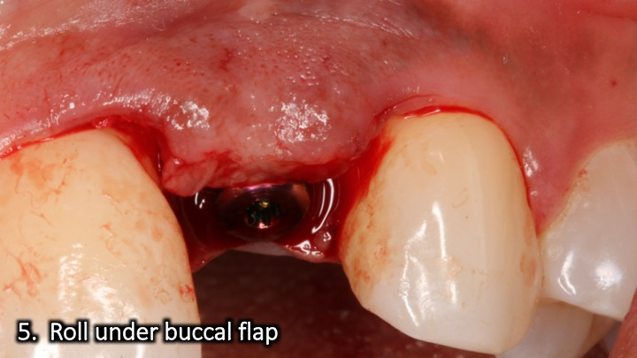
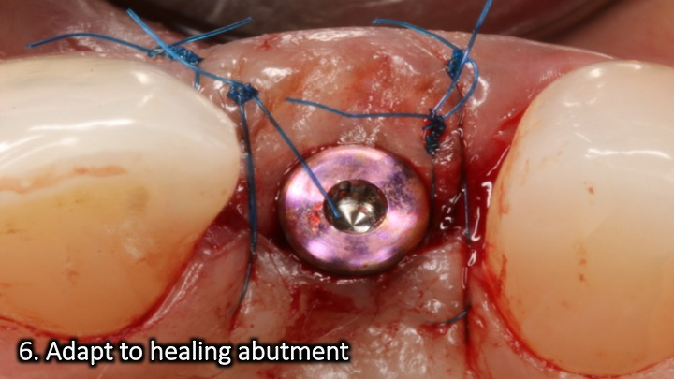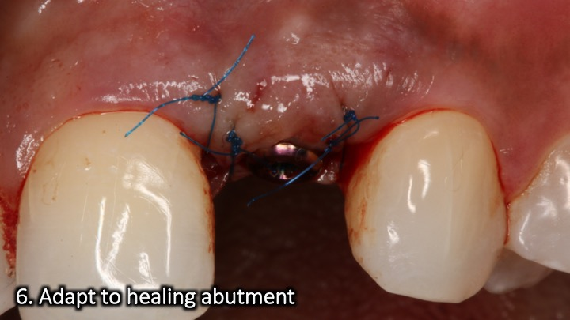
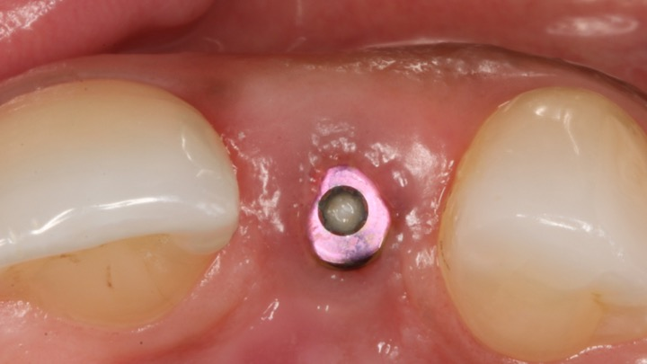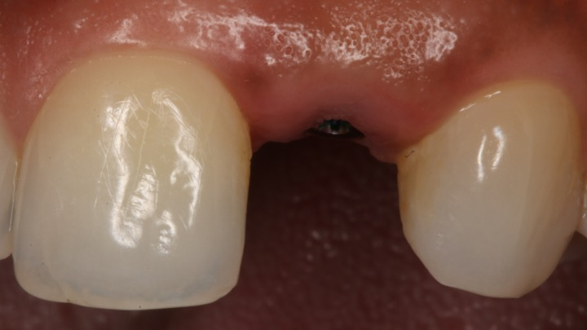
Flap design #24
Implant placement & simultaneous grafting
- Crestal palatal incision
- Intrasulcular on the adjacent
- Vertical release away from grafted site
- Primary closure
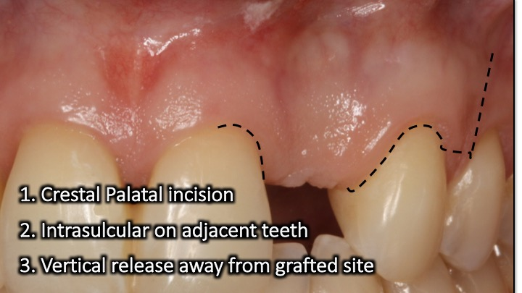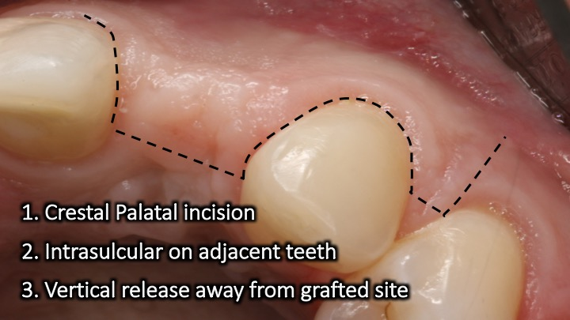
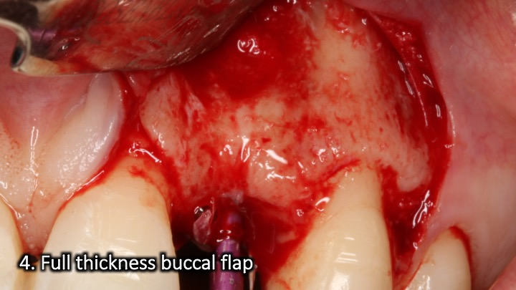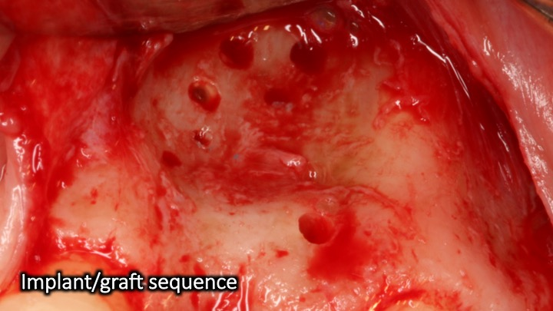
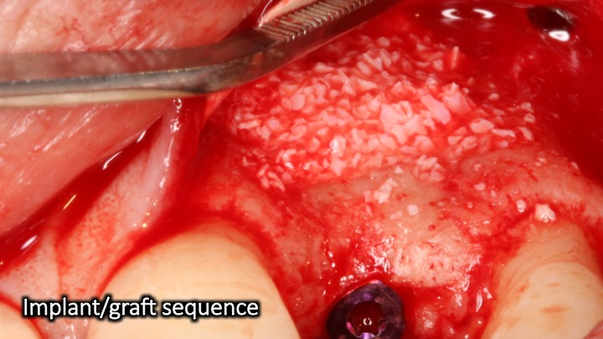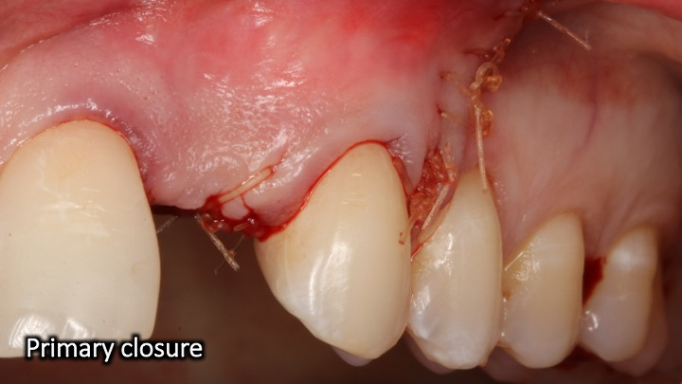

IMPLANT FLAP DESIGN SUMMARY

Mid crestal Punch

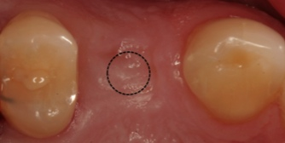
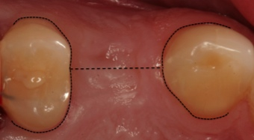

½ Punch Papilla sparing

Mesial Papilla sparing Distal papilla sparing
