The BEST Flap Designs
The Cutting-Edge Incision Outlines for Successful Surgeries

Ziv Simon, DMD, MSc
Creator of SurgicalMaster®



Failure starts before you even put the blade to the tissue.

Failure starts with poor planning like not choosing the right flap design for your case.
Most of what we learn about soft tissue and flap design in dental schools and other programs is dogma & hype. Despite dentists going through major training, over 50% of all surgical cases have soft tissue problems. You too may be struggling right now.
Here’s the good news
- You can master soft tissue skills.
- You can learn to “see and think” like a surgeon.

This book teaches you the best flap designs for various procedures that I’ve used for past 20 years.
If you are currently struggling with flap design, my goal is not to further confuse you but rather give you clarity and confidence. I created a simple and concise method to convey the steps of each flap and illustrate them so you fully understand and ultimately implement.
I risk the giving the impression of a simplistic “recipe book”. Here’s what I’m thinking. You are intelligent and know that reading this short book is only part of the big picture. I created an online course that goes right along with this book plus many other resources that teach you how to master soft tissue surgery.

How to use this book?
Browse through it first and don’t get hung up on the small details. Get the general idea.
It’s very simple. You will see a procedure name, short description with procedure highlights, step-by-step flap design and the corresponding photos.
Then, go over it a second time in detail and watch the online program on the best flap designs. Finally, review it before you perform the procedure.
You can master flap design and be excellent in soft tissue surgery. I am here to help you get there.

To your surgical success!

Ziv.

Flap design #1
Functional crown lengthening
The Steps (Flap #1)

- Line angle--> line angle (2 teeth over)
- Intrasulcular
- Excision of tissue
- Full thickness flap

The goal of functional crown lengthening is to expose adequate tooth structure for restorative reasons (ferrule and biologic width). The procedure involves three steps: gingivectomy, ostectomy and osteoplasty. Follow this flap design but make sure you have enough attached and keratinized gingiva to create the first excision. If you don’t, resort to an intrasulcular incision to preserve tissue. The same flap design applies on the lingual/palatal aspect. Following a full thickness flap, proceed with ostectomy and osteoplasty. Below are the flap designs for a single tooth and multiple teeth.

Single tooth

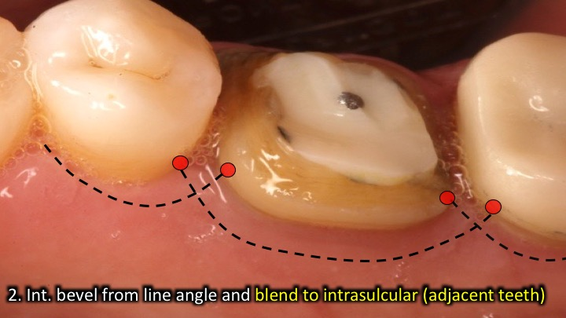
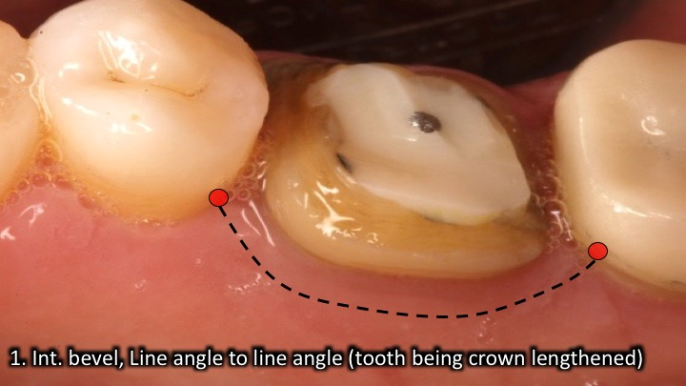

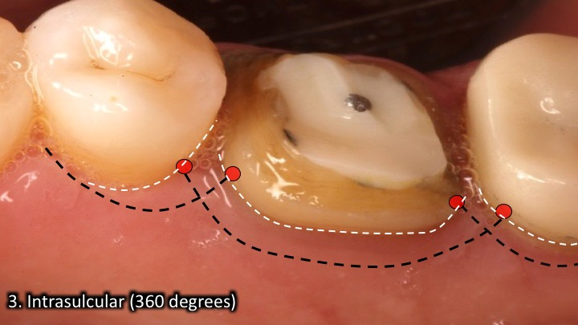
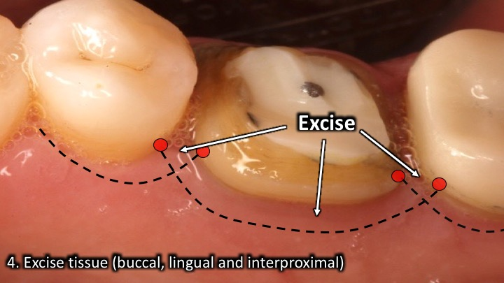

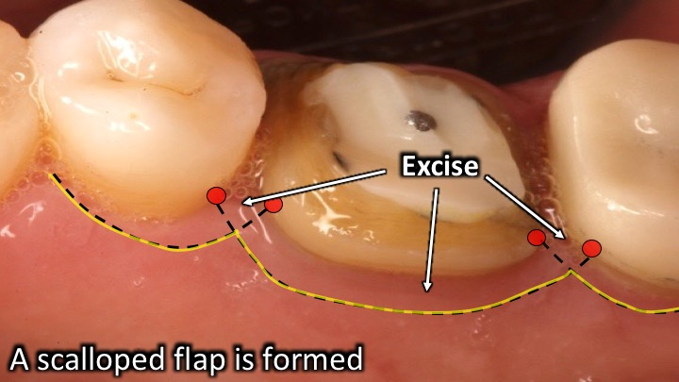
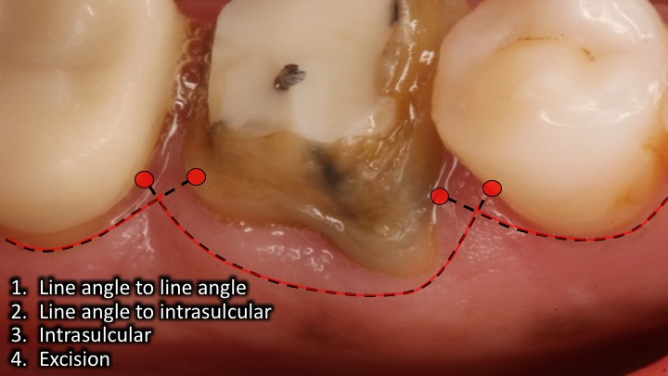

Multiple teeth
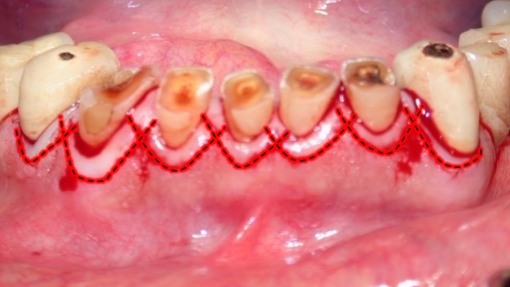
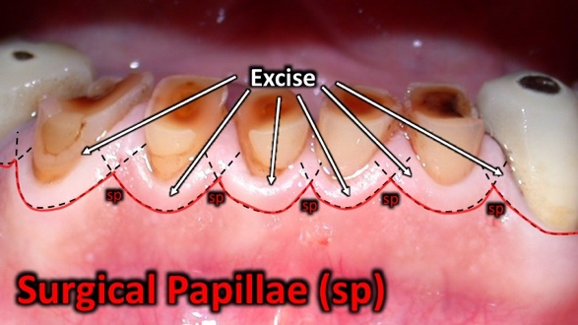

Flap design #2
Esthetic crown lengthening
The Steps (Flap #2)
- Line angle--> line angle (same tooth, buccal only)
- Intrasulcular line to angle line angle
- Soft tissue excision
- Secondary intrasulcular
- Connect with split thickness in the papilla
- Full thickness buccal flap

Different than functional crown lengthening, this procedure involves tissue and bone reduction only on the buccal surface of teeth. The goals are to improve teeth proportions, create gingival symmetry, reduce gingival display and in preparation for restorative treatment. It is critical to preserve the papilla and use a thin split thickness that connects the first incisions in the sequence. Measure the amount of attached and keratinized gingiva to ensure that soft tissue excision is safe. A full thickness flap needs to be reflected beyond the mucogingival junction and is followed by ostectomy and osteoplasty.
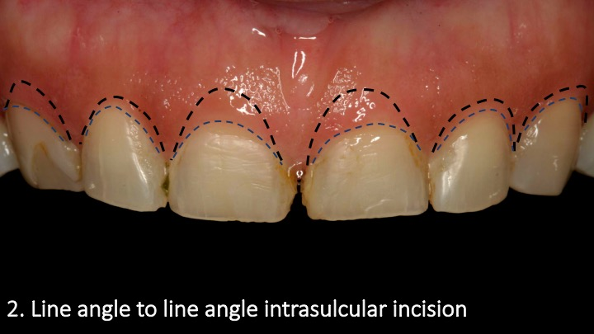
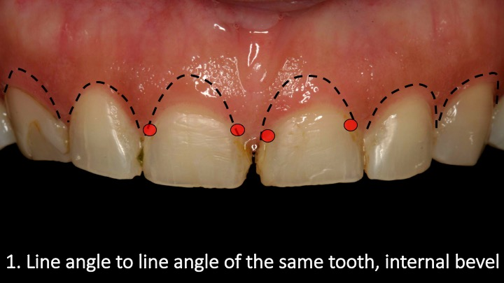

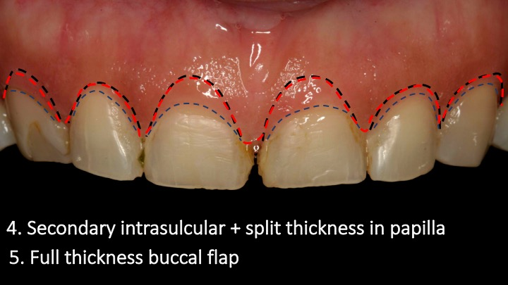
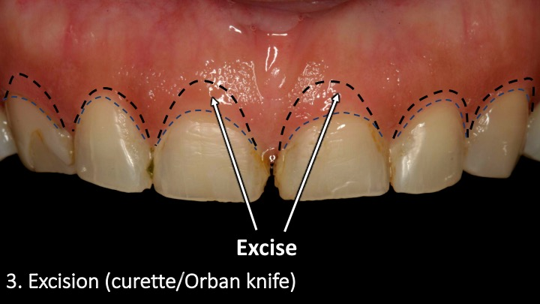

Flap design #3
Frenectomy
The Steps (Flap #3)
- Detach from gingiva – Parallel to attached gingiva
- Detach from Mucosa – Triangular
- Periosteal scoring – straight incisions
This procedure involves 3 basic movements: detachment of frenum from the attached gingiva, detachment from the mucosa and periosteal scoring. Make sure to identify the frenum and hold it with cotton pliers for an accurate dissection. Once the 3 movements have been completed, suture the mucosa in primary closure and the leave the attached gingiva for secondary intention healing.
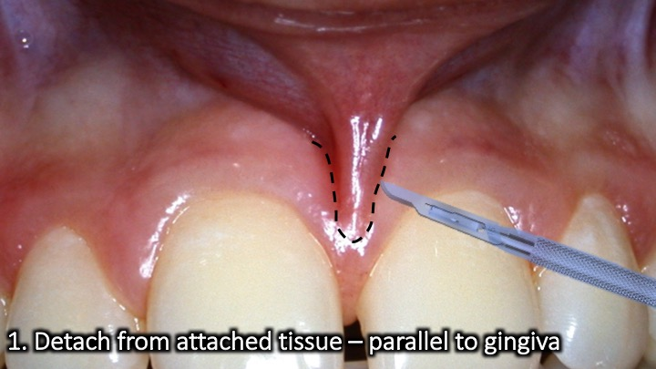
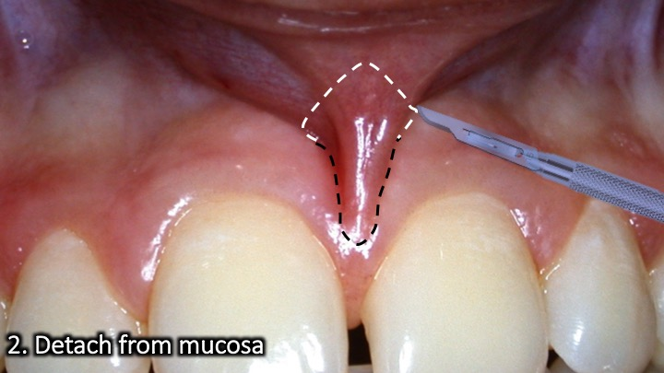
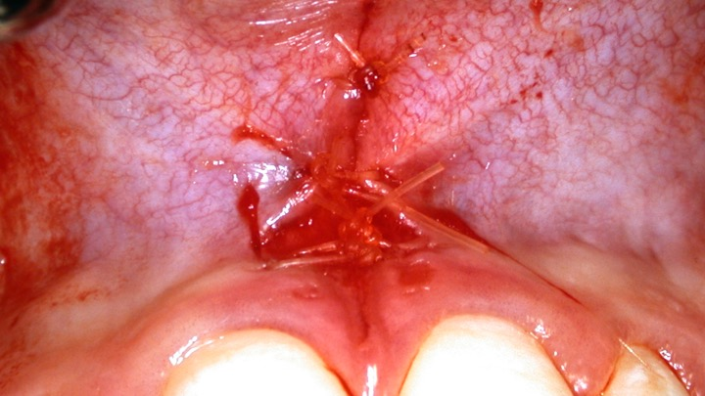

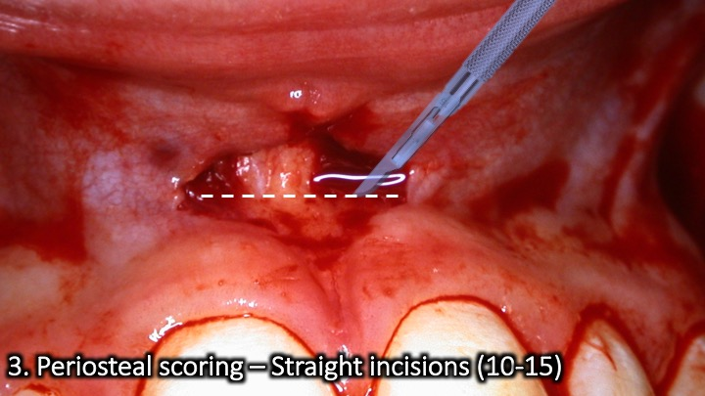

Flap design #4
Gingivectomy
The Steps (Flap #4)
- Horizontal resection at the base.
- Vertical dissection
This flap design depends on the location and type of gingival hyperplasia. Very often it is enough to resect the hyperplastic tissue at the base (if pedunculated) and follow up with a vertical dissection. With more fibrotic gingiva, you can follow an incision outline like functional crown lengthening and resect the excessive tissue. This is followed be a gingivoplasty (blade, diamond but or laser).

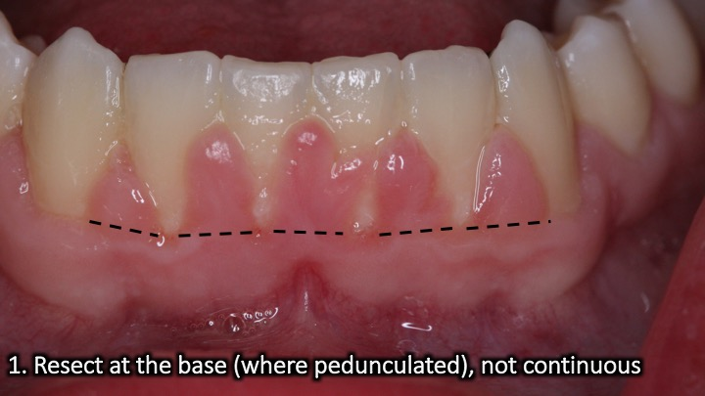
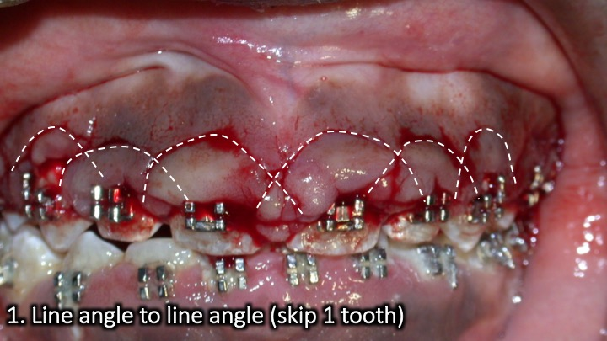
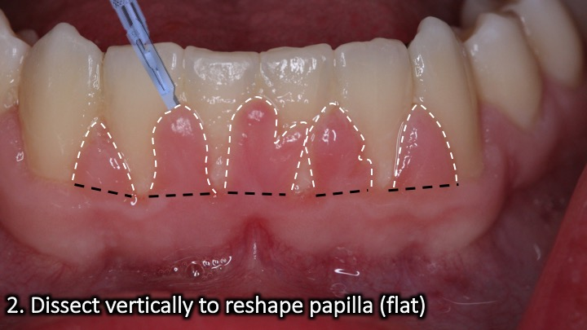
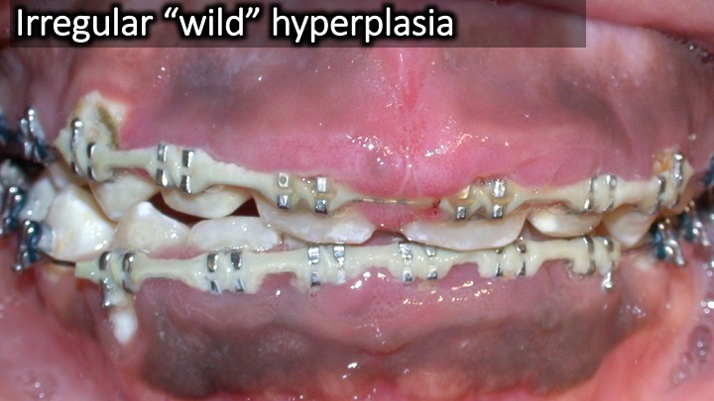
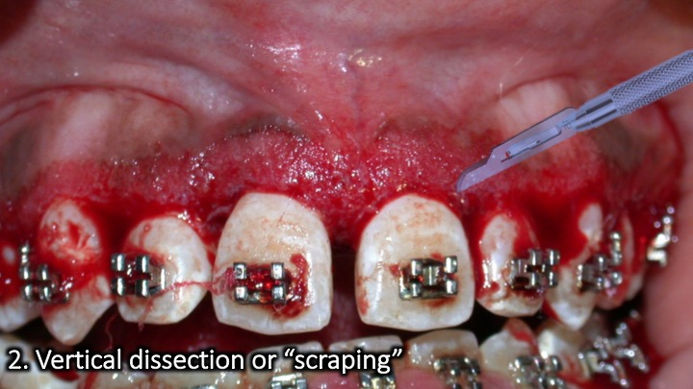
The Steps (Flap #4)
- Line angle to line angle (skip 1 tooth)
- Gingivoplasty (#15 blade, round diamond bur, laser)

Flap design #5
The Steps (Flap #5)
- Parallel to palatal tissue (to bone)
- Parallel to buccal tissue (to bone)
- Connect distally
- Connect mesially
- Extend with mid crestal (mesial & distal if needed)
Tuberosity reduction

The key in this procedure is to estimate the distance between both parallel incisions. The distance will roughly determine the thickness of the soft tissue wedge removed from the tuberosity. Make sure to reach bone level and connect the incisions accurately. Take caution not to thin out tissue too much or perforate.

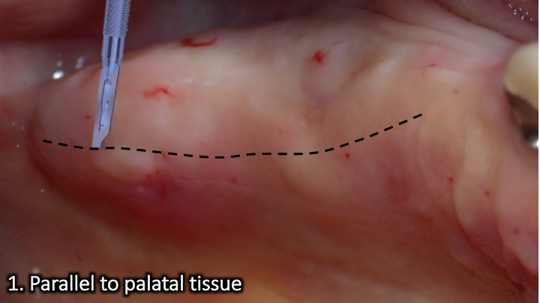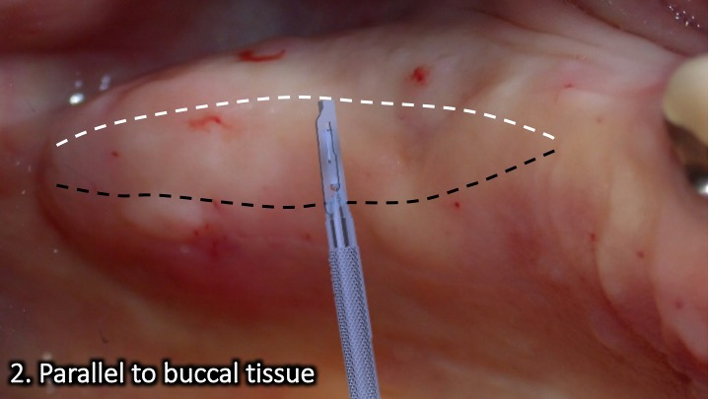
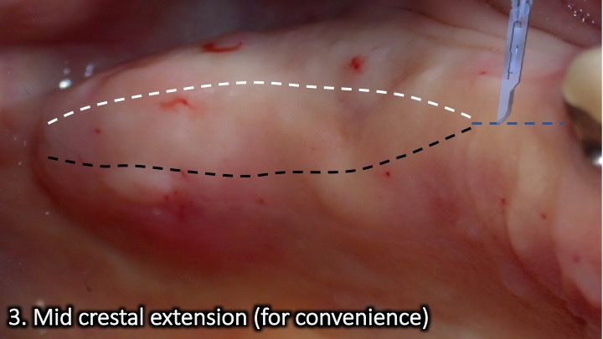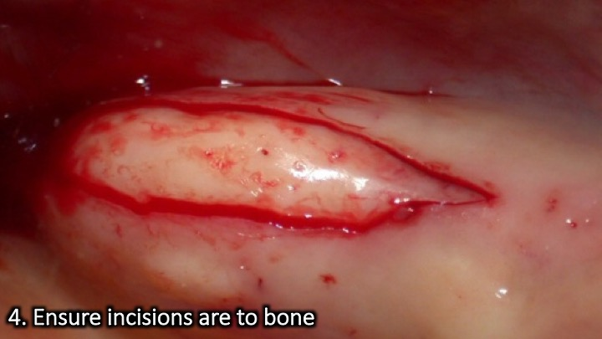
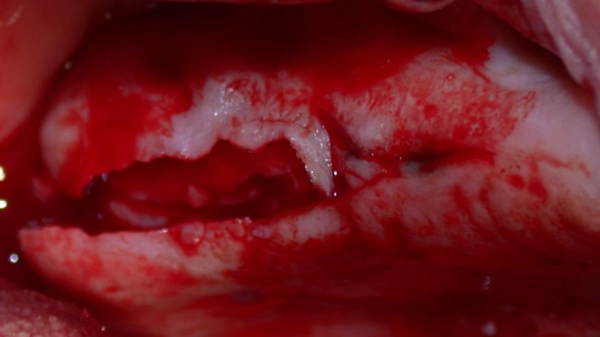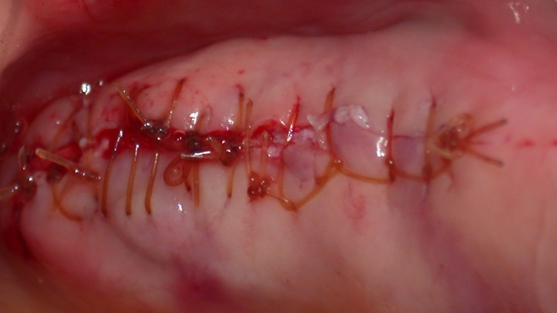

Flap design #6
Free gingival graft

The procedure involves 2 incision outlines; recipient and donor sites. Start with the recipient site and suture the flap apically. Once ready, harvest the graft from the palate through a sharp dissection, parallel to the palate and with a thickness of ~1.5mm.

Donor:
- Split thickness rectangular outline (#15, 1.5mm)
- Split thickness dissection parallel to palate
- Detach graft
Recipient:
- Split thickness at mucogingival junction
- Split thickness flap, stabilized apically
- De-epithelialize attached gingiva (parallel #15)

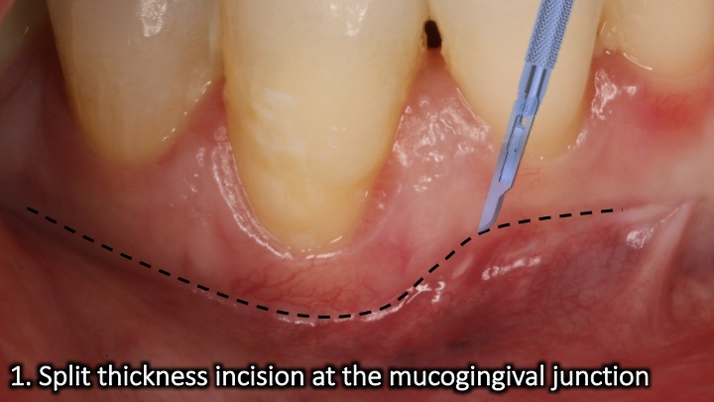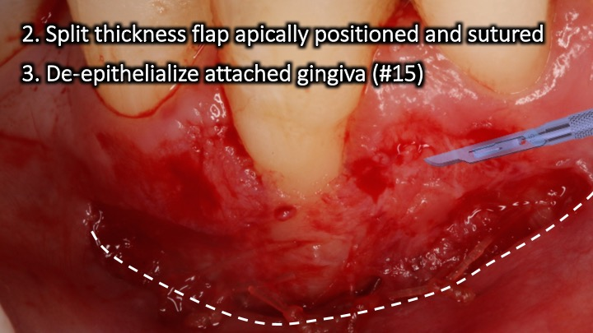
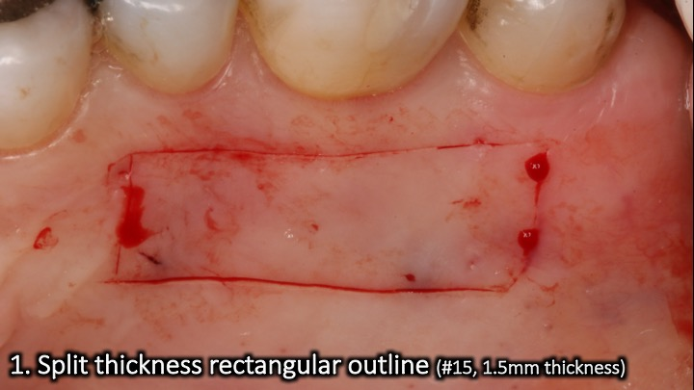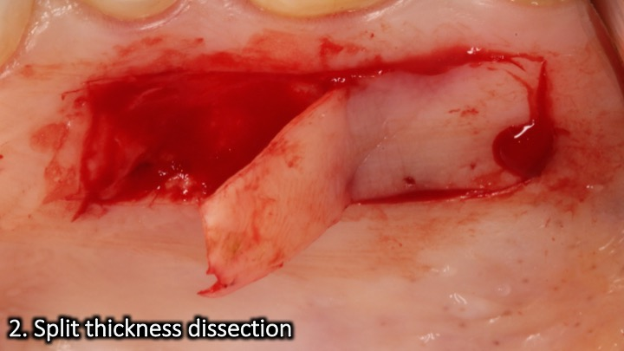

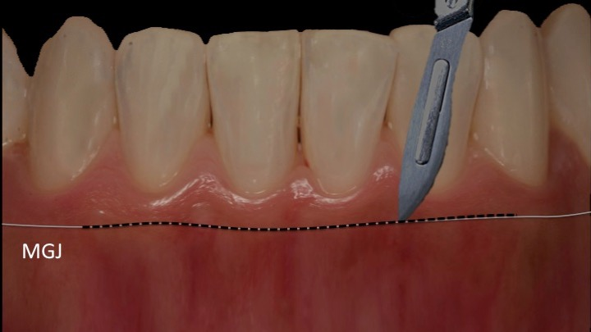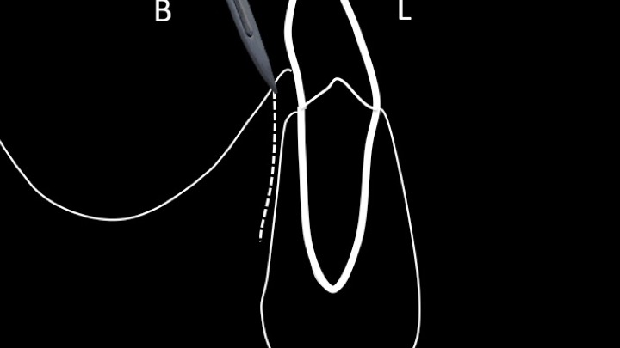
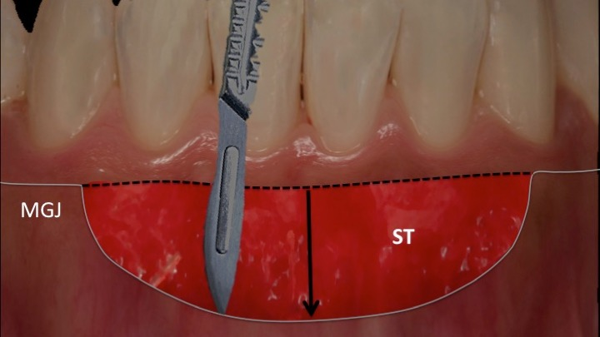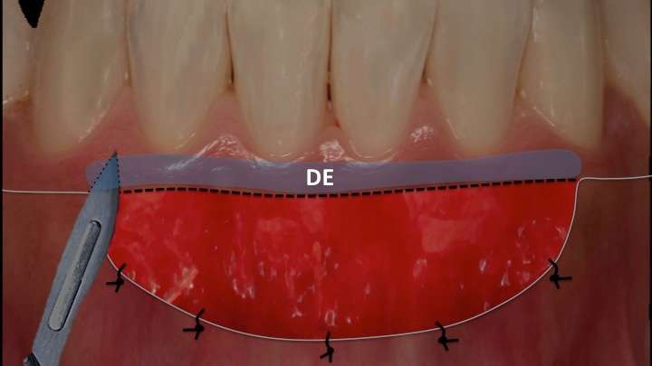

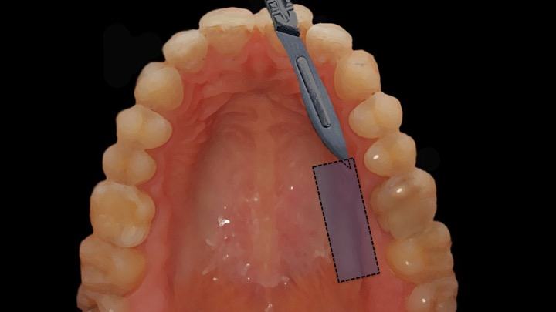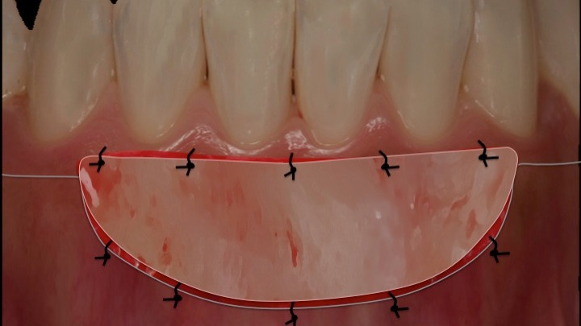

Flap design #7
Soft tissue ridge augmentation

This procedure is like a free gingival graft for teeth. Remember to follow the mucogingival junction even if it “climbs” on top of the ridge. There is usually no need to de-epithelialize the attached gingiva.

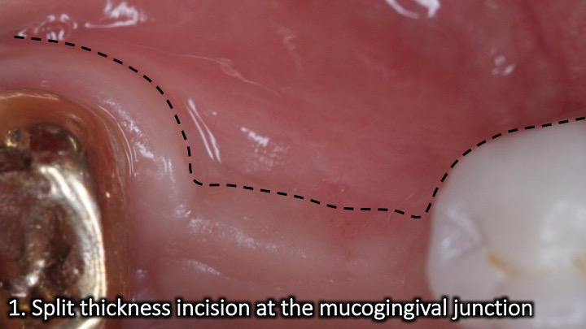
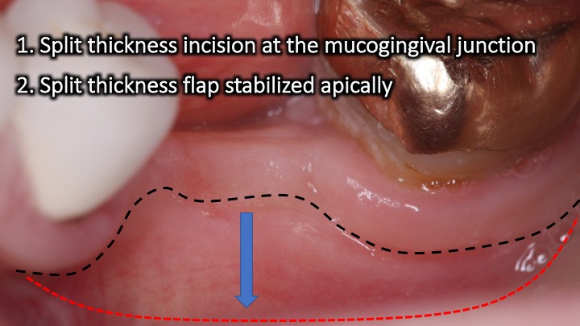

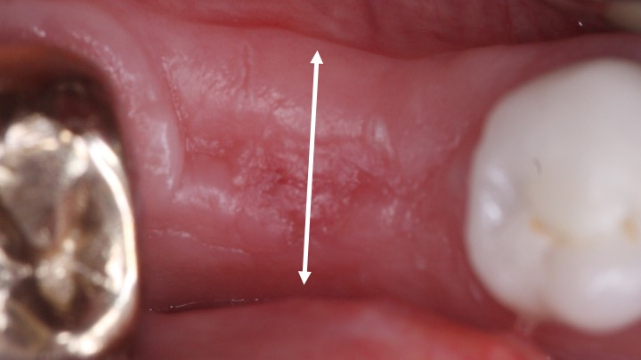
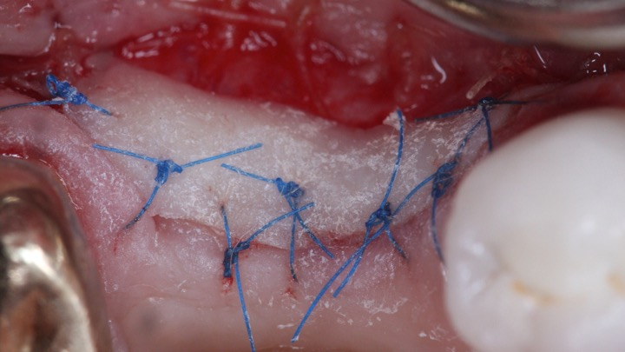

Recipient:
- Split thickness at mucogingival junction
- Split thickness flap, stabilized apically

Donor:
- Split thickness rectangular outline (#15, 1.5mm)
- Split thickness dissection

Flap design #8
Connective tissue graft (recipient site)
The steps (Flap #8)
- Intrasulcular incision (#15)
- Split thickness triangular
3. Split thickness flap
4. De-epithelialize Papillae (buccal)
5. Coronally advance and stabilize

The recipient site in a connective tissue graft procedures involves a split thickness flap and coronal advancement. The extension in the papilla can be straight or triangular (see below). Ideally, no vertical releasing incisions are made as part of this procedure.

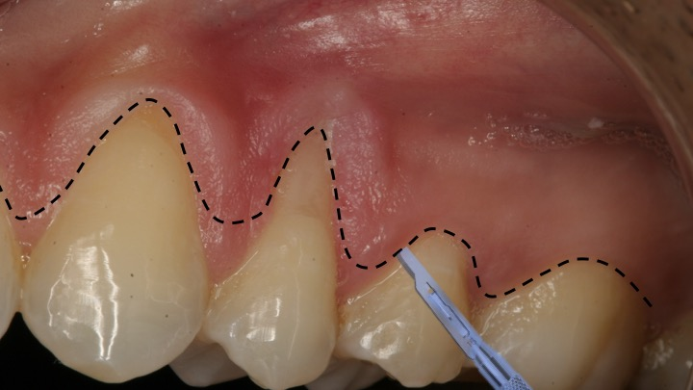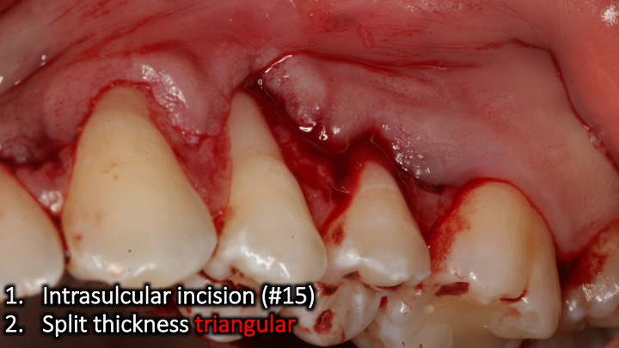
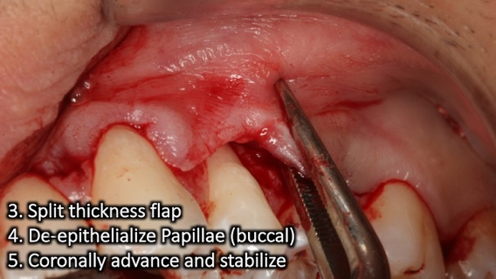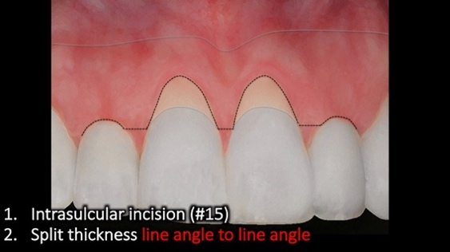
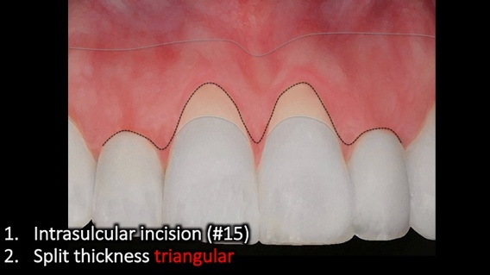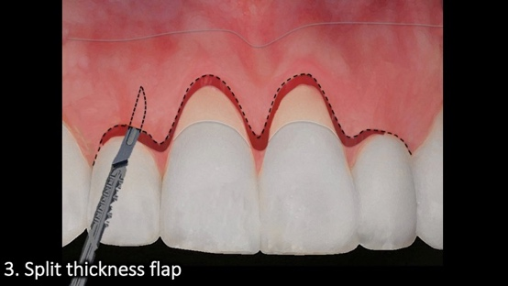
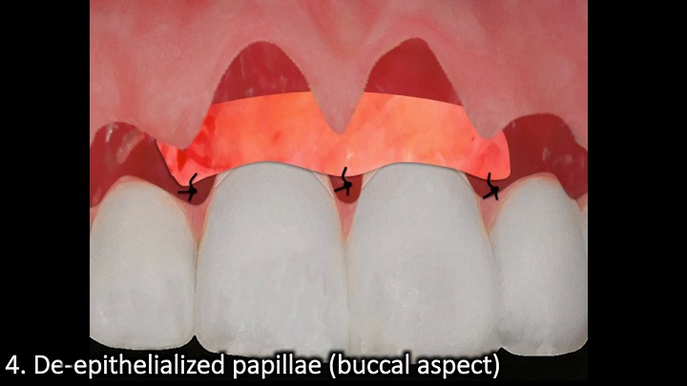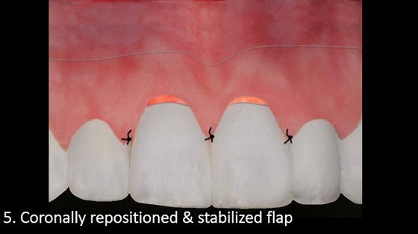

Flap design #9
Connective tissue graft (donor site)
6 incisions technique (Flap #9)
- Straight to bone
- Superficial incision
- Profound incision (or FTF)
- Mesial detachment
- Distal detachment
- Apical detachment
Harvesting a connective tissue graft involves 6 types of incisions. They are all made through the first incision. This technique allows for maximum thickness graft harvest and allowing for primary closure of the donor site.

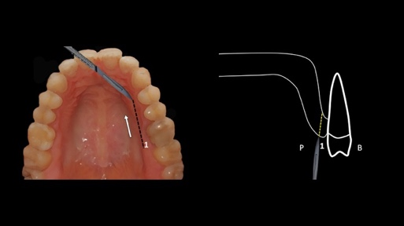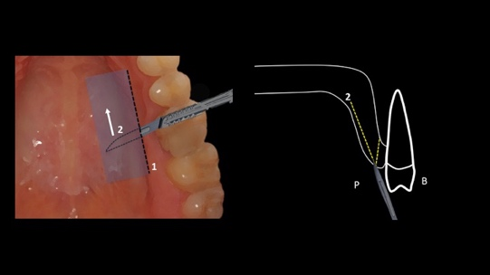

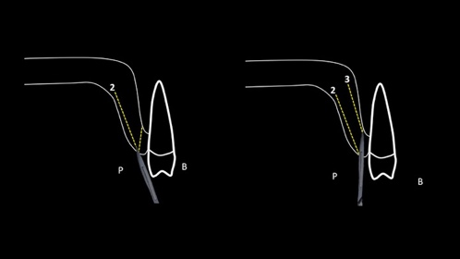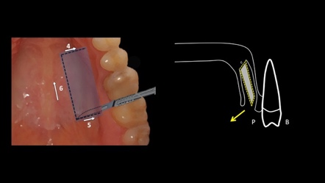

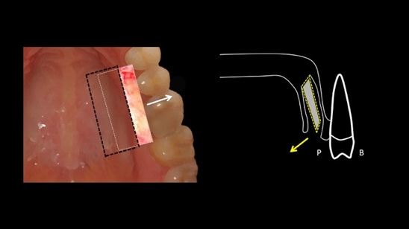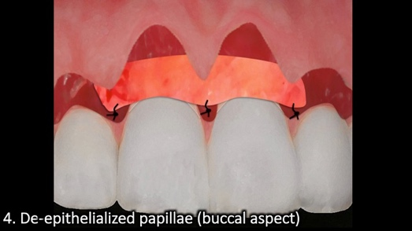

Flap design #10
Localized pouch (recipient)

This procedure works best for localized narrow recession sites. The key to success is to create a pouch that is wide enough laterally and apically (beyond the mucogingival junction). A connective tissue graft works best and needs to be inserted and stabilized with sutures in the pouch preparation to gain vascularity. It can be left partially exposed (not true for an allograft)

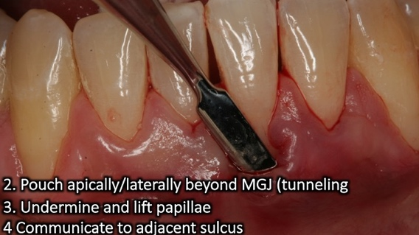
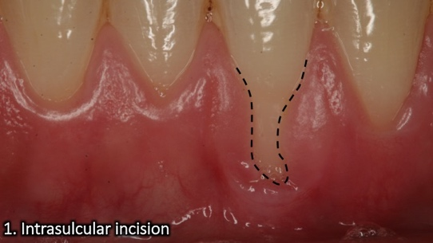

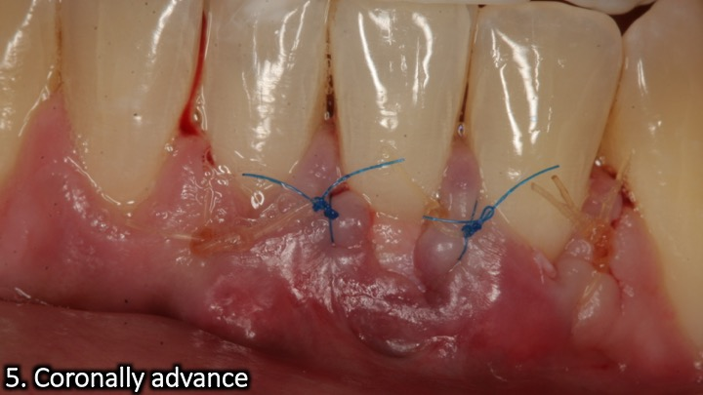
The steps (Flap #10)
- Intrasulcular incision (#15)
- Pouch apically/laterally beyond the MGJ
- Undermine and lift papilla
- Communicate to adjacent sulcus
- Coronally advance as best as possible

Flap design #11
The steps (Flap #11)
- Spare 1-1.5mm
- Straight/curved vertical releases
- Beyond MGJ if contour graft
- Connect to crestal palatal incision on bone
- Full thickness flap
- Allows for contour graft and options (1 and 2-stage)

Implant placement (papilla sparing)

The concept behind the technique is to avoid reflection of the papilla during implant placement and prevent its loss which is an esthetic benefit. Figure out the implant diameter and that would be the distance between the two vertical incisions (in a 2-stage approach). If additional buccal contour is needed, you must create a larger distance to account for the increased volume. Often, the 2 incisions cannot be far apart and then papilla sparing is not advised.

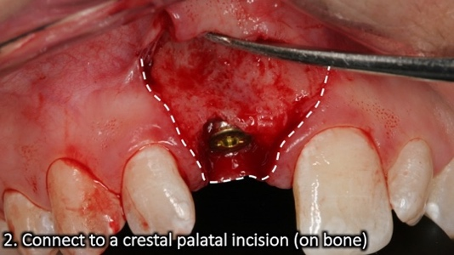
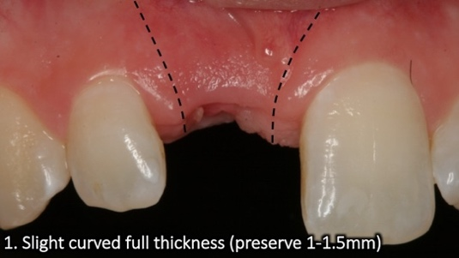

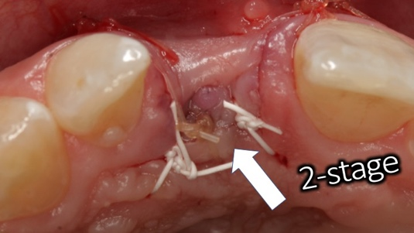
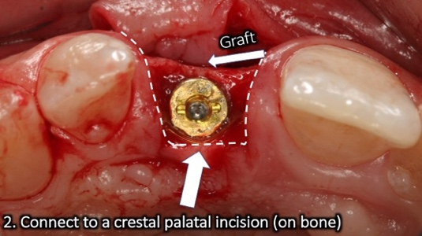

Flap design #12
Implant uncovering (papilla sparing)
The steps (Flap #12)
- Spare 1-1.5mm
- Straight/curved vertical releases
- Beyond MGJ if contour graft
- Connect to crestal palatal incision on bone
- Full thickness flap
- Allows for contour graft and options (1 and 2-stage)

This flap design is useful Implant uncovering when the buccal contour is deficient. Creating a palatal-crestal incision and mobilizing the flap to the buccal will create additional buccal contour and allow you to graft. This flap design also brings attached and keratinized tissue to the buccal of the healing abutment and the final restoration. A palatal roll is using a similar flap design while rolling in part of the flap and adjusting to the healing abutment (see flap #23).

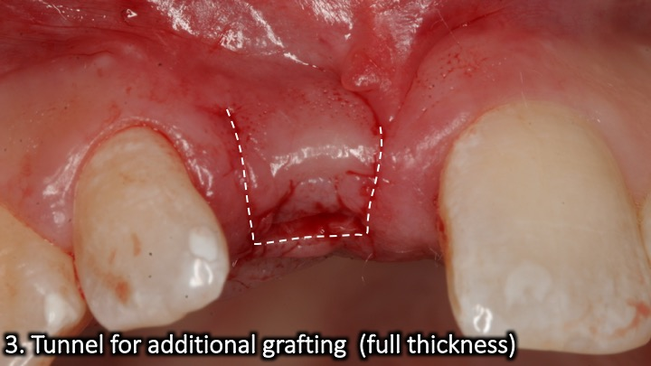
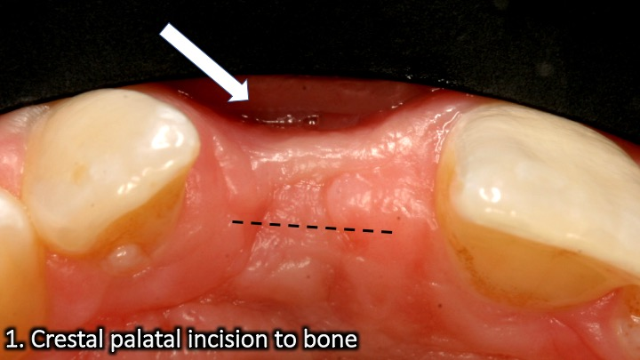
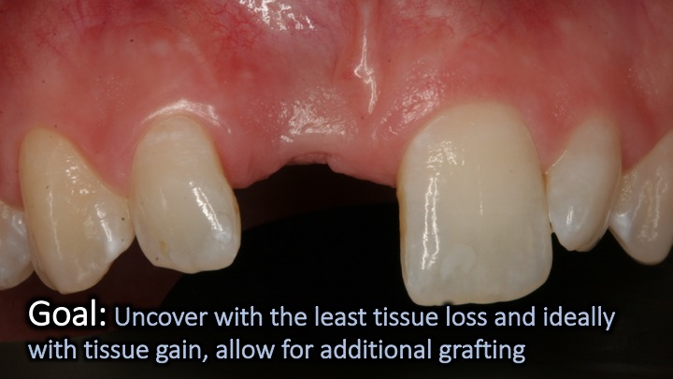
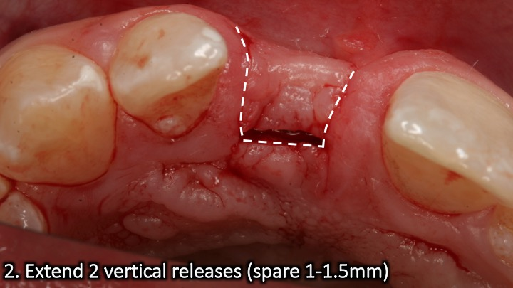
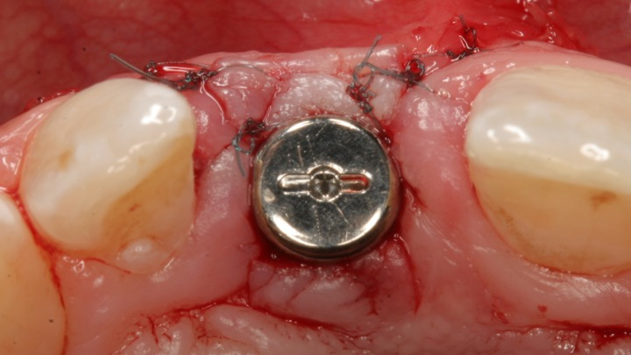
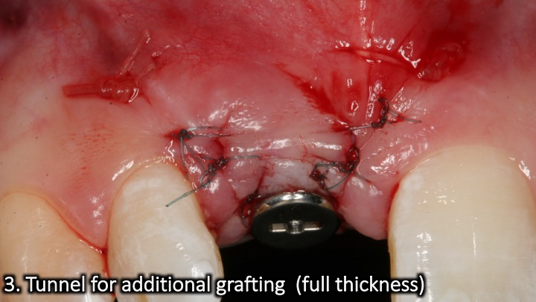

Flap design #13
Coronally advanced flap (multiple teeth)
The steps (Flap #13)
- Intrasulcular between line angles
- Split thickness line angle to line angle
- Full thickness ~2mm
- Transition to split thickness beyond MGJ
- De-epithelialize papillae
- Periosteal release
- Advanced coronally

The keys to success with this flap is sufficient lateral extension and a split thickness flap in the mucosal aspect of the flap that allows flap mobility. Avoid starting the split thickness at the free gingival margin which is difficult. Start as a full thickness and transition to a split thickness. The papillae need to be de-epithelialized to increase vascularity to a potential graft and the flap. The split-thickness incision in the papilla area can be horizontal (line angle to line angle) or triangular.

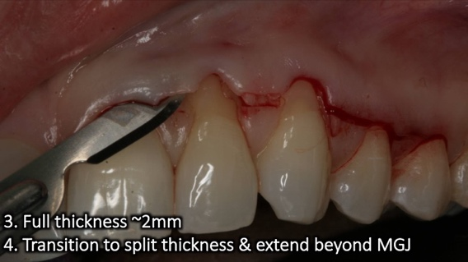
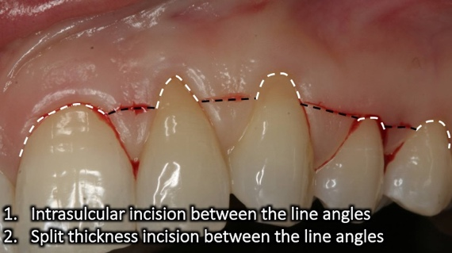
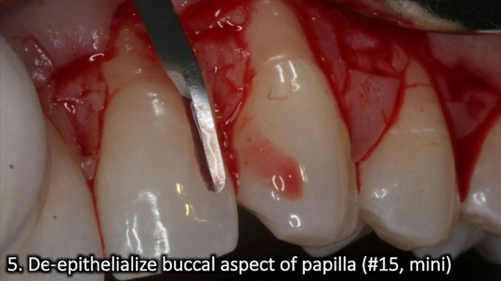
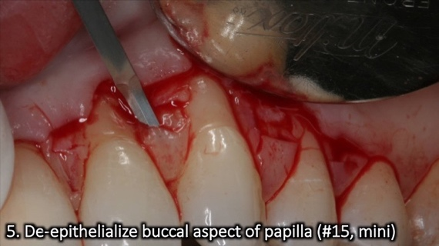
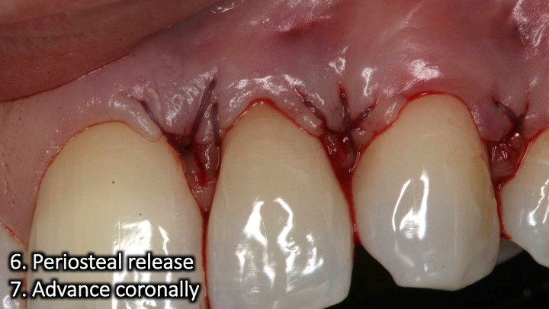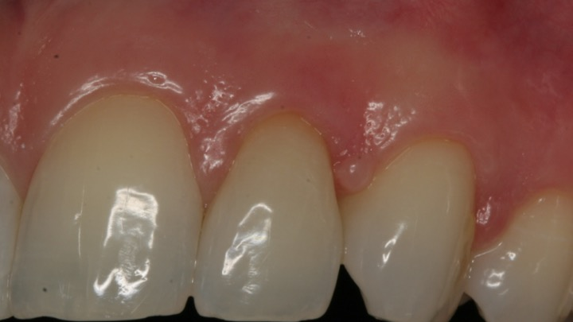
Flap design #14
The steps (Flap #14)
- Intrasulcular separation (tunneling instruments)
- Lateral extension (full thickness)
- Apical extension beyond MGJ (full thickness)
- Papilla elevation (full thickness)
- Mobilize coronally

Tunneling

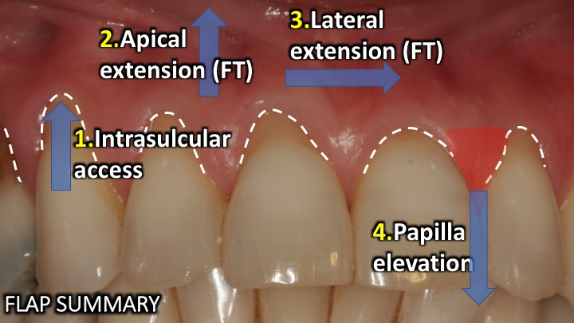
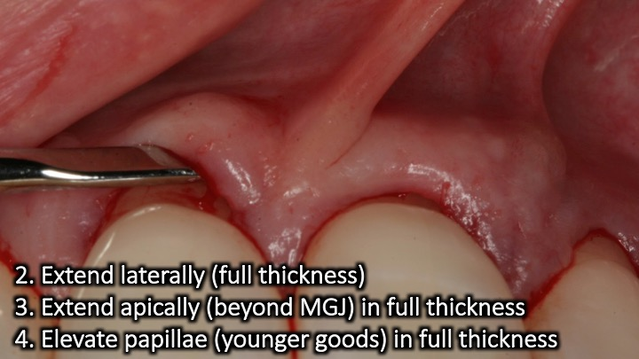
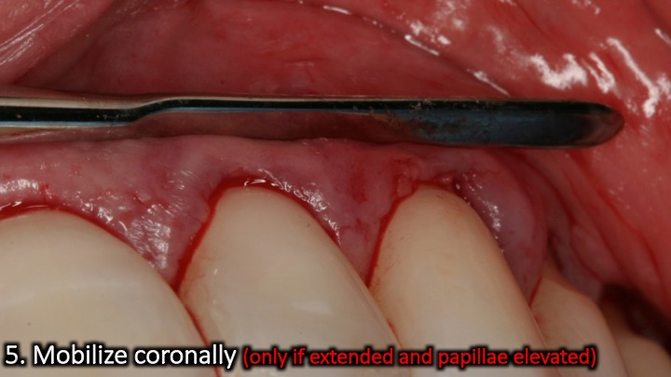
The keys to success in tunneling is adequate lateral extension, apical extension (beyond the mucogingival junction) and papillae elevation. The tunnel can be created from a coronal to apical approach, apical to coronal approach or a combination of the two which helps to bypass bone irregularities and undercuts. Make sure to undermine the papillae to allow for complete tissue mobility and suturing with minimal tension.
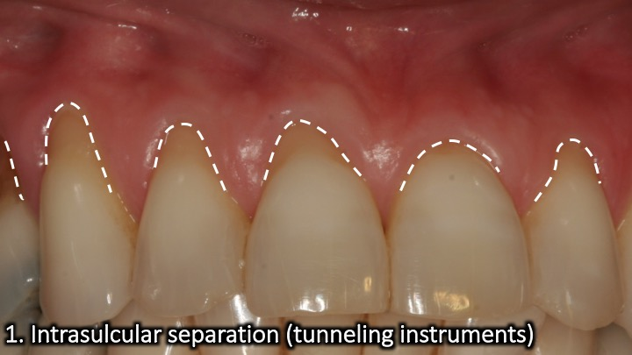

Flap design #15
Sliding flap for root coverage

The goal of this flap is to cover a recession on one tooth by mobilizing tissue from an adjacent one. The tissue covering the recession has a constant blood supply compared with free grafts. Case selection is important and you must ensure that the donor tooth has ample tissue and will not be damaged in the process. A cuff of marginal gingival tissue needs to be maintained on the donor tissue as well as exposed periosteum. That will minimize risks of damage to the donor tooth. The sliding flap needs to be fully mobile and passive to prevent opening of sutures and flap retraction. The “cut-back” incision is critical in the lateral movement.
The steps (Flap #15)
- Split thickness scalloped incision on the donor tooth between line angles of adjacent teeth.
- Vertical diagonal split thickness incision parallel to root with recession (on adjacent tooth)
- Vertical diagonal split thickness incision on tooth to be parallel to root with recession (on adjacent tooth)
- Cut back incision
- De-epithelialize sliding flap vascular bed
- De-epithelialize papillae
- Mobilize flap laterally

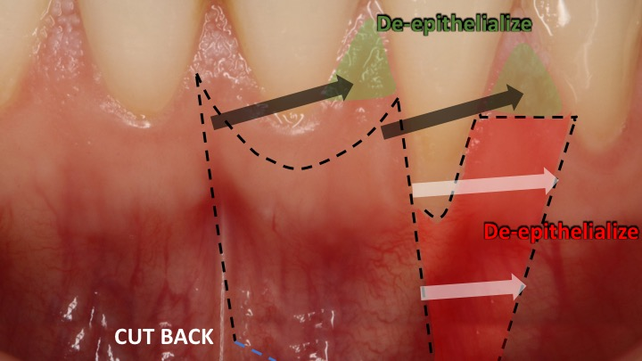

Flap design #16
Rotated palatal flap

This flap is useful in augmenting tissue volume in the esthetic zone. You will utilize some of the incisions used for harvesting a connective tissue graft (see flap #9). The connective tissue from the palatal flap is separated in a distal to mesial direction until the grafted site. At that point the tissue is “hinged” and flipped to the buccal. The keys to success is to avoid perforation of the palatal flap and to extend far enough mesially to allow the tissue to fully extend to the buccal aspect of the site.
The steps (Flap #16)
- Intrasulcular 2nd molarsocket
- Full thickness
- Split flap distal mesial
- Tunnel buccal tissue
- Flip pedicle over extraction socket
- Tuck underneath buccal tissue

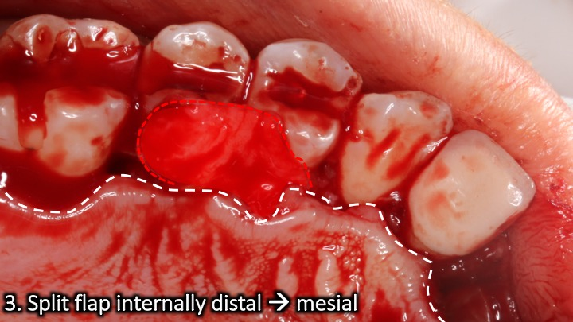
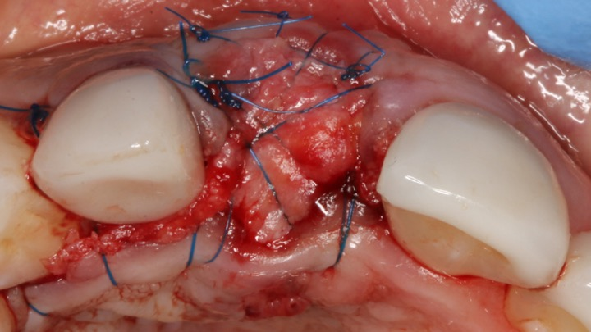
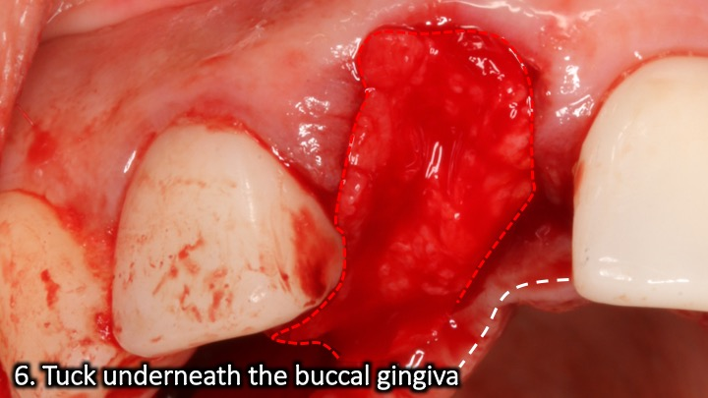
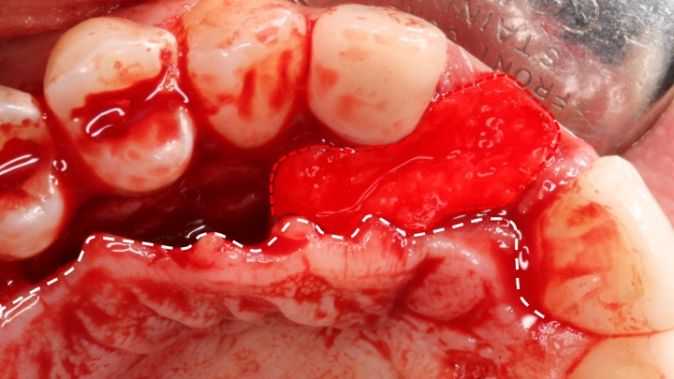
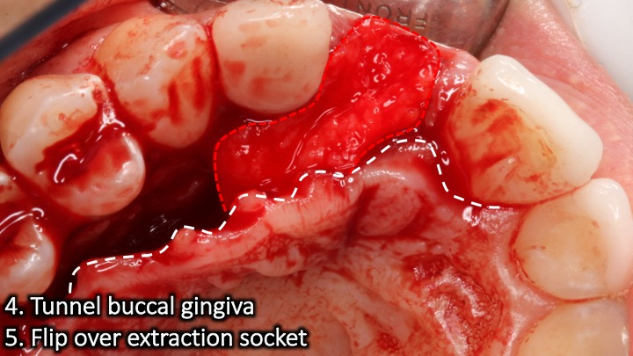
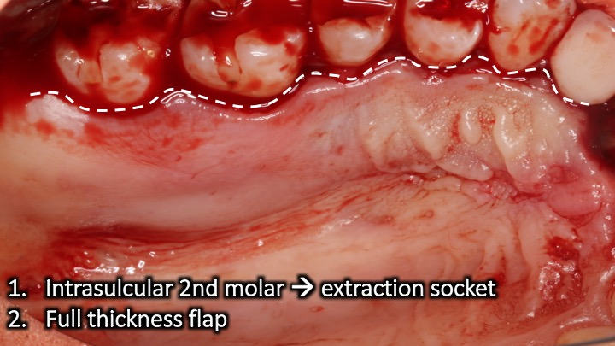

Flap design #17 Surgical lip repositioning
The steps (Flap #17)
- Split thickness incision at the mucogingival junction
- Split thickness incision in the mucosa 10-12mm apically (connect both)
- Sharp dissection of the mucosa created between lines 1,2
- Coronally advance and suture line 2 to line 1

The goal of the procedure is to minimize a gummy smile by limiting the retraction of the elevator muscles. A strip of mucosa apical to the mucogingival junction is removed and once the denuded area is sutured in primary closure, the smile elevator muscles will be limited, thus reducing the gummy smile. The procedure can relapse as the mucosa can stretch and regain its original dimension.
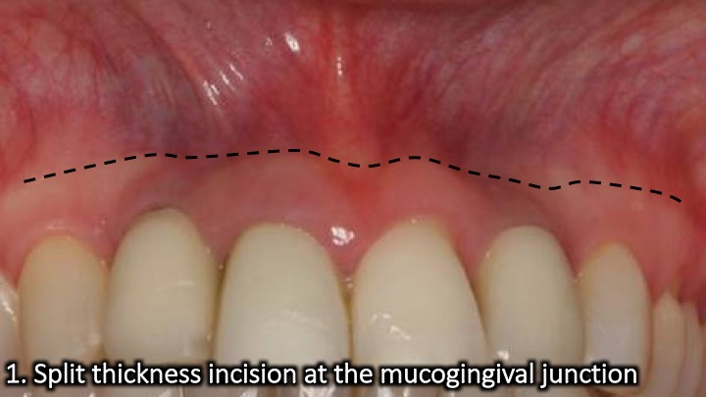
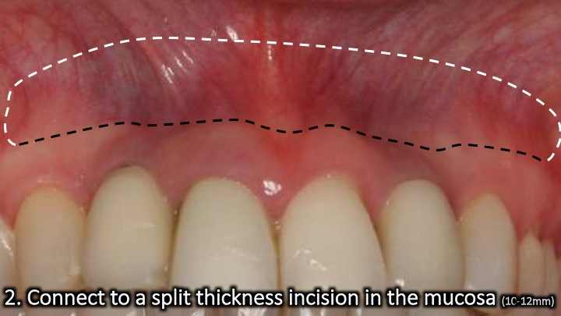
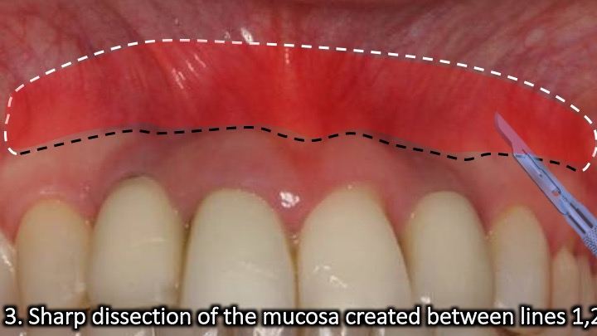
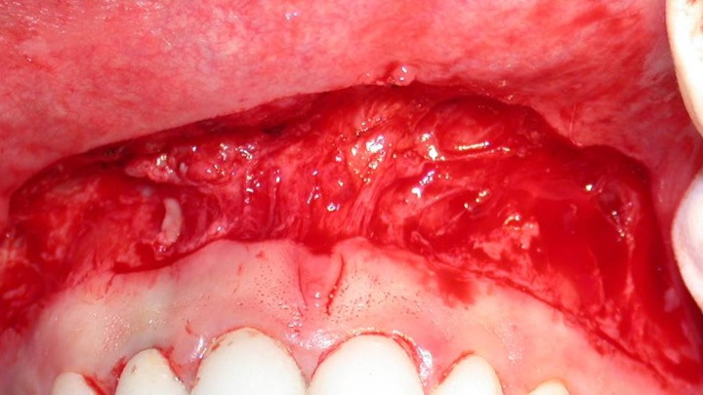

Flap design #18
The steps (Flap #18)
- 2-3 mm of attached and keratinized gingiva
- Measure from where the gingiva transitions from occlusal to buccal
- Blade, punch tool or punch drill

Punch approach (implant)

A “punch” is a circular incision to gain access for implant placement or uncovering. The keys to success are having good tissue quality and some to spare after the punch is performed and knowing the bony anatomy beforehand as it is not visible during the surgery. Guided surgery is ideal for that purpose. As a general rule you need 2-3 mm of attached and keratinized gingiva on the buccal aspect of the implant.

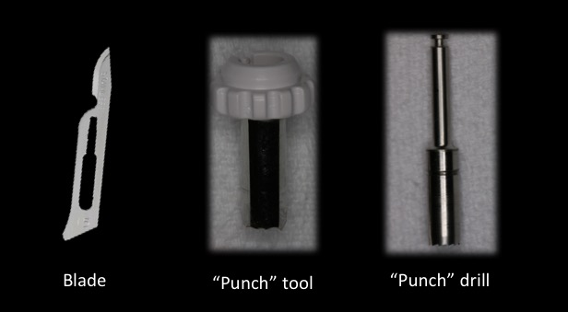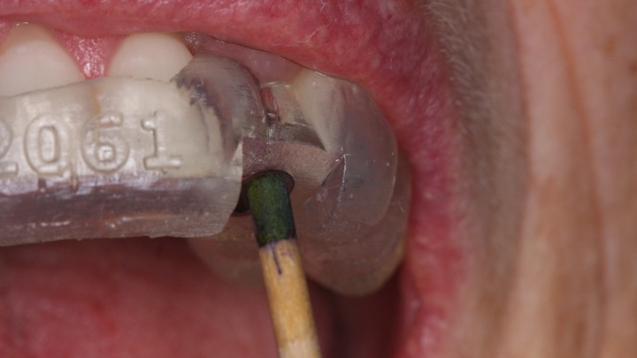

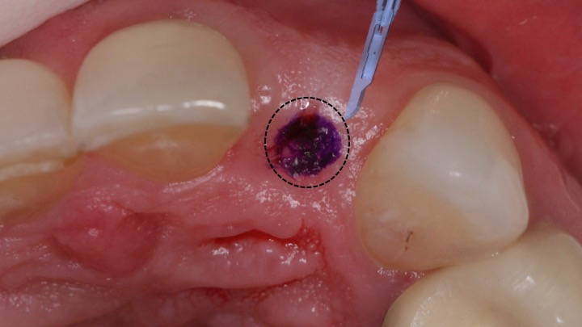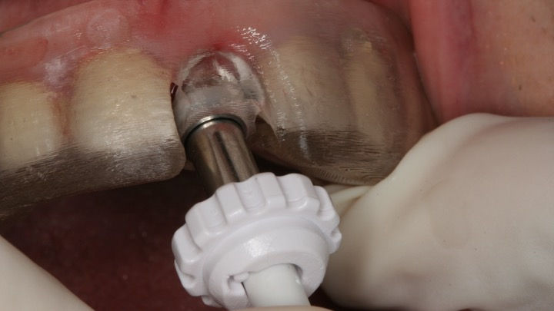

Flap design #19
The steps (Flap #18)
- Mid crestal incision
- Intrasulcular on buccal of adjacent teeth
- Full thickness buccal flap
- ½ punch of lingual tissue

½ punch approach (implant)

This approach requires adequate tissue volume to execute. Once a mid crestal incision is made, only a buccal flap is reflected to create good tissue quality and quantity on the buccal of the implant. The lingual or palatal flap are “punched” only with a half of the circumference of the punch tool (hence the name ½ punch approach). This flap design combines retaining good tissue with a relatively minimal approach.
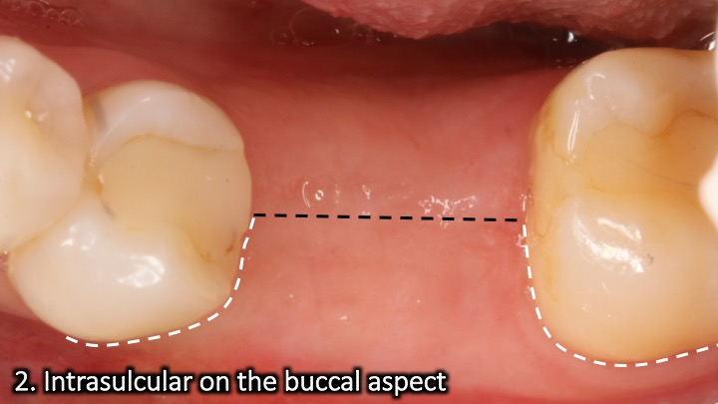
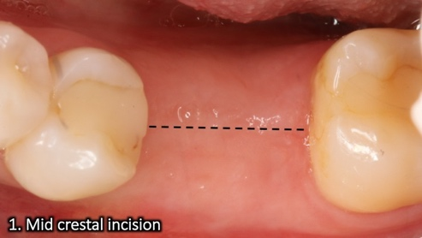

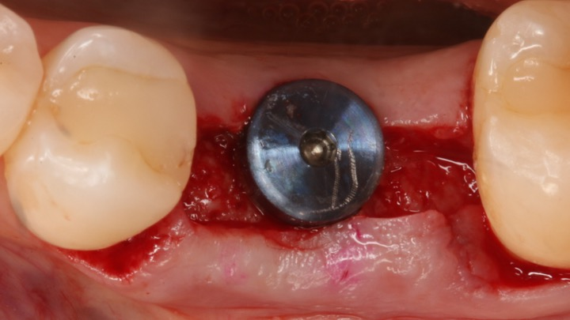
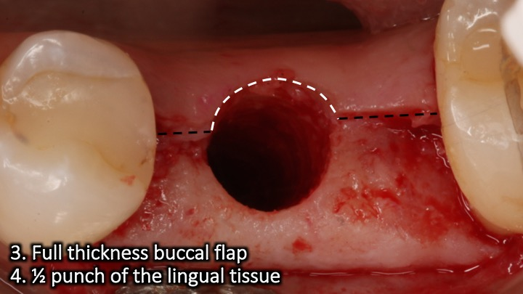

Flap design #20
The steps (Flap #20)
- Distal wedge
- Mid crestal extension (optional)
- Intrasulcular around implants
- Full thickness buccal/palatal
- Remove wedge
- Thin out buccal/palatal internally as needed
Implant site tissue reduction

Abundance of tissue around implant is favorable but too much tissue height can create maintenance and access problems if >4mm. This is common in the posterior maxilla and tissue reduction is needed. This flap design combines a periodontal distal wedge procedure with thinning out of the buccal and palatal flaps to allow them to be sutured in a more apical position with shallow peri-implant sulcus depths.

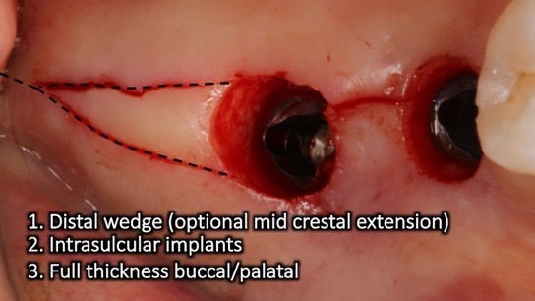
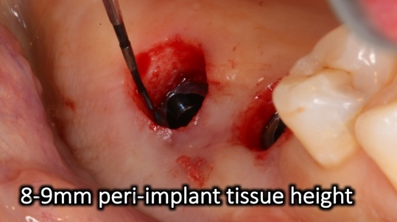

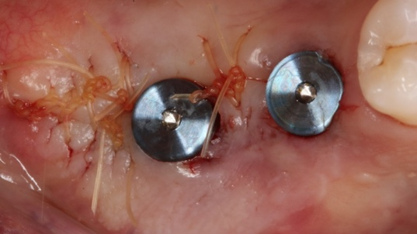
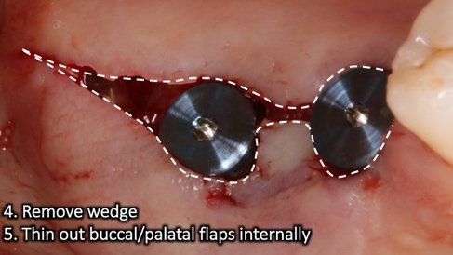

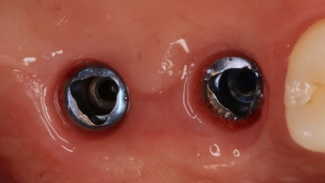
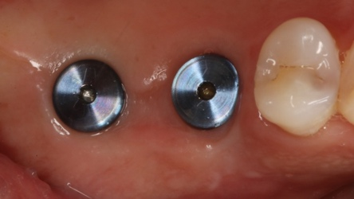

Flap design #21
The steps (Flap #21)
- Mid crestal incision
- Intrasulcular on adjacent teeth
- Full thickness flap (buccal & lingual)
Mid crestal approach (implant surgery)

When the tissue quality and quantity is insufficient, a “punch” approach is contraindicated and the mid crestal flap design is recommended to spare the tissue. It requires full thickness reflection of both the buccal and lingual/palatal flaps during the osteotomy preparation and potential grafting. The key to success is an accurate split in the middle of the tissue and careful reflection to minimize tissue loss.

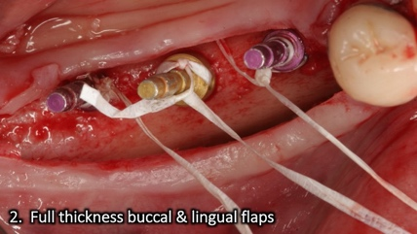
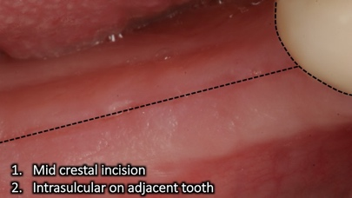

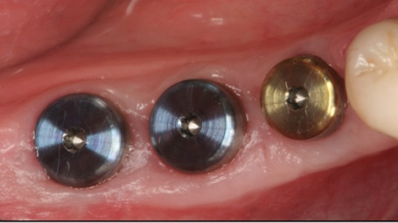
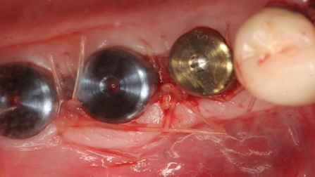

Flap design #22
Palatal approach (Multiple implants surgery)
The steps (Flap #22)
- Crestal palatal incision
- Intrasulcular on adjacent or vertical releases
- Full thickness buccal flap only
- Optional: Palatal roll combined with buccal flap (see Flap #23)

Incisions in ridges with poor tissue quality or with inflammation, create tissue tears and compromised healing. Therefore, a more palatal full thickness incision to bone will allow mobilizing it to the buccal aspect of the implants and engage sutures in good tissue quality.

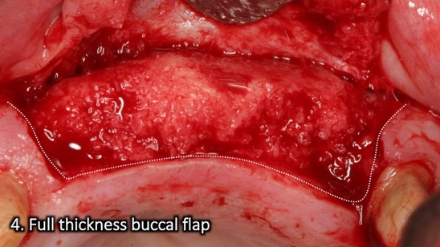
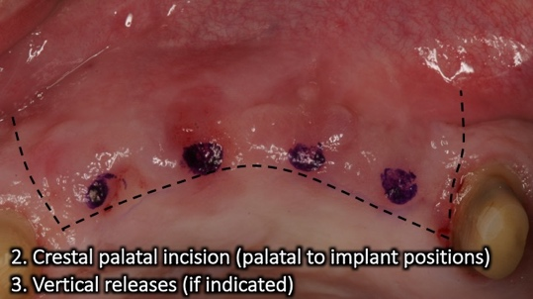

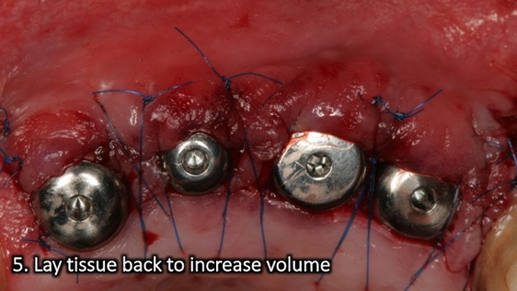
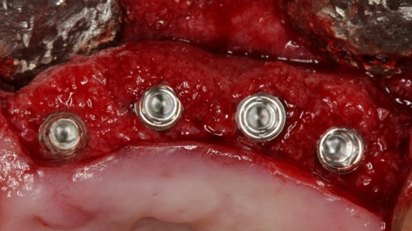

Flap design #23
The steps (Flap #23)
- Crestal palatal incision
- Connect with intrasulcular incisions on adjacent teeth
- Full thickness buccal flap
- De-epithelialize flap coronal aspect
- Roll under the buccal flap
- Adapt to healing abutment
Palatal roll (implant placement/uncovering)

The palatal roll is a flap that starts with a crestal palatal incision and followed by a full thickness flap mobilized to the buccal of the implant. The coronal part of the flap is then de-epithelialized and tucked underneath the buccal flap for additional volume. The modified palatal roll is different in having a connective tissue extension that is taken more palatal to the initial incision and is more technique-sensitive.

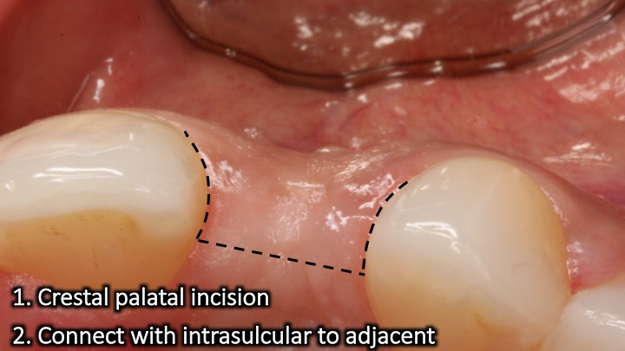
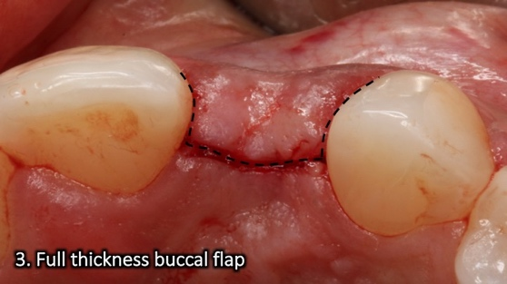

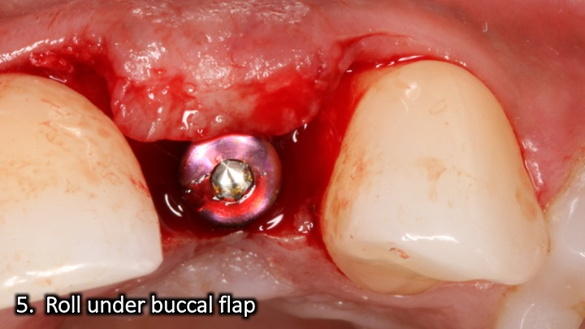
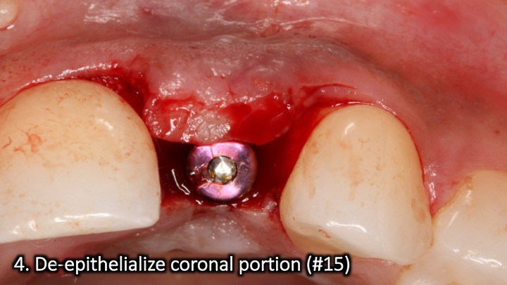
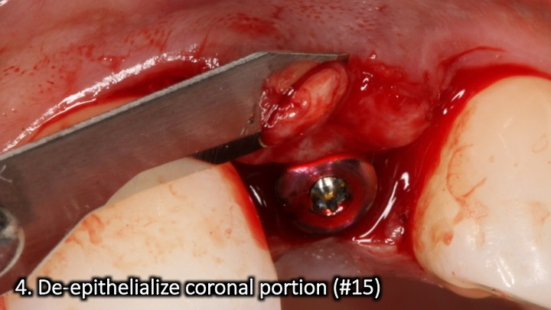
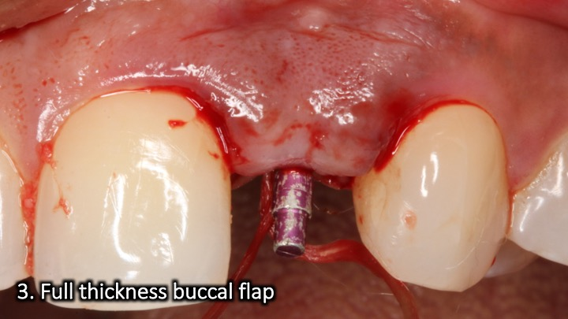

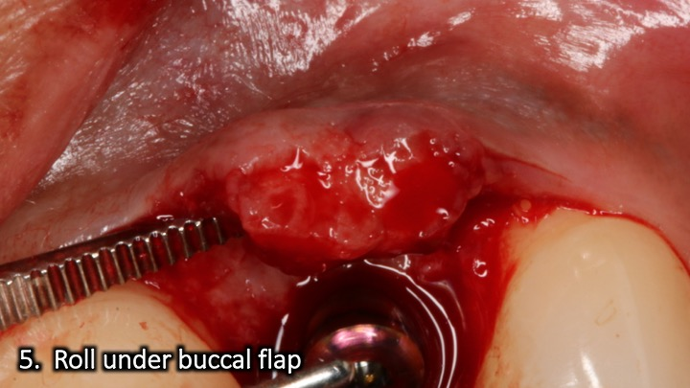
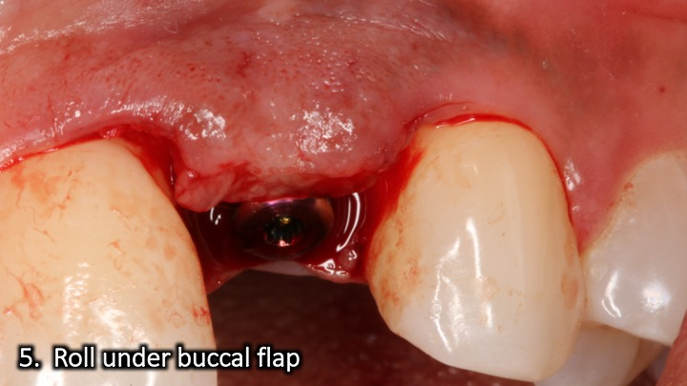

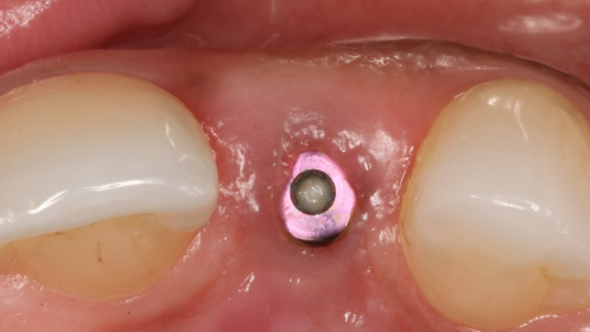
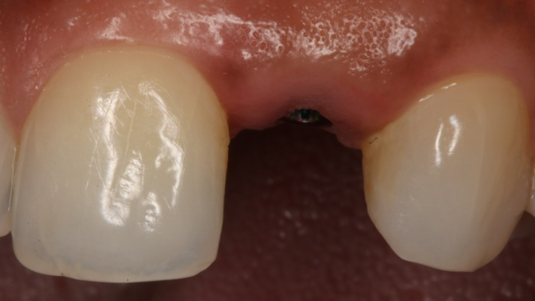
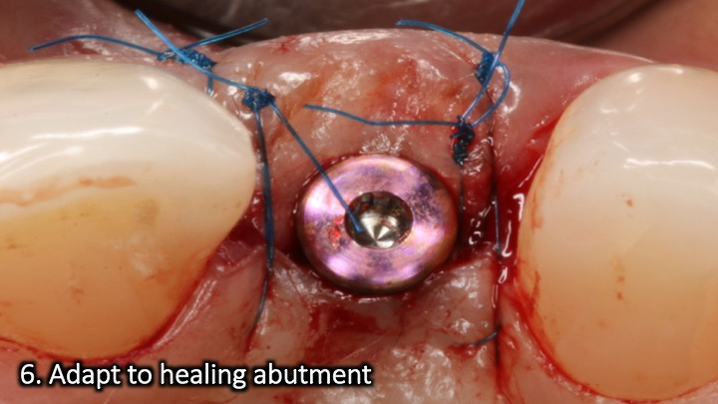
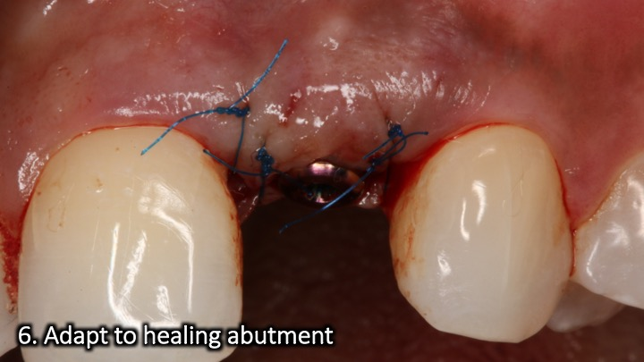

Flap design #24
The steps (Flap #24)
- Crestal palatal incision
- Intrasulcular on the adjacent
- Vertical release away from grafted site
- Primary closure
- Adapt to healing abutment
Implant placement & simultaneous grafting

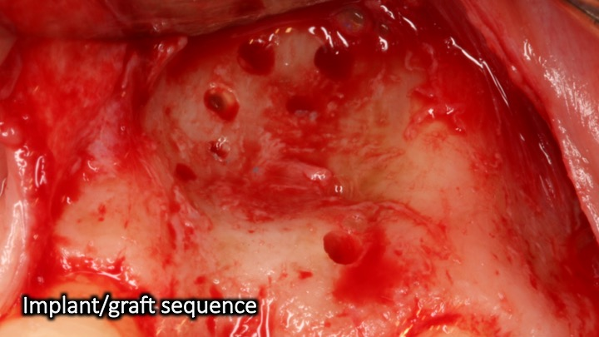
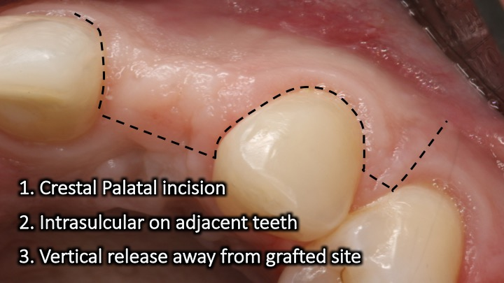
When planning to place an implant and simultaneously graft, you need to consider proper exposure and visualization of the site and allow for primary closure. A vertical release can be made in the most distal aspect of the flap. The tissue corresponding with the vertical release should be ideally perpendicular to the vertical release to allow proper alignment and suturing at the end of the surgery. The reason for a large flap that extends beyond the mucogingival junction is that additional bone contour will be added and therefore the tissue volume in a form of a large flap needs to be appropriate.
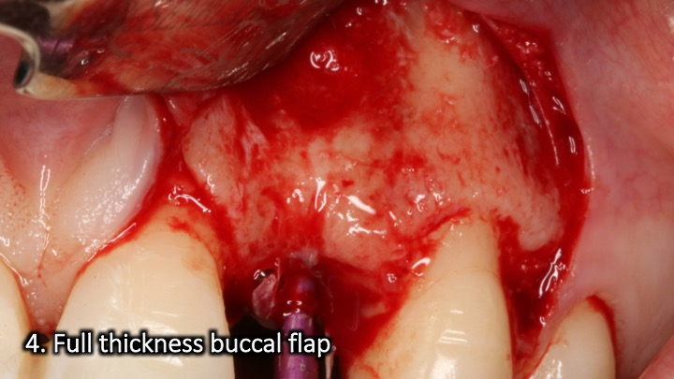
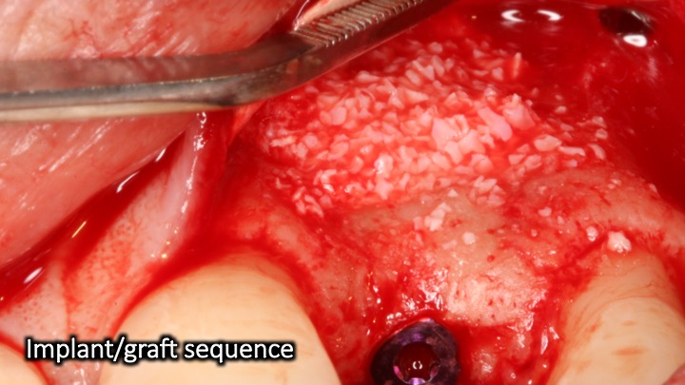
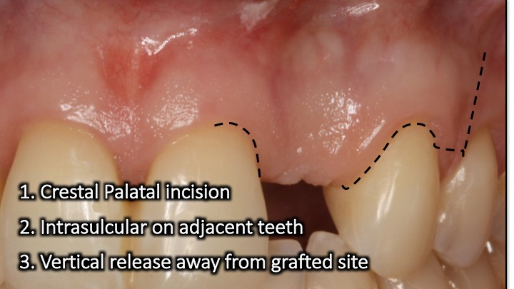
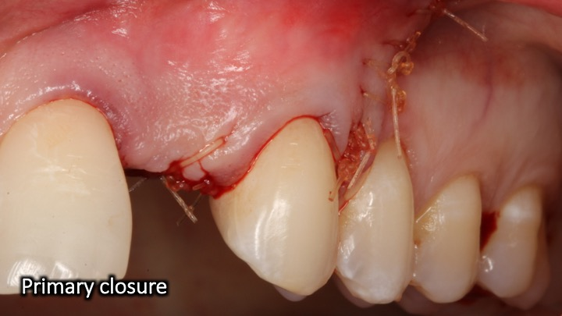

IMPLANT FLAP DESIGN SUMMARY

Remember that the shape of the flap and the incision outline stems primarily from the goal of the surgery (e.g., implant placement, augmentation, advancement) and also from unfavorable things that you would like to avoid (e.g., recession, bone graft exposure, loss of papilla).
Here is a summary of some implant flap designs:
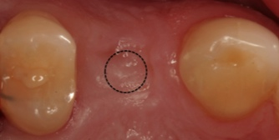
Mid crestal Punch

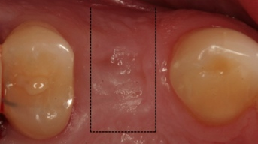
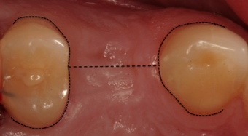
½ Punch Papillae sparing
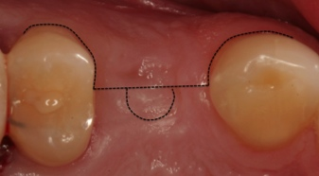
Mesial Papilla sparing Distal papilla sparing
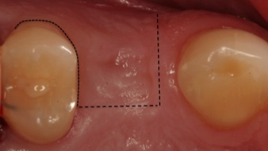
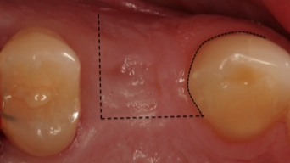

A few last words about the best flap designs.

You are an artist and I know you could simply follow the same incision outlines in this book.
DON’T!

Each procedure is different and there are various circumstances that will dictate varioations in flap designs.

When planning your incisions always:
- Think
- Visualize and
- Plan

The thought process is critical. Think like a surgeon.
Think about what you are trying to achieve with the procedure and what could be damaging and counterproductive.
When I think about the procedure’s goal and the dangers I’d like to avoid, I come up with the best flap design.
You can do the same if you keep thinking-through, visualizing and planning your surgeries.
I hope this book was helpful and valuable. The online course on the best flap design is next for you.
To your surgical success!

Ziv.

