Sahar Aidipour  Legal Assistant; Communications Manager | Sahar joined our team in May 2018. She has a Bachelor of Arts degree in Psychology from the University of Houston and worked for Apple for over three years. Sahar can be reached at sahar@clark.law | 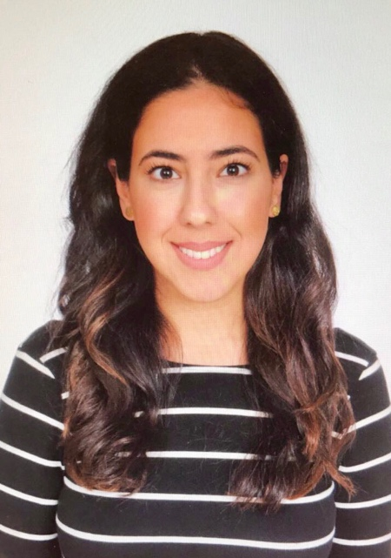
Dac Cannon  Attorney | Dac joined our team in May. He holds BA, JD, and MBA degrees from UNC-Chapel Hill, where he was a Morehead Scholar. Dac previously worked at McGuireWoods in Charlotte; he also advises real estate and business owners in capital raising and disposition transactions. Dac assists clients with a wide range of business matters. He can be reached at dac@clark.law. | 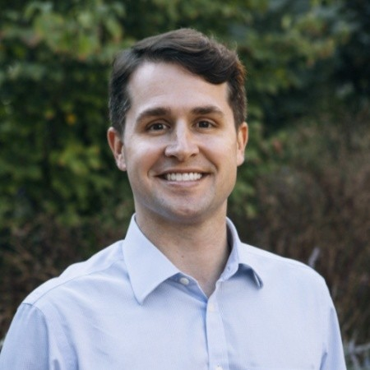
Chris Clark  Attorney/Founder | Chris Clark co-founded The Law Office of Chris Clark, PLLC in 2016. He holds a Bachelor of Music degree from Radford University and a JD degree from UNC-Chapel Hill. Chris can be reached at chris@clark.law. | 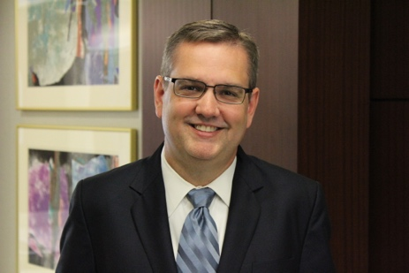
Christy Clark  Paralegal/Founder | Christy Clark co-founded The Law Office of Chris Clark, PLLC in 2016. She has a Bachelor of Arts degree in English from Roanoke College, and obtained her Certificate in Paralegal Studies from Duke University in 2011. She is a North Carolina State Bar Certified Paralegal. Christy can be reached at christy@clark.law. | 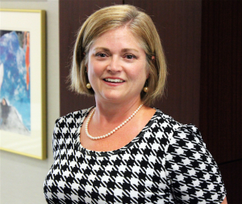
Amy Eades  Paralegal | Amy joined the firm in August 2018. She has a Bachelor of Arts degree in English from the University of Kentucky and a Certificate in Paralegal Studies from the University of Cincinnati. She has work experience in the areas of civil litigation, intellectual property, legal coaching, and business development consulting. Amy can be reached at amy@clark.law. | 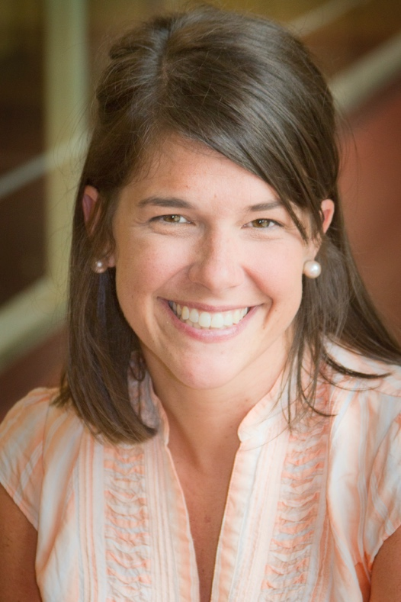
Liza Leah  Attorney | Attorney Yelizaveta (“Liza”) Leah holds an International Law degree from Kazakh State Law Academy in Almaty, Kazakhstan, and a second law degree from Duke University School of Law. She previously worked at Alston & Bird in Charlotte and has extensive domestic and international experience in intellectual property, corporate, contract, and business law. Liza can be reached at liza@clark.law. | 