Packaging Design Brief

We need a thematic packaging design that fits our elderly nutrition products, that is based on our "3 Ws ethos" - eating Wisely, Widely & Wholly.



Wisely - selected superfoods and ingredients - NZ and other sources
Widely - based on the "rainbow diet" philosophy
Wholly - all natural, (no artificial flavours, colors etc). Formulated as complete meals (NOT supplementation)

Deliverables:
* 5 packaging designs in the range.
1x yellow + orange colored foods (star ingredient: “fresh as” – passion fruit powder)
1x red colored foods (star ingredient: (star ingredient: - dried appled )
1x blues/purple colored foods: (star ingredient: viberi blackcurrant)
1 x green coloured foods (star ingredient: Green kiwi)
1 x brown/white (star ingredients: mitchell’s grass fed bone broth)

Mediums
- 400-450gram re-selable doy packs
- 400-450gram re-sealable tin cans
Mandatory:
- clear visual que of the food color/s
- "New Zealand" origin must come through strongly.
- must have a blurp or feature of the star ingredient for each with mention of brand.
e.g. for the blues+ purple, NZ blackcurrant powder for improved eyesight (cataract prevention).
- icons for “heart health, “eyesight”, “mobility”, “gut-health”.
- every other ingredient must be stated.
The name of product may/may not be “essentialkai”. Our on-going research tells us that for the Asian market, an icon or character to personify our product may be a sound strategy. This is only for the designer to take note off.

Desirables:
Ingredient origin story - e.g blackcurrant comes from Timaru etc.
(refer to Whitakers destination marketing…)
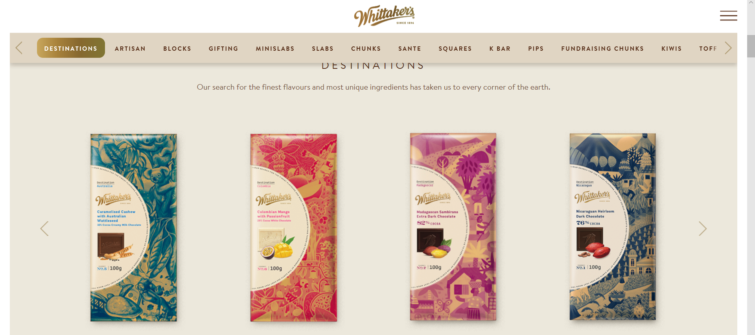

Whose attention we are trying to grab?

Primary:
- 20 to 40 year olds buying these products for their parents/grand parents
- Health Nutrition conscious “golden agers”
Secondary
- Professional Caregivers to the elderly (homes, private hospitals etc)
- 40 year olds in the “prevention” mind set.

“Look n feel”

