Roll Up 1: Mobile Version of JoVE Core
The Textbook Model is Broken!

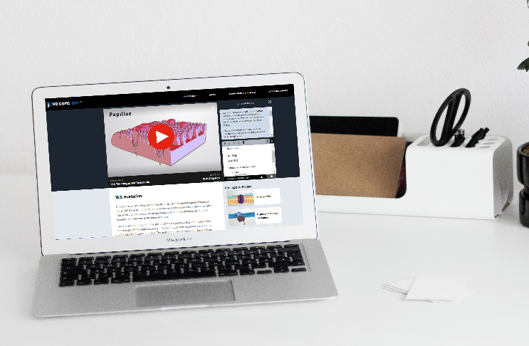



A BETTER WAY TO LEARN

Saves Students Money
Focuses on What Matters

Personalized Support

Geared Towards All Learning Styles

Roll Up 2: One with Old Man Textbook

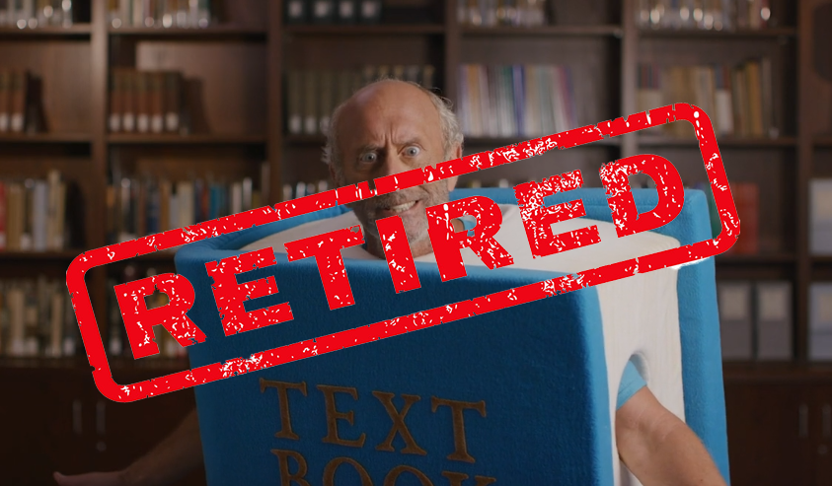

RETIRE
THE TEXTBOOK
TODAY!

www.jovecore.com

The Textbook Model is Broken!

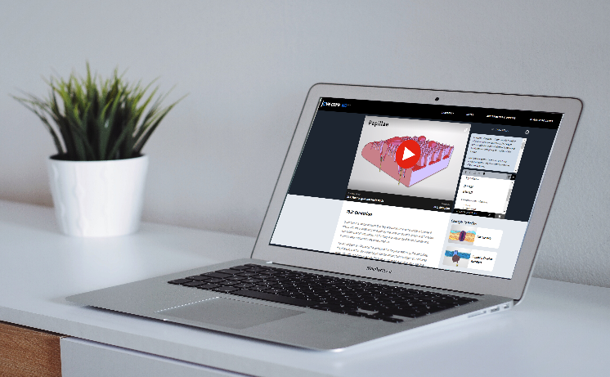

Saves Students Money
Focuses on What Matters
Personalized Support

Geared Towards All Learning Styles
A BETTER WAY TO LEARN

The Textbook Model is Broken!
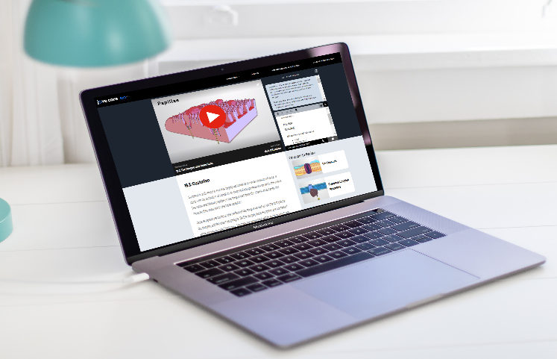
A BETTER WAY TO LEARN
Geared Towards All Learning Styles
Personalized Support

Focuses on What Matters
Saves Students Money

