Proposed copy:

GROW YOUR DSO WITH CUSTOMIZED TRAINING SOLUTIONS
Services
- Clinical Training
- Web-Based Learning
- Chairside Coaching
- Train Your Trainer
- Regional or Annual Meetings
- Metric Analytics

Why partner with us?
Do you want to:
- Make hygiene the driver of every dental practice?
- Consistently achieve production goals?
- Provide excellent care for every patient in every practice?
- Provide continuity of care between providers?
- Standardize scripting to increase treatment enrollment?
- Improve the retention of both your staff and your patients?
- Supplement your education initiatives with metrics-based needs assessment?
If you said yes to any of these questions, then DEP is right for you!

​ “Dental Education Partners delivered training for our team that isn't offered anywhere else. Their training has dramatically changed our team’s ability to influence treatment acceptance. I would recommend their services to any DSO looking to increase profitability!”
Dr. Steven Wingfield, Chief Clinical Officer, Dental Whale Practice Group

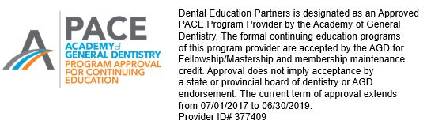

Copy for above:
Dental Education Partners, LLC is designated as an Approved
PACE Program Provider by the Academy of General
Dentistry. The formal continuing education programs
of this program provider are accepted by the AGD for
Fellowship/Mastership and membership maintenance
credit. Approval does not imply acceptance by
a state or provincial board of dentistry or AGD
endorsement. The current term of approval extends
from 07/01/2017 to 06/30/2019.
Provider ID #377409

DENTAL EDUCATION PARTNERS, LLC

Mary K. Hughes
(585) 354-9942
mary@dentaleducationpartners.com

Stephanie Palmer
(818) 469-6630
steph@dentaleducationpartners.com

web: dentaleducationpartners.com

