

Step into a new universe of learning with EX-IQ

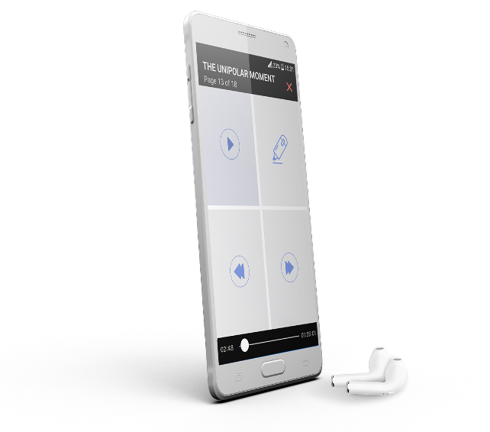
EX-IQ’s revolutionary mobile and desktop applications empower life-long learners and leaders to make the most out of every moment. EX-IQ’s dynamic, artificial intelligence technology transforms any environment into a personalized high-speed learning laboratory—offering users unprecedented autonomy, efficiency, and productivity.

“EX-IQ helped me pass a professional certification. The ability to listen to the material and highlight important topics was invaluable; I completed the requirements in half the time and passed on the first attempt.”

Suely
Lawyer
FORTUNE 100 COMPANY
“Ex-IQ provides a unique and elegant solution that magically transforms my phone, and by extension my commute, into productive time for course prep, research, and brainstorming on the go. Ex-IQ’s technology is now integral to my work as a professor.”

Allison
Lecturer
JOHNS HOPKINS

The EX-IQ Difference


Audio Unleashed
Put your intellectual achievement into overdrive with limitless audio content at your fingertips. EX-IQ’s cutting-edge technology effortlessly converts any written document into an interactive, high-quality IQBook. EX-IQ is the first to produce “study grade” audio content specifically for learners. Our turn-key solution allows any individual or organization to transform their one-dimensional library of written material into a multisensory ecosystem featuring audible, interactive content.



Notetaking Transformed
Start learning at lightning speed with notetaking for audio content. Users listening to an IQBook can instantly highlight and tag sentences in the corresponding written document by simply tapping their phone screen or issuing a voice command. Even better, these highlighted sentences are automatically copied into a searchable, shareable, cloud-based notefile of the user’s choice. Dictated notes can be attached to the highlighted sentences or as standalone thoughts, thereby ensuring your next aha moment doesn’t get lost just because you’re on a plane, train, treadmill or commute.



Desktop Supercharged
Experience exponential productivity with EX-IQ’s supercharged desktop. Say goodbye to endless clicking, copying, pasting and searching across documents. Simply highlight any desired number of sentences from your computer, and EX-IQ automatically cuts and pastes them to a cloud-based note file of choice. A pop-up menu allows you to Tag and embed comments in the text as well. EX-IQ’s personalized portal gives you access to all of your mobile and desktop material in one intuitive, convenient place. Search across your EX-IQ material by tag, date, keyword or numerous other categories, and then download, export, or share important notes in seconds.

Find out more at www.ex-iq.com

