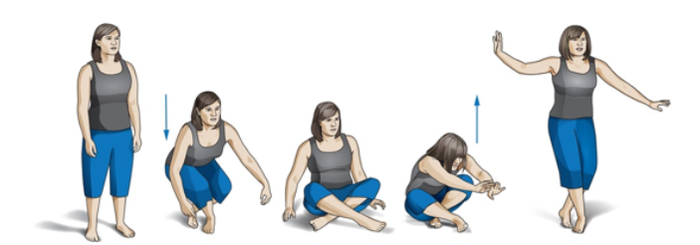

Mortality Risk Test: Barefoot, cross your feet and sit on the floor crisscross applesauce. If you can do this, you get 5 points. Then stand back up. If you can do this, you get 5 more points. Now, deduct 1 point for every hand, arm, or knee you had to use for leverage or support (either on the way down or back up). Then take off an additional 1/2 point for every time you lost your balance (either going down or up). For every point you have left at the end, there is a 21% DECREASE in mortality. That’s a 21% INCREASE in your life expectancy. It’s not just about how far you can run, how much you can squat, or what size jeans you wear friends. It’s about overall strength, flexibility, and stabilization (balance). #themoreyouknow #takecareofYOself #livelongandprosper

