Site pages (I want the name and logo in the center of the header and the other pages links on either side.)
Home
Home page features should include:
An image slider at the top Please use the one personal image of her running as the start. Then use the gym equipment images. Please overlay these quotes on the images.
- Kettle Bell (“If it doesn’t Challenge you, it won’t Change you”).
- Battle Ropes (I can, and I will)
- Dumbbell (Killing it)
- Barbell (Just Believe in Yourself)
- Slam Ball (Hustle)
- TRX Image (You don’t get the Butt you Want by Sitting on it)

I would like a “Ask Ally” section so visitors can submit training questions
Links to YouTube Channel
Links to Facebook page
Certifications
Images of all NASM certification should be posted in a appealing visual manor. A list of additional certifications and qualifications should also be here
Bio
Text should be laid out in an attractive manor
Blog
First blog provided. Blog should have image that goes with the text.
Videos
This section should link to YouTube Channel if possible. It should also house any uploaded video with a header for each.
Online Training
Text provided. Each section should have a bold and numbered header with corresponding image.
Functional Movement Screening
All text provided with image as a header
Nutrition Section
This section needs to accommodate Favorite Recopies and Supplements
Merchandise

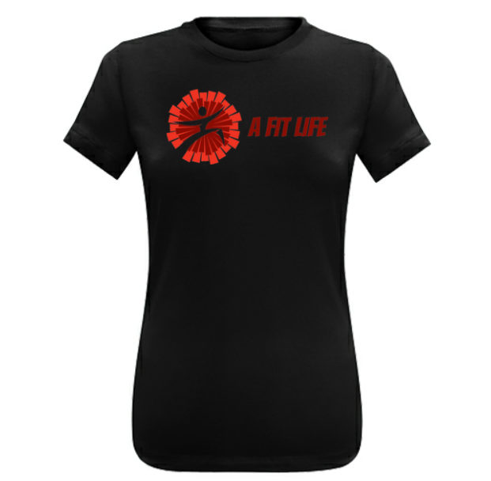

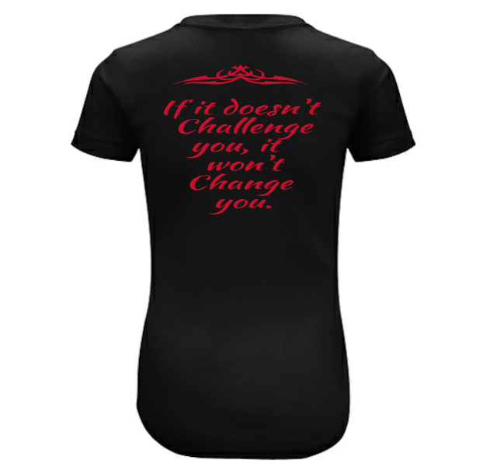

Contact Us
Name
Address
Email
Phone Number
Comments

