Group 314 is a Registered Training Organisation (RTO) delivering Nationally Accredited qualifications
If you are looking for an RTO that is committed to YOU, the professional and your educational requirements then look no further!
What we do…

The team at Group 314 are an energetic and enthusiastic group of professionals providing nationally recognised education to individuals and CPE programs.
Our specialty is in the personalised delivery of training by our industry specialists who have a vast amount of experience and skills to deliver exceptional services.
We tailor our programs to the needs of individual. This allows us to determine the duration and content for each program on an individual basis. We want each of our candidates to experience personal success so we make sure they have the personal skills to achieve this.
We make sure that not only are our candidates competent but they have the confidence to use their skills and knowledge in the workplace.

Our philosophy on education…
We believe that if something has been taught, it does not mean it has been learnt. We focus on the individual learning needs of candidates and utilise Recognition of Prior Learning (RPL) techniques at all times.
A lifetime of experience should be recognised, whether there are associated certificates and qualifications or not. In order
to make an assessment decision we get to know our candidates as people, we don’t endorse ‘tick the box’ courses.
Tax Practitioner Board Approved
These units are specifically approved by the Tax Practitioner Board Approved as units meeting the Boards education requirements for specific purposes.
  - BAS Agent Registration Compliance Program Skill Set (FNSSS00004)
  - TASA 2009, including the code (CPE0317)
  - BAS and Payroll Challenge Exam (CPE05) – a fast track approach to meeting the education requirements for BAS agent registration.
FINANCIAL SERVICES
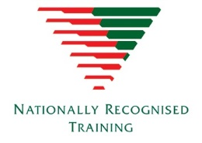
The Financial Services qualifications are designed to reflect the job roles of bookkeepers and accountants working for organisations in a range of industries, employed or contract.
The BAS Agent Registration Skill Set is one of the requirements for registration as a BAS Agent under the Tax Agent Services Act 2009 regime.
Each of the financial services courses have been developed with the professional bookkeeper and accountant in mind. Where possible RPL opportunities will be encouraged in order to reward you for the years of hard work in the industry.
Qualifications
  - Diploma of Payroll Services (FNS50417) NEW
  - Diploma of Accounting (FNS50217)
  - Certificate IV in Accounting and Bookkeeping (FNS40217)
Skill Sets
  - BAS Agent Registration Skill Set (FNSSS00004)
  - Commercial Law for Tax Agents Skill Set (FNSSS00005)
  - Tax Law for Tax Agents Skill Set (Tax documentation) (FNSSS00008)
  - Payroll Administrator Skill Set (FNSSS00012) NEW
  - Business Ethics and Conduct Skill Set (FNSSS00013)
  - Accounting Principles Skill Set (FNSSS00014)
  - Advanced Accounting Principles Skill Set (FNSSS00015)
Units (complete 1 or many)
  - Complete business activity and instalment activity statements (FNSTPB401)
  - Establish and maintain payroll systems (FNSTPB402)
  - Process salary packaging arrangements and additional allowances in payroll (FNSPAY501)
  - Process superannuation payments in payroll (FNSPAY502)
  - Process complex employee terminations in payroll (FNSPAY503)
  - Interpret and apply knowledge of industrial regulations relevant to payroll (FNSPAY504)
  - Interpret and apply knowledge of taxation systems relevant to payroll (FNSPAY505)




Business Services
The range of Business Services programs are designed to skill those who are self-employed, consulting or those working in a broad range of industries. They are beneficial to both employed and contract staff as well as business owners and provide a diverse learning opportunity and a valuable skill set.
Qualifications
  - Diploma of Leadership and Management (BSB51915)
  - Certificate IV in Leadership and Management (BSB42015)
  - Certificate IV in Work Health and Safety (BSB41415)
Skill Sets
  - BSBSS00035 Copyright Skill Set
  - BSBSS00043 Key Management Skill Set
  - BSBSS00057 Trade Mark Skill Set
  - BSBSS00059 Workforce Planning and Development Skill Set
  - BSBSS00063 Team Leader Skill Set
  - BSBSS00064 Promoting Diversity Awareness in the Workplace
Units

Tax Practitioner Board Approved
These units are specifically approved by the Tax Practitioner Board Approved as units meeting the Boards education requirements.
  - CPE05 BAS and Payroll Challenge Exam (Streamlined)
  - CPE0317 TASA 2009, including the Code of Professional Conduct
  - FNSSS00004 BAS Agent Registration Skill Set

Continuing Professional Education (CPE)

We offer a ran
  - CPE05 BAS and Payroll Challenge Exam (Streamlined)

Education is the Key to Success

Get Qualified NOW!
Nationally Recognised Training
Continuing Professional Education (CPE)

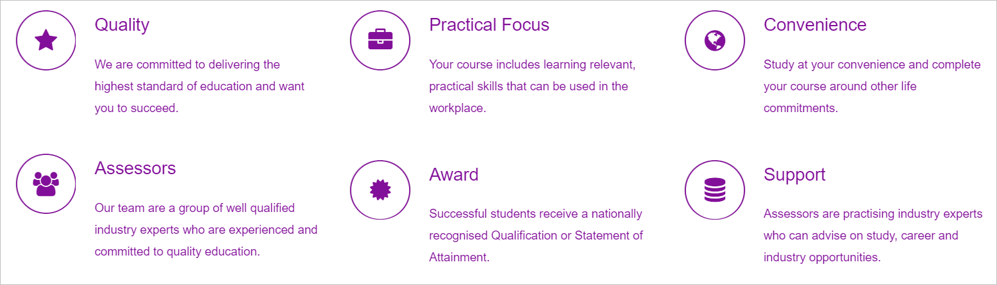

Support
The dedicated team at Group314 is available to assist with any questions you may have in relation to:
- How to enroll in a program
- Payment options
- Terms and conditions
- Program curriculum
- RPL process
- Assessment processes
- Administration queries

Why study with Group 314?
Group 314 have been delivering quality training and assessment solutions for over a decade. We deliver a range of formal and non-formal programs, including courses specifically approved by the Tax Practitioners Board. Our professional and enthusiastic trainers and assessors look forward to exceeding your expectations.
Empower yourself to build a successful career in the Accounting and Bookkeeping industry. Enrol NOW!
Get inspired by our students who can testify that with the right support, flexibility and motivation you can achieve your goals.



G314 Testimonials
What we don’t tell you about us
BAS and Payroll Challenge Exam (CPE05) - The course material was great. I was frustrated when the TPB told me I was required to complete a course even though I have previously been registered and had experience. However, now that I have completed the program I am pleased that all bookkeepers have this training as I am sure many were unskilled. From my experience when working in accounting firms we found a lot of errors with businesses not completing activity statements labels correctly, incorrect reporting of lump sums, what to include in assessable income for super and you covered this thoroughly. I think it would even be great to offer this to accounting firms for PD days or for new staff to view the slideshow. Kylie Porter
I am very happy with my choice to complete the Certificate IV in Bookkeeping with Group314. I have found the course subjects to be very relevant and conducive to my day to day work as a bookkeeper. Group314 subjects relate directly to your work as a bookkeeper, which is not only beneficial to the professional, but to the client also. So I now have no hesitation in using the Group314 templates in my professional work. I had moved my studies from another training organisation as I had felt it was not providing the skills and professional development I required as a bookkeeper. The structure of the Group314 course provides for a practical learning base for people wanting to enter the bookkeeping industry and for people like me who have been in the industry for years and are required to update their qualifications. I would strongly recommend Group314 for the proactive course, Cert IV in Bookkeeping. Megan Hamilton

