Our Company  Group 314 Pty Ltd  T: 1300 448 779  W: www.group314.com  E: info@group314.com | Design:  - Need a trifold DL flyer

Suggestion for DL Flyer
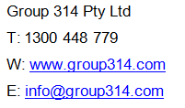

Visit us at ABN Conference 2018 and ask about…
- NEW Payroll Qualifications
- Conference Specials
- CPE programs
- Prize Draw! Enter the competition to win our NEW Payroll Administrator Skill Set (FNSSS00012).

Courses we offer (Need this on the DL Flyer)
Note: Not all Individual Units will fit, so add as many as possible
Qualifications  A qualification is a certification awarded that recognises the successful completion of a nationally recognised training program. A qualification contains a selection of individual units of competency.  - Diploma of Payroll Services (FNS50417) NEW  - Diploma of Accounting (FNS50217)  - Certificate IV in Accounting and Bookkeeping (FNS40217)  - Diploma of Leadership and Management (BSB51915)  - Certificate IV in Leadership and Management (BSB42015)  - Certificate IV in Work Health and Safety (BSB41415)  TPB Approved  The Tax Practitioners Board (TPB) approved certain courses as meeting their specific requirements in addition to those offered under the AQF framework.  The units listed under this category have been been independently certified by Professor Robert Deutsch BEc LLB(Sydney) LLM(Cambridge) and formally approved by the Tax Practitioners Board and comply with the Boards specific requirements.  - BAS Agent Registration Compliance Program Skill Set (FNSSS00004)  - TASA 2009, including the code (CPE0317)  - BAS and Payroll Challenge Exam (CPE05) – a fast track approach to meeting the education requirements for BAS agent registration. | Skill Sets  A Skill Set is a shorter program consisting of two or more units of competency. A nationally recognised Statement of Attainment is awarded on successful completion of a Skill Set.  - BAS Agent Registration Skill Set (FNSSS00004)  - Commercial Law for Tax Agents Skill Set (FNSSS00005)  - Tax Law for Tax Agents Skill Set (Tax documentation) (FNSSS00008)  - Payroll Administrator Skill Set (FNSSS00012) NEW  - Business Ethics and Conduct Skill Set (FNSSS00013)  - Accounting Principles Skill Set (FNSSS00014)  - Advanced Accounting Principles Skill Set (FNSSS00015)  - Copyright Skill Set (BSBSS00035)  - Key Management Skill Set (BSBSS00043)  - Trade Mark Skill Set (BSBSS00057)  - Workforce Planning and Development Skill Set (BSBSS00059)  - Team Leader Skill Set (BSBSS00063)  - Promoting Diversity Awareness in the Workplace Skill Set (BSBSS00064) | Individual Units  Individual units are an excellent CPE activity and contribute to Qualifications and Skill Sets. A nationally recognised Statement of Attainment is awarded on successful completion of a unit.  - Complete business activity and instalment activity statements (FNSTPB401)  - Establish and maintain payroll systems (FNSTPB402)  - Process salary packaging arrangements and additional allowances in payroll (FNSPAY501)  - Process superannuation payments in payroll (FNSPAY502)  - Process complex employee terminations in payroll (FNSPAY503)  - Interpret and apply knowledge of industrial regulations relevant to payroll (FNSPAY504)  - Interpret and apply knowledge of taxation systems relevant to payroll (FNSPAY505)  - Apply legal principles in contract and consumer law (FNSTPB503)  - Apply legal principles in corporations and trust law (FNSTPB504)  - Apply legal principles in property law (FNSTPB505)  - Apply taxation requirements when providing tax (financial) advice services (FNSTPB506)  - Apply legal principles in commercial law when providing tax (financial) advice services (FNSTPB507)  - Manage personal work priorities and professional development (BSBWOR501)  - Introduce cloud computing into business operations (BSBSMB412)  - Maintain inventory records (FNSACC405)  - Produce job costing information (FNSACC407)  - Work effectively in the accounting and bookkeeping industry (FNSACC408 )  - Process business tax requirements (FNSACC411)  - Prepare operational budgets (FNSACC412)  - Prepare financial statements for non-reporting entities (FNSACC414)  - Establish and maintain accounting information systems (FNSACC505)  - Provide financial and business performance information (FNSACC511)  - Prepare tax documentation for individuals (FNSACC512)  - Manage budgets and forecasts (FNSACC513)  - Prepare financial reports for corporate entities (FNSACC514)  - Implement and maintain internal control procedures (FNSACC516)  - Provide management accounting information (FNSACC517)  - Prepare and administer tax documentation for legal entities (FNSACC601)  - Evaluate business performance (FNSACC607)  - Identify situations requiring complex ethical decision making (FNSINC503)  - Apply ethical frameworks and principles to make and act upon decisions (FNSINC504)
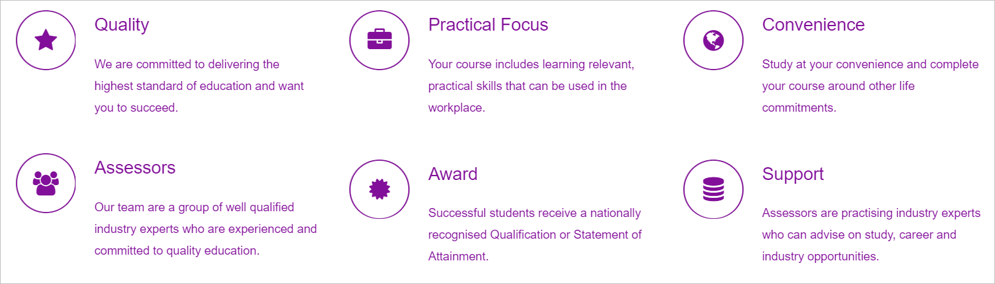
What is CPE?
CPE has been introduced under the Tax Agent Service regime to ensure agents registered with the TPB remain informed on current developments in the dynamic financial services industry and maintain a high level of professional knowledge and the appropriate skills to competently deliver the services they are registered to perform.
The Tax Practitioners Board define CPE as “any education activity relevant to the tax (financial) advice, tax agent or BAS services you provide that maintains, develops or promotes your skills, knowledge or attributes, is considered to be a continuing professional education (CPE) activity under the CPE policy.”
ASK our team about our conference specials for CPE!

