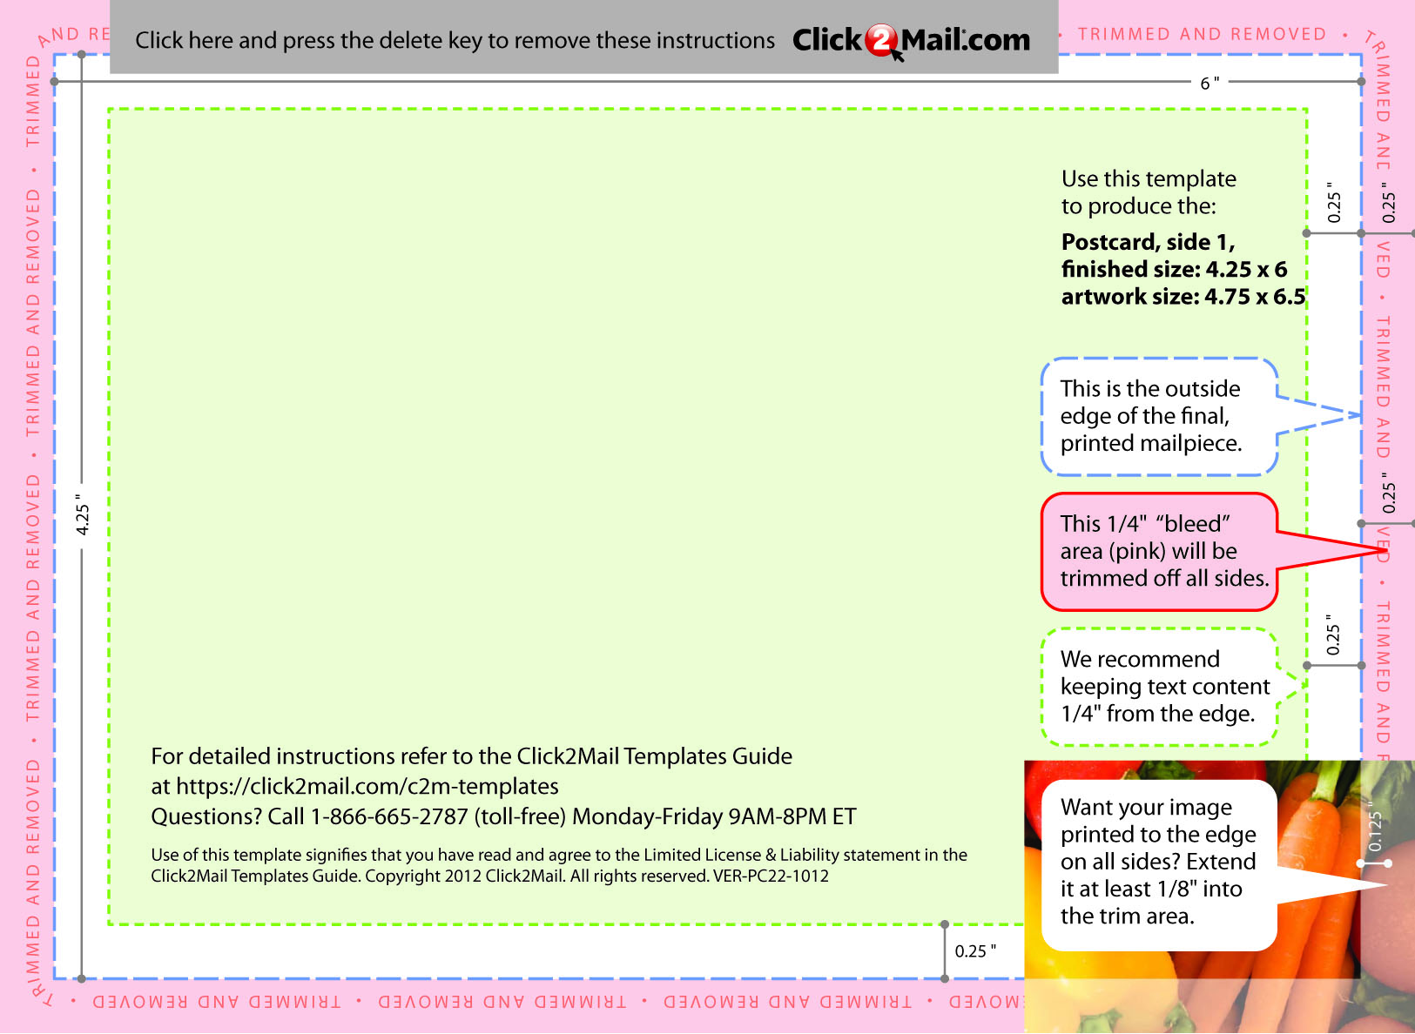
Placeholder text... Replace this placeholder text with text
of your own. Use Click2Mail.com to print, finish, post, and
deliver your mailpieces quickly and economically.
Click2Mail.com makes it easy to design brilliant, full-color,
affordable postal mail without permits, sorting, stamps, or
trips to the Post Office. How does it work? We use a
network of strategically located, high-quality printers to
print, prep, and sort large volumes of mail daily.

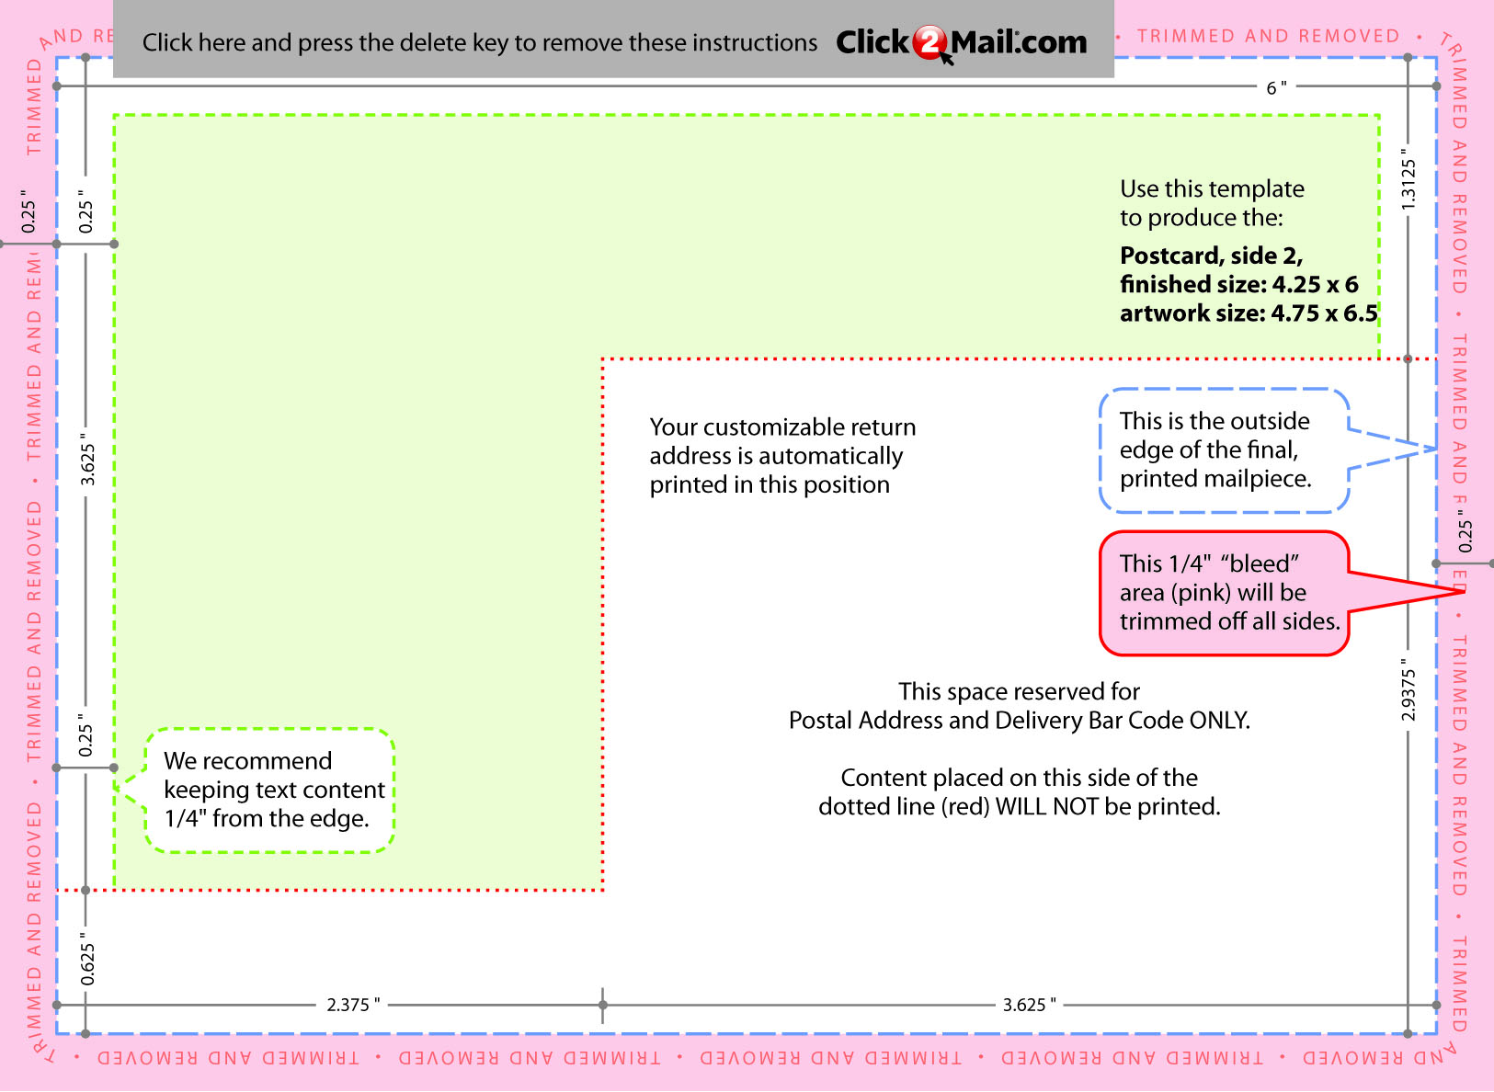
Placeholder text... Replace this placeholder text with text
of your own. Use Click2Mail.com to print, finish, post, and
deliver your mailpieces quickly and economically.
Click2Mail.com makes it easy to design brilliant, full-color,
affordable postal mail
without permits, sorting,
stamps, or trips to the Post
Office.

