RESIDENT INFORMATION



Table of Contents

Page Our Family Pledge . . . . . . . . . . . . . . . . . . . . . . . . . . . . . . . . . . . . . . . 2
Letter from the Founder and CEO . . . . . . . . . . . . . . . . . . . . . . . . . . . . 3, 4, 5
“Silver Tray” Service and Care . . . . . . . . . . . . . . . . . . . . . . . . . . . . . . . 6, 7, 8, 9
Special Service . . . . . . . . . . . . . . . . . . . . . . . . . . . . . . . . . . . . . . . . . . 10, 11 Service Levels and Fees - Sandy Springs . . . . . . . . . . . . . . . . . . . . . . . 12A, 12B Service Levels and Fees - Cumming . . . . . . . . . . . . . . . . . . . . . . . . . . 12C Respite Care . . . . . . . . . . . . . . . . . . . . . . . . . . . . . . . . . . . . . . . . . . . 13
All Levels of Healthcare Include . . . . . . . . . . . . . . . . . . . . . . . . . . . . . 14 Our Heritage . . . . . . . . . . . . . . . . . . . . . . . . . . . . . . . . . . . . . . . . . . . . 15

Our Pledge.
To Our Families and Residents.

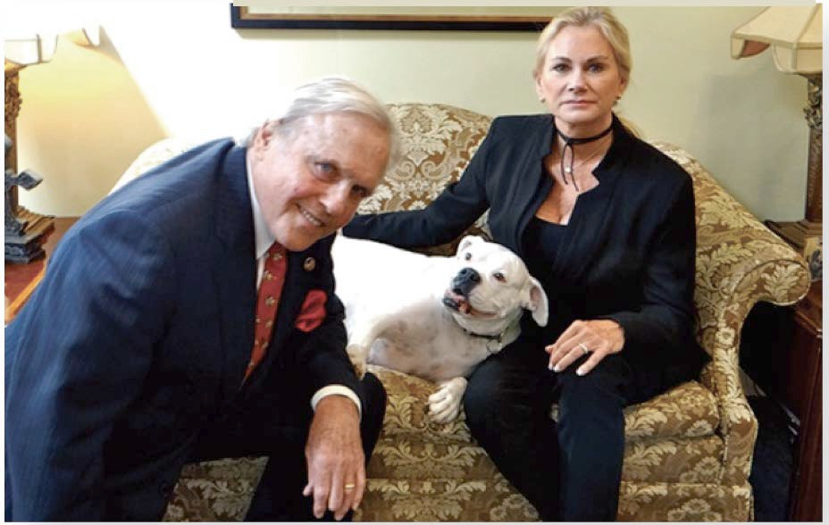
We promise to devote our love, strength and understanding daily to bring as much happiness, confidence, self-esteem, security and well being as possible to our family of residents. We understand that the real value of our care giving is not measured by our education and credentials or even by our years of experience. It is rather the amount of heart and giving of ourselves, which we willingly share with our resident family members.

We pledge to create in our homes an atmosphere of friendship, care and love, realizing that an unexpected hug, a gentle taking of a hand or a whispered compliment can do more good and bring more joy than we can imagine.

We dedicate and commit ourselves to
offering a quality of care and service to our residents, which will only be second to the family’s or special friend’s love and concern.

With the help of a devoted, loving and dedicated management and staff; the family’s and special friend’s interest and love; and with the protection and guidance of God, we make this pledge to each resident and to his/her family and friends.


Composed for the opening of
The Mann House Sandy Springs in 1988
Dear Friends, Families and our special Residents

The Mann House is the fulfillment of a dream to honor the life’s work of my father, and a determination to provide a superior level of care, dignity and lifestyle unique in the rapidly expanding field of residential health care. Forty years ago, my mother and I tried to find the kind of care and service The Mann House offers for my Alzheimer’s stricken father, but couldn’t. It’s a good feeling knowing we have made a real positive difference in the lives of hundreds of our residents and their families since we opened in 1988. We are here for one reason - to serve you and your family.

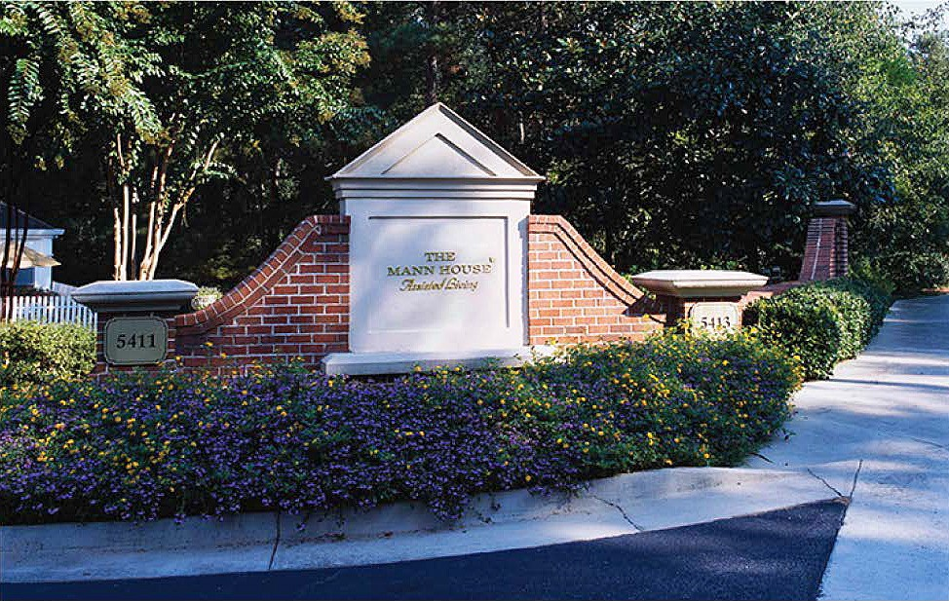
We are different from most other Licensed Assisted Living (as differentiated from lower care level “personal care” facilities) homes in that, most importantly, we are a true Residential Healthcare Home specializing in quality health services, a health care model, and secondarily, a social model. This distinction is crucial because, as your loved one
ages, we have the trained, competent and essential staff members to handle their increasing health and personal health needs. Of course, we provide all the entertainment and stimulating activities, exercise programs, mental stimulation, etc; but from Day One of this family business, we have focused on providing top- level health care services first and foremost, complemented by our solid social/ activity/hospitality schedule. Most other residential care facilities put their social program first and are primarily a social model giving less than full attention, and importance (and financial support) to quality personal wellness and health care services. As you might expect, the health care model is much more expensive to implement and operate.

Additionally, a true advantage The Mann House has over others is our bundled services program for one competitive, flat fee (with the exception of a few electives, such as personal telephone, special therapy and beauty appointments). Our rates are all-inclusive; therefore, our families appreciate the fact that there are no surprise add-ons each month. Our one fee covers every need your family member has as often as he or she needs it. From personal laundry, numerous daily diaper changes, complete feeding assistance at meals, multiple nursing visits per day to daily suite, and bathroom cleaning - whatever is needed and appropriate is promptly performed without extra add-on charges.

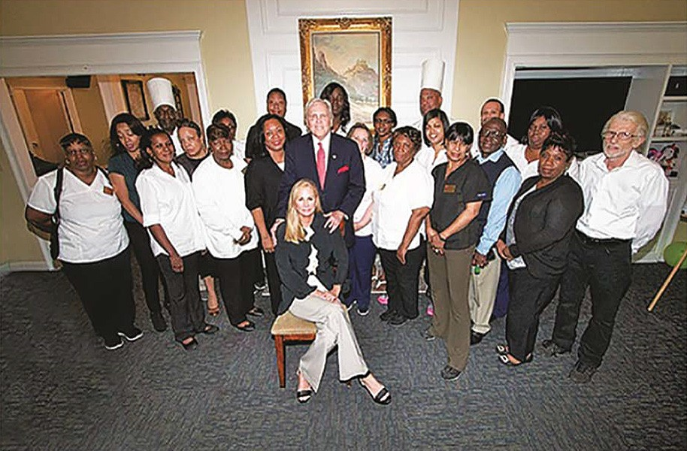
You’ll be interested in knowing our extraordinary Care Staff to Resident ratio average of 1:3/1:5 is incomparable, and largely accounts for our capability of managing higher care residents as their needs increase, making it highly unlikely your family member will ever have to move from The Mann House.

During the past nearly thirty (30) years, our home has established a superior reputation, a tradition of excellence and an outstanding record of managing our residents’ day-to-day healthcare needs (i.e. Alzheimer’s, Parkinson’s Disease, and acute memory impaired persons, stroke, heart attack, arthritis, cancer and accident victims, individuals with various chronic and emotional or physical disabilities) offering solutions for an increasing number of families with loved ones who can no longer live independently.
Further, setting us apart from most other residential health care homes is our ability to care for couples, often with differing levels of independence and healthcare needs. Enabling these couples to continue living together and not be forced into separate living facilities when one has more extensive health care requirements than the other is something we’ve identified since 1989, as a real needed service and accommodation.
There are many other features and benefits of The Mann House, but these are most prominent: our small size of only 25 suites and penthouses in Sandy Springs and 50 suites in Cumming, our less than 10 % annual staff turnover, our 1 :3-1
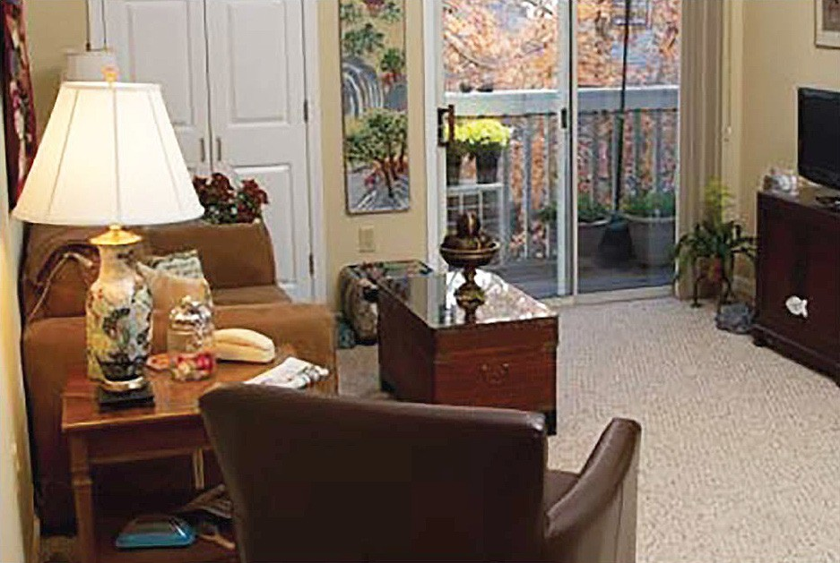
:5 Healthcare Staff to Resident ratio, our central locations, and our legendary 24- hour care giving. My personal promise to each resident and family is that we will strive each day to provide the very best healthcare and personal services humanly possible for our residents who range in age from 65-100+ years.

We set the standard for our industry,
both in Atlanta and across the South. We sincerely realize that our responsibility is not only to aspire and continue to be the best, but to improve every day to make living at The Mann House the best possible alternative for those unable to continue living in their own homes or at alternative living arrangements. (Especially, if they are unable to provide the level of care you desire and expect, and your family member requires.)

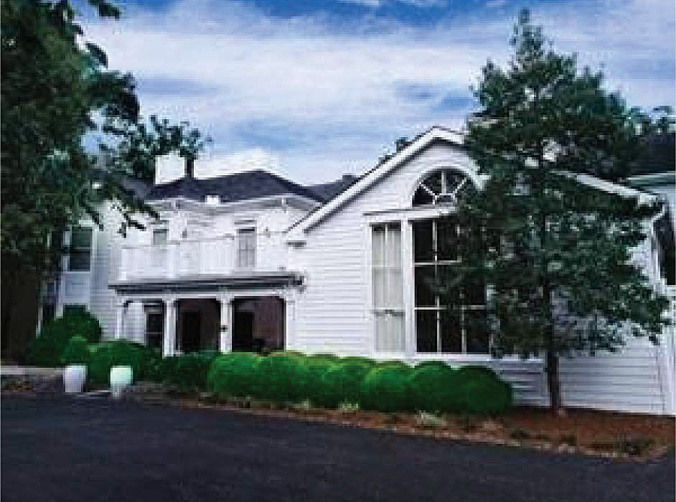
Thank you for thinking of us. It would be a pleasure to meet you personally.

Just call 404-250-9300 for an appointment. All best wishes to you and your family,
Founder and President

“Silver Tray” Service And Care
18 Reasons Why The Mann House Is Most Preferred By Prospects And Families With High Expectations.

The #1 service we provide: Our Health Care Team Staff to Resident Ratio average is 1:3-1:5. Our health care staff has fewer people to care for per person than any other licensed assisted living home. Our average time spent per resident per day is 3.5 hours - more than any skilled nursing facility!

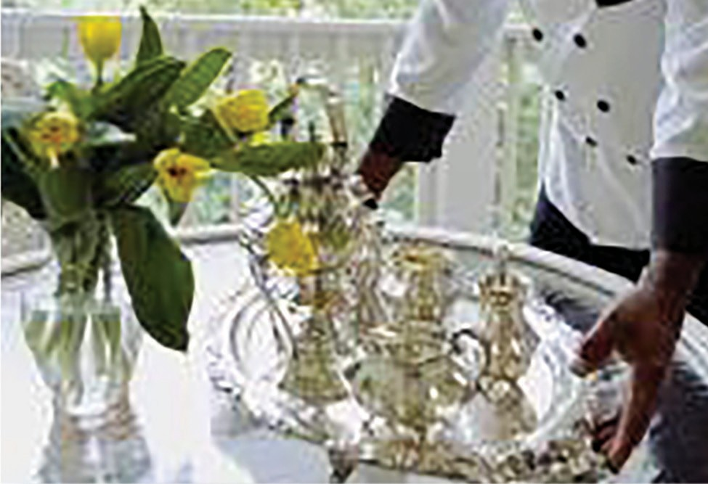
- The most experienced residential health care owner/operator, The Mann Group, Inc. A distinguished thirty (30) year track record serving Atlanta families. Our company has proven
financial stability and an unmatched standard of care and reputation built over many years. We have been in business continuously over twice as many years as many of the large out-of-state publicly owned Assisted Living chains.

- Licensed RN’s and CNA’s provide 24- hour care and assistance. Healthcare
Director and Skilled Home Health and Hospice nurses on call as required or ordered by your family member’s physician.

- Our small, intimate size of twenty five to thirty (25-30) residents in Sandy Springs and fifty (5O) in Cumming. Our Southern Style setting creates an exceptional
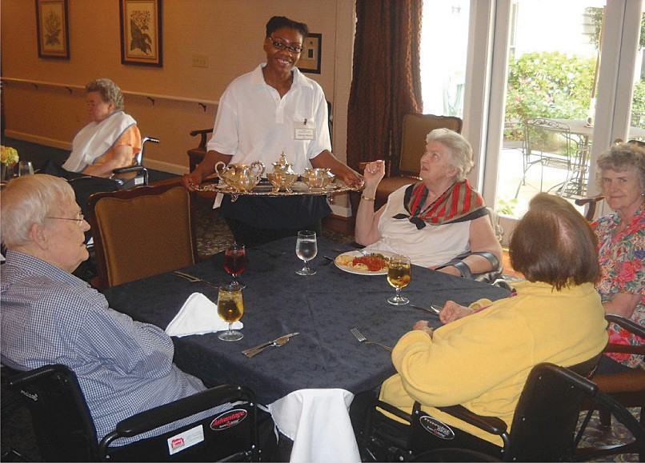
residential environment and dignified lifestyle. Screened-in porches and a secured courtyards allow residents the opportunity to enjoy the outdoors nearly year round. There is not another assisted living home of our intimate size offering superior healthcare where the staff knows each of the residents personally and the residents know each member of the staff in like manner.
- Outstanding hospitality services including “Silver Tray” Service available to each Suite/Penthouse. We’re like a very small, exclusive European boutique hotel with individualized services on demand.

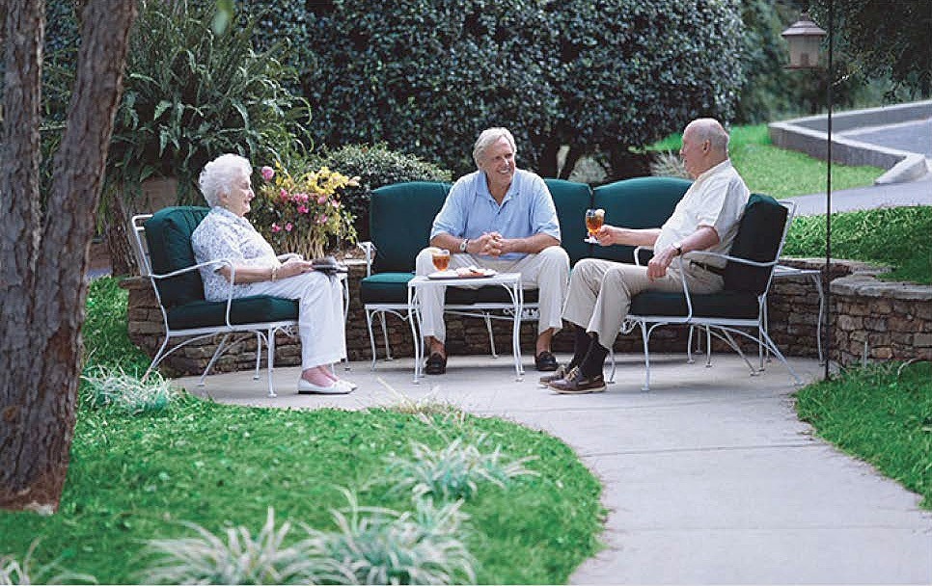
- Ladies and gentlemen are able to Age-in-Place at The Mann House. Families feel secure knowing our high care level of Licensed Assisted Living will, in all probability, eliminate the trauma or necessity of another move for any level of healthcare necessary.

- The top quality provider in Atlanta, locally owned and operated by founder and CEO, Charles H. Mann Ill. The oldest family owned and operated Licensed Assisted Living program in Metro Atlanta founded in 1988.

- Our Healthcare Director and Medical Doctor, is available for personal visits in your loved one’s suite/penthouse as requested. You may choose to utilize Charles Scott, MD as your attending physician to avoid tiresome trips to your doctor’s offices, (you, of course, may remain with your physician of choice).


- The Mann House is routinely able to manage very frail and/or challenging health (Alzheimer’s/ advanced memory issues) of persons other Assisted Living or Nursing Homes reject/refuse because of their less favorable staffing ratios (meaning less time being spent with each resident) and their inability to provide the hands on care your loved one requires and you desire.

- Very competitive, all inclusive rates, include all hospitality, health and intensive 24/7 personal care services. One guaranteed price, based on our assessment and your service choices, with no surprises at the end of the month.

- Our operating philosophy from Day One has been to provide the level of care needed by each resident each hour of the day, which can fluctuate and change without notice. Our delivered services are not fixed at a specific care-for-cost level. We do not contract for a single, inflexible, restrictive care level; where we would possibly need to change it frequently (adding ala-carte costs for a higher care level). We are finding that a good number of residents move to The Mann House from outside facilities simply because they weren’t receiving the care they were paying for. We adjust to our resident’s needs daily-he/she doesn’t have to adjust to our schedule!

- Finest menus prepared by our own top chefs. All special diets honored. For years, we have set the standard for fine food service in Assisted Living since our founding in 1988. From scratch cooking and baking using the freshest meats, fish and produce.

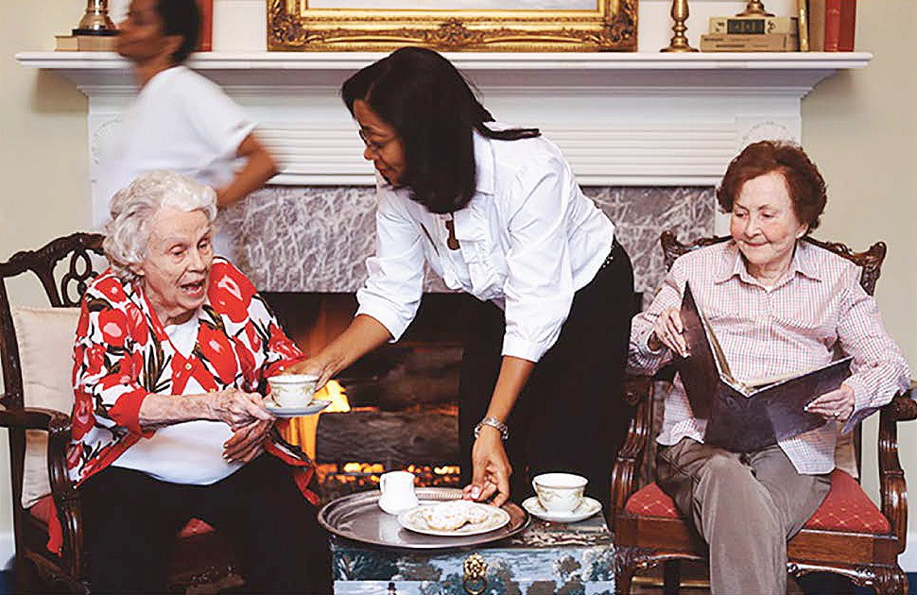
- We can assist with difficult end-of-life decisions and facilitate healthcare choices by our residents and their family. Our company owns two (2) Medicare and Medicaid certified Hospice in-patient units (IPU’s), operated by Halcyon in Sandy Springs and Seasons Hospice in Cumming. The Mann Houses are adjacent to both Hospice IPU’s.

- As of July 2017, we will have launched MannCare Home Health, operating out of both of our Mann Houses in Sandy Springs and Cumming on a Private pay basis (no Medicare/Medicaid billing on our part). This represents a commitment to return to In Home
Care where we owned and operated a major program 10 years ago. We have many requests for our staff to do private duty for residents. We now are extending that to the homes of our neighbors in Sandy Springs and metro Atlanta as well as Cumming, Forsyth Co., Cobb Co., Cherokee Co., etc., to make our solid and exceptional area services available to family members in their own homes to enable them to remain independent or semi-independent for as long as possible.

We Are Not Just A Licensed Assisted Living Home, But Rather The Finest Combination Of Quality Hospitality
And Assisted Living Healthcare Services Available.

- Stimulating, dignified, entertaining, and mentally stimulating social, exercise programs, based on the capabilities and functionality of each resident. Our Activity Directors coordinates outings, exercise, stimulating entertainment, games and special events.

- Personal laundry and linens washed and hand ironed at no extra charge.

- Residents’ accommodations are all private suites and penthouse apartments. Central heating and air conditioning with individual thermostats in each suite for your own personal preference. The Mann House is secured and sprinkled, with all safety and emergency systems.

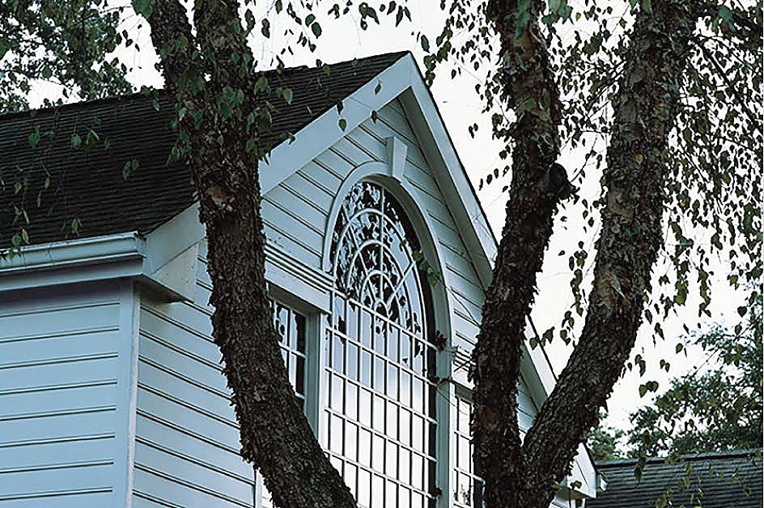
- We have the most professional, experienced, stable licensed assisted living management and staff of any care home in Atlanta and Cumming. Our annual turnover is less than 10%. Most
Assisted Living properties average anywhere between 50% to 100%. We have two (2) employees who have been with us over 28 years, the majority over 8 years!

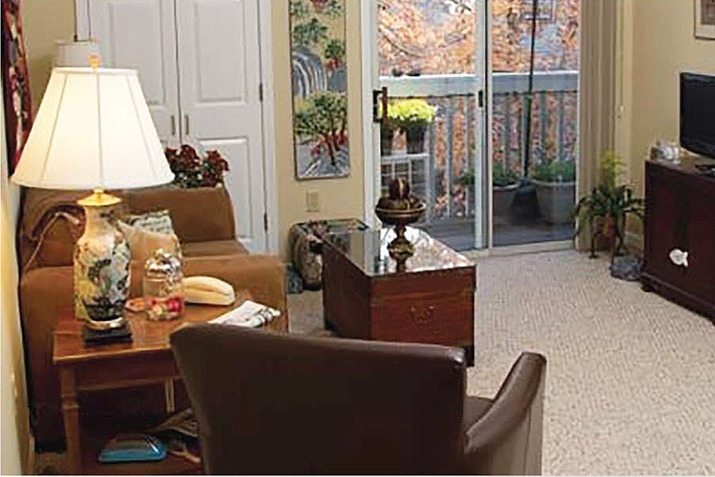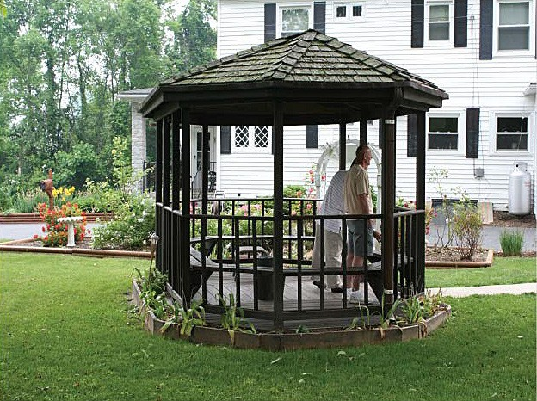

Special Services Available to Residents

Medical Director Our Medical Director is available for consultation with residents and families and on call for emergencies.

Director of Health Services Facilitating the healthcare needs of our residents around the clock, our Director of Healthcare Services monitors the 24- hour close personal hands on care provided by our in-house CNA staff, as well as coordinates services with our Home Health agency, MannCare® in Your Home, hospice, physicians, pharmacies and durable medical equipment providers. She and her team also perform frequent checks of all vital signs to assure residents maintain an optimal level of health.

Podiatrist Our podiatrist visits regularly. Treatments may be covered by Medicare if criteria are met. Consent form required. Co-pay usually applies.


Hair Stylist The Mann House Ladies and Gentlemen visit our excellent beautician/ barber, Karen Harper (30 years at The Mann House) in our salon. By appointment each week. Charge to resident: $30 shampoo, cut and set; $80 perm; $80 color, men’s haircut $20.

Manicures, Pedicures Also provided are manicures by Faye. The charge for a manicure is $20; pedicure $28. These services are available by appointment weekly.

Flowers For that added touch; we will deliver fresh flowers to a resident’s suite or penthouse
apartment or to your family member’s apartment/suite on a weekly basis or for special occasions. Prices generally range from $75 to $100 per arrangement, as you advise.

Special Services Available to Residents

Cable Television The buildings are pre-wired for cable television. Direct billing to resident by Cable Company. No charge for wireless internet.

Telephone All Suites and Penthouse apartments are pre-wired for telephone service. Direct billing to resident by our provider for a private phone number.


Laundry We provide twice weekly or more frequently as needed laundry service (including hand ironing) at no extra charge.

Transportation There is no charge for scheduled group trips, arranged through a variety of Limousine companies. For individual trips a charge will be made to the resident
by a transportation company or MARTA. For wheelchair transportation, we have ACT Transportation. We have used this company on numerous occasions and are confident in recommending them to our residents’ families.

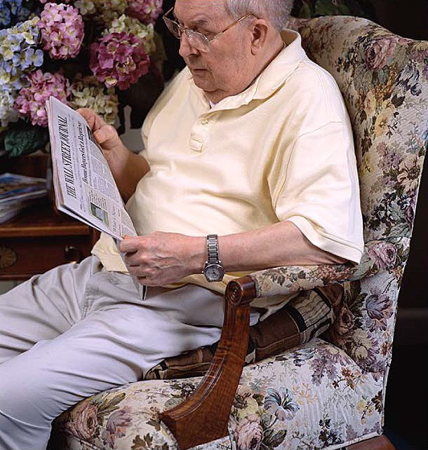
Bottled Water Soft Drinks/Fresh Juices
We provide bottled mineral water, etc, upon request to all Suites and Penthouses.

Meals
You are invited to dine with us for any meal. Please make your reservations at least 24 hours in advance. Charges for meals are $8 for breakfast, $12 for lunch and $10 for dinner. You may pay cash or direct us to use your petty cash account.

Service Levels & Fees
The Mann House is an exclusive State of Georgia, Licensed Assisted Living healthcare residence (founded by the Mann Family in 1988) for persons who require significantly higher levels of healthcare and ancillary hospitality services to remain as independent as possible. To apply for residence and to ascertain with you the appropriate and necessary combination of ADL’s (activities-in-daily- living) and personal and assisted living hands-on health care services and their costs, an Assessment will be scheduled with our Director of Healthcare Services.

Health Care Program Levels
Fees include a private single occupancy suite
Silver Level 1 Service-- $6540.00
$215.00 per day (24 hr day) base rate inclusive of the following:
24 hour moderate assistance with activities-of-daily-living (ADL’s which customarily include eating assistance, dressing, toileting, grooming, bathing, walking, maintaining continence, medication supervision, hospitality and dining services (our “Silver Tray” Service included), reminders for meals and activities, ambulation with walker or wheelchair. Includes early stage Alzheimer’s/dementia and memory care management and supervision.
Gold Level 2 Service-- $7148.00
$235.00+ per day base rate inclusive of the following:
Progressive 24 hour assistance with ADL’s covers a higher level of hands-on personal care and interdisciplinary care services, incontinence management, assistance with transfers, diabetes monitoring/glucose checks and insulin, and assistance with eating (our”SilverTray” Service included). Includes care for advancing Alzheimer’s/dementia and memory issues.
Platinum Levels 3 and 4 Service {The Annex/Special Care Unit)
$245-275 per day base rate inclusive of the following:
Our two most advanced levels of 24 hour assistance with ADL’s includes intensive 24/7 personal health care. Includes advanced Alzheimer’s/dementia with incontinence management, assistance with transfers, behavioral issues such as agitation, wandering, elopement, insomnia, diabetes monitoring/glucose checks and insulin, and assistance with eating (our “Silver Tray” Service included). Includes late stage Alzheimer’s/dementia and acute memory issues.
Level 3 - In each home’s special care annex, as determined by our assessment and discussion with the family.
Level 4- In each home’s special care annex, as determined by our assessment and discussion with the family.

Penthouse Apartments, Sandy Springs With Health Care And Hospitality Services

The Mann House is proud to offer a limited number of exclusive Penthouses in Sandy Springs unique in the world of high level care Assisted Living. We also offer two (2) room apartment units in Cumming.

The Asheville Penthouse
One luxurious bedroom with handicap equipped bath and shower, full kitchen, living room, private balcony. ($8500 per month* single occupancy)

The Charleston Penthouse
One large bedroom with bath, living room, full kitchen, and a large sun deck. ($9500 per month* single occupancy)

The Eden Penthouse
One bedroom with bath, full kitchen, living room, private balcony. ($11,500 per month* single occupancy)

The Durham Penthouses
Two bedrooms, with two baths (one handicap equipped bath), full kitchen w/ pantry, living room, private balcony. Note: Unit may be rented as two separate units (see below) ($11,500 per month*)

Durham A (single)--$8000 Durham B (single)--$6500

The Berkshire Penthouses
Atlanta’s finest. Two bedrooms, two baths, walk-in closet, living room with fireplace and bay window, full kitchen, dining room, large deck, screened porch. ($13,000 per month*) single occupancy.

Berkshire A--$7000 - Single Occupancy Berkshire B--$7000 - Single Occupancy

*All prices quoted for single occupancy. Second person adds$ 7,500 per month, including meals, as long as second occupant requires no health care or assisted Jiving needs. (Available at additional charge.)

Service Levels & Fees, Cumming
The Mann House is an exclusive State of Georgia, Licensed Assisted Living healthcare residence (founded by the Mann Family in 1988) for persons who require significantly higher levels of healthcare and ancillary hospitality services to remain as independent as possible. To apply for residence and to ascertain with you the appropriate and necessary combination of ADL’s (activities-in-daily- living) and personal and assisted living hands-on health care services and their costs, an assessment will be scheduled with our Director of Healthcare Services.

Health Care Program Levels
Silver Level 1 Service - $4000.00/month $132 /day
24 hour moderate assistance with activities-of-daily-living (ADL’s which customarily include eating assistance, dressing, toileting, grooming, bathing, walking, maintaining continence, medication supervision, hospitality and dining services (our “Silver Tray” Service included), reminders for meals and activities, ambulation with walker or wheelchair. Includes early stage Alzheimer’s/dementia and memory care management and supervision.

Gold Level 2 Service - $5000.00/month $164 /day
Progressive 24 hour assistance with ADL’s covers a higher level of hands-on personal care and interdisciplinary care services, incontinence management, assistance with transfers, diabetes monitoring/glucose checks and insulin, and assistance with eating (our “Silver Tray” Service included). Includes care for advancing Alzheimer’s/dementia and memory issues.

Platinum Levels 3 Service- $6000.00/month $197 /day Platinum Levels 4 Service- $6500.00/month $214 /day
Our two most advanced levels of 24 hour assistance with ADL’s includes intensive 24/7 personal health care. Includes advanced Alzheimer’s/dementia with incontinence management, assistance with transfers, behavioral issues such as agitation, wandering, elopement, insomnia, diabetes monitoring/glucose checks and insulin, and assistance with eating (our “Silver Tray” Service included). Includes late stage Alzheimer’s/dementia and acute memory issues.

Level 3 - In each home’s special CHMann MD Special Care Annex, as determined by our assessment and discussion with the family.

Level 4 - In each home’s special CHMann MD Special Care Annex, as determined by our assessment and discussion with the family.

Respite Care

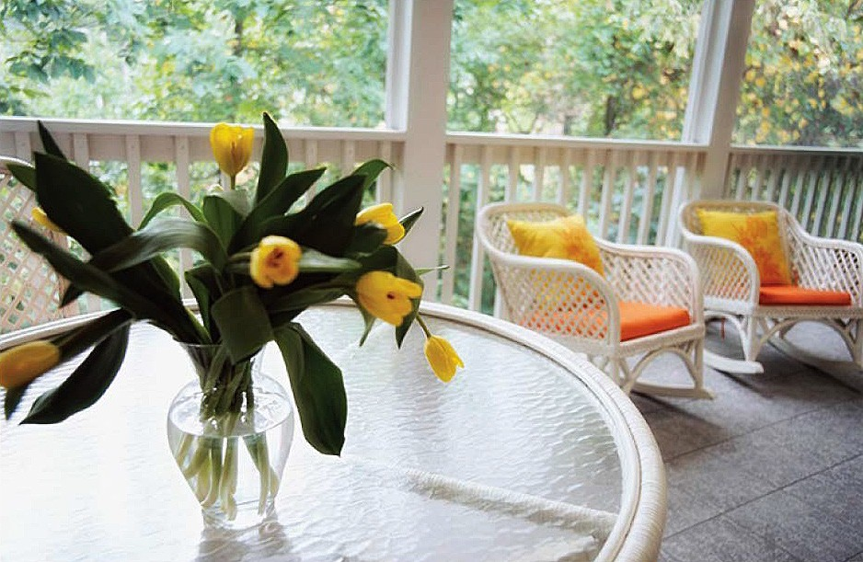
From time to time, on a space available basis, The Mann House will accept persons on a short-term respite basis. This may be strictly for the respite benefits of a resident and/or his/her family or preliminary to permanent residence in The Mann House. (Assessment required.)

The rate is $350 per-day all-inclusive, on an as available basis. Minimum stay is one week. Payable in advance. One month minimum if rental furniture required. Standard security deposit required.

All Levels of Health Care Programs Include
Our Heritage.

Each phase of life, aging or health issues carries its own challenges. So we are

- Assistance with all medications as often as ordered by your physician.
- Coordination of outside health care providers including:
- Attending physician
- Home Health
(private pay available from MannCare)
- In Your Own Home Hospice Care (we own the two (2) Hospice in-patient units next door to each Mann House)
  - Pharmacy
  - Podiatrist
  - Psychologist
  - Psychiatrist
- Full daily activity schedule programmed to allow each resident’s functional ability and attention level to be maximized.
- Laundry services three (3) times per week, or as needed.
- Emergency call system in each bedroom and bathroom.
- Our Signature “Silver Tray Room Service” when a resident is not able, or chooses not, to join us in the dining room.
- Housekeeping services a minimum of twice per week. More often as needed.
- All utilities included except telephone and cable. Units wired for service. No extra charge for wireless.
- Special diets available including:
  - Diabetic
  - Low salt
  - Soft mechanical Gluten free
- Bottled water and soft drinks to enjoy upon request.
- Multiple common rooms for the resident/resident family’s enjoyment:
  - Large living rooms with cathedral ceiling and fireplaces
  - Screened porches overlooking wooded areas (The Mann House- Sandy Springs)
  - Enclosed courtyards with tables, chairs and gazebos, game rooms, family rooms with fireplace, and beauty/barber salon
- Private dining areas available for special family celebrations.
- A variety of nutritious snacks and goodies provided between meals from The Mann House kitchens.
here with strength and support, uniquely equipped to assist you with the great majority of your loved one’s needs. And that’s among the many reasons people choose The Mann House over other options in the region. We have a distinguished record of serving residents and families for thirty years. This makes us the most experienced provider of Alzheimer’s and advanced Memory Care in a residential setting in our region.

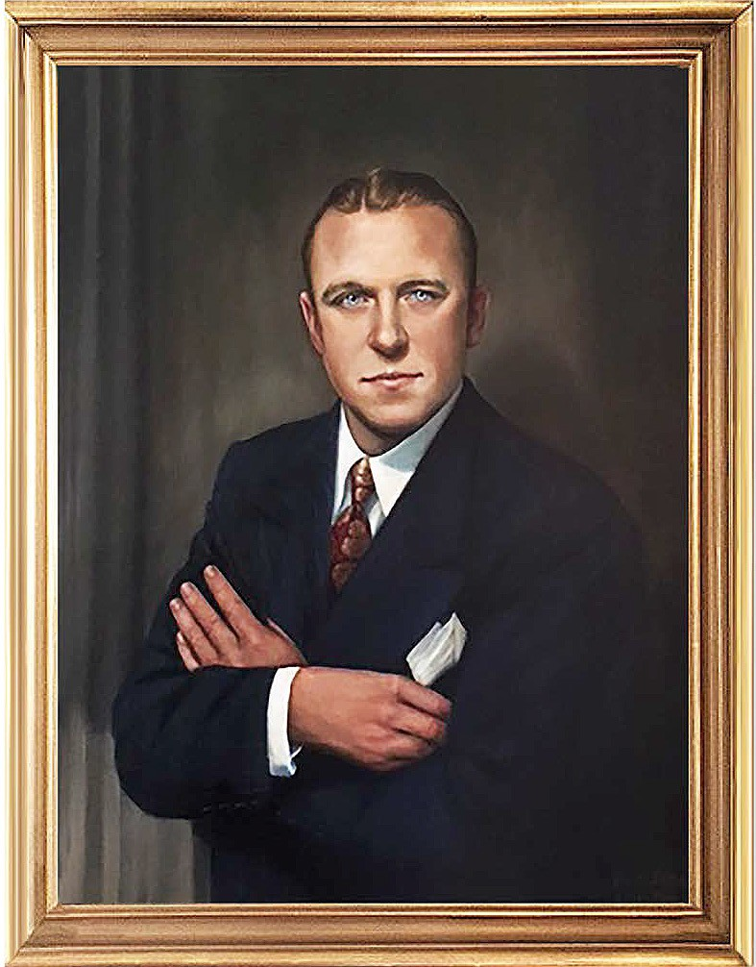
Our founder’s father, Dr. Charles H, Mann Jr. was the inspiration for The Mann House. He was a Doctor of Public Health and a nationally prominent physician, educator and pharmaceutical research executive.

His exemplary inspiration, dedication and lifelong pursuit of medical answers for some of humanity’s most destructive diseases, along with his personal struggle with Alzheimer’s over 17 years, is the legacy of The Mann House.

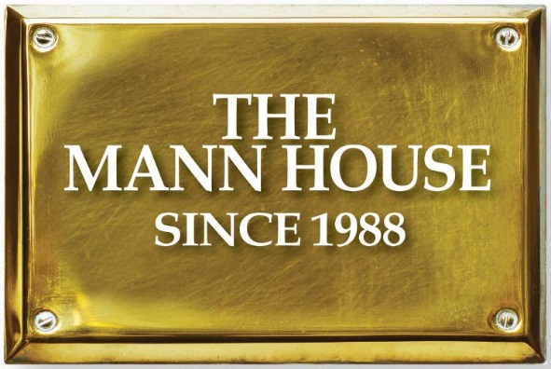
CONTACT INFORMATION:

www.TheMannHouse.com info@TheMannHouse.com

404.250.9300

www.TheMannHouseForsyth.com

(770) 844-9055

