Branding Brief

Business Name: Dayland
Contact: Dan Cabrera / danncabrera@gmail.com
Business Description:
We are growing the family company into new business (parent companies); today we rent, manage, invest and hold real estate properties and we will be launching sales/marketing and land development all sharing “Dayland” as a prefix.
Brand Promise:
Trust and quality. We want to build a brand/company that put customers needs first and conceptualize communities that enhance the value of the neighborhoods and will make them proud of being owners/renters.
We want to evoque Trust, Quality, Community, Confidence, Inspiration, Loyalty, and Connectedness.
Brand Guidelines:
Balanced composition with an elegant, modern and creative logo with both; a pictorial element (ex. apple’s apple, twitter bird) and wordmark or logotype style (Coca-cola’s font, VISA) since we want both elements of our identity to be “brandable”. Please keep in mind that we want a sans-serif font.
Proclivity Colors:
Black, Blue, Green, Grey.
Scope:
We are doing a re-branding to incorporate the new divisions and have a consistent brand identity throughout all business divisions. These logo will be used next to every parent company/division, being “Dayland” the umbrella group holding company, and the parent company/division would be “Dayland Developments” and or “Dayland Property Management”, “Dayland Realty Marketing”, “Dayland Holdings”, “Dayland Construction” etc.
We will use the logo and its colors and essence front and center of all of our client facing materials like webpage, stationary, advertising, etc.
Problem:
We don’t have a graphic identity to go along with the clear concept that we have of what the brand stands for and the name, we would like to have something that we can invest on and create a long term brand “image” to be recognized for years to come, we want to stay away from design “trends” and come up with something that could last 10+ years.

Audience/Target:
We must appeal to young, well-educated couples (30+ yrs) with 1-2 young children, with a family lifestyle and interested in elegant design. They are focused in family and work with a good sense of style. Our target will likely work in a management role in the IT, retail, hospitality, or services industry. They appreciate technology, sustainability, community and have a healthy and hip lifestyle.
Competition:
Anthem, Onni Group, Adera, Beedie.
Milestones:
To have our clients identify our brand by just a pictogram or the type form independently. Being able to just attach the pictogram to different new businesses and developments and relate to our “Dayland” brand.
Reference Images/ Designs:
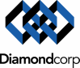

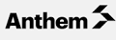

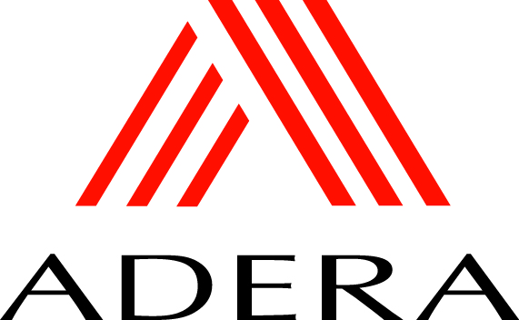
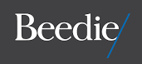

Desired Layout (Balanced):
Type 1 Type 2
Monogram Here
Monogram Here
TYPOGRAPHY HERE
TYPOGRAPHY HERE

Research Materials:
N/A
Copyright & Delivery:
We will own all rights for publishing or any other use; you must treat this brief as confidential. We will require EPS / AI / PDF / PNG (all other vector & high resolution files you might generate from this project).

