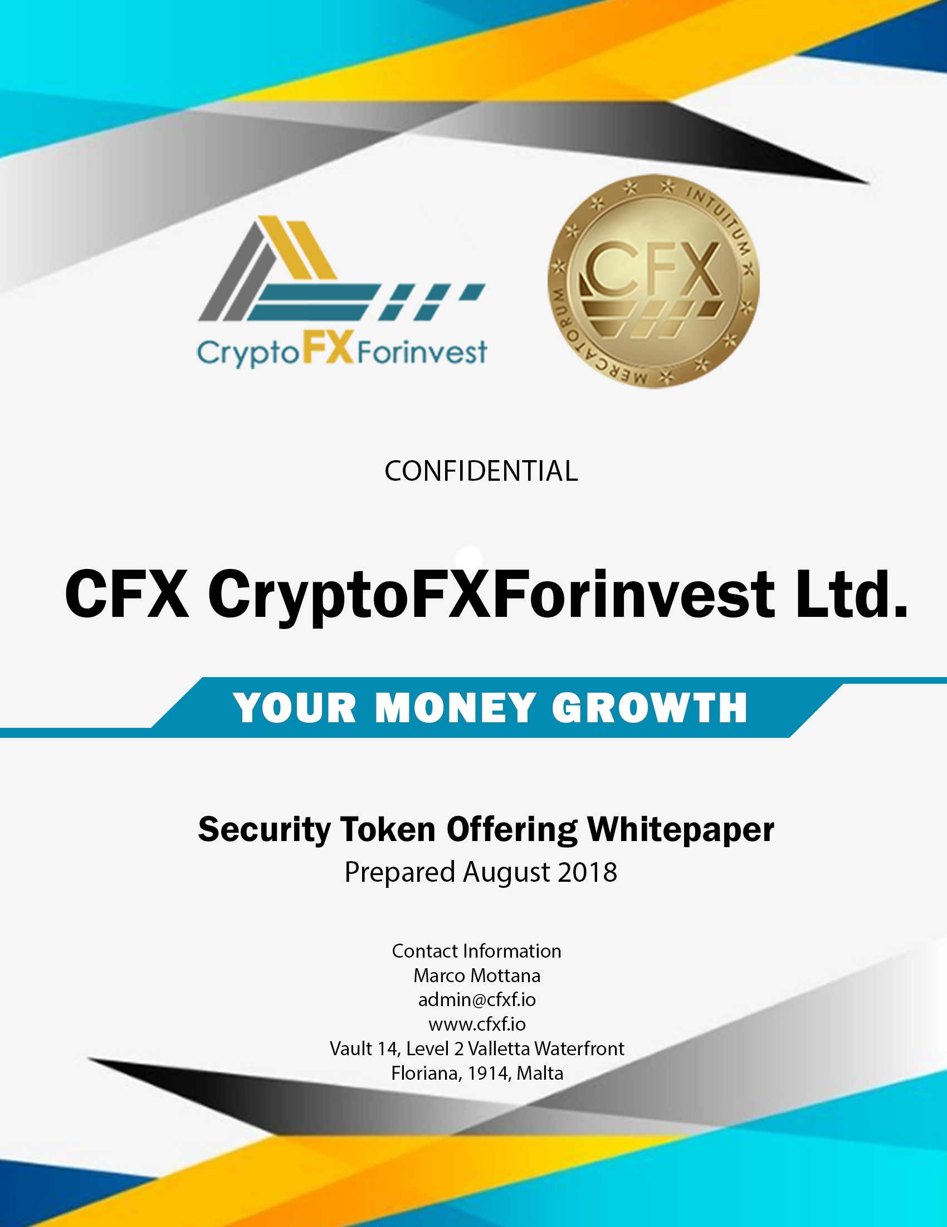
Table of Contents

Summary 3
Opportunity 4
Security Token Offering (STO) 5
HATS with CFX Sentiment Index on Blockchain 5
Issuer Details 8
Issuance Details 10
CFX Token 14
Milestones/lifecycle 17
Funds Allocation 19
Benefits for third parties and other expenditure 20
Expectations 21
Forecast 21
Financial Highlights by Year 22
Target Market 23
Market Size & Segments 24
Funds raised by type of investor 25
Market Trends 25
Competition 27
Execution 29
Marketing & Sales 29
Operations 34
Company 38
Overview 41
Advisors 42
Financial Plan 42
Forecast 42
Financing 47
Appendix 51
Profit and Loss Statement (With monthly detail) 51
Balance Sheet (With Monthly Detail) 53
Cash Flow Statement (With Monthly Detail) 55
Token Risk Factors 57
Risk Factors Relating to Purchase, Sale, and Use of Tokens 57

Summary
This whitepaper is not a prospectus or solicitation.

Investor Warning: Evaluate the full whitepaper before investing.

Issuer Warning: Civil liability attaches to the persons who table this summary.

Issuer: CFX CryptoFXForinvest Ltd.

Declarations by the persons responsible for this whitepaper
To the best of my knowledge, the information contained in this whitepaper is in accordance with the facts, and this whitepaper makes no omission likely to affect its import.

Name: Marco Mottana, CEO
Signature:_______________________________________________Date_________________
Name: Fabrizio Crimi, COO
Signature:_______________________________________________Date_________________
Name: , CFO
Signature:_______________________________________________Date_________________

Name: Virgilio Degiovanni, Advisor
Signature:_______________________________________________Date_________________

Name: ,
Signature:_______________________________________________Date_________________

Name: ,
Signature:_______________________________________________Date_________________

Opportunity

PROBLEM
Investors and money managers want an increased return on investment with a minimal amount of added risk, at the same time that the investment opportunity landscape is fast-changing and becoming more complex every day.
Recent developments in Blockchain technology, alongside with Artificial Intelligence and Broadband Internet have created the possibility to create new systems of trading capable of achieving the best equilibrium between the risk and reward.

SOLUTION
The solution is to have a personal fund managed in the most professional and advanced way possible.
CFXhas developed an advanced Trading System Software called HATS (Highly Advanced Trading System) based on Technical Analysis, Statistics, Artificial Intelligence, and Quantitative Analysis. CFX is creating a breakthrough blockchain-based indicator named the CFX Sentiment Index that will add a unique, transparent, and reliable market indicator to HATS. Our index will establish an understanding of people’s attitude towards financial market trends at any given moment, worldwide.
CFX HATS is not a single trading system; rather, it is the sum of four different trading systems, each one with its own characteristics and specific risk/reward strengths. Added to this, CFX will insert an indicator created on the blockchain by its token
CFX Sentiment Index is an indicator based on pure feelings of people for specific markets or instruments negotiated in a given moment, worldwide.
CFX does not require any upfront price for its HATS license: it bases all its remuneration to results granted for real by its HATS at customer portfolios. This offers tremendous opportunity for value creation in the long term, and, at the same time, lowers entry barriers so that customers pay only when they make a profit.
FORMULA
- expected average return per annum of HATS on third-party Assets under management = 21%
- expected average fee on the 21% = 20%
- net fee on Asset Under management of Institutional customers 4.2%

MARKET
CFX operates in the Alternative Investment Fund industry that manages $3.5 Trillion from institutions and $1.25 trillion from private investors. We project to reach a 0.4% market share in 5 years.

COMPETITION
There does not exist, in any place worldwide, an entity offering a competing solution comparable to our “real people” AI and Sentiment Index. Competition could arrive from any Bank, Fund or Financial Organization that offers products to investors.

WHY US?
We are a team with proven market experience capable of offering deep innovation, breakthrough systems, and an impressive rate of return based on knowledge, backtesting, vision, and willingness.

Security Token Offering (STO)

REASON FOR OFFERING
Investors want a better return on investment with a minimum of added risk. The solution is to have investment funds managed in the most professional and advanced way. CFX has developed an advanced trading system software named Highly Advanced Trading System (HATS) based on technical analysis, quantitative analysis, and Artificial Intelligence. The CFX STO will provide the resources necessary for the successful launch of our next-gen fintech product/service “HATS + CFX Sentiment Index”.
HATS with CFX Sentiment Index on Blockchain
Recent advances in blockchain technology, along with Artificial Intelligence and Broadband Internet, have opened the possibility to create a new system of trading.



CFX HATS is the sum of four different trading systems, each with its own unique characteristics and specific risk/reward aspects. Added to this, CFX will insert the CFX Sentiment Index indicator housed on blockchain through its token owners. This is the first time an indicator will be available that is based on the feelings of people for specific markets or instruments negotiated, in a given moment, worldwide. Crowdsourced prediction platforms often demonstrate the superior accuracy compared with the predictions of experts and pundits.

CFX will develop a blockchain-based indicator named the CFX Sentiment Index and use it to optimize HATS to reach the best equilibrium between the desired result and risk-acceptability. The CFX Sentiment Index will measure the public's attitude toward financial market trends in a given moment, worldwide.

- CryptofxForinvest will not open personal accounts to manage as it is not a money management company. Therefore, it does not, in any case, solicit private investment to anyone, in any form.
- The company will operate on its own, through its Investment Blockchain Pool (IBP) trading activity through the issued Tokens.
- Token subscribers who contribute to the Sentiment Index will indirectly benefit from the pool.
- CFX Token is the “TOKEN”. Owners have the opportunity to contribute to Sentiment Indicator (or Index) that can be utilized for trading in Stock, Currencies, and Commodities.
- “Sentiment” is a well-known indicator used by traders. There are different Sentiment indicators on market, all of them built on data. CFX Sentiment is the first one coming directly from people.
- Together with CryptofxForinvest trading system, the Sentiment indicator enables a sort of “System of Systems” that reduces risk while, at the same time, increasing performance.

CryptoFXForinvest Trading System

The System is based on an integration of:
- Big Data
- Token Sentiment
- Artificial Intelligence: systems that “learn by themselves”will be integrated with to increase efficiency and maintain drawdown risk to a minimum.
- Robots: these read trend signals and operative levels generated by the AI Engine and find out the best strategy to follow.
- Autotraders: under continuous control and direction from expert traders, Robots strategies transform in buy and sellorders on Stock Exchange; Currency; Futures; Precious Metals.
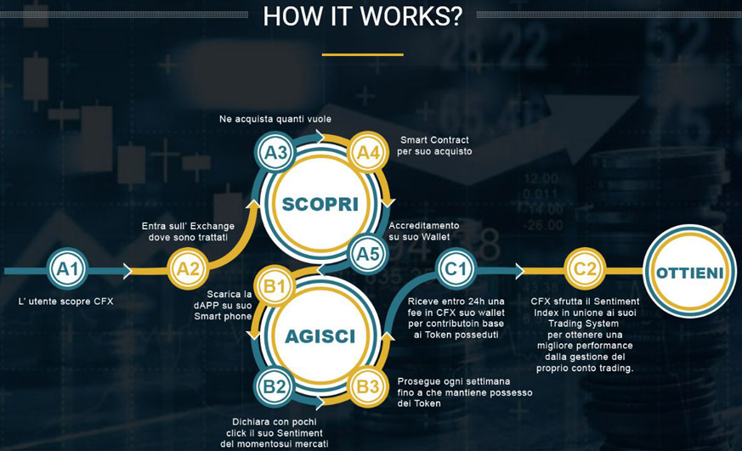

Sentiment Bonus Reward for CFX Token
- CFX Token owners will insert their Sentiment on markets with a fast and easy to use App on their phones, answering (Yes; No; Not sure) to simple questions on markets.
- Every owner that contributes sentiment for at least 3 months will receive a Bonus in CFX Tokens for the contribution offered.

Issuer Details
Name: CFX CryptoFXForinvest Ltd.

Registered address and registration number:
CFX Advance Ltd, Vault 14, level 2, Valletta Waterfront, FRN 1914 Floriana, MT

Date of registration: TBD

Objects:
  - To develop and exploit blockchain related software and databases and to grant licenses thereon worldwide.
  - To purchase or otherwise acquire, under any title whatsoever, all types of property, movable or immovable, corporeal or incorporeal, or any interest therein, by any tenure or title, and to hold, improve, develop, construct, enlarge, extend, alter, maintain, transfer, sell, convey or otherwise dispose of such property or any interest therein, as shall from time to time be expedient or necessary.
  - To carry on any other business which may seem to the company capable of being conveniently carried on, and which is directly or indirectly related to its business or ancillary thereto.
  - In furtherance of the company's objects as aforesaid, the company is also empowered to carry out the following:
To lend or advance money, with or without security, only where necessary and as may be required in connection with the company’s business.
To undertake, enter into, fulfill, and otherwise perform all types of agreements and contracts which the company may deem necessary in furtherance of the business of the company.
To give, by way of security, lease, sell or otherwise dispose of the whole or any part of the property or assets of the company.
To borrow, or in any manner raise money, without any limit, for the purpose of, or in connection with, the company's business; to secure the repayment of any moneys borrowed by the company, or any other obligation of the company, by giving hypothecary or other security upon the whole or part of the movable and/or inamovable property of the company.
(v) Either with or without the company receiving any consideration or other benefit whatsoever, to guarantee, support or secure, whether by direct obligation, or by assigning, mortgaging, pledging, hypothecating, or otherwise charging all or any part of the undertaking, property, assets (present and future) and/or uncalled capital of the company, or by issuing any security of the company, or by any one or more of all such methods, or by any other method, the performance of any obligation or commitment of any person, firm, company or corporation, including (without prejudice to the generality of the foregoing) any company which is, for the time being, a subsidiary company or holding company, or which is otherwise directly or indirectly associated with the company in business or through shareholding.
To derive income from anywhere in the world, including, but not limited to, income which would fall to be allocated to the foreign income account, as defined in Article 2 of the Income Tax Act, Chapter 123 of the Laws of Malta.
To do all such other things as are incidental, ancillary, or conducive to the attainment of the objects and/or the exercise of the powers of the company.

The objects and powers set forth in this Article shall not be restrictively construed, but the widest interpretation shall be given thereto. None of the above-described objects and powers shall be deemed subsidiary or ancillary to any other object or power provided for above. The company shall have full power to exercise all or any of the powers, and to achieve or to endeavor to achieve all or any of the objects conferred by, and provided for, in any one or more of the above sub-Articles. Nothing in the foregoing shall be construed as empowering or enabling the company to carry out any activity or service which requires a license or other authorization, under any law in force in Malta, without such a license or other appropriate authorization from the relevant competent authority, and the provisions of Article 77 (3) of the Companies Act shall apply.

Locations where issuer has been established for a period exceeding three years: None (new company).
Financial track record, group of undertakings, principal activities, etc (where applicable): New company, no financial track record. The company will have a share capital of 100,000 euros.
Directors exercising a determining role in issuer’s administration (directly or indirectly):
Marco Mottana, Fabrizio Crimi

Legal proceedings disclosure (any impacting issuer’s financial position): none

Board of administration:
Marco Mottana, Via Crotto Rosa 6a, 22036 Erba Co, Italy, CEO
Fabrizio Crimi, Portomaso 23101, Vjal Portomaso, Paceville, San Giljan, STJ Malta, COO
Gianfranco Scordato, CFO

Issuance Details
CFX is based in Malta and will follow all procedures defined by MFSA and, on conclusion, will make its first public offer of CFX Token, with a hard cap at €100 million.
CFX will maintain the option to make two further offers in the next 5 years if opportunities arise and it's convenient for every token owner.
CFX Token will guarantee its owners a dividend equal to:
- 70% of ROI generated on internal Funds managed directly by CFX.
- 20% of Performance Fees Revenues generated by all external Funds utilizing HATS for their management.
Soft cap: 3000 ETH
Investors will get their contribution back if soft cap is not reached.

Hard cap: 225,000 ETH (~€100 million)

Refund mechanism: ETH is sent to a refund-contract. Participants can then trigger a pull-function on the contract to claim back the ETH they invested from the same wallet that was used during the token sale. The participant's transaction costs (GAS fees) are not covered by the refund.

Refund timeline: 30 days

Date ranges of offer:
- Phase 1: Starting January 1 - Ending Feb 1
  - Price: 1500 tokens per ETH - Hard cap in ETH: 50,000
- Phase 2: Starting Feb 2 - Ending March 1
  - Price: 1250 tokens per ETH - Hard cap in ETH: 75,000
- Phase 3: Starting March 2 -Ending May 1
  - Price: 1000 tokens per ETH - Hard cap in ETH: 100,000

Number of tokens to be issued and features: Number? CFX Token will be an ERC20 Security Token on the Ethereum Platform.

Token distribution:
- Total issuance: 100,000,000 CFX
- Distributed in ICO: 51,000,000 CFX (51%)
- Reserved for founders: ? CFX (x%)

Token exchange rate:
- Phase 1: 0.00067. ETH
- Phase 2: 0.0008 ETH
- Phase 3: 0.001 ETH

Token delivery methods and time-limits: Instant transfer to contributor’s ETH address. Duration-dependent on network load, and subject to periods of congestion. Median time 2.5 minutes.

Early investor bonuses
- Phase 1: 50%
- Phase 2: 25%
- Phase 3: 0%

Smart contract voluntary withdrawal period (if any): None

Free transferability restrictions (if any) on token: Only whitelisted wallets can receive the CFX token. It is impossible to own the token without approval from CFX. This whitelisting functionality can be turned off, but only by the CFX owner themself. Activators are able to whitelist wallet addresses to hold the token, and only CFX owners are able to give others the Activator role. An activator could, for example, be a security token exchange that wants to allow trading with the token.

Free transferability restrictions on exchange/s on which token may be traded: None

Payment methods: ETH, BTC, EUR

Taxes: TBD

VFA agent: TBD

Development team:
? ? ? ?

Advisors: ICO Launch Malta are technical advisors, by virtue of their token sale platform upon which the STO will run.

Service providers:
- ICO Launch Malta
- EMD advocates
- IT Legals Ltd - AML compliance, 23, Level 1, Triq Giuseppe Calleja, Swatar - MSD2270 Msida (MT)GetAmbassador.com – relationship marketing software, 333 W 7th Street, Ste 310, Detroit - Royal Oak, MI 48067 USA
- Ivano Menabue - Big Data and Financial Platform Expert
- Avramis Despotis - Trading System Expert
- Abalone Asset Management, Malta
- (descriptions in annex PowerPoint)

Underwriter: TBD

Targeted investor base: There are four investor categories to be targeted.
- HNWI Investors
- Institutional (Banks, Funds, Private Equity Management companies)
- Private investors who typically choose UCITS (Undertakings for Collective Investments in Transferable Securities) or AIF (Alternative Investment Funds)
- Millennials

Protocol description and benefits: The Ethereum protocol is dominant in the ICO world. It has a huge development community. It is easy to get an ERC20 token listed on the cryptocurrency exchange. Wallet compatibility is also easy.

Consensus algorithm: Ethereum Proof-of-Work

Transaction processing incentive mechanism and/or fees: Proof-of-Work is the current transaction processing protocol for Ethereum. Ether miners use computers to solve mathematical puzzles and process transactions and, in return, they get a reward. The fees depend on how congested the blockchain is and what type of transaction is being processed.
Ethereum transaction speed estimate: The Ethereum blockchain currently supports roughly 15 transactions per second. How long the transaction takes depends on the network congestion and GAS spent on the transaction. A transaction can take around 30 seconds up to several days.

Smart contract underlying protocols, functionality, operational costs: Smart contracts are written in Solidity and deployed upon the Ethereum blockchain. To deploy a smart contract you have to pay GAS fees. To interact with a smart contract, a transaction has to be made.

Underlying protocol’s interoperability with other protocols: Ethereum smart contracts can access external data through trusted data feeds, call Oracles, that send information into the Smart Contract, and remove the need for Smart Contracts to directly access information outside their network, thus lightening their workload. Oracles are usually supplied by third parties and are authorized by the companies that use them.

Smart contract embedded restrictions: None

Oracles: None

Procedure for exercise of any right of pre-emption: None applicable

Challenges/risks and mitigation: request from client

Issuer’s wallets: Any ERC20-compatible wallet.

Issuer’s wallets safeguards: The tokens will be held in a 3/4 Gnosis multisigwallet. ICO Malta will hold two signatures to ensure that no funds are taken out before the withdrawal period. A minimum of two of these signatures will be required by a Trezor or Nano Ledger wallet.

Smart contract auditors: OpenZeppelin and ParsecLabs

Intellectual property rights:
- Trademarks and logos are into registration now:
- "CFX" + logo
- "CFX Token" + design
- CFX Sentiment Index
- "HATS" "Higly Advanced Trading System"
- "CFX Cryptofxforinvest" + logo
- "Cryptofxforinvest"

Over 100 trading systems formulas composing HATS are in our vault in Italy and will be deposited and protected in a vault in Malta as soon as possible. HATS System and CFX Sentiment Index will be patented as soon as we have defined the details of the integrated software procedures and, therefore, the company will own the systems. We have budgeted 6 million euros to buy all the systems involved, 1 million euro to further develop them.

Intellectual property rights protection: Deposit of trademarks worldwide and patents to be defined.

CFX Token
MAIN FEATURES AND REQUIREMENTS

- Should only be transferable to whitelisted wallets
- The requirement for whitelisting can be turned off if the token is listed on a regulated centralized exchange or there is a change in regulations
- Compatible with the ERC20 interface

IMPLEMENTATION DETAILS

Base Token
The implementation will be based on the ERC20 contract provided by the OpenZeppelin (https://openzeppelin.org/) organization on the master branch of their GitHub repository. These contracts are well-tested and reviewed, and have been successfully utilized in many production deployments without any incidents.

Mintable
This implementation adds minting to the base token, which gives CFX the ability to issue tokens in tranches for later stages of the sale. This requires us to create the owner role, which is an address with the privilege to mint tokens. CFX will need to associate this role with a secure account, preferably a multisig wallet.
Upgradable
Good software engineering practices mandate an upgrade path for any deployed software and hardware. We are going to use an upgradable and mintable version of the ERC20. Making the token upgradable allows us to correct any possible bugs that could be found in the token’s lifetime or switch to newer standards without any downtime/outage while keeping the same contract address.

While it has been difficult in the past to provide good upgradability for smart contracts, the Metropolis hard fork deployed September 18th, 2017 introduced support for returndatasize in the delegatecall opcode. Using this, we can separate the implementation of the contract from the deployment address of the contract using the Solidity library function.

Whitelisting
- A global boolean flag, isWhitelistActive, will be added to the contract storage. This flag can be flipped by the owner role and will allow enabling/disabling the whitelist checking for transfers.
- Each account will receive a whitelisted flag, which will indicate if the account is able to receive/send tokens. Every account is blacklisted by default.
- addToWhitelist(address)and removeFromWhitelist(address) functions will be added, which can set any account as whitelisted or blacklisted. These functions will only be accessible by the activator role.
- addToWhitelist(address[]) and removeFromWhitelist(address[]) functions will be added, which can set a group of accounts as whitelisted or blacklisted. They call the previous functions in a loop for the given array of addresses. These functions will only be accessible by the activator role.
- The transfer() function will be modified to respect the whitelist and the isWhitelistActive flag.
- An additional role, activator, will be added. This role will have the right to call the activate() function. The role will be given to the sale stage contract to begin with, and to any address that requires this privilege in the future.
- The function activate(address, amount) will be created. When called, this function will first whitelist an investor if not already whitelisted, then transfer the stated amount of tokens to the investor.

Process description for token sale:
- An investor will arrive at the Sale Dapp and verify his or her identity. Once all KYC and AML requirements are cleared, an investment receipt is issued for the Investor.
- The receipt is signed by the operator of the Sale Dapp and contains information for the Sale contract to verify if a transaction is eligible for investment or not.
- The investor sends an Ethereum transaction, including the receipt. The investment is forwarded to the wallet of CFX.
- The sale contract calls the activate(address, amount) function on the CFX token contract, which first whitelists the account if it is not already whitelisted, and then transfers the appropriate amount of tokens from the account of the sale contract to the account of the investor.
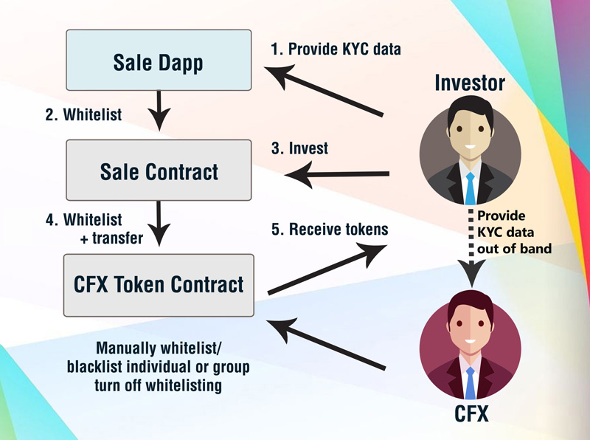
Additional processes can happen outside of the initial ICO workflow. For this purpose, CFX has the ability to manually whitelist and blacklist single or sets of addresses in the CFX token contract. At some point, it might become relevant to turn off the requirement for whitelisted accounts altogether, which is an additional function that the CFX token contract will contain.

KYC Process:
1. User fills in personal details; these details are checked through an AML checklist provided by ComplyAdvantage.
2. User uploads passport; passport details are checked against personal details given in the previous step and the authenticity of the document is verified. This service is provided by OnFido. If it passes all checks, the user is whitelisted and can proceed with the token sale.

Milestones/lifecycle
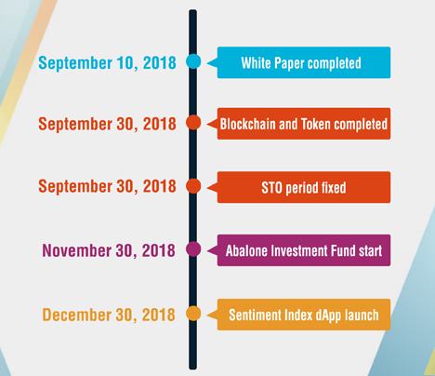
PROJECT FINANCING:

June 2018 presale-ICO starting. Reserved for family, friends, colleagues, and CFX internal and external staff. It is possible to subscribe a limited amount of CFX Token at the historical lowest value that the company will ever propose.

July/August 2018 presale-ICO second phase. Reserved to first subscribers parents and friends. They will have the possibility to be introduced to company top management and book CFX Token with favorable conditions, up to a certain limit of quantity communicated by the company’s top management.

September/October 2018 Testing. Trading System and the initial version of the Sentiment Index will be tested with Company’s financial trading.

September/October 2018 dApp Sentiment Index Launch. Official Launch of the dApp with which every CFX Tokenownerwill be able to test on their phone.

September/October 2018 Presale ICO third phase. The last possibility to subscribe CFX Token with most favorable conditions if there will remain after the first and second phase.

Sometime between Dec 2018 and March 2019 ICO. Planned for the end of the present year, according with Advisor and Legal team. Only in clearly adverse market conditions may be postponed to the new year, but not further than 2019 Spring in any case.

The intention is to conduct an Initial Coin Offering (“ICO”). The ICO will be in compliance with EU prospectus legislation and subject to regulatory approval will be open for 90 days (or less) starting 1 st of January 2019 at 13:00:00 CET.

All updated information regarding our ICO can be found https://cfx.com

3 days from ICO end CFX Tokens assignment. We will make our best effort to send out all Tokens within 3 days from ICO end. All Tokens subscribed and paid in ICO and presale ICO periods will be assigned on their owner’s wallet, according to KYC requirements.

CFX Tokens will be negotiable at a public exchange at market price within 60 days from ICO end. All subscribers in ICO and presale ICO phase will have protection through a lockup period that will be fully described on our website with Legal and Advisor approval by end of August. This will guarantee that price will not be manipulated – as it has occurred in different ICO cases – with dumping actions by first subscribers.

PRIVILEGED CONDITIONS IN PRESALE-ICO PHASE

STO is open to all investors who satisfy the issuer’s strict criteria for investments sophistication, portfolio diversification, risk profile and tolerance, background and suitability check. It is also open to all known people, friends and parents of the Company’s staff. All early investors may enjoy the possibility of privileged conditions offered by the company before ICO takes place. All conditions are for limited quantities of Tokens, dependent in any moment from the total demand coming from the above mentioned restricted target.

Privileged condition starts with a 50% discount in respect to ICO value. The discount gets lower in direct proportion to the time left to approach ICO. Those persons interested in more detail, please contact admin@cryptoforinvest.com

Funds Allocation by Percent - Details
% | Destination | Note
70% | Internal Fund | Will be entirely managed with the full use of HATS with all 4 different TS. Company will maintain a 30% performance fee, while 70% will be shared among token holders.
10% | Marketing expenses | High Standard PR; Social Media Mix; Classic Advertising; Event marketing in order to explain HATS use and benefits
5% | HATS improvement and updates | Continuous control and implementation through extensive research on AI possibilities
8% | Sentiment Index | First two years budget to incentivize common people to participate in Sentiment Index creation
5% | General Expenses | First two years budget for Office Rent; Management and Employees Salary; other Office, Travel, and minor expenses
2% | Various not forecasted

Project sustainability and scalability: Since the major expense over time is marketing, that is defined as a percentage of the revenues coming from the sale of tokens and of the sale of products, the project sustains itself from a minimum of 15 million euro of tokens sold. That will give 4.5 million euros of investments possible, and approximately a minimum return for the company of 1 million euros per year. This is enough to ensure proper management and growth.

Benefits for third parties and other expenditure
Preliminary expenses (amount or estimated amount) and persons by whom they have been paid or are payable:
- 300,000 euros of cash. Investments by Marco Mottana and Fabrizio Crimi of 100,000, and CFX Holding Ltd of 200,000 by means of debt towards third investors financing.
- 300,000 of actual work time by Marco Mottana, Fabrizio Crimi, and external consultants before company setup in order to construct the project during 2017-2018 (to be certified).

Issuance expenses paid or payable: KYC costs are 3.5€/participant, excluding server costs and web services.

VFA agent fees or benefits: TBD

Endorser fees or benefits, terms: TBD

Expectations

Forecast
In the next couple of years, we count on:
      - Achieving authorizations for direct money management and distribution of our Funds.
      - Proving results of our Trading System, in a clear and unquestionable way: official NAV of Funds managed with its directives, listed at major Stock Exchanges in Germany and Switzerland.
      - Bring Sentiment Index to full efficacy, worldwide, with further utilization in Politics; Events; Surveys; Market research and more.
      - Start Everybody Fund, the first ever that is open to investors with no money to invest.

Financial Highlights by Year
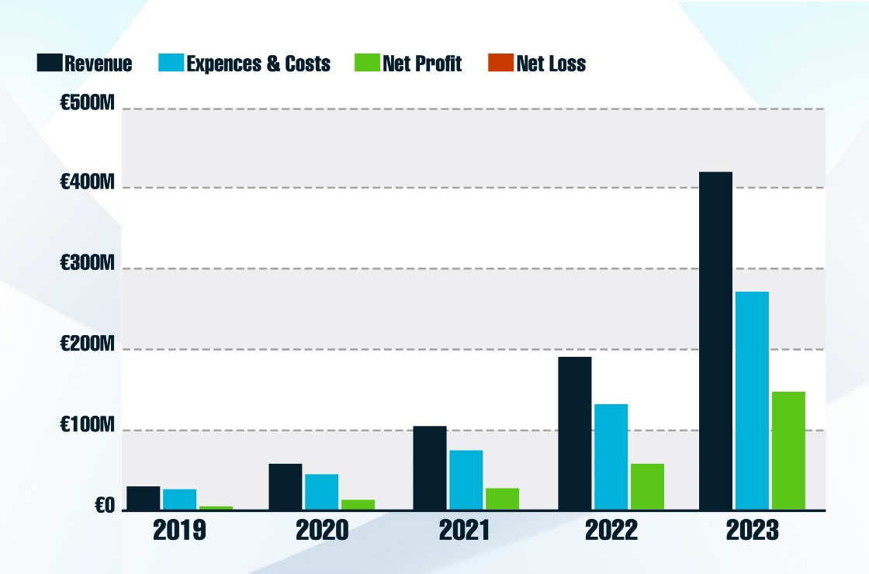

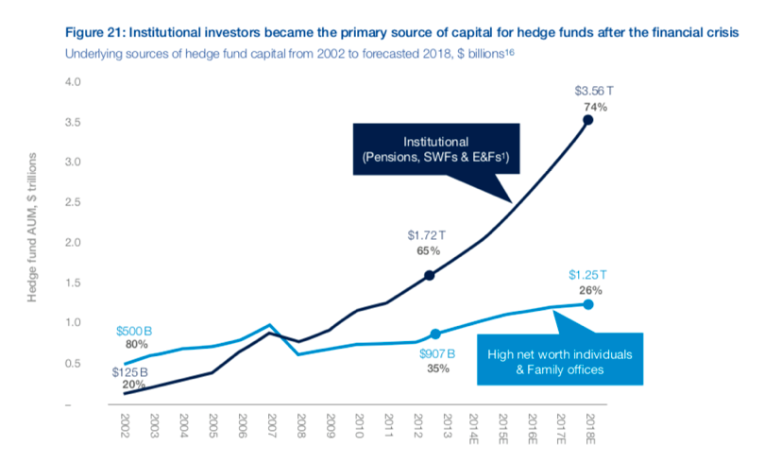
Target Market

Market Size & Segments
CFX offer is directed to Standard and HNWI Investors (High Net Worth Individuals) via the Institutions with whom they operate via Funds subscription or account managed.
Europe only represents 34% of the entire market.
TYPE OF INVESTOR
CFX will approach HNWI Investors and Institutional Org (Banks and Funds). The CFX security token will also enable standard investors to access results normally only available to top investors and financial institutions.

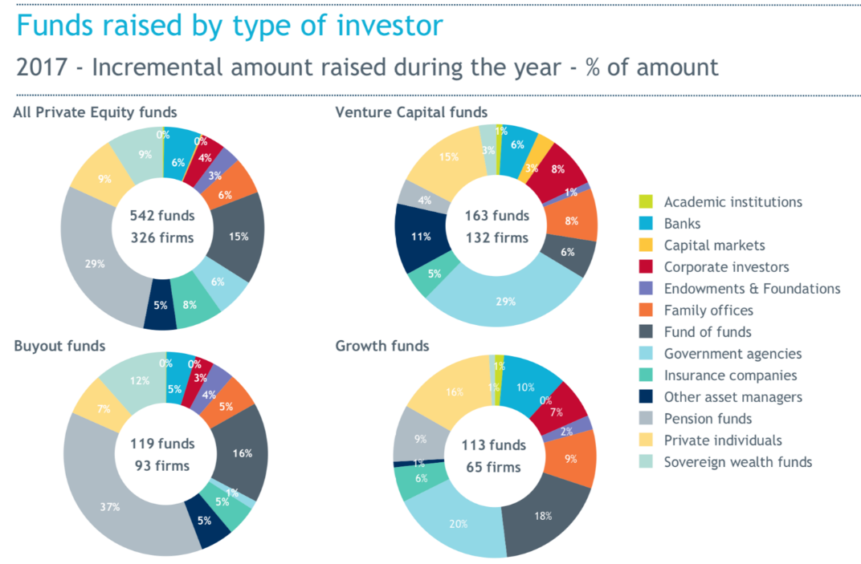
Funds raised by type of investor

CFX’s market is represented mainly by private investors who typically choose UCITS (Undertakings for Collective Investments in Transferable Securities) or AIF (Alternative Investment Funds). Millennials are also a key target for CFX as they represent the best guarantee for the future growth of the company.
The market, however, is dominated by institutional investors, represented by Banks, Funds, and Private Equity Management companies that would be willing to utilize CFX.
Net sales in Europe of UCITS and AIFs recorded net inflows of EUR 222 billion in Q1 2018, compared to EUR 189 billion in the last quarter of 2017.
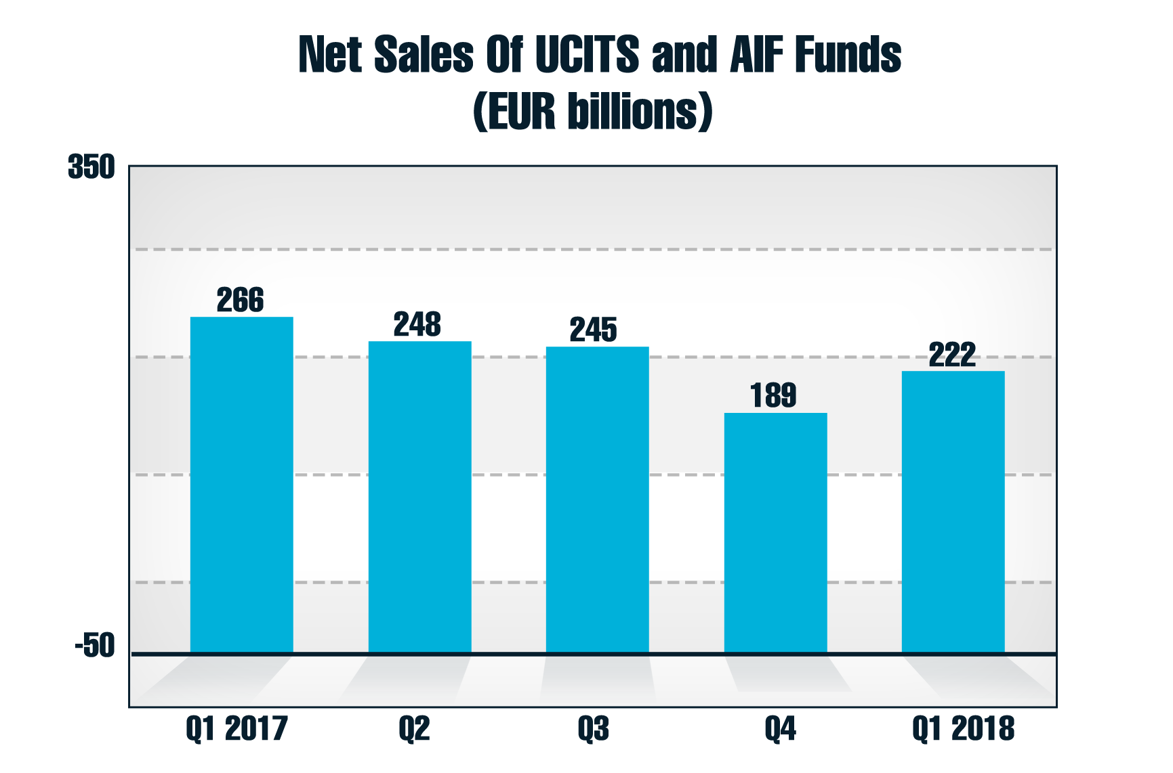

Market Trends

MARKET GROWTH
Assets and inflows to European investment funds broke records in 2017 as the bull market continued in fixed income and equities. European fund assets hit a record €15.6trillion in 2017, according to statistics from the European Fund and Asset Management Association.
More than three-quarters of $1 trillion of inflows was raised just for Ucits funds.

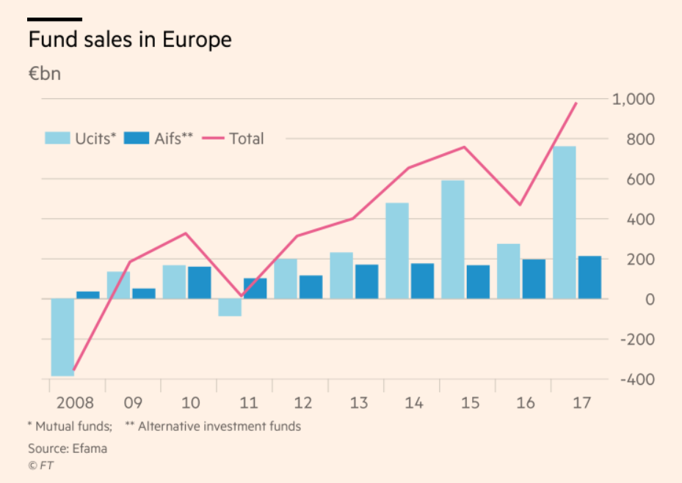
PERFORMANCE
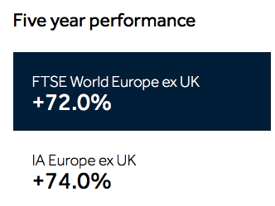
5-year performance of European funds in a medium-long term
www.hl.co.uk/funds/research-and-news/fund-sectors/europe

During the last 20 years, total Assets under management in Europe have constantly increased despite long economic crisis from 2007/8 to 2015.
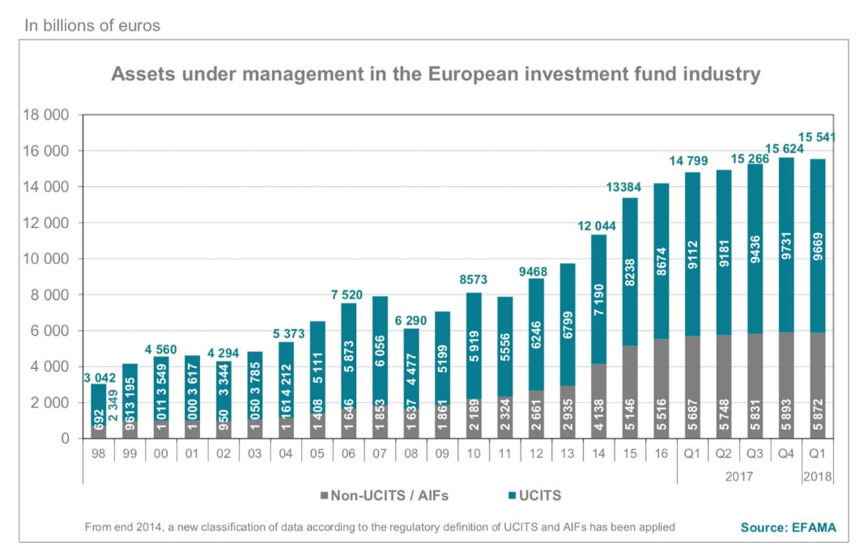

Competition

CURRENT ALTERNATIVES
We quite understand the kind of competitive market in which we are going to operate. The investment market is huge with many long-established firms sharing the space with new ones. CFX will have to face top competition with a superior experience brand, image, customer base, resources to invest, established structure and market position.

OUR ADVANTAGES
Summary of CFX advantages in 4 + 1 main features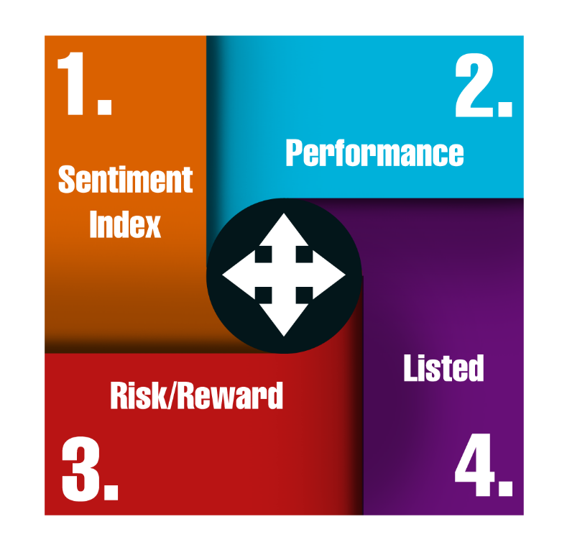
1. Sentiment Index
CFX will have the first Sentiment Index on markets built on real-people sentiment, upgraded constantly, worldwide, on the blockchain.

2. Performance
Funds invested with recommendations from the CFX Trading System will generate profit on a full year basis as proven by 3 years of testing.

3. Risk/reward ratio
Customers will be able to choose their preferred risk/reward ratio. CFX cannot legally guarantee future performance,but we can guarantee that customer risk will be optimally managed.

4. Listed
CFX will start by offering its Trading System to Funds listed at stock exchanges. This guarantees that their value is totally dependent on CFX TS and nothing else. Being officially listed, they'll be bought and sold in real time, with no paper to manage or time to wait.

Execution

Marketing & Sales

PRICING
Price for Licensing HATS software depends on the type of License utilizer and the type of Product.
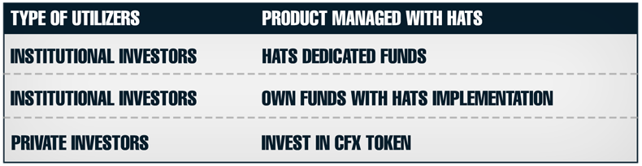
HATS may be used from Institutions willing to create funds entirely managed with CFX system, with price based on results, and, therefore offering the best return.
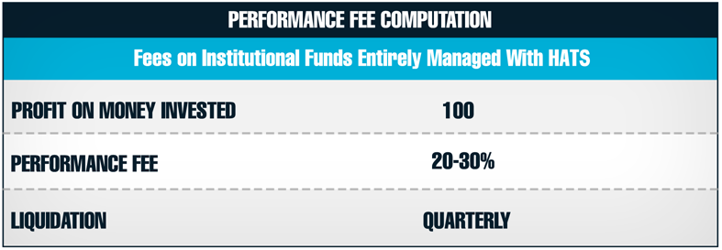
Funds managed entirely with HAFS will also have an entry and management commission fee that will be split among the Institution and CFX, to cover fixed costs.
Same Performance fees are fixed for Private investors who invest through CFX Token acquisition. In this case, 70% of tokens first value is invested in internal Funds managed entirely under HATS specific indication of every single trade.
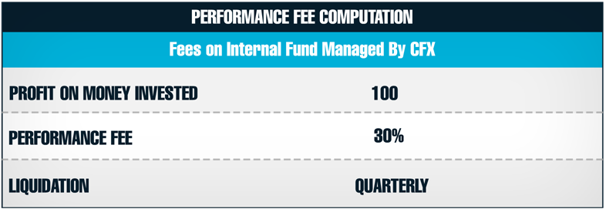
On the quarterly return, a 30% performance fee is detracted and the net return is split among all token holders at that moment, in equal part.
Institutional investors negotiate with CFX both in price and usage modalities of HATS, which may vary deeply from customer to customer. Percentages are much lower, compared to Funds dedicated, as Capital is much superior.
CFX expects a significant portion of its profit coming from direct money management of its financial resources arriving from different sources:
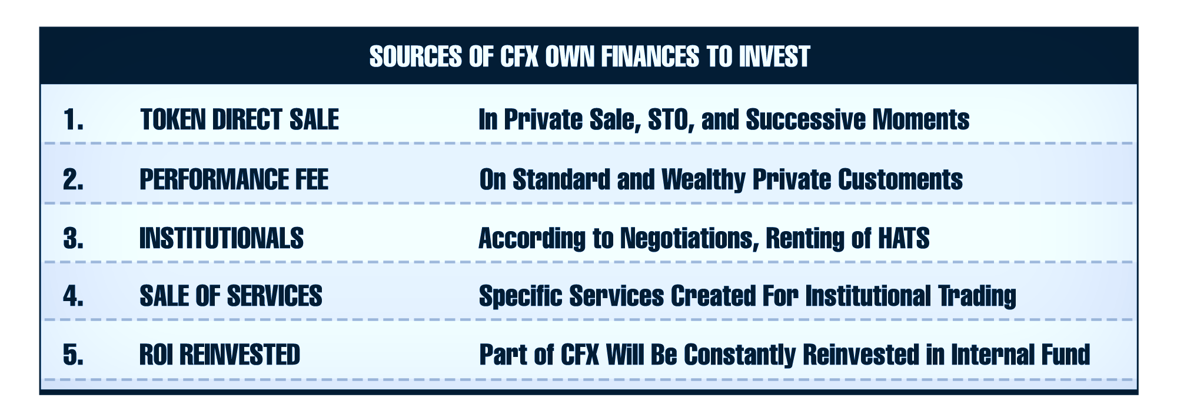
MARKETING PLAN
Marketing focus activities
In order to educate Partners and customers to fully understand the HATS system, Sentiment Index, and Blockchain basics, the CFX marketing department will be deeply focused on the following:

- Web Adverting and Promotion

We'll cooperate with a premier Web Marketing Agency, already operating in Europe, in order to take care of the different tasks involved in the process of a full Social Media Marketing campaign. The principal Social Media instruments that will be utilized include Social Network, Interactive Videos, Landing Pages, Group activity, Social Events, and Prizes.

- Customer Support Department

CFX will hire, train, and coordinate the activity of a highly professional customer support team that will use Salesforce CRM.

- Referral marketing

Superior results generated by HATS will lead to referrals. We expect an average of 0,5 Customers referred x active customer.

- PR

We'll select one of the most credible PR Agencies operating in the international field, with whom there will be a total focus in organizing a continuous series of PR Events in each Country where we'll operate.

Direct and Indirect Investment procedures
There will be two different way to become Private Customer:
1. Direct, via Token offered by the company

Anyone willing to buy CFX Token, directly offered by CFX in Presale/STO/Following issues, will have 70% of his money invested in Token, directly invested in CFX Internal Fund that will be managed according to the Main CFX Trading System.
2. Indirect, via Investment Funds bought in Exchange
Indirect customers will be able to buy, with Fiat Currency, HATS managed Funds in Germany and the SwissStock Exchange, at certified NAV value.
In the table below, we show our sales plan for each market segment.
SALES PLAN
It is important to remember that CFX does not, in any way, act as a money manager for this parties. It generates revenues and profits by:
- Managing its internal portfolio, created with funds derived from the Token sale in private and pre-sale; STO period; and successive issues

- Licensing the use of its HATS Software by Funds dedicated, owned by Institutions and entirely managed with software indications

- Licensing the use of HATS Software and selling related service to Institutional Customers for their funds.
In the table, we show our Sales plan for each market segment. The objective is to explain CFX Token specifics to private customers, on account of the companies that will manage Funds dedicated to our system.
With this plan we indicate:
- Countries where we'll launch specific Marketing campaigns for SPC
- Campaigns will be planned with a specialized Agency operating in each territory:
  - Social Media Marketing
  - Email
  - Web advertising
  - Special Events
  - Referral marketing
The plan also shows Target number of customers for Partner Fund from which we expect an average investment of 11300€.
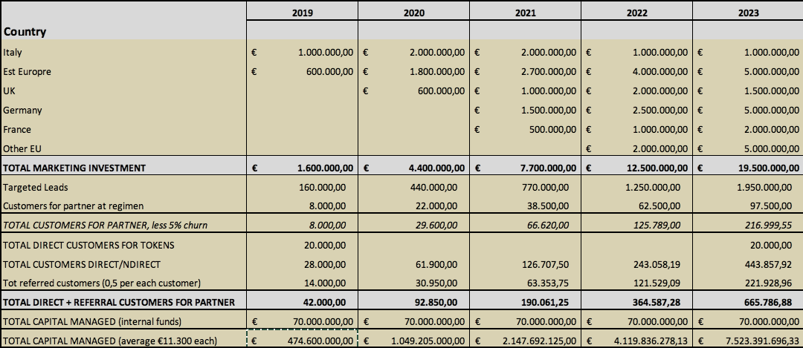
Below is the sales plan for Institutional Investors that aims to manage their funds with a less strict direction by the HATS system.
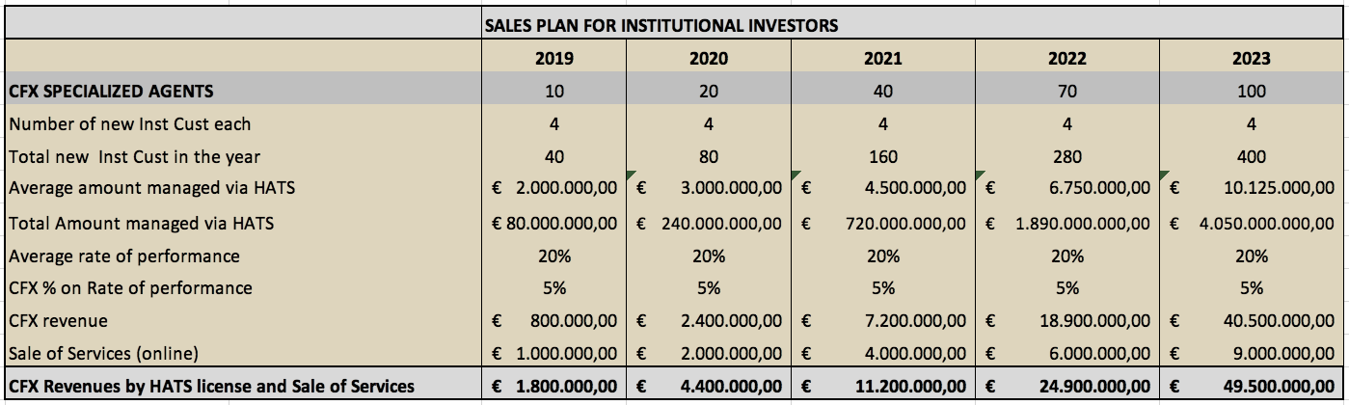

Operations

PARTNERS & RESOURCES
CFX is finding the most reputable partners in every field of operation, with a special focus on investment forecast and trading.
A) Blockchain and Token technologies and practices: ICO MALTA
- ICO Malta has been created by the Blockchain and ICO expert Jan Sammut to deliver state of the art Blockchain and ICO management software and platforms, as well as consultancy over delicate regulatory issues.
B) Big data of finance information: Ivano Menabue
Ivano has a long history with the CEO of CFX in the development of financial Big Database that has evolved over 15 years. The database allows a profound analysis of deep market information, giving high-level forecasting embedded into proprietary trading systems that have been in use for ten plus years by HNWI, institutional traders, and money managers.
C) Financial platform and trading systems
Four different proprietary systems that range from intraday operation to daily, weekly and monthly strategies on every asset class, taken from big private institutions for their own liquidity. These institutions trade the market against average people and also against big funds so that they retain most of the profits.
Partners cannot be disclosed at present.
Each of the four partners has these unique resources:
- A long-term tested forecasting platform
- Trading systems with outstanding performance and proven track record
- Technological structure with multiple servers around the globe
- Long-term BIG DATA of financial information
- Artificial intelligence software.
D) Artificial Intelligence support: TBD
Every system has its own artificial intelligence engine. One specialized partner will find the best fit of all of the systems’ risk/reward strengths.
E) Compliance and AML procedures
CFX will engage IT LegalLtd, a company with a long history in AML in the gambling sector.
F) Legal and accounting procedures: EMD consultants, Valletta - MT
- EMD is a historical law and accountancy firm of Malta with over 50 people specialized in following the most complex issues both in the gambling and investment sectors and is thoroughly updated in the new Virtual Financial Asset laws and Blockchain regulations of Malta.
- CFX legal registered offices are at the address of EMD.
G) Fund creation and Management: ABALONE Asset Management - MT
Abalone is a certified money management company that in only five years became the second largest private asset manager in Malta. They create and manage several funds both in Malta and in Luxembourg, in total compliance with the most recent European directives. Abalone is a CFX partner in the creation of the first Institutional fund, accessible only to professional and High Net Worth Individuals. The fund will be managed using the set of HATS trading systems provided by CFX.
H) Certificates creation and Management: FX FinancialabSA - CH
- FX Financialab SA is a fiduciary and money management company authorized in Zurich, Switzerland.
- Thanks to their long-term experience, they become partners of CFX in order to create and launch the first certificates of deposit that will be managed using the HATS technology. The certificates will be emitted by a Swiss bank in Lugano and quoted at the SIX stock exchange of Zurich, allowing them to be bought by small private investors. The certificates will be guaranteed by the emitting bank and the SIX exchange as well.

KEY PLANNED HIRES
The structure will begin with a few key managers and then evolve fast into a complete operative environment following growth created by the marketing development.
CFX has four major divisions:
- Money management experts
- Technology experts
- Web marketing and Customer Support
- General management staff
A detailed table of costs and hiring plan of action is included in the Business Plan.
1) Money management experts
The aim of this division is to apply and evolve the four main systems of CFX in the real market to manage the internal fund and support the institutional customers of HATS to implement the systems in their own fund management.
Head of investment analysis: a manager with a strong curriculum in the investment sector ranging from consultancy, banks, key global investment companies, with competences in any asset class. He has personally developed several trading and arbitrage systems.
He will be responsible for the global return of the portfolio under the direct supervision of the CEO. He will select, hire and train the key Investment and trading experts and create the optimal environment to grow a group of highly skilled people.
Investment and trading experts with expertise in trading systems and execution, to be specialized by asset class and responsible for the performance of specific parts of the global portfolio under the supervision of the Head of investment analysis. They will support HATS customers on any operative issue.
The number of Investment experts will begin with the necessary people to manage the internal fund and grow every month to follow the growth of the client base.
2) Technology experts
A group of programmers will be in charge of evolving the existing software platforms into a unique integrated platform for trading and money management and integrate the Sentiment indicator into the global systems. Create, maintain, and evolve the Apps and Dapps to be given to token holders and to institutional customers. Maintain and integrate the Big Data financial instruments, implement the artificial intelligence engines, both in the single trading system and in the money management decisions, in order to optimize the global return and minimize the risk on every asset class.
CTO: a programmer of long and profound experience both in the Cryptocurrencies, blockchain development and financial data analysis. He will be responsible for the group of experts that will be hired and trained under his supervision. He will cooperate with the external partner, ICO Malta, and primarily interact with CEO and the Head of investment analysis.
Technology Staff: the group will be selected by the CTO and begin with four people with different expertise: Blockchain, Database management, Artificial intelligence, High-level statistics. The group will then evolve also for the purpose of following the growth of HATS customers. They will also define the necessary computing power and grow the server farms as necessary.
3) Web marketing and customer support
The main operations of web marketing and customer support will be given to external specialized companies. This process will be supervised by the COO with long experience in gaming sector marketing.
The internal group will aim to support, interface and control external suppliers for the general public and token holders, and directly assist institutional customers.
4) General management staff
This group of people will be managed by the CEO and COO in order to give adequate support to all external partners and internal staff. The first key people will be dedicated to accountancy, KYC, AML, and terrorism counter-financing support. The group will grow according to the evolution of operations and size of customer base.

Personnel Table
 | 2019 | 2020 | 2021 | 2022 | 2023
Performance fees Internal bonuses (9.7) | €71,079 | €230,040 | €519,589 | €1,150,217 | €2,944,310
EXTERNAL Relationship Managers (19) | €81,023 | €431,324 | €1,039,179 | €2,396,286 | €6,309,236
Top Managers (3) | €432,000 | €734,400 | €1,248,480 | €2,122,416 | €3,608,106
Head of Investment analysis | €120,000 | €156,000 | €202,800 | €263,640 | €342,732
Investment and trading experts (11.3) | €270,000 | €648,000 | €950,400 | €1,451,520 | €2,239,488
Internal staff and marketing (14.47) | €192,000 | €475,200 | €725,760 | €1,244,160 | €1,642,300
CTO | €120,000 | €144,000 | €172,800 | €207,360 | €248,832
Technology Staff (15.32) | €309,000 | €554,400 | €696,960 | €862,488 | €1,054,160
Totals | €1,595,102 | €3,373,364 | €5,555,968 | €9,698,088 | €18,389,163

Locations & Facilities
CFX is a decentralized company for which location is less important. The management team is working in several different locations:
- Malta, with registered offices in Valletta Waterfront, for legal and accounting, the offices of EMD have a dedicated team of two seniors and four juniors for our company.
- Malta has operative offices in Portomaso, Sliema, the best location in Malta for business and leisure as well, with the support of Hilton Malta and the business center for meetings and conventions.
- CFX is beginning with 200 sqm involving internal meetings, with a commercial staff of 5 to 10. Group secretary and accountancy.
- The offices are meant to grow in consideration of the fast pace of development up to 1000 sqm over time.
- A group of five specialized financial trading experts will be networked in Italy, Milan and other locations. A second group will be created in the Portomaso offices for institutional customer support.
- Italy and abroad, several undisclosed server farms.

TECHNOLOGY
CFX is founded on long-term expertise in financial markets that have been converted into a specific database, software, and application. Here are the main issues regarding technology and the developments needed.
Definitions
- UD= under development
- R# = actual release
- TBI = to be integrated into the final platform
All software could be either internally developed, rented, leased, or bought.
Blockchain And Ico Related
- UD- Crowdsale smart contract
- UD- ERC20 Tokens
- UD- KYC Protocols integrated with Crowdsale contract
- UD- Multisignature Wallet
- UD- DDOS protection
Web And Marketing
- R 1.0 - Website and social media integrated
- R 1.0 - Web Marketing automation tools
- UD- Advanced traffic analysis
- R 1.0 - Email automation
Customer Support
- UD - Web chat system
- UD - Call center app
- UD - Voice over IP
Financial Platforms
- R 10.0 - TBI- BIG DATA of worldwide financial assets
- R 7.5 - TBI - Trading system projects and formulas
- R 3.0 - TBI - Execution automation
- R 8.0 - the Institutional financial platform on all asset classes, multi-timeframes, proprietary forecasting systems
- R. 6.5 - TBI - Artificial intelligence engine
- UD - CFX Sentiment application (Web- mobile app)
- UD - Statistical analysis of sentiment data
- UD - Engine for database info extraction and automatic publishing

EQUIPMENT & TOOLS
The Equipment of CFX is made up of office hardware and furniture. No office, cars or servers will be bought unless essential. Once the growth has been consolidated, an office may be bought instead of rented.
Hardware At Startup
- 5 Laptop PC - Managers
- 5 tablet - Managers
- 5 iPhone - Managers
- 10 Desktop PC - operative offices in Malta
- 6 High-end workstations with double screen - CTO -Head of Investment - Traders
- Leased servers on server farms, flexible based on traffic and computing capacity needs.

Company

Overview

Ownership & Structure

Company history

Management Team

Add bios and headshots
The management team of CFX is composed of 4 people who will cover the major aspects of company creation and development, and then be supported by vice presidents and staff.
CEO: Marco Mottana
COO: Fabrizio Crimi
CTO: Already chosen and working. Identify him
CFO: TBD
CMM (Chief Money Manager): Giovanni Lombardo
CRI: (Chief, Relations Institutional Customers): Vladimir Muidza- MT
Guarantee Committee: TBD
A group of key persons in Malta and worldwide will suggest the board as per best practices and monitor the results.

External Key Consultants
Strategic Advisor: Virgilio Degiovanni
ICO MALTA: Blockchain and Token - Jan Sammut
AMD Consultant: TBD

Advisors
Financial & Auditor Advisors
The internal funds will be certified by a major company in the most transparent way possible. The listed FUNDS NAV will be officially certified, guarantying investors high performance.

Financial Plan

Forecast

KEY ASSUMPTIONS
CFX Three Main Streams of Income and the Disruption of the Sentiment Index
1) Performance of the internal fund.
The internal fund has a minimum target return of 28% per annum. While this may be considered high, it’s not even the half of what we expect given the technology and methods applied.
2) Turnover coming from renting the HATS system to institutional customers are subdivided into two main streams: related to results of the HATS system and institutional marketing. We expect a result of 20% of the average result of 21% over the total asset managed by customers using HATS technology. The increase of customer base for the external funds it the key factor of growth coming from precise indirect marketing calculations.
3) The fees coming from the sale of "Self trading" instruments for private and professionals traders/investors. These systems can only be bought from token holders and paid in CFX Tokens. The fees are very low per customer, growing gradually over the years, creating value and loyalty at affordable prices.
The growth of numbers come from word-of-mouth about the performance of the fund over time, and the global marketing campaign over social media, roadshows, and conventions, especially aimed at creating a community of like-minded investors.
Every customer, both Institutional or private, can access the services only by having CFX Tokens. Therefore, the price of CFX tokens will be subject not only to economic results but also from the scarcity effect of a broadening base of customers over time.
The Sentiment Boost
What cannot be foreseen, but may be impressive over time, are the revenues coming from the CFX Sentiment Index’s disruptive technology. The CFX Sentiment data will be collected and applied in many sectors ranging from Politics to Economics, and even the sales of basic products. The Statistics will be refined every day and will become an impressive source of forecasting data for many uses. This will be on blockchain; immutable, incorruptible, and independent of global organizations, central banks, and states.

Revenue by Month
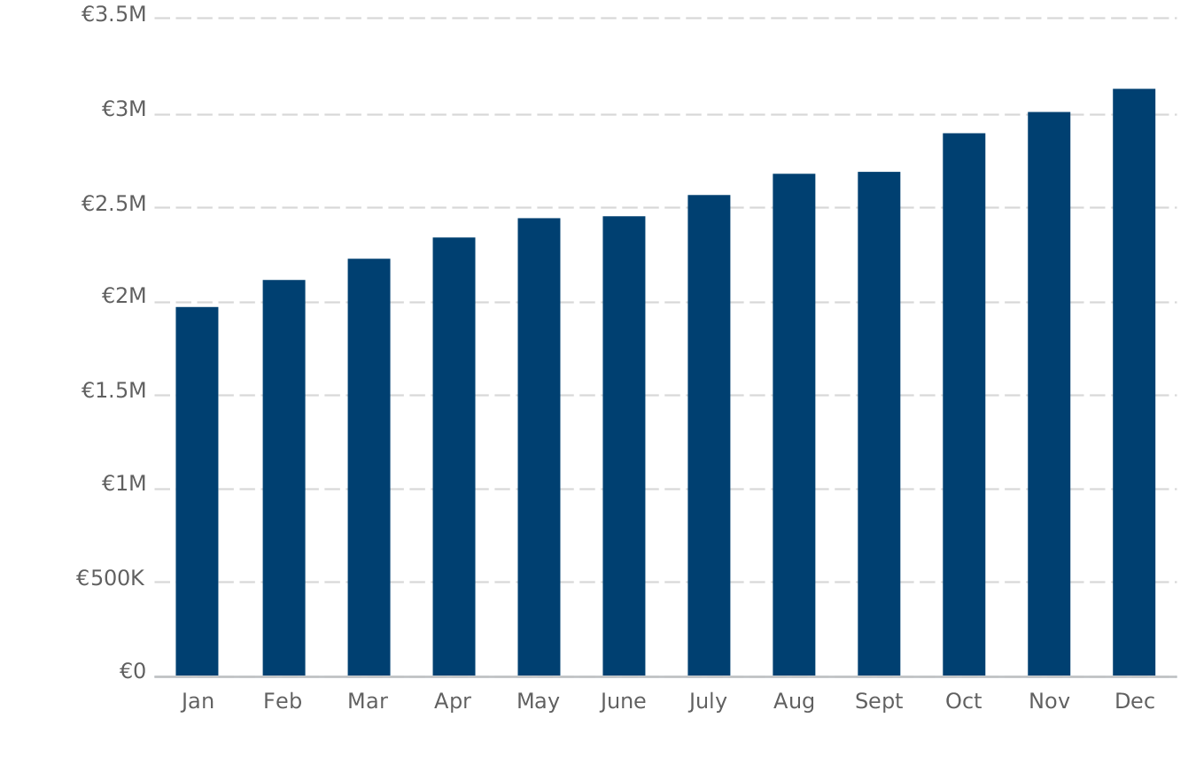

Expenses by Month
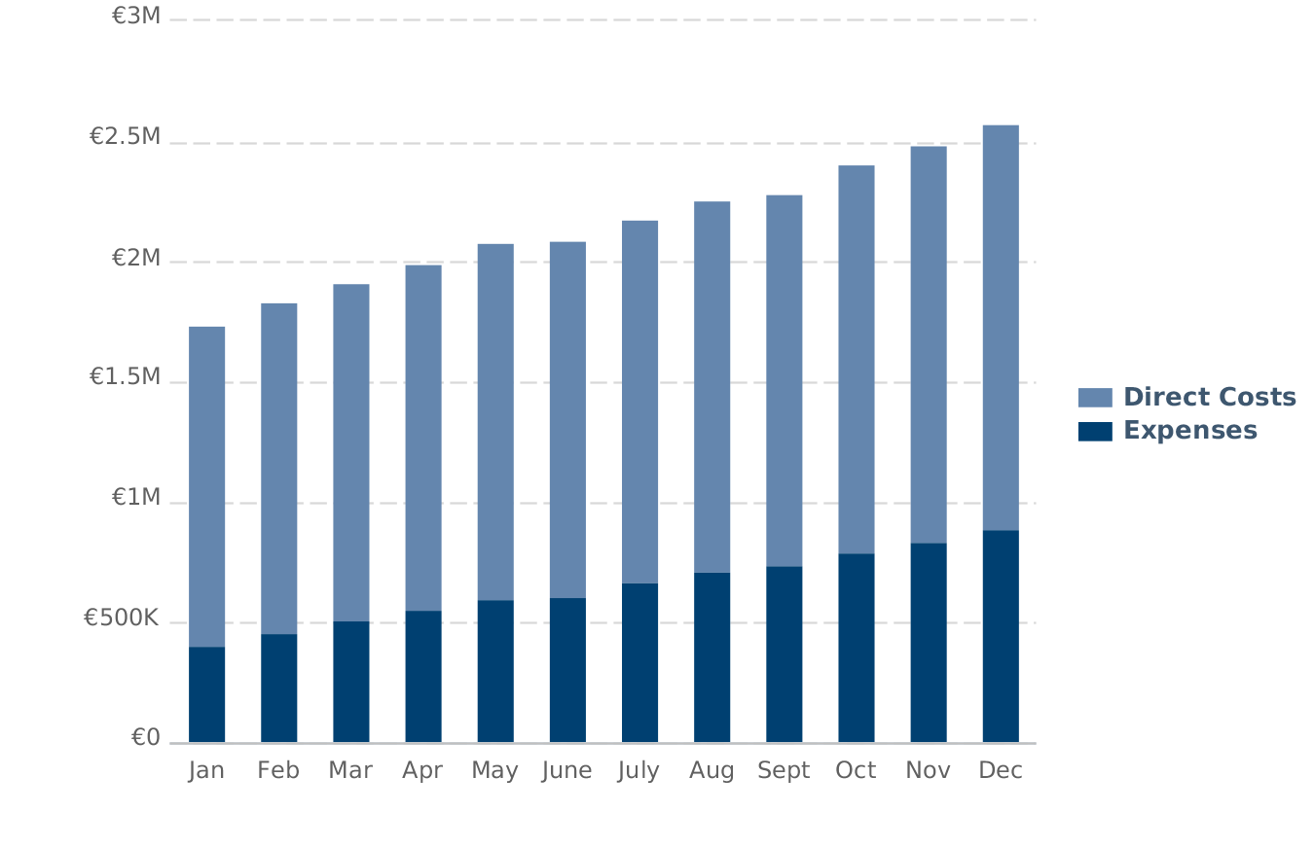

Net Profit (or Loss) by Year
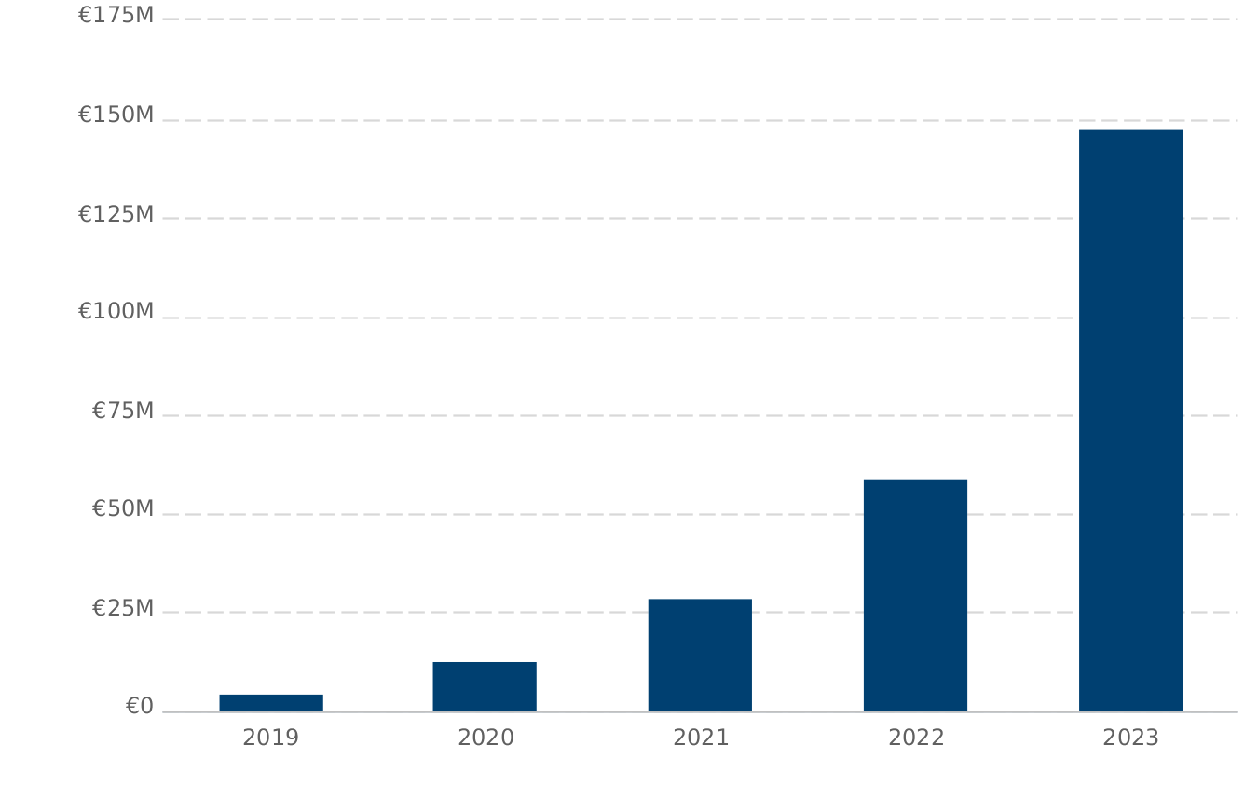

Financing

USE OF FUNDS

SOURCES OF FUNDS

STATEMENTS

Projected Profit and Loss
 | 2019 | 2020 | 2021 | 2022 | 2023
Revenue | €30,606,003 | €57,509,905 | €103,917,839 | €191,702,920 | €420,615,717
Direct Costs | €18,049,904 | €26,745,586 | €42,106,219 | €71,985,501 | €149,614,255
Gross Margin | €12,556,099 | €30,764,320 | €61,811,620 | €119,717,419 | €271,001,461
Gross Margin % | 41% | 53% | 59% | 62% | 64%
Operating Expenses
Salaries & Wages | €1,443,000 | €2,712,000 | €3,997,200 | €6,151,584 | €9,135,618
Employee Related Expenses | €152,100 | €302,040 | €469,116 | €762,260 | €1,174,894
OFFICES | €99,000 | €192,000 | €240,000 | €300,000 | €300,000
Bills | €31,400 | €48,000 | €54,000 | €60,000 | €72,000
WEB Servers | €57,000 | €96,000 | €144,000 | €192,000 | €240,000
Accountancy and KYC and AML | €54,000 | €100,000 | €140,000 | €160,000 | €200,000
Transfers and General exp. | €52,000 | €108,000 | €144,000 | €160,000 | €180,000
Cars and Fringes | €39,200 | €48,000 | €60,000 | €80,000 | €100,000
MARKETING | €1,600,000 | €4,400,000 | €7,700,000 | €12,500,000 | €19,500,000
Customer Service and Activation | €1,200,000 | €2,400,000 | €4,000,000 | €8,000,000 | €12,000,000
Total Operating Expenses | €4,727,700 | €10,406,040 | €16,948,316 | €28,365,844 | €42,902,512
Operating Income | €7,828,399 | €20,358,279 | €44,863,304 | €91,351,575 | €228,098,949
Interest Incurred
Depreciation and Amortization | €504,651 | €545,873 | €618,161 | €676,579 | €750,849
Income Taxes | €2,563,312 | €6,934,342 | €15,485,800 | €31,736,249 | €79,571,835
Total Expenses | €25,845,567 | €44,631,841 | €75,158,495 | €132,764,174 | €272,839,452
Net Profit | €4,760,436 | €12,878,064 | €28,759,344 | €58,938,746 | €147,776,265
Net Profit / Sales | 16% | 22% | 28% | 31% | 35%

Projected Balance Sheet
 | 2019 | 2020 | 2021 | 2022 | 2023
Cash | €102,047,199 | €119,797,564 | €158,169,685 | €235,281,161 | €435,682,118
Accounts Receivable | €0 | €0 | €0 | €0 | €0
Inventory
Other Current Assets
Total Current Assets | €102,047,199 | €119,797,564 | €158,169,685 | €235,281,161 | €435,682,118
Long-Term Assets | €6,506,000 | €6,976,000 | €7,461,000 | €7,971,000 | €8,511,000
Accumulated Depreciation | (€504,651) | (€1,050,524) | (€1,668,685) | (€2,345,264) | (€3,096,113)
Total Long-Term Assets | €6,001,349 | €5,925,476 | €5,792,315 | €5,625,736 | €5,414,887
Total Assets | €108,048,548 | €125,723,040 | €163,962,001 | €240,906,897 | €441,097,005
Accounts Payable | €0 | €0 | €0 | €0 | €0
Income Taxes Payable | €2,563,312 | €6,934,342 | €15,485,800 | €31,736,249 | €79,571,835
Sales Taxes Payable | €724,800 | €1,150,198 | €2,078,357 | €3,834,058 | €8,412,315
Short-Term Debt
Prepaid Revenue
Total Current Liabilities | €3,288,112 | €8,084,540 | €17,564,157 | €35,570,307 | €87,984,150
Long-Term Debt
Total Liabilities | €3,288,112 | €8,084,540 | €17,564,157 | €35,570,307 | €87,984,150
Paid-In Capital | €100,000,000 | €100,000,000 | €100,000,000 | €100,000,000 | €100,000,000
Retained Earnings |  | €4,760,436 | €17,638,500 | €46,397,844 | €105,336,590
Earnings | €4,760,436 | €12,878,065 | €28,759,343 | €58,938,746 | €147,776,265
Total Owner's Equity | €104,760,436 | €117,638,500 | €146,397,844 | €205,336,590 | €353,112,855
Total Liabilities & Equity | €108,048,548 | €125,723,040 | €163,962,001 | €240,906,897 | €441,097,005

Projected Balance Sheet
 | 2019 | 2020 | 2021 | 2022 | 2023
Net Cash Flow from Operations
Net Profit | €4,760,436 | €12,878,064 | €28,759,344 | €58,938,746 | €147,776,265
Depreciation & Amortization | €504,651 | €545,873 | €618,161 | €676,579 | €750,849
Change in Accounts Receivable | €0 | €0 | €0 | €0 | €0
Change in Inventory
Change in Accounts Payable | €0 | €0 | €0 | €0 | €0
Change in Income Tax Payable | €2,563,312 | €4,371,030 | €8,551,458 | €16,250,449 | €47,835,586
Change in Sales Tax Payable | €724,800 | €425,398 | €928,159 | €1,755,701 | €4,578,257
Change in Prepaid Revenue
Net Cash Flow from Operations | €8,553,199 | €18,220,366 | €38,857,121 | €77,621,476 | €200,940,958
Investing & Financing
Assets Purchased or Sold | (€6,506,000) | (€470,000) | (€485,000) | (€510,000) | (€540,000)
Investments Received | €100,000,000
Change in Long-Term Debt
Change in Short-Term Debt
Dividends & Distributions
Net Cash Flow from Investing & Financing | €93,494,000 | (€470,000) | (€485,000) | (€510,000) | (€540,000)
Cash at Beginning of Period | €0 | €102,047,199 | €119,797,564 | €158,169,685 | €235,281,161
Net Change in Cash | €102,047,199 | €17,750,366 | €38,372,121 | €77,111,476 | €200,400,958
Cash at End of Period | €102,047,199 | €119,797,564 | €158,169,685 | €235,281,161 | €435,682,118

SWOT ANALYSIS

RISKS & MITIGATION

Appendix

Profit and Loss Statement (With monthly detail)
2019 | Jan '19 | Feb '19 | Mar '19 | Apr '19 | May '19 | June '19 | July '19 | Aug '19 | Sept '19 | Oct '19 | Nov '19 | Dec '19
Total Revenue | €1,979,333 | €2,123,333 | €2,233,333 | €2,343,333 | €2,453,333 | €2,463,333 | €2,573,333 | €2,683,333 | €2,693,333 | €2,903,333 | €3,013,333 | €3,143,340
Total Direct Costs | €1,329,758 | €1,373,308 | €1,406,700 | €1,441,373 | €1,475,040 | €1,477,085 | €1,510,866 | €1,543,417 | €1,546,813 | €1,612,871 | €1,647,093 | €1,685,580
Gross Margin | €649,575 | €750,025 | €826,633 | €901,960 | €978,293 | €986,248 | €1,062,467 | €1,139,917 | €1,146,520 | €1,290,462 | €1,366,240 | €1,457,760
Gross Margin % | 33% | 35% | 37% | 38% | 40% | 40% | 41% | 42% | 43% | 44% | 45% | 46%
Operating Expenses
Salaries and Wages | €84,000 | €87,000 | €101,000 | €104,000 | €115,000 | €118,000 | €129,000 | €129,000 | €137,000 | €137,000 | €151,000 | €151,000
Employee Related Expenses | €9,300 | €9,300 | €10,950 | €10,950 | €12,150 | €12,150 | €13,350 | €13,350 | €14,550 | €14,550 | €15,750 | €15,750
OFFICES | €5,000 | €5,000 | €5,000 | €7,000 | €7,000 | €7,000 | €9,000 | €9,000 | €9,000 | €12,000 | €12,000 | €12,000
Bills | €1,200 | €1,500 | €1,700 | €1,800 | €2,000 | €2,200 | €2,500 | €2,700 | €3,500 | €3,800 | €4,000 | €4,500
WEB Servers | €2,000 | €2,500 | €3,000 | €3,500 | €4,000 | €4,500 | €5,000 | €5,500 | €6,000 | €6,500 | €7,000 | €7,500
Accountancy and KYC and AML | €2,000 | €2,000 | €3,000 | €3,000 | €4,000 | €4,000 | €5,000 | €5,000 | €6,000 | €6,000 | €7,000 | €7,000
Transfers and General exp. | €2,000 | €2,000 | €3,000 | €3,000 | €3,500 | €4,000 | €4,500 | €5,000 | €5,500 | €6,000 | €6,500 | €7,000
Cars and Fringes | €2,000 | €2,200 | €2,600 | €2,800 | €3,000 | €3,200 | €3,400 | €3,600 | €3,800 | €4,000 | €4,200 | €4,400
MARKETING | €80,000 | €90,000 | €100,000 | €110,000 | €120,000 | €130,000 | €140,000 | €150,000 | €160,000 | €170,000 | €170,000 | €180,000
Customer Service and Activation | €50,000 | €60,000 | €70,000 | €80,000 | €90,000 | €80,000 | €100,000 | €120,000 | €130,000 | €130,000 | €140,000 | €150,000
Total Operating Expenses | €237,500 | €261,500 | €300,250 | €326,050 | €360,650 | €365,050 | €411,750 | €443,150 | €475,350 | €489,850 | €517,450 | €539,150
Operating Income | €412,075 | €488,525 | €526,383 | €575,910 | €617,643 | €621,198 | €650,717 | €696,766 | €671,170 | €800,612 | €848,790 | €918,610
Interest Incurred
Depreciation and Amortization | €41,746 | €41,746 | €41,885 | €41,921 | €42,004 | €42,004 | €42,123 | €42,123 | €42,206 | €42,242 | €42,325 | €42,326
Income Taxes | €129,615 | €156,373 | €169,574 | €186,896 | €201,474 | €202,718 | €213,008 | €229,125 | €220,137 | €265,430 | €282,262 | €306,700
Total Expenses | €1,738,619 | €1,832,928 | €1,918,408 | €1,996,240 | €2,079,168 | €2,086,856 | €2,177,748 | €2,257,814 | €2,284,507 | €2,410,393 | €2,489,131 | €2,573,755
Net Profit | €240,714 | €290,405 | €314,925 | €347,093 | €374,165 | €376,477 | €395,585 | €425,519 | €408,826 | €492,940 | €524,202 | €569,585
Net Profit / Sales | 12% | 14% | 14% | 15% | 15% | 15% | 15% | 16% | 15% | 17% | 17% | 18%
 | 2019 | 2020 | 2021 | 2022 | 2023
Total Revenue | €30,606,003 | €57,509,905 | €103,917,839 | €191,702,920 | €420,615,717
Total Direct Costs | €18,049,904 | €26,745,586 | €42,106,219 | €71,985,501 | €149,614,255
Gross Margin | €12,556,099 | €30,764,320 | €61,811,620 | €119,717,419 | €271,001,461
Gross Margin % | 41% | 53% | 59% | 62% | 64%
Operating Expenses
Salaries and Wages | €1,443,000 | €2,712,000 | €3,997,200 | €6,151,584 | €9,135,618
Employee Related Expenses | €152,100 | €302,040 | €469,116 | €762,260 | €1,174,894
OFFICES | €99,000 | €192,000 | €240,000 | €300,000 | €300,000
Bills | €31,400 | €48,000 | €54,000 | €60,000 | €72,000
WEB Servers | €57,000 | €96,000 | €144,000 | €192,000 | €240,000
Accountancy and KYC and AML | €54,000 | €100,000 | €140,000 | €160,000 | €200,000
Transfers and General exp. | €52,000 | €108,000 | €144,000 | €160,000 | €180,000
Cars and Fringes | €39,200 | €48,000 | €60,000 | €80,000 | €100,000
MARKETING | €1,600,000 | €4,400,000 | €7,700,000 | €12,500,000 | €19,500,000
Customer Service and Activation | €1,200,000 | €2,400,000 | €4,000,000 | €8,000,000 | €12,000,000
Total Operating Expenses | €4,727,700 | €10,406,040 | €16,948,316 | €28,365,844 | €42,902,512
Operating Income | €7,828,399 | €20,358,279 | €44,863,304 | €91,351,575 | €228,098,949
Interest Incurred
Depreciation and Amortization | €504,651 | €545,873 | €618,161 | €676,579 | €750,849
Income Taxes | €2,563,312 | €6,934,342 | €15,485,800 | €31,736,249 | €79,571,835
Total Expenses | €25,845,567 | €44,631,841 | €75,158,495 | €132,764,174 | €272,839,452
Net Profit | €4,760,436 | €12,878,064 | €28,759,344 | €58,938,746 | €147,776,265
Net Profit / Sales | 16% | 22% | 28% | 31% | 35%

Balance Sheet (With Monthly Detail)
2019 | Jan '19 |  | Feb '19 | Mar '19 | Apr '19 |  | May '19 | June '19 |  | July '19 | Aug '19 |  | Sept '19 | Oct '19 |  | Nov '19 | Dec '19
Cash | €94,090,422 |  | €94,748,813 | €95,448,863 | €95,702,360 |  | €96,513,269 | €97,331,534 |  | €97,601,317 | €98,512,750 |  | €99,396,387 | €99,790,265 |  | €100,877,122 | €102,047,199
Accounts Receivable | €0 |  | €0 | €0 | €0 |  | €0 | €0 |  | €0 | €0 |  | €0 | €0 |  | €0 | €0
Inventory
Other Current Assets
Total Current Assets | €94,090,422 |  | €94,748,813 | €95,448,863 | €95,702,360 |  | €96,513,269 | €97,331,534 |  | €97,601,317 | €98,512,750 |  | €99,396,387 | €99,790,265 |  | €100,877,122 | €102,047,199
Long-Term Assets | €6,480,000 |  | €6,480,000 | €6,485,000 | €6,488,000 |  | €6,491,000 | €6,491,000 |  | €6,497,000 | €6,497,000 |  | €6,500,000 | €6,503,000 |  | €6,506,000 | €6,506,000
Accumulated Depreciation | (€41,746) |  | (€83,492) | (€125,377) | (€167,298) |  | (€209,302) | (€251,306) |  | (€293,429) | (€335,552) |  | (€377,758) | (€420,000) |  | (€462,325) | (€504,651)
Total Long-Term Assets | €6,438,254 |  | €6,396,508 | €6,359,623 | €6,320,702 |  | €6,281,698 | €6,239,694 |  | €6,203,571 | €6,161,448 |  | €6,122,242 | €6,083,000 |  | €6,043,675 | €6,001,349
Total Assets | €100,528,676 |  | €101,145,320 | €101,808,486 | €102,023,062 |  | €102,794,967 | €103,571,229 |  | €103,804,888 | €104,674,199 |  | €105,518,629 | €105,873,265 |  | €106,920,796 | €108,048,548
Accounts Payable | €0 |  | €0 | €0 | €0 |  | €0 | €0 |  | €0 | €0 |  | €0 | €0 |  | €0 | €0
Income Taxes Payable | €129,615 |  | €285,988 | €455,562 | €642,458 |  | €843,932 | €1,046,650 |  | €1,259,658 | €1,488,783 |  | €1,708,920 | €1,974,350 |  | €2,256,612 | €2,563,312
Sales Taxes Payable | €158,347 |  | €328,213 | €506,880 | €187,467 |  | €383,733 | €580,800 |  | €205,866 | €420,533 |  | €636,000 | €232,266 |  | €473,333 | €724,800
Short-Term Debt
Prepaid Revenue
Total Current Liabilities | €287,962 |  | €614,201 | €962,442 | €829,925 |  | €1,227,665 | €1,627,450 |  | €1,465,524 | €1,909,316 |  | €2,344,920 | €2,206,616 |  | €2,729,945 | €3,288,112
Long-Term Debt
Total Liabilities | €287,962 |  | €614,201 | €962,442 | €829,925 |  | €1,227,665 | €1,627,450 |  | €1,465,524 | €1,909,316 |  | €2,344,920 | €2,206,616 |  | €2,729,945 | €3,288,112
Paid-In Capital | €100,000,000 |  | €100,000,000 | €100,000,000 | €100,000,000 |  | €100,000,000 | €100,000,000 |  | €100,000,000 | €100,000,000 |  | €100,000,000 | €100,000,000 |  | €100,000,000 | €100,000,000
Retained Earnings
Earnings | €240,714 |  | €531,119 | €846,044 | €1,193,137 |  | €1,567,302 | €1,943,779 |  | €2,339,364 | €2,764,883 |  | €3,173,709 | €3,666,649 |  | €4,190,851 | €4,760,436
Total Owner's Equity | €100,240,714 |  | €100,531,119 | €100,846,044 | €101,193,137 |  | €101,567,302 | €101,943,779 |  | €102,339,364 | €102,764,883 |  | €103,173,709 | €103,666,649 |  | €104,190,851 | €104,760,436
Total Liabilities & Equity | €100,528,676 |  | €101,145,320 | €101,808,486 | €102,023,062 |  | €102,794,967 | €103,571,229 |  | €103,804,888 | €104,674,199 |  | €105,518,629 | €105,873,265 |  | €106,920,796 | €108,048,548
 |  | 2019 |  |  |  | 2020 |  |  | 2021 |  |  | 2022 |  |  | 2023
Cash |  | €102,047,199 |  |  |  | €119,797,564 |  |  | €158,169,685 |  |  | €235,281,161 |  |  | €435,682,118
Accounts Receivable |  | €0 |  |  |  | €0 |  |  | €0 |  |  | €0 |  |  | €0
Inventory
Other Current Assets
Total Current Assets |  | €102,047,199 |  |  |  | €119,797,564 |  |  | €158,169,685 |  |  | €235,281,161 |  |  | €435,682,118
Long-Term Assets |  | €6,506,000 |  |  |  | €6,976,000 |  |  | €7,461,000 |  |  | €7,971,000 |  |  | €8,511,000
Accumulated Depreciation |  | (€504,651) |  |  |  | (€1,050,524) |  |  | (€1,668,685) |  |  | (€2,345,264) |  |  | (€3,096,113)
Total Long-Term Assets |  | €6,001,349 |  |  |  | €5,925,476 |  |  | €5,792,315 |  |  | €5,625,736 |  |  | €5,414,887
Total Assets |  | €108,048,548 |  |  |  | €125,723,040 |  |  | €163,962,001 |  |  | €240,906,897 |  |  | €441,097,005
Accounts Payable |  | €0 |  |  |  | €0 |  |  | €0 |  |  | €0 |  |  | €0
Income Taxes Payable |  | €2,563,312 |  |  |  | €6,934,342 |  |  | €15,485,800 |  |  | €31,736,249 |  |  | €79,571,835
Sales Taxes Payable |  | €724,800 |  |  |  | €1,150,198 |  |  | €2,078,357 |  |  | €3,834,058 |  |  | €8,412,315
Short-Term Debt
Prepaid Revenue
Total Current Liabilities |  | €3,288,112 |  |  |  | €8,084,540 |  |  | €17,564,157 |  |  | €35,570,307 |  |  | €87,984,150
Long-Term Debt
Total Liabilities |  | €3,288,112 |  |  |  | €8,084,540 |  |  | €17,564,157 |  |  | €35,570,307 |  |  | €87,984,150
Paid-In Capital |  | €100,000,000 |  |  |  | €100,000,000 |  |  | €100,000,000 |  |  | €100,000,000 |  |  | €100,000,000
Retained Earnings |  |  |  |  |  | €4,760,436 |  |  | €17,638,500 |  |  | €46,397,844 |  |  | €105,336,590
Earnings |  | €4,760,436 |  |  |  | €12,878,065 |  |  | €28,759,343 |  |  | €58,938,746 |  |  | €147,776,265
Total Owner's Equity |  | €104,760,436 |  |  |  | €117,638,500 |  |  | €146,397,844 |  |  | €205,336,590 |  |  | €353,112,855
Total Liabilities & Equity |  | €108,048,548 |  |  |  | €125,723,040 |  |  | €163,962,001 |  |  | €240,906,897 |  |  | €441,097,005

Cash Flow Statement (With Monthly Detail)
2019 | Jan '19 |  | Feb '19 | Mar '19 |  | Apr '19 | May '19 |  | June '19 | July '19 | Aug '19 |  | Sept '19 | Oct '19 |  | Nov '19 | Dec '19
Net Cash Flow from Operations
Net Profit | €240,714 |  | €290,405 | €314,925 |  | €347,093 | €374,165 |  | €376,477 | €395,585 | €425,519 |  | €408,826 | €492,940 |  | €524,202 | €569,585
Depreciation & Amortization | €41,746 |  | €41,746 | €41,885 |  | €41,921 | €42,004 |  | €42,004 | €42,123 | €42,123 |  | €42,206 | €42,242 |  | €42,325 | €42,325
Change in Accounts Receivable | €0 |  | €0 | €0 |  | €0 | €0 |  | €0 | €0 | €0 |  | €0 | €0 |  | €0 | €0
Change in Inventory
Change in Accounts Payable | €0 |  | €0 | €0 |  | €0 | €0 |  | €0 | €0 | €0 |  | €0 | €0 |  | €0 | €0
Change in Income Tax Payable | €129,615 |  | €156,373 | €169,574 |  | €186,896 | €201,474 |  | €202,718 | €213,008 | €229,125 |  | €220,137 | €265,430 |  | €282,262 | €306,700
Change in Sales Tax Payable | €158,347 |  | €169,866 | €178,667 |  | (€319,413) | €196,266 |  | €197,067 | (€374,934) | €214,667 |  | €215,467 | (€403,734) |  | €241,067 | €251,467
Change in Prepaid Revenue
Net Cash Flow from Operations | €570,422 |  | €658,391 | €705,050 |  | €256,497 | €813,909 |  | €818,265 | €275,783 | €911,434 |  | €886,637 | €396,878 |  | €1,089,857 | €1,170,077
Investing & Financing
Assets Purchased or Sold | (€6,480,000) |  |  | (€5,000) |  | (€3,000) | (€3,000) |  |  | (€6,000) |  |  | (€3,000) | (€3,000) |  | (€3,000)
Investments Received | €100,000,000
Change in Long-Term Debt
Change in Short-Term Debt
Dividends & Distributions
Net Cash Flow from Investing & Financing | €93,520,000 |  |  | (€5,000) |  | (€3,000) | (€3,000) |  |  | (€6,000) |  |  | (€3,000) | (€3,000) |  | (€3,000)
Cash at Beginning of Period | €0 |  | €94,090,422 | €94,748,813 |  | €95,448,863 | €95,702,360 |  | €96,513,269 | €97,331,534 | €97,601,317 |  | €98,512,750 | €99,396,387 |  | €99,790,265 | €100,877,122
Net Change in Cash | €94,090,422 |  | €658,391 | €700,050 |  | €253,497 | €810,909 |  | €818,265 | €269,783 | €911,434 |  | €883,637 | €393,878 |  | €1,086,857 | €1,170,077
Cash at End of Period | €94,090,422 |  | €94,748,813 | €95,448,863 |  | €95,702,360 | €96,513,269 |  | €97,331,534 | €97,601,317 | €98,512,750 |  | €99,396,387 | €99,790,265 |  | €100,877,122 | €102,047,199
 |  | 2019 |  |  | 2020 |  |  | 2021 |  |  |  | 2022 |  |  | 2023
Net Cash Flow from Operations
Net Profit |  | €4,760,436 |  |  | €12,878,064 |  |  | €28,759,344 |  |  |  | €58,938,746 |  |  | €147,776,265
Depreciation & Amortization |  | €504,651 |  |  | €545,873 |  |  | €618,161 |  |  |  | €676,579 |  |  | €750,849
Change in Accounts Receivable |  | €0 |  |  | €0 |  |  | €0 |  |  |  | €0 |  |  | €0
Change in Inventory
Change in Accounts Payable |  | €0 |  |  | €0 |  |  | €0 |  |  |  | €0 |  |  | €0
Change in Income Tax Payable |  | €2,563,312 |  |  | €4,371,030 |  |  | €8,551,458 |  |  |  | €16,250,449 |  |  | €47,835,586
Change in Sales Tax Payable |  | €724,800 |  |  | €425,398 |  |  | €928,159 |  |  |  | €1,755,701 |  |  | €4,578,257
Change in Prepaid Revenue
Net Cash Flow from Operations |  | €8,553,199 |  |  | €18,220,366 |  |  | €38,857,121 |  |  |  | €77,621,476 |  |  | €200,940,958
Investing & Financing
Assets Purchased or Sold |  | (€6,506,000) |  |  | (€470,000) |  |  | (€485,000) |  |  |  | (€510,000) |  |  | (€540,000)
Investments Received |  | €100,000,000
Change in Long-Term Debt
Change in Short-Term Debt
Dividends & Distributions
Net Cash Flow from Investing & Financing |  | €93,494,000 |  |  | (€470,000) |  |  | (€485,000) |  |  |  | (€510,000) |  |  | (€540,000)
Cash at Beginning of Period |  | €0 |  |  | €102,047,199 |  |  | €119,797,564 |  |  |  | €158,169,685 |  |  | €235,281,161
Net Change in Cash |  | €102,047,199 |  |  | €17,750,366 |  |  | €38,372,121 |  |  |  | €77,111,476 |  |  | €200,400,958
Cash at End of Period |  | €102,047,199 |  |  | €119,797,564 |  |  | €158,169,685 |  |  |  | €235,281,161 |  |  | €435,682,118

Token Risk Factors

Risk Factors Relating to Purchase, Sale, and Use of Tokens
Important note:the company expressly disclaims any and all responsibility for any direct or consequential loss or damage of any kind whatsoever arising directly or indirectly from: (i) reliance on any information contained the whitepaper and all associated materials, including this document, (ii) any error, omission or inaccuracy in any such information or (iii) any action resulting from such information.

By purchasing, owning, and using Tokens, you expressly acknowledge and assume the following risks:

General Suitability of Token Purchase
The purchase of tokens from the Company is only suitable for financially sophisticated persons who are capable of evaluating the merits and risks of such a purchase, or other persons who have been professionally advised with regard to token purchase, and who have sufficient financial resources to be able to bear any losses that may arise therefrom (which may be equal to the whole amount spent in connection with the token purchase). Such a purchase should not be seen as an investment or a financial asset.

Risk of Losing Access to Tokens Due to Loss of Private Key(s), Custodial Error or Purchaser Error
A private key, or a combination of private keys, is necessary to control and dispose of Tokens stored in your digital wallet or vault. Accordingly, loss of requisite private key(s) associated with your digital wallet or vault storing Tokens will result in loss of such Tokens. Moreover, any third party that gains access to such private key(s), including by gaining access to login credentials of a hosted wallet service you use, may be able to misappropriate your Tokens. Any errors or malfunctions caused by or otherwise related to the digital wallet or vault you choose to receive and store Tokens, including your own failure to properly maintain or use such digital wallet or vault, may also result in the loss of your Tokens. Additionally, your failure to follow precisely the procedures set forth for buying and receiving Tokens, including, for instance, if you provide the wrong address for the Purchaser Address, or provides an address that is not ERC-20 compatible, may result in the loss of your Tokens.

Risks Associated with the Ethereum Protocol
Because Tokens and the Platform are based on the Ethereum protocol, any malfunction, breakdown or abandonment of the Ethereum protocol may have a material adverse effect on the Platform or Tokens. Moreover, advances in cryptography, or technical advances such as the development of quantum computing, could present risks to the Tokens and the Platform, including the utility of the Tokens for obtaining Services, by rendering ineffective the cryptographic consensus mechanism that underpins the Ethereum protocol.

Risk of Mining Attacks
As with other decentralized cryptographic tokens based on the Ethereum protocol, the Tokens are susceptible to attacks by miners in the course of validating Token transactions on the Ethereum blockchain, including, but not limited, to double-spend attacks, majority mining power attacks, and selfish-mining attacks. Any successful attacks present a risk to the Platform and the Tokens, including, but not limited to, accurate execution and recording of transactions involving Tokens.

Risk of Hacking and Security Weaknesses
Hackers or other malicious groups or organizations may attempt to interfere with the Platform or the Tokens in a variety of ways, including, but not limited to, malware attacks, denial of service attacks, consensus-based attacks, Sybil attacks, smurfing and spoofing. Furthermore, because the Platform is based on opensource software, there is a risk that a third party or a member of the Company team may intentionally or unintentionally introduce weaknesses into the core infrastructure of the Platform, which could negatively affect the Platform and the Tokens, including the utility of the Tokens for obtaining Services. Hackers or other malicious groups or organizations may also attempt to get access to private keys or other access credentials in the Wallet or any other wallet, vault, or other storage mechanism used to receive and hold Tokens. As the result, the Tokens may be lost forever.

Risks Associated with Markets for Tokens
The Tokens are intended to be used solely within the Platform, and Company will not support or otherwise facilitate any secondary trading or external valuation of Tokens. This restricts the contemplated avenues for using Tokens to the provision or receipt of Services, and could, therefore, create illiquidity risk with respect to the Tokens you own. Even if secondary trading of Tokens is facilitated by third-party exchanges, such exchanges may be relatively new and subject to little or no regulatory oversight, making them more susceptible to fraud or manipulation. Furthermore, to the extent that third-parties do ascribe an external exchange value to Tokens (e.g., as denominated in a digital or fiat currency), such value may be extremely volatile and diminish to zero.

Risk of Uninsured Losses
Unlike bank accounts or accounts at some other financial institutions, Tokens are uninsured unless you specifically obtain private insurance to insure them. Thus, in the event of loss or loss of utility value, there is no public insurer, such as the Federal Deposit Insurance Corporation, or private insurance arranged by Company, to offer recourse to you.

Risks Associated with Uncertain Regulations and Enforcement Actions
The regulatory status of the Tokens and distributed ledger technology is unclear or unsettled in many jurisdictions. It is difficult to predict how or whether regulatory agencies may apply existing regulation with respect to such technology and its applications, including the Platform and the Tokens. It is likewise difficult to predict how or whether legislatures or regulatory agencies may implement changes to law and regulation affecting distributed ledger technology and its applications, including the Platform and the Tokens. Regulatory actions could negatively impact the Platform and the Tokens in various ways, including, for purposes of illustration only, through a determination that the purchase, sale, and delivery of the Tokens constitutes unlawful activity or that the Tokens are a regulated instrument that requires registration or licensing of those instruments or some or all of the parties involved in the purchase, sale, and delivery thereof. The company may cease operations in a jurisdiction in the event that regulatory actions, or changes to law or regulation, make it illegal to operate in such jurisdiction, or commercially undesirable to obtain the necessary regulatory approval(s) to operate in such jurisdiction.

Risks Arising from Taxation
The tax characterization of Tokens is uncertain. You must seek your own tax advice in connection with purchasing Tokens, which may result in adverse tax consequences to you, including withholding taxes, income taxes and tax reporting requirements. In addition, the proceeds of the Token sale (which include any moneys that purchaser has paid for the Tokens) may be taxable to the Company, which may adversely affect financial resources available to the Company, Company’s business and the Company's ability to achieve its business objectives.

Risk of Competing Platforms
It is possible that alternative Platforms could be established that utilize the same open source code and protocol underlying the Platform and attempt to facilitate services that are materially similar to the Services. The Platform may compete with these alternatives, which could negatively impact the Platform and Tokens, including the utility of the Tokens for obtaining Services.

Risk of Insufficient Interest in the Platform or Distributed Applications
It is possible that the Platform will not be used by a large number of individuals, companies and other entities or that there will be limited public interest in the creation and development of distributed Platforms (such as the Platform) more generally. Such a lack of use or interest could negatively impact the development of the Platform and therefore the potential utility of the Tokens, including the utility of the Tokens for obtaining Services.

Risks Associated with the Development and Maintenance of the Platform
The Platform is still under development and may undergo significant changes over time. Although Company intends for the Tokens and Platform to function as described in the Whitepaper, and intends to take commercially reasonable steps toward those ends, Company may have to make changes to the specifications of the Tokens or Platform for any number of legitimate reasons. Moreover, Company has no control over how other participants will use the Platform, what products or services will be offered through the Platform by third parties, or how third-party products and services will utilize Tokens (if at all). This could create the risk that the Tokens or Platform, as further developed and maintained, may not meet your expectations at the time of purchase. Furthermore, despite Company’s good faith efforts to develop and participate in the Platform, it is still possible that the Platform will experience malfunctions or otherwise fail to be adequately developed or maintained, which may negatively impact the Platform and Tokens, and the potential utility of the Tokens, including the utility of the Tokens for obtaining Services.

Risk of an Unfavorable Fluctuation of ETH, BTC or Other Coin Value If the value of ETH, BTC or other coins fluctuates unfavorably during or after the Token sale, the Company team may not be able to fund development, or may not be able to develop or maintain the Platform in the manner that itis intended. In addition to the usual market forces, there are several potential events which could exacerbate the risk of unfavorable fluctuation in the value of ETH, BTC or other coins, including another DAO-like attack on the Ethereum network, or significant security incidents or market irregularities at one or more of the major cryptocurrency exchanges.
Risk of Dissolution of the Company or Platform
It is possible that, due to any number of reasons, including, but not limited to, an unfavorable fluctuation in the value of ETH, BTC or ICOCOIN (or other cryptographic and fiat currencies), decrease in the Tokens’ utility (including their utility for obtaining Services), the failure of commercial relationships, or intellectual property ownership challenges, the Platform may no longer be viable to operate or the Company may dissolve.

Risks Arising from Lack of Governance Rights
Because Tokens confer no governance rights of any kind with respect to the Platform or the Company, all decisions involving the Company’s products or services within the Platform or the Company itself will be made by the Company at its sole discretion, including, but not limited to, decisions to discontinue its products or services in the Platform, to create and sell more Tokens for use in the Platform, or to sell or liquidate the Company. These decisions could adversely affect the Platform and the utility of any Tokens you own, including their utility for obtaining Services.

Regulatory Risks
The Company, and by extension the Platform, is subject to a variety of federal, state and international laws and regulations, including those with respect to privacy and data protection, consumer protection, data security, and others. These laws and regulations, and the interpretation or application of these laws and regulations could change. In addition, new laws or regulations affecting the Platform could be enacted, which could impact the utility of the Tokens in the Platform. Additionally, the Platform participants are subject to industry-specific laws and regulations or licensing requirements. If any of these parties fail to comply with any of these licensing requirements or other applicable laws or regulations, or if such laws and regulations or licensing requirements become more stringent or are otherwise expanded, it could adversely impact the Platform and the Tokens, including the Tokens’ utility for obtaining Services.

Also, changes in laws or regulations governing the Company's operations may adversely affect its business. Any change in the Company's tax status, or in taxation legislation in the United States or elsewhere, could affect the value of its financial holdings, its business and the Company's ability to achieve its business objective. Prospective purchasers are urged to consult their tax advisers with respect to their particular tax situations and the tax effects of the purchase of Tokens from the Company.

Operational Risks
The Company is a young company and the growth of the team and its capabilities may take longer than expected to result in the intended usefulness for the Tokens. The Tokens are just one product in a highly competitive market, and broad adoption by other users and developments by technology partners may take longer than expected. The usefulness of the Tokens depends on the extent of widespread adoption of the offered technology by the marketplace.

Risk of Lack of Adoption
The success of the Platform, Services, and Tokens is dependent in large part on the adoption of the Platform, Services, and underlying technology by users. It is possible that users do not adopt or use the Platform. Such lack of use or interest could negatively impact the development of the Platform and therefore the potential utility of the Tokens, including the utility of the Tokens for obtaining Services.

Technology Risks
The Tokens are intended to represent a new capability on emerging technology that is not fully proven in use. As the technology matures, new capabilities may dramatically alter the usefulness of the Tokens or the ability to use or sell them. The functionality of the Tokens is complex, will require enhancements and product support over time, and full functionality may take longer than expected. The full functionality of the Tokens is not yet complete and no assurance can be provided of such completion.

Unanticipated Risks
Cryptographic tokens such as the Tokens are a new and untested technology. In addition to the risks included in this document, there are other risks associated with your purchase, possession, and use of the Tokens, including unanticipated risks. Such risks may further materialize as unanticipated variations or combinations of the risks discussed in this document.

Forward-Looking Statements
The Company’s Token sale whitepaper and the documents attached thereto or associated wherewith contain forward-looking statements within the meaning of Section 27A of the Securities Act and Section 21E of the Exchange Act. These forward-looking statements are based on current expectations, estimates and projections about our industry, Company management’s beliefs, and assumptions made by Company management. Words such as “anticipates,” “expects,” “intends,” “plans,” “believes,” “seeks,” “estimates,” and variations of such words and similar expressions are intended to identify such forward-looking statements. These statements are not guarantees of future performance and are subject to certain risks, uncertainties, and assumptions that are difficult to predict; therefore, actual results may differ materially from those expressed or forecasted in any forward-looking statements. The risks and uncertainties include those noted in “Risk Factors” above and in the exhibits. We undertake no obligation to update any forward-looking statements, whether as a result of new information, future events or otherwise, except to the extent that we are required to do so by law.

- END -

