LABEL INFORMATION
Day Cream & Night Cream Bottles – White Bottles with Silver Lids
Neck Size: 24mm
Neck Height: 410
Height: 105mm
Diameter: 33.4mm
Max Label Size: 71H x 105L
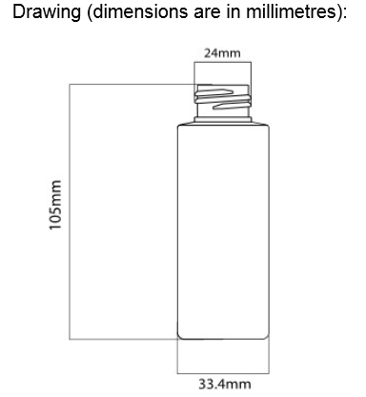

LABEL INFORMATION
Toner & Cleanser Bottles – White Bottles with Silver Lids
Neck Size: 24mm
Neck Height: 410
Height: 120mm
Diameter: 44mm
Max Label Size: 89H x 138L
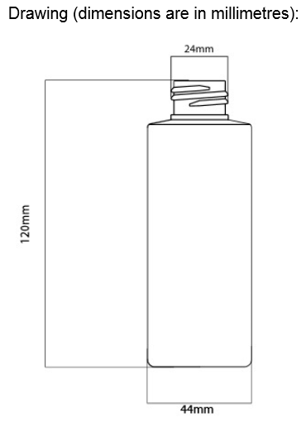

LABEL INFORMATION
Facial Scrub Jar – White with Brushed Silver Lids
Neck Size: 58mm
Height: 33mm
Diameter: 60mm
Max label size: 16mm H x 189.2mm L
