Caithness Raiders Rum
Ice and Fire Distillery
Ice and Fire Distillery has started out making Caithness Highland Gin and Crofter’s Tears gin.
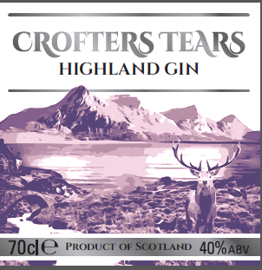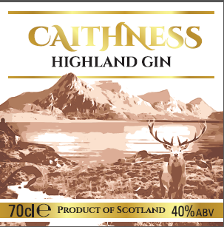
We are now diversifying into rum. The rum will be rum flavoured with honey and spices and then aged on oak to give it a light golden oak colour. The honey is made from our own bees in beehives.
Ice and Fire Distillery is in Caithness Scotland. Caithness is surrounded on 2 sides by the Pentland Firth on the north and the North Sea on the East. The Pentland Firth is one of the most ferocious straits in the world with tidal races, whirlpools and eddies. There have been many shipwrecks in the Pentland Firth which still continue to this day.
Historically Caithness was raided and settled by Viking Norsemen from Norway. Caithness has many Viking place names and Viking burial sites.
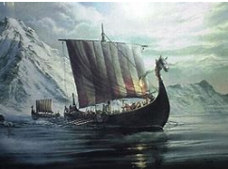
I want the label for this rum to signify that it is a premium product;
The label has to have a luxury feel and look to it.
The label needs to signify that this is an area with a large seafaring heritage. Caithness is an area of high sea cliffs and large expanses of water along 2 sides of the county.
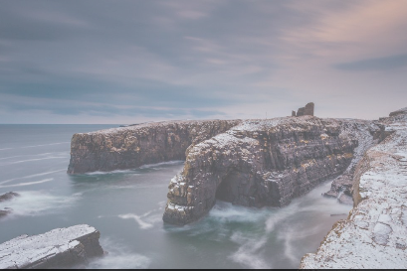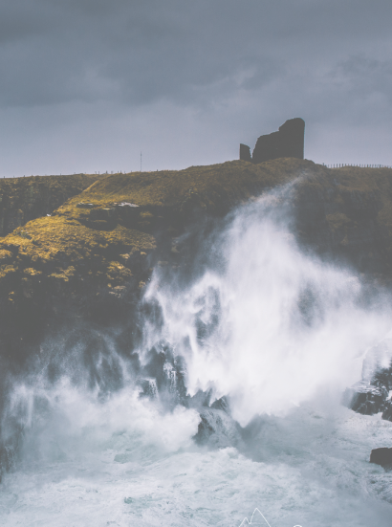
The Viking heritage and norse legends and symbols is important factor in this branding. View google images for Viking symbols as there are too many to put into the brief.
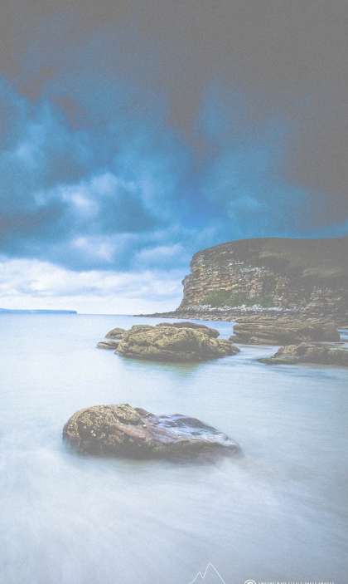
Caith was one of the seven provinces of pre-Celtic Pictland, named for the tribe who took the wildcat as its animal totem. The Viking invaders added ness-- old Norse for headland.
Seeing as how the Vikings reigned over Caithness, Orkney and the Shetland Isles from 850 A.D. until the Treaty of Perth in 1266 A.D., and that Norn, a dialect of Old Norse, was spoken in these parts well into the 16th century

