Nutrients
Ingredients
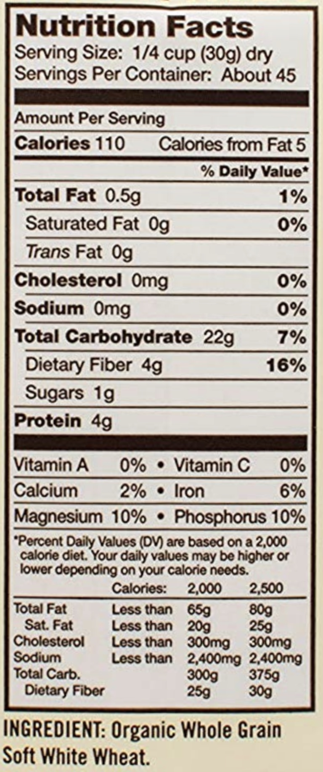

Barcode
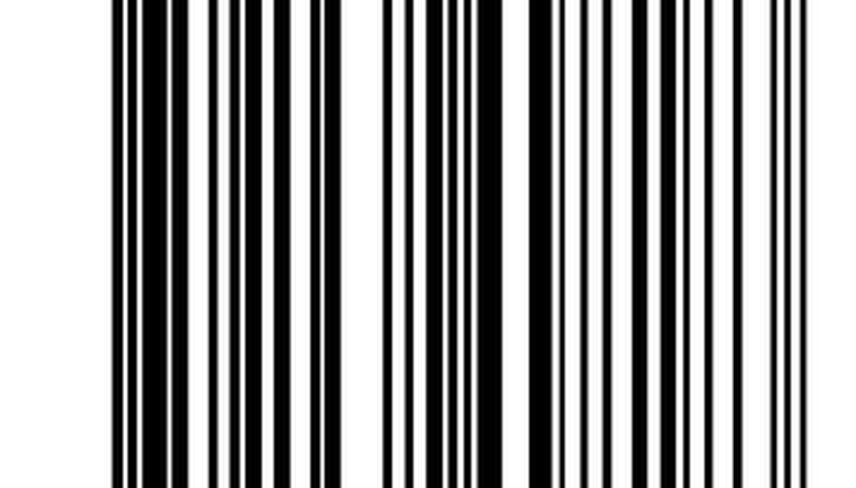

Stone Mill


Whole Wheat – Made with 100% Whole Grain
- Good source of Fiber
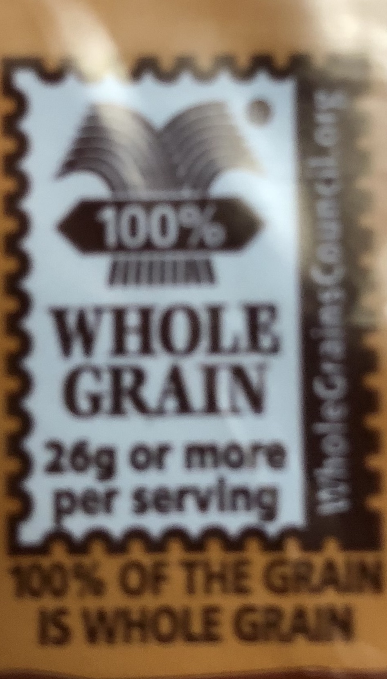

Heart Healthy –
In a Low Fat Diet, Whole Grain Foods Like this Flour May reduce the Risk of Heart Disease. Diets rich in while grain foods and other plant foods and low in fat and saturated fat, and cholesterol may help reduce the risk of heart disease and certain cancers.
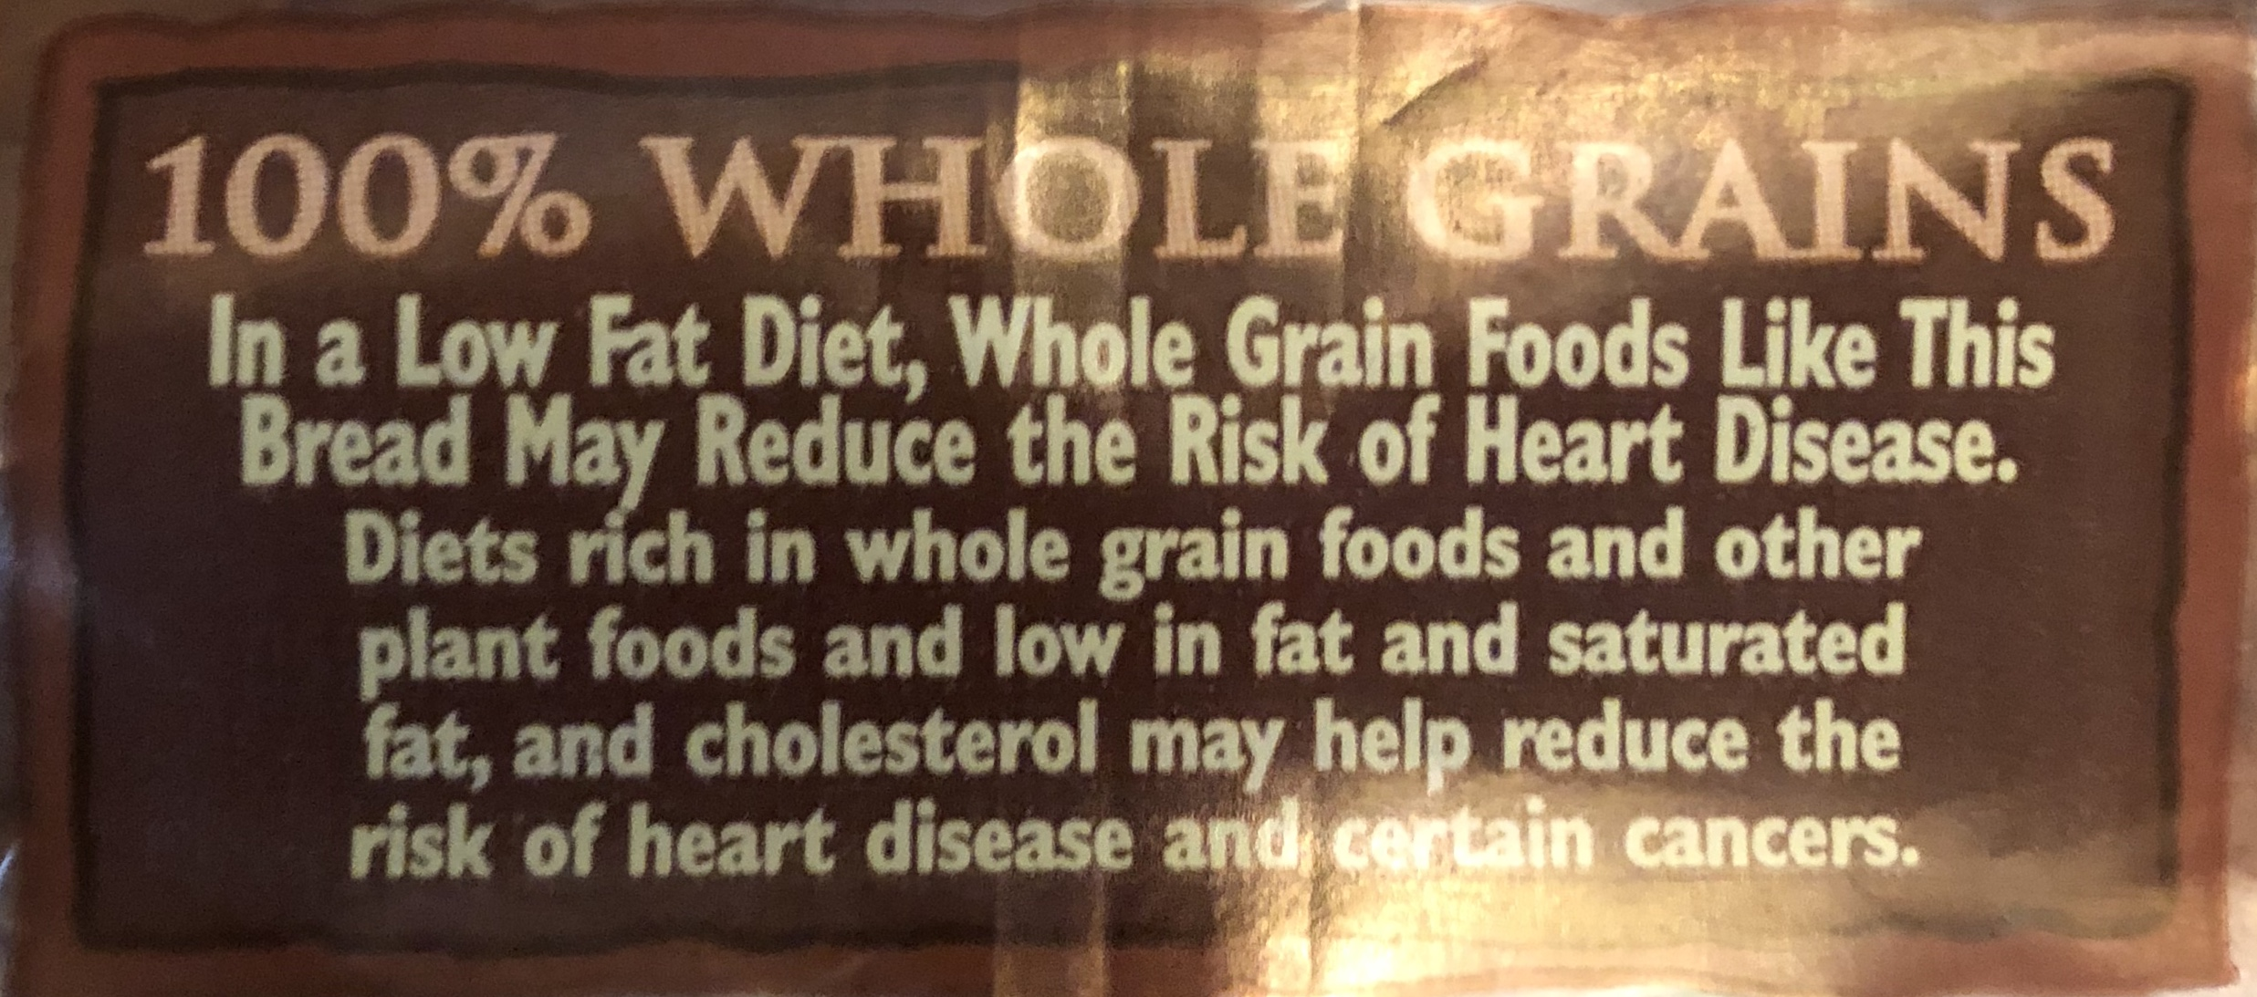

Flour Type and Grain type Chart

- Wheat Grain Flour
- Rye (Thec) Flour
- Barly (Elb) Flour
- Buckwheat Flour
- Spelt
- Rice
- Oat Nut Flours
Recipe
Ingredients
- 2-1/4 Tbsp Active Dry Yeast.
- 3 cups Water (warm)
- 1 Tbsp Salt.
- 1/3 cup Honey.
- 1/3 cup Vegetable Oil.
- 1/2 cup Vital Wheat Gluten.
- 8 cups Whole Wheat Flour or Organic Whole Wheat Flour.

Website
- www.babasmill.com
Oz/Kilos/Pounds

