Front side:


Ever Wonder what is going on in your child’s head? So do we!

Researchers in the Department of Psychology at the University of Toronto, St. George campus are studying how children learn new things, remember their experiences, and interact with their worlds.

We are always looking for more volunteers to participate in our research studies. If you are the parent of a baby, child, or teen living in the Greater Toronto Area, you might be eligible to participate!

For more information: childstudycentre.psych.utoronto.ca


Sign up now!

Back side:

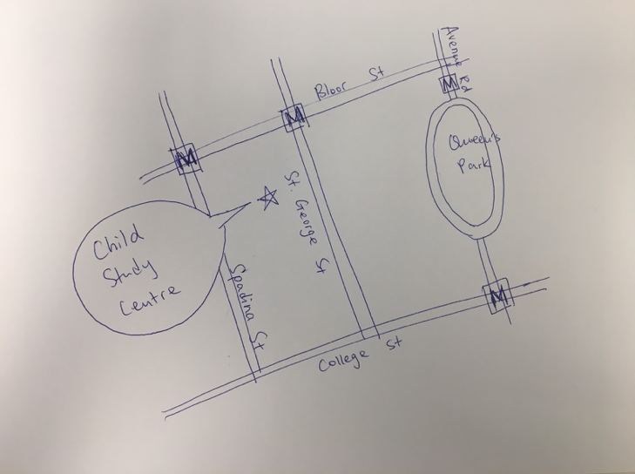(a map of where we are, we are hoping to have a map that resembles the style of the map below. A google map screenshot is also attached below.)
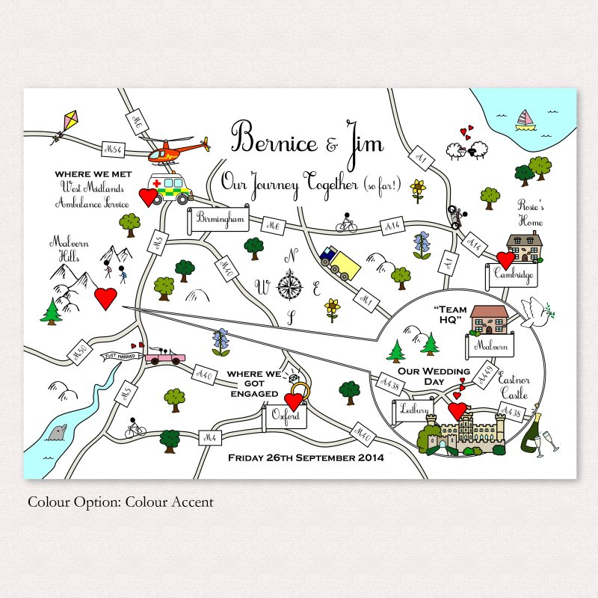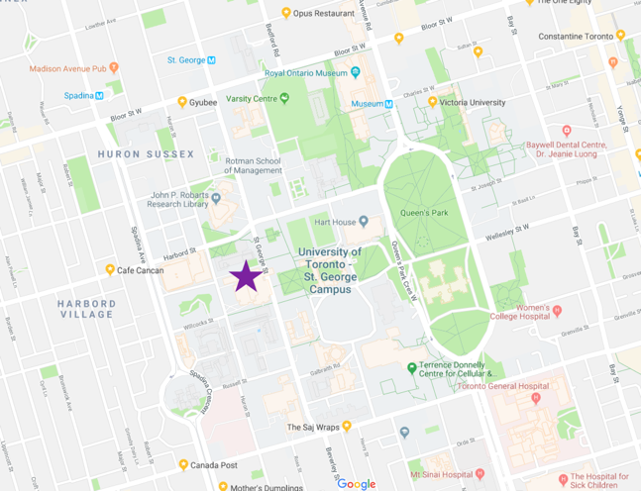

What is involved? Our research studies typically involve engaging in fun activities and/or computer games with one of our trained researchers. Studies can take anywhere from 15 minutes to a few hours.
Where are you located? The Child Study Centre is conveniently located on the St. George (downtown) Campus of the University of Toronto. We are accessible by TTC (St. George subway station) and provide free parking to all. Thank you for your time.

