KINGDOM CONCEPT:
Our church exists to glorify God and make disciples by: connecting our community for real relationship with God and with one another.

MISSIONAL MANDATE:
(a clear and concise statement that describes what your church is ultimately supposed to be doing; compass; north star)

cultivating community by removing the walls that divide us and building bridges that connect us as one human family, each person created in the image of God.
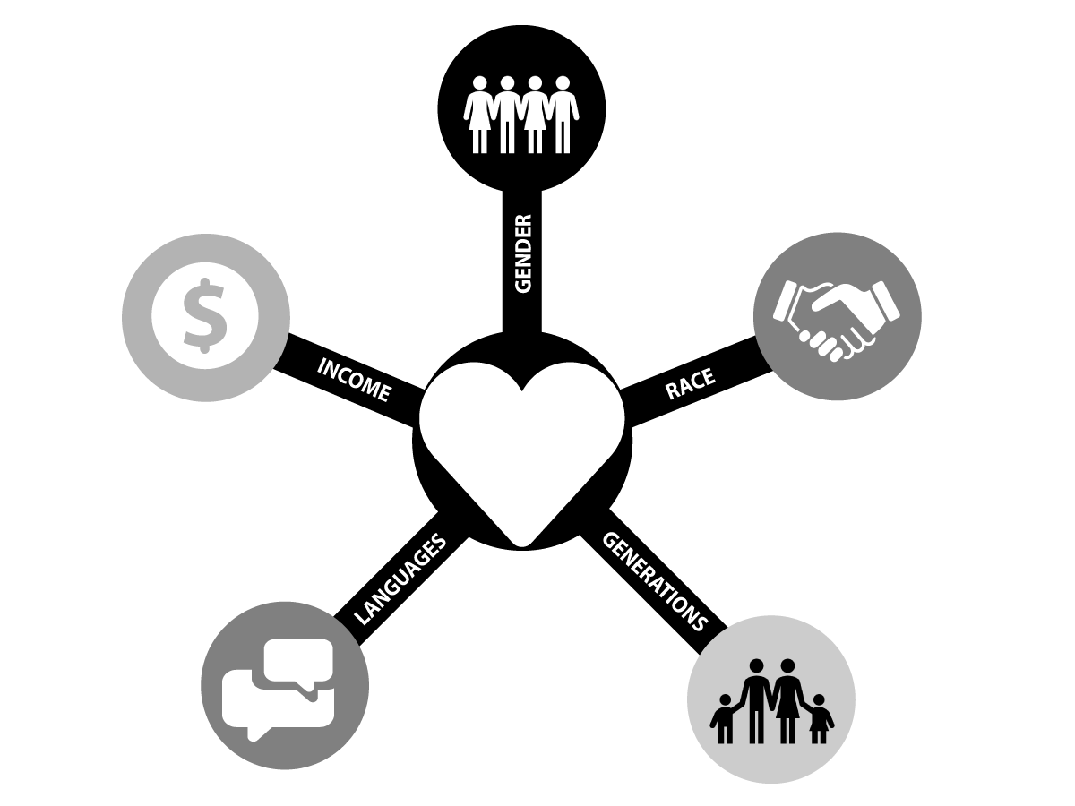
MISSIONAL MOTIVES:
(shared convictions that guide the actions and reveal the strengths of the church;
answers the question, “why?”)

- Dignity/worth of each individual
- Diversity
- Unity in Christ
- Service to our community

- Responsiveness to the Holy Spirit

