

Matrix Asset Management
Diversified Commercial Income Fund (DCIF)
Matrix Funds Management seeks to deliver Institutional Grade Investments to investors; providing access to the best risk adjusted returns in the Australian marketplace. With a strong balance sheet and a portfolio of A- Grade commercial assets; investors will have peace of mind knowing that their capital is in safe hands.
Fund Allocation
Fund is allocated 100% to Commercial Properties; this includes:
- Luxury International Hotel Brands
- Shopping Centres
- Mixed-Use Retail
- Office Buildings
Stability of future income is achieved through strong covenants and an average WALE expiry of 15 years.
Investment Criteria
- Post-DA/Under Construction
- Executed contractual agreements in place
- Local Institutional funding in place

Fund Summary
Fund Category | Unlisted Property Fund
Fund Cap | $50,000,000
Projects End Value | $500,000,000
Highlights | Corporate Guarantee  Income Guarantee  Redeemable Preference Units (RPU)
Investment Term | 1 Year Minimum
Rate (Net of Fees) | 1 Year Lock-in: 8% p.a.  2 Year Lock-in: 10% p.a.
Distribution Frequency | Every 6 Months
Pricing | 1 Dollar Units
Management Fee | 1.5% p.a.
Expense Recovery Fee | 0.5% p.a.
Entry/Exit Fee | Nil
Minimum Investment¹ | $500,000²
Redemption | Within 45 business days after investment term

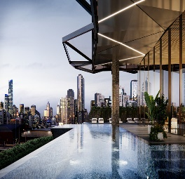
¹Fund manager reserves the right to accept amounts below the Minimum Investment
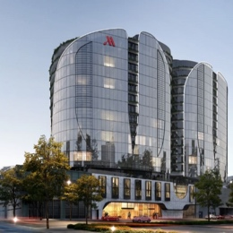
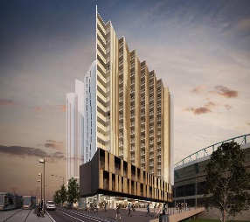
² Must be Wholesale/Sophisticated Investors under ASIC definition

