Packaging Description

Window box style hanging packaging for earbuds
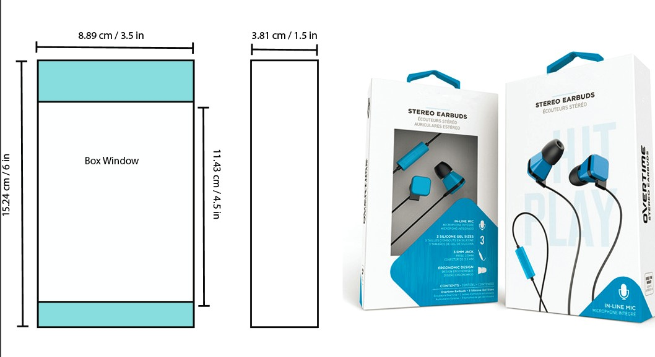
Packaging Size: 6” x 3.5” x 1.5”
Front (6” x 3.5”) should Include
Title: Customizable Stereo In- Ear Earphones
Model Number: SC-1
Features:
- Customizable earbuds
- In Line Mic
- Silicone Gel Ear tips
- 3.5mm Jack
- Ergonomic Design

The window in front should show below actual product
Earbuds, Controller, Jack, 4 Customizable caps

Back (6” x 3.5”) should include
Contents
2 Pairs of Switchable Caps
3 Pairs of Silicone Ear tips
User Manual

Specification:
Frequency Response: 20-20KHz
Sensitivity: 105±3dB
THD: <3%
Cord Length: 3.6ft

Side 6” x 1.5” should include
Product name in big: Customizable Stereo In- Ear Earphones

Designs of packaging we like
