Briefing Website Vibropac

Hello Designer, We would like to ask you to build a website for our Automotive Company. Vibropac B.V. is a company that specializes in the development and production of special dismantling tools for the automotive industry. The tool is especially suitable for the removal of glow plugs and injectors by means of vibrations.
Business Logo:
We would like you to build the following pages:
- Home page
- Loginpage/Register for clients
- Service
- Rental
- Shop
- Contact
- About us
- Terms and Conditions
- Videopage
- Faq page

Homepagina
At the top a slider with 3 slides. Here comes the following slogan: Innovative in Automotive.
Below is a menu bar with the following menu from left to right (also include the following dropdowns, these are not in bold):
- Home page
- Shop
- VPE 010
- VPE 020
- VPE 030
- VPE 040
- VPE 070
- VPE 120
- VPE 130
- VPE 140
- Nose break sets
- Fire plates
- Cleaning/ sanding sets
- Hydraulic sets
- Extensions /accessoires
- Service
- Rental
- About us
- Contact
Take an example of this: 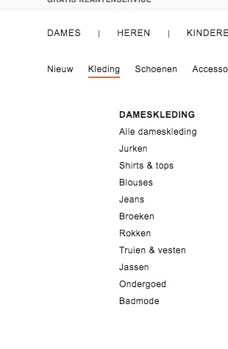
This was the menu bar. Below we want 5 blocks with the following points:
Block 1: Service. Right or left a photo with next to it the next piece of text with a button below that leads to the service page:
Vibropac Service kunt u inschakelen als u incidenteel problemen heeft met het verwijderen van verstuivers en/of gloeibougies en het op dit moment voor u bedrijfseconomisch nog niet haalbaar is om in onze producten te investeren. Vibropac Service heeft voor meeste "probleem" motoren het benodigde gereedschap en de technische knowhow om de verstuivers te kunnen verwijderen. Mail het aanvraagformulier, en u wordt vervolgens teruggebeld over de mogelijkheden.
Belangrijk is hierbij wel dat de verstuivers die problemen geven niet beschadigd zijn ten gevolge van het door uzelf proberen te verwijderen met ongeschikt gereedschap. Het inschakelen van de Servicedienst vergroot de kans op een succesvolle demontage.
Take an example of this: 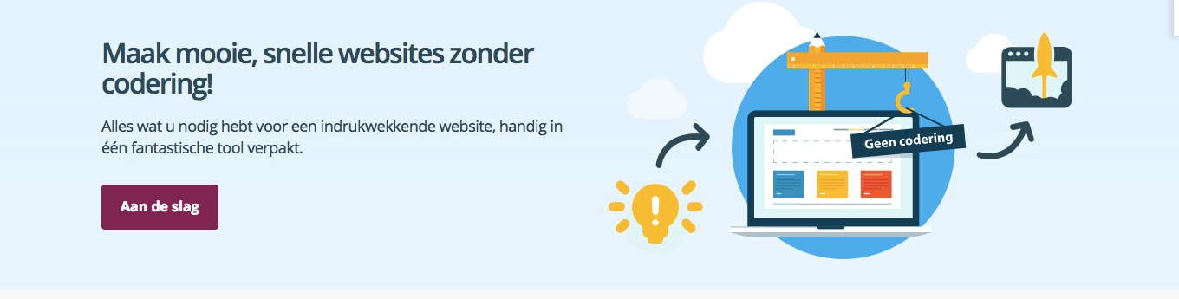
Button: "Request service"
Block 2: Rental. Right or left again a picture with next to it the next piece of text and below that a button that leads to the rental page. Take an example here:
Rent a Vibropac now. Get good prices and get all engines apart.
Button: "Request rental"
Block 3: Experiences. here we want to add 3 customer reviews that share previous experiences with Vibropac. Take this as an example: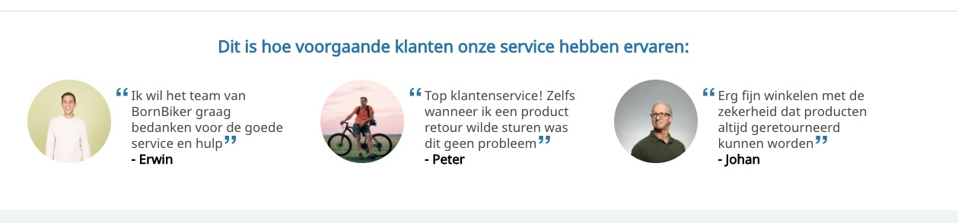
Block 4: Shop. Would like to show 3 bestsellers here. Also buttons to process by clicking on the products.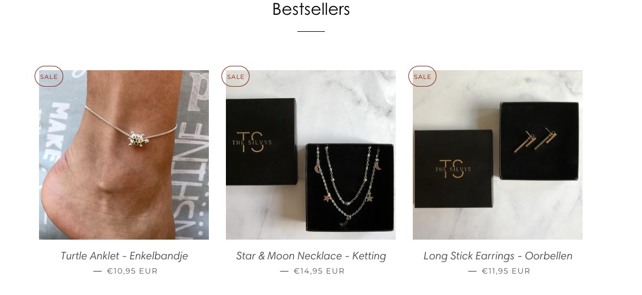
Block 5: Video. Here like a block where I can place a video with a title above it.
These were the blocks. Below a footer. Take an example here: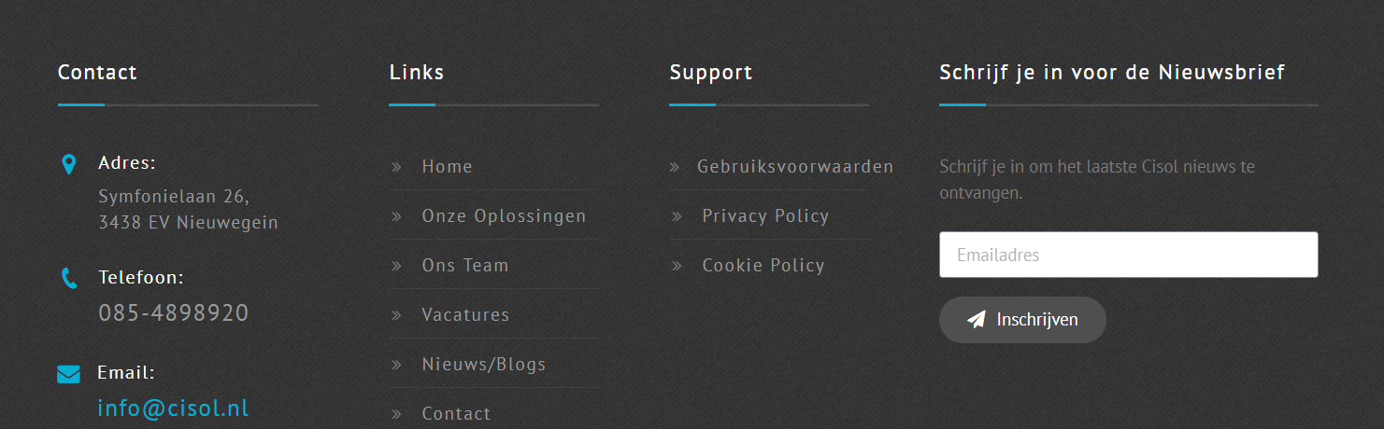
This was the Home page.

Service page

Piece of text about the Service of Vibropac with an image or icons. This includes an application form with a button to send the application. The application form must be easily editable and end up in a mailbox.
Take this form as an example:
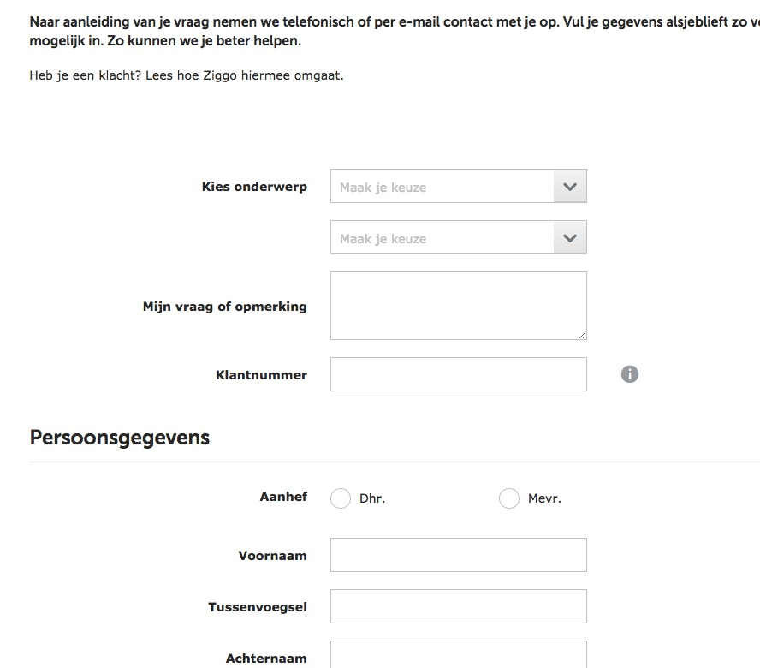
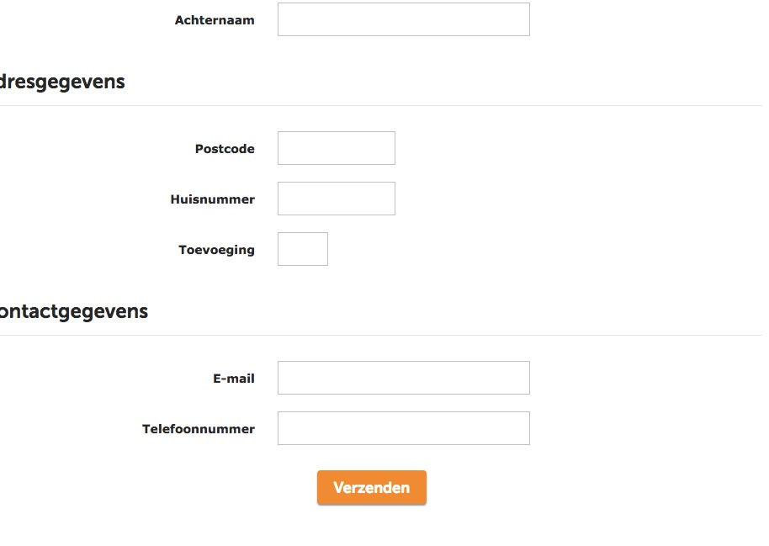

This was the service page.

Rentalpage

This is almost the same as the Service page. At the top a piece of text with possibly image or icons. Below that an application form. This must be easily adaptable and end up in a mailbox.

Take the example as with Servicepage.

Loginpage/Registrationpage

We would like a page with a simple login form. This should also include the option for new users to register. For registration of new users like a pop up. Take this as an example. 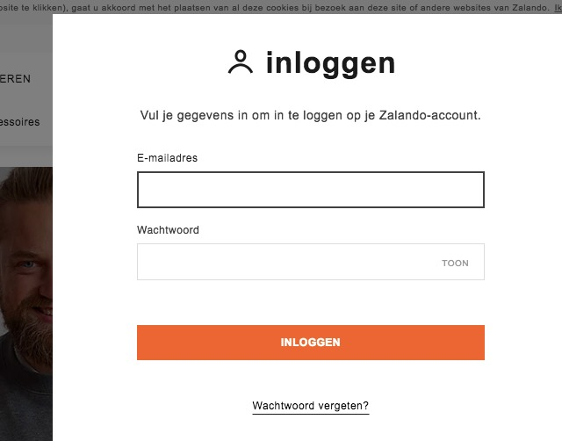

Here an example of how the pop up should look. 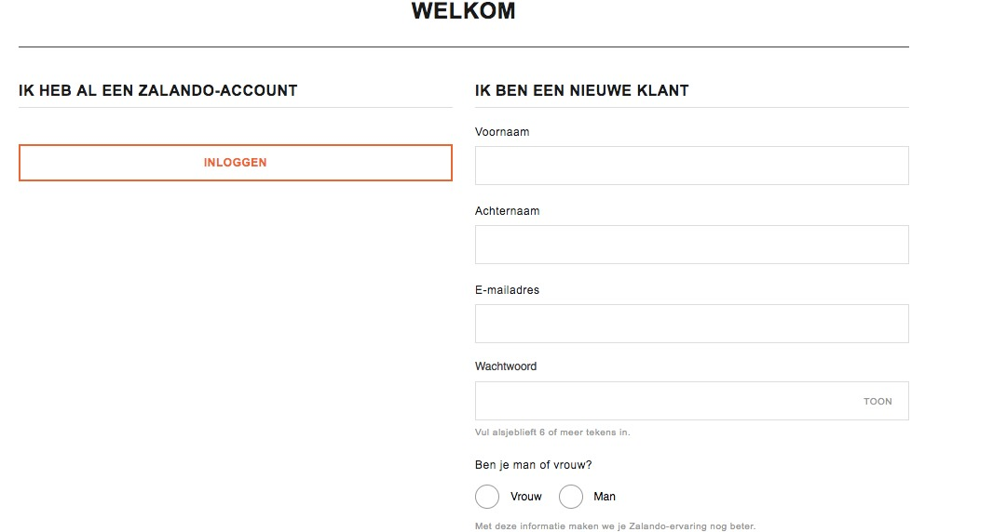

The users must be linked to a CRM system.
This was the loginpage.

Shop
When someone clicks on Shop, he comes to a page with a small piece of text first. Below that all blocks from the dropdown menu as previously indicated. This will be 13 blocks which will all go to the next page (they must be clickable). The blocks are as follows:
- VPE 010
- VPE 020
- VPE 030
- VPE 040
- VPE 070
- VPE 120
- VPE 130
- VPE 140
- Nose break sets
- Fire plates
- Cleaning / Sanding sets
- Hydraulic sets
- Extensions/accessoires
Take this as an example.
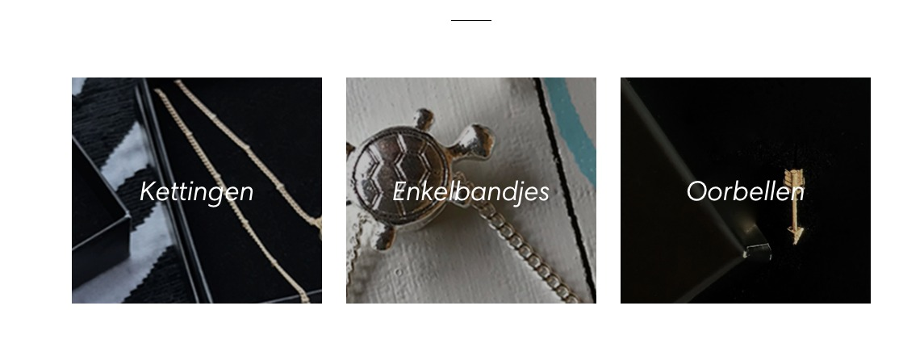

The landing pages of these blocks must be made into a template in which people can select and order the products that are on the page.
Take an example of this, but we also want a piece of text with the products with the possibility to read further (as in example 2):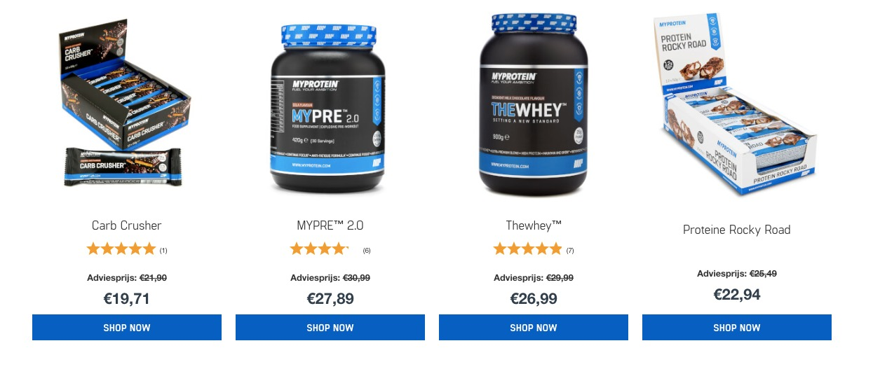
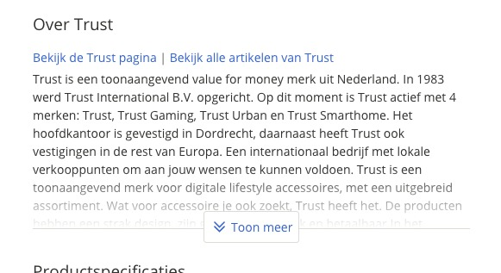

Furthermore, we want to keep the shop as simple as possible and use a well-functioning application that supports this.
That was the shop.

About us page

Keep it simple. 2 blocks with text and pictures.

Contactpage
Here a location visible through a folder of the organization. Further a contact form.
See photo below: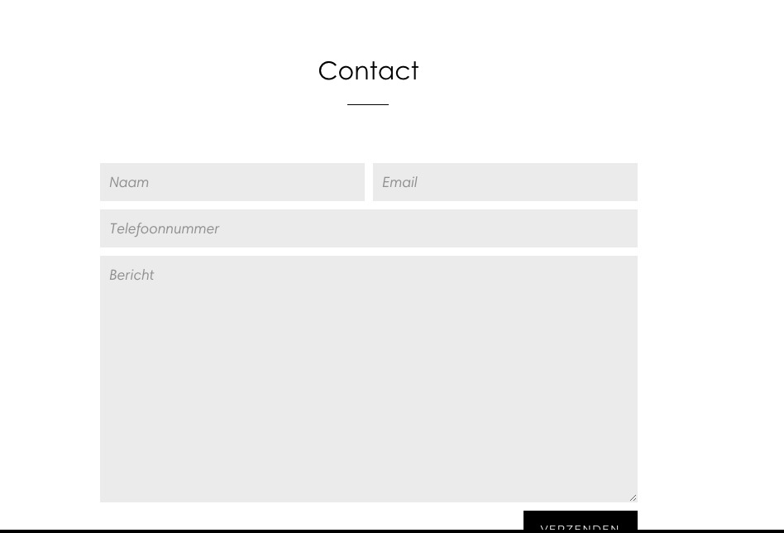

Faq Page

We want a page with the most frequently asked questions and answers. See example: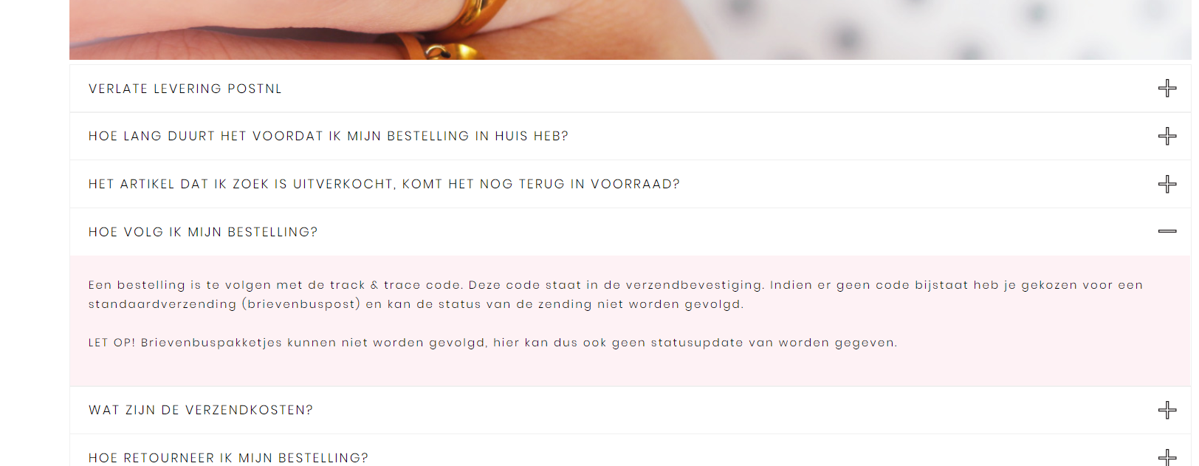

If there are any questions about the site, please let me know! Good luck with the assignment.
Greetings,

Tristen van Schaik and Marck van Baal
Managers Vibropac

