Date:

Addressee:

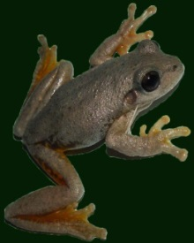
FROGS Landcare Inc
GOULBURN

Friends and Residents Of Goulburn Swamplands

