August 1, 2017

Plus Brand Style Guide Outline

Brand story
This can be centered around our mission and vision, or can be our mission/vision, along with the personality and values we are defining.

Mission
We empower our clients by focusing on their business objectives in order to deliver appropriate holistic technology solutions.
Bridging the gap between business and technology, we provide strong leadership and consulting skills to develop a comprehensive and intelligent strategy, leading to design and implementation based on best practices, strong partnerships, and execution expertise. By leveraging strong methodologies, we ensure on-time and on-budget fulfilment of client objectives while maintaining the highest standards of quality.

Vision
Brand Promise
How do we want people to feel about us
Brand Attributes
Who are we, what do we represent
BoilerPlate (Elevator Pitch)
Who is Plus, what do we do. This will be the basis for every press release, description, or listing for events/media.
Plus Consulting is a business-driven technology leader focused on delivering the most effective solutions for our clients by strategically designing and deploying enterprise CRM, Microsoft platform, and Information Security services.

Standard Legal Copy
The following paragraph should appear on all corporate literature, sales, and marketing materials:

Name & TradeMark

Name Usage

Plus vs. Plus consulting guidelines

Tagline

Trademarks

Logo: Propper usage, sizing & unacceptable forms

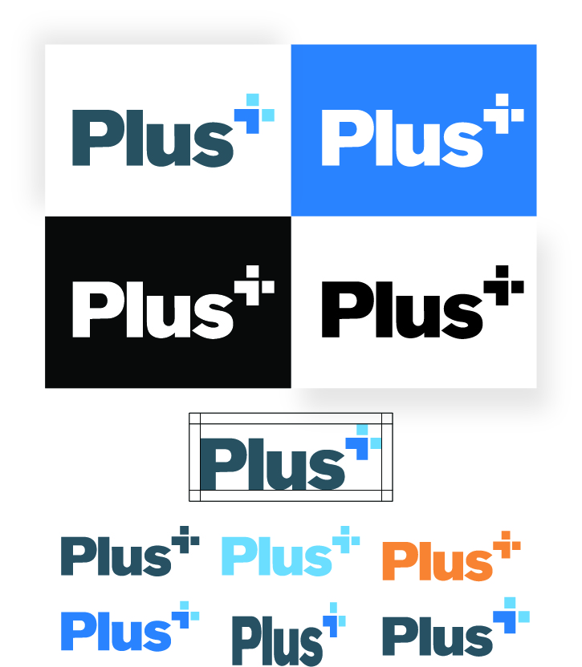

COLOR PALETTE
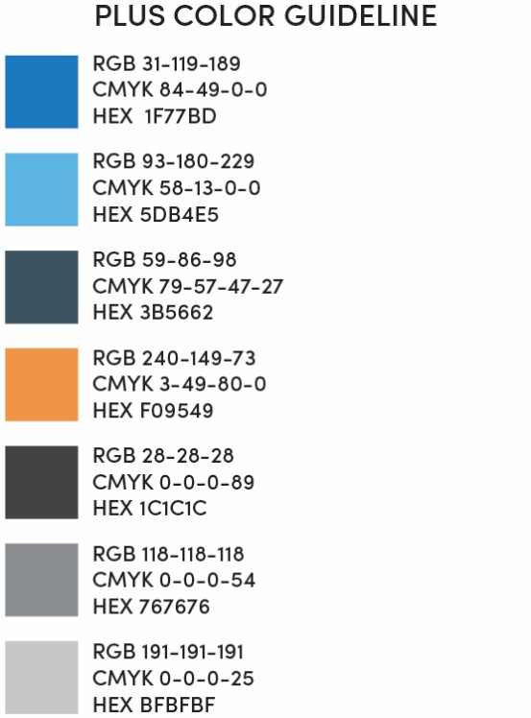

FONTS
Century Gothic is acceptable for all internal employee use whereas marketing materials can use a combination of Century gothic and Sofia Pro

IMAGE GUIDELINES
I would like our internal team to also be a beta for the App Devs Photo Gallery application. We can use it to post images and do internal feelers for what resonates well with our internal team. We will define our image best practices and steer the direction of the types of images we will use in all our public facing materials

MESSAGING
This is more our style of writing. Words we will use consistently and words we need to shy away from using. Having a strong messaging guideline significantly helps the organization become better “writers”.

WEBSITE
- Imaging
- How solutions are presented
- What images are consistent with the intention of the website
- What do we want the website to accomplish, which will lead the pages we layout

Social media
Define the expectations of social media not only at the business level, but at the individual level. What platforms will we use, policies for use, strategy, etc.

LinkedIn

Facebook

Twitter

Instagram

YouTube

Google

Printed material standards
Define what we need to have as standard printed materials. This is not meant to define marketing materials, rather think marketing materials and stationary design.

Envelopes

Letterhead

Business Cards

One Pagers

Invoices

Contracts

PowerPoint Presentations

Signage
Email Signatures

