REconsider Life Overview

Why is human change so hard? Or is it? Neuroplasticity has revealed that our brains can change and adapt, making new and stronger neural connections based on new beliefs and habits. What is getting in our way? What limits us as we strive to change habits, improve our behavior, and thrive in our relationships and communication? What are we bumping up against - resistance, fear and separation? How and why has life become such a struggle?

We are more powerful than we can even imagine. When we know ourselves as the creators of our own lives, instead of settling for the way things are, we can choose the lives we most deeply desire and experience true freedom and possibility.

There is a way to live and experience life beyond what we can even imagine. Knowing ourselves as the creators of our own life is the path to freedom, possibility and the life most deeply desire.

REconsider offers experiential workshops to break free from patterns that victimize our minds and relationships. REconsider takes participants on a journey of discovery and transformation within themselves, to enhance their relationships with others, and to change the environments in which they exist—and ultimately the society—for the better. The REconsider process re-frames and challenges the stories that limit our growth and evolution through inquiry, play, writing, self-reflection, exercises and discussion.

The facilitated workshop enacts the transformation through exploring five principles: Curiosity, Awareness, Owning Your Own Creation, Reimagining, and Manifestation. Opening with curiosity to pause and ask why, REconsider then dives deep into awareness and our ability to own our creation so we can reimagine what an astonishing gift life is. Once our creative imaginations are rekindled, we are free to embrace new horizons of possibility which manifest as newfound relationships and a celebration of the infinite game of life from a place of profound knowing.
REconsiders’ work is based on two primary questions:

What kind of life do you want to create?
What kind of world do we want to live in?

Each workshop is tailored to the specific audience, understanding that there are multiple ways for people to enter the conversation of transformative thinking and to process change. Testimonials from participants nationally and internationally demonstrate that the workshop experience is highly engaging and effective for individual participants as well as community groups, corporate, and nonprofit organizations.

The work of the foundational REconsider Workshop—REconsider Life—is focused on the creative experience of life. Through compelling and advanced techniques, the workshop is designed to unveil our identities as Creators. It is designed to allow us to experience ourselves both individually and collectively and to discover how what we create in this life is related to the narratives we are born into and the belief systems we choose to follow. The Workshop process brings greater understanding and insights to explore all of the patterns, energies and communications - both conscious and unconscious - that together make up the world as we know it.
No matter our challenges, we can choose responses that are empowering and life-affirming to live in a more dynamic, connected way.
The Workshop takes participants through five transformational core values:

- Curiosity—Nothing happens without an energy igniting it.
Moving from a place of judgment to a place of curiosity, we begin to understand how our current situation makes sense. By fostering curiosity, we can open to each other’s narratives, and release preconceived ideas.

- Awareness—Life has patterns and structures.
Where do our beliefs and narratives come from? How do we shift them if they are not working? Rather than simply defending our beliefs, we can become conscious of how situations and systems are created and sustained, a critical step in a process of renewal and perpetual creation.

- Own Your Creation—Taking 100% responsibility for our lives.
What does it mean to be responsible for the world around me? How can I feel fully empowered when as an individual I can’t control the world around me? Recognizing ourselves as creators and sustainers of our systems and society is an invitation to engage in a more deliberate, connected and dynamic way.

- Reimagine— is where we see the issue resolved.
The ability to dream and imagine beyond our current state leads to questions such as: What kind of world do you want to live in? What kind of life do you want to create? What challenges can we expect to face as we reimagine a new possibility? Here we are invited to see ourselves as full co-creators of our lives.

- Manifest—Working together to create.
What are the challenges of working together? How can we experience common values? What are ways to support both common and differing visions? Here we enact and embody new visions and possibilities in communication and collaboration with others—and in relationship to Life.

The Reconsider Life Workshop is about reconnecting to life as a creative experience and exploring the ways we construct and live our lives. Such an expansive experience allows us to discover how to craft the masterpiece of our lives to make our lives more meaningful, engaging, and powerful.

The Reconsider Life workshop is a wonderful vehicle for giving us new perspective and noticing where we have our blind spots. We are invited to see where we have already made a decision about ourselves and about others, and are encouraged to challenge those decisions. What opens up is a whole new way of relating to ourselves and to one another. If everyone did this workshop, there would be a lot more understanding and fewer conflicts in the world. And the world certainly needs that!
-Jacqueline Buckingham

REconsider Team

REconsider is a 501(c)3 nonprofit organization, founded in 2013, with a focus on creating media, workshops and immersive experiences that focus on creating dialogue, awareness and action regarding our most pressing societal issues. Key Individuals on the team include:
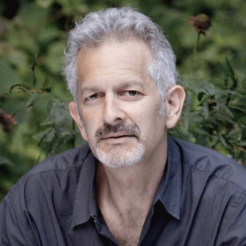
Stephen Apkon is a filmmaker and social entrepreneur and the Co-Founder of Reconsider. He is the Founder and former Executive Director of the Jacob Burns Film Center, a non-profit film and education center located in Pleasantville, NY. Opened in 2001, the JBFC has become one of the premier film institutions in the United States, with a Board of Directors that includes Steven Spielberg and Ron Howard, among others. In his 15 years running this organization, he led development campaigns raising more than $100 million and has overseen the creation of groundbreaking education programs focused on literacy. He continues to serve on its Board of Directors.
He is an award-winning Director and Producer of Disturbing the Peace, as well Producer of Presenting Princess Shaw, I’m Carolyn Parker, and Enlistment Days, and Executive Producer of Planetary. He is the author of The Age of the Image: Redefining Literacy in a World of Screens, published by Farrar, Straus & Giroux in April 2013 – foreword by Martin Scorsese. Stephen is a graduate of Georgetown University and received an M.B.A. from Harvard Business School in 1986. In 2012 he was awarded an Honorary Doctorate in Humane Letters from Pace University.

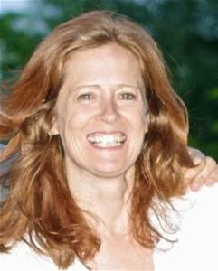
Marcina Hale is a Co-Founder of REconsider. Marcina has spent the last two decades developing and facilitating workshops around transformational change, focused on both individuals and communities. With degrees in both Media and Psychotherapy, Marcina’s vision is to utilize film as a catalyst to create experiences that evoke thought and conversations that challenge and inspire living life more dynamically. Marcina is also a Licensed Marriage and Family Therapist (LMFT). In her roles as a master therapist and dynamic facilitator, she conducts workshops that challenge and inspire others to live their lives more consciously and to take responsibility for their own creations. She is a Producer of Disturbing the Peace and is the primary facilitator for REconsider workshops, including REconsider Life and Disturbing the Peace which have been taught both in the United States and internationally.

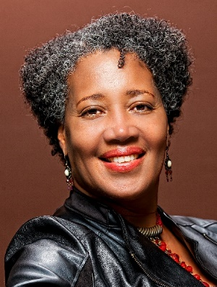
Jewel Kinch-Thomas is a Co-Founder of G&J Productions, which focuses on arts and culture event planning and productions. She’s currently the COO of the Jazz Leadership Project. Jewel is the former Artistic and Executive Director at the historic Theatre of The Riverside Church, where she championed the work of artists dedicated to illuminating social justice issues, while dramatically increasing the capacity and budget of the institution. Over a 14-year period, she founded and produced several annual programs including: a Cultural Animators Theatre of the Oppressed Series; a New York Times acclaimed NuDance festival; annual galas featuring luminaries such as Phylicia Rashad, Max Roach, Patti Austin and Arthur Mitchell; special events such as Women of Excellence in the Arts with Ruby Dee and Sonia Sanchez; a New York Family Arts Festival; a African Diaspora Film Festival; several dramatic productions; and a Youth Theatre Program. More recently, she served as the Executive Director of the Hudson Valley Writers' Center in Sleepy Hollow, NY. Jewel was selected to participate in New York Foundation for the Arts Leadership Circles, Columbia University’s Arts Leadership Institute, and the Women & Power: Leadership for the 21st Century program at the Kennedy School of Government at Harvard University.

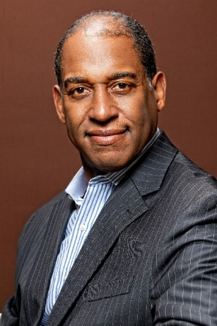
Greg Thomas, Co-Founder of G&J Productions, is a writer, editor, and public speaker. He’s CEO of the Jazz Leadership Project, which applies the democratic principles and practices of jazz music to organizational leadership and teamwork. Through G&J Productions, he has been instrumental in developing programs such as the National Jazz Museum in Harlem’s flagship interview series, Harlem Speaks. As a professional writer for over 25 years, Greg has written about culture, race, and democratic life and values in publications ranging from the Village Voice, New Republic, Salon, UPTOWN, The Root, the Guardian Observer, and the New York Daily News—as jazz columnist. Greg has lectured on American cultural history and politics, and black American thought at Columbia, Jazz at Lincoln Center, Hamilton College and Harvard.

