
424 Sandpoint Ave • (208) 263-1103 • thewildflowerdayspa.com
Facials

Aveda Goddess Facial
Gentlemen’s Facial
45 min $75
75 min $105
105 min $140

Lifeline Anti-Aging Facial
75 min $130
105 min $160

Back Facial Treatment
45 min $75
Massages

Ceyet Massage
45 min $75
75 min $105
105 min $140

Earth Keepers Hot Stone Massage
75 min $135
105 min $170

Chakra Balancing Massage
75 min $105

Side-by-Side Massage
75 min $180
105 min $240

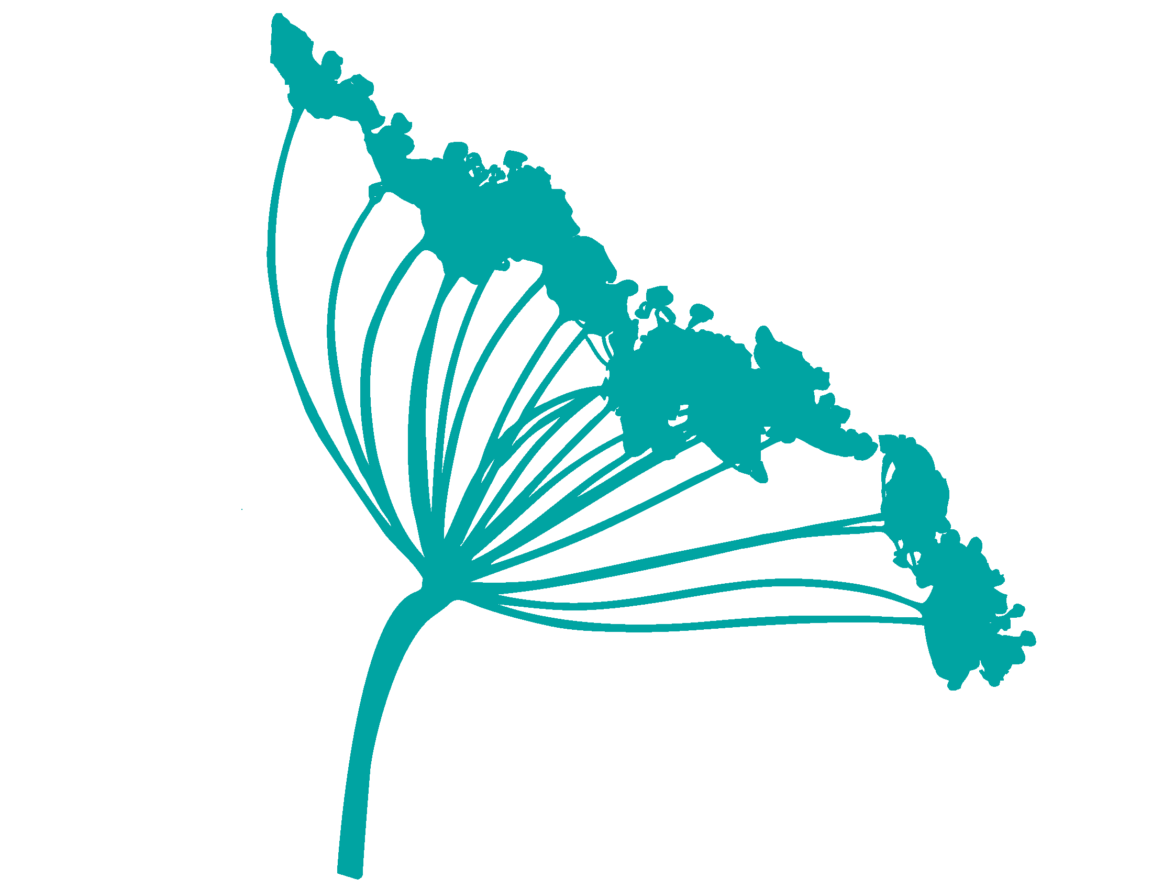

Vishy Wetroom

Hydrotherapy
45 min $90
75 min $120
Packages

Platinum - $360
105 min Earth Keepers Hot Stone Massage • 105 min Lifeline Anti-Aging Facial
Spa Pedicure • Spa Manicure

Gold - $230
75 min Ceyet Massage • 75 min Aveda Goddess Facial or Gentleman’s Facial
Spa Pedicure

Silver - $180
75 min Ceyet Massage • 75 min Aveda Goddess Facial or Gentlemen’s Facial

Bronze - $130
45 min Ceyet Massage • 45 min Aveda Goddess Facial or Gentlemen’s Facial
Hands and Feet

Spa Pedicure $60
Express Pedicure $45

Spa Manicure $40
Express Manicure $25

Reflexology
45 min $60
Waxing and Tinting

Brow Tint $15
Lash Tint $15
Brow Wax $20
Lip or Chin $15
Full Face $50
Underarms $25
Arms $30+
Lower Legs $40
Full Legs $75
Simple Bikini $35+
Back or Chest $50+

