Be Happy Now newsletter
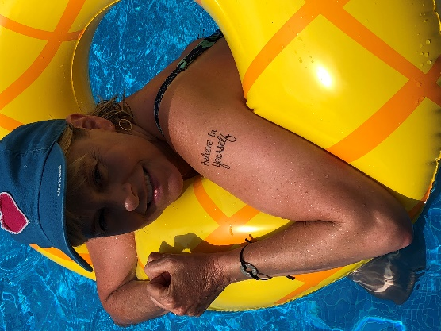

Hello Friends!!
I am excited to (hopefully) add a little love to your in-box with this newsletter. I love connecting with moms and helping them find tools to make their lives happier, more intentional, and more fun and this is a new way to do that!
If you don’t know me well, I am a certified Infinite Possibilities Trainer and I lead coaching groups for moms. My IP workshops and Empowered Moms Coaching Group have the goal of fostering connections between amazing women and empowering moms with tools to build lives they are enthusiastic about living, on purpose – and that will be the goal of this newsletter, as well!
I hope you find something useful and helpful and enjoy receiving this info (and if not, feel free to unsubscribe and my feelings will not be hurt! )!
With love,
Kim

Be Happy Now Tips & Tools: I think that is what this content section will be titled… I’m not sure yet… Montly “content” / “lesson” - its own section of the newsletter.
Building Happiness
I firmly believe that thinking about your happiness is important and that happiness itself is a worthwhile goal! If you think about all the things you focus on in your life and all the goals you set for yourself, all of those things are leading you toward feeling happier. Happiness, in the end, is the ultimate goal.
Of course, what makes each person happy is totally different – and that’s awesome and one part of what makes life fun and exciting! Many happiness experts and authors note that the key ingredieents in our lives that will make us happier are pursuing 2 categories:
- things that bring us pleasure (positive emotions) and
- things that bring us meaning & fulfillment
Give yourself a minute to think about (it’s extra powerful if you write it down!) what makes YOU happy.
What are things that make you feel happy / provide you with pleasure (little and big things!)? For me: joking & laughing with my kids & husband, petting with my dog, sitting with a soft blanket and a book, my first sip of coffee in the morning, walking in nature, travelilng, scuba diving, exercise classes, making my friends laugh.
What are things that are meaningful to you / make you feel fulvilled (little and big things!)? For me: teaching Infinite Possibilitites workshops, spending quality time with my family, making gratitude lists, volunteering, leading moms’ coaching groups, making my kids breakfast.

How could you add more of those things that bring you happiness to your days?
Try to add 1 or 2 of those things per week and see how your happiness increases! You are worth it!

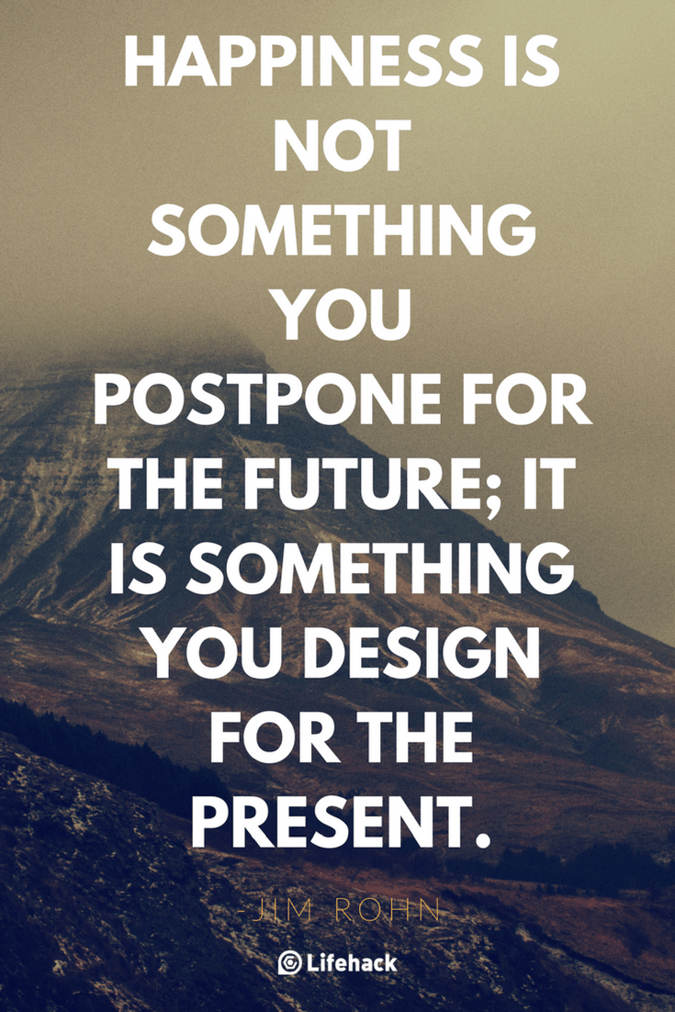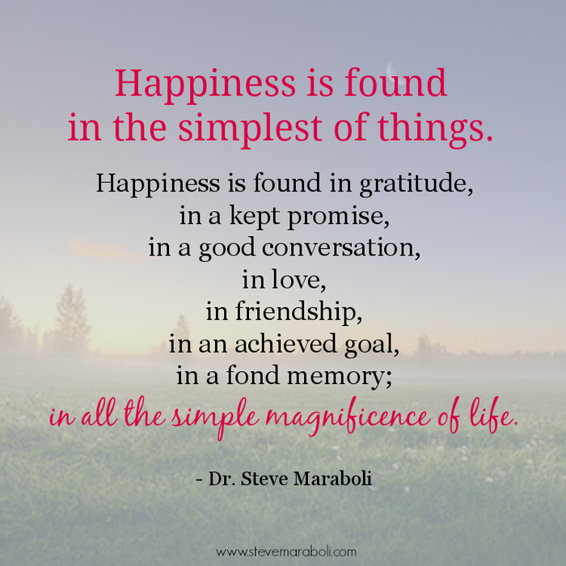

Book graphic??
Empowering Books: I love to read uplifting, inspiring material. Each newsletter, I’ll suggest a few books that I’ve enjoyed!
The Happiness Project by Gretchen Rubin
You are a Badass. How to Stop Doubting Your Greatness and Start Living an Awesome Life” by Jen Sincero

Upcoming Events: (its own section)
I lead an Infinite Possibilities Workshop 2-3 times per year. The next one is coming up in September/October. More details to come – but here is a little info…

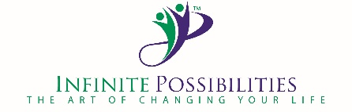
Moms - Back to School, Back to You!
In September, the kids will be going back to school and you can spend time focusing on YOU. Let this be the year where you take time to focus on yourself so that you can feel amazing, focused, fulfilled, purposeful, and happier! Take the time to learn some simple tools to help you live a life you love, deliberately, instead of just juggling what comes at you and juggling your to-do list. In this workshop, you will be empowered to build a life you love.

Dates: 3 morning workshop - September 27, October 4, October 11
9:30 – 12:30
Kim’s home in Issaquah Highlands
Interested? Email me: kimfoster@ihmail.com

Enjoy the rest of Summer Break! Savor each amazing day! How can you add a little more HAPPY to your August?? Make the choice and do it!

