Side One of Card:

Healing the Hurting Heart
Women's Trauma & Loss Group
Led by Licensed Professional Counselor, Kim Thomas Haar

10 Week Group
Cost - $35 session
Group size limited to 10 participants

Topics Include:
What is Trauma?
How Trauma Affects Us
Creating a Feeling of Safety
Managing Trauma Triggers
Importance of Self Care
Healthy vs. Unhealthy Coping
Guilt, Shame, and Blame
Victim vs. Victimized
Grieving through Loss
Anger and Forgiveness
Imagining a Better Future

For More Information, Contact:
Kim Thomas Haar, LPC, LMFT
(918) 277-0777
kim@thereshopehere.com

On Side Two of the card:

Life hurts and does not seem fair. So what do you do when you are faced with an event in your life that knocks you off your feet? It seems no one understands what you are feeling and no one knows just what to say. It is tempting to pull away and isolate or put up a mask and pretend everything is OK.

It is my desire you know that you are not alone! There are others who understand the feelings you are going through and offer a safe place for encouraging support. I want to invite you to embark on a courageous journey of healing where you will not only learn how to "survive" after trauma and loss, but instead, learn that you can once again "thrive"!
- Kim Thomas Haar, LPC, LMFT

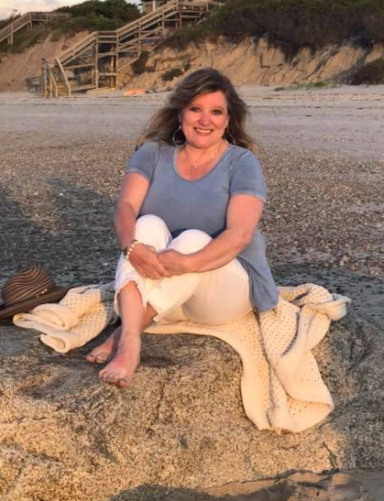
Kim Thomas Haar is a Licensed Professional Counselor and Licensed Marriage and Family Therapist. She is the owner of There's Hope! Counseling Services located in Tulsa, OK.

Kim is a trauma survivor herself and understands firsthand the unique challenges that can arise on the journey to healing.

