While the first logo contains elements for both law (scales of justice) and water (wave line), the logo does not work well on social media. | The second badge style logo works well on social media, but does not resonate with the legal community. Also, the working of the tagline is not legible when the image is reproduced on letterhead, business cards or social media sites.
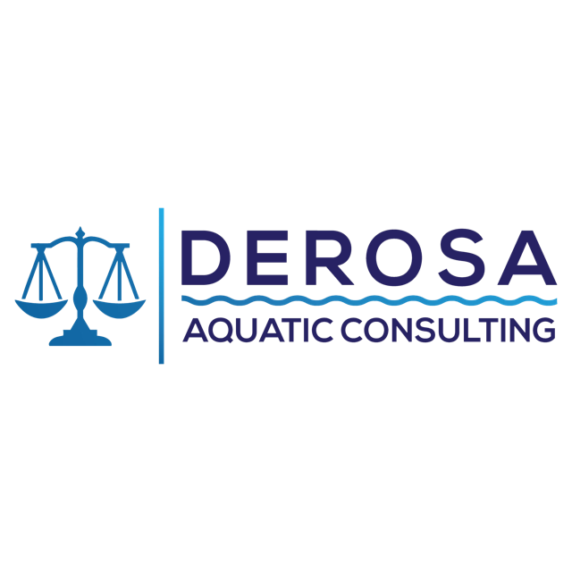 | 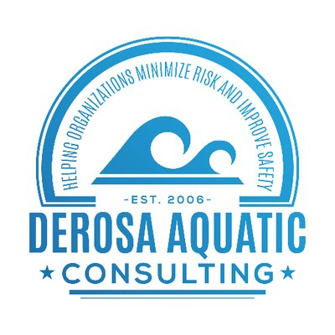

I currently use the logo for my Practical Pool Management PLUS pool operator certification course. It works well on social media, reprints easily on certificates and on clothing. | This logo is from a competitor in Canada. It's simple, conveys authority, (Badge) and reflects safety (lifeguard rescue buoy), and aquatics (water, braided rope) and the similarity to a life ring on a boat.
 | 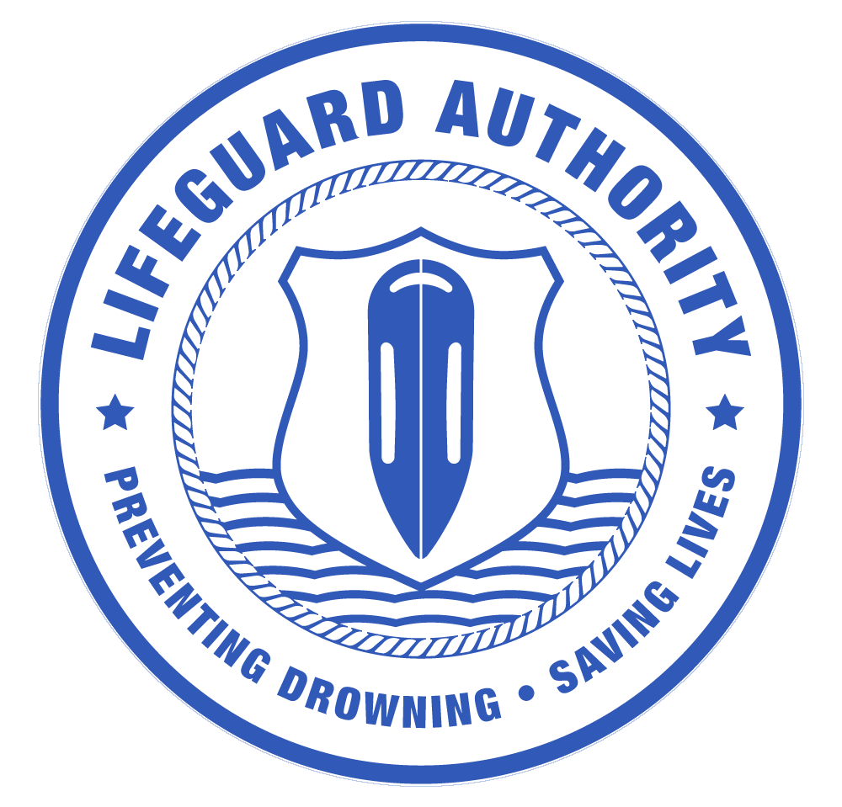

Another company that uses a horizontally oriented logo. . . | ... with the ability to take part of the logo and use it in social media sites. This part is unique to the brand, so its recognized as the company even without the text.
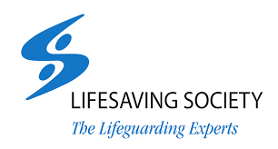 | 
Bondi Lifeguards (Australia). Badge is simple to use on social media, reproduces easily, suggests authority. Works well on social media. | A logo from a competitor. This logo doesn't convey the message I want, but the top triangle can be separate from the text for use in social media.
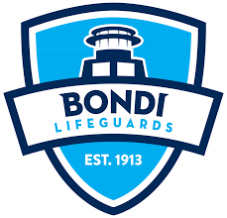 | 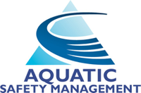  Social Media Version: 

